BENCHMARKING DISCOVERY & COMMERCIAL DEFINITION PHASE
Benchmarking Agent
Benchmarking Service
Product Requirements Document (PRD)

Prepared for | Executive Management, Product and the Development team
Purpose | Define the scope, analysis types, sector KPIs, client inputs, agent outputs and the MVP versus Premium offer
Status | Draft for review
Version / date | 1.0 · October 2026
Research cut-off | 2 October 2026. Every external fact is numbered and listed in Appendix B

Contents
1. Summary
2. What benchmarking is, and how the market delivers it
3. Core definition: problems solved and scope
4. Analysis typology: what the agent can run
5. Industry segmentation: peer groups and sector KPIs
6. Client inputs
7. Agent outputs: the exact report format
8. How the agent works
9. Data sources
10. Legal and compliance guardrails
11. Deliverables structure: MVP versus Premium
12. Commercial viability
13. Success metrics and release criteria
14. Risks, assumptions and open questions
Appendix A. KPI definitions used in this document
Appendix B. References

1. Summary
The Benchmarking Agent tells a client how its performance compares with a relevant group of peers, where the biggest gaps are, and what better performers do differently. It works from the client's own figures and from approved external sources. Every external number in a report carries its source, and the agent never uses competitors' confidential data.
Benchmarking is an established management discipline. Robert Camp of Xerox described it in his 1989 book as "the search for industry best practices that lead to superior performance" [1]. Today it is sold at every scale: enterprise programmes from APQC, The Hackett Group and Gartner [23][31][32]; mid-market competitive-intelligence platforms [33][34]; financial ratio books and reports for smaller firms [24][35]; and free benchmark reports published by SaaS investors and lenders [11][12][13]. In June 2026 Xero added industry benchmarks to its accounting software for small businesses [36].
What this means for the product
Basic financial ratio comparison is becoming a free feature inside accounting software. Our offer has to win on four things the research shows clients value: the right peer group, sector-specific KPIs, a clear explanation of each gap, and a practical plan, with every number traceable to its source.

4  benchmarking types classified | 3+1  sector KPI sets plus a cross-industry core | 2  packages: MVP and Premium | 0  confidential competitor figures used

Recommendation
- MVP: performance benchmarking against an aggregated industry peer group, plus internal benchmarking of the client's own units or years. Three sectors (retail, SaaS, manufacturing) and a cross-industry financial core. Delivered as a report, a KPI scorecard and a data file.
- Premium: adds named-competitor comparison from public data, practice benchmarking (functional and generic), finer peer segmentation, multi-year trends, a presentation deck, periodic refresh and an analyst review.

Decisions requested
- Approve the scope and non-goals in Section 3.
- Approve the MVP and Premium split in Section 11 as the basis for pilot pricing tests.
- Commission a legal review of the guardrails in Section 10 before any client pilot.

2. What benchmarking is, and how the market delivers it

2.1 Definitions and method
Spendolini describes benchmarking as "the continuous and systematic process of evaluating the products, services or processes of organizations that are recognized as representative of best practices for purposes of organizational improvement" [43]. APQC, a non-profit benchmarking body, structures every study in four phases [4]:
APQC phase | What happens | Who does it in our service
Plan | Choose the focus area, key measures and definitions | Client and agent together (intake)
Collect | Gather quantitative and qualitative data, internal or external | Agent, from approved sources and client data
Analyze | Understand the gaps and why best performers do better | Agent, with analyst review
Adapt | Build an improvement plan with progress tracking | Agent proposes; the client implements

2.2 Two ways to classify benchmarking
APQC separates what is compared from who it is compared against [2][3]. Performance benchmarking compares quantitative measures; practice benchmarking looks at how the results are achieved. On the second axis, the standard types are internal, competitive, functional and generic [3]. The classic functional example is Xerox studying the warehouse order-picking of L.L. Bean, an outdoor-clothing mail-order retailer, to improve its own logistics [6].

2.3 How benchmark results are presented in practice
Provider | How results are shown | What we take from it
APQC Open Standards Benchmarking | Gap analysis against top, median and bottom performers; more than 2,000 measures [23] | Show the client against quartiles, not only an average
The Hackett Group | "World-class" defined as the top quartile on efficiency and effectiveness [31] | Use the top quartile as the stretch target
RMA Annual Statement Studies | 19 ratios across 640+ industries (NAICS), arrayed by asset and sales size [24] | Peer groups must be cut by size, not only industry
Benchmarkit (SaaS) | Filters by company size, contract value, go-to-market motion, region [13] | Segment SaaS peers by business model
Xero Industry Benchmarks | Cohorts by industry and country; growth, profitability, debtor days, cost-to-income [36] | This is the free baseline we must exceed

3. Core definition: problems solved and scope

3.1 Problems the agent solves for the client
Client question | What the agent provides | Package
"Are we doing well or badly?" | The client's position against the peer median and quartiles for each KPI | MVP
"Where is our biggest gap?" | Gaps ranked by size and, where the data allows, by financial value | MVP
"Are our targets realistic?" | Targets anchored to the peer median and top quartile | MVP
"Which of our units performs best?" | Internal comparison of sites, units or years | MVP
"How do we compare with named rivals?" | Comparison using the rivals' public filings and public information only | Premium
"What do better performers do differently?" | Practice findings from published research, cited | Premium

3.2 Where it sits in our service ecosystem
The Macroenvironment Agent (Phase 2) describes the economy a client operates in. The Benchmarking Agent describes how the client performs against peers inside that economy. Both share the same rule: no invented figures. A proposed interface, to be confirmed in architecture, is that benchmarking reuses the macro agent's verified exchange rates and inflation figures when it converts currencies or adjusts periods.

3.3 Out of scope (non-goals)
Naming non-goals explicitly is standard practice in PRDs [38][39]. The agent will not:
- Collect, receive or use competitors' non-public data, or act as a channel for exchanging data between competitors [5][9][10].
- Recommend prices based on competitors' prices or pricing data [10].
- Pool one client's confidential data into another client's benchmark (see Section 10).
- Run primary research on other companies: site visits, interviews or consortium surveys.
- Provide real-time competitor monitoring. Dedicated competitive-intelligence platforms already serve that need [34].
- Give investment, legal, tax or audit opinions, or value companies.
- Implement improvements. It proposes a plan; the client owns execution.
- Benchmark a sector that has no approved KPI set and source list (Section 5.7).

4. Analysis typology: what the agent can run
The matrix below combines APQC's two axes [2][3]. Each cell shows whether the agent offers that analysis and in which package.
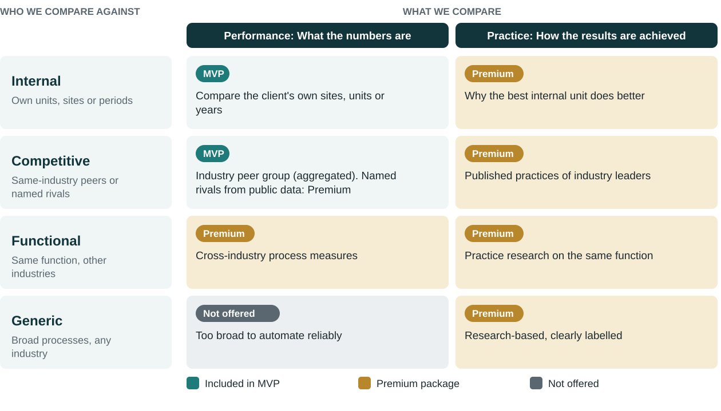
Figure 1. Benchmarking typology and package coverage
Type | Question it answers | Data the agent uses | Package
Internal | Which of our units, sites or periods performs best, and by how much? | The client's own data only | MVP
Competitive: peer group | How do we compare with similar firms in our industry? | Aggregated industry data from official and licensed sources (Section 9) | MVP
Competitive: named rivals | How do we compare with specific competitors? | Rivals' public filings and other public information | Premium
Functional | How does our function (for example finance or logistics) compare with the same function in other industries? | Cross-industry process measures, such as those built on the APQC Process Classification Framework [22] | Premium
Generic | What can we learn from any organisation about a broad process? | Published practice research, cited | Premium (practice only)

Performance benchmarking (numbers) is the MVP's core because it can be automated with sourced data. Practice benchmarking (how and why) depends on qualitative research, so it sits in Premium and always carries citations.

5. Industry segmentation: peer groups and sector KPIs

5.1 How a peer group is built
A benchmark is only useful if the peers are comparable. The agent builds every peer group from four dimensions, each drawn from how established providers segment their data.
Dimension | How it is set | Evidence
Industry | Official classification code: NAICS (North America) or NACE (EU). The client's description is mapped to a code and confirmed | RMA uses NAICS [24]; Eurostat uses NACE [29]
Size | Revenue or asset band, and employee count where available | RMA arrays by asset and sales size [24]; the Census QFR reports by asset size [25]
Region | Country first; wider region only if country data is too thin | Xero cohorts by industry and country [36]; World Bank Enterprise Surveys by economy [30]
Business model | For SaaS: contract value and go-to-market motion. For retail: store-based or online | Benchmarkit filters [13]; SaaS Capital shows retention varies with contract value [12]

Minimum peer count
Every benchmark shows how many peers it is based on. Below a minimum count the agent does not publish the figure and says why. The threshold will be set in architecture with legal input, because aggregation that prevents identifying any single firm is also a competition-law expectation [9].

5.2 Cross-industry core KPIs (all sectors)
KPI | What it shows | Where peer data comes from
Revenue growth | Pace of growth versus peers | Public filings [27]; Xero cohorts (SMB) [36]
Gross, operating and net margin | Pricing power and cost control | RMA [24]; Census QFR [25]; Damodaran industry margins [28]
Gross operating rate | Operating surplus as a share of turnover | Eurostat structural business statistics [29]
Labour productivity | Value added per person employed | Eurostat [29]
Debtor days (DSO) | How fast customers pay | RMA [24]; Xero [36]
Current ratio, debt ratios | Liquidity and balance-sheet strength | RMA [24]; Census QFR [25]

5.3 Retail
KPI | Definition | Published reference or source
Comparable (same-store) sales growth | Sales growth of stores open at least 12 months, versus the same period last year | Company filings [27]
GMROI | Gross profit ÷ average inventory at cost [45] | Client data; peer filings
Inventory-to-sales ratio | Inventory held relative to monthly sales | Census Monthly Retail Trade Survey [17]
Shrink | Inventory lost to theft, damage or error, as % of sales | NRF: average 1.6% in FY2022, up from 1.4% [16]
E-commerce share of sales | Online sales as % of total sales | US: 17.1% of retail sales in Q2 2026 [44]
Online cart abandonment | Share of online carts not completed | Baymard: 70.22% average across 50 studies [18]
Sales per square foot | Annual sales ÷ selling space | Company filings [27]

5.4 SaaS (software as a service)
KPI | Definition | Published reference or source
ARR growth | Year-on-year growth in annual recurring revenue | KeyBanc/Sapphire 2025: median expected to rise from 15% (2024) to 20% (2025) [11]
Net revenue retention (NRR) | Revenue kept from existing customers including upsell, minus churn and downgrades | SaaS Capital 2025: median 101% for private B2B SaaS, down from about 117% in 2021 [12]
Gross revenue retention (GRR) | As NRR but without upsell; cannot exceed 100% | KeyBanc/Sapphire: around 90% [11]
CAC payback | Months of gross profit needed to recover the cost of acquiring a customer | KeyBanc/Sapphire survey [11]; Benchmarkit [13]
Burn multiple | Net cash burn ÷ net new ARR over the same period | Defined by David Sacks (Craft Ventures) [14]
Rule of 40 | Revenue growth % + profit margin % should be at least 40 | Widely used investor test [15]

5.5 Manufacturing
KPI | Definition | Published reference or source
Overall equipment effectiveness (OEE) | Availability × performance × quality | 85% is the commonly cited "world-class" level from Nakajima's Total Productive Maintenance [19]
First pass yield | Share of units made right first time, without scrap or rework | MESA's 28 manufacturing metrics [21]
On-time delivery to commit | Share of orders delivered on the date committed | MESA [21]
Manufacturing cycle time; changeover time | Order release to finished goods; time to switch products | MESA [21]
Capacity utilisation | Output used as a share of total capacity | MESA [21]
Financial ratios by industry | Margins, returns, balance sheet | Census Quarterly Financial Report [25]; Census Annual Integrated Economic Survey [26]

Operational KPI definitions follow ISO 22400-2, the international standard for manufacturing operations KPIs [20]. Peers rarely publish operational figures such as OEE, so the MVP compares these against published reference levels (clearly labelled as such) or runs them as internal benchmarking across the client's own plants.

5.6 KPI coverage by sector
KPI family | Retail | SaaS | Manufacturing
Growth | Comparable sales | ARR growth | Revenue growth
Profitability | Gross margin, GMROI | Gross margin, Rule of 40 | Gross and operating margin
Efficiency | Sales per sq ft, inventory-to-sales | CAC payback, burn multiple | OEE, cycle time
Customer | Cart abandonment, e-commerce share | NRR, GRR | On-time delivery
Quality / loss | Shrink | Churn (within GRR) | First pass yield
Financial health | Core ratios (5.2) | Core ratios (5.2) | Core ratios (5.2)

5.7 Adding a new sector
A new sector goes live only when it has: a KPI set with written definitions, at least one approved peer data source per KPI, a peer-group rule, and a test run reviewed by an analyst.

6. Client inputs
If a mandatory input is missing or unclear, the agent stops and asks. It never fills a gap with a guess.

6.1 Mandatory
Input | Why it is needed | Validation
Industry | Selects the KPI set and peer data | Mapped to a NAICS or NACE code; client confirms
Country or region | Selects regional peers and currency | Must have peer data available
Company size | Builds a like-for-like peer group | Revenue band; employees if available
Objective and benchmarking type | Decides internal versus peer comparison and the KPI focus | One of the types offered in the package
Period | Aligns client and peer data in time | Fiscal year(s); flagged if peers report a different year
Client figures for the chosen KPIs | The client side of every comparison | Financial statements or KPI values, with currency and units
Data-use confirmation | Confirms the client may share the data and agrees how we use it | Required before processing

6.2 Optional
Input | What it adds | Package
Business units, sites or prior years | Enables internal benchmarking | MVP
Targets or budget | Compares plans with peer reality | MVP
Named competitors | Public-data comparison with specific rivals | Premium
Practice questionnaire | Basis for practice benchmarking | Premium
Internal reports (PDF) | Context; each figure cited to its page and confirmed | MVP
Preferred language and format | Output in PDF or Word; deck in Premium | MVP

Client figures are checked for internal consistency before use: for example, a gross margin above 100% or a period that does not match the statements stops the run.

7. Agent outputs: the exact report format

7.1 Report structure
Cover and document control | Client, sector, peer group, period, data cut-off, sources
1. Executive summary | Overall position, top three strengths, top three gaps
2. Peer group definition | Criteria, number of peers, data sources and dates
3. KPI scorecard | One row per KPI (format in 7.2)
4. Gap analysis | Gaps ranked by size and, where computable, by value
5. Interpretation by KPI family | What drives each gap, in plain language
6. Recommendations and targets | Targets at peer median and top quartile; actions
7. Method and limitations | Definitions, adjustments, what the data cannot show
Appendix | Full source list; data file (Excel)

7.2 KPI scorecard format
Column | Content
KPI and definition | Name, formula and whether higher or lower is better
Client value | From client data, with period and unit
Peer P25 / median / P75 | Lower quartile, median and upper quartile of the peer group
Client position | Quartile and approximate percentile
Gap | Distance to the median and to the top quartile
Peer count (n) | Number of peers behind the figure
Source and date | Publisher, link and edition of the peer data

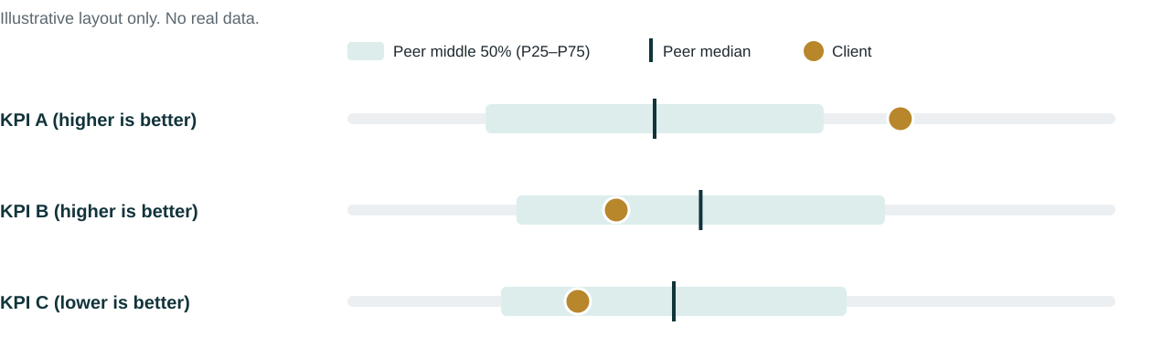
Figure 2. How each KPI is visualised in the report (layout only)

7.3 Output rules
- Every external number shows its source, date and peer count.
- Client figures, published reference levels and analyst estimates are labelled differently.
- Currency and period adjustments are stated next to the figure.
- A KPI with too few peers is withheld and the reason is given.
- Recommendations are presented as analysis and cite the evidence behind them.

8. How the agent works
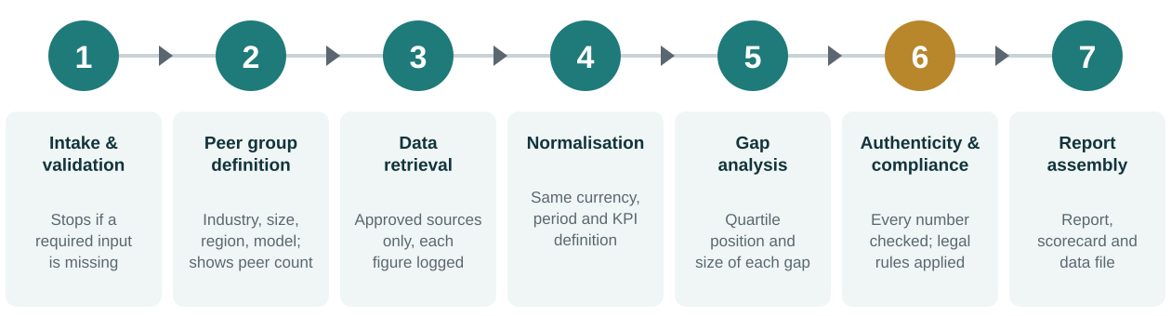
Figure 3. The seven-step workflow
Step | What happens
1. Intake and validation | Collects mandatory inputs, checks client figures for consistency, stops if anything is missing
2. Peer group definition | Applies industry, size, region and model rules; shows the peer count to the client
3. Data retrieval | Pulls figures only from the approved source list (Section 9); logs source and date for each
4. Normalisation | Puts client and peer data on the same currency, period and KPI definition
5. Gap analysis | Calculates quartile position and gap size for every KPI
6. Authenticity and compliance checks | Matches every number in the text to the data log; applies the legal rules in Section 10
7. Report assembly | Produces the report, scorecard and data file; analyst sign-off before release

Research on large language models in finance shows they can misreport numerical values, and that retrieving data from external sources and using calculation tools reduces this [42]. That is why figures in the agent come only from the data log and calculations run in code, while the language model writes the explanation.

9. Data sources
Only sources on this list may supply peer figures. Licensing terms must be confirmed for each licensed or published report before automated use (open point in Section 14).
Source | What it provides | Access | Use
SEC Financial Statement Data Sets | Financial statement data of US-listed companies from XBRL filings, quarterly since 2009 [27] | Free | MVP
Census Quarterly Financial Report | Income statements, balance sheets and ratios by industry and asset size [25] | Free | MVP
Census AIES and retail surveys | Annual revenues, expenses and assets; retail sales, inventories, e-commerce [26][17] | Free | MVP
Eurostat structural business statistics | Productivity and operating rates by NACE sector [29] | Free | MVP
World Bank Enterprise Surveys | Firm-level surveys in 154 economies (as of 2023), 100+ indicators [30] | Free (registration for firm-level data) | MVP
Damodaran industry datasets | Margins and multiples by industry (January 2026 update) [28] | Free | MVP
RMA Annual Statement Studies | 19 ratios, 640+ industries, by size, from 182,000+ statements [24] | Paid licence | MVP or Premium
APQC Open Standards Benchmarking | 2,000+ process measures across industries [23] | Membership or fee | Premium
SaaS benchmark reports | KeyBanc/Sapphire [11], SaaS Capital [12], Benchmarkit [13] | Free to read; terms to check | MVP (SaaS)
Sector bodies | NRF retail security survey [16]; Baymard [18]; MESA [21] | Published | Reference levels
Client data | Statements, KPIs, internal reports | Provided by client | All

10. Legal and compliance guardrails
Benchmarking touches competition law because it compares firms in the same market. The research points to four facts the product must respect.
Finding | Source
The Benchmarking Code of Conduct sets principles of legality, exchange, confidentiality and use. It warns against discussing prices or costs that feed into pricing with competitors, and against acquiring trade secrets improperly | [5]
On 11 December 2024 the US FTC and DOJ withdrew their 2000 guidelines on collaborations among competitors, removing the earlier "safety zones". In February 2026 they asked for public comment on new guidance, including on information sharing and algorithmic pricing | [7][8]
The EU's 2023 Horizontal Guidelines treat prices, quantities, capacity, customers and future plans as competitively sensitive. Shared data should be aggregated so that no firm's data can be extracted; older data is generally less sensitive, judged case by case | [9]
Under the DOJ's November 2025 settlement with RealPage, live recommendations may use only a firm's own data and public information; non-public competitor data may be used for model training only if at least 12 months old, and not at a level narrower than a state | [10]

Rules for the agent
- Peer figures come only from public, official or properly licensed aggregated sources, plus the client's own data.
- One client's confidential data is never used in another client's benchmark. Any future pooled peer database needs its own legal design (aggregation, minimum peer count, data age).
- No forward-looking competitor information (prices, plans, capacity) is collected or shown.
- The agent gives no price recommendations based on competitor data.
- Legal review is required in each launch country before the first client report.

11. Deliverables structure: MVP versus Premium
Eric Ries defines a minimum viable product as the version that "allows a team to collect the maximum amount of validated learning about customers with the least effort" [40]. The MVP below is therefore the smallest offer that tests whether clients value and pay for sourced peer benchmarking. Packaging follows Simon-Kucher's "leaders, fillers and killers" logic: build each tier around the feature clients most want to pay for, and keep features that put buyers off out of the entry tier [41].
Feature | MVP | Premium
Performance benchmarking vs industry peer group | ✓ | ✓
Internal benchmarking (units, sites, years) | ✓ | ✓
Sectors: retail, SaaS, manufacturing + core financials | ✓ | ✓
KPI scorecard with quartiles, peer count and sources | ✓ | ✓
Gap analysis and targets (median, top quartile) | ✓ | ✓
Report (PDF or Word) and data file (Excel) | ✓ | ✓
Named-competitor comparison from public data | – | ✓
Practice benchmarking (functional and generic) | – | ✓
Finer peer segmentation (sub-sector, business model) | Basic | ✓
Multi-year trend (3 or more years) | Current year | ✓
Presentation deck for leadership | – | ✓
Periodic refresh (for example quarterly) | – | ✓
Analyst review session with the client | – | ✓

11.1 Market price reference points
These are published price points for comparable products. They show that clients pay for benchmarking at every level, from free tools to enterprise programmes. They are references for pricing tests, not our prices.
Offer | Published price | Source
Xero Industry Benchmarks (small businesses) | Included in the accounting subscription | [36]
SaaS benchmark reports (KeyBanc/Sapphire, SaaS Capital, Benchmarkit) | Free | [11][12][13]
RMA Annual Statement Studies 2025–26 | $610 list; $410 members | [24]
Similarweb Starter / Professional (one user) | $125 / $333 per month, billed yearly | [33]
APQC Open Standards Benchmarking, non-members | Up to $5,000 per survey | [23]
Crayon or Klue competitive intelligence | About $20,000–40,000 per year (third-party estimate) | [34]
The Hackett Group, Gartner benchmarking | Enterprise; price on request | [31][32]

Pricing hypotheses to test in the pilot
- MVP: a one-off report, priced above free tools and data books but well below a consortium survey fee.
- Premium: an annual subscription with refresh, priced below dedicated competitive-intelligence platforms.
- Test willingness to pay with pilot clients before fixing prices, as the MVP principle requires [40][41].

12. Commercial viability
Factor | Evidence | Implication
Demand | Paid benchmarking exists at every scale, from data books to enterprise programmes [23][24][31][33] | Clients already pay for benchmarking
Commoditisation | Xero now includes industry benchmarks for small businesses [36]; free SaaS reports are widely available [11][12][13] | Raw ratios alone will not sell; interpretation and action must
Data cost | Strong free official sources exist [25][26][27][29]; deeper data is licensed [23][24] | MVP on free official data keeps cost low; licences in Premium
Legal risk | No US safe harbours since December 2024; scrutiny of data-driven tools [7][8][10] | Guardrails in Section 10 are a launch condition
Accuracy risk | Language models can misreport numbers [42] | Numbers from data and code only; analyst sign-off

Assessment
Viable, on three conditions: the offer differentiates on peer-group quality, sector KPIs and actionable interpretation rather than on raw ratios; the MVP runs mainly on free official data; and the legal guardrails are reviewed before the first client report.

13. Success metrics and release criteria

MVP release criteria
Criterion | Target
External figures in reports with source, date and peer count | 100%
Numbers in the text that match the data log | 100%
Runs with a missing mandatory input stopped before analysis | 100%
Legal review completed for each launch country | Before first client report
Analyst sign-off on every pilot report | 100%

Business metrics to track in the pilot
Pilot-to-paid conversion, MVP-to-Premium upgrade rate, repeat purchase, and client rating of report usefulness. Numeric targets are set after the first pilot cohort, once there is a baseline.

14. Risks, assumptions and open questions

Risks
Risk | Mitigation
Peer data too thin for a small sector or country | Show peer count; fall back to wider region or published reference levels, labelled
Different KPI definitions between sources | Written definitions per KPI; normalisation step; adjustments disclosed
Licence terms forbid automated use of a source | Licence check before a source is added to the approved list
Competition-law exposure | Rules in Section 10; legal review per country
Free tools erode the entry market | Differentiate on interpretation, sector depth and action plan

Assumptions (to confirm)
- Target clients range from small businesses to mid-market firms. Client size mix is not yet confirmed.
- Clients can supply financial statements or KPI values for the chosen period.
- The Macroenvironment Agent's verified exchange-rate and inflation data can be reused.

Open questions
Question | Owner | Needed by
Which countries launch first? | Management | Architecture start
Minimum peer count for publishing a benchmark | Product + Legal | Architecture
Which licensed sources to buy for Premium | Product + Finance | Premium build
Pilot clients and pricing test design | Commercial | Before pilot
Who signs off each report | Management | Before pilot

Appendix A. KPI definitions used in this document
Term | Meaning
Benchmark | A reference value from a peer group or published standard, used for comparison
Peer group | The set of comparable organisations the client is compared with
Median, P25, P75 | The middle value of the peer group, and the values a quarter of the way up and three quarters of the way up
Quartile | One of four equal parts of the peer group, ranked from lowest to highest
Top quartile | The best-performing quarter of peers; used as the stretch target, following Hackett's world-class definition [31]
NAICS / NACE | Official industry classification systems used in North America and the EU
ARR | Annual recurring revenue from subscriptions
NRR / GRR | Net and gross revenue retention (Section 5.4)
GMROI | Gross margin return on inventory investment (Section 5.3)
OEE | Overall equipment effectiveness (Section 5.5)

Appendix B. References
Sources were reviewed on 1–2 October 2026. Figures quoted from secondary reports and price estimates are marked as such in the text. The structure of this PRD follows common practice: Cagan's purpose, features and release criteria [37], Atlassian's assumptions, open questions and out-of-scope sections [38], and explicit non-goals [39].
[1] Robert C. Camp's definition of benchmarking, Xerox, 1989. Plant Engineering, "Benchmarking closes the gaps in your operation". https://www.plantengineering.com/articles/benchmarking-closes-the-gaps-in-your-operation/
[2] APQC, "Key types of benchmarking organizations should perform". https://www.apqc.org/resources/blog/key-types-benchmarking-organizations-should-perform
[3] APQC, "What are the four types of benchmarking?". https://www.apqc.org/blog/what-are-four-types-benchmarking
[4] APQC, "Inside APQC's Benchmarking Methodology" (Plan, Collect, Analyze, Adapt). https://www.apqc.org/resource-library/resource-listing/inside-apqcs-benchmarking-methodology-plan-phase
[5] Benchmarking Code of Conduct (Global Benchmarking Network, 2018 edition). https://www.globalbenchmarking.org/wp-content/uploads/2018/07/2018_Benchmarking_Code_of_Conduct.pdf
[6] ICMR case study, Xerox benchmarking and L.L. Bean. https://icmrindia.org/free%20resources/casestudies/xerox-benchmarking-6.htm
[7] Morgan Lewis, "FTC and DOJ withdraw guidelines for collaboration among competitors", December 2024. https://www.morganlewis.com/pubs/2024/12/ftc-and-doj-withdraw-guidelines-for-collaboration-among-competitors
[8] DLA Piper, "DOJ and FTC seek public input on new competitor collaboration guidelines", February 2026. https://www.dlapiper.com/en-ma/insights/publications/2026/02/doj-and-ftc-seek-public-input-on-new-competitor-collaboration-guidelines
[9] Herbert Smith Freehills, "Overview of the EU Commission's guidance on information exchange", November 2023. https://www.hsfkramer.com/insights/2023-11/overview-of-the-eu-commission%E2%80%99s-guidance-on-information-exchange
[10] Baker McKenzie, "United States: DOJ settles RealPage case", December 2025. https://www.bakermckenzie.com/en/insight/publications/alerts/2025/12/united-states-doj-settles-realpage-case
[11] KeyBanc Capital Markets & Sapphire Ventures, 2025 SaaS Survey. https://info.sapphireventures.com/2025-keybanc-capital-markets-sapphire-ventures-saas-survey
[12] SaaS Capital, "SaaS retention benchmarks for private B2B companies" (2025). https://www.saas-capital.com/research/saas-retention-benchmarks-for-private-b2b-companies/
[13] Benchmarkit, SaaS Performance Metrics Benchmark Report (via Maxio). https://www.maxio.com/resources/benchmarkit-2024-saas-performance-metrics-report
[14] Corporate Finance Institute, "Burn multiple". https://corporatefinanceinstitute.com/resources/valuation/burn-multiple-capital-efficiency-saas/
[15] Corporate Finance Institute, "The SaaS Rule of 40 explained". https://corporatefinanceinstitute.com/resources/valuation/rule-of-40
[16] National Retail Federation, "Shrink accounted for over $112 billion in industry losses in 2022". https://nrf.com/media-center/press-releases/shrink-accounted-over-112-billion-industry-losses-2022-according-nrf
[17] US Census Bureau, Quarterly Retail E-Commerce Sales and Monthly Retail Trade Survey. https://www.census.gov/retail/ecommerce/about_the_surveys.html
[18] Baymard Institute, "Cart abandonment rate statistics". https://baymard.com/lists/cart-abandonment-rate
[19] LineView, "World-class OEE: set targets to drive improvement". https://www.lineview.com/resources/blog/world-class-oee-set-targets-to-drive-improvement
[20] ISO 22400-2:2014, KPIs for manufacturing operations management. https://www.iso.org/standard/54497.html
[21] LNS Research / MESA International, "28 manufacturing metrics that actually matter". https://blog.lnsresearch.com/blog/bid/188295/28-Manufacturing-Metrics-that-Actually-Matter-The-Ones-We-Rely-On
[22] APQC Process Classification Framework (PCF), Cross-Industry. https://www.apqc.org/resource-library/resource-listing/apqc-process-classification-framework-pcf-cross-industry-pdf-3
[23] APQC, Open Standards Benchmarking FAQs and fee schedule. https://www.apqc.org/sites/default/files/files/OSBC%20Campaigns/Open%20Standards%20Benchmarking%20FAQs.pdf
[24] RMA, Annual Statement Studies: Financial Ratio Benchmarks. https://rmahq.org/statementstudies
[25] US Census Bureau, Quarterly Financial Report. https://bhs.econ.census.gov/bhs/qfr/about.html
[26] US Census Bureau, Annual Integrated Economic Survey (AIES). https://www.census.gov/data/developers/data-sets/aies.html
[27] US SEC, Financial Statement Data Sets. https://www.sec.gov/data/financial-statement-data-sets
[28] Aswath Damodaran, NYU Stern, margins by industry (January 2026). https://pages.stern.nyu.edu/~adamodar/New_Home_Page/datafile/psdata.html
[29] Eurostat, Structural business statistics methodology. https://ec.europa.eu/eurostat/cache/metadata/Annexes/sbs_esms_an_2.pdf
[30] World Bank, Enterprise Surveys Manual and Guide. https://www.enterprisesurveys.org/content/dam/enterprisesurveys/documents/methodology/Enterprise-Surveys-Manual-and-Guide.pdf
[31] The Hackett Group, Sourcing and procurement benchmarking. https://www.thehackettgroup.com/?p=1657
[32] Gartner, IT Key Metrics Data (abstract). https://www.gartner.com/en/documents/5971871
[33] Similarweb, pricing plans. https://www.similarweb.com/corp/pricing
[34] Prospeo, "Best competitive intelligence tools" (third-party price estimates). https://prospeo.io/s/best-competitive-intelligence-tools
[35] BVResources, "Three reasons to use Bizminer in your next report". https://www.bvresources.com/blogs/bvwire-news/2023/05/19/three-reasons-to-use-bizminer-in-your-next-report
[36] CPA Practice Advisor, "Xero introduces industry benchmarking intelligence for small businesses", June 2026. https://www.cpapracticeadvisor.com/2026/06/29/xero-introduces-industry-benchmarking-intelligence-for-small-businesses/185864/
[37] UXPin, "How to write a painless product requirements document" (Marty Cagan's PRD sections). https://www.uxpin.com/studioblog/write-good-product-requirements-document
[38] Atlassian, Product requirements template. https://www.atlassian.com/software/confluence/templates/product-requirements
[39] Lenny's Newsletter, "My favorite templates" (Kevin Yien's PRD with non-goals). https://www.lennysnewsletter.com/p/my-favorite-templates-issue-37
[40] Lean Startup Co., "What is an MVP?" (Eric Ries definition). https://leanstartup.co/what-is-an-mvp/
[41] Simon-Kucher "leaders, fillers and killers" packaging framework (summary). https://saassygtm.substack.com/p/saassy-nuggets-leaders-fillers-and
[42] Kang & Liu, "Deficiency of large language models in finance: an empirical examination of hallucination", arXiv 2311.15548. https://arxiv.org/pdf/2311.15548
[43] Spendolini's definition of benchmarking, cited in Journal of Indonesian Economy and Business. https://journal.ugm.ac.id/jieb/article/download/39999/22542
[44] US Census Bureau, Quarterly Retail E-Commerce Sales, 2nd quarter 2026. https://www.census.gov/retail/mrts/www/data/pdf/ec_current.pdf
[45] Shopify, "GMROI: gross margin return on investment". https://www.shopify.com/ie/blog/gmroi

