DISCOVERY & STRATEGIC DEFINITION PHASE
Macroenvironment Agent
Economic Study
Business Requirements Document (BRD)

Prepared for | Board of Directors and Executive Management
Purpose | Explain the agent's value, scope and operating flow before technical development is authorised
Status | Draft for Board review
Version / date | 1.0 · September 2026
Next phase | Architecture mapping by the development team

Contents
1. Executive summary
2. Business purpose and value
3. How the IMF and World Bank structure macroeconomic reports
4. The Authenticity Core: where every number comes from
5. What the client provides (inputs)
6. What the client receives (deliverables)
7. How the agent works, step by step
8. Scope: what the agent will and will not do
9. Success criteria
10. Decisions requested and next steps
Appendix A. Outline of the two reports
Appendix B. Glossary

1. Executive summary
The Macroenvironment Agent prepares a country-level economic study for a client. The client tells us four things: the country, the currency, the sector and the period they care about. The agent then collects the official economic figures for that country, checks them, and turns them into three documents: a written report on the economic outlook, a matrix of risks and opportunities, and a clean data file that our financial models can use in the next phases.
The design rests on one rule. The agent does not invent numbers. Every figure comes from an official publisher, such as the International Monetary Fund (IMF), the World Bank, or the country's own central bank or statistics office, and every figure keeps a record of where it came from and when it was published. If a figure cannot be found in an official source, the documents say so openly rather than filling the gap.
3  deliverables from one request | 4  mandatory client inputs | 6  steps from request to release | 100%  of figures show their source and date

What the Board is asked to approve
- The scope set out in Section 8, including what the agent will not do.
- The Authenticity Core (Section 4) as a non-negotiable design rule.
- Release of this document to the development team as the starting point for architecture mapping.

2. Business purpose and value
A country economic study done by hand involves collecting figures from several institutions, checking that they refer to the same year and the same edition of the data, and writing them up consistently across more than one document. It is slow, and a single wrong number in a client report can undermine the credibility of the whole piece of work.
The agent is designed to take the collection and consistency work off the analyst's desk, while keeping every figure traceable.
Problem today | How the agent addresses it
Figures are gathered by hand from many places | Figures are collected directly from official publishers
Different documents can quote different numbers for the same thing | Each figure is decided once and reused in all three deliverables
Forecasts can be mistaken for actual results | Every figure is labelled "actual" or "forecast"
Numbers in client work are hard to verify later | Every figure carries its source, link and publication date
Written analysis cannot be used directly in financial models | A structured data file is produced alongside the reports

Who benefits
Stakeholder | Benefit
Clients | A consistent, fully sourced economic study for the country and sector they care about
Analysts | Less time spent collecting and cross-checking figures, more time on judgement and advice
Finance / later phases | A clean indicator file that feeds the financial calculations without retyping
Management | Lower reputational risk: every number in client work can be traced back to its source

3. How the IMF and World Bank structure macroeconomic reports
Before defining the agent's outputs, we studied how the two main international economic institutions publish their analysis. Their reports are the reference that governments, central banks and investors already trust, so following their structure makes our deliverables familiar and credible.

3.1 International Monetary Fund (IMF)
- World Economic Outlook (WEO). Published twice a year, in April and October, with shorter updates usually in January and July. It presents the IMF's view of global and country prospects. Its public database holds historical data and projections for member countries, with projections running about five years ahead.
- Article IV consultations. The IMF's regular review of each member country's economy, usually held once a year. The staff report follows a consistent pattern: recent developments, outlook and risks, policy discussions and a staff appraisal.
- Risk Assessment Matrix (RAM). Included in Article IV staff reports. It lists the main risks to the economy, rates how likely each one is and how large its impact would be, and states the recommended policy response.

3.2 World Bank
- Global Economic Prospects (GEP). Published twice a year, in January and June, with growth forecasts for the world, regions and individual countries.
- World Development Indicators (WDI). The World Bank's main collection of development statistics, compiled from officially recognised sources.
- Macro Poverty Outlook (MPO). Short country notes with macroeconomic projections, published twice a year around the Spring and Annual Meetings.

3.3 What we adopt from them
Institutional practice | How the agent applies it
A steady report sequence: recent developments, outlook, risks, policy implications | The Macroeconomic Impact Report follows the same sequence
Figures tied to a named source and a specific edition ("vintage") of the data | Every figure carries its publisher, link and publication date
Historical data and projections kept clearly apart | Every figure is marked "actual" or "forecast"
Risks scored by likelihood and impact, each with a response (IMF RAM) | The Risk & Opportunities Matrix uses the same scoring logic
Standard indicator codes in the published databases | The Key Indicators Database uses official codes where they exist

4. The Authenticity Core: where every number comes from
The Authenticity Core is the set of rules that governs every number in the study. Put simply: the agent reports official figures; it does not create them. All figures pass through one central record, the Verified Figures Register, and every document reads from that record. This is what keeps the three deliverables consistent with each other and with the official sources.
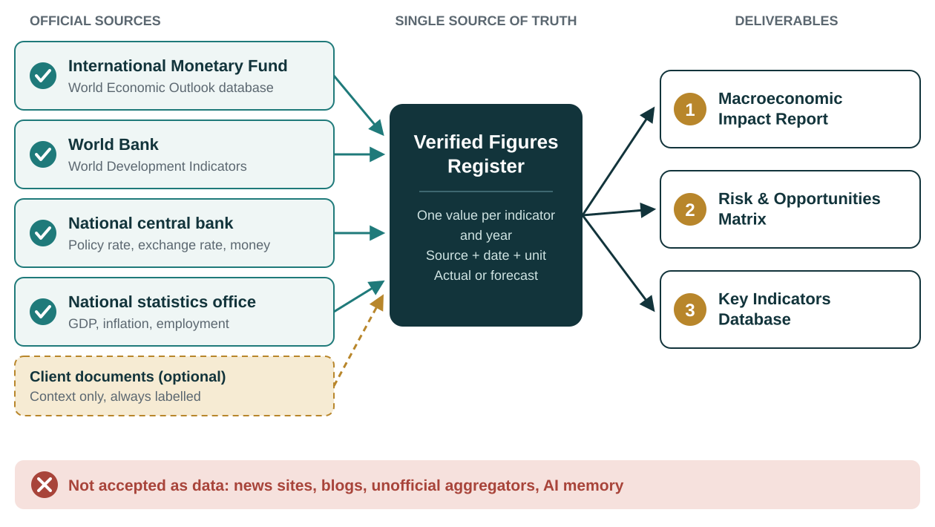
Figure 1. How figures travel from official sources to the three deliverables

4.1 The five rules
Rule | What it means in practice
1. No source, no number | A figure without an official source, link and date is not used anywhere.
2. One figure, used everywhere | Each figure is decided once. If the register says inflation for a given year is a certain value, the report, the matrix and the data file all show that same value.
3. Actual or forecast, always stated | A projection is never presented as a settled result.
4. Official sources come first | IMF, World Bank, central bank and national statistics office data take priority over any secondary source. Client documents add context but never replace official data unless the client explicitly asks, and then the figure is labelled "client-provided".
5. Gaps are shown, never filled | If a figure is missing or fails the checks, the document says so. Where an estimate is genuinely needed, it is labelled "analyst estimate" and its method is explained.

4.2 When two official sources disagree
Official sources sometimes publish different values for the same indicator, for example because of different release dates or definitions. The agent will not average them or pick one silently. It applies a fixed order of priority and records the alternative value in the source log. The exact priority order is a decision for the architecture phase (see Section 10); the rule that the choice is always recorded is fixed.

4.3 Why the agent is structurally prevented from inventing figures
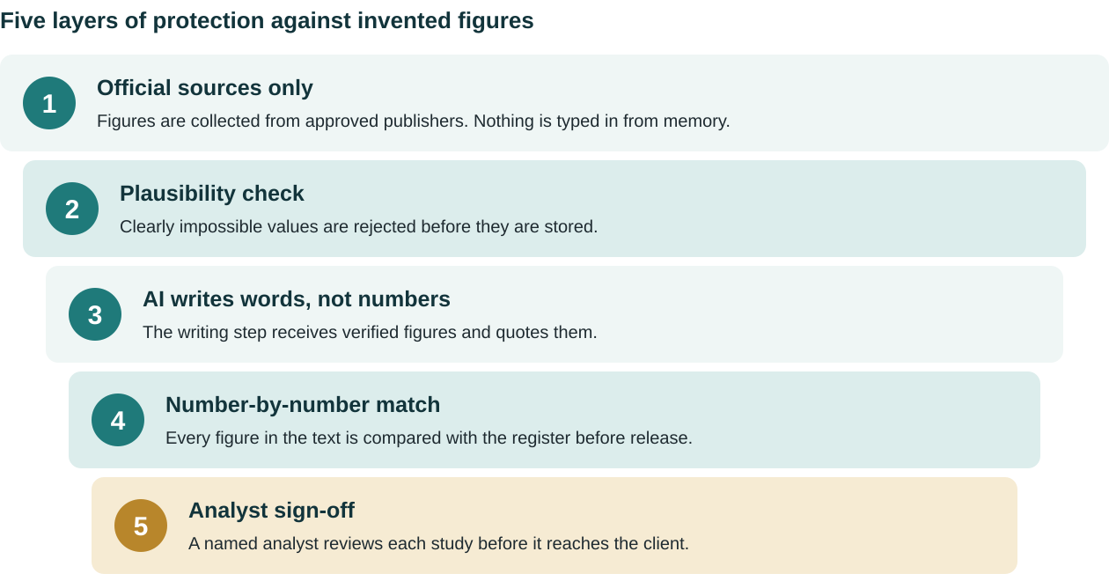
Figure 2. Layered controls between the data and the client
A plain note on guarantees
These controls are designed so that an invented or altered figure cannot reach a client document without being caught. No automated system is entirely free of error, which is why the controls are layered and why we recommend that a named analyst signs off every study before release. What we can state with confidence is that the agent has no route to put a number into a document other than through the Verified Figures Register.

5. What the client provides (inputs)
The agent needs a small amount of information to run. Four items are mandatory. Without them the study would be built on guesses, so the agent stops and asks for the missing item instead of assuming a default.

5.1 Mandatory inputs
Input | What it is | Example | Why it is required
Target country | The economy to be studied | Chile | Decides which official sources and series are collected
Reporting currency | The currency for all monetary figures | Chilean peso (CLP) or US dollar (USD) | Avoids mixing currencies; any conversion uses an official exchange rate
Industry sector | The client's line of business | Retail, mining, agriculture | Focuses the analysis on the variables that affect that sector
Time horizon | The period the study covers | 2026–2030 | Sets how many years of history and forecast are included

Time horizon limit
Official forecasts such as the IMF World Economic Outlook run about five years ahead. If a client asks for a longer horizon, the years beyond the official forecast range cannot be filled with official data, and the agent will say so rather than extend the numbers itself.

5.2 Optional inputs
Input | What it adds | How it is handled
Internal reports or PDFs | Sector studies, market reports or earlier analyses that give context | Each extracted figure is cited back to the page it came from and confirmed with the client before use
Client financial assumptions | The client's own plans, such as budgeted exchange rate or planned price increases | Used to compare the client's plan with the official outlook; always labelled "client assumption"
Specific concerns | Topics the client wants emphasised, such as reliance on imported inputs | Given more depth in the report and the risk matrix
Output preferences | Language and file format (PDF or Word) | Applied at the assembly step
Data cut-off date | Which edition of the official data to use | Defaults to the latest available edition if not given

6. What the client receives (deliverables)
Each request produces three documents. They are built from the same Verified Figures Register, so a number that appears in more than one of them is always identical.
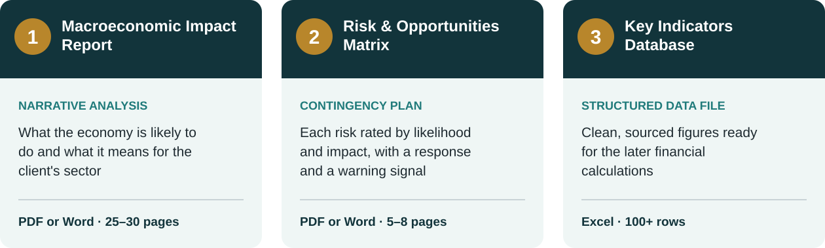
Figure 3. The three deliverables (page and row counts are design targets)

6.1 Macroeconomic Impact Report
What it is. A written analysis of the country's economic outlook and what it means for the client's sector. It follows the IMF sequence of recent developments, outlook, risks and implications.
Business value. Gives the client's leadership a single, sourced view of the economy they are operating in, to support decisions such as entering a market, expanding, setting prices or building a budget.
Main contents. Economic overview; growth (GDP), including the client's sector; inflation and its effect on costs; interest rates and central bank policy; government finances and tax; exchange rate and trade; specific impact on the sector; base, upside and downside scenarios; conclusions. Full outline in Appendix A.

6.2 Risk & Opportunities Matrix
What it is. A short contingency plan built on the logic of the IMF Risk Assessment Matrix. Each risk is rated by how likely it is and how much it would hurt, and each one has a planned response and a signal to watch.
Business value. Turns the economic outlook into a practical plan: what could go wrong, what could go right, how to prepare, and which indicator tells the client it is time to act.
Column | What it records
Risk | What could happen and why (for example inflation, currency devaluation, interest rates, tax policy, input costs, weaker demand)
Likelihood | Low, medium or high, on a scale defined at the start of the document
Expected impact | Low, medium or high, with the size of the effect where the data allows
Time horizon | Short, medium or long term
Response | The practical action, for example price clauses, natural currency hedging, fixed versus floating debt
Early-warning signal | The indicator to watch and the level that should trigger action

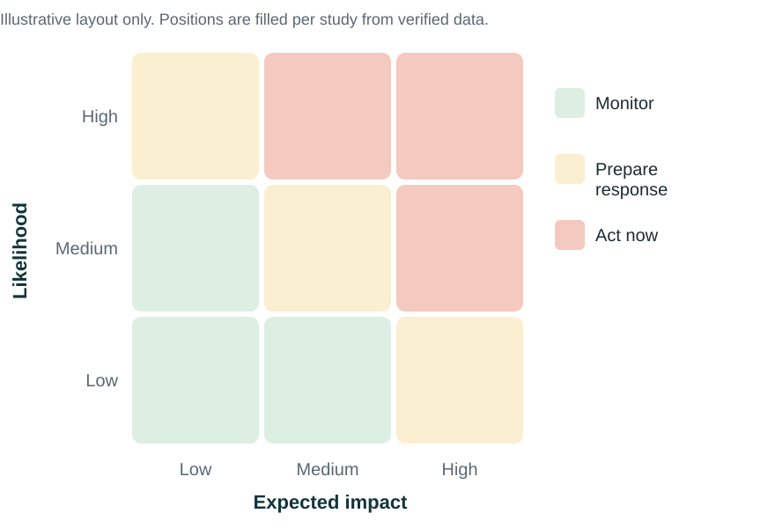
Figure 4. How risks are positioned in the matrix (layout only, no data)

6.3 Key Indicators Database
What it is. An Excel file containing the historical and forecast economic figures used in the study, with a target of more than 100 rows. It is built directly from the Verified Figures Register by fixed rules, not written by the AI.
Business value. This is the clean input for the later financial phases, for example cost of capital calculations. The numbers in the models will match the numbers in the report, with no retyping.
Sheet | Contents
Indicators | One row per indicator per year: name, official code, year, value, unit, actual or forecast, source
Sources | Every publisher, link and access date: the audit trail
Metadata | Country, currency, data edition, date produced, and a definition of each indicator

Indicator group | Examples
National accounts | Real GDP growth, nominal GDP, GDP per person, sector GDP, investment, household consumption
Prices | Consumer price inflation, core inflation, producer prices
Monetary | Central bank policy rate, lending and deposit rates, money supply, foreign reserves
Government finances | Budget balance, government debt, revenue, spending
External | Exchange rate against the US dollar, current account, trade balance, exports, imports
Labour and population | Unemployment rate, labour force, population

7. How the agent works, step by step
The process below is described at management level. Technical design is left to the architecture phase.
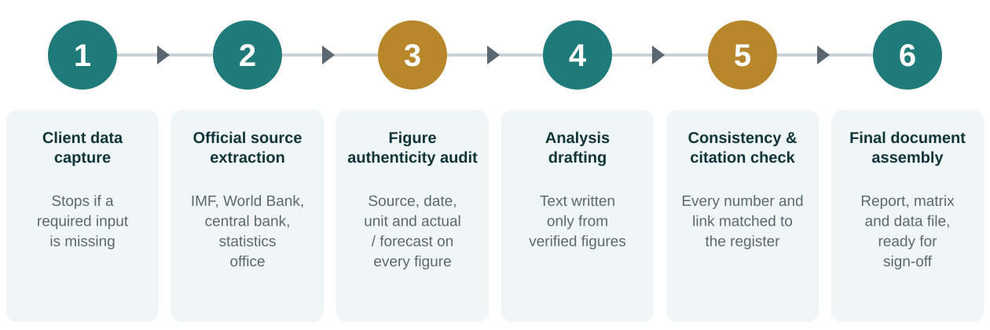
Figure 5. The six-step process from client request to release
Step | What happens | What management can rely on
1. Client data capture | The agent collects the client's request and checks that the four mandatory inputs are present and clear. | No study starts on an assumption.
2. Official source extraction | Figures are collected from the IMF, World Bank, central bank and national statistics office. Client documents are read if provided. | Data comes from the institutions governments themselves cite.
3. Figure authenticity audit | Each figure gets its source, date, unit and actual/forecast label, passes a plausibility check, and one value per indicator and year is recorded in the Verified Figures Register. | One agreed number for each indicator, with its origin on record.
4. Analysis drafting | The report and the risk matrix are written using only the figures in the register. | The writing step has no other source of numbers.
5. Consistency and citation check | Every number in the text is compared with the register and every link is checked against the approved sources. | A mismatch blocks release.
6. Final document assembly | The three deliverables are produced. The data file is built straight from the register. The study goes to an analyst for sign-off. | Three documents that agree with each other.

8. Scope: what the agent will and will not do
These boundaries define the blueprint for the development team. Anything outside them would need a separate decision.
The agent WILL | The agent will NOT
✓ Produce an economic study for one target country per request  ✓ Use official sources only for all economic figures  ✓ Deliver the report, the risk matrix and the data file, all consistent with each other  ✓ Label every figure with its source, date and actual/forecast status  ✓ Say openly when a figure is missing or could not be verified  ✓ Use client documents and assumptions as clearly labelled context  ✓ Explain how the economic outlook may affect the client's sector  ✓ Stop and ask when a mandatory input is missing | ✕ Invent, guess or silently estimate any figure  ✕ Use news sites, blogs, social media or unofficial aggregators as data sources  ✕ Present its own estimates as official forecasts  ✕ Extend forecasts beyond the horizon covered by official sources  ✕ Give investment, legal, tax or accounting advice, or recommend specific financial trades  ✕ Perform company valuations or financial models (these belong to the later phases)  ✕ Provide real-time market data or ongoing monitoring  ✕ Replace review and sign-off by a qualified analyst

9. Success criteria
The development team and management can use these criteria to judge whether the built agent meets this brief.
Criterion | Target
Figures in all deliverables that show their source and date | 100%
Estimates or client-provided figures shown without their label | Zero
Differences between the same figure across report, matrix and data file | Zero
Figures labelled actual or forecast | 100%
Runs with a missing mandatory input that are stopped before analysis | 100%
Rows in the Key Indicators Database, across six indicator groups | 100 or more
Studies released without analyst sign-off | None

10. Decisions requested and next steps

For the Board
- Approve the scope in Section 8.
- Confirm the Authenticity Core as a fixed requirement.
- Authorise the development team to begin architecture mapping on the basis of this document.

Open points to settle during architecture mapping
Open point | Why it matters
Priority order when two official sources disagree | Makes the choice of figure predictable and auditable
Countries and sectors for the first pilot | Official data coverage varies by country
Who signs off each study before release | Sets accountability for client-facing work
Languages of the deliverables | Affects report templates and review
Plausibility thresholds for each indicator | Defines what counts as an impossible value

Appendix A. Outline of the two reports

Macroeconomic Impact Report
Cover and document control | Country, currency, data edition, sources, disclaimer
Executive summary | Growth, inflation, interest rates and key risks on one page
1. Introduction and scope | Purpose, country, sector, time horizon, data sources and method
2. Economic overview | Current position and the last three to five years
3. Growth outlook | GDP history and projection, the client's sector, drivers of growth
4. Inflation | History and projection, effect on the client's costs
5. Monetary policy and interest rates | Central bank rate and stance, effect on borrowing costs
6. Government finances | Budget balance, public debt, tax outlook, measures affecting the sector
7. External sector | Exchange rate outlook, trade and current account, reserves
8. Impact on the sector | How each variable reaches demand, costs and margins
9. Scenarios | Base, upside and downside
10. Conclusions and implications | What the client should take from the study
Appendices | Data tables, full source list, method and assumptions

Risk & Opportunities Matrix
Cover and document control
1. How to read this matrix | Likelihood and impact scales defined
2. Risk matrix | Inflation, currency, interest rates, tax and policy, input costs, demand
3. Opportunities | Upside scenarios and how to capture them
4. Contingency playbook | Responses to inflation, currency and interest rate risk
5. Early-warning indicators | What to watch and the trigger levels
6. Summary and priority actions

Appendix B. Glossary
Term | Meaning
Actual figure | A published value for a period that has already ended
Forecast (projection) | An institution's published estimate for a future period
Data edition (vintage) | The specific release a figure comes from, for example the April or October edition of the IMF World Economic Outlook
GDP | Gross domestic product: the total value of goods and services an economy produces
Inflation (CPI) | The rate at which consumer prices rise, measured by the consumer price index
Policy rate | The central bank's main interest rate, which influences borrowing costs across the economy
Budget balance | Government revenue minus government spending
Current account | A country's net trade in goods, services and income with the rest of the world
Devaluation | A fall in the value of a currency against other currencies
Hedging | Actions that reduce exposure to a financial risk, such as currency or interest rate movements
Verified Figures Register | The single record inside the agent that holds every approved figure with its source

