Software Installation Guide
- Tws setup :-
Download Tws software through https://www.interactivebrokers.co.in/en/index.php?f=16040 link. After download, open tws and login with credentials.
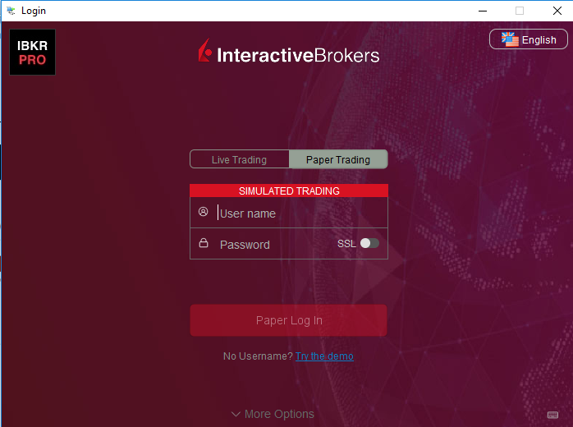
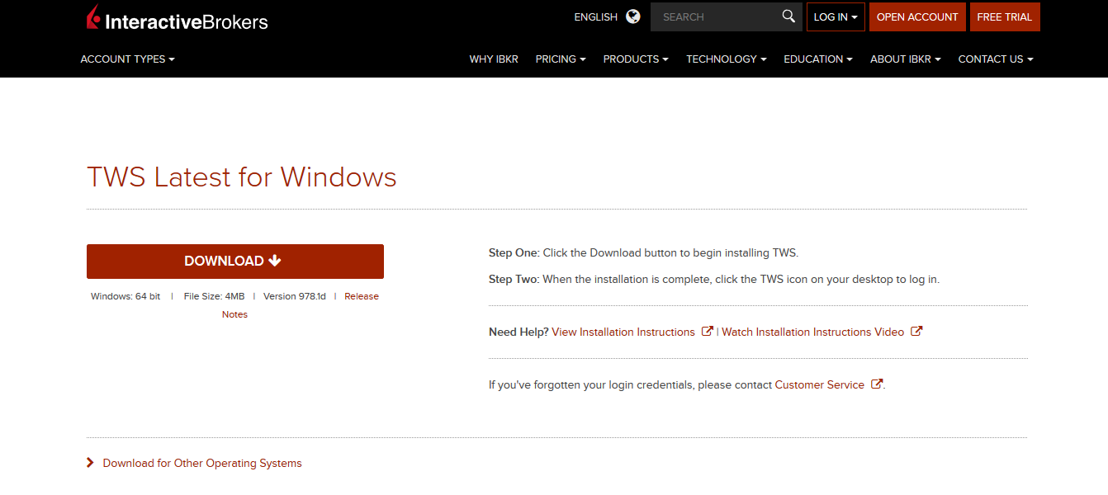

After login click setting button. And change some setting according to image.
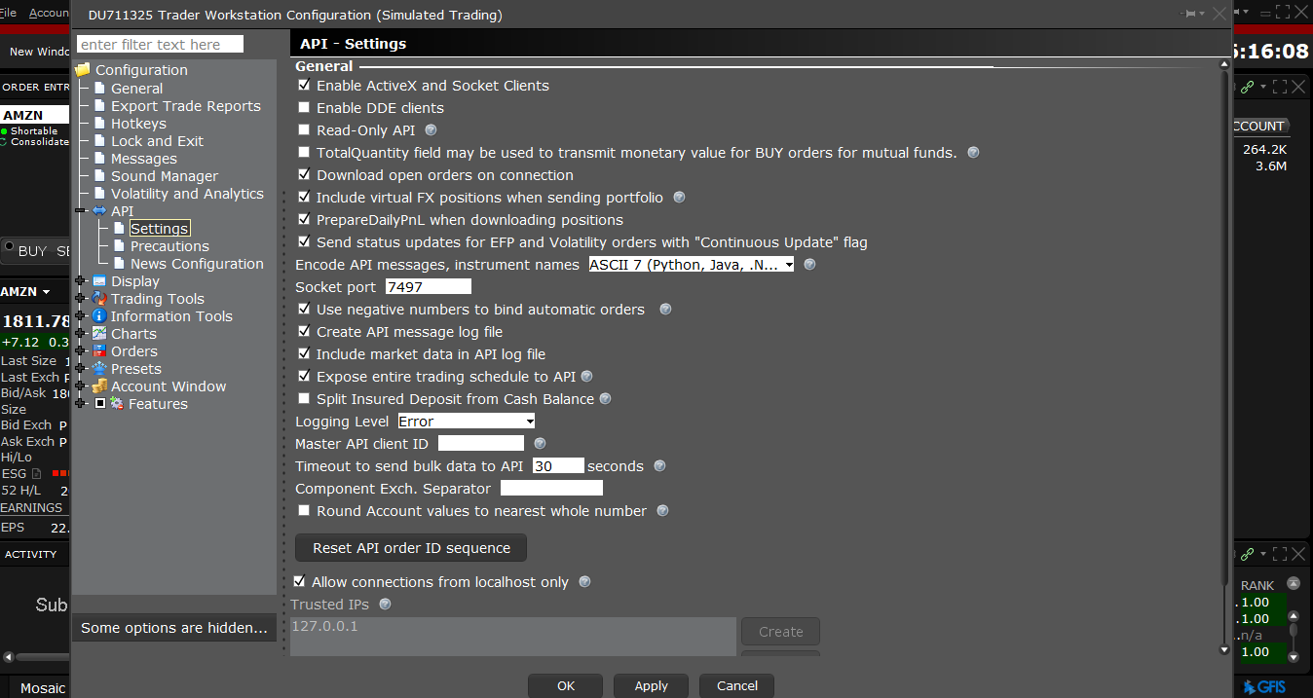
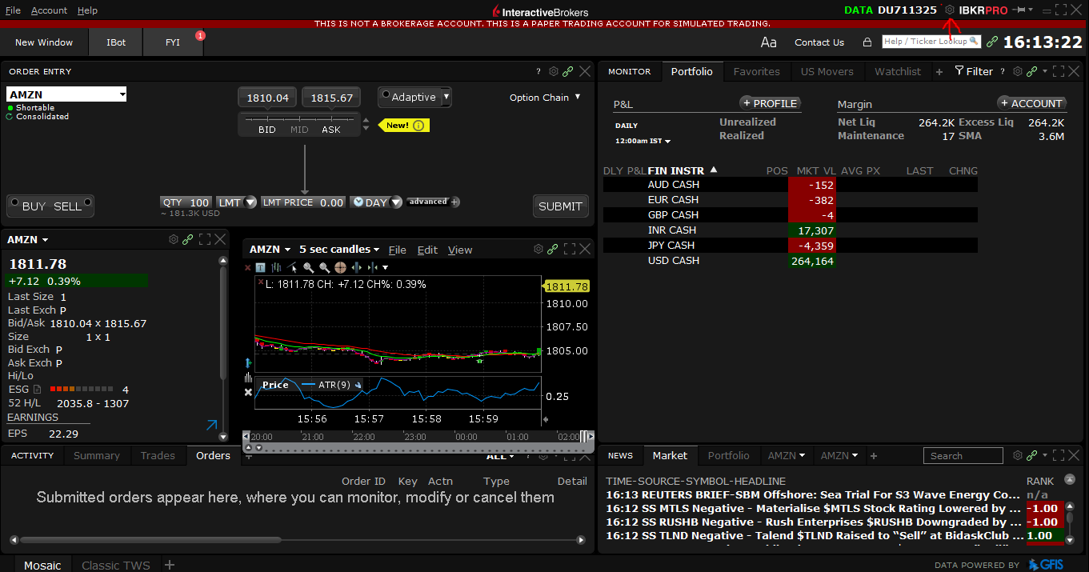

All things has done in tws. Now follow second step

- software:-
You can easily run project through pycharm community software. Download pycharm community software through https://www.jetbrains.com/pycharm/download/
Link. You need to download python 3.7.3 through https://www.python.org/downloads/ link. After install python, check python version in command prompt (cmd)
“python --version” cmd will show python version, that means python successfully installed. After install pycharm software, open project in pycharm.

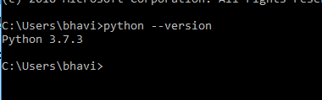

Now you need to install all library. Please follow some step...
- Click === File -> Settings -> Project Interpreter
- Set project interpreter path. Here you will set python version.
- With the help of “ + ” sign you can install all library. Note:- when you open you project in pycharm, may be it can show “install plugins” . you can install all
Library automatically after click on install plugins link. Otherwise you can install all library through + sign.
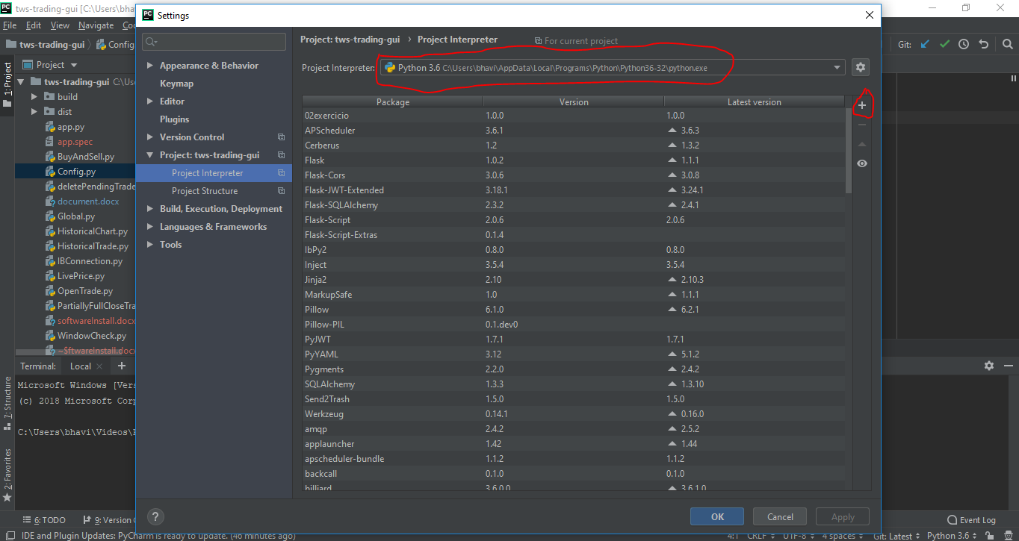

- After click on + sign, you can search library and install all library.
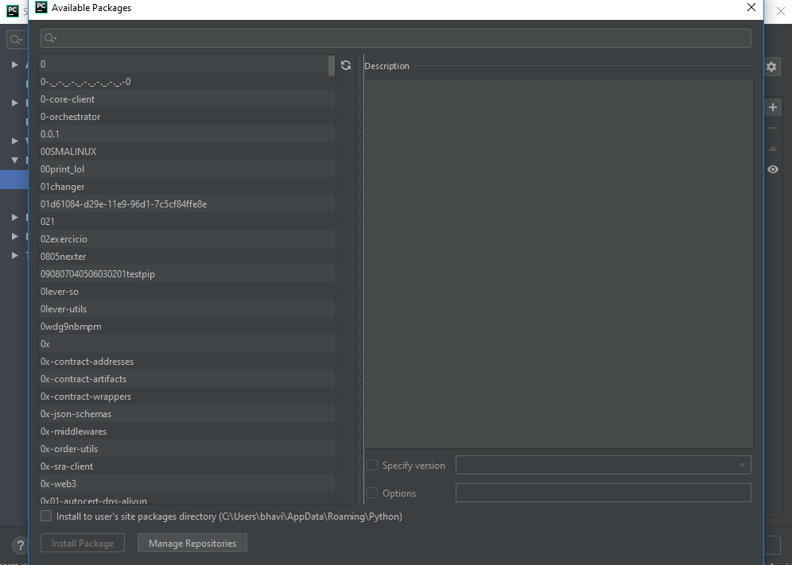
- You need to install tkinter, asncio, ib_insync, logging, nest_asyncio, tkinter.messagebox library. Then you can run software, open app.py and press right click
And click on ‘ run app ‘.
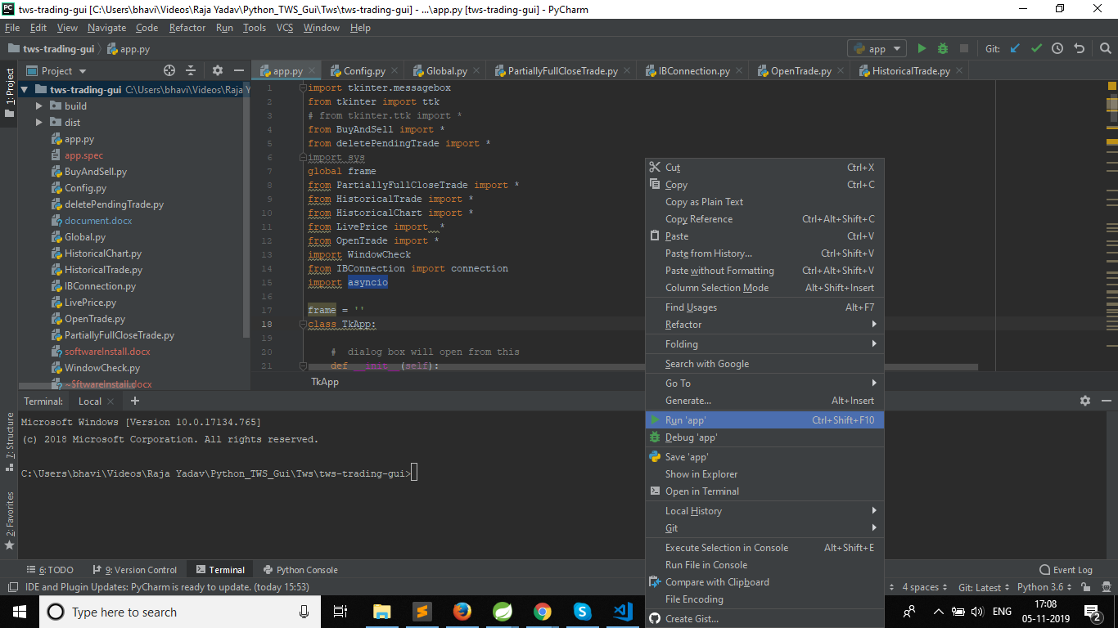

- If any library is missing then console will give error no module found. You can install this library through “ + ” sign.

