**[HOME](http://techthoughts.jakemorrison.name/adpinger/" \o "ADPinger)** [**DOWNLOAD**](http://techthoughts.jakemorrison.name/adpinger-download)[**SUPPORT**](http://techthoughts.jakemorrison.name/adpinger-support)[**ABOUT**](http://techthoughts.jakemorrison.name/adpinger-about)

**What is ADPinger?**

ADPinger is a tool designed for Active Directory administrators to assist with managing devices within the Active Directory environment.  Its purpose is assist administrators in identifying old and unused computer accounts that can safely be deleted.  This is accomplished by rapidly sending ICMP ping requests to all objects within an Organizational Unit or Active Directory container.  ADPinger is designed from the ground up to accomplish this with minimal network impact.  In many cases, you may be hard pressed to even notice the traffic it generates.

ADPinger is capable of generating an overall health status of an OU / container after a scan.  It can also save the results of a scan to a CSV report for more robust data manipulation and tracking.

ADPinger can be used to identify the overall health of an OU by gauging the ICMP ping response levels from the devices within an OU.  Over time, this information can be utilized to delete old and unused computer accounts (as well as other devices) from your AD environment.

While there are other methods for accomplishing this, such as dsquery, these methods are often dependent on the 'last logon' feature.  In many cases 'last logon' doesn't fully indicate the status of a device on the domain.  ADPinger aims to compliment dsquery and other tools to provide an administrator with a comprehensive health status of devices within Active Directory.

[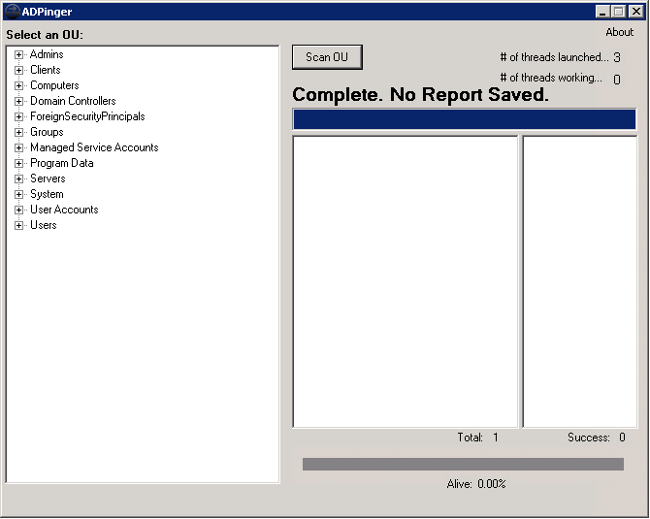](http://techthoughts.jakemorrison.name/wp-content/uploads/2013/04/ADPinger_ScreenShot.png)

ADPinger ScreenShot

Top of Form

  
https://www.paypalobjects.com/en_US/i/scr/pixel.gif

Bottom of Form