Access Modifier:
Variable declaration:
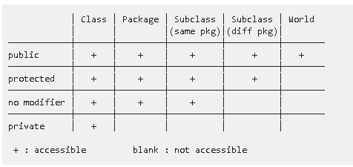
- Public
  - Variable and Method accessible to the world
- Private
  - Variable and Method accessible class only
  - Using getter and setter method – private variable can be access outside of the class and subclass and class and subclass outside package
  - Using getDeclaredMethod – method can be access outside the class and subclass
- Protected
  - Visible to the package and subclass
  - Protected variable can be accessed outside package and subclass by inheritance using extend keyword
  - Using getter and setter method – protected variable can be access outside of the class and subclass and class and subclass outside package

- Default
  - Visible to the package, No modifiers are needed

Note: using getter and setter method – we can access private, default and protracted variable and method anywhere in class and subclass inside and outside of the package

Abstraction and Interface class

- Abstraction class
  - Abstraction class cannot be instantiated
  - Abstraction method should not have any body – just is a signature
  - Abstraction class contain abstraction method and concrete method (regular method which is having body)
  - A class contains abstract method then class should be abstract
  - Abstraction class is not required to have abstract method always
  - Abstraction method should be implemented in extended class as public method
  - Abstraction class must be extended before implementing interface in case if abstract and interface class used in subclass
    - Eg class sum extends <abstract_class> implements <interface class>
- Interface class
  - Interface cannot be instantiated
  - Interface class cannot have concrete or regular method
  - All methods in an interface are implicitly public and abstract
  - Interface method should not have any body
  - Interface must be implemented in implementation class with public keyword
  - Variable declared in interface always be static and final in default
  - Interface can be extend be to one or many another interface, It has to extend another interface if needed

Inheritance
Note:
Java - super class and subclass
C++ - Parent and child class
C – Parent and Derived

- Inheritance
  - Is the properties of an object to acquire all the properties and behaviors of its parent object
  - Represents IS-A relationship which also know parent – child relation
  - The class which inherits the properties of other is known as subclass (derived class, child class) and the class whose properties are inherited is known as super class (base class, parent class).
  - Private members cannot be inherited and constructor cannot be inherited directly however default constructor will be called though Supper() method (which is hidden default in java)
Eg: class A{
Public class A(){
Super() //this is hidden java, while execute main pgm will call through this method
System.out.println(“Constructor”)
}

  - Multiple inheritance is not permitted in Java
  - Supper keyword required when methods are overridden (same method names) in parent and child class – in child(extended) class create dummy method to call child and parent method
    - Eg: void printMessage(){
      - display() //this is method from child
      - Super.display() // this is from parent
}
  - Supper keyword is not required when there is no method overridden – you can directly parent instant member method by creating dummy method in child or instant parent members can also called directly from main class using subclass object when parent class is extended
  - Super method is required in subclass under subclass constructor with argument to access super class constructor with argument
Class A{ public a(int i){ sysoout(A body)}
Class B {public b(int i){ super(i);sysout( b body)}
Main- jst call b obj = new b(3)
Polymorphism:

Method Overloading:
    - Also called – Static Polymorphism or Early Binding or Compile time polymorphism
    - Means – same methods with different behaviors
    - Method overloading and Method overriding is possible
    - Constructor overloading possible or overriding is not possible as class and constructor name will be same
Method Overriding:
      - Also called – Dynamic Polymorphism or Late Binding or Runtime time polymorphism
      - Means – Same method and same behavior

Encapsulation:
- is a mechanism of wrapping up of data and code acting on the method together as a single unit

Collection:
- Collection is an interface which cannot be instantiated any object so we need to search for implementation class to use this collection
- Implementation class are ArrayList : e.g. Collection value= new ArrayList();
- Collection are being used when we don’t the size of arrays
- Collection can hold any values
- As Collection can hold any values, if you want to use any specific data type then you have to use Generics. E.g. Collection<Integer> value = new ArraysList<>()
- Collection doesn’t support index so we cannot add element in between. So we use List or Set or Map alternatively
- To sort the collection, we need use the list to add the values and use the “Collections” to sort array
e.g Collections.sort(list)

Generics:
- It gives the type safety

List:
- List interface which extends collection
- List can have duplicate values

Set:
- Set<Integer> val = new HashSet<>() -- output will value not be sequence order instead it displays Random
- Set<Integer> val = new TreeSet<>() -- output will give the element in sorted format

- Set will always display unique values
Map:
- Map is also interface and its implementation class is HashMap()
- Every value will have key e.g: Map<Integer, String> vale = ne w HashMap()
- HashMap will not print the values in sequence manner

HashMap and HashTable:
- HashMap is not synchronized where as HashTable is synchronized
- HashMap is not thread safe and it is fast
- HashMap can have on null key

ENUM:
- Enum generally is used for defining constants
- Enum can be instantiated without using “new” keyword
- Enum can be defined inside the main class
- We can have main method in Enum class as well
- Enum class can have variable and methods
- We can define constructor inside the Enum class
- Every Enum is extend the class called Enum class
- Enum can implements the interface

Username: techtolearn
Password: Tanvi@123@

GIT:
GIT is version control and file management tool
Jenkins:
- Build and Deployment tool
- Used for Continuous Integration and Continuous Delivery
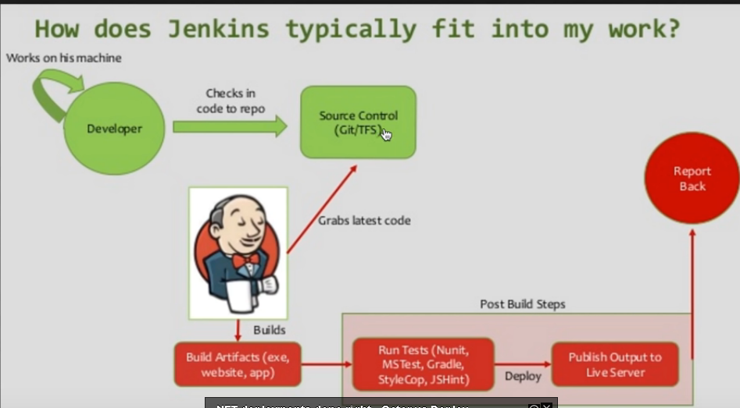

General Knowledge:
OOPS core concepts are;
1. Abstraction
2. Encapsulation
3. Polymorphism
4. Inheritance
5. Composition
6. Association
7. Aggregation

The following statement(s) are true for java

JVM is responsible to converting Byte code to the machine specific code.
We only need JRE to run java programs.
JDK is required to compile java programs.

The below are unchecked exceptions in java

ClassCastException
NullPointerException
RuntimeException

RuntimeException and its subclasses are unchecked exceptions. Unchecked exceptions do not need to be declared in a method or constructor’s throws clause.

The below are built-in class loaders in java

Bootstrap Class Loader
Extensions Class Loader
System Class Loader

Can we have two main methods in a java class?
This was a tricky question. We can have multiple main methods in java through method overloading.

The below are reserved keyword in java:
goto and int are reserved keywords in java.
array and null are not keywords in java

