Code Impact Visualizer

Features and technical design
A proposed VS Code extension for understanding, reviewing, and investigating AI-assisted Python changes. This document defines eight user-facing features, their visual design, the shared analysis engine, and the conditions required for a reliable first release.
Revision 4 — expanded to eight capabilities in four navigation groups. All features and screens are proposals, not completed implementation. Earlier four-tab mockups remain as historical detail examples; the navigation design in the expansion section supersedes those tab bars.

Foundation features
Feature | Developer question
Change Review | What changed in the code and its local behavior?
Impact Map | Which callers and dependencies could be affected?
Code Walkthrough | How does this function work, step by step?
Debug the Failure | Where should I investigate this traceback?

Product boundaries
The first release targets Python repositories in desktop VS Code, including remote workspaces where the extension host can access the repository and interpreter. Analysis is local to that host. No AI model, AI API, or local LLM is included. Explanations use deterministic rules. Git supports comparison; source exploration remains available without Git.
The extension examines human and AI-written changes alike. The expanded offering also includes Compatibility Checks, Code Quality Review, Security and Dependency Review, and Test Coverage Gaps. Test execution remains with existing tooling.

Reading guide
Start with the feature catalog on page 2. The original sections retain code and interaction detail. The final six sections define the expanded scope, current navigation, four added capabilities, analyzer integration and acceptance checks.

Feature catalog
Eight planned capabilities, grouped into four navigation areas. Implementation and coverage must be validated; this catalog describes the target offering.

Change Review
REVIEW — Categorize edits; show before/after evidence, affected symbols and review progress.

Compatibility Checks
REVIEW — Flag potentially broken callers, removed symbols, import issues and signature mismatches.

Code Quality Review
REVIEW — Surface duplication, complexity increases, oversized functions and possible unused code.

Security and Dependency Review
REVIEW — Connect scanner findings and dependency advisories to changes and source evidence.

Impact Map
EXPLORE — Explore callers, callees, imports, inheritance and possible impact paths.

Code Walkthrough
EXPLORE — Follow static statements, branches, loops and resolved calls with Back and Next.

Failure Investigation
INVESTIGATE — Map tracebacks to source and related changes without claiming a proven root cause.

Test Coverage Gaps
COVERAGE — Connect changed code to supplied coverage and show where execution evidence is missing.

Shared controls and boundaries
Editor and Explorer actions, Follow, Pin, Expand, source evidence, filters and visible analysis status. Python first; no AI model. No guarantee of business correctness, security, complete dynamic resolution or adequate assertions. Missing analyzer results mean Not checked, not Passed.

1 Change Review
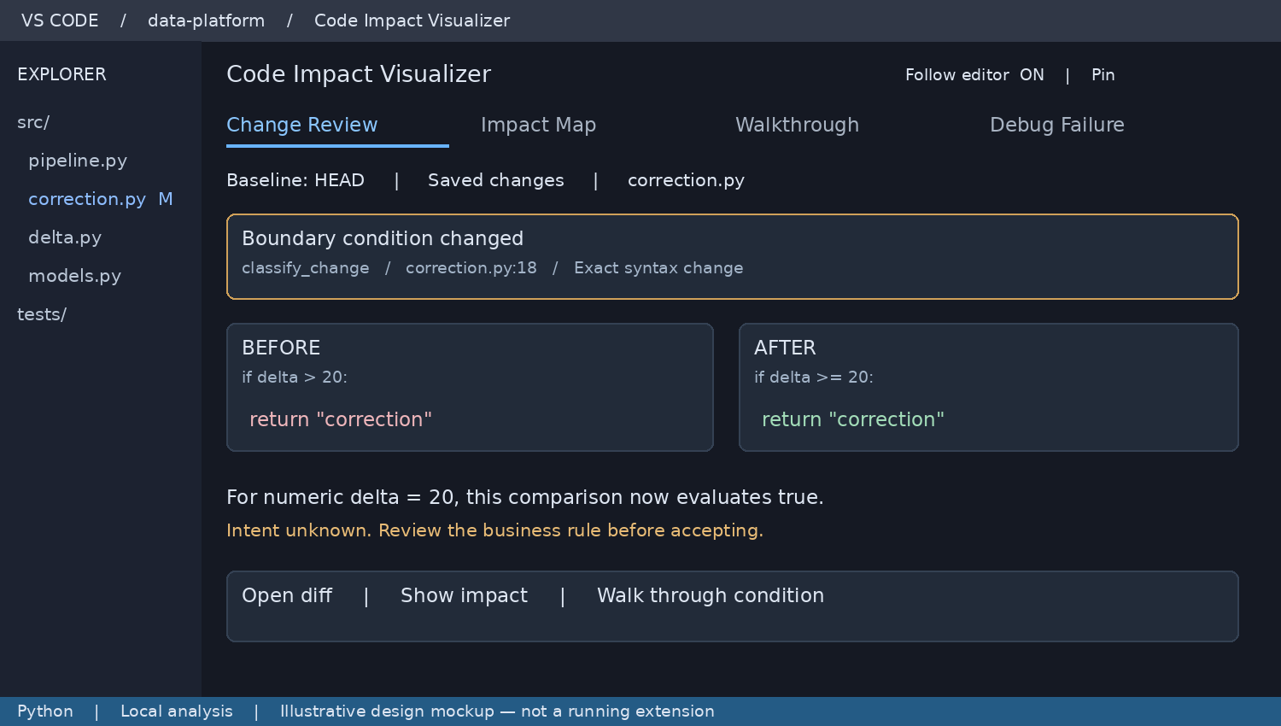
Illustrative screen design with sample code and data. Not an implementation screenshot.

User workflow
Open the panel after editing code. Select the comparison baseline, review changed symbols, then open a diff, inspect impact, or start a walkthrough. Default comparison is HEAD versus saved working files. Staged changes remain included in this aggregate; separate staged and unstaged modes must be labeled explicitly.

What the feature shows
Group changed lines by module, class, and function. Detect added or removed symbols, parameter changes, comparison operators, return expressions, exception handlers, and call targets. Each finding links to both source versions where available. Distinguish a syntactic edit from a supported local behavioral observation.

Technical approach
Read Git snapshots using argument arrays, then parse old and current Python into ASTs. Match symbols by file and qualified name; use location and structural similarity only as a labeled heuristic for renames. Map diff ranges to symbols. Untracked files appear as new; deleted symbols remain navigable in the baseline snapshot.

Limits and acceptance
A numeric comparison change can support a boundary explanation; arbitrary overloaded operators cannot. Never invent business intent. Formatting-only edits must not become behavior findings. Unsaved edits show a pending status. A change from > to >= must reveal the exact operator and source span, and navigation must open the correct revision.

2 Impact Map
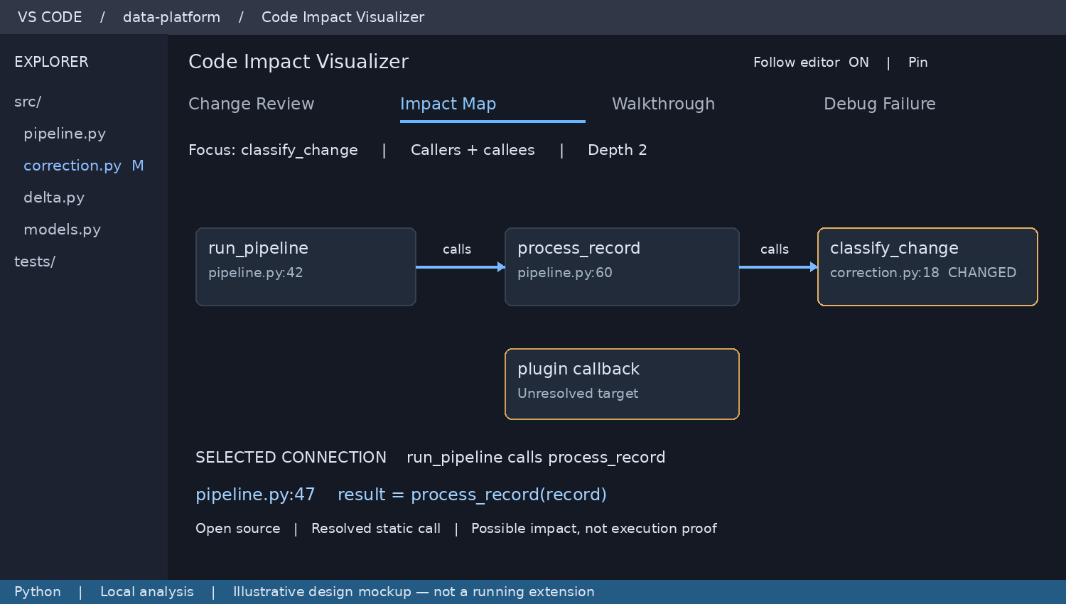
Illustrative screen design with sample code and data. Not an implementation screenshot.

User workflow
Selecting a function focuses the map. Expand callers or callees, change depth, search symbols, and click a connection to inspect its source evidence. Follow mode tracks editor selection; Pin preserves the focus while the developer navigates elsewhere. A graph can be opened in an editor tab for more space.

What the feature shows
Display the focus, changed symbols, direct callers, and called functions first. Add more nodes only on expansion. Label edges by relation: calls, imports, inherits, or references. An import alone must not be presented as a confirmed call. Direction controls use “Callers” and “Callees” to avoid ambiguous upstream labels.

Technical approach
Build forward and reverse adjacency indexes from definitions, imports, and call expressions. Resolve module aliases and lexical names; use language-provider results as optional enrichment. Traverse with visited sets and depth limits. Keep unresolved dynamic dispatch as an explicit unknown target rather than guessing a link.

Limits and acceptance
A possible dependency is not proof of runtime execution or data lineage. Every resolved edge must have a valid source range. Cycles must not freeze traversal. Dangling nodes must be rejected before layout. For large results, display a bounded subset and “Show more”; provide a keyboard-accessible list alternative.

3 Code Walkthrough
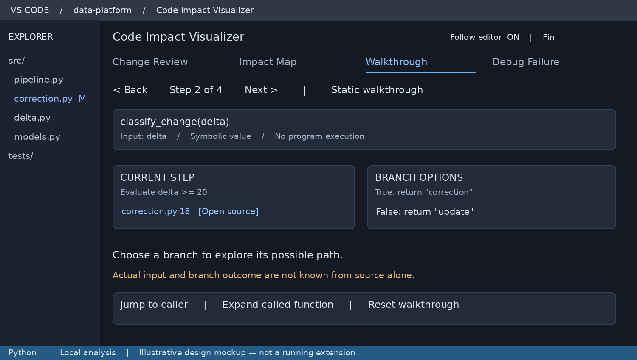
Illustrative screen design with sample code and data. Not an implementation screenshot.

User workflow
Select a function or class and choose Walkthrough, even when Git reports no changes. Back and Next move through statements and highlight matching source ranges. At a condition, choose a possible branch. Expand a call into its function and return to the prior frame without losing your place.

What the feature shows
Show parameters, relevant assignments, conditions, calls, returns, and exception paths in small steps. A class opens with its methods and inheritance links, then lets the user select a method. Values are symbolic unless the source contains an unambiguous literal. The default is clearly labeled Static walkthrough.

Technical approach
Build a lightweight control-flow representation from the AST. Store step identifiers, source ranges, successor steps, and branch labels. Maintain a separate navigation stack for nested calls. Fold loops into one expandable construct and stop recursive expansion with a cycle marker.

Limits and acceptance
This feature does not execute code or simulate Python completely. Mark generators, async scheduling, context managers, and complex exception behavior as partial when unsupported. Branch choice means exploration, not an observed outcome. Back must restore the previous step and expansion state; every step must navigate to evidence.

4 Debug the Failure
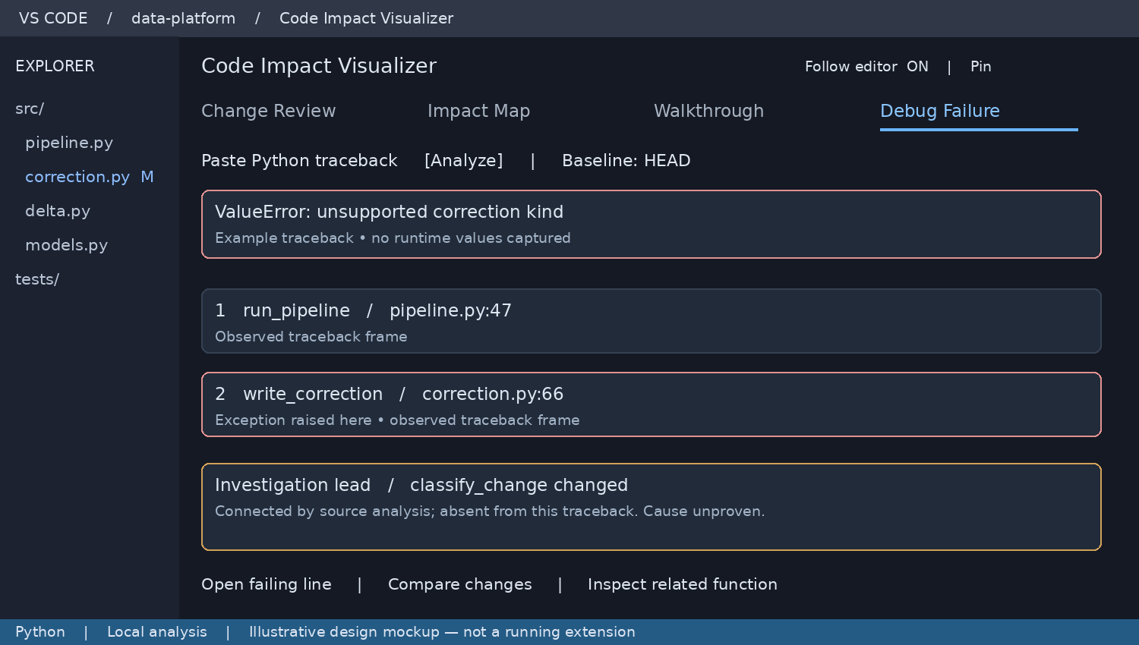
Illustrative screen design with sample code and data. Not an implementation screenshot.

User workflow
Paste a Python traceback and analyze it. Select a frame to open its line. Review recent changes on the observed stack, then inspect related changed functions separately. Choose the Git baseline that matches the failing deployment when known. No automatic terminal scraping is needed for the first release.

What the feature shows
Separate observed traceback frames from statically connected code and investigation hypotheses. A helper that already returned may not appear on the stack, even if its output matters. Display exception type, frame order, source availability, and change evidence; do not label a related edit as the root cause.

Technical approach
Parse standard Python tracebacks into typed frames and exception sections. Resolve paths only against allowed workspace roots or explicit user mappings. Correlate resolved frames with symbol ranges and the selected diff. Prioritize direct overlap with changed lines, changed frame symbols, then one-hop related changes. Explain this ordering instead of inventing confidence percentages.

Limits and acceptance
Tracebacks usually do not contain local variable values. Mismatched source versions must show a warning and disable exact-line certainty. Unmapped remote paths remain visible with a Map path action. Chained exceptions retain their boundaries; unsupported exception groups produce a partial result. Debugger integration is a later enhancement.

5 Shared technical architecture
Use shared analysis records across the eight capabilities. Source identity and evidence are shared so that a user can move from a changed condition to its graph, walkthrough, or failure context without contradictory results.
Component | Proposed responsibility
VS Code host in TypeScript | Commands, selection events, document versions, Git snapshots, navigation and workspace settings.
Python analysis worker | Parse source text with ast; emit symbols, calls and control-flow steps without importing project modules.
Analysis store | Content hashes, snapshot IDs, source spans, graph indexes and incremental invalidation.
Feature services | Change rules, impact traversal, walkthrough state and traceback correlation.
Webview presentation | Review, Explore, Investigate and Coverage groups, evidence details and view state.

Event processing
An editor selection changes the focused symbol without requiring a full reparse. A save or filesystem change schedules analysis for affected files. The host sends source text and a snapshot ID to the worker; the store accepts only results matching the latest requested snapshot. Update the view through typed messages rather than rebuilding its entire HTML.

VS Code integration
Proposed APIs include WebviewViewProvider for the side panel, createWebviewPanel for expanded graphs, editor selection events for Follow mode, filesystem watchers for external edits, and showTextDocument for source navigation. The host mediates all file access. Webviews only request validated operations. [1, 2]

Packaging and deployment assumptions
Bundle extension JavaScript and the analysis script in the VSIX. Launch an available, compatible Python interpreter with argument arrays; do not install dependencies silently. The initial parser uses the Python standard library. If the interpreter cannot parse the project syntax, explain the version mismatch and retain basic text diffs. Remote execution belongs on the workspace extension host.

Existing extension integration
Before implementation, inspect the existing extension entry points, analysis payloads, graph renderer and tests. Reuse working components where they satisfy these contracts. This document does not assert that existing CodeLens builds already implement any component.

6 Data contracts and evidence
Record | Required information
Snapshot | Workspace root URI, baseline revision, content hashes, parser version and generation ID.
Symbol | Snapshot ID, file URI, qualified name, kind, name span and body span.
Edge | Source symbol, target symbol or unresolved target, relation, resolution method and evidence span.
Change | Old and new symbol references, old and new ranges, rule ID and bounded explanation.
Walkthrough step | Step ID, owning symbol, source span, operation, successors and support status.
Failure frame | Traceback ordinal, original path, mapped URI, line, symbol match and mapping status.

Identity and source positions
Use snapshot-scoped symbol IDs; do not rely on line numbers as stable identity across edits. Cross-snapshot matching produces an explicit mapping with its method. Store VS Code positions as zero-based UTF-16 coordinates. Python AST columns use UTF-8 byte offsets, so the adapter must convert correctly, including Unicode before a token. [3]

Analysis rules
Resolve lexical function names, explicit imports and aliases conservatively. Mark receiver types, decorators, monkey patches, dependency injection and reflective lookups unresolved when evidence is insufficient. Include module-level executable statements. File deletions invalidate their symbols and connected edges; import changes invalidate dependent resolution results.

Presentation contract
Use “Resolved from source” for statically resolved relationships, “Observed in traceback” for supplied frames, and “Possible relationship” for uncertain matches. Use “Partial analysis” when some code is unsupported. No generic “safe” or “verified” badge is permitted. Suggested explanations must always state their scope.

Message contract
Host-to-view updates carry schemaVersion, requestId, snapshotId and a typed payload. View-to-host requests contain a command and known entity ID, not arbitrary shell commands. Validate every message. Reject stale navigation requests or refresh the evidence first. Preserve selection, zoom and pin state across valid updates.

7 Operating behavior and reliability
State | Expected user experience
Initial indexing | Show progress and cancel control; keep the editor responsive.
No changes or no Git | Review explains the state; Map and Walkthrough still work.
Incomplete Python syntax | Show partial analysis and mark prior results stale; never silently treat them as current.
No Python interpreter | Explain the requirement; retain text-level change review.
Missing source for traceback | Retain the frame and offer path mapping; no guessed navigation.
Worker or renderer failure | Show an actionable error and retry; preserve the last valid state as stale.

Local processing and access
Core source analysis requires no network calls or model API keys. Optional scanner integrations disclose any network or installation requirements. Respect workspace trust before starting processes. Avoid executing project modules. Use strict webview resource restrictions, a content security policy, escaped source text and validated links. Keep tracebacks in memory by default; they can include sensitive paths and messages. Diagnostic logs should omit code and traceback bodies by default.

Performance targets to measure
Targets are provisional, not benchmark results: selected-symbol lookup within 200 ms after indexing; saved-file updates within 1 second for ordinary files; initial indexing within 10 seconds for a representative 500-file Python repository on the agreed test machine. Record repository size and hardware with results. Cap the initial graph at 80 nodes and expand on request.

Incremental work and caching
Debounce save bursts, cancel superseded jobs and cache by content hash plus parser version. Exclude virtual environments, generated files and ignored directories by default with overrides. Keep the graph independent of layout coordinates. Validate endpoints before layout, initialize coordinates defensively, and isolate a bad record so it cannot blank the whole view.

Accessibility and layout
Use VS Code theme tokens, visible focus states and text labels alongside color. On narrow panels, stack details below the graph and allow tabs to scroll. Offer an expanded editor view for wide graphs. Clicking evidence must not change pinned focus. Large text and keyboard-only navigation are release checks.

8 Delivery and acceptance

Implementation sequence
Establish versioned analysis records, navigation and resilient rendering first. Build Change Review and Impact Map, then add compatibility checks, quality adapters, security adapters and coverage ingestion. Walkthrough and failure investigation reuse the index. Release each capability only after its acceptance checks pass; stages are sequencing, not scope removal.
Feature | Release acceptance scenario
Change Review | A > to >= edit is identified with exact old and new spans; whitespace-only edits do not imply behavior changes.
Impact Map | A six-layer sample resolves known calls, handles cycles and aliases, and displays dynamic targets as unknown.
Walkthrough | Branches, loops and nested calls support Back and Next with correct highlights and explicit static labeling.
Debug Failure | A pasted traceback maps valid frames, retains unmapped paths and separates related edits from observed stack evidence.
Shared behavior | Rapid saves cannot overwrite new results with old ones; deleted nodes and malformed edges do not crash rendering.

How to judge product value
Ask developers to review one unfamiliar change and investigate one failure, with and without the extension. Measure time to identify affected callers, accuracy of their explanation, and time to reach the relevant source. Record misleading links and missing relationships. Do not claim that the features solve most problems until these tasks demonstrate useful results.

Documentation basis
Scope follows the evolving feature discussion. The expanded design includes compatibility, quality, security and coverage-gap analysis. Earlier mockup tab bars illustrate the original layout; use the expanded navigation section as the current UI specification.
[1] VS Code Webview API
https://code.visualstudio.com/api/extension-guides/webview
[2] VS Code Extension API reference
https://code.visualstudio.com/api/references/vscode-api
[3] Python ast documentation
https://docs.python.org/3/library/ast.html
References checked 20 September 2026. All architecture choices, screen layouts and performance targets are proposals for review.

9 Feasibility without AI
The extension is a source-analysis and navigation tool. Its explanations come from explicit rules, its relationships come from resolvable code references, and its failure view comes from supplied tracebacks. No model is needed for these operations. Accuracy and performance still require measurement on representative repositories.
Feature | Reliable first scope | Boundary
Changes | AST differences, changed symbols and rule-based descriptions. | Business intent and arbitrary behavior are not inferred.
Impact | Imports, lexical calls, aliases and explicit inheritance. | Dynamic dispatch and framework wiring may remain unknown.
Walkthrough | Source statements, possible branches and nested navigation. | No actual variable values or execution path.
Debug | Traceback frames, source mapping and relevant edits. | Root cause is not proven by proximity to a change.

What replaces an AI explanation
A change rule has an identifier, required AST pattern, preconditions, message template and source spans. For example, comparison_operator_changed identifies > becoming >= and says “Comparison now includes equality.” A stronger numeric-boundary message is permitted only when numeric semantics are established or explicitly assumed. Unknown operand types receive the structural message only.
ruleId: comparison_operator_changed
oldOperator: Gt
newOperator: GtE
message: Comparison now includes equality
evidence: old span + current span
semanticScope: structural

Feasibility checks before implementation claims
Create a hand-labeled sample with direct calls, aliases, classes, inherited methods, recursion, callbacks and decorators. Count correct resolved edges, incorrect edges, missed expected edges and explicitly unresolved calls separately. Report precision and recall for the supported subset, plus unresolved coverage for the complete sample. Do not hide unknowns to improve the score.
Also check formatting-only changes, renamed and deleted functions, Unicode source positions, rapid saves, source-version mismatches and a 500-file repository. All example counts and timings in this design are targets or illustrative values, not measured results.

10 Code beside Change Review
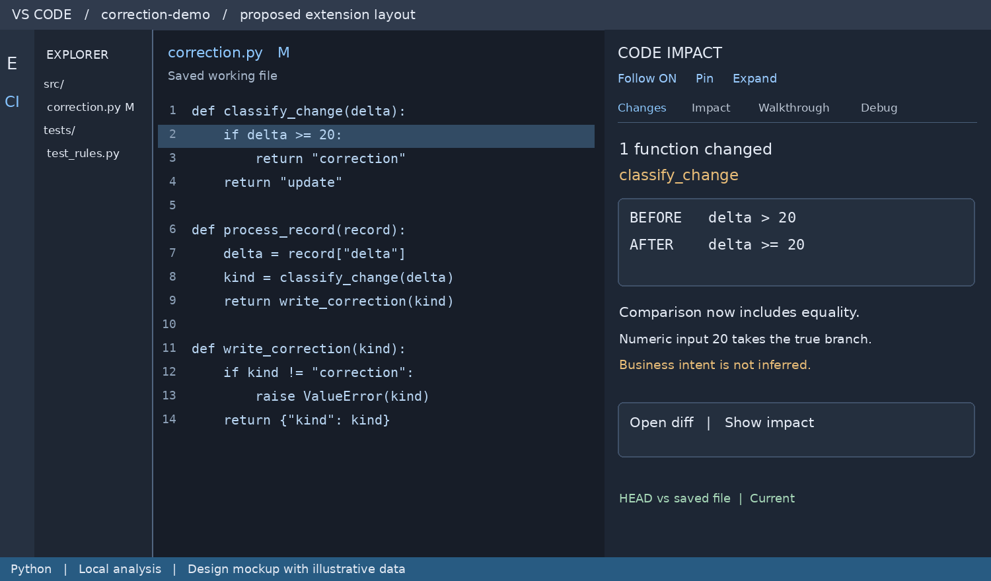
Figure 5. Source on the left and the Changes panel on the right. Illustrative UI.

User action and visible response
The user changes line 2 from > to >= and saves correction.py. The code stays open. The extension lists one changed function and shows the old and new comparison. Clicking Open diff uses the baseline and current document; Show impact keeps classify_change as the focus while switching tabs.

Data that drives this screen
{ "snapshotId": "working-17", "baseline": "HEAD",
"symbol": "correction.classify_change",
"ruleId": "comparison_operator_changed",
"oldOperator": ">", "newOperator": ">=",
"currentRange": {"start": [1,4], "end": [1,19]},
"status": "current", "scope": "structural" }
Payload coordinates are zero-based and end-exclusive; screen line numbers are one-based. The highlighted range covers the condition statement. The numeric boundary sentence in the mockup assumes the example input is numeric; the generic implementation must not assume that for arbitrary Python objects.

Navigation contract
The panel sends a known change ID and snapshot ID to the host. The host resolves the allowed URI and range. It never trusts a webview-supplied path blindly. If the file changed after the result, refresh or show that the finding is stale before navigating.

11 Code beside Impact Map
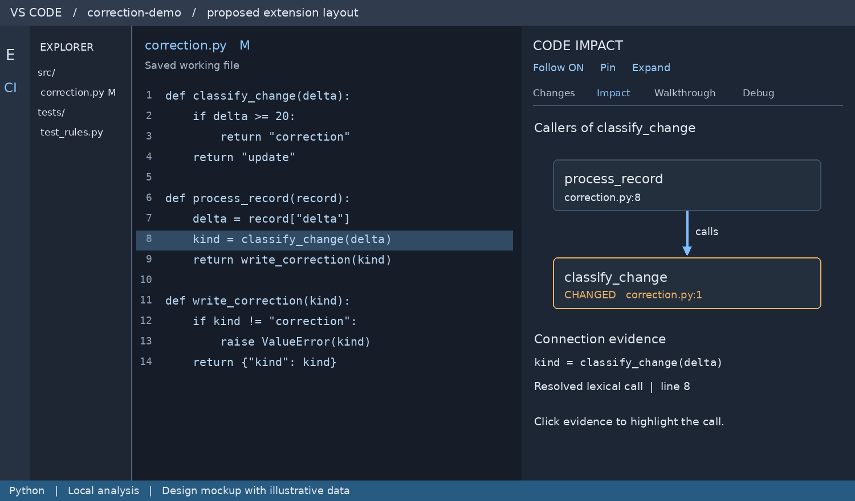
Figure 6. A call connection is backed by the highlighted source statement on line 8.

User action and visible response
Select classify_change and open Impact. The panel shows process_record as a caller. Selecting the edge highlights line 8, not the definition line. Selecting the function node instead opens its definition. Expand adds more relationships without replacing the selected connection.

Data that drives this screen
{ "from": "correction.process_record",
"to": "correction.classify_change", "relation": "calls",
"resolution": "lexical", "snapshotId": "working-17",
"evidence": {"uri": "<workspace>/correction.py",
"start": [7,11], "end": [7,33]},
"executionObserved": false }
The URI shown above is a documentation placeholder. The real payload uses a canonical workspace URI. No edge should be created solely because two functions have similar names. Calls through handlers[event] remain unresolved unless a supported analysis establishes the target.

What is excluded
This map does not claim complete data lineage, runtime frequency, or proof that all downstream results change. Imported modules, inheritance and call edges have separate labels. Counts include the selected filters and depth so that a small graph is not mistaken for the whole repository.

12 Code beside Walkthrough
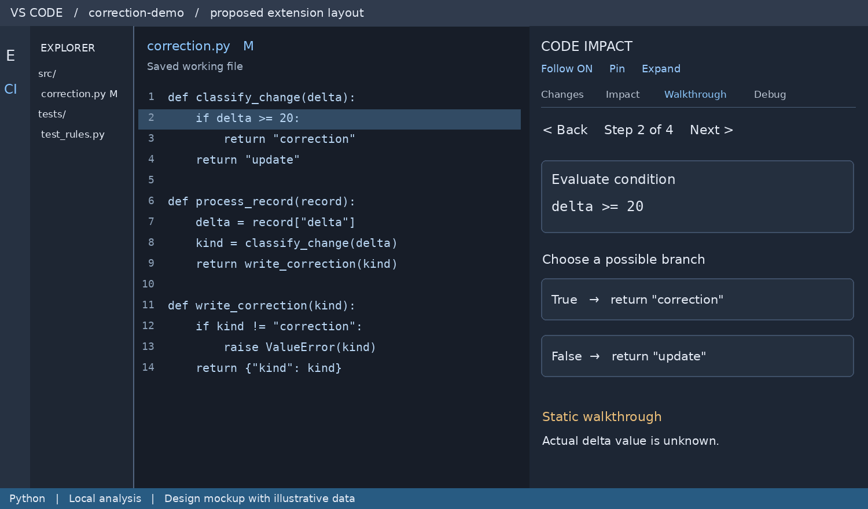
Figure 7. A static step highlights the condition while the panel offers possible branches.

User action and visible response
Open Walkthrough on classify_change without making an edit. Step 1 introduces delta. Step 2 highlights the comparison. The developer chooses True or False to inspect the corresponding return. Back restores the preceding step; Reset returns to the selected function entry.

Data that drives this screen
{ "stepId": "classify:condition", "kind": "branch",
"mode": "static", "sourceLine": 2,
"expression": "delta >= 20",
"successors": {"true": "classify:return-correction",
"false": "classify:return-update"},
"values": {"delta": {"state": "unknown"}} }
sourceLine in this simplified display model is one-based; canonical navigation still uses a source range. The UI must never substitute a guessed delta value. Choosing a branch changes exploration state and does not execute code.

Bounded control flow
Loops are folded with an explanation that the body may repeat. Recursion shows a cycle marker. A call can be expanded only when its target is resolved. Unsupported constructs retain source navigation and a partial-analysis label. A class starts with method selection rather than inventing an execution order across methods.

13 Code beside Debug
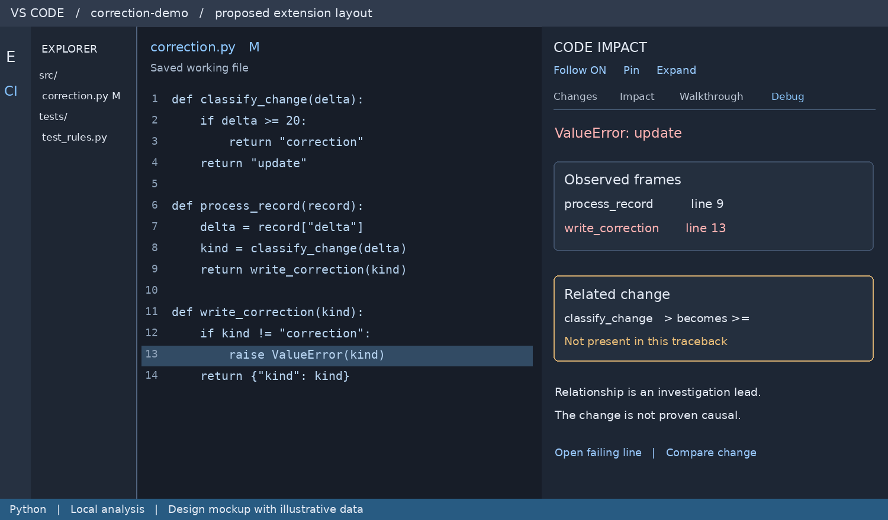
Figure 8. Observed traceback frames and related source changes occupy different sections.

Input for the illustrated failure
Traceback (most recent call last):
File "correction.py", line 9, in process_record
return write_correction(kind)
File "correction.py", line 13, in write_correction
raise ValueError(kind)
ValueError: update

What the extension can establish
The supplied traceback identifies process_record and write_correction. Source analysis separately shows that process_record calls classify_change. The classifier changed, but that fact alone cannot explain this failure. In this sample, an update value is rejected by the writer; changing > to >= is not proof of why that value occurred.

Data and interaction
Store frames in order with original path, mapped URI, line, exception section and source-version status. Clicking frame 2 highlights line 13. Compare change opens the related classifier diff. The result must remain useful when no recent changes exist: show frames and source, with “No related changes found.” Input values are unavailable unless supplied separately.

14 Partial results beside code
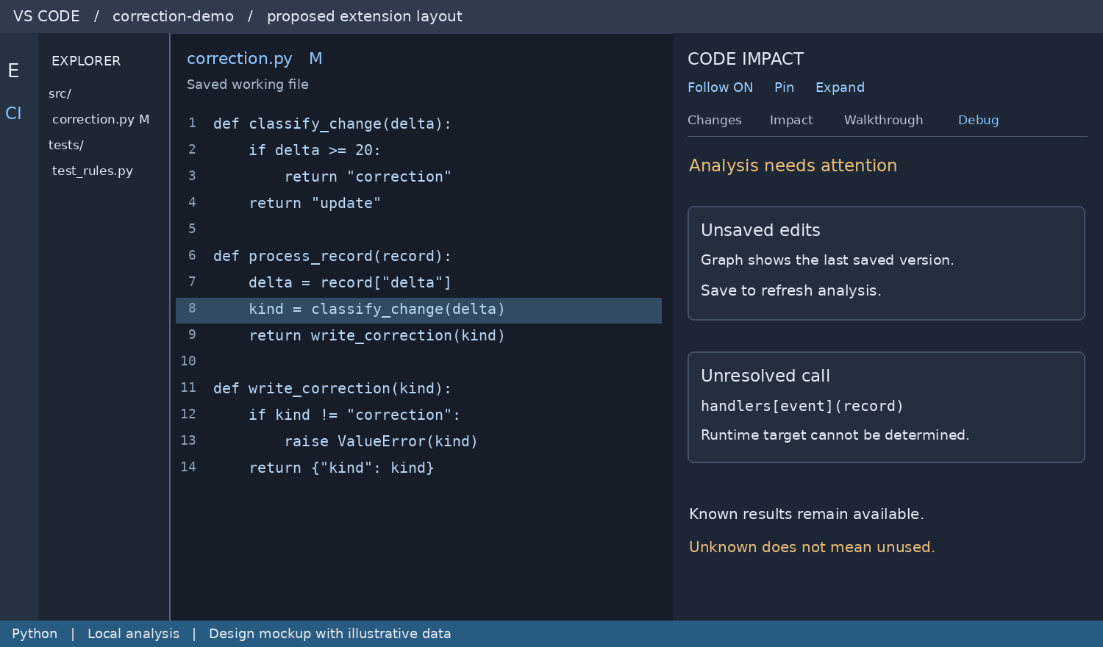
Figure 9. Unsaved or unresolved states remain visible beside the editor. State examples are illustrative.

Keep current and stale data separate
An editor selection can update focus immediately. Unsaved text receives an “Unsaved edits” notice because the initial version indexes saved files. On save, increment the requested generation, analyze the file and invalidate dependent resolutions. Results from an older generation cannot overwrite newer results.

Unknown relationships
The unresolved-call card is a separate example and is not a finding from the visible correction.py sample. For handlers[event](record), display the call expression and its source location, with target unknown. Do not draw a confirmed edge to a convenient-looking function. Unknown does not imply dead or unused code.

Recovery and settings
Provide a visible analysis state with Refresh, Cancel and Open diagnostics actions. A parse error reports the file and line, preserving last-known results as stale. Settings include Follow editor, comparison baseline, graph depth, excluded folders and Python interpreter path. A Clear analysis cache command removes derived records without altering source.

15 Code to extension data
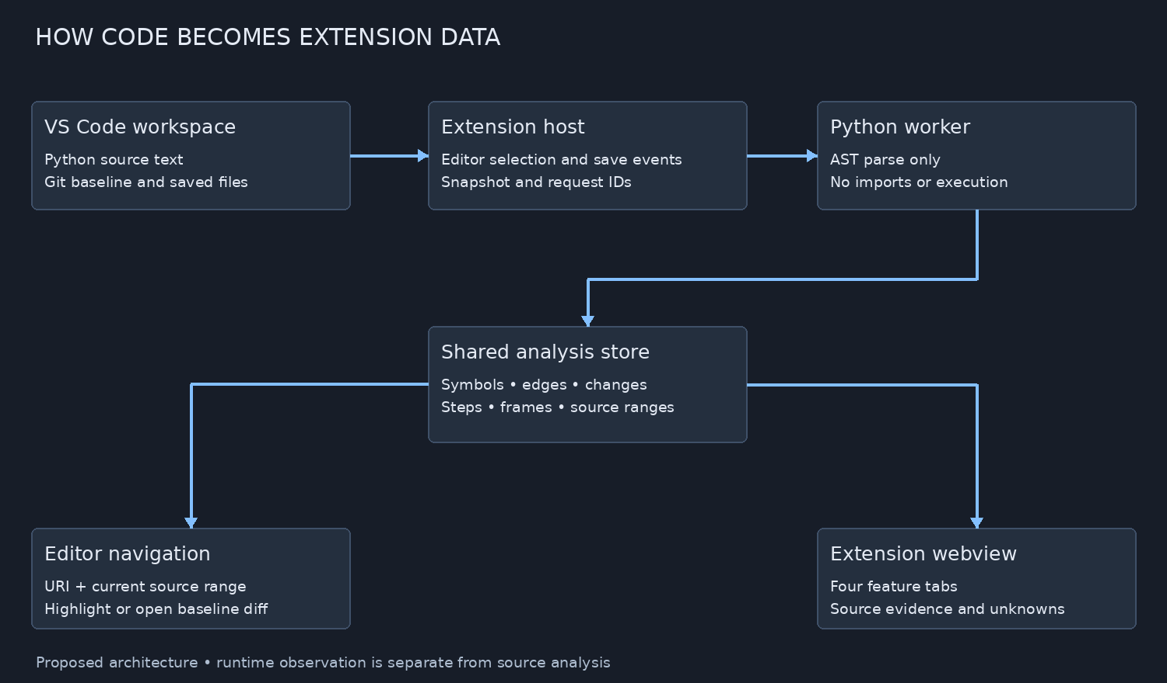
Figure 10. Proposed processing boundaries. Both navigation and presentation use the same analysis store.

One source of truth
The TypeScript host owns workspace access, Git reads, request generation and UI events. A Python worker receives text snapshots and emits structured records. The store builds forward and reverse indexes. Feature services and analyzer adapters select records for the webview, while the same records supply exact editor navigation.

Transport and persistence
Use newline-delimited JSON over the worker standard input and output. Reserve standard error for diagnostics. Each response includes protocol version, request ID, snapshot ID, status and payload. Reject malformed messages and cap message size. Restart a failed worker with bounded retries; never loop indefinitely.
Keep the index in memory initially. If persistent caching is added, use workspace-scoped extension storage keyed by root URI, content hash and parser version. Persist only the derived records needed; keep pasted tracebacks in memory by default. Do not insert generated analysis files into the project repository.

Extension ownership
The webview cannot read project files directly. It sends validated requests such as openEvidence, focusSymbol, expandCallers and selectStep. The host validates entity and snapshot IDs, resolves source locations and returns updates. Selecting another tab reuses the same focus and index rather than starting a new scan.

16 VS Code integration and packaging
This is an installable VS Code extension, not a standalone web application. The Activity Bar entry opens a webview view; the editor remains available beside it. Expanded graphs use a webview editor panel. The earlier full-width mockups are expanded views, and Figures 5–9 show the proposed code-plus-panel working layout.

Proposed extension source structure
File or folder | Responsibility
package.json | Extension metadata, commands, menus, views and settings.
src/extension.ts | Activate registrations and dispose resources.
src/host/ | Editor events, Git baseline reads and source navigation.
src/analysis/ | Worker client, snapshots, indexes and typed records.
src/features/ | Changes, impact, walkthrough and traceback services.
webview/ | Four navigation groups, feature views and theme-aware styles.
python/analyzer.py | AST extraction; receives text and never imports project modules.
test/fixtures/ | Known dependency graphs, code edits and traceback samples.

Registration example
Illustrative fragment only. CodeImpactViewProvider is a proposed class, not an existing implementation. Its view ID must match the contributes.views entry in package.json.
export function activate(context: vscode.ExtensionContext) {
const provider = new CodeImpactViewProvider(context);
context.subscriptions.push(
vscode.window.registerWebviewViewProvider(
"codeImpact.panel", provider),
vscode.commands.registerCommand("codeImpact.open",
() => vscode.commands.executeCommand("codeImpact.panel.focus"))
);
}

Manifest and editor behavior
Declare a codeImpact Activity Bar container and a webview view named codeImpact.panel. Register commands for opening the panel, reviewing changes, exploring impact, starting a walkthrough and analyzing a traceback. Add editor and Explorer context menus with Python conditions. When invoked from Explorer, use the clicked resource URI; from the editor, use the active document and selected symbol. Store disposable event subscriptions and cancel workers on shutdown. [2]

Build and install
Compile TypeScript, bundle local webview assets and include the Python worker. Run unit and extension-host checks, then package with vsce package. Inspect the VSIX contents and install through Extensions → Install from VSIX in a clean profile. Validate Windows, macOS and the intended remote host before claiming support. Marketplace publication is a separate step. [4]
[4] VS Code Publishing Extensions
https://code.visualstudio.com/api/working-with-extensions/publishing-extension

17 Opening the extension
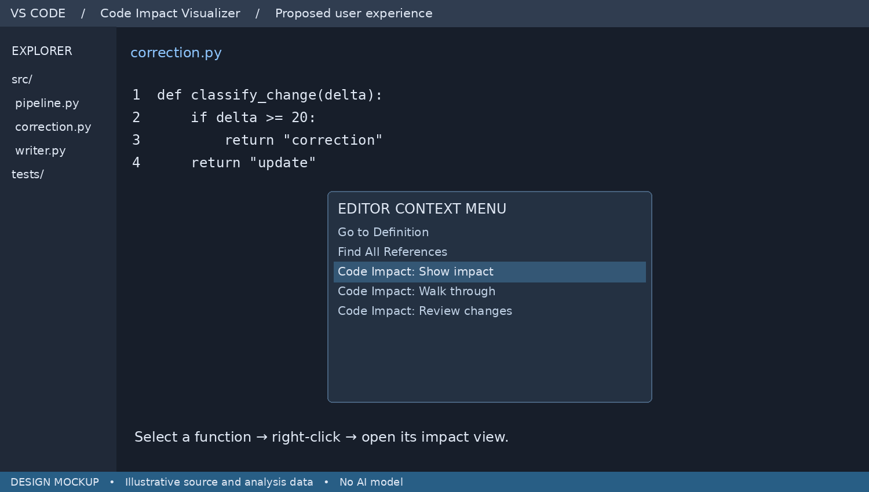
Figure 11. Editor context menu opens the selected function in Code Impact.

Entry points
The Activity Bar opens the panel at its last focus. In the editor, select a function and choose Show impact or Walk through. Explorer actions use the clicked file, even if another file is active. Command Palette actions use the current editor or ask for a file when no editor is available.

Selection behavior
Resolve the smallest containing function or class at the cursor. If selection is at module level, show the file overview. Highlight the selected focus in the panel and offer a clear route back to the module. The extension never replaces the source editor.

Acceptance check
Invoking a command from Explorer must analyze that resource. Invoking it from a function must focus that symbol. A missing interpreter shows an actionable status rather than a blank panel.

18 Reviewing changes across files
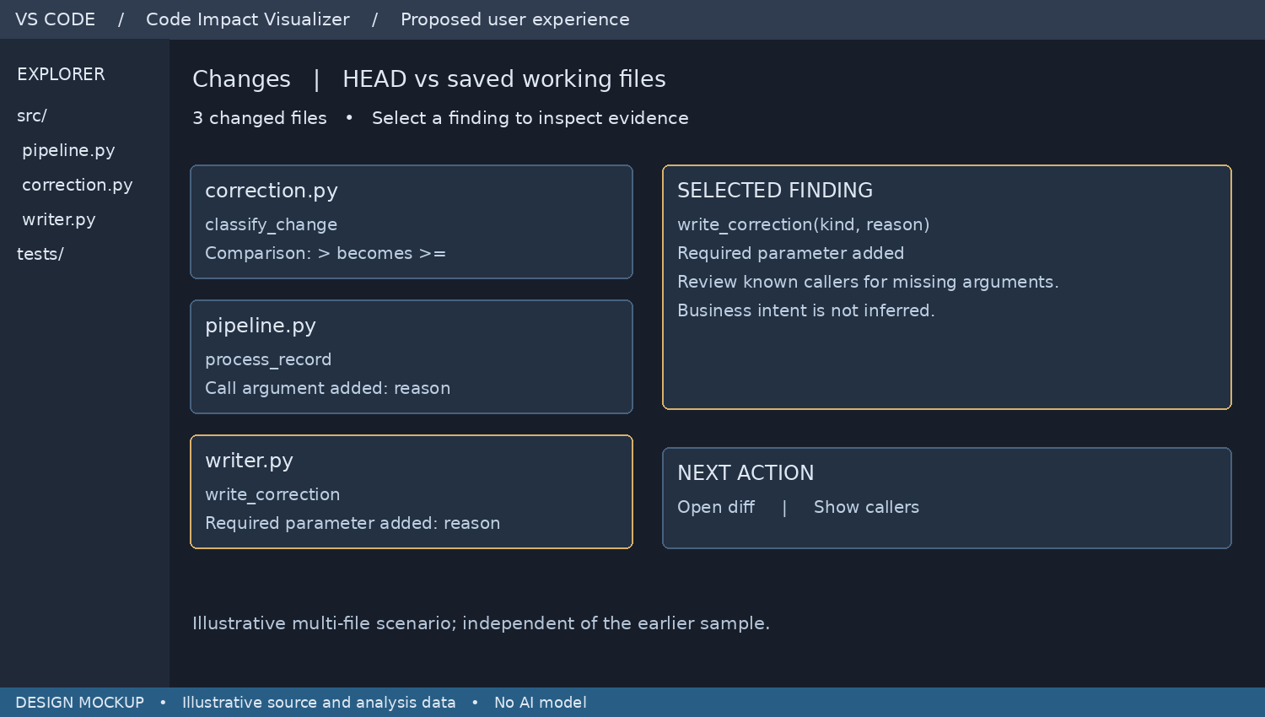
Figure 12. Multiple file changes are grouped while details remain focused on one finding.

Progressive detail
Start with file and function names and short change labels. Expand only the selected finding to show the exact syntax change, source evidence and actions. This avoids overwhelming the developer with a generated report.

Consistent comparisons
All cards use the same baseline and current snapshot. A function signature change links to known callers, but the extension must not claim every caller is invalid. Calls using defaults, keyword arguments or dynamic argument expansion need separate handling.

Acceptance check
Changing three files produces three relevant groups. Clicking a card updates the details without losing the group selection. Source positions and graph data must refer to the same snapshot; older results are marked stale.

19 Expanding the dependency graph
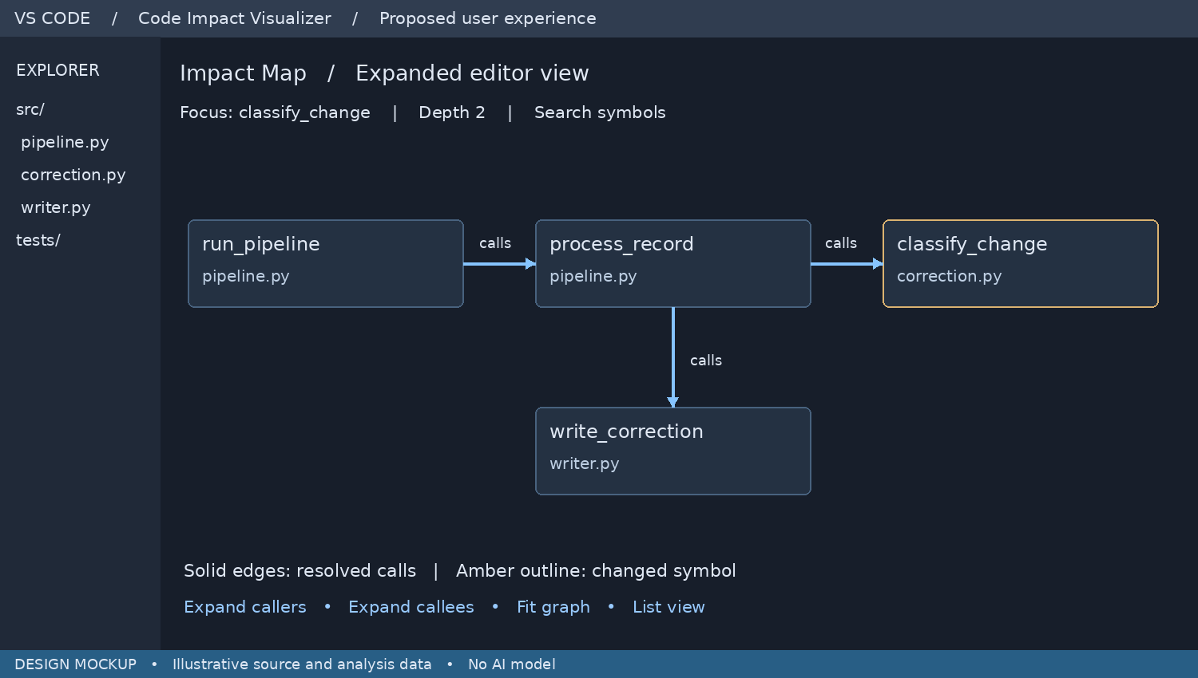
Figure 13. Expanded graph view keeps the caller and callee directions visible.

Readable exploration
Open the graph in an editor tab when the side panel is too narrow. Show immediate relationships first. Expand additional depth on demand, preserve selection and camera position, and offer Fit graph after expansion. Search focuses a symbol instead of drawing the entire repository.

Meaning of connections
This is a separate multi-file example. run_pipeline calls process_record, which calls classify_change and write_correction. The arrows show calls, not chronological execution or data movement. Highlighting the classifier change does not prove that the writer output changes.

Acceptance check
Each displayed edge opens a real call site in the sample fixture. Cycles remain navigable, unresolved targets are labeled and graph expansion respects a node cap. The list alternative exposes the same relationships for keyboard navigation.

20 Keeping focus while reading evidence
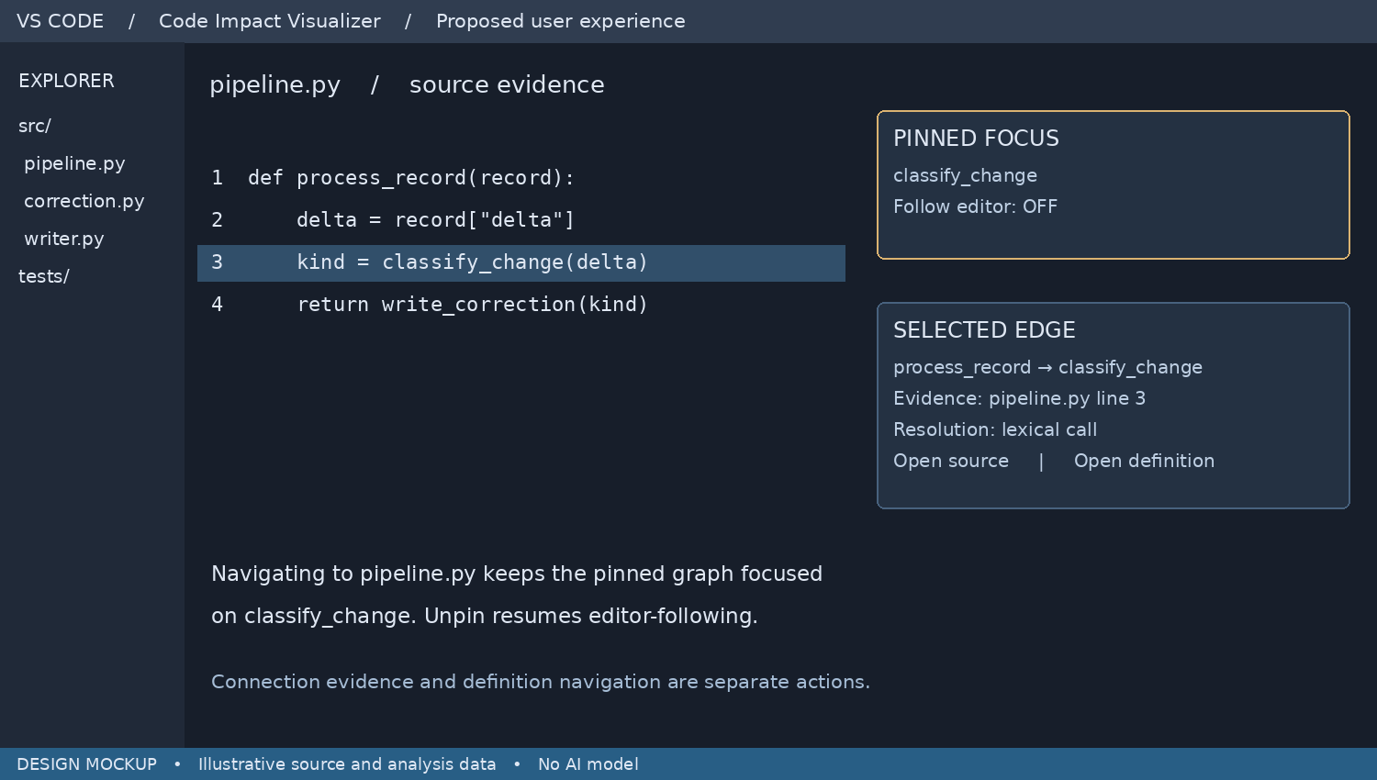
Figure 14. Pin preserves the graph focus while a different file opens in the editor.

Follow and Pin
Follow editor updates the focused symbol as the user navigates code. Pin freezes the focus and disables following for that view. Clicking evidence opens the supporting file without replacing the pinned graph. Unpin resumes following the active editor.

Two navigation targets
A node opens a symbol definition; an edge opens the call expression supporting the relationship. The detail panel shows which target will open. In this independent sample, line 3 is the call site, while process_record is defined on line 1.

Acceptance check
Pin classify_change, open its caller and inspect the call line. The panel must remain focused on classify_change. Closing and restoring the view should preserve pin state only if the referenced symbol and workspace are still valid.

21 Showing progress and recovery
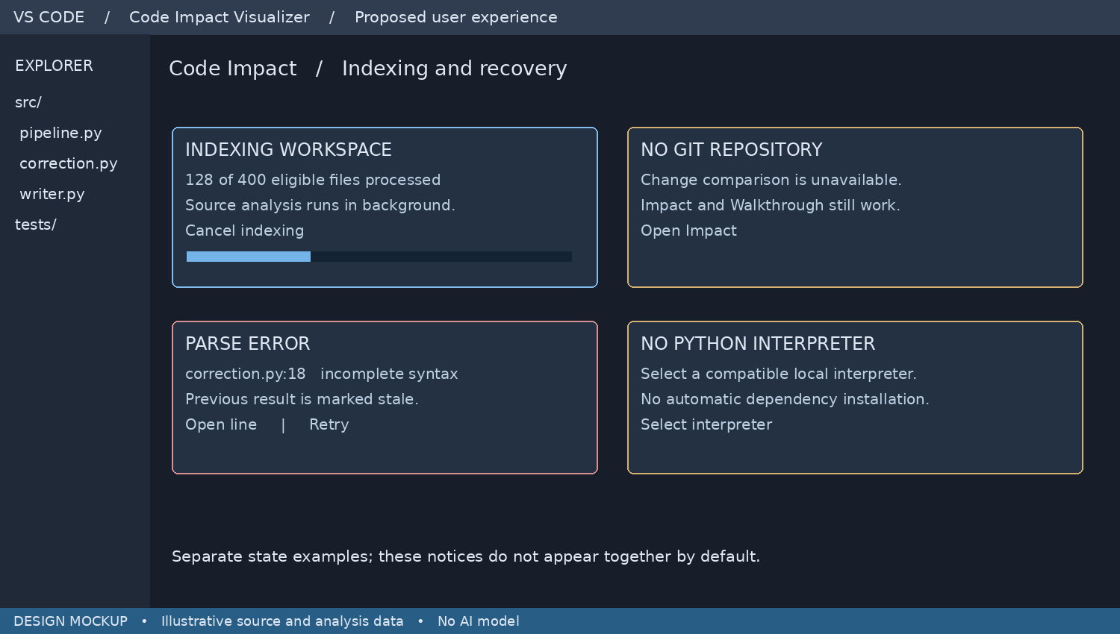
Figure 15. Four independent operating states demonstrate visible recovery actions.

Useful partial operation
Indexing shows processed eligible files and cancellation. A project without Git still supports source exploration. A parse failure marks affected results stale. A missing interpreter offers configuration without silently installing software.

Simple messages
Explain what is unavailable, what still works and the next action. Keep raw worker output in diagnostics, not the main panel. Do not display a successful state just because an indexing task stopped; completion and cancellation are different outcomes.

Acceptance check
Test each state independently. Cancellation stops pending analysis; retry only rebuilds the needed scope. A stale snapshot cannot be mistaken for current results. Counts shown in this mockup are illustrative and are not benchmark measurements.

22 Expanded scope and navigation
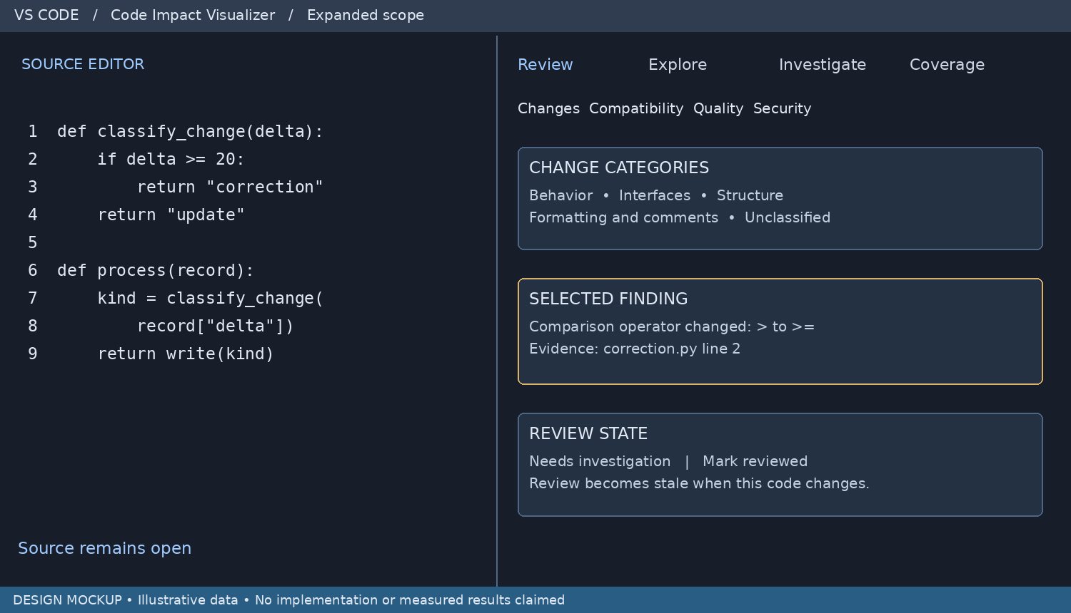
Figure 16. Current navigation replaces the earlier feature tab bars.

Eight capabilities in four groups
Review contains Changes, Compatibility, Quality and Security. Explore contains Impact and Walkthrough. Investigate opens Failure Investigation. Coverage opens Test Coverage Gaps. Keep one selected symbol and snapshot across groups. Findings link to source and can open the relevant Explore view without rebuilding the index.

Large change review
Classify edits as behavior, interfaces, structure, formatting and comments, or unclassified. Multiple categories can reference one finding without duplicating review work. Every changed file remains discoverable, including unsupported files and parse failures. Separate comments, docstrings and tool directives from whitespace-only edits.

Developer review state
Use Unreviewed, Reviewed and Needs investigation. Reviewed records a human decision, not a correctness guarantee. Tie the state to baseline and current content hashes; edits to underlying evidence invalidate the mark. Review filters never hide the number of unsupported or unclassified changes.

23 Compatibility Checks
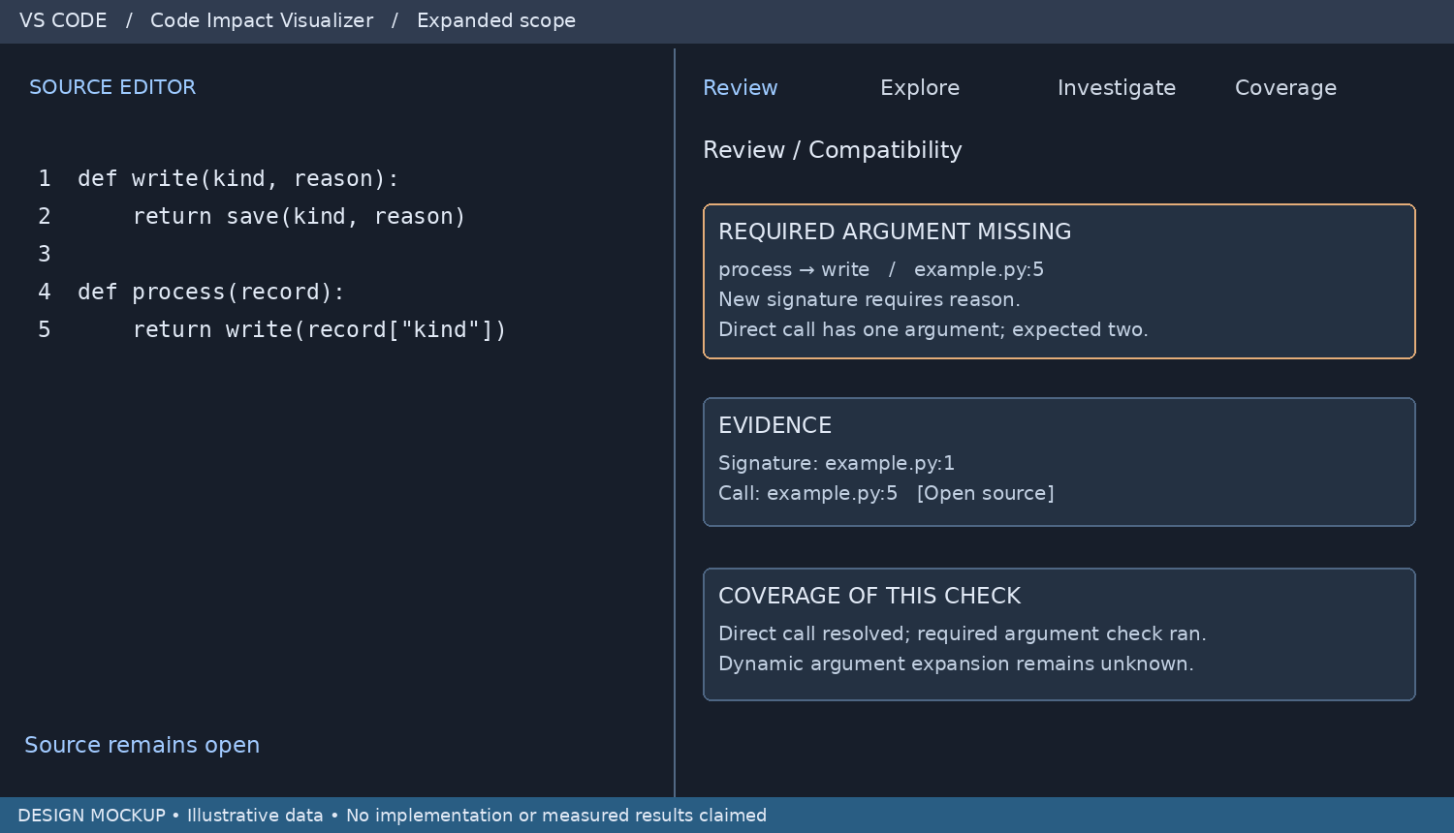
Figure 17. A resolved call and its new signature provide compatibility evidence.

Checks and implementation
Compare required parameters, defaults, positional-only and keyword-only rules, argument counts and explicit keyword names. Resolve deleted or renamed symbols and imports within the available project environment. Type-checker adapters can supply deeper diagnostics; identify their source separately from built-in checks.

Uncertainty and limits
Do not definitively reject calls involving unresolved receivers, decorators that change signatures, or unknown *args and **kwargs. Missing imports may reflect an unavailable environment rather than broken code. Link each finding to the caller, callee and exact baseline; report unresolved and skipped checks separately.

Acceptance
A direct call missing a newly required argument is flagged with both source locations. A new optional argument does not trigger that finding. Fixtures cover keyword calls, defaults, bound methods and variadic arguments. Dynamic cases produce Unknown rather than a false pass or confident failure.

24 Code Quality Review
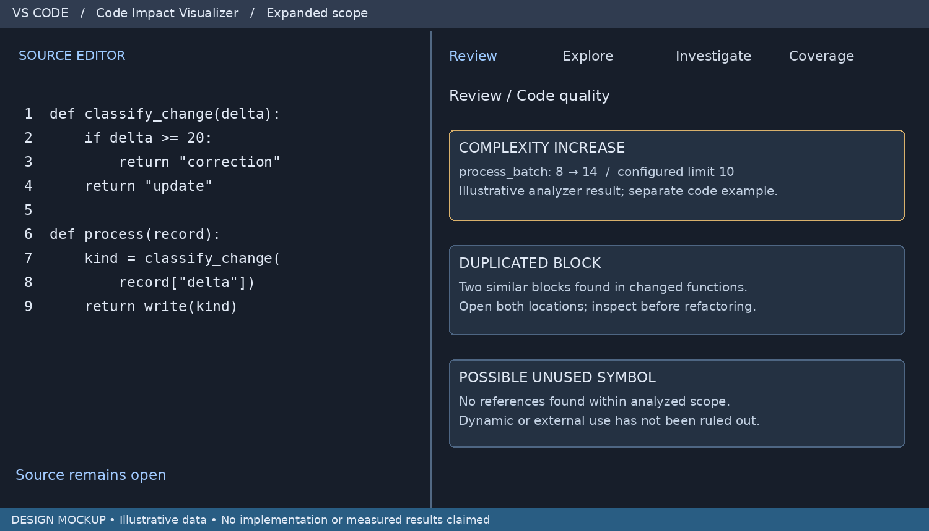
Figure 18. Quality findings include metric evidence and conservative unused-code wording.

Checks and implementation
Use deterministic AST or token analysis for changed-function complexity, size and duplicate blocks, or import those findings through analyzer adapters. Normalize formatting for duplication comparisons while retaining source locations. Compare baseline and current metrics under the same rule version and configuration.

Interpretation
Quality thresholds are configurable signals, not correctness judgments. Display the measured change and configured threshold. A symbol with no discovered references is “Possibly unused in analyzed scope”; framework hooks and external callers prevent a definitive dead-code claim. The visual contains illustrative findings from separate examples.

Acceptance
Formatting-only edits do not inflate complexity or duplicate findings. A reported duplicate opens both spans. Existing unchanged findings remain distinguishable from new or worsened ones. Suppression records a reason and rule ID; suppressing a finding must not erase analysis gaps.

25 Security and Dependency Review
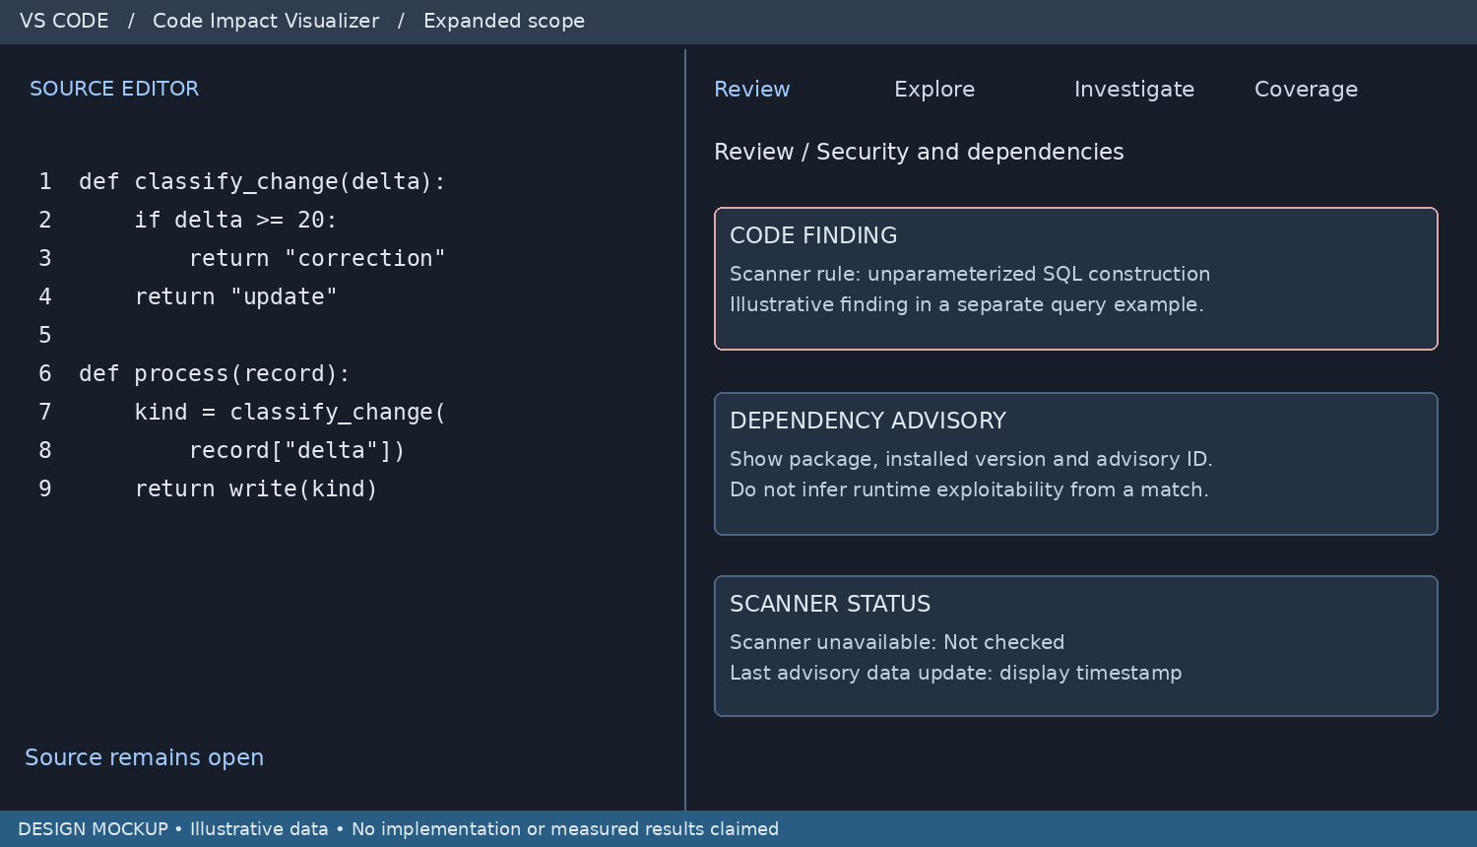
Figure 19. Source findings and dependency advisories remain distinct from scanner status.

Checks and implementation
Integrate established code and dependency scanners through versioned adapters. Capture tool name, version, rule or advisory ID, severity, source span or package identity, and evidence. Determine dependency versions from supported lockfiles or explicit environment inventories; do not guess a version from a loose requirement range.

Data freshness and privacy
Core code analysis stays local and uses no AI. A dependency scanner may require an advisory database download or an installed tool. Disclose what is fetched or sent and allow an offline mode with a visible database timestamp. Scanner absence, failure or stale data must never produce a clean-security badge.

Acceptance
Fixtures verify finding-to-source navigation, duplicate result handling, new versus existing findings, missing tooling and scanner failure. A dependency advisory match is not proof of reachable exploitation. No automatic remediation is included. The displayed security finding is an independent sample, not a claim about the visible classifier.

26 Test Coverage Gaps
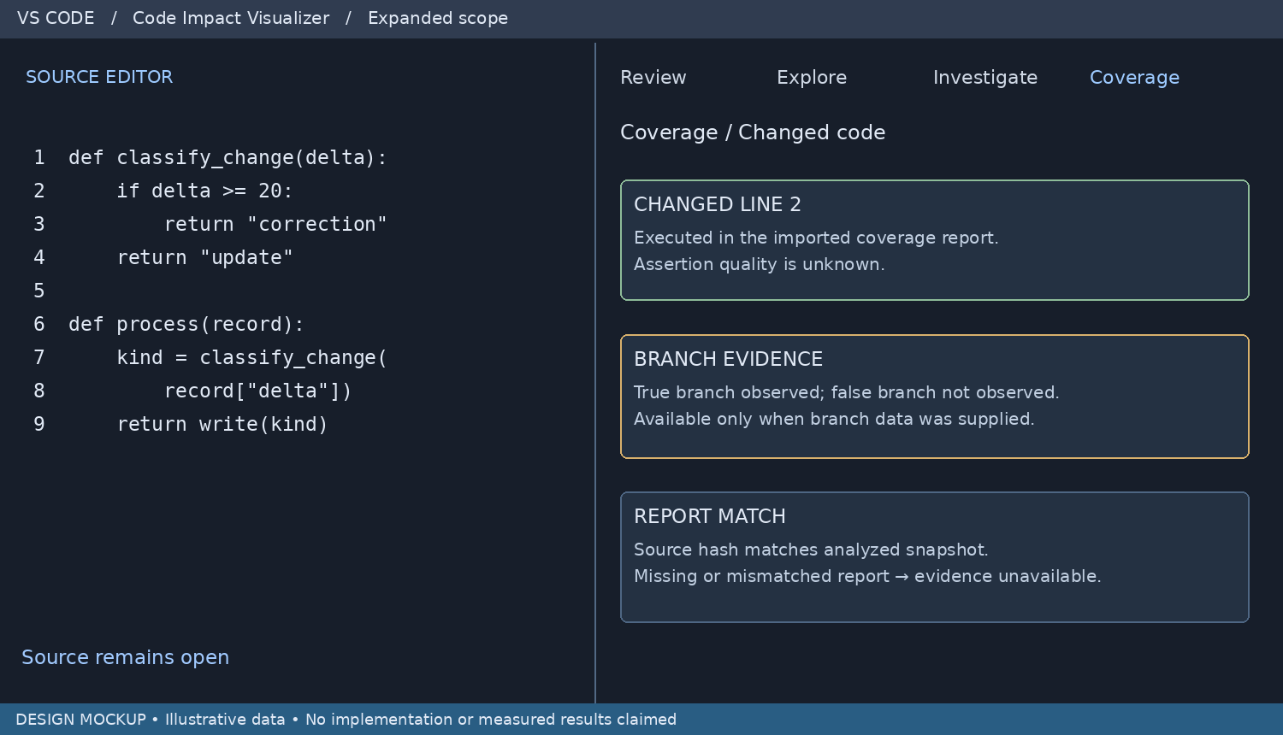
Figure 20. Execution evidence is displayed without claiming that assertions prove correctness.

Inputs and implementation
Import existing Python coverage reports through a supported adapter. Normalize paths to workspace URIs, record generation metadata and map executed lines and available branch arcs to changed source. Show affected functions with and without evidence. Per-test links are available only when the supplied report contains test contexts.

Source matching
Prefer source hashes recorded when coverage is generated. If a report lacks reliable snapshot identity, display “Source match unverified”; timestamps alone do not establish an exact match. Missing coverage, unobserved execution, and unverified source matching are different states. Never infer a missing boundary assertion merely because a branch was executed.

Acceptance
For a matching report, changed executed lines and missing execution evidence are distinct. Branch gaps are shown only with branch data. A stale or unmapped report cannot produce a confident covered badge. The extension imports evidence; it does not add a competing test runner.

27 Shared findings and delivery checks

Unified finding record
Every analyzer emits a normalized record: finding ID, capability, category, rule ID, producer and version, baseline/current snapshot IDs, location, evidence, severity when applicable, certainty, analysis status and related symbol IDs. Preserve the original diagnostic for inspection. User review status is separate from analyzer severity or execution status.

Analyzer status and adapters
Each adapter reports Completed, Partial, Failed, Unavailable or Not run, plus the analyzed scope. Record skipped files and reasons. A feature that has not run displays Not checked. Cancellation and failure are not successful completion. Run external tools without shell interpolation, respect workspace trust and keep concurrency bounded.

Feasibility gates
First validate parser and graph accuracy on hand-labeled Python fixtures. Then measure compatibility precision, quality metric consistency, scanner result mapping and coverage snapshot matching independently. Report correct findings, false positives, missed findings and unresolved cases. Do not turn a clean subset into a claim that every edit was checked.

Implementation sequence
Stage 1: shared snapshots, source evidence, Change Review and Impact Map. Stage 2: compatibility rules, quality adapters and review-state tracking. Stage 3: security adapters and coverage ingestion. Stage 4: complete walkthrough and failure navigation, cross-view integration and packaging. All eight remain in target scope; a staged release lists exactly which capabilities are implemented.

User-facing completion criteria
A developer can open the extension on a changed function, inspect categorized edits, see relevant compatibility or scanner findings, trace dependencies, inspect available test evidence and investigate a traceback. Each result opens source and explains its limits. Unsupported inputs remain visible. Validate this end-to-end in the VS Code Extension Development Host and a packaged VSIX before any implementation-complete claim.

Current status
This revision updates the technical design only. The mockups, result examples and registration fragment are illustrative. No source repository was modified, no analyzer integration was benchmarked and no VSIX was built during this document update.

