Code change tracing and developer review
Code Impact Visualizer
This companion design explains how the extension traces changes, presents evidence in the UI, and helps developers decide what to inspect, test, keep or revise. It applies to human and AI assisted edits across a Python repository.
The central experience is a guided review of logical changes, linked to exact source revisions and expandable dependency paths. The developer remains responsible for interpreting the requirement and accepting the change.
Status: proposed design, not an implementation report. This document extends the existing technical design and preserves its Review, Explore, Investigate and Coverage navigation. Screens, paths and counts below are illustrative.

Developer problems and the proposed response
Developer problem | UI response | Decision supported
Twenty files hide the main change | Suggested groups and before and after evidence | Where should I start?
Impact extends into unchanged code | Expandable callers and consumer paths | What else must I inspect?
A graph connection is hard to trust | Typed edges with exact source evidence | Why is this code included?
Extra edits may be unnecessary | Requirement links and unlinked changes | Does this belong in the task?
Tests may not cover the changed behavior | Execution evidence and visible gaps | What should I verify?
AI keeps editing during review | Snapshot status and review invalidation | Is my earlier decision still current?

Scope and working assumptions
Python first in desktop VS Code, including remote extension hosts. Core analysis stays on the extension host and requires no model or paid API. Test execution remains in existing tooling; this design imports results. Source exploration also works without Git, while change comparison requires a baseline.

1 Capture exactly what changed

Choose a comparison that matches the task
At task start, let the developer record a baseline. If work has already begun, choose a commit, branch comparison or available earlier snapshot. Default to HEAD versus saved working files and label that choice. A clean baseline helps isolate a task; preexisting edits cannot reliably be attributed to AI after the fact.
Mode | Compared content | UI rule
Saved working files | HEAD versus current tracked content, plus untracked additions | Includes staged and unstaged final content
Staged changes | HEAD versus index | Show only the staged result
Unstaged changes | Index versus working tree | List untracked files separately
Branch review | Merge base of target and HEAD versus HEAD | Label commit only scope
Task snapshot | Captured source bytes versus saved current content | Show snapshot time and included paths

Create a stable analysis snapshot
Capture baseline identity, target file hashes, repository root, comparison mode and analyzer versions in a snapshot ID. Unsaved buffers show Pending save in the first release. Read saved file bytes consistently; if files change during collection, retry affected reads or mark the snapshot incomplete.
Detect additions, deletions and renames. Preserve baseline source for deleted functions and changed lines. Treat rename matches as inferred when based on similarity. Exclude generated and vendor paths using visible settings, and report exclusion counts.

Translate text changes into code changes
Parse baseline and target Python into syntax trees. Match symbols by module, qualified name and kind. Compare signatures, conditions, arguments, assignments, return expressions, exception handlers and structure. A moved or renamed symbol may require a heuristic match; keep both source identities and label the match.
Use conservative descriptions such as “comparison changed from > to >=”. Explain boundary behavior only when operand semantics are known. If parsing fails, retain a text diff and show Syntax analysis unavailable for that file. Never classify comments as irrelevant: pragmas and tool directives may affect behavior.

Developer benefit
The developer can distinguish the main logic edit from supporting edits and knows exactly which saved code was analyzed. Each finding opens the correct old and new source, including removed code.

2 Trace relationships and possible impact

Build indexes for both source versions
Index definitions, imports, aliases, references, calls and inheritance for both baseline and target. Maintain forward and reverse adjacency lists. Looking only at the new graph can hide callers of a deleted function; versioned graphs preserve those broken or removed relationships.
Each edge records its type, source symbol, target symbol or unresolved target, supporting source span, snapshot and resolver. Source references and language provider results may enrich one another, but conflicting or unsupported resolutions remain visible.

Follow the relationship that matters
Relationship | Meaning in the UI | Limit
Calls | A source expression calls a resolved symbol | Does not prove that branch ran
Referenced by | A symbol appears at this source location | Not necessarily a call
Imports or inherits | Module or type relationship | Not proof of data flow
Result used by | Supported local assignment or argument use | Cross function propagation may be partial
Reads or writes resource | Recognized database, file or event adapter | Dynamic names may remain unresolved

For a changed return value, inspect callers that consume it. For a changed signature, inspect call arguments. For a changed input or side effect, inspect relevant callees and consumers when supported. Avoid using “downstream” alone: display Callers, Callees or Data consumers so direction is explicit.

Bound the traversal
Start with the selected symbol and one hop. Traverse with a visited set, cycle markers, depth limit and node budget. Show omitted counts and Show more. A relationship path marks potential impact; it does not prove that the change propagates through every step.
Treat decorators, dependency injection, reflection, monkey patching and dynamic dispatch conservatively. An unresolved call remains an unresolved item with its expression and location. SQL, Spark, Airflow and message consumers require explicit adapters or imported lineage evidence; import graphs cannot supply these relationships.

Developer benefit
Unchanged callers become visible, and each suggested impact has an inspectable reason. Developers can stop at the relevant path instead of navigating the whole repository.

3 Review changes in the UI
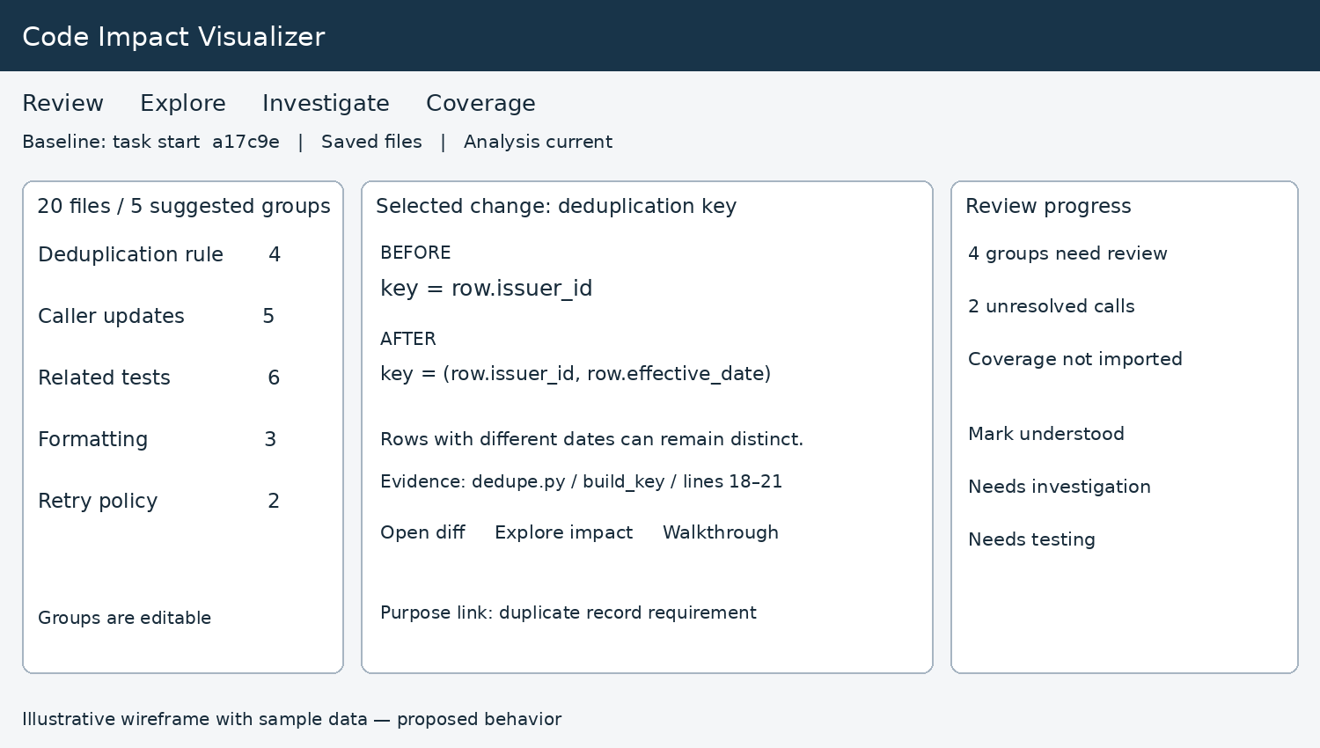
Figure 1. Proposed Review screen. Sample counts total 20 files; real files may participate in more than one group, so the summary must count unique files.

Group by an explainable relationship
Suggest groups from changed symbols, their call relationships, associated tests and paths. State why each file belongs, such as “calls the changed signature”. Allow rename, split and move actions. A group title derived only from code describes an operation; it must not invent business intent.

Keep the selected change readable
The center shows the before and after excerpt, a short factual description, change category and source links. Expand for the full diff. The right side shows review state, unresolved evidence and test status. Formatting can be collapsed but all edits remain discoverable.

Check necessity using the requirement
Let the developer attach a short task description or acceptance criteria. They can link a group to a criterion and note the reason. Show Purpose not linked when no link exists. A dependency can justify a supporting edit; proximity in a folder cannot establish necessity.

Developer action and resulting value
Open diff verifies the edit. Explore impact checks related code. Walkthrough builds an explanation. Mark understood records comprehension only; it does not approve or merge code. Needs investigation and Needs testing retain open questions for later review.

4 Explore impact with evidence
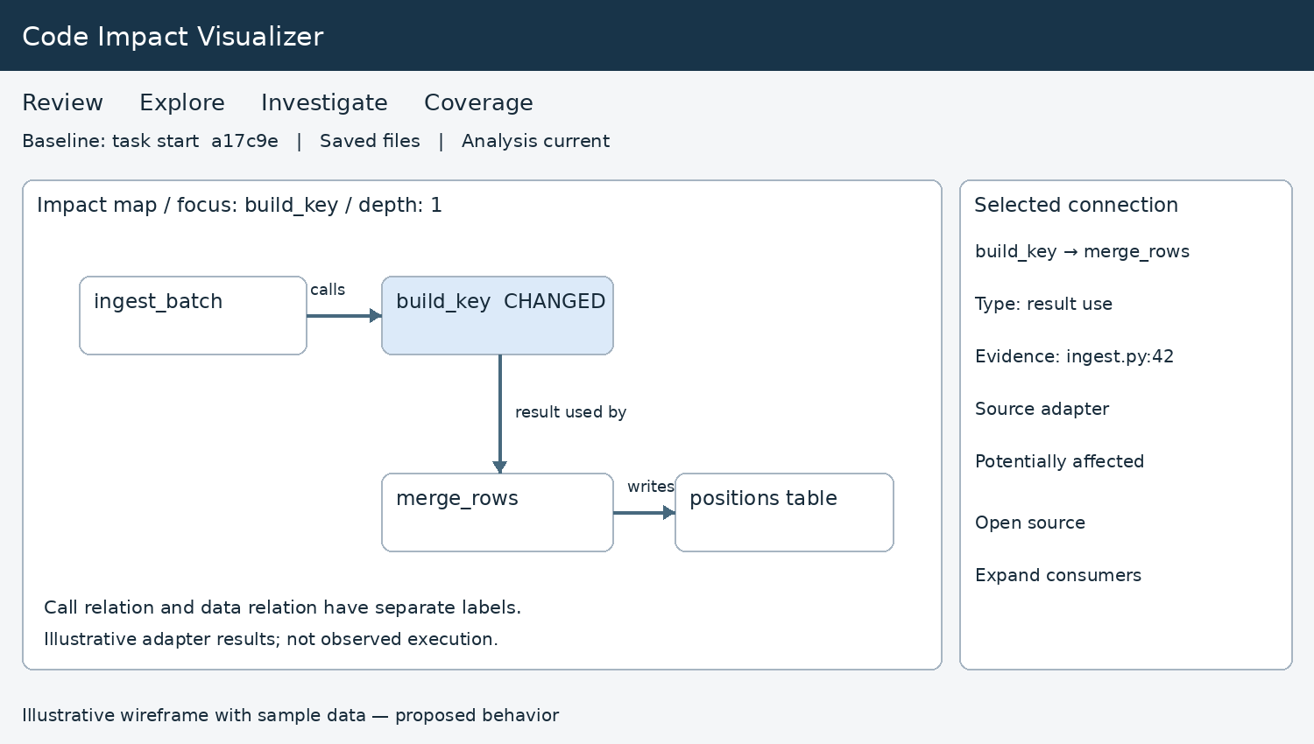
Figure 2. Proposed Explore screen. This example assumes an adapter recognizes the local result use and table write. Without that evidence the UI must omit those edges or show unresolved expressions.

Interaction rules
Click a node to inspect its symbol and change. Click an edge to show its relationship type, source expression, resolver and snapshot. Open source navigates to that exact revision. Expand callers or consumers adds one step. Back restores focus, zoom and expansion state.
Follow tracks the editor selection after a short debounce. Pin preserves the selected symbol when the user opens evidence. Include search, relationship filters, depth controls, fit to view and a keyboard accessible relationship list. Changed, unchanged and removed nodes use labels as well as color.

Show the strength of evidence
Label | What it means
Changed | Confirmed by the selected source comparison
Reference found | Source analysis resolved a relationship
Potentially affected | A supported path suggests something to inspect
Observed in test | Imported run evidence exercised this code or path
Unresolved | The analyzer cannot determine the target reliably
Stale or partial | Source changed or analysis did not cover all paths

Do not show invented confidence percentages. Execution coverage confirms execution in a particular run, not a correct assertion or a complete impact assessment.

5 Guide the developer through the change

A review walkthrough across files
Begin with the task and main edit, then visit affected interfaces, selected callers or consumers and relevant tests. Each step states what to inspect, why it is included and where the evidence lives. Back and Next stay at the top. Developers may skip, revisit and record notes.
This review walkthrough differs from the existing static code walkthrough: the first explains a change across files; the second follows statements and possible branches inside a function. Both use the same source navigation and evidence records.

Worked example with twenty changed files
Step | What the developer sees | Question to answer
1 Main rule | 4 files change the deduplication key to issuer plus date | Does this match the intended duplicate definition?
2 Callers | 5 files pass the required date field | What happens when the date is absent?
3 Tests | 6 files contain related test edits | Do assertions cover same issuer with different dates?
4 Formatting | 3 files contain formatting edits | Should these remain in this change?
5 Retry policy | 2 files change retries without a purpose link | Is this needed for the task?

These groups are illustrative and disjoint for this example. After examining the main rule, the developer expands an unchanged reporting consumer. The tool shows a potential path from altered record identity to the merge and report; actual row count changes require data and execution evidence.

Useful decisions the screen enables
The developer may retain the key change, request a missing date test, investigate the reporting consumer and ask for the retry edits to be separated. Those are human decisions supported by evidence. The extension should not automatically label the whole patch safe or unnecessary.

Carry review progress forward carefully
Store notes and state against a change fingerprint that includes baseline, symbol identity and relevant source hashes. If the code or supporting evidence changes, show Needs re-review for affected decisions. Keep notes for context; do not silently carry forward a completed review.

6 Connect testing and failures to changes

Coverage evidence
Import existing coverage and test results. Record the source revision or hash manifest, run time, environment and tool version where available. Match report paths to workspace paths through explicit mappings. If source identity cannot be verified, show Revision unverified and avoid presenting old coverage as current.
When per-test contexts are available, link a test to executed changed lines. Without contexts, show aggregate line or branch coverage only. A test filename or static reference can suggest a relevant test, but its status remains Suggested rather than Executed.
Condition | UI message | Developer use
No report supplied | Not checked | Choose existing test tooling to run
Matching run missed changed line | No execution evidence for this line | Inspect scenario coverage
Line executed but branch unmeasured | Line executed; branch evidence unavailable | Consider boundary and exception paths
Report from older source | Stale coverage | Rerun against the current source
Relevant test failed | Failed in imported run | Open failure and investigate

Investigate a failure
Parse a pasted traceback into observed frames. Map paths against allowed workspace roots or explicit mappings, and compare against the source version used by the failing run when known. Show direct overlap with changed lines first, then related changes as investigation leads.
A related edit is not a proven cause. A function that already returned may not appear in the traceback. Keep observed frames separate from static paths, and preserve unavailable frame locations without guessing a match.

Other existing review capabilities
Compatibility, quality and security findings enter the same evidence panel through adapters. Each result includes tool and rule identity, source location, scan status and freshness. Missing scanners mean Not checked. The UI can prioritize findings without blocking the developer or silently executing project code.

Developer benefit
The developer can separate a possible impact from an observed failure and determine what additional verification is needed. Neither a green coverage marker nor an empty findings list means the change is correct.

7 Implementation contracts and UI states

Separate collection from presentation
The extension host captures Git and file snapshots. A Python analysis worker parses symbols and produces typed relationships. A coordinator combines change records, imported evidence and review state into a view model. The webview renders only validated models and sends explicit navigation or expansion requests.
Record | Required information
Snapshot | Repository, baseline, comparison mode, file hashes, timestamp, analyzer versions
Symbol | Stable local identity, qualified name, kind, revision, file and source range
Change | Old and new symbols and spans, category, factual description, match method
Relationship | Type, endpoints or unresolved target, evidence span, resolver, snapshot
Evidence | Origin, source or run reference, scope, freshness and limitations
Review decision | Change fingerprint, state, note, timestamp and invalidation reason

Never mix results from different edits
Assign each request a generation ID. Cancel or discard older worker results after a new edit, baseline switch or repository switch. Cache by source hash and analyzer configuration; reanalyze changed files and invalidate affected relationship resolution. Publish a coherent snapshot rather than mixing fresh nodes with stale edges.

Handle partial and failed analysis
Show Indexing, Current, Partial, Stale or Failed in the panel. Keep the last good view visible during refresh, clearly marked stale. Validate edge endpoints and source ranges before layout. Invalid edges are excluded with a diagnostic; empty results get a useful empty state, not a blank canvas.
No Git: offer source exploration. No changes: offer Explore or change the baseline. Syntax error: show text diff and unavailable semantic analysis. Missing language provider: retain supported local analysis. Large graph: show a bounded subset and omitted count. Renamed or deleted files: open revision content rather than an unrelated current line.

Performance and safety boundaries
Use incremental indexing, debounced selection changes and cancellable expansion. Keep source and review notes local by default. Do not import Python modules to inspect them, run tests, execute tour commands or send source externally as a side effect of opening a view. These are separate explicit actions if added later.

8 Delivery sequence and acceptance criteria

Build in useful increments
First deliver a complete vertical workflow: capture one comparison, identify changed symbols, show immediate callers with evidence, open correct diffs and record review state. Next add grouped walkthroughs and graph expansion. Then connect coverage and failure evidence. Add resource adapters only with dedicated fixtures and explicit supported patterns.

Acceptance scenarios
Scenario | Required observable result
Signature changes; caller unchanged | Caller appears with exact call evidence; supported argument mismatch is explained
Function deleted or renamed | Old source remains accessible; inferred rename is labeled
Only whitespace changes | No invented behavior change; original diff remains available
Dynamic call target | Unresolved expression is visible; no fabricated edge
Cycle or missing graph endpoint | Traversal terminates and layout remains usable
Edit arrives during analysis | Old result cannot replace newer snapshot; affected review states are invalidated
Coverage belongs to earlier code | Stale or revision unverified status, never current passed status
Twenty file review | Every changed file is reachable; group totals deduplicate overlaps

Measure whether it helps
Compare ordinary diff review with the extension on matched tasks. Ask developers to explain the main behavior change, identify affected unchanged code, locate evidence and list missing verification. Measure time to a correct explanation, missed known impacts, false impact suggestions and navigation effort. Counterbalance task order and use a human reviewed answer key.
Track unresolved relationships and source navigation correctness by supported pattern. Treat latency budgets as targets to establish on a representative repository, not achieved performance. The release should not claim complete impact coverage based only on a small demonstration.

Completion means evidence is usable
A developer should be able to point to what changed, follow why another symbol appears, identify uncertainty and record a decision without losing context. Each visible claim must remain connected to the source snapshot or imported run that supports it.

9 Design sources and interpretation
The recommendations combine official project documentation, engineering guidance and research reviewed during the preceding discussion. They are design inputs, not proof that the proposed extension is already effective. The existing Code Impact Visualizer Technical Design revision 5 supplies the navigation and local Python scope.

Google Engineering Practices
Review design, functionality, complexity, tests and system context. These principles inform the evidence panel and requirement links.
https://google.github.io/eng-practices/review/reviewer/looking-for.html

Difftastic
Structural diffing informs how to reduce formatting noise. It does not establish business intent or complete behavioral equivalence.
https://github.com/Wilfred/difftastic

Microsoft CodeTour
Source linked steps and Git revision references inform walkthrough navigation and freshness rules.
https://github.com/microsoft/codetour

Pyan
Static Python relationships, caller and callee filtering and graph depth controls inform exploration. Resolution limitations remain explicit.
https://github.com/Technologicat/pyan

Archify
Focused diagrams and source evidence inform the visual presentation. Authored topology is not runtime impact evidence.
https://github.com/tt-a1i/archify

Coverage contexts and test selection
Execution contexts can connect tests and source. Their usefulness depends on collected runs and compatible source versions.
https://coverage.readthedocs.io/en/latest/contexts.html
https://github.com/tarpas/pytest-testmon

Code review research
File position affected detection of one studied defect type. A separate decomposition study found fewer incorrect issue reports, but no increase in detected defects or rationale understanding. These motivate evaluation, not effectiveness claims.
https://arxiv.org/abs/2208.04259
https://arxiv.org/abs/1805.10978

10 UI that makes a large change understandable
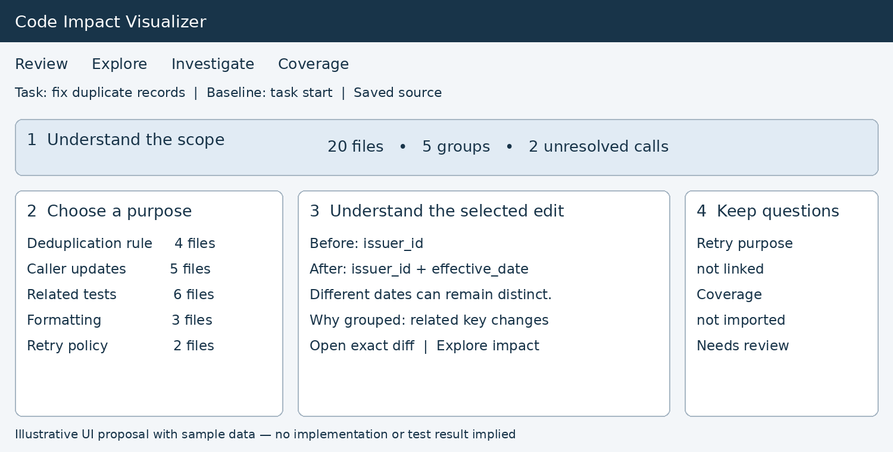
Screen A. The developer starts with the scope and a logical change group. Numbered areas explain the reading order; they are annotations for this document.

Read the change in four small steps
1. Establish the scope. The baseline and saved source label answer “Which changes am I reviewing?” File and unresolved counts stay visible, so a compact summary does not hide incomplete analysis.
2. Choose a purpose. Selecting Deduplication rule brings related edits together. Caller updates and tests remain nearby. The developer can correct a suggested group without losing its source evidence.
3. Compare the behavior. A short before and after description gives the developer a starting point. Open exact diff exposes the implementation. Wording remains factual when business intent is unknown.
4. Keep open questions visible. Purpose not linked and Coverage not imported invite specific follow-up. They do not turn into a blanket failure or safety verdict.

How this reduces effort
The developer starts with one understandable change and can move directly to its evidence. The full file list remains one click away. Reviewing one group does not automatically mark its shared files or other groups complete.

11 UI that explains why code may be affected
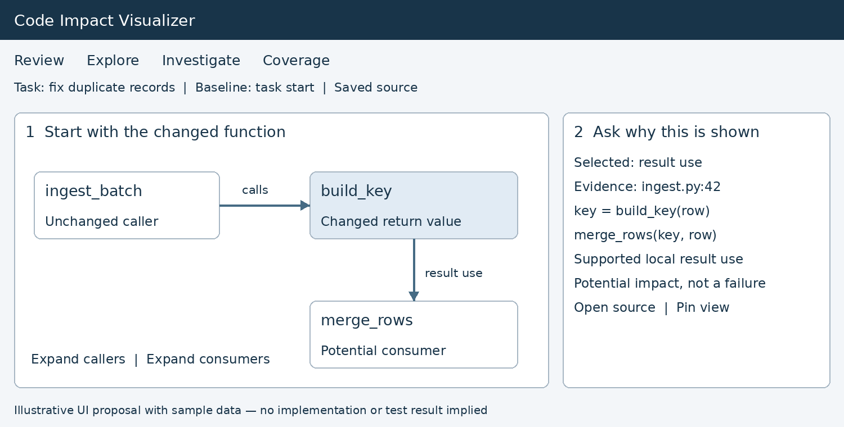
Screen B. A focused map and an evidence panel work together. The result use shown here assumes supported source analysis; it is not an observed execution trace.

Make every connection explain itself
1. Start small. Show the changed function, an unchanged caller and a supported result consumer. Changed and unchanged labels supplement color. Expand one relationship at a time to preserve context.
2. Inspect the reason. Selecting a connection opens the exact expression, file location and relationship type. The developer can distinguish a call from result use and inspect the code before accepting the impact suggestion.

Keep navigation predictable
Open source goes to the snapshot used by the analysis. Pin keeps the graph focused while the developer reads another file. Back restores the previous focus and expanded nodes. Keyboard navigation and a relationship list expose the same evidence without requiring graph interaction.

How this helps the developer decide
The developer can answer “Why is this unchanged file included?” and “Which path should I investigate?” A distant dependency is not automatically a high risk. Unresolved calls and hidden node counts stay visible, and potential impact remains distinct from a confirmed failure.

When the map becomes large
Group by module, retain the selected path and offer Show more with an omitted count. Keep unresolved items in a separate list. Use explicit Callers, Callees and Data consumers controls rather than an ambiguous upstream or downstream switch.

12 UI that guides understanding step by step
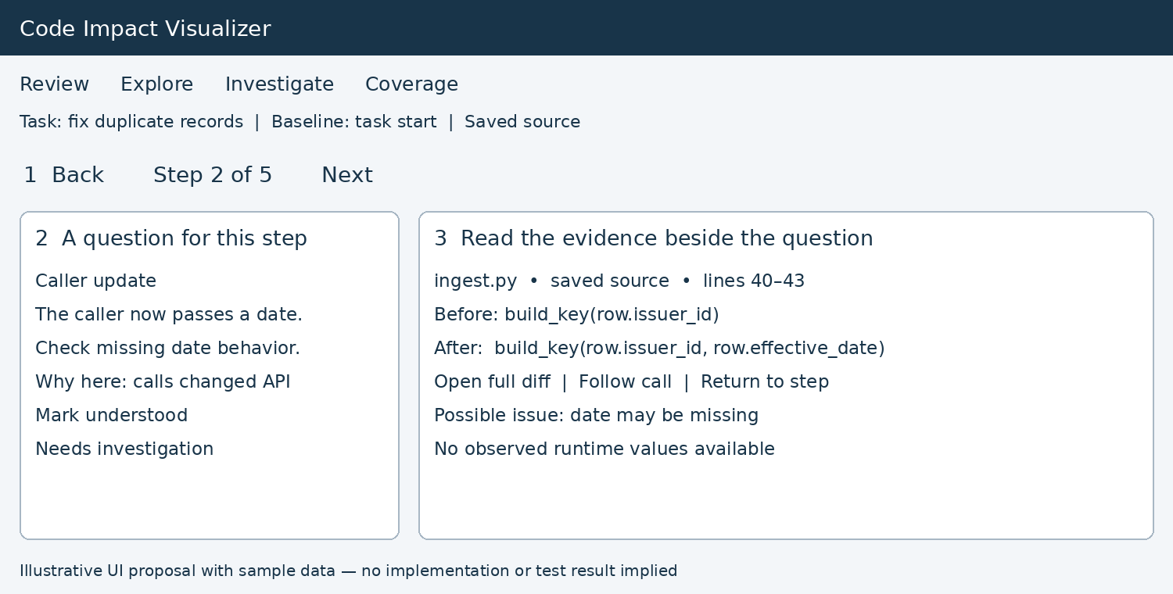
Screen C. The walkthrough keeps a review question beside the exact before and after code. Steps can span multiple files.

Turn navigation into a guided explanation
1. Back and Next stay at the top. Step position makes progress visible. A developer may open a dependency and return without losing the walkthrough position.
2. Each step has a reason and a question. Here the caller appears because a signature changed, and the review question is how a missing date behaves. The question is an investigation prompt, not a detected bug.
3. Evidence stays alongside the explanation. The source excerpt, file, revision and full diff are available together. A static walkthrough shows symbolic values and possible branches; actual values require separate runtime evidence.

Example route through the twenty file change
Begin with the deduplication rule, inspect the required caller updates, explore an unchanged consumer, examine relevant tests, and finish with edits whose purpose remains unlinked. Suggested ordering is editable; skipping a step leaves it unreviewed.

How this helps the developer
The developer can explain the change to a reviewer using the same sequence they followed to understand it. Mark understood records comprehension. Needs investigation records uncertainty. Neither action approves, merges or modifies the code.

13 UI that preserves decisions and open questions
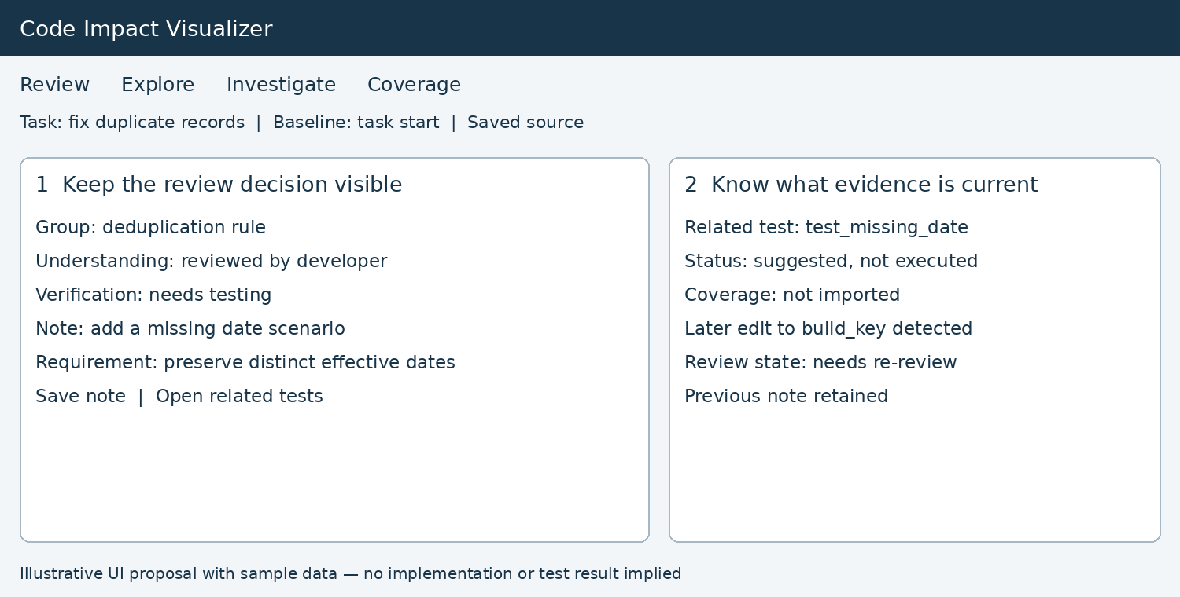
Screen D. Understanding and verification have separate states. A later edit can invalidate review evidence while preserving the developer’s note.

Separate understanding from verification
1. Keep the developer’s decision and reason together. The developer may understand the change while still needing a missing date test. Requirement links help them evaluate necessity; an unlinked edit remains a question rather than an automatic rejection.
2. Label the test evidence precisely. Suggested means a test appears relevant. Executed requires a matching imported run. Passed describes that run, not the entire change. Missing or stale coverage remains explicit.

Make later edits visible
When AI or a person edits the relevant code again, change the affected review state to Needs re-review and show what changed since the decision. Preserve the note. Recompute the impact paths against a consistent snapshot and discard older analysis results.

UI acceptance checks
Evaluate these screens with real developers against ordinary diff review. Measure correct explanations, missed impacts, misleading suggestions and time spent finding evidence. The wireframes describe the intended experience; usefulness still requires validation.

