Cascaded Convolutional Neural Network for Solar Panel Defect Classification
Project Report
Divyamshi Jain | Syed Mohammad Ghouse | Purvee Singh
RA2311026010639 | RA2311026010643 | RA2311026010645
Department of Computer Science and Engineering

Abstract: Automated inspection of large photovoltaic (PV) installations is essential for sustained power output and safety. This report presents Cascaded-SolarNet, a three-stage cascade of five small convolutional neural networks that classifies the 12 classes of the InfraredSolarModules benchmark from single-modality infrared (IR) images: a binary triage stage with early exit for healthy panels, a fault-family stage and one fine-grained specialist per family. We implemented the system in PyTorch and evaluated it on a fixed stratified held-out split. Removing brightness and noise augmentation, which destroys the temperature signal in thermal images, raised the from-scratch cascade from 61.7% to 79.8% accuracy; fine-tuning an ImageNet-pretrained EfficientNet-B0 at every stage reached 83.2% accuracy, macro-F1 0.700 and 95.8% on the healthy-versus-defect decision. A flat classifier with the same backbone is essentially tied (82.6%), so the cascade did not show a clear accuracy advantage, and the family-routing stage remains the largest source of errors. Published 12-class results of up to 93.9% use cross-validation and pretrained features and are not directly comparable with our fixed hold-out; we report the comparison and its limits.

1. Introduction

1.1 Problem Statement
Solar farms contain thousands of PV modules that develop defects over time, including hotspots, cracks, soiling, shadowing and diode failures. Each of these reduces power output, and some, such as undetected hotspots, create a fire risk. Manual thermal inspection is slow, expensive, labour-intensive and error-prone, and it cannot scale to utility-grade installations. Deep learning applied to drone-captured IR imagery offers an automated and scalable alternative, because a trained classifier can label a panel in milliseconds.
Most existing CNN approaches use a flat, single-stage classifier that must choose directly among all classes. This design has two weaknesses. First, visually similar fault types produce overlapping features, so the network confuses them. Second, healthy panels vastly outnumber faulty ones, which biases the network towards the majority class and hurts the rare faults. Across the 84 studies reviewed, accuracy drops from about 73% for binary classification to about 68% for multi-class classification, and the best single-stage baseline on InfraredSolarModules (EfficientNet with an SVM) stops at 93% while still misclassifying rare fault subtypes. These are structural limits of the flat design rather than tuning problems.
This project therefore proposes a three-stage cascaded CNN. Stage 1 separates normal from anomalous panels, Stage 2 groups anomalous panels into fault families, and Stage 3 identifies the exact defect subtype. The aim was to improve on flat classifiers by restructuring the class decision space rather than by scaling up the model; Section 6 reports what was achieved.

1.2 Research Gaps
The literature survey identified the following gaps in existing work.
G1. Dual-sensor approaches are impractical. Models reaching 98-99% accuracy rely on paired thermal and visual data, which a single-camera drone cannot supply (for example B-CNN).
G2. Scaling the model gives negligible gains. Heavier backbones add little accuracy over lightweight ones (for example PV-faultNet).
G3. Bounding-box detectors split thin defects. Detection models mislocalise fine crack boundaries (for example Cascade R-CNN).
G4. Naive cascades add latency. Detection-plus-classification pipelines are too slow for real-time drone use (for example Faster R-CNN with EfficientNet).
G5. Accuracy drops as the number of classes grows. Roughly 73% for binary classification against 68% for multi-class.
G6. Similar defect types are systematically confused. Intra-family confusion persists in flat classifiers.

1.3 Contributions
C1. A hierarchical three-stage cascade in place of a flat 12-class classifier.
C2. An early-exit binary front end that removes the dominant No-Anomaly class before any fine-grained processing.
C3. A systematically motivated fault-family grouping (Electrical, Environmental, Structural) applied before fine classification.
C4. A single-modality design that uses only single-camera IR thermal images (24 x 40 px).
C5. A pure classification pipeline that eliminates localisation and bounding-box failure modes.

2. Literature Survey
Table 1 summarises the nine studies reviewed. The detailed discussion of each work is given in the separate literature survey document.
Table 1. Summary of reviewed studies.
# | Study | Approach | Key result | Limitation
1 | Enhanced Fault Identification via Binary Cascaded CNN with Thermal-Visual Augmentation. Pathak and Patil, IJIGSP 17(4), 2025. | Cascade with thermal-visual fusion | 99.8% precision, 98.5% accuracy | Needs paired thermal and visual data
2 | PV-faultNet: Optimized CNN to Detect Defects in PV Production. arXiv:2411.02997, 2024. | Lightweight CNN vs. Siamese / multi-spectral | 93% accuracy at 8 ms per image | Heavier backbones gain little accuracy
3 | Defect Detection of PV Modules Based on Improved VarifocalNet. Scientific Reports 14, 2024. | Cascade R-CNN and YOLOv7 comparison | High coarse detection confidence | Mislocalises fine crack boundaries
4 | Segmentation of Cell-Level Anomalies in EL Images of PV Modules. Otamendi et al., Solar Energy 220, 2021. | Faster R-CNN + EfficientNet pipeline | High overall precision | Too slow for real-time drone use
5 | Field-Adapted ResNet-50 for PV Defect Detection via Transfer Learning. | Transfer learning with 8x augmentation | 98.59% accuracy on field data | High resource demand
6 | PV Panel Defect Classification Using Deep Learning Ensemble Methods. Tella et al., Case Studies in Thermal Eng. 66, 2025. | 8 CNNs / ViTs on ELPV benchmark | ~68% multi-class vs. 73% binary | Large drop from binary to multi-class
7 | CNN-Based Classification of Solar Panel Defects on RGB Images. | 4-class: normal / cracked / dusty / shadowed | Coarse classes only | No fine-grained subtypes tested
8 | CNN + Bacterial Foraging Optimization for PV Defect Detection. | 5 pretrained CNNs + BFO feature selection | VGG-16 + BFO: 98.75% accuracy | Extra tuning overhead
9 | Infrared Solar Module Dataset for Anomaly Detection. Millendorf et al., ICLR 2020 Workshop. | Random Forest, EfficientNet+SVM, custom CNN | RF 84%, CNN 92.5%, EffNet+SVM 93% | Single-stage accuracy plateau

Four conclusions follow from the survey. Cascaded and staged models consistently outperform flat single-stage classifiers. High-accuracy models (98-99%) require dual-sensor input and are therefore impractical for single-camera UAVs. Lightweight single-modality models cap at roughly 93% accuracy. Finally, multi-class fault detection remains difficult across all reviewed architectures.

3. Dataset Description
The experiments use the InfraredSolarModules dataset released by Raptor Maps (Millendorf et al., ICLR 2020) on GitHub under a CC BY 4.0 licence. It contains 20,000 infrared images of 24 x 40 pixels each (24 wide, 40 tall), captured from real drone flights over commercial solar installations. There are 12 classes: 11 anomaly types and one No-Anomaly class. The anomaly types are Cell, Cell-Multi, Diode, Diode-Multi, Hot-Spot, Hot-Spot-Multi, Soiling, Shadowing, Vegetation, Cracking and Offline-Module.
The dataset is strongly imbalanced: half of the images (10,000) are No-Anomaly, while the rarest classes have only 175 to 251 images (Diode-Multi 175, Soiling 205, Hot-Spot-Multi 247, Hot-Spot 251), which causes majority-class bias in flat models. The images are very small because of the altitude of capture, so the task depends mainly on recognising temperature-pattern signatures rather than fine structural detail. The dataset paper itself reports no model accuracies; the published results we compare with in Section 6.6 come from later papers.

4. Proposed Architecture: Cascaded-SolarNet

4.1 Overview
Cascaded-SolarNet replaces one large 12-way classifier with five small specialist CNNs arranged in three stages (Figure 1). The principle is divide and conquer: instead of asking one network to separate twelve classes at once, each network answers one small, well-defined question, and the answer of one stage decides which network runs next. A healthy panel passes through only one network. A defective panel passes through exactly three: CNN-1, CNN-2 and one of the three Stage 3 specialists.
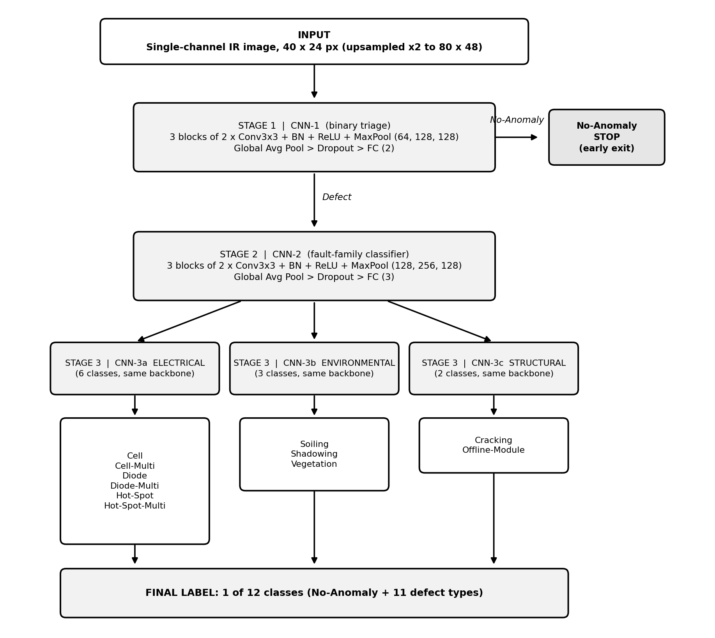
Figure 1. The implemented 3-stage Cascaded-SolarNet architecture (class names are the real dataset labels).
The following subsections explain every element of Figure 1 in the order in which an image flows through it.

4.2 Input: single-channel IR image, 24 x 40 pixels
The input is a single-channel (grayscale) thermal image of one PV module. In an IR image, brightness encodes temperature. A healthy module heats fairly uniformly during operation, whereas a defect produces a localised temperature anomaly: a hot spot, a cold region, or a characteristic thermal pattern. At 24 x 40 pixels there is almost no fine texture to exploit, so the network has to recognise where heat is concentrated, how large the region is and what shape it takes. This is why small CNNs trained from scratch already work reasonably; an ImageNet-pretrained backbone still helped further (Section 6).
Preprocessing. Pixel values are scaled to [0, 1] and normalised with the mean and standard deviation of the training split only. In the from-scratch networks the image is upsampled by a factor of two (bilinear) to 80 x 48 so that the small defects survive three pooling steps; the pretrained networks resize the image to 160 x 96 and repeat the channel three times to match their ImageNet input. During training only random horizontal and vertical flips are applied. Brightness, contrast and noise jitter were tested and removed because they lowered accuracy (Section 6.3).
Only one sensor is used. Approaches that fuse thermal and visual images need two cameras and an alignment step, which is impractical on a single-camera drone. Using single-modality IR input is therefore a deliberate design choice (contribution C4).

4.3 The building blocks used in every network
All five networks are assembled from the same small set of layers. Their roles are explained once here and then referred to in the stage descriptions.
Table 2. Layers used in Cascaded-SolarNet.
Layer | What it does | Why it is used here
Conv2D (n) | Slides n learnable small filters (typically 3 x 3) over the image. Each filter produces a feature map that responds to one pattern, such as a bright blob or an edge. Output has n channels. | Extracts local thermal patterns. Stacking layers lets later layers combine simple patterns into larger, more meaningful ones.
BatchNorm | Normalises the activations of each channel across the mini-batch to zero mean and unit variance, then rescales them with learnable parameters. | Stabilises and speeds up training and reduces sensitivity to weight initialisation, which matters for small networks trained on imbalanced data.
ReLU | Applies f(x) = max(0, x) to every value. | Introduces the non-linearity that lets the network learn complex decision boundaries, and is cheap to compute.
MaxPool (2) | Keeps the maximum of each 2 x 2 window, halving height and width. | Reduces computation and gives tolerance to small shifts in where the heat pattern sits in the image.
Dropout | Randomly sets a fraction of activations to zero during training only. | Acts as a regulariser against overfitting, which is a real risk with small and imbalanced classes.
Flatten | Reshapes the feature maps into a single vector. | Prepares the features for the fully connected layer.
Global Pooling | Averages each feature map to a single number. | Compresses the features into one value per channel, which keeps the final layer small and further reduces overfitting.
FC (k) | Fully connected layer with k outputs, followed by softmax during training to give class probabilities. | Converts the learned features into the k class scores; the highest score is the prediction.

4.4 Stage 1: CNN-1, binary triage
Question answered. Is this panel healthy (No-Anomaly) or defective?
Layers (implemented). Three blocks, each with two 3 x 3 convolutions (BatchNorm and ReLU after each) followed by 2 x 2 max pooling, with 64, 128 and 128 channels, then global average pooling, dropout (0.2) and a fully connected layer with 2 outputs. In the pretrained variant this network is an ImageNet-pretrained EfficientNet-B0 with a new two-way head.
How it works. Each block learns richer thermal patterns than the one before (64, then 128, then 128 feature maps). BatchNorm and ReLU normalise and activate the features, and MaxPool halves the spatial size, so the 80 x 48 input becomes 64 x 40 x 24, 128 x 20 x 12 and finally 128 x 10 x 6. Global average pooling summarises each of the 128 maps into one value and the final fully connected layer scores the two classes. Figure 2 shows the layers.
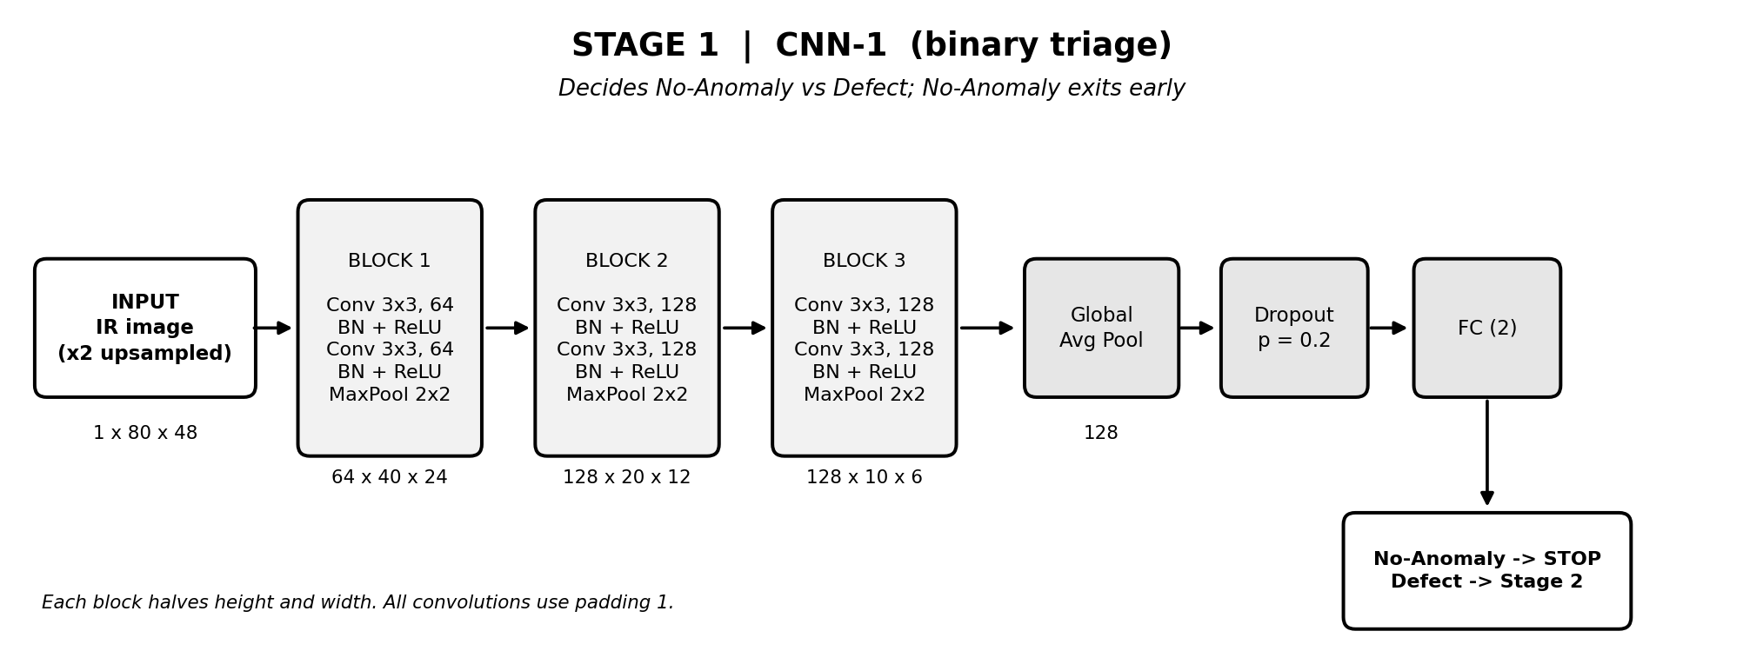
Figure 2. Stage 1: CNN-1, binary triage (layer by layer, with feature-map sizes).
The two branches leaving Stage 1.
Healthy branch (arrow to the No-Anomaly box). If the prediction is No-Anomaly the pipeline outputs that label and stops. This is the early exit. Because healthy panels are the large majority, most images cost only one small network, which is the main source of the cascade's speed advantage.
Defect branch (arrow labelled defect). Any panel classified as defective moves on to Stage 2.
Why this stage exists. It removes the dominant class first. Every later network then trains and runs only on defective panels, so none of them is dominated by the healthy majority. This addresses class imbalance by structure instead of relying only on loss re-weighting. Stage 1 is also the easiest decision in the system, which is important because a mistake here (a defective panel declared healthy) cannot be recovered by later stages.

4.5 Stage 2: CNN-2, fault-family classifier
Question answered. Given that the panel is defective, which broad family does the fault belong to: Electrical, Environmental or Structural?
Layers (implemented). The same three-block design with 128, 256 and 128 channels, global average pooling, dropout (0.4) and a fully connected layer with 3 outputs (EfficientNet-B0 with a three-way head in the pretrained variant).
How it works. CNN-2 is wider than CNN-1 because separating fault families is harder than separating healthy from faulty. The 128-256-128 channel pattern expands the feature set in the middle block to capture a richer variety of thermal patterns and then compresses it again before classification. Dropout is added because this network is trained on a smaller, defect-only dataset and is more prone to overfitting. The three output scores correspond to the three families, and the highest decides the route (Figure 3).
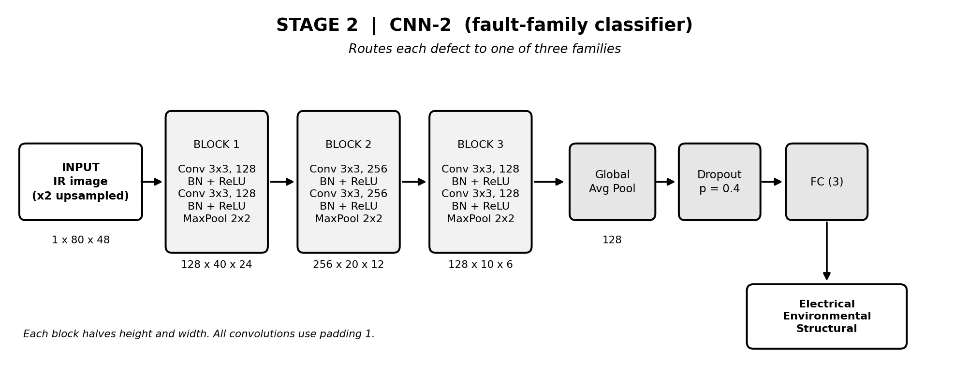
Figure 3. Stage 2: CNN-2, fault-family classifier.
Table 3. The three fault families.
Family | Nature of the faults | Thermal behaviour in IR
Electrical | Faults in cells or diodes that change how current flows: Cell, Cell-Multi, Diode, Diode-Multi, Hot-Spot, Hot-Spot-Multi. | Typically compact, sharply defined warm regions caused by locally dissipated power.
Environmental | External conditions on or around the panel: Soiling, Shadowing, Vegetation. | Often broader or irregular temperature patterns that follow the shape of the obstruction or deposit.
Structural | Physical state of the module: Cracking, Offline-Module. | Patterns that follow the geometry of the damage, such as lines or whole-cell regions.

Why this stage exists. It is the routing layer of the cascade. Faults that share a family look similar to each other and different from faults in other families, so a three-way decision is much easier than an eleven-way one. It also guarantees that the confusable subtypes inside a family are only ever compared against each other, by a network built for that purpose.
The three arrows leaving Stage 2. Each arrow carries the same image to one of three specialists. Only one arrow is followed for any given panel; the other two specialists stay idle, so the cost of having three specialists is not paid at inference time.

4.6 Stage 3: CNN-3a, CNN-3b and CNN-3c, fine-grained specialists
Question answered. Within the family chosen by Stage 2, which exact defect is it?
Layers (implemented, identical for all three). The same 128-256-128 three-block design with global average pooling, dropout (0.4) and a fully connected layer with as many outputs as the family has classes.
How it works. The Stage 3 networks make the finest distinctions. Global average pooling summarises each map into one value, which keeps the final FC layer small and helps against overfitting on the few examples available for rare faults. The three networks share the same design but are trained separately and have different output sizes, so each learns features specific to its own family (Figure 4).
CNN-3a, Electrical (6 classes). Outputs Cell, Cell-Multi, Diode, Diode-Multi, Hot-Spot or Hot-Spot-Multi. Cell is a hot spot with square geometry in a single cell, Cell-Multi the same in several cells, Diode an activated bypass diode (typically one third of the module), Diode-Multi several activated diodes, and Hot-Spot and Hot-Spot-Multi hot spots on thin-film modules.
CNN-3b, Environmental (3 classes). Outputs Soiling, Shadowing or Vegetation: dirt, dust or debris on the module, sunlight blocked by nearby objects, and panels covered by vegetation. The specialist separates them by the spatial layout of the temperature pattern.
CNN-3c, Structural (2 classes). Outputs Cracking or Offline-Module (the entire module is heated). The dataset has no further structural classes, so the poster's finer categories (delamination, ribbon, water stain and so on) are not used.
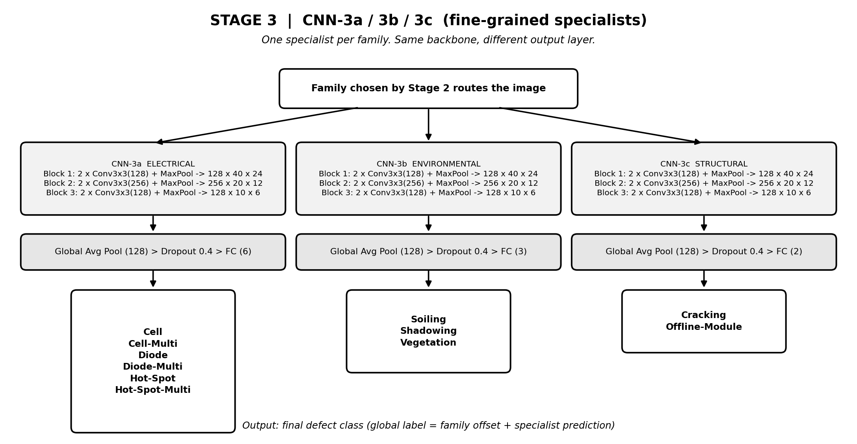
Figure 4. Stage 3: the three fine-grained specialists and their classes.
Why this stage exists. A flat classifier must spend its capacity separating, for example, a soiling pattern from a broken cell, a distinction that is easy and wastes capacity. A specialist only needs to separate two to six related classes and can spend all its capacity on the subtle differences between them. Stage 3 also performs whole-image classification: it labels the entire module image and does not draw bounding boxes, so thin defects such as cracks are not fragmented by a detector.

4.7 Output: final label
The prediction of the active specialist becomes the final output. Combined with the early-exit No-Anomaly label from Stage 1, the system can output any of the 12 classes: one healthy class plus the 11 defect types. The class hierarchy summarises this: Stage 1 separates 2 classes, Stage 2 splits the defect branch into 3 families, and Stage 3 resolves each family into its subtypes.
Table 4 consolidates the architecture of all five networks (from-scratch variant). In the pretrained variant each network is replaced by an ImageNet-pretrained EfficientNet-B0 fine-tuned with a new classification head.
Table 4. Architecture summary of Cascaded-SolarNet.
Network | Stage | Input | Layers | Output
CNN-1 | 1: Binary triage | 40 x 24 IR image (upsampled to 80 x 48) | 3 blocks of 2 x (Conv3x3, BatchNorm, ReLU) + MaxPool, 64-128-128; GAP, Dropout 0.2, FC | 2 classes: No-Anomaly / Defect
CNN-2 | 2: Fault family | Defective image | Same, 128-256-128; GAP, Dropout 0.4, FC | 3 classes: Electrical / Environmental / Structural
CNN-3a | 3: Electrical | Image routed as Electrical | Same as CNN-2, FC with 6 outputs | 6 classes: Cell, Cell-Multi, Diode, Diode-Multi, Hot-Spot, Hot-Spot-Multi
CNN-3b | 3: Environmental | Image routed as Environmental | Same as CNN-2, FC with 3 outputs | 3 classes: Soiling, Shadowing, Vegetation
CNN-3c | 3: Structural | Image routed as Structural | Same as CNN-2, FC with 2 outputs | 2 classes: Cracking, Offline-Module

4.8 End-to-end inference procedure
1. Feed the 24 x 40 IR image (preprocessed as in Section 4.2) to CNN-1.
2. If CNN-1 predicts No-Anomaly, output No-Anomaly and stop.
3. Otherwise feed the image to CNN-2 and read off the fault family.
4. Send the image to the specialist for that family (CNN-3a, CNN-3b or CNN-3c).
5. Output the specialist's predicted subtype as the final label.
The average cost per image is therefore a weighted mix of one network for healthy panels and three networks for defective ones. When healthy panels dominate, as they do in this dataset, the average is close to the cost of a single small CNN.

4.9 Training strategy
Each of the five networks is trained independently on the data that matches its task, using only the training split (70% of the images, stratified by class). CNN-1 is trained on all images with a binary label (No-Anomaly against any defect). CNN-2 is trained on defect images only, labelled with their fault family. Each Stage 3 specialist is trained only on the defect images of its own family, labelled with the exact subtype. Training uses Adam (learning rate 5e-4 for the from-scratch networks and 3e-4 for the pretrained ones, weight decay 1e-4), a class-weighted cross-entropy loss with weights N / (K x n) to counter imbalance, and early stopping on validation macro-F1 (patience 25 from scratch, 6 for the pretrained networks). The pretrained variant uses mixed-precision training. All networks are implemented in PyTorch; the code, configurations and results are at github.com/techwack/cascaded-cnn.

4.10 Why a cascade can outperform a flat classifier, and what we measured
There are four reasons. First, smaller decision spaces: two-way, three-way and three-to-five-way decisions replace a single twelve-way decision, so look-alike classes are separated by networks trained for that purpose. Second, imbalance is handled by design, because the majority class is removed at Stage 1. Third, efficiency: early exit saves computation on most panels and every network is small enough for edge hardware. Fourth, practicality: single-modality IR input and the absence of a localisation step make the system deployable on a single-camera drone.
The main trade-off is error propagation. If Stage 2 routes a defect to the wrong family, the Stage 3 specialist cannot correct it, so overall accuracy is approximately the product of the accuracies of the stages the image passes through. The cascade therefore only beats a flat classifier if Stages 1 and 2 are highly accurate, which is why they are deliberately given the easiest tasks (a binary decision and a three-way decision). Section 6 reports how large these effects were in practice.

4.11 Architecture rationale
Each design decision in Figure 1 answers a specific weakness identified in the literature (Section 1.2).
• Single IR input. Optimal for single-modality drones and avoids expensive sensor fusion (answers gap G1).
• Five specialised CNNs. Lightweight per-stage specialists replace one heavy model, because scaling a single model gives negligible gains (G2).
• Whole-image classification. Eliminates the bounding-box fragmentation seen with thin defects such as cracks (G3).
• Early exit and lightweight stages. Keeps latency low enough for real-time drone edge use and avoids the delay of naive cascades (G4).
• Hierarchical routing. Counters the accuracy drop that comes with a growing class count by decomposing the problem (G5), and keeps look-alike faults inside one family-specific network (G6).

5. Experimental Setup
Table 5. Experimental setup.
Item | Details
Dataset | InfraredSolarModules benchmark (Raptor Maps): 20,000 IR images, 12 classes (1 healthy, 11 faults), 24 x 40 px
Task | Real-time, fine-grained PV module defect classification on drone edge hardware
Data split | Stratified 70/15/15 (14,000 train / 3,000 validation / 3,000 test images), seed 42, identical for all models
Evaluation metrics | Accuracy, macro-F1, Cohen's kappa, healthy-versus-defect accuracy of Stage 1, per-stage error counts
Baselines | Flat CNN (same building blocks, and with the pretrained backbone), raw-pixel Random Forest, EfficientNet-B0 features + SVM; published results as cited
Implementation | PyTorch; Adam; class-weighted loss; early stopping on validation macro-F1; flips-only augmentation; mixed precision for the pretrained networks

Macro-F1 is included alongside accuracy because it weights every class equally and so exposes poor performance on rare faults, which accuracy alone would hide under class imbalance. Cohen's kappa measures agreement beyond chance and is similarly robust to imbalance. Per-stage error counts attribute every mistake of the cascade to the first stage that went wrong. The test split is used only for the final numbers; early stopping and all tuning use the validation split.

6. Results and Discussion

6.1 Evaluation protocol
All numbers are measured on the same held-out test split of 3,000 images (stratified 70/15/15, seed 42) and are single runs per configuration. The test images are never used for training, early stopping, normalisation or model selection. We compare the following configurations: a from-scratch cascade in several refinements, a cascade whose five networks are ImageNet-pretrained EfficientNet-B0 models fine-tuned at each stage, and flat 12-class baselines.

6.2 Results
The best result is the pretrained cascade: 83.2% accuracy, macro-F1 0.700 and Cohen's kappa 0.764 on the 12-class problem, and 95.8% on the Stage 1 healthy-versus-defect decision. The best cascade trained from scratch reaches 79.8% accuracy (data-driven families) or 79.6% with the semantic families.
Table 6. Test results by configuration.
Configuration | Model | Accuracy | Macro-F1 | Kappa | Stage 1 binary
Default (brightness/contrast/noise jitter) | Cascade | 61.7% | 0.368 | 0.461 | 81.0%
 | Flat CNN (same split) | 47.6% | 0.379 | 0.357 | n/a
No photometric jitter (flips only) | Cascade | 71.1% | 0.509 | 0.583 | 86.0%
 | Flat CNN (same split) | 68.5% | 0.571 | 0.586 | n/a
Improved: 80x48 input, 2 convs per block | Cascade | 76.0% | 0.582 | 0.656 | 89.5%
 | Flat CNN (same split) | 76.8% | 0.653 | 0.689 | n/a
Improved2: + balanced sampling, label smoothing | Cascade | 75.5% | 0.576 | 0.648 | 89.1%
Improved3: + larger Stage 1/2 CNNs | Cascade | 79.6% | 0.638 | 0.714 | 93.8%
Data-driven family grouping | Cascade | 79.8% | 0.646 | 0.717 | 94.1%
Pretrained: ImageNet EfficientNet-B0 at every stage | Cascade | 83.2% | 0.700 | 0.764 | 95.8%
 | Flat CNN (same split) | 82.6% | 0.708 | 0.761 | n/a
Raw-pixel Random Forest | RF | 61.6% | 0.337 | 0.324 | n/a
EfficientNet-B0 features + SVM (Duranay-style) | SVM | 78.7% | 0.640 | 0.689 | 90.4%

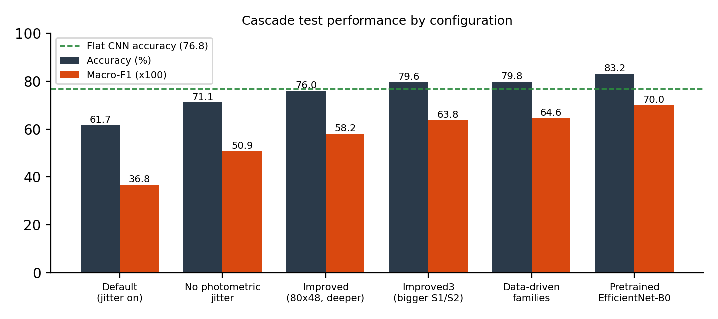
Figure 5. Cascade test accuracy and macro-F1 by configuration (dashed line: from-scratch flat CNN).

6.3 Main findings
• Brightness and noise jitter hurt. Brightness, contrast and noise augmentation lowered cascade accuracy to 61.7%; flips only gave 71.1%. In thermal images brightness is temperature, so jittering it removes the signal that separates the classes.
• Input size and capacity helped. Upsampling to 80 x 48 and using two convolutions per block raised accuracy to 76.0%; enlarging the Stage 1 and Stage 2 networks raised it to 79.6%, and Stage 1 binary accuracy from 89.5% to 93.8%.
• ImageNet pretraining helped most late in the project. Fine-tuning a pretrained EfficientNet-B0 at every stage raised the cascade from 79.8% to 83.2% accuracy (macro-F1 0.646 to 0.700), and training took minutes instead of an hour.
• The cascade and a flat classifier are essentially tied. With the pretrained backbone the cascade scores 83.2% / 0.700 / 0.764 (accuracy, macro-F1, kappa) and the flat CNN 82.6% / 0.708 / 0.761. The cascade has about 20 million parameters (five EfficientNets) against 4 million for the flat model, so we did not measure an accuracy or efficiency benefit. From scratch the cascade was ahead on accuracy and kappa but not on macro-F1.
• Tried without gain: soft routing (multiplying stage probabilities), flip test-time augmentation, tuning the Stage 1 threshold on validation data (the optimum stayed at 0.5) and balanced sampling with label smoothing.

6.4 Where the cascade makes its errors
Because the cascade routes each image through several networks, every mistake can be attributed to the first stage that went wrong. Table 7 gives the counts out of 3,000 test images.
Table 7. Error attribution (test errors per stage).
Configuration | Stage 1 missed defect | Stage 1 false alarm | Stage 2 wrong family | Stage 3 wrong subtype | Total
Improved (from scratch) | 233 | 83 | 294 | 109 | 719
Improved3 (from scratch) | 108 | 79 | 300 | 126 | 613
Data-driven families (from scratch) | 110 | 66 | 116 | 313 | 605
Pretrained | 75 | 52 | 272 | 106 | 505

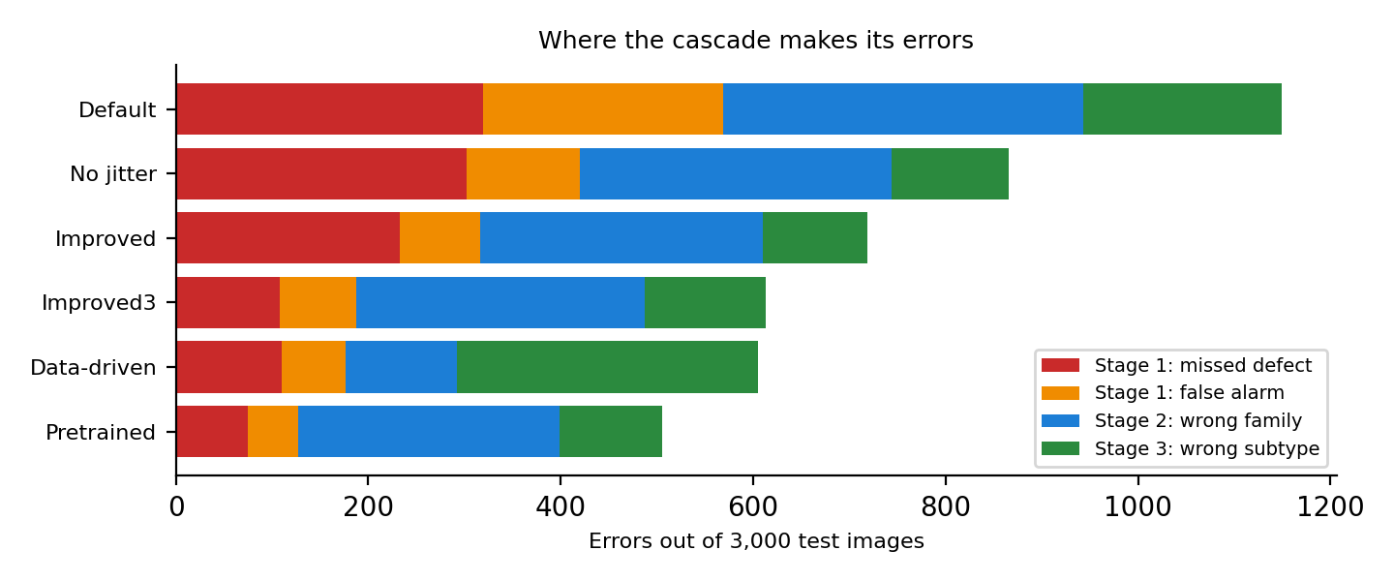
Figure 6. Where the cascade makes its errors, by configuration.
Pretraining reduced errors at every stage compared with the from-scratch 'improved3' cascade (total 613 to 505), but Stage 2, the family decision, remains the largest source (272 of 505 errors) and an error there cannot be corrected by Stage 3. Re-grouping the classes by their measured confusions cut Stage 2 errors from 300 to 116 but moved the difficulty into Stage 3 (126 to 313 errors), so the net accuracy changed little. About 50.8% of the test images leave the cascade at Stage 1.

6.5 Per-class performance
The rare classes are the weak point. They have only 123 to 174 training images and several look alike (Cell versus Cell-Multi, Hot-Spot versus Cell). Class weighting, stratified splitting and macro-F1 reduce but do not remove this problem.
Table 8. Per-class F1 on the test set.
Class | Test images | Cascade, from scratch (improved3) | Cascade, pretrained | Flat CNN, pretrained
No-Anomaly | 1500 | 0.94 | 0.96 | 0.94
Cell | 281 | 0.63 | 0.69 | 0.69
Cell-Multi | 193 | 0.47 | 0.52 | 0.49
Diode | 225 | 0.93 | 0.96 | 0.96
Diode-Multi | 26 | 0.82 | 0.87 | 0.91
Hot-Spot | 37 | 0.54 | 0.65 | 0.62
Hot-Spot-Multi | 37 | 0.57 | 0.65 | 0.62
Soiling | 31 | 0.22 | 0.30 | 0.35
Shadowing | 159 | 0.67 | 0.72 | 0.74
Vegetation | 246 | 0.65 | 0.65 | 0.71
Cracking | 141 | 0.65 | 0.70 | 0.75
Offline-Module | 124 | 0.59 | 0.74 | 0.71

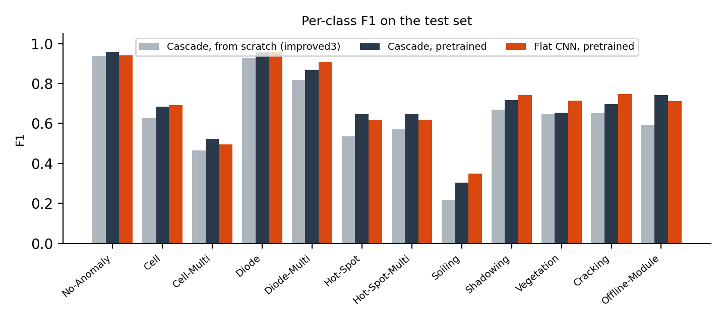
Figure 7. Per-class F1 on the test set.

6.6 Comparison with published work
We re-checked the literature at the primary sources. The dataset paper (Millendorf et al.) reports no model accuracies; the figures attributed to it in our earlier survey (Random Forest 84%, CNN 92.5%, EfficientNet + SVM 93%) come from later papers. Those papers differ from our setup in task, protocol and features, so their numbers can be placed next to ours but not ranked.
Table 9. Published results on InfraredSolarModules and our results.
Paper | Method | Task and protocol | Reported | Checked
Duranay 2023, Electronics 12(21):4397 | EfficientNet-B0 features (ImageNet-pretrained), NCA selection, SVM | 12 classes, 10-fold cross-validation | 93.93% accuracy, 89.82% F1 | Full paper read
Alves et al. 2021, Renewable Energy 179:502 | Custom CNN with data augmentation | Anomaly detection (binary); 8 selected classes; cross-validation | 92.5% binary; 78.85% for 8 classes | Abstract (library record)
Multi-scale CNN, transfer learning (Eng. Appl. Artif. Intell. 113, 2022), as cited by Duranay | Three-branch CNN, transfer learning | Fault detection; 11 anomaly types | 97.32% detection; 93.51% for 11 types | As cited by Duranay
Corley et al. 2025 (CVPRW), their Random Forest | Random Forest | Anomaly classification, split not stated | 84.0% | arXiv text read
Barraz et al. 2025; Gopalakrishnan et al. 2024, as cited by Corley | Cascading ensemble with voting CNN; NASNet + LSTM | Not stated | 88%; 85% | As cited by Corley
Millendorf et al. 2020 (dataset paper) | - | - | No model results reported | Full paper read
Preprints and listings (SSRN Hyperband CNN; diffusion + ViT) | Hyperband-tuned CNN; transformer | 12 classes, repeated k-fold CV (SSRN) | 98.75%; 92.78% | Not verified (listings only)
Ours: pretrained cascade | ImageNet EfficientNet-B0 fine-tuned at each of 5 stages | 12 classes, single stratified 70/15/15 hold-out | 83.2% accuracy, macro-F1 0.700 | Our results
Ours: cascade from scratch (data-driven families) | Five small CNNs | Same hold-out | 79.8% accuracy, macro-F1 0.646 | Our results
Ours: Stage 1 only (pretrained / from scratch) | Binary triage CNN | Healthy vs defect, same hold-out | 95.8% / 94.1% | Our results
Ours: flat CNN (pretrained / scratch), Random Forest | EfficientNet-B0 / same blocks / raw pixels | 12 classes, same hold-out | 82.6% / 76.8%; RF 61.6% | Our results
Ours: Duranay-style baseline on our split | EfficientNet-B0 features + RBF SVM (no NCA, last layer only) | 12 classes, same hold-out | 78.7% accuracy, macro-F1 0.640 | Our results

• Binary triage. Our pretrained Stage 1 reaches 95.8% (94.1% from scratch). That is above Alves et al. (92.5%, cross-validated) and below the multi-scale transfer-learning CNN (97.32%). It is a single hold-out run, so we claim to be at or slightly above the 92.5% to 93% range, not a new best.
• 12 classes. Our best, 83.2%, is below the published 12-class figures (84.0% Random Forest, 85% to 88% for ensembles, 93.93% for EfficientNet features with an SVM). On the published protocols we did not beat them and did not reach the 93% ceiling or the 95% target stated in our proposal. However, a Duranay-style pipeline run on our split scored only 78.7% (macro-F1 0.640), below our pretrained cascade. This suggests the gap to the published 93.93% is largely due to the evaluation protocol and to details we did not replicate, not to a weaker model, but it does not prove it.
• Why the numbers are not like for like. Duranay uses 10-fold cross-validation, a network trained end to end on the dataset and a supervised feature selection (NCA) before the cross-validation; as described, test images can influence these steps. Our test images are never used for training or selection. We also measured overlap in our own split: about 7% of test images have a near-identical training image (distance below 0.5, 96% of them with the same label) and about 54% have a close one (distance below 1, 78% with the same label), so random folds would put near-duplicates on both sides and raise cross-validated scores. This cannot explain the whole gap: a raw-pixel Random Forest scores 61.6% on our split against the 84.0% reported by Corley et al., whose protocol is not stated.
Sources: Duranay, Electronics 12(21):4397; Corley et al., arXiv:2503.02128; Alves et al., Renewable Energy 179:502-516 (abstract only); Millendorf et al., ICLR 2020 workshop. Rows marked 'as cited' were read in the citing paper; rows marked 'Not verified' appeared only in search listings.

6.7 Limitations
• Single runs. Every configuration was run once with seed 42. Differences below about 0.5 points are within noise and no confidence intervals were computed. A 10-fold cross-validation of the pretrained cascade was prepared but did not complete, so it is not reported.
• Near-duplicate images. The benchmark has no module or site identifiers, so near-identical crops can fall on both sides of any split.
• Rare classes. Soiling, Hot-Spot and Diode-Multi remain weak, which keeps macro-F1 well below accuracy.
• Efficiency. Latency was not measured reliably (timings were taken while the GPU was busy). The pretrained cascade has five times the parameters of the flat model, so the early exit did not give a demonstrated efficiency advantage in our setting.
• Comparison with published work. Protocols differ (cross-validation, pretrained features) and some sources could only be checked through abstracts or citing papers.

7. Conclusion and Future Work
We implemented Cascaded-SolarNet, a three-stage cascade of five CNNs for 12-class infrared solar module defect classification, with a reproducible split, tests, architecture diagrams and live demos. After diagnosing and removing harmful photometric augmentation, enlarging the input and strengthening the front stages, accuracy rose from 61.7% to 79.8% from scratch and to 83.2% with ImageNet pretraining (macro-F1 0.37 to 0.70); healthy-versus-defect triage reaches 95.8%, comparable to the 92.5% binary figure published for this dataset.
The claim that a cascade clearly beats a flat classifier was only partly supported. From scratch the cascade is ahead on accuracy and kappa; with the same pretrained backbone it ties a flat CNN while using five times the parameters. Error propagation is the central trade-off: a wrong decision at Stage 1 or Stage 2 cannot be undone, and the family decision remains the largest error source. Published 12-class results (84% to 93.93%) are higher than ours, but they use cross-validation and pretrained features, and the 93% ceiling and 95% target stated in the proposal were not reached under our stricter fixed hold-out. A practical lesson is that thermal images need thermal-aware augmentation: flips help, while brightness, contrast and noise jitter hurt.
Future work includes running several seeds and a leak-free 10-fold cross-validation for a like-for-like comparison with published results; improving the family decision, for example by training Stage 2 jointly with the specialists or on the cascade's own routing errors; class-specific augmentation for the rare faults; deduplicating near-identical crops before splitting; measuring latency and memory on a drone-class edge device; and investigating additional modalities such as RGB.

References
1. Millendorf M., Obropta E., Vadhavkar N. (2020). Infrared Solar Module Dataset for Anomaly Detection. ICLR 2020 Workshop on AI for Earth Sciences. Raptor Maps Inc.
2. Pathak, S.P., Patil, S.A. (2025). Enhanced Fault Identification in Solar Panels through Binary Cascaded Convolutional Classifiers with Thermal-Visual Image Augmentation. International Journal of Image, Graphics and Signal Processing (IJIGSP), 17(4). DOI: 10.5815/ijigsp.2025.04.01
3. PV-faultNet: Optimized Convolutional Neural Network to Detect Defects in PV Production. (2024). arXiv preprint arXiv:2411.02997.
4. Defect Detection of Photovoltaic Modules Based on Improved VarifocalNet. (2024). Scientific Reports, 14. DOI: 10.1038/s41598-024-66234-3
5. Otamendi, U., Martinez, I., Quartulli, M., et al. (2021). Segmentation of Cell-Level Anomalies in Electroluminescence Images of Photovoltaic Modules. Solar Energy, 220, 914-926. DOI: 10.1016/j.solener.2021.03.058
6. Tella, H., Hussein, A., Rehman, S., et al. (2025). PV Panel Defect Classification Using Deep Learning Ensemble Methods. Case Studies in Thermal Engineering, 66. DOI: 10.1016/j.csite.2025.105749
7. Cai, Z., Vasconcelos, N. (2018). Cascade R-CNN: Delving into High Quality Object Detection. CVPR, pp. 6154-6162.
8. Tan, M., Le, Q.V. (2019). EfficientNet: Rethinking Model Scaling for Convolutional Neural Networks. ICML. arXiv:1905.11946.
9. He, K., Zhang, X., Ren, S., Sun, J. (2016). Deep Residual Learning for Image Recognition. CVPR, pp. 770-778.
10. Duranay, Z.B. (2023). Fault Detection in Solar Energy Systems: A Deep Learning Approach. Electronics, 12(21), 4397. DOI: 10.3390/electronics12214397
11. Alves, R.H.F., de Deus Junior, G.A., Marra, E.G., Lemos, R.P. (2021). Automatic fault classification in photovoltaic modules using Convolutional Neural Networks. Renewable Energy, 179, 502-516.
12. Corley et al. (2025). Aerial Infrared Health Monitoring of Solar Photovoltaic Farms at Scale. CVPR Workshops (PBVS). arXiv:2503.02128.
13. Paszke, A., et al. (2019). PyTorch: An Imperative Style, High-Performance Deep Learning Library. NeurIPS 32.
14. Deng, J., et al. (2009). ImageNet: A Large-Scale Hierarchical Image Database. CVPR.

