Customer Engagement & Product Utilization Analytics
for Retention Strategy
  - An Applied Data Analytics Research Paper Using Engagement Classification, Product Utilization Metrics, High-Value Disengagement Detection, Retention Strength Scoring, and Dashboard-Based Strategic Recommendations

Document Field | Details
Author | Mohit Gupta
Domain | Banking Retention Analytics / Customer Behavior Analytics
Project | Customer Engagement & Product Utilization Analytics for Retention Strategy
Tool Stack | Python, Pandas, NumPy, Plotly, Streamlit, data validation, dashboard analytics
Research Type | Applied data analytics research paper with EDA, KPI measurement, dashboard evidence, insights, recommendations, and appendix
Prepared | June 2026
Company | Unified Mentor Private Ltd

Research scope
This research paper reframes banking churn from a behavior and relationship-strength perspective. It evaluates engagement behavior, product depth, credit card stickiness, high-value disengagement, and retention scoring to support targeted retention strategy rather than generic customer retention campaigns.

Core KPI | Dashboard Value | Executive Reading
Engagement Retention Ratio | 1.17 | Active member retention is stronger than inactive member retention.
Product Depth Index | 100.92 | Retained customers show slightly stronger product relationship depth than the overall base.
High-Balance Disengagement Rate | 49.51% | Nearly half of high-value customers are behaviorally disengaged and require intervention.
Credit Card Stickiness Score | 79.82% | Credit card ownership is associated with a relatively strong retention profile.
Relationship Strength Index | 64.44 | Overall relationship strength is moderate-to-strong, but segment differences remain important.

1. Executive Summary / Abstract
This research paper presents a dashboard-supported banking retention analytics study focused on customer engagement, product utilization, high-value disengagement, and relationship strength scoring. The analysis uses customer-level churn indicators and derived behavioral fields to understand which customer profiles require targeted retention attention.
The project begins from a practical banking problem: customers may appear financially valuable because of high balances or salaries, but still churn when engagement is weak, product adoption is limited, or the relationship with the bank lacks depth. The dashboard therefore moves beyond generic demographic churn reporting and evaluates retention through measurable behavioral and relationship-strength indicators.
The dashboard baseline analyzes 10,000 customers, of whom 7,963 are retained and 2,037 are churned. The overall retention rate is 79.63%, while inactive customers account for 63.9% of churn. Product-depth evidence shows that two-product customers have the strongest retention profile at 92.42%, while single-product customers carry higher churn exposure. The high-value customer detector identifies 4,351 high-value customers, 2,154 of whom are high-value disengaged, generating a high-balance disengagement rate of 49.51% and balance exposure of 232,942,972.
The most important strategic conclusion is that financial value alone does not guarantee loyalty. A customer may hold a high balance but still have low engagement, weak product relationship, and elevated churn risk. The retention scoring module further confirms that churn risk declines sharply as retention strength increases: Critical Retention Risk has 69.0% churn, while Very Strong Retention has 0.0% churn.
Executive Question | Evidence from Dashboard | Strategic Meaning
Are active customers more loyal? | Engagement Retention Ratio = 1.17 | Active engagement is linked with stronger retention quality.
Which segment contributes most to churn? | Inactive Members contribute 63.9% of total churn | Reactivation and engagement recovery should be first-priority campaigns.
Does high balance guarantee loyalty? | 49.51% high-value disengagement rate | Premium customers can still carry silent churn risk.
Which product count performs best? | 2-product customers show 92.42% retention | Product bundling should target optimal relationship depth.
Can scoring separate risk? | Critical tier churn 69.0%; Very Strong tier churn 0.0% | Retention tiers can prioritize campaign urgency.

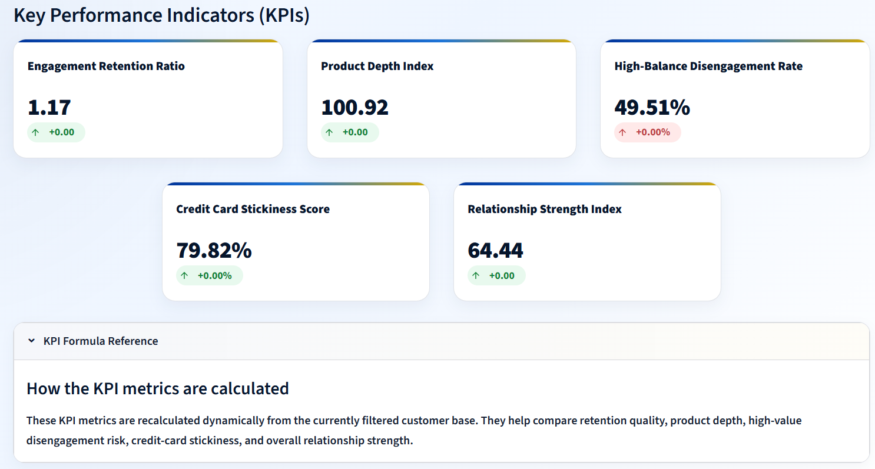
Figure 1. Key Performance Indicator snapshot showing the five required retention strategy KPIs.
Analyst interpretation
The KPI snapshot provides the executive baseline for the research paper: engagement retention, product depth, high-balance disengagement, card stickiness, and relationship strength all contribute to the overall retention strategy view.

Executive takeaway
The bank should prioritize inactive-member reactivation, high-value disengagement recovery, optimal two-product bundling, and retention-tier based campaign prioritization. These actions directly align with the largest observed churn contributors and the strongest dashboard signals.

1.1 Executive Decision-Readiness Snapshot
The executive value of this project is not limited to identifying a churn rate. It converts churn evidence into a prioritized decision framework that separates broad customer retention from targeted retention action. Each dashboard module answers a specific leadership question and connects that answer to a practical action pathway.
Decision Lens | Evidence Signal | Recommended Executive Action
Engagement recovery | Inactive Members contribute 63.9% of churn | Prioritize inactive-member reactivation campaigns before broad generic campaigns.
Product strategy | Two-product customers show 92.42% retention | Promote need-aligned product bundles that move single-product customers toward optimal depth.
Premium retention | 2,154 high-value disengaged customers and 232,942,972 balance at risk | Assign high-value disengaged customers to relationship recovery and premium outreach workflows.
Scoring governance | Critical Retention Risk churn is 69.0% | Use retention strength tiers to sequence campaign urgency and customer-success actions.
Risk interpretation | 4-product churn reaches 100% but likely involves smaller segment size | Review customer count and product-fit context before treating extreme rates as broad policy.

Research contribution snapshot
The research contribution is a complete applied analytics framework that joins engagement status, product utilization, premium value exposure, and retention strength scoring into one dashboard-supported retention strategy. This makes the project suitable for portfolio, research repository, and professional analytics submission use.

1.2 Retention Strategy Action Hierarchy
The executive evidence is converted into a practical action hierarchy so that leadership can move from dashboard reading to campaign sequencing. The order below prioritizes actions by observed churn contribution, financial exposure, and scoring severity.
Action Layer | Primary Evidence | Why It Matters | Recommended Use
1. Reactivate inactive members | Inactive Members contribute 63.9% of churn | This is the largest churn-contribution signal in the dashboard. | Start with targeted reactivation journeys, reminders, service outreach, and digital engagement nudges.
2. Recover high-value disengaged customers | 2,154 high-value disengaged customers; 232,942,972 balance at risk | Premium customers can look financially valuable while remaining behaviorally weak. | Prioritize relationship-manager outreach, premium retention offers, and service-quality review.
3. Optimize product depth | 2-product customers show 92.42% retention | Product depth has an optimal zone rather than a simple more-is-better pattern. | Move suitable single-product customers toward need-aligned second products.
4. Use retention tiers for campaign order | Critical Retention Risk churn is 69.0% | Retention strength scoring separates urgent risk from sticky customers. | Sequence campaigns by tier, with critical and weak tiers handled first.

2. Table of Contents
Section | Title | Purpose
1 | Executive Summary / Abstract | C-level summary of evidence, findings, and recommendations
2 | Table of Contents | Document navigation
3 | Introduction | Research motivation and banking retention context
4 | Background and Context | Customer engagement, product adoption, and retention rationale
5 | Problem Statement | Decision problem and research questions
6 | Dataset Overview | Field structure and derived analytical variables
7 | Methodology and Data Governance | Data ingestion, validation, feature engineering, and KPI modeling
8 | Data Limitations and Scope | Responsible interpretation boundaries
9 | Key Performance Indicators | Five required KPIs and strategic meaning
10 | Exploratory Data Analysis | Pattern discovery across engagement, product depth, high-value risk, and scoring
11 | Result and Analysis | Main dashboard evidence and interpretation
12 | Findings and Insights | Evidence-to-insight synthesis
13 | Actionable Recommendations | Retention strategy actions and 90-day roadmap
14 | Dashboard Implementation | Streamlit, data validation, filtering, and module architecture
15 | Data Interpretation Governance | Rules for responsible KPI reading
16 | Conclusion | Final synthesis
17 | References | Source and technical references
18 | Appendix | KPI formula register, figure register, and metadata

Navigation note
Page references should be checked after final PDF export because Word pagination can shift slightly across devices. The section order and figure register are fixed and publication-ready.

2.1 Evidence Flow Roadmap
The report follows a structured evidence path. It starts with the executive KPI baseline, then explains data preparation, evaluates core behavioral patterns through EDA, presents dashboard evidence module by module, and ends with retention actions and governance rules.
Reading Stage | Sections | Evidence Used | Expected Decision Output
Strategic baseline | Executive Summary, KPIs | Five KPI cards and executive readings | Understand the retention problem and priority signals.
Data credibility | Dataset, Methodology, Limitations | Field dictionary, derived metrics, validation rules | Confirm that metrics are traceable and responsibly interpreted.
Pattern discovery | EDA | Engagement, product depth, high-value, and retention score snapshots | Identify where churn risk concentrates before final interpretation.
Evidence analysis | Result and Analysis | 20 dashboard screenshots and module findings | Convert visual evidence into segment-level findings.
Action planning | Findings, Recommendations, Governance | Action roadmap and interpretation rules | Translate insights into retention campaign strategy.

3. Introduction
Banking retention analytics increasingly depends on understanding how customers behave rather than only describing who they are. Traditional churn analysis often focuses on demographics or financial indicators, but customer engagement, product usage, and relationship depth provide stronger decision signals for designing targeted retention strategies.
This project evaluates customer retention through the combined lens of engagement behavior and product utilization. It focuses on whether active customers retain better than inactive customers, whether product depth strengthens loyalty, whether high-value customers can still be disengaged, and whether relationship strength scoring can separate sticky customers from high-risk customers.
The study is designed as an applied analytics research paper. It combines EDA, KPI measurement, feature-engineered segmentation, dashboard visualization, and strategic recommendations. The goal is not merely to report churn rate, but to identify actionable micro-segments that banks can target through reactivation campaigns, product bundling, premium retention outreach, and tier-based relationship management.
Research positioning
The paper positions customer churn as a behavioral relationship-strength issue. Financial value, such as balance or estimated salary, is treated as an important business value signal, but not as a substitute for engagement or loyalty.

Analytical Dimension | Retention Question | Dashboard Evidence Used
Engagement behavior | Do active customers retain better than inactive customers? | Engagement retention ratio, engagement outcome split, churn contribution donut
Product utilization | Does product depth improve loyalty? | Product count impact, single vs multi-product retention split, product depth risk matrix
Premium customer risk | Can high-value customers still be disengaged? | High-value disengaged detector, segment mix, balance exposure
Retention scoring | Can a score-based framework prioritize intervention? | Retention strength distribution, tier box plot, relationship map, churn risk ranking

4. Background and Context
Banks increasingly recognize that customer retention depends on the depth and quality of the relationship. Customers with more active engagement, meaningful product usage, and stronger relationship indicators tend to be easier to retain than customers who hold accounts passively or interact minimally with the bank.
The project guidelines emphasize that high balance or salary does not automatically guarantee loyalty. A customer can appear financially strong but still churn because of limited product adoption, low engagement, weak relationship depth, or lack of perceived value from the bank. This is especially important for premium customers because losing a high-value customer can create both revenue and balance exposure.
Product utilization is also not a simple linear success metric. A customer with one product may have a shallow relationship and higher churn risk, but a customer with too many products may also show friction if products are poorly matched to needs. The dashboard therefore evaluates product count, product depth, and retention tiers together.
Banking Signal | Meaning | Retention Relevance
IsActiveMember | Whether the customer is active or inactive | Active membership is a direct behavioral engagement signal.
NumOfProducts | Number of bank products used | Measures product depth and cross-sell relationship breadth.
HasCrCard | Credit-card ownership indicator | Supports evaluation of card stickiness and product-linked retention.
Balance | Account balance | Captures financial value but does not prove loyalty.
EstimatedSalary | Estimated annual salary | Supports financial context and mismatch analysis.
Exited | Churn target variable | Indicates whether the customer left the bank.

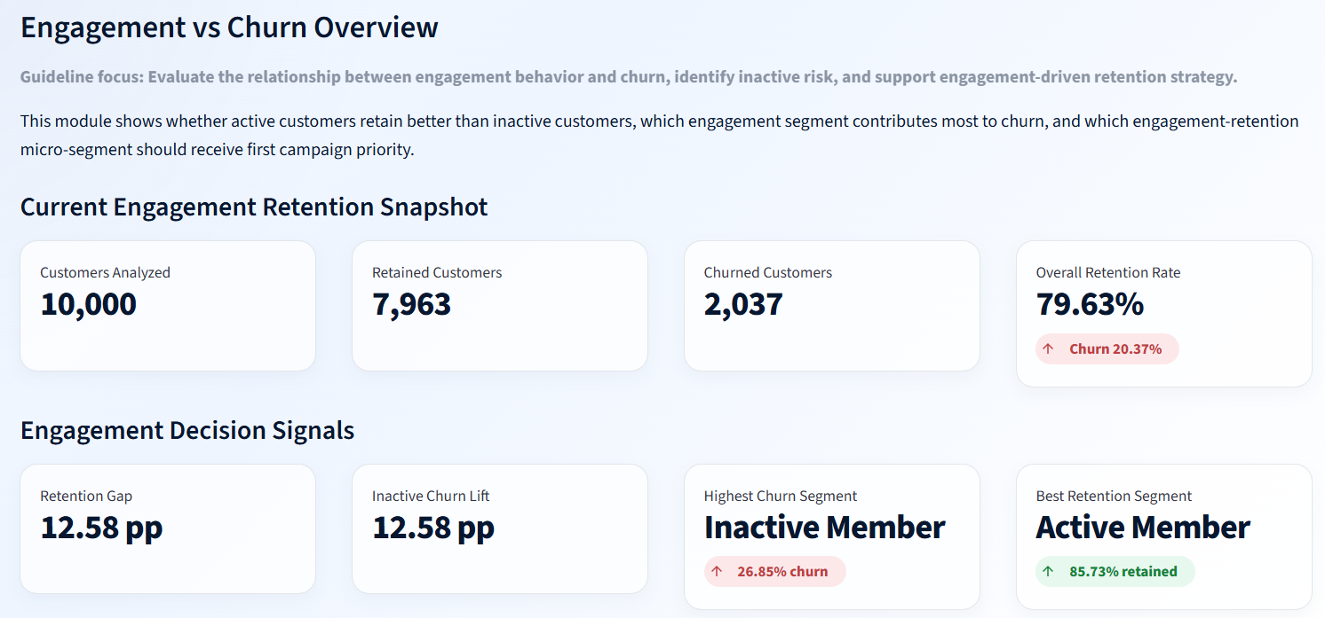
Figure 2. Engagement vs Churn Overview dashboard snapshot.
Analyst interpretation
The engagement module defines the behavioral retention context: inactive members show higher churn exposure, while active members represent the stronger retention segment.

5. Problem Statement
Despite having customer engagement and product usage data, banks often lack clear quantitative insight into which behaviors are most strongly associated with retention. Retention actions can become generic when analytics does not distinguish between active customers, inactive customers, single-product users, high-value disengaged customers, and relationship-strength tiers.
A key risk is that financially valuable customers may be assumed to be loyal simply because they hold high balances or show strong salary indicators. This can hide silent churn risk. Without identifying high-value disengagement, the bank may fail to prioritize customers whose financial value is high but whose relationship signals are weak.
This research paper therefore answers a practical retention strategy question: how can engagement behavior, product utilization, high-value risk detection, and relationship strength scoring be used to create targeted, evidence-based retention actions?
Research Question | Analytical Evidence
Do active customers retain better than inactive customers? | Engagement Retention Ratio, retention gap, engagement outcome split
Which engagement segment contributes most to churn? | Churn Contribution Share by Engagement Segment
Does product depth improve retention? | Product Count Impact and Single vs Multi-Product Retention Split
Which product-count groups show elevated churn risk? | Product Depth x Retention Tier Risk Matrix
Are high-value customers vulnerable to disengagement? | High-Value Disengaged Customer Detector and Balance Exposure
Can retention scoring prioritize intervention? | Retention Tier Churn Risk Ranking and Relationship Strength Map

6. Dataset Overview
The dataset contains customer-level banking churn records. The raw fields describe identity, demographic context, financial strength, product usage, activity status, and the churn target. The dashboard uses these raw fields together with engineered relationship and retention-strength features.
Field Group | Columns | Analytical Purpose
Customer identity | CustomerId, Surname | Customer-level reference and row uniqueness.
Demographic profile | Geography, Gender, Age, Tenure | Customer segmentation context and tenure-based interpretation.
Financial profile | CreditScore, Balance, EstimatedSalary | Creditworthiness, financial value, and premium-risk context.
Product usage | NumOfProducts, HasCrCard | Product depth, cross-sell, and credit-card stickiness analysis.
Engagement behavior | IsActiveMember | Behavioral engagement signal used to compare active vs inactive retention.
Target outcome | Exited | Binary churn indicator where 1 means churned and 0 means retained.

The Streamlit dashboard uses a final feature-engineered master dataset rather than only the raw input table. This enables segment labels, retention scoring, risk tiers, product-depth segments, and high-value disengagement status to be consistently reused across modules.
Derived Field | Research Meaning
Churn_Status | Human-readable retained/churned customer outcome.
Engagement_Status | Active Member or Inactive Member segmentation.
Credit_Card_Status | Credit-card holder status for stickiness scoring.
Product_Depth_Segment | Single Product, Optimal Product Depth, or High Product Load.
High_Value_Customer_Status | High-value customer identification based on value logic.
High_Value_Disengaged_Status | Premium customers who are financially valuable but behaviorally disengaged.
Salary_Balance_Mismatch_Status | Flag for salary-balance mismatch risk analysis.
Customer_Risk_Segment | Composite business risk segment for targeted action.
Relationship_Strength_Index | Numerical relationship strength score.
Retention_Strength_Score / Tier | Retention prioritization score and categorical tier.

7. Methodology and Data Governance
The methodology follows a structured data analytics workflow: data ingestion, validation, feature engineering, KPI modeling, exploratory analysis, dashboard module design, interpretation governance, and recommendation development. The dashboard validates raw and derived columns before rendering analytical modules, which reduces the risk of misleading outputs.

7.1 Data Ingestion and Validation
The final master dataset is loaded from a processed retention-strength dataset. The app validates required raw and derived columns before analysis. It also validates key binary variables such as HasCrCard, IsActiveMember, and Exited to ensure that the dashboard does not run on inconsistent input values.

7.2 Feature Engineering
Feature engineering converts raw customer records into behavior and relationship signals. Engagement status, credit-card status, product-depth segment, high-value status, high-value disengagement status, salary-balance mismatch, customer risk segment, relationship strength index, and retention strength tier are used to make the dashboard actionable rather than descriptive only.

7.3 KPI Modeling
Five required KPIs are recalculated from the filtered dataset: Engagement Retention Ratio, Product Depth Index, High-Balance Disengagement Rate, Credit Card Stickiness Score, and Relationship Strength Index. These KPIs allow the bank to compare engagement quality, product relationship depth, premium disengagement risk, card-linked retention, and overall relationship strength.
Methodology Step | Technique | Output | Research Value
Data ingestion | Load processed master dataset | Validated customer-level dataset | Creates a stable analytical foundation.
Data validation | Required-column and binary-variable checks | Quality-controlled input layer | Prevents dashboard failure and inconsistent metrics.
Feature engineering | Create segment, risk, and scoring variables | Behavioral relationship dataset | Supports customer-level retention strategy.
KPI modeling | Calculate five required KPIs | Executive KPI snapshot | Creates comparable retention strategy indicators.
EDA | Segment charts, churn rates, matrices, distributions | Pattern discovery | Identifies engagement, product, premium, and scoring signals.
Dashboard implementation | Streamlit filters and Plotly visuals | Interactive decision-support system | Supports targeted and filter-aware analysis.


Figure 3. KPI formula reference and KPI calculation context.
Analyst interpretation
The KPI formula reference supports governance by clarifying how each KPI is calculated and why each metric contributes to retention strategy.

7.4 KPI Calculation Governance Matrix
Because retention KPIs are recalculated from the filtered customer base, each KPI must be interpreted with the selected segment, denominator, and business decision in mind. The governance matrix below documents how the KPI should be read in a professional analytics review.
KPI | Primary Denominator | Decision Question | Governance Guardrail
Engagement Retention Ratio | Active and inactive member retention rates | Are active members retaining better than inactive members? | Report N/A when both segments are not available in the selected filter state.
Product Depth Index | Retained customer product count vs overall product count | Do retained customers show stronger product depth? | Interpret with product-count distribution to avoid over-valuing small groups.
High-Balance Disengagement Rate | High-value customer base | How much premium value is behaviorally disengaged? | Use as a premium outreach trigger, not as an automatic churn label.
Credit Card Stickiness Score | Customers with credit card ownership | Are card holders showing a stronger retained profile? | Compare with product depth and engagement before designing card-only campaigns.
Relationship Strength Index | Filtered customer base | How strong is the overall relationship quality? | Use with retention tier ranking for campaign prioritization.
Calculation reliability note
KPI values should always be reported with the active filter state. A high or low value may change when the analyst filters by engagement status, product count, balance threshold, or salary threshold.

8. Data Limitations and Scope
This research paper is an applied descriptive and diagnostic analytics study. It identifies retention patterns and actionable segments, but it does not prove causal relationships. For example, active membership is associated with stronger retention, but causal proof would require experiments, longitudinal tracking, or causal modeling.
Limitation | Impact on Interpretation | Future Improvement
Observational dataset | Associations should not be interpreted as causation. | Add experiments, causal modeling, or longitudinal retention tracking.
No transaction history | Engagement is represented mainly by active membership status. | Add login activity, transaction frequency, app usage, complaints, and support interactions.
No detailed product mix | NumOfProducts shows count, not exact product categories. | Add exact products, product age, usage frequency, and profitability.
No campaign history | Cannot measure response to retention interventions. | Add campaign exposure, offers, and response outcomes.
Snapshot-style data | Cannot observe customer journey over time. | Add monthly customer snapshots and event-based history.
Small-segment sensitivity | Groups like 4-product customers can show extreme rates. | Display segment sizes and confidence intervals for small groups.

Responsible-use note
The dashboard should be used as a decision-support layer, not as an automated customer judgment system. Risk segments should guide review, prioritization, outreach, and experimentation, while final retention actions should consider customer context and business rules.

9. Key Performance Indicators
The KPI framework translates the project guidelines into measurable, dashboard-ready retention signals. Together, these metrics cover engagement quality, product depth, premium-customer risk, credit-card retention, and relationship strength.
KPI | Value | Formula / Logic | Business Interpretation
Engagement Retention Ratio | 1.17 | Active Member retention rate divided by Inactive Member retention rate. | Active customers retain better than inactive customers.
Product Depth Index | 100.92 | Retained average product count divided by overall average product count x 100. | Retained customers show slightly stronger product-depth quality.
High-Balance Disengagement Rate | 49.51% | High-value disengaged customers divided by high-value customers x 100. | Nearly half of high-value customers are disengaged.
Credit Card Stickiness Score | 79.82% | Retention rate among customers with a credit card. | Credit-card ownership is associated with stronger retention.
Relationship Strength Index | 64.44 | Average relationship strength index across the filtered base. | Overall relationship strength is moderate-to-strong.

KPI governance trigger
The most urgent risk KPI is High-Balance Disengagement Rate because it combines financial value with behavioral weakness. This metric should trigger premium-customer review when it remains high across filters or business segments.

9.1 KPI Action Trigger Matrix
The KPI framework is designed for decision action rather than passive reporting. The trigger matrix below links each KPI to a practical monitoring signal and recommended business response.
KPI | Current Reading | Watch Trigger | Recommended Action
Engagement Retention Ratio | 1.17 | Ratio declines toward 1.00 or inactive churn contribution increases. | Strengthen inactive-member journeys and reactivation offers.
Product Depth Index | 100.92 | Product depth rises without retention improvement or high product-load churn increases. | Review product suitability and rebalance cross-sell targeting.
High-Balance Disengagement Rate | 49.51% | Premium disengagement stays near or above half of the high-value base. | Launch high-value relationship recovery and service-quality outreach.
Credit Card Stickiness Score | 79.82% | Card-owner retention declines below overall retained baseline. | Review card benefits, usage engagement, and bundled loyalty campaigns.
Relationship Strength Index | 64.44 | Index declines in strategic segments or critical-risk tier grows. | Use retention scoring to prioritize customer success and relationship deepening.
KPI decision-use note
The five KPIs should be read together. Engagement explains behavioral activity, product depth explains relationship breadth, high-balance disengagement explains financial exposure, credit-card stickiness explains product-linked loyalty, and relationship strength summarizes overall customer relationship quality.

10. Exploratory Data Analysis
The exploratory analysis examines four major behavioral retention dimensions: engagement, product utilization, high-value disengagement, and retention strength. The EDA is designed to discover where churn risk concentrates and which segments require the first strategic response.

10.1 Engagement EDA
The engagement module identifies 10,000 customers, 7,963 retained customers, and 2,037 churned customers. The overall retention rate is 79.63%, but the retention gap and inactive churn lift both show a 12.58 percentage-point difference, confirming that engagement status is a major retention signal.

Figure 4. Current Engagement Retention Snapshot and Engagement Decision Signals.
Analyst interpretation
This figure establishes the engagement baseline and identifies Inactive Member as the highest churn segment while Active Member is the best retention segment.

10.2 Product Utilization EDA
Product utilization EDA evaluates whether customers with deeper product relationships are more likely to retain. The dashboard shows an average product count of 1.53, a single-product churn rate of 27.71%, and a multi-product retention rate of 87.23%.
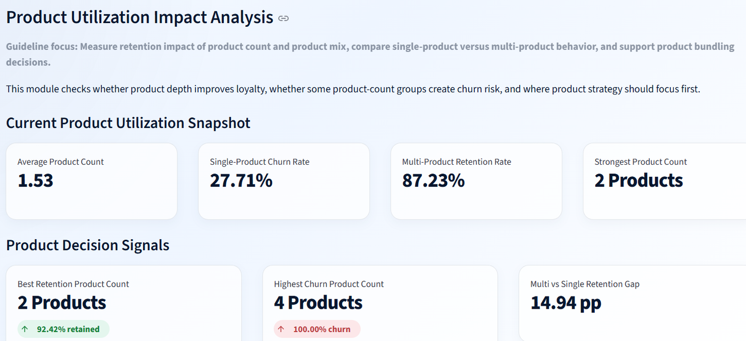
Figure 5. Product Utilization Impact Analysis snapshot.
Analyst interpretation
The product utilization snapshot indicates that 2 products is the strongest product count and that multi-product customers retain at a materially higher rate than single-product customers.

10.3 High-Value Customer EDA
The high-value detector identifies 4,351 high-value customers and 2,154 high-value disengaged customers. This means nearly half of high-value customers are exposed to disengagement risk, with 232,942,972 balance at risk.
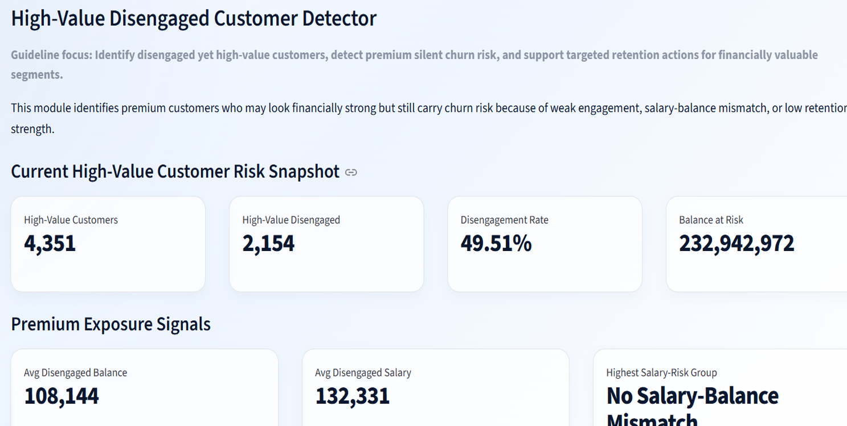
Figure 6. High-Value Disengaged Customer Detector snapshot.
Analyst interpretation
This figure shows the premium silent-churn problem: high financial value does not automatically mean high loyalty or strong relationship depth.

10.4 Retention Strength EDA
Retention strength EDA evaluates whether a score-based framework can create meaningful risk separation. The dashboard shows an average retention strength score of 57.63 and an average relationship strength of 64.44. Very Strong Retention is the strongest tier, while Critical Retention Risk is the highest-risk tier.
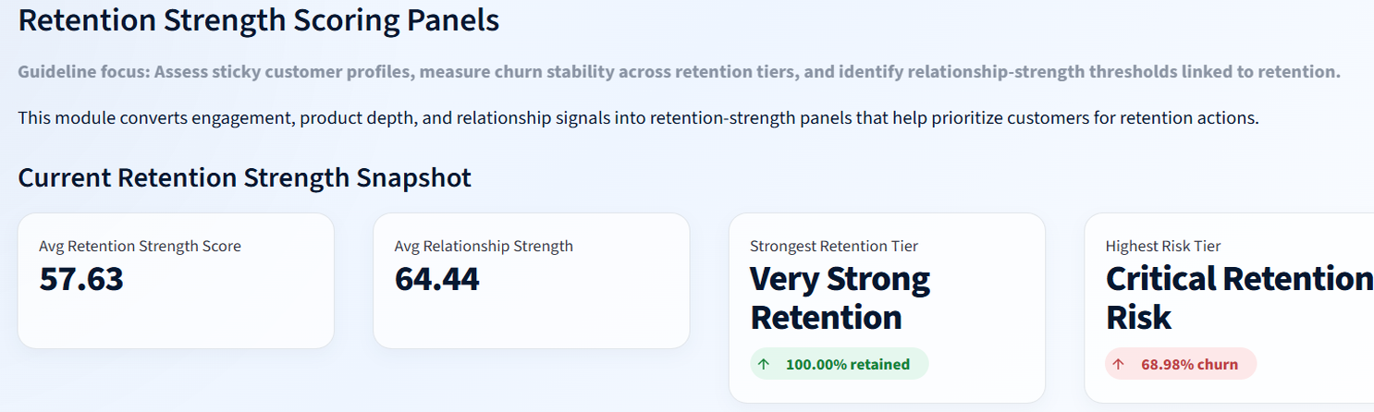
Figure 7. Retention Strength Scoring Panels snapshot.
Analyst interpretation
The retention strength module converts behavioral and relationship indicators into an actionable prioritization layer for campaign planning.

EDA decision-use note
EDA should be read as a sequencing layer: engagement identifies who is behaviorally at risk, product analysis identifies relationship depth, high-value analysis identifies financial exposure, and retention scoring ranks intervention priority.

10.5 EDA Synthesis Bridge
The EDA stage connects individual charts into a research storyline. The sequence below explains how exploratory evidence transitions into the results section.
EDA Layer | Main Evidence | Interpretation Role | Result Section Connection
Engagement behavior | 10,000 customers, 79.63% retention, inactive churn lift 12.58 pp | Identifies the first retention-risk dimension. | Section 11.1 Engagement vs Churn Overview
Product utilization | Average product count 1.53; 2 products strongest retention | Tests whether product depth is linked with retention quality. | Section 11.2 Product Utilization Impact Analysis
High-value risk | 2,154 high-value disengaged customers; 232,942,972 balance at risk | Adds financial exposure to behavioral disengagement. | Section 11.3 High-Value Disengaged Customer Detector
Retention scoring | Average score 57.63; critical-risk tier highest churn | Creates intervention priority and campaign sequencing. | Section 11.4 Retention Strength Scoring Panels
EDA-to-results transition
The next section converts these exploratory patterns into formal dashboard results, using the full set of visual evidence to support findings and recommendations.

11. Result and Analysis

11.1 Engagement vs Churn Overview
The engagement module provides the clearest behavioral evidence in the dashboard. Active Members have 4,416 retained customers and 735 churned customers, while Inactive Members have 3,547 retained customers and 1,302 churned customers. Inactive Members therefore contribute a larger share of total churn despite the full customer base having an overall retention rate close to 80%.
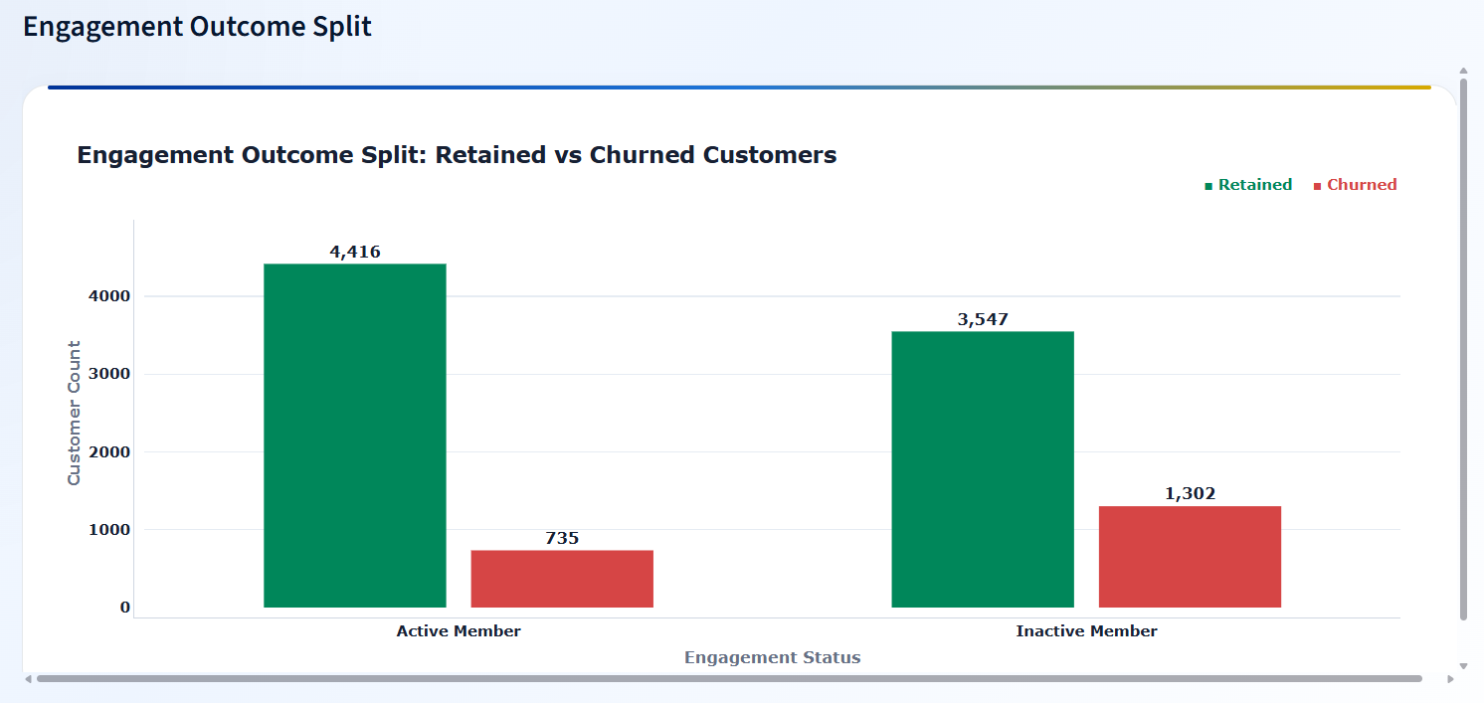
Figure 8. Engagement Outcome Split: retained vs churned customers by engagement status.
Analyst interpretation
The outcome split shows that inactive customers generate far more churned customers than active customers. This supports engagement recovery as the first retention strategy pillar.

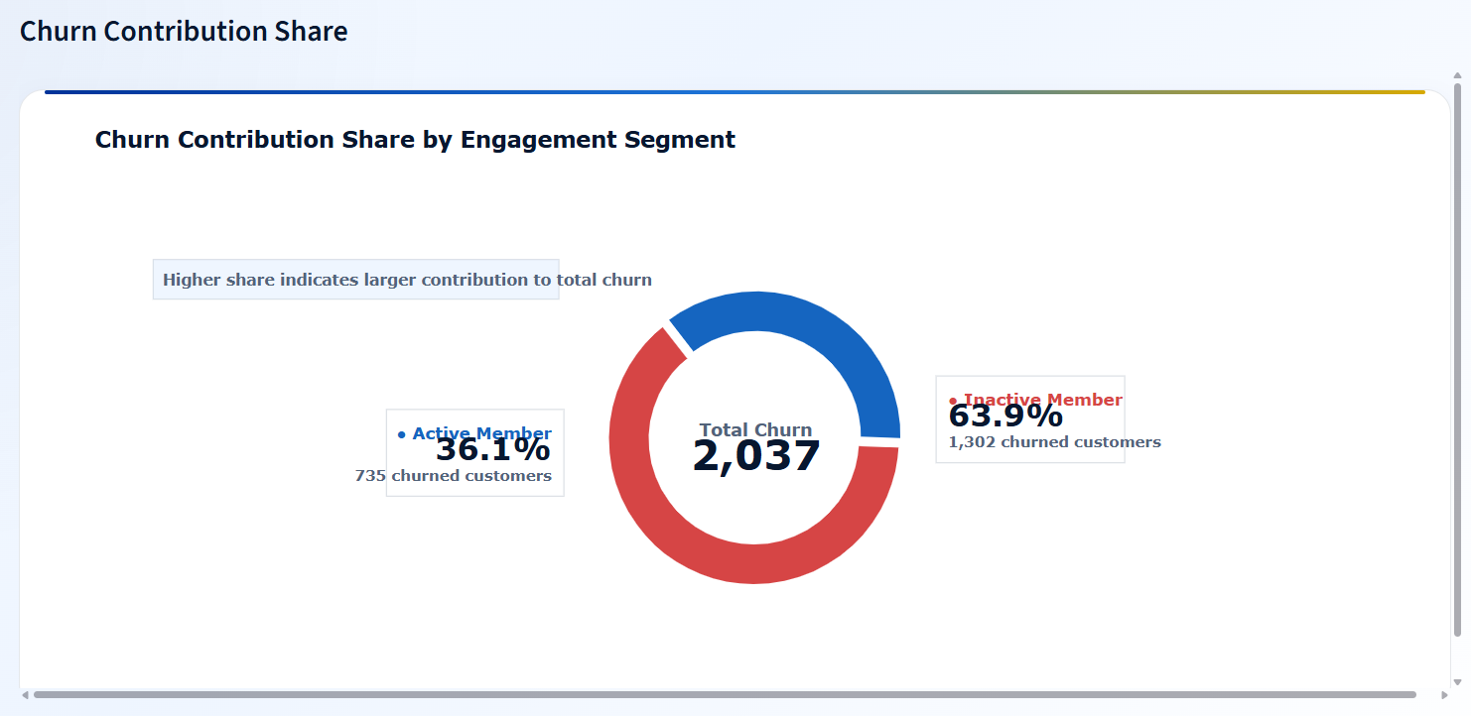
Figure 9. Churn Contribution Share by Engagement Segment.
Analyst interpretation
Inactive Members contribute 63.9% of total churn, while Active Members contribute 36.1%. This makes inactive-member reactivation a high-priority retention strategy.

The engagement x retention tier matrix adds a second layer of evidence. Active customers in Critical Retention Risk still show very high churn, while Active customers in Strong and Very Strong tiers show much lower churn. Inactive customers in critical or weak tiers should be prioritized for immediate intervention.
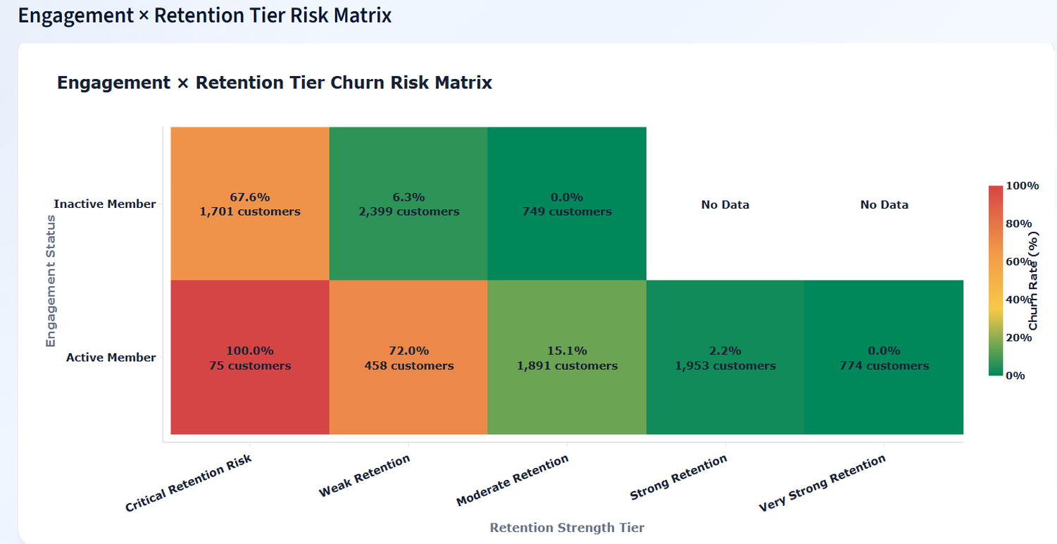
Figure 10. Engagement x Retention Tier Churn Risk Matrix.
Analyst interpretation
The matrix shows that engagement status should be interpreted together with retention strength tier. Risk is highest where weak engagement and low retention strength overlap.

11.2 Product Utilization Impact Analysis
The product utilization module shows that product count has a non-linear relationship with retention. Two-product customers show the strongest retention at 92.42%, while single-product customers retain at 72.3% and have 27.7% churn. Product count groups with three or four products show high churn in the dashboard and must be interpreted carefully with customer count context.
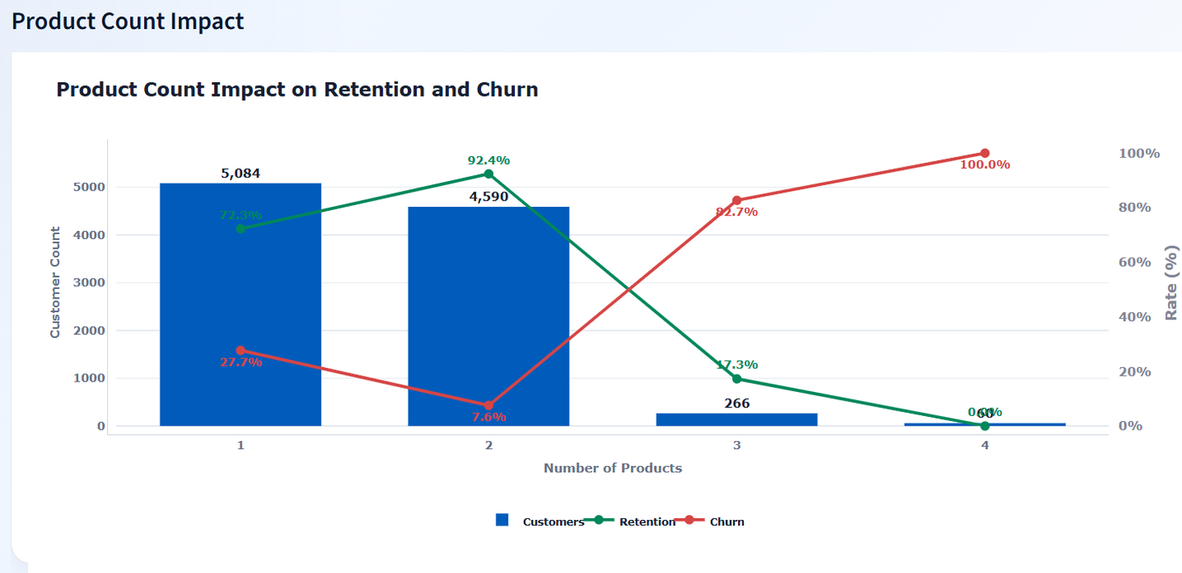
Figure 11. Product Count Impact on Retention and Churn.
Analyst interpretation
Two-product customers represent the strongest retention zone. One-product customers require product-bundling campaigns, while three- and four-product customers require product-load and suitability review.

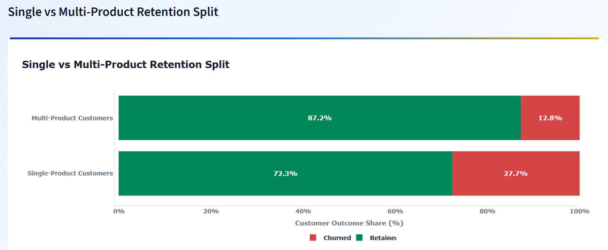
Figure 12. Single vs Multi-Product Retention Split.
Analyst interpretation
Multi-product customers retain at 87.2% compared with 72.3% for single-product customers. The 14.94 percentage-point gap supports product bundling as a retention lever.

The product relationship strength bubble map compares product count groups by relationship strength, retention strength, and churn. The chart indicates that product count alone is not enough; product depth must be evaluated with relationship quality and churn outcome.
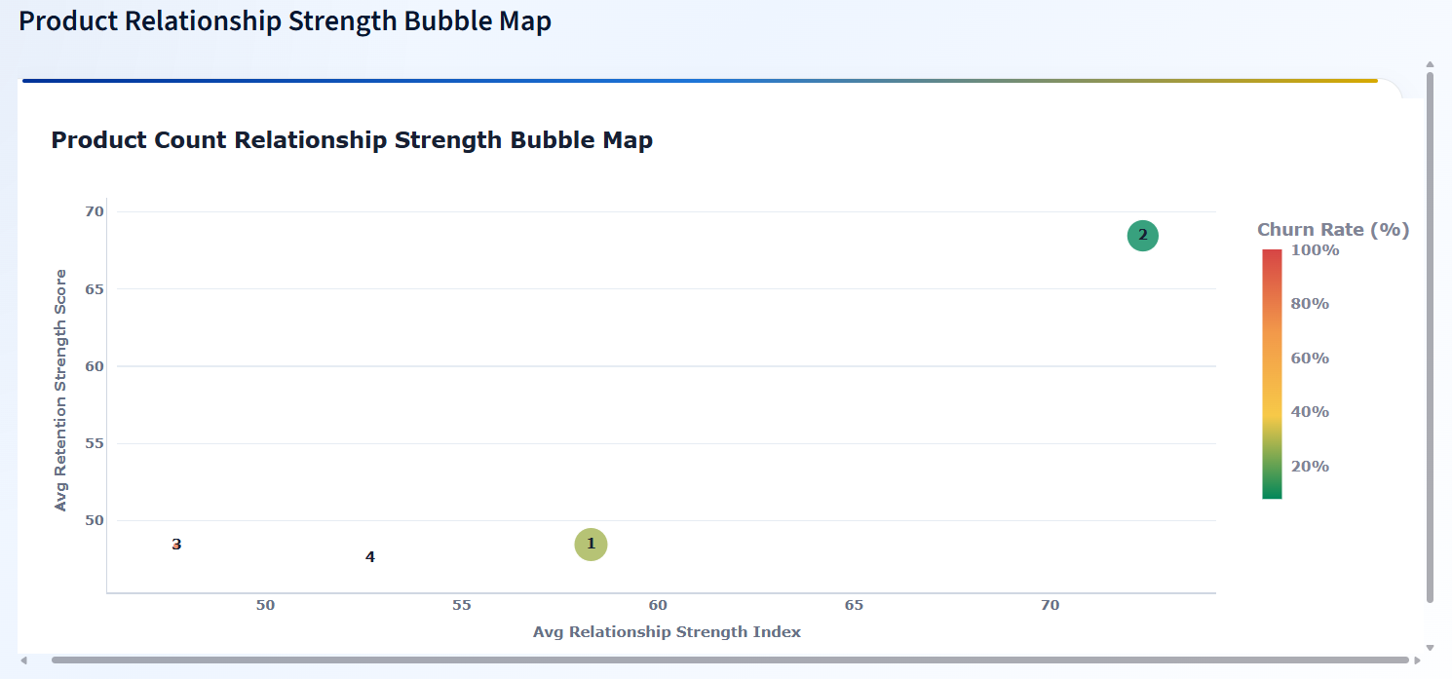
Figure 13. Product Relationship Strength Bubble Map.
Analyst interpretation
The bubble map supports a quality-over-quantity interpretation of product usage: the strongest product strategy is not simply more products, but the right product depth for the customer profile.

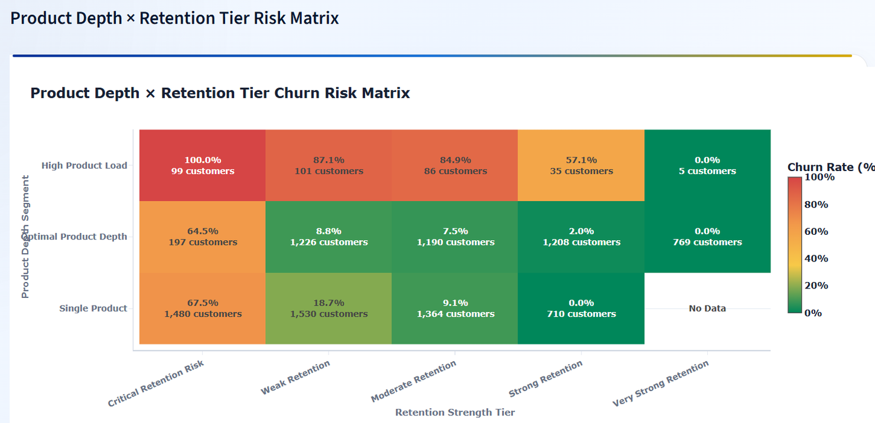
Figure 14. Product Depth x Retention Tier Churn Risk Matrix.
Analyst interpretation
The matrix shows that high product load can still be risky when retention strength is weak. This prevents over-simplified cross-sell conclusions.

11.3 High-Value Disengaged Customer Detector
The high-value module provides the strongest premium risk insight. Of 4,351 high-value customers, 2,154 are high-value disengaged, creating a disengagement rate of 49.51%. This is a critical finding because premium customers can create significant balance exposure when they disengage.
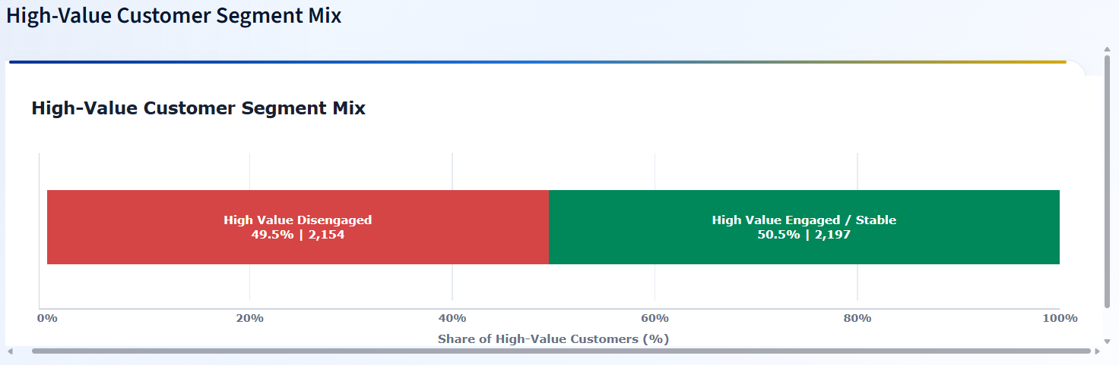
Figure 15. High-Value Customer Segment Mix.
Analyst interpretation
The high-value customer base is nearly evenly split between engaged/stable and disengaged segments. This makes premium relationship recovery a major retention strategy priority.

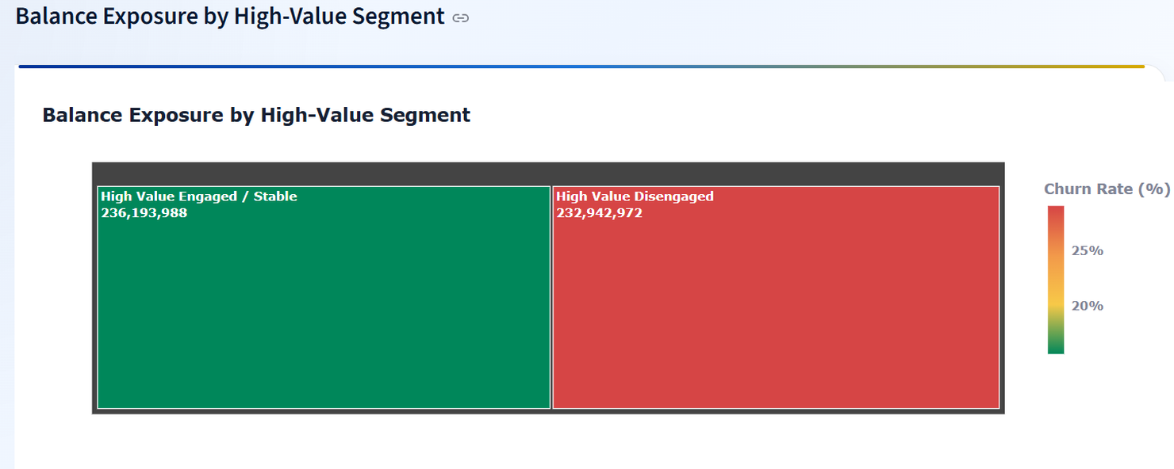
Figure 16. Balance Exposure by High-Value Segment.
Analyst interpretation
High-value disengaged customers account for 232,942,972 in balance exposure, nearly matching the balance exposure of high-value engaged/stable customers.

The salary-balance mismatch bubble map shows a churn difference between mismatch and no-mismatch groups. This should be interpreted as a risk signal rather than a causal conclusion. The key action is to investigate why certain high-salary or high-balance profiles still churn.
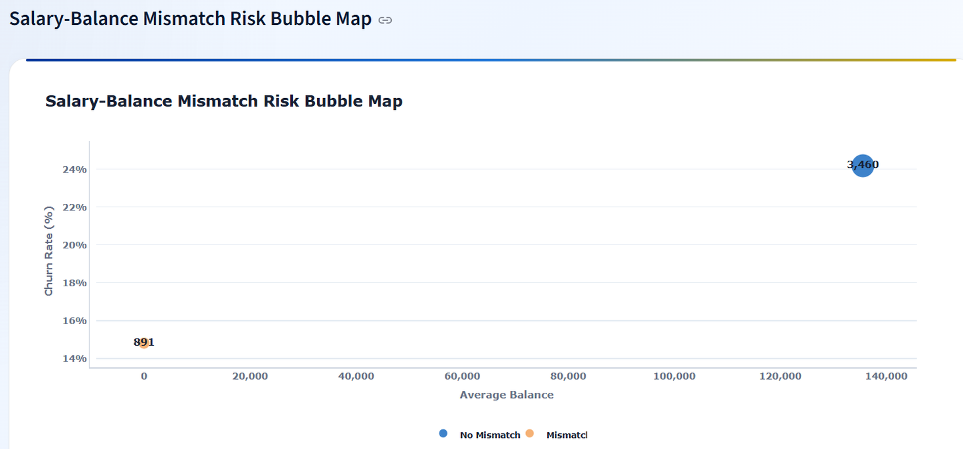
Figure 17. Salary-Balance Mismatch Risk Bubble Map.
Analyst interpretation
The mismatch map helps connect financial value with churn risk. It supports premium-customer monitoring where financial profile and engagement behavior do not align.

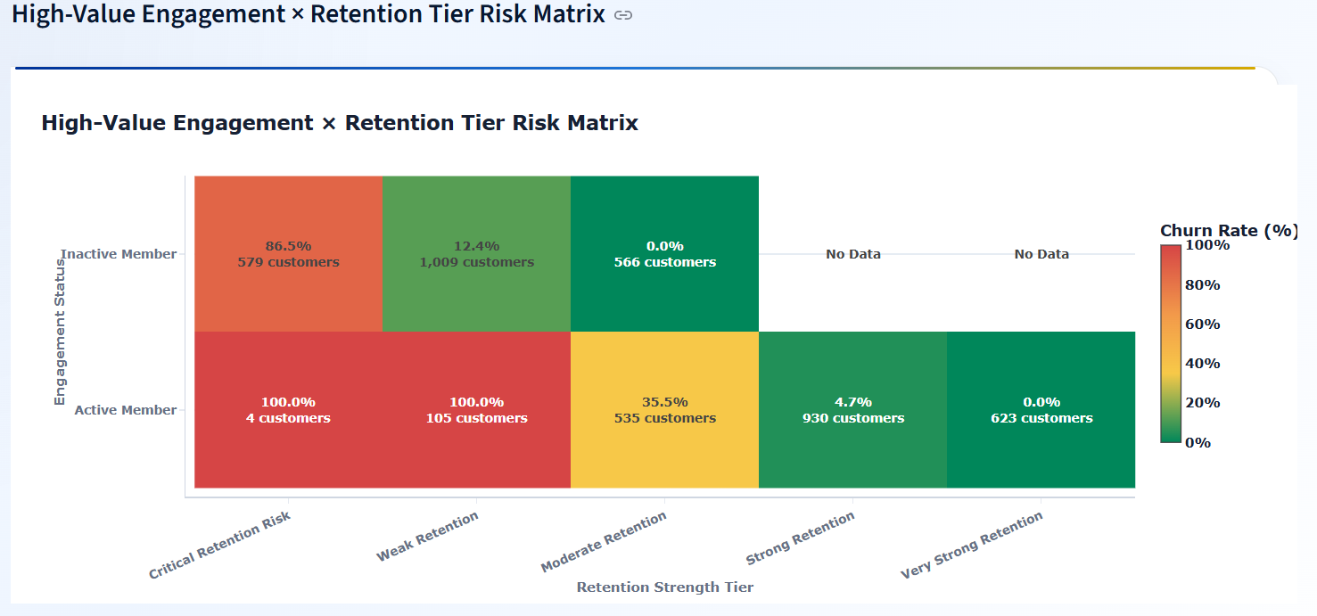
Figure 18. High-Value Engagement x Retention Tier Risk Matrix.
Analyst interpretation
The high-value risk matrix identifies which premium customers require urgent intervention. Critical and weak tiers remain risky even among financially valuable segments.

11.4 Retention Strength Scoring Panels
The retention scoring module converts engagement, product depth, and relationship indicators into a prioritization framework. The most important result is the clear separation between Critical Retention Risk and Very Strong Retention.
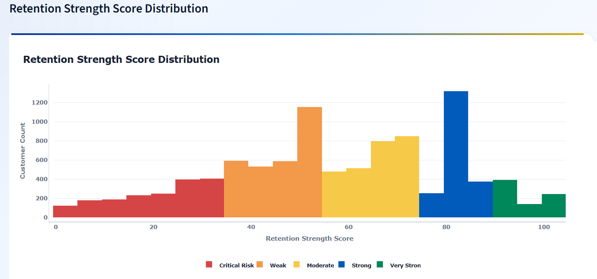
Figure 19. Retention Strength Score Distribution.
Analyst interpretation
The distribution shows how customers are spread across risk and strength ranges, providing a campaign-prioritization view instead of a single churn percentage.

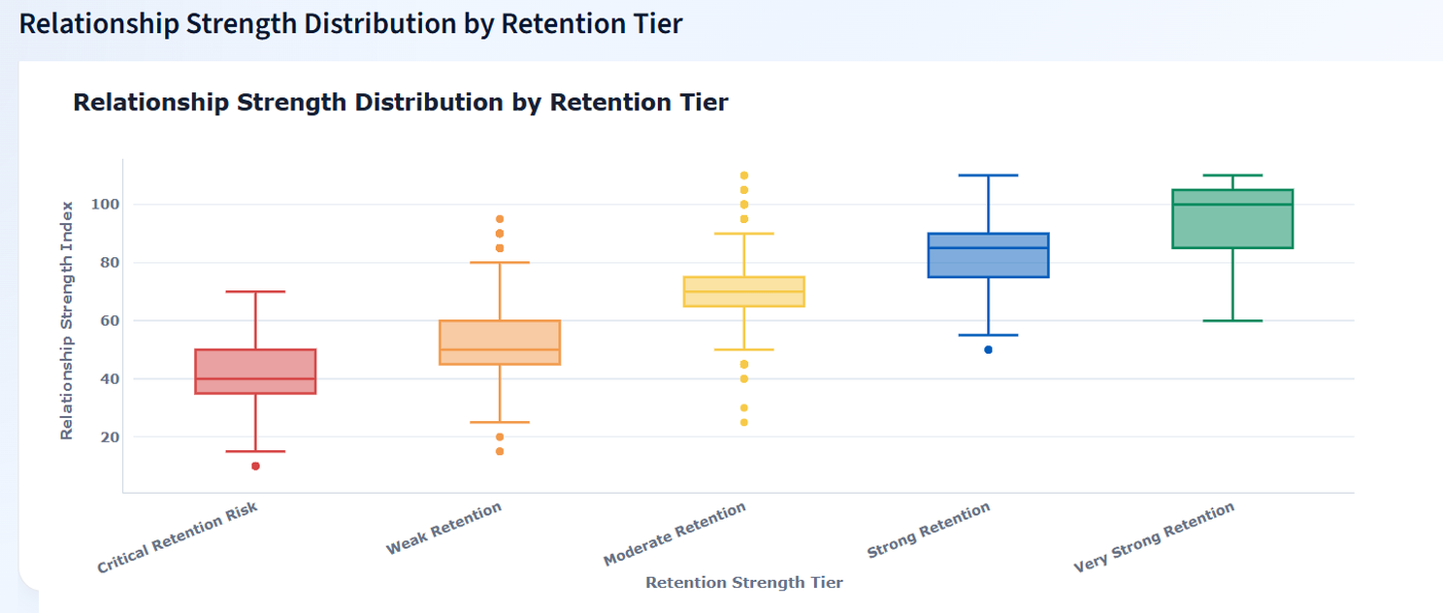
Figure 20. Relationship Strength Distribution by Retention Tier.
Analyst interpretation
Relationship strength rises across retention tiers, confirming that stronger relationship quality aligns with lower churn risk.

The relationship strength vs retention strength map shows a clear positive pattern between relationship strength index and retention strength score. Churned customers appear across the map, but stronger relationship and retention scores are associated with better retention outcomes.
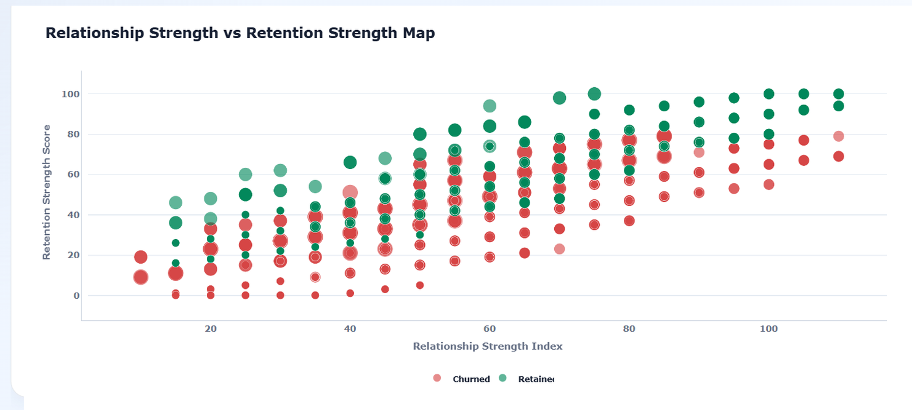
Figure 21. Relationship Strength vs Retention Strength Map.
Analyst interpretation
The scatter map supports a score-based retention strategy: stronger relationship strength should be actively maintained, while low-score customers should receive targeted recovery actions.

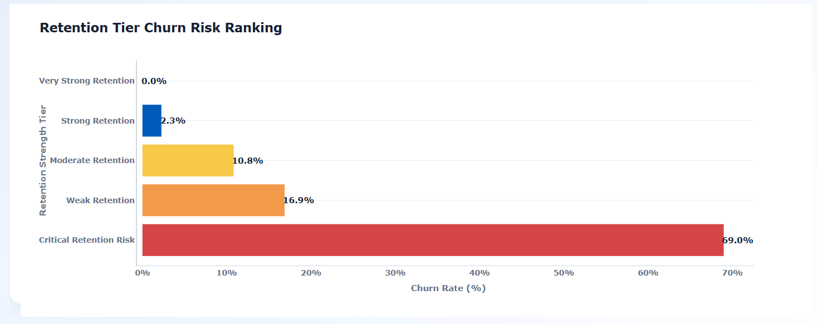
Figure 22. Retention Tier Churn Risk Ranking.
Analyst interpretation
Churn risk falls from 69.0% in Critical Retention Risk to 0.0% in Very Strong Retention, proving that retention tiers separate risk meaningfully.

12. Findings and Insights
The dashboard evidence supports seven major findings. These findings should guide retention strategy design, customer prioritization, cross-sell planning, and premium-customer recovery actions.
Finding | Evidence | Insight | Business Meaning
Engagement matters | Inactive Members contribute 63.9% of churn | Inactive customers are the largest churn contributors. | Reactivation should be a first-priority retention campaign.
Active customers retain better | Active Member retained rate 85.73%; retention gap 12.58 pp | Active membership is linked with stronger loyalty. | Engagement programs can support retention quality.
Product depth has an optimal zone | 2 products show 92.42% retention | Cross-sell is most valuable when it creates useful relationship depth. | Product bundling should target two-product pathways.
Single-product customers are vulnerable | Single-product churn rate 27.71% | Shallow relationships carry higher churn exposure. | Single-product customers need bundled offers and engagement nudges.
High-value disengagement is serious | 2,154 high-value disengaged customers; 49.51% rate | Financial value does not guarantee loyalty. | Premium recovery programs should prioritize disengaged high-value customers.
Balance exposure is large | 232,942,972 balance at risk | Silent churn can affect valuable balances. | High-value outreach should be linked to relationship managers.
Retention scoring works | Critical tier churn 69.0%; Very Strong tier 0.0% | Scoring separates high-risk from sticky customers. | Campaign priority should be based on retention tier.

Synthesis
The central insight is that retention strategy should combine engagement status, product depth, value exposure, and scoring. Using any one signal alone can be misleading: high balance can hide disengagement, product count can hide product-load risk, and overall retention can hide critical micro-segments.

13. Actionable Recommendations
The recommendations translate dashboard evidence into retention strategy actions. The focus is on customer prioritization, reactivation, product bundling, premium relationship recovery, and score-based campaign governance.
Priority | Recommendation | Evidence | Target Stakeholder
High | Launch inactive-member reactivation campaigns using personalized engagement nudges. | Inactive Members contribute 63.9% of churn. | Retention marketing / CRM team
High | Create premium disengagement recovery program for high-value disengaged customers. | 2,154 high-value disengaged customers and 232,942,972 balance at risk. | Relationship managers / premium banking
High | Use retention strength tiers to prioritize outreach queues. | Critical Retention Risk churn is 69.0%. | Customer success / retention operations
Medium | Promote two-product relationship bundles as an optimal product-depth pathway. | 2-product customers show 92.42% retention. | Product and cross-sell strategy teams
Medium | Monitor 3-product and 4-product customers for product-load friction. | 3-product and 4-product groups show high churn. | Product governance / risk analytics
Medium | Use credit-card customers for loyalty and engagement initiatives. | Credit Card Stickiness Score is 79.82%. | Card product / loyalty teams
Medium | Track salary-balance mismatch as a premium-risk investigation signal. | Mismatch bubble map shows differentiated churn patterns. | Analytics and relationship management teams

13.1 90-Day Retention Action Roadmap
Timeline | Action | Expected Output
Days 1-30 | Segment inactive, high-value, single-product, and critical-risk customers. | Target lists for retention campaigns.
Days 31-60 | Launch reactivation, product bundling, and premium recovery campaigns. | Early engagement and offer-response evidence.
Days 61-90 | Track retention score movement, churn reduction, and product adoption changes. | Closed-loop retention measurement dashboard.

Recommended governance cadence
Retention leaders should review high-value disengagement, inactive-member churn contribution, product-depth risk, and retention-tier movement monthly. Critical-risk and high-value disengaged customers should be reviewed more frequently during campaign periods.

14. Dashboard Implementation
The dashboard is implemented using Streamlit with Python, Pandas, NumPy, and Plotly. It loads a final master dataset, validates required raw and derived fields, applies user filters, recalculates KPIs dynamically, and renders four evidence-based modules aligned with the project guidelines.
Dashboard Feature | Implementation Role | Research Value
Required column validation | Checks raw and derived columns before rendering. | Protects metric reliability and reproducibility.
Binary validation | Validates HasCrCard, IsActiveMember, and Exited values. | Reduces classification risk in KPI calculation.
Engagement filter | Filters Active Member and Inactive Member segments. | Enables engagement-specific retention comparison.
Product count slider | Filters customers by number of products. | Supports product-depth scenario analysis.
Balance and salary thresholds | Filters high-value and financial-profile groups. | Supports premium-risk investigation.
Dynamic KPI recalculation | Recomputes KPI values for the selected customer base. | Makes dashboard filter-aware and decision-ready.
Four-module structure | Engagement, product utilization, premium risk, retention scoring. | Matches project requirements and research sections.
Plotly visual layer | Charts, donut, heatmaps, bubble maps, treemap, histogram, box plot. | Provides multiple evidence types for research interpretation.

The dashboard architecture is aligned with the project requirements: engagement filters, product count sliders, balance and salary thresholds, and four core analytical modules. The implementation supports both executive summary interpretation and deeper diagnostic analysis.

15. Data Interpretation Governance
Interpretation governance is required because customer-retention dashboards can be misused when visual evidence is treated as causal proof or when small segments are interpreted without sample-size caution. This paper treats the dashboard as a decision-support system rather than an automated final judgment layer.
Governance Rule | Reason | Practical Application
Do not treat correlation as causation | The dataset is observational. | Use language such as associated with or linked with, not caused by.
Interpret 4-product churn with sample-size caution | Small groups can create extreme rates. | Review customer counts before designing broad product policy.
Combine engagement and product depth | Product count alone is incomplete. | Use product depth with engagement status and retention tier.
Use high balance with engagement status | Financial value does not guarantee loyalty. | Prioritize high-value disengaged customers.
Use retention tiers for prioritization | Scores guide campaign urgency. | Do not use score as the only customer decision rule.
Recalculate KPIs after filters | Dashboard values are filter-aware. | Document selected filters when publishing screenshots.

Publishing note
When publishing this paper with dashboard screenshots, include the dataset version, dashboard version, filter state, and interpretation boundaries. This protects against misreading static screenshots as universal customer-level conclusions.

16. Conclusion
This research paper demonstrates that customer retention can be evaluated more effectively when churn is framed as a behavioral and relationship-strength problem. Engagement status, product depth, high-value disengagement, credit-card stickiness, and retention scoring collectively provide a richer retention strategy framework than generic churn reporting.
The most important finding is that inactive customers contribute most of total churn, while high-value disengagement creates a major premium-risk exposure. Product analysis shows that two-product customers have the strongest retention profile, but higher product count is not automatically safer. Retention-tier analysis confirms that critical-risk customers need urgent attention, while very strong retention customers represent the most stable loyalty profile.
The final recommendation is to use this dashboard as a retention decision-support system. Banks should use engagement recovery, targeted product bundling, premium customer outreach, and retention-tier prioritization to move from broad churn prevention to precise, data-driven customer relationship management.

16.1 Final Decision Summary
Decision Area | Final Research Reading | Action Priority
Engagement | Inactive behavior is the largest churn-contribution signal. | High
Product utilization | Two-product depth appears strongest, while excessive product load requires review. | High
Premium risk | High-value disengagement creates major financial exposure. | High
Retention scoring | Tier-based scoring separates critical-risk customers from sticky customers. | High
Governance | Insights should be used for prioritization, not causal or automated final judgment. | Medium

Final readiness note
This paper is ready for professional portfolio use, internship submission, GitHub documentation, LinkedIn project storytelling, and Zenodo-style research repository packaging. A peer-reviewed academic manuscript would require formal literature review expansion, causal validation, and journal-specific formatting.

17. References
Reference | Type | Use in Research Paper
Project Guidelines: Customer Engagement & Product Utilization Analytics for Retention Strategy. Prepared for the applied data analytics project. | Project source | Defines objectives, KPIs, methodology, dashboard requirements, and deliverables.
Dashboard source file: app.py for Customer Engagement & Product Utilization Analytics Streamlit dashboard. | Technical artifact | Supports methodology, KPI logic, filters, validation, and dashboard implementation.
Python Software Foundation. Python documentation. | Technical documentation | Programming language and analytical workflow.
Pandas development team. Pandas documentation. | Technical documentation | Data loading, cleaning, grouping, aggregation, and feature engineering.
NumPy developers. NumPy documentation. | Technical documentation | Numeric calculations and safe KPI computation.
Plotly Technologies Inc. Plotly Python documentation. | Technical documentation | Interactive dashboard visualizations and analytical charts.
Streamlit documentation. | Technical documentation | Dashboard application framework and user controls.
Customer churn analytics and CRM retention strategy literature. | Domain reference | Supports the business interpretation of engagement, product usage, and retention strategy.

Note: This applied research paper uses internal project guidelines, dashboard implementation artifacts, and dashboard screenshots as primary evidence. External references should be expanded if the paper is later converted into a peer-reviewed journal-style manuscript.

18. Appendix

18.1 KPI Formula Register
KPI | Formula | Decision Use
Engagement Retention Ratio | Active Member Retention Rate / Inactive Member Retention Rate | Compare active vs inactive retention quality.
Product Depth Index | Retained Avg NumOfProducts / Overall Avg NumOfProducts x 100 | Assess whether retained customers hold deeper product relationships.
High-Balance Disengagement Rate | High Value Disengaged Customers / High Value Customers x 100 | Detect premium customers who are valuable but behaviorally weak.
Credit Card Stickiness Score | Retention Rate among customers with a credit card | Evaluate whether card ownership is associated with customer stickiness.
Relationship Strength Index | Average Relationship_Strength_Index | Summarize customer relationship quality across the filtered base.

18.2 Figure Register
Figure | Evidence Source | Research Placement
Figure 1 | Screenshot 1 | KPI Cards
Figure 2 | Screenshot 2 | Engagement Overview
Figure 3 | Screenshot 1 | KPI Formula Reference
Figure 4 | Screenshot 2 | Engagement Retention Snapshot
Figure 5 | Screenshot 6 | Product Utilization Snapshot
Figure 6 | Screenshot 11 | High-Value Disengaged Snapshot
Figure 7 | Screenshot 16 | Retention Strength Snapshot
Figure 8 | Screenshot 3 | Engagement Outcome Split
Figure 9 | Screenshot 4 | Churn Contribution Share
Figure 10 | Screenshot 5 | Engagement x Retention Risk Matrix
Figure 11 | Screenshot 7 | Product Count Impact
Figure 12 | Screenshot 8 | Single vs Multi-Product Split
Figure 13 | Screenshot 9 | Product Relationship Bubble Map
Figure 14 | Screenshot 10 | Product Depth Risk Matrix
Figure 15 | Screenshot 12 | High-Value Segment Mix
Figure 16 | Screenshot 13 | Balance Exposure
Figure 17 | Screenshot 14 | Salary-Balance Mismatch Bubble Map
Figure 18 | Screenshot 15 | High-Value Retention Risk Matrix
Figure 19 | Screenshot 17 | Retention Score Distribution
Figure 20 | Screenshot 18 | Relationship Strength Distribution
Figure 21 | Screenshot 19 | Relationship vs Retention Strength Map
Figure 22 | Screenshot 20 | Retention Tier Churn Risk Ranking

18.3 Dashboard Module Register
Dashboard Module | Required by Guidelines | Research Section
Engagement vs Churn Overview | Yes | Results Section 11.1 and EDA Section 10.1
Product Utilization Impact Analysis | Yes | Results Section 11.2 and EDA Section 10.2
High-Value Disengaged Customer Detector | Yes | Results Section 11.3 and Findings
Retention Strength Scoring Panels | Yes | Results Section 11.4 and Recommendations

18.4 Publication Metadata
Metadata Field | Value
Author | Mohit Gupta
Research Paper Title | Customer Engagement & Product Utilization Analytics for Retention Strategy
Project Domain | Banking retention analytics / customer churn analytics
Recommended Keywords | customer retention analytics; banking churn analysis; product utilization; high-value disengagement; relationship strength scoring; Streamlit dashboard
Recommended Repository Assets | Research paper DOCX/PDF, dashboard app.py, project guidelines, screenshots, processed dataset summary, README, requirements.txt
Source Integrity Note | Metrics and visuals are based on the uploaded project guidelines, app.py implementation, and 20 dashboard screenshots provided for this research paper.

18.5 Repository Packaging Checklist
Asset | Purpose | Status Recommendation
Research paper DOCX and PDF | Main publication artifact for review and upload. | Include final version only.
Dashboard app.py | Reproducible dashboard implementation. | Include with requirements.txt and README.
Project Guidelines | Business problem and project requirements. | Reference as source artifact.
Screenshot evidence pack | Dashboard visual evidence used in the paper. | Store in a clearly named folder.
Processed dataset summary | Explains derived variables and master dataset fields. | Include if dataset sharing is allowed.
README file | Public-facing project explanation. | Summarize problem, KPIs, dashboard modules, and key findings.

Final source integrity statement
The document intentionally separates dashboard evidence from causal claims. The metrics, charts, and recommendations are based on the uploaded dashboard artifacts and should be read as applied decision-support evidence for retention strategy design.

