Product Line Profitability & Margin Performance Analysis
for Nassau Candy Distributor
Data Analytics Research Paper and Dashboard-Based Profitability Study
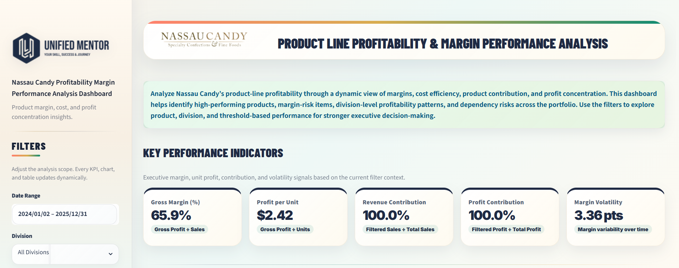
Figure 1. Dashboard header and KPI overview used as the visual context for the study
Document Element | Details
Author | Mohit Gupta
Project Domain | Product profitability analytics, gross margin analysis, cost efficiency, and business intelligence dashboarding
Analytical Scope | Product-level profitability, division performance, margin risk, cost-to-sales diagnostics, and Pareto profit concentration
Tools Used | Python, Pandas, NumPy, Plotly, Streamlit, CSV-based analytical datasets
Company | Unified Mentor Private Ltd

KPI Snapshot | Observed Value | Executive Meaning
Gross Margin | 65.9% | The default portfolio view shows strong gross profitability after cost deduction.
Profit per Unit | $2.42 | Each unit contributes positive gross profit, supporting product-level margin health.
Cost-to-Sales Ratio | 34.1% | Approximately one-third of sales value is absorbed by cost in the visible portfolio.
Products Below Threshold | 1 | Only one product falls below the selected 30% gross-margin benchmark.
Top 5 Product Profit Share | 95.1% | A small set of products drives almost the entire profit base, creating moderate dependency risk.

Research Paper Scope: This document converts the interactive Streamlit dashboard into a structured research paper containing executive summary, methodology, data governance, limitations, EDA, result analysis, findings, actionable recommendations, dashboard implementation, references, and appendix support. The format is intentionally simple, clean, readable, and content-rich rather than over-designed.

1. Executive Summary / Abstract
This research paper presents a comprehensive product profitability analysis for the Nassau Candy Distributor dataset. The study evaluates whether product lines are generating healthy gross profit, whether sales performance is aligned with margin performance, and whether the organization is exposed to concentration or margin-risk issues. The analysis is framed for executive decision-makers who need a clear and evidence-based view of product portfolio strength, pricing quality, cost efficiency, and profit dependency.
The central finding is that the visible product portfolio is financially strong at the aggregate level, with a gross margin of 65.9%, profit per unit of $2.42, and a cost-to-sales ratio of 34.1%. These values indicate that the default portfolio view is not structurally weak; however, the distribution of profit is highly concentrated. The top product contributes 20.7% of profit, the top three products contribute 59.3%, and the top five products contribute 95.1%. This pattern means that the portfolio is profitable, but management should not confuse overall margin strength with diversified profit resilience.
The analysis also identifies Kazookles as the primary margin-risk product under the selected 30% margin threshold. Kazookles records a gross margin of only 7.7%, which is materially below the benchmark and indicates a product-level margin quality issue. At the same time, the revenue at risk is $1,206 and the profit at risk is $93, which means the issue is localized rather than system-wide. This distinction is important because it prevents management from overreacting to a low-margin outlier while still prompting a focused review of pricing, cost, sourcing, packaging, or product continuation strategy.
At the division level, Chocolate is the dominant profit engine. It generates approximately $88.8K in gross profit and maintains a strong division margin profile, while Other and Sugar operate at a much smaller scale. This evidence supports a differentiated product portfolio strategy: protect and scale the strongest profit drivers, review low-margin exceptions, and develop secondary profit contributors to reduce dependency risk. The dashboard therefore serves not only as a visual reporting tool but as a business intelligence system for profitability governance.
Executive Question | Evidence from Dashboard | Strategic Takeaway
Is the product portfolio profitable? | Gross margin is 65.9% and profit per unit is $2.42. | The portfolio is profitable in the default filter view and has a stable margin base.
Where is margin risk visible? | One product is below the 30% margin threshold; Kazookles has 7.7% margin. | Margin risk is localized and should be reviewed through pricing and cost diagnostics.
Is profit diversified? | Top 5 products contribute 95.1% of profit. | Profit concentration is high; dependency monitoring is required.
Which division anchors performance? | Chocolate generates approximately $88.8K profit and has the strongest financial presence. | Chocolate should receive priority in inventory, promotion, and supply continuity planning.
What should management do next? | Dashboard evidence links margin, cost, product rank, and concentration risk. | Adopt monthly margin governance and protect core profit drivers while reviewing low-margin products.

The strategic recommendation is not to remove low-margin products automatically, nor to focus only on high-revenue products. The correct approach is product portfolio governance: classify products as protect, grow, improve, monitor, or rationalize based on gross margin, profit contribution, cost-to-sales ratio, dependency role, and operational importance. This paper demonstrates how exploratory data analysis, KPI measurement, dashboard interactivity, and Pareto profit concentration can create a rigorous product profitability framework for distribution analytics.

2. Table of Contents
Section | Primary Focus | Main Output
1. Executive Summary / Abstract | C-level summary of problem, findings, and strategic implications. | Executive interpretation of profitability, risk, and dependency.
2. Table of Contents | Reader navigation and report structure. | Clear research paper roadmap.
3. Introduction | Why product profitability analytics matters. | Research context and analytical purpose.
4. Background and Context | Business context, dashboard modules, and product portfolio logic. | Operational setting and decision environment.
5. Problem Statement | Visibility gaps in product margin and profit contribution. | Research questions and decision problem.
6. Dataset Overview | Dataset fields, granularity, time frame, and analytical variables. | Data dictionary and analytical scope.
7. Methodology and Data Governance | Data cleaning, preprocessing, KPI engineering, and analytical models. | Reproducible analytical workflow.
8. Data Limitations and Scope | Transparency on boundaries, assumptions, and non-causal interpretation. | Credibility and responsible interpretation.
9. Key Performance Indicators | KPI formulas and dashboard values. | Measurement framework for profitability.
10. Exploratory Data Analysis | Product, division, cost, margin risk, and Pareto exploration. | EDA evidence and pattern discovery.
11. Result and Analysis | Detailed evidence from dashboard visuals and charts. | Empirical interpretation of all figures.
12. Findings and Insights | Evidence-to-insight conversion. | Senior analyst interpretation.
13. Actionable Business Recommendations | Strategic next steps linked to evidence. | Prioritized management action plan.
14. Dashboard Implementation | Streamlit application architecture and analytical traceability. | Technical-business linkage.
15. Data Interpretation Governance | Rules for interpreting metrics, thresholds, and dashboard outputs. | Analytical discipline and review cadence.
16. Conclusion | Final synthesis and future research directions. | Publication-ready closure.
17. References | Project, tool, and analytical references. | Citation support.
18. Appendix | Formula register, figure register, metadata, and source integrity note. | Supplementary documentation.

The document is structured to move from business context to technical methodology, then from exploratory evidence to decision recommendations. This sequence ensures that the reader does not see isolated dashboard screenshots; each visual is converted into analytical meaning and managerial relevance. The report follows a standard corporate research layout with high text visibility, large charts, readable tables, and restrained formatting.

3. Introduction
Product profitability analysis is one of the most important forms of business intelligence in distribution, retail, and fast-moving consumer goods environments. Sales volume and revenue provide useful commercial signals, but they are incomplete when evaluated without cost and margin context. A product can appear successful because it generates high sales, yet it may erode portfolio profitability if cost is disproportionately high, profit per unit is weak, or the product requires operational support that is not reflected in revenue alone.
For Nassau Candy Distributor, the analytical challenge is to understand which products genuinely create financial value, which divisions operate as profit anchors, and which products require pricing, sourcing, or rationalization review. The dataset includes product sales, cost, units, gross profit, product names, divisions, dates, shipping fields, and customer geography. This allows the analysis to move beyond static reporting and develop a multi-dimensional profitability view that combines gross margin analytics, cost-to-sales diagnostics, product contribution analysis, margin risk monitoring, and Pareto profit concentration.
The research objective is to convert dashboard outputs into a formal data analytics report that can support business decision-making and public portfolio publication. The analysis uses exploratory data analysis, descriptive analytics, diagnostic analytics, threshold-based risk detection, and dashboard-driven scenario analysis. The study does not claim causal inference; instead, it provides an evidence-based decision framework for monitoring product profitability and identifying risk signals.
The paper is designed for senior analysts, business managers, portfolio owners, and stakeholders who need to translate data into action. It uses the language of product profitability analysis, gross margin analytics, data-driven decision-making, KPI monitoring, and Streamlit business intelligence dashboards. The purpose is not only to report values but to explain what those values mean, why they matter, and how they should influence operational and strategic decisions.
Analytical Contribution | Description | Decision Value
Revenue-to-profit reframing | The study evaluates profitability rather than relying only on sales value. | Prevents high-revenue but low-margin products from being misclassified as strong performers.
Product-level margin intelligence | Each product is evaluated using gross profit, margin, and contribution metrics. | Supports pricing, cost control, and portfolio classification.
Division-level profitability view | Chocolate, Other, and Sugar divisions are compared by revenue, profit, and margin. | Identifies the strongest financial anchor and weaker categories.
Risk monitoring layer | A dynamic margin threshold identifies products below the selected benchmark. | Creates practical monitoring for margin deterioration.
Pareto concentration analysis | Profit dependency is assessed using cumulative profit share. | Shows whether the business relies too heavily on a small product group.

4. Background and Context
Nassau Candy Distributor operates in a product portfolio environment where multiple product lines and divisions contribute to overall financial performance. The project guidelines define the core business challenge clearly: distributors cannot rely on sales volume alone because some products may sell well while generating weak margins or consuming disproportionate manufacturing and operational cost. The company therefore needs visibility into which products truly drive profit, which divisions underperform financially, and where pricing or product rationalization decisions may be required.
The dashboard environment created for this project is designed around four major analytical modules: Product Profitability Overview, Division Performance Dashboard, Cost vs Margin Diagnostics, and Profit Concentration Analysis. Together, these modules convert raw transaction-level or product-level data into a decision-support system. The product profitability view identifies top and bottom contributors; the division performance view evaluates category-level financial strength; the cost diagnostics view identifies cost-heavy and margin-poor products; and the Pareto view exposes whether the portfolio depends too heavily on a small number of products.
The business context requires both operational interpretation and strategic interpretation. Operationally, managers need to know which products require repricing, cost renegotiation, promotion review, or discontinuation evaluation. Strategically, the organization needs to know whether profit is diversified across a balanced portfolio or concentrated in a narrow group of products. This distinction is central because a portfolio can show strong gross margin while still being vulnerable to disruption if the majority of profit depends on a handful of products.
Dashboard Module | Analytical Purpose | Business Question Answered
Product Profitability Overview | Ranks products by gross profit, gross margin, and profit share. | Which products are the strongest profit drivers?
Division Performance Dashboard | Compares revenue, gross profit, and margin distribution by division. | Which division anchors financial performance?
Cost vs Margin Diagnostics | Analyzes cost-to-sales ratio and margin-risk flags. | Which products are cost-heavy or margin-poor?
Margin Threshold Risk Monitor | Tracks products below a selected margin benchmark. | How much revenue or profit is exposed to low-margin products?
Profit Concentration Analysis | Uses Pareto logic and dependency indicators. | Is profit overly dependent on a small number of products?

This context positions the project as an applied data analytics study rather than a simple dashboard demonstration. The dashboard is the evidence layer, while the research paper provides the interpretation layer. The combined output gives stakeholders both interactive analytics and a formal narrative explaining how the evidence should be used.

5. Problem Statement
The core problem is the absence of a structured product-line profitability view. Without integrated margin analytics, product contribution measurement, and cost diagnostics, the organization may make pricing, promotion, sourcing, or product portfolio decisions based on incomplete signals. Revenue alone can mask low-margin products, and aggregate profitability can hide product-level outliers or concentration risks.
The project guidelines identify four major visibility gaps: the organization lacks clarity on which product lines deliver the highest gross margin, whether high-sales products are actually profitable, how profitability varies across product divisions, and which products represent margin risk. These gaps create a practical business risk: management may overinvest in products that look attractive from a sales perspective but contribute weak gross profit, or underprioritize products that quietly generate strong margin and portfolio value.
This research paper addresses the problem by developing a dashboard-supported profitability framework. The framework evaluates product performance through multiple lenses: gross margin percentage, profit per unit, revenue contribution, profit contribution, margin volatility, cost-to-sales ratio, threshold-based risk flags, and Pareto profit concentration. The intent is to move decision-making from intuition-based review to data-driven product portfolio governance.
Problem Dimension | Evidence Required | Decision Impact
Product profitability visibility | Gross profit, gross margin, profit per unit, and product contribution. | Determines which products should be protected, promoted, improved, or reviewed.
Revenue-profit misalignment | Revenue vs profit comparison at product and division levels. | Prevents management from treating sales volume as a proxy for profitability.
Margin risk detection | Products below the selected margin threshold and profit/revenue at risk. | Enables targeted repricing, cost review, or rationalization.
Cost structure diagnostics | Cost-to-sales ratio and cost vs sales scatter patterns. | Identifies products where cost load threatens financial efficiency.
Profit concentration risk | Top 1, top 3, top 5, and 80% profit-driver indicators. | Supports portfolio resilience and dependency monitoring.

Research Questions
- Which products generate the highest gross profit and profit share within the current dashboard view?
- Which products fall below the selected gross-margin threshold and therefore represent margin risk?
- Which division contributes the largest share of revenue, gross profit, and margin strength?
- Does the portfolio depend too heavily on a small number of products for most of its profit?
- Which evidence-based actions should management prioritize to improve margin governance and portfolio resilience?
The problem is therefore not simply to describe product performance. The problem is to design a repeatable analytical process that allows decision-makers to identify profit drivers, diagnose weak-margin products, interpret division-level performance, and take targeted action based on empirical evidence.

6. Dataset Overview
The dataset supports a product-line profitability analysis for Nassau Candy Distributor. It contains transactional and product-level fields that allow financial performance to be evaluated across product, division, time, and operational dimensions. The dashboard default date range shown in the screenshots is 2024/01/02 to 2025/12/31, with 15 products and 3 divisions visible in the full portfolio view. The primary financial fields used in the analysis are Sales, Cost, Gross Profit, and Units.
The dataset granularity allows product-level aggregation and division-level aggregation. Product-level granularity is essential for identifying margin-risk products, profit leaders, long-tail products, and Pareto concentration. Division-level aggregation is essential for determining whether portfolio profitability is anchored in a specific division or distributed across categories. The dataset also includes fields such as Order Date, Ship Date, Ship Mode, Customer ID, Country/Region, City, State/Province, Postal Code, Division, Region, Product ID, Product Name, Sales, Units, Gross Profit, and Cost.
In the dashboard implementation, the analysis is supported by multiple processed datasets. The app.py registry includes cleaned_nassau_candy.csv, feature_engineered_nassau_candy.csv, final_feature_engineered_dataset.csv, dashboard_kpi_summary.csv, product_level_analysis.csv, division_level_analysis.csv, cost_sales_scatter_dataset.csv, margin_risk_products.csv, pareto_profit_analysis.csv, dependency_indicators.csv, top_profit_products.csv, bottom_products.csv, top_sales_products.csv, cost_vs_profit_analysis.csv, pareto_sales_analysis.csv, product_margin_leaderboard.csv, and segment_performance.csv. This registry provides traceability between raw data preparation, analytical tables, dashboard modules, and research paper evidence.
Field Group | Example Fields | Analytical Use | Governance Note
Identifier fields | Row ID, Order ID, Product ID, Customer ID | Support record traceability and product-level aggregation. | Unique identifiers should be checked for duplication and consistency.
Date fields | Order Date, Ship Date | Enable time filtering and margin volatility analysis. | Date parsing must be validated to avoid incorrect trend calculations.
Product fields | Product Name, Division | Enable product and division profitability analysis. | Labels should be standardized to avoid split categories.
Financial fields | Sales, Cost, Gross Profit | Support gross margin, profit contribution, and cost-to-sales calculations. | Zero or invalid sales/cost records should be reviewed before KPI calculation.
Volume fields | Units | Support profit per unit and product scale interpretation. | Missing or zero unit values affect unit-level profitability.
Geographic/operational fields | Region, State/Province, Ship Mode | Provide context for downstream operational analysis. | These fields are secondary in this paper but useful for future extensions.

Processed Data Component | Level of Detail | Research Use
dashboard_kpi_summary.csv | Dashboard summary level | KPI snapshot and executive metric reporting.
product_level_analysis.csv | Product level | Gross profit ranking, product margin analysis, and product-level insights.
division_level_analysis.csv | Division level | Revenue vs profit comparison and margin distribution analysis.
cost_sales_scatter_dataset.csv | Product cost-sales level | Cost-to-sales diagnostics and cost-heavy product detection.
margin_risk_products.csv | Risk-flagged product level | Below-threshold product review and profit-at-risk calculation.
pareto_profit_analysis.csv | Product contribution level | Pareto profit concentration and 80% driver identification.
dependency_indicators.csv | Portfolio dependency level | Top product, top 3, top 5, and dependency-risk interpretation.

Dataset Readiness Assessment
The dataset is suitable for descriptive and diagnostic profitability analytics because it includes the minimum financial variables required to evaluate product economics: Sales, Cost, Gross Profit, and Units. It also includes product and division attributes, which allow the analysis to move from overall portfolio performance to product-level and division-level performance. This structure is appropriate for exploratory data analysis because each visual output can be linked back to a defined field group and metric formula.
The dataset is also suitable for dashboard-driven scenario analysis because the date, division, product, and threshold controls can reshape the analytical view without changing the underlying logic. For example, a manager can compare all divisions against a specific division, or compare the full product list against a searched product subset. This interactivity is critical for business intelligence because profitability questions are rarely answered by one static view.
From a governance standpoint, the dataset should be treated as a controlled analytical asset. Any future upload or publication should identify the data version, the dashboard version, and the research paper version together. This ensures that a reader can reproduce the same values, including the 65.9% gross margin, $2.42 profit per unit, 34.1% cost-to-sales ratio, one below-threshold product, and 95.1% top-five profit concentration reported in this paper.
Readiness Check | Reason It Matters | Recommended Control
Financial field completeness | Missing Sales, Cost, Gross Profit, or Units would weaken KPI validity. | Validate non-null and numeric values before dashboard refresh.
Product-label consistency | Inconsistent product names can split one product into multiple analytical rows. | Standardize Product Name and Product ID before aggregation.
Division-label consistency | Incorrect division labels can distort Chocolate, Other, and Sugar comparisons. | Validate division mapping against the product-factory correlation table.
Date parsing | Incorrect dates can distort date range filters and margin volatility. | Parse dates consistently and flag invalid calendar values.
Metric reproducibility | Published KPI values should match dashboard output. | Lock dataset and app.py version before Zenodo upload.

7. Methodology and Data Governance
The methodology follows a structured data analytics workflow that converts raw product and financial data into dashboard-ready profitability intelligence. The workflow includes data collection, cleaning, preprocessing, feature engineering, exploratory data analysis, KPI measurement, diagnostic analytics, risk flagging, and business recommendation development. The objective is not only to calculate metrics but also to ensure that the metrics are reproducible, interpretable, and aligned with decision-making needs.

7.1 Data Collection and Input Structure
The analysis uses the Nassau Candy Distributor dataset and processed dashboard files. The data contains product, division, sales, cost, gross profit, units, and time-based fields. The Streamlit application reads processed CSV files from the data/processed directory and uses them as analytical inputs for KPI cards, charts, filters, and data tables. This architecture separates raw data preparation from dashboard visualization, improving traceability and maintainability.

7.2 Data Cleaning and Validation
The cleaning process validates sales, cost, profit, units, product names, division labels, and date fields. Sales and cost values must be numeric because gross margin, cost-to-sales ratio, and contribution percentages are sensitive to invalid financial values. Zero-sales records require special handling because gross margin is calculated as gross profit divided by sales; division by zero would create invalid or infinite values. Missing unit values must also be reviewed because profit per unit depends directly on valid unit counts.
Product and division labels require standardization because inconsistent strings can split one product into multiple categories. Date parsing is necessary for date filtering and margin volatility measurement. Duplicate records should be reviewed at the order and product level to determine whether they represent legitimate line items or accidental duplication. These governance steps ensure that the dashboard metrics are not merely visually attractive but analytically reliable.

7.3 Preprocessing and Feature Engineering
Feature engineering transforms financial fields into decision-ready profitability measures. Gross margin percentage is calculated as Gross Profit divided by Sales. Profit per unit is calculated as Gross Profit divided by Units. Revenue contribution is calculated as filtered sales divided by total sales. Profit contribution is calculated as filtered profit divided by total profit. Cost-to-sales ratio is calculated as Cost divided by Sales. Margin volatility is calculated from margin movement over time. Margin risk flags are assigned when a product falls below the selected threshold, which is 30% in the dashboard screenshots.

7.4 Analytical Models Used
The project uses descriptive analytics to summarize profitability, diagnostic analytics to explain margin and cost behavior, exploratory data analysis to identify product and division patterns, threshold-based classification to detect margin risk, and Pareto concentration analysis to measure product dependency. Regression, clustering, and predictive modeling are not applied in the current version because the research objective is diagnostic and dashboard-based rather than causal or predictive. These methods are recommended as future extensions once additional variables such as price changes, promotions, customer segments, supplier cost, and inventory cost become available.

7.5 Tools and Libraries
The analytical environment uses Python for data processing, Pandas for tabular transformation and aggregation, NumPy for numerical calculations, Plotly for interactive visualizations, and Streamlit for the dashboard application. This toolchain is appropriate for a business intelligence project because it supports rapid exploration, reusable computations, dynamic filters, responsive dashboard layouts, and reproducible evidence generation.
Methodological Step | Technique | Output | Business Purpose
Data validation | Type checks, missing value review, zero-sales handling, label standardization. | Clean analytical dataset. | Prevents misleading KPI calculations.
Feature engineering | Gross margin, profit per unit, contribution, cost-to-sales ratio. | Product and division profitability metrics. | Creates comparable profitability measures.
EDA | Product ranking, division comparison, scatter diagnostics, Pareto analysis. | Pattern discovery and outlier detection. | Identifies where management attention is required.
Risk classification | Threshold-based margin flagging. | Products below margin benchmark. | Supports targeted cost and pricing review.
Dashboard analysis | Interactive filters, dynamic cards, Plotly visuals. | Scenario-based decision support. | Allows stakeholders to test views by date, division, product, and threshold.

Governance Position: This paper treats dashboard metrics as decision signals, not as unquestioned truth. Each metric is interpreted with awareness of data granularity, business context, denominator effects, and the difference between correlation and causation.

8. Data Limitations and Scope
A rigorous data analytics report must be transparent about what the data can and cannot prove. This analysis is based on the available Nassau Candy product profitability dataset and the processed files used by the Streamlit dashboard. The results are valid for the selected data scope, dashboard filters, and metric definitions. They should not be interpreted as a full enterprise profitability audit because supplier contracts, customer profitability, inventory carrying cost, discounts, promotions, returns, and overhead allocation are not fully modeled in the dashboard evidence provided.
The analysis is primarily descriptive and diagnostic. It identifies profitability patterns, margin-risk products, cost-to-sales behavior, and profit concentration. It does not claim that a particular product causes high or low profitability in a causal statistical sense. For example, a low-margin product may be explained by price, supplier cost, packaging, promotion strategy, inventory economics, or role in customer acquisition. The current data can identify the symptom and prioritize review, but deeper causal validation would require additional operational and commercial variables.
The selected 30% margin threshold is a managerial benchmark rather than a universal statistical threshold. It is useful for monitoring and classification, but threshold interpretation should be aligned with category strategy. Some low-margin products may be retained for strategic reasons, such as bundle support, customer retention, traffic generation, or supplier relationship value. Therefore, threshold-based risk flags should initiate investigation, not automatic discontinuation.
Limitation | Impact on Analysis | Future Improvement
No supplier-level cost breakdown | The analysis cannot determine whether margin issues originate from supplier pricing, logistics, packaging, or manufacturing cost. | Add supplier cost, freight cost, and procurement terms.
No customer profitability layer | Product profitability cannot be linked to customer segment value or retention impact. | Integrate customer cohorts, order frequency, and customer margin.
No promotion or discount data | High sales or low margin may be influenced by promotional pricing that is not separately modeled. | Add discount, campaign, and promotion variables.
No inventory carrying cost | Gross profit may not fully reflect storage, spoilage, stockout, or holding-cost effects. | Connect product profitability to inventory analytics.
No causal model | Dashboard results show association and pattern, not causal proof. | Use regression, experimental design, or causal inference with richer features.
Default filter context | Screenshots represent the visible dashboard context and selected filters. | Repeat analysis across alternative thresholds, product groups, and time windows.

The scope is therefore intentionally focused: product profitability, division performance, cost efficiency, margin risk, and profit concentration. This scope is appropriate for a dashboard-based research paper and for Zenodo or portfolio publication because it clearly documents the analytical boundaries and avoids overclaiming beyond the available evidence.

9. Key Performance Indicators
The KPI framework translates raw product and financial data into executive-ready measures. These indicators are designed to answer five questions: how profitable the portfolio is, how much profit each unit generates, how much of the total sales/profit is represented by the current filter view, how stable margins are over time, and how much low-margin exposure exists under the selected threshold.
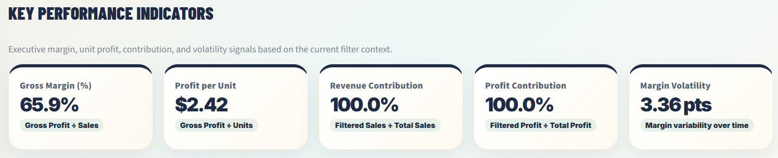
Figure 2. Key Performance Indicators: gross margin, profit per unit, revenue contribution, profit contribution, and margin volatility
KPI | Formula | Dashboard Value | Interpretation | Action Trigger
Gross Margin (%) | Gross Profit ÷ Sales | 65.9% | The visible portfolio generates strong margin after cost deduction. | Investigate if margin falls below target or declines across periods.
Profit per Unit | Gross Profit ÷ Units | $2.42 | Average unit-level profitability is positive. | Review products with low unit profit despite meaningful volume.
Revenue Contribution | Filtered Sales ÷ Total Sales | 100.0% | The current view covers the full sales base under default filters. | Use filters to isolate division or product contribution.
Profit Contribution | Filtered Profit ÷ Total Profit | 100.0% | The current view covers the full profit base under default filters. | Compare product groups to identify profit dependency.
Margin Volatility | Margin variability over time | 3.36 pts | Margins show moderate variability but not severe instability. | Review periods with sudden margin movement or cost pressure.

The gross margin KPI provides the highest-level profitability signal. A value of 65.9% indicates that the portfolio retains a meaningful portion of sales value after cost. However, this aggregate value should not be interpreted as proof that every product is healthy. Portfolio averages can conceal low-margin products, and for that reason the dashboard includes both product-level diagnostics and margin threshold monitoring.
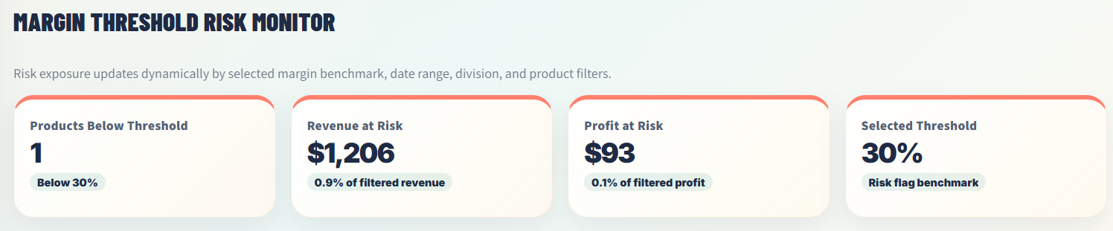
Figure 3. Margin Threshold Risk Monitor showing below-threshold products, revenue at risk, profit at risk, and selected margin benchmark
The margin risk monitor adds governance discipline to the KPI framework. Under a 30% benchmark, only one product is below threshold, with $1,206 in revenue at risk and $93 in profit at risk. This means the margin issue is real but financially contained. A senior analyst would treat this as a targeted review case rather than a broad profitability crisis.
Risk Metric | Observed Value | Meaning for Management
Products Below Threshold | 1 | Only one product requires immediate margin-quality review.
Revenue at Risk | $1,206 | The low-margin exposure is small relative to the full visible portfolio.
Profit at Risk | $93 | The absolute profit exposure is limited, but the product still signals pricing/cost weakness.
Selected Threshold | 30% | The threshold acts as a benchmark for monitoring low-margin products.

KPI Governance Interpretation
The KPI dashboard should be interpreted as a monitoring system rather than a final decision engine. Gross Margin explains overall profitability strength, Profit per Unit explains unit economics, Contribution metrics explain the scope of the current view, and Margin Volatility explains movement over time. The margin risk monitor then adds exception management by isolating products that fail the selected benchmark. These KPIs become most valuable when reviewed together because each metric protects against a different type of misinterpretation.
For example, a high gross margin can hide profit concentration, while a low-margin product can appear alarming even if its revenue and profit exposure are limited. Similarly, a strong profit per unit does not automatically mean that a product contributes heavily to total profit if volume is small. The dashboard therefore encourages balanced analysis: profitability, scale, margin stability, risk exposure, and product contribution should be reviewed as one connected measurement system.
The recommended KPI review cadence is monthly for management reporting and weekly for operational monitoring during promotion periods or cost volatility. Threshold values should be reviewed by category rather than applied blindly to every product. A 30% threshold is a useful default risk benchmark, but products with strategic roles may require contextual interpretation before repricing or rationalization decisions are made.
KPI Governance Question | Metric Used | Decision Discipline
Is the whole portfolio healthy? | Gross Margin and Profit per Unit | Review portfolio profitability before diagnosing individual products.
Is any product financially weak? | Margin Risk Flag and Profit at Risk | Investigate below-threshold products with proportionate urgency.
Is profit overly concentrated? | Top Product, Top 3, Top 5, and Pareto indicators | Protect top drivers and develop secondary contributors.
Are costs absorbing too much value? | Cost-to-Sales Ratio | Review cost-heavy products and supplier terms.

10. Exploratory Data Analysis
Exploratory data analysis is the bridge between raw metrics and business interpretation. In this study, EDA is used to understand the distribution of profit across products, the role of divisions in financial performance, the relationship between cost and sales, the behavior of products below the margin threshold, and the degree of profit concentration within the portfolio. The goal is to identify patterns before jumping to recommendations.

10.1 Product-Level EDA
Product-level EDA shows that profit contribution is not evenly distributed. The leading profit product is Wonka Bar - Scrumdiddlyumptious, and several Wonka chocolate products dominate the top-profit list. This indicates that product profitability is concentrated in a relatively small set of high-performing items. Long-tail products contribute comparatively little profit, which means management should evaluate whether they play a strategic role or simply add complexity.

10.2 Division-Level EDA
Division-level EDA reveals that Chocolate is the dominant division by revenue and gross profit. The division contributes approximately $88.8K in gross profit and has the strongest financial presence in the dashboard. Other and Sugar are smaller in financial scale. This does not mean they should be ignored, but it means their strategic role should be evaluated differently: they may support variety, customer choice, or niche demand, while Chocolate functions as the core profit engine.

10.3 Cost vs Sales EDA
Cost vs Sales EDA evaluates whether products with higher sales also carry proportionate cost. A portfolio-level cost-to-sales ratio of 34.1% indicates reasonable cost efficiency. Most products appear stable, but the analysis identifies Kazookles as the highest cost-risk product because its gross margin is only 7.7%. This is a classic margin-risk signal: the product may not have large absolute exposure, but its unit economics are weak relative to the selected benchmark.

10.4 Margin Risk EDA
The margin risk EDA applies a 30% gross-margin threshold. Under this threshold, only one product is flagged below benchmark. This confirms that the overall margin profile is not broadly damaged. However, the flagged product should still be reviewed because low-margin items can reduce portfolio efficiency, distort promotion decisions, or consume management attention if not monitored. The correct interpretation is targeted intervention, not full portfolio restructuring.

10.5 Pareto and Dependency EDA
Pareto analysis shows that 4 products drive approximately 80% of profit, while the top 5 products contribute 95.1%. This is the strongest structural insight in the project. The business is profitable, but profit is concentrated. Concentration creates dependency risk because a disruption to a few high-profit products could materially affect overall profitability. The dashboard classifies the risk level as Moderate, which is appropriate because concentration is high but the top product alone does not account for a majority of total profit.
EDA Area | Pattern Observed | Evidence | Analytical Meaning
Product-level profitability | Top profit is concentrated in a small group of Wonka products. | Top product profit share is 20.7%. | Product strategy should protect leading profit drivers.
Division performance | Chocolate dominates revenue and profit. | Chocolate gross profit is approximately $88.8K. | Chocolate is the portfolio anchor.
Cost diagnostics | Cost structure is generally controlled but has one weak-margin outlier. | Cost-to-sales ratio is 34.1%; Kazookles margin is 7.7%. | Risk is localized but should be reviewed.
Margin threshold | Only one product falls below 30%. | Products below threshold = 1. | Low-margin exposure is not systemic.
Pareto concentration | Top products drive most profit. | Top 5 products = 95.1% profit share. | Profit dependency requires governance.

EDA Decision Logic
The exploratory analysis shows that the portfolio should be interpreted through a dual lens: profitability strength and portfolio dependency. Gross margin confirms that the current view is financially strong, while Pareto analysis confirms that the profit base is concentrated. These two findings are not contradictory. They describe different dimensions of performance: margin quality shows how efficiently sales convert into profit, while concentration shows how resilient the profit base is if core products face disruption.
The EDA also shows the difference between a product-level exception and a portfolio-level threat. Kazookles is a clear exception because its margin is far below the selected threshold, but the revenue and profit at risk are small. This means the product should be investigated through a focused improvement workflow rather than treated as a major portfolio crisis. A mature analytics function should distinguish between alert severity and financial materiality.
Finally, the EDA confirms that product and division analytics must be reviewed together. The top products are concentrated in the Chocolate division, which means Chocolate is not only a division-level winner but also a product-level dependency zone. A disruption in Chocolate supply, pricing, demand, or promotion strategy would likely have a much larger effect on total profit than a disruption in the smaller long-tail products.
EDA Interpretation Rule | Application in This Study | Management Value
Combine margin and contribution. | High margin and high profit share products receive priority attention. | Prevents focus on margin percentage alone.
Separate exception from systemic risk. | Kazookles is weak-margin but low absolute exposure. | Supports proportionate response.
Track concentration as resilience risk. | Top 5 products drive 95.1% of profit. | Encourages diversification and core-driver protection.
Connect product and division views. | Chocolate dominates both product and division profitability. | Aligns category strategy with financial evidence.

11. Result and Analysis
This section presents the empirical results generated from the dashboard screenshots and supporting processed datasets. Each figure is interpreted as an analytical finding rather than a standalone visual. The result structure follows the dashboard modules: product profitability, division performance, cost diagnostics, margin risk, Pareto concentration, and dependency indicators.

11.1 Dashboard Overview and Analytical Context

Figure 4. Full dashboard overview with filters, KPI cards, and product profitability context
The dashboard overview confirms that the application is structured for interactive business intelligence. It contains date filters, division filters, product search, KPI cards, and analytical modules. This matters because product profitability is not static; managers often need to evaluate profitability by date range, division, product group, and margin threshold. The dashboard gives users a controlled environment to test these different scenarios.

11.2 Product Profitability Overview
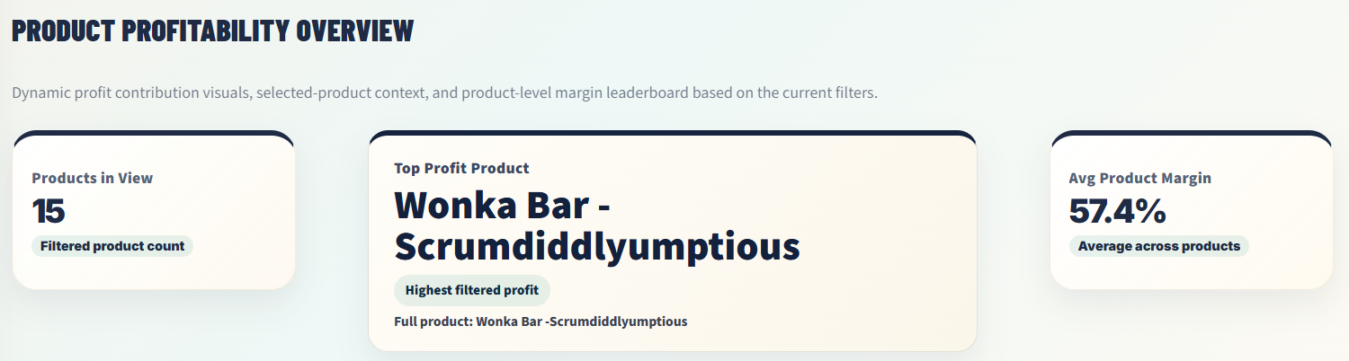
Figure 5. Product Profitability Overview showing products in view, top profit product, and average product margin
The product profitability overview shows 15 products in the current view, identifies Wonka Bar - Scrumdiddlyumptious as the top profit product, and reports an average product margin of 57.4%. This confirms that the portfolio is not only profitable at aggregate level but also has a clear product leader. However, the presence of a top product also introduces dependency considerations because excessive reliance on one or a few products can reduce resilience.
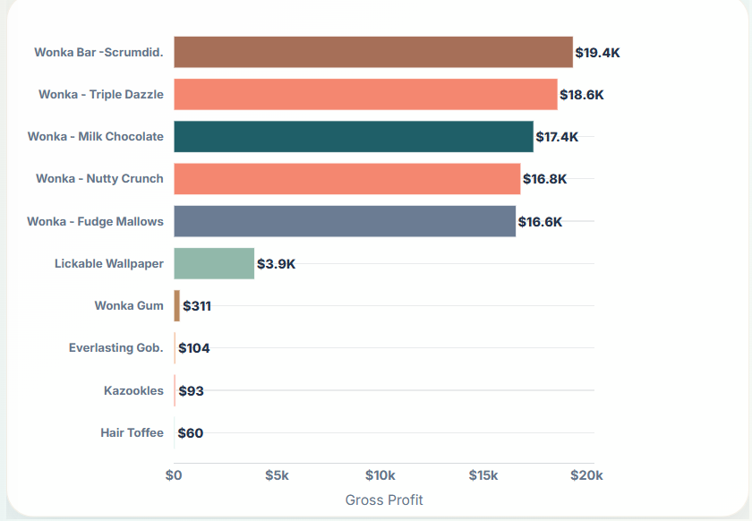
Figure 6. Top products by gross profit
The top product ranking shows a strong profit cluster among Wonka-branded products. Wonka Bar - Scrumdiddlyumptious leads with approximately $19.4K gross profit, followed by Wonka - Triple Dazzle at approximately $18.6K and Wonka - Milk Chocolate at approximately $17.4K. The ranking indicates that a small group of products is responsible for the majority of profit creation. This supports the need for active monitoring of stock availability, supplier continuity, and promotional discipline for these top contributors.
Supporting evidence table: top product contribution and management interpretation.
Product / Group | Observed Profit Signal | Analytical Interpretation | Recommended Management Use
Wonka Bar - Scrumdiddlyumptious | $19.4K gross profit | Highest profit contributor in the current portfolio view. | Protect availability, promotion quality, and margin discipline.
Wonka - Triple Dazzle | $18.6K gross profit | Second strongest profit driver and part of the core profit cluster. | Monitor pricing and avoid unnecessary discount erosion.
Wonka - Milk Chocolate | $17.4K gross profit | Large contribution product that reinforces Chocolate division strength. | Prioritize inventory continuity and product visibility.
Long-tail products | Small individual profit shares | Useful only if they support variety, bundles, or customer choice. | Classify as monitor, improve, or rationalize based on strategic role.
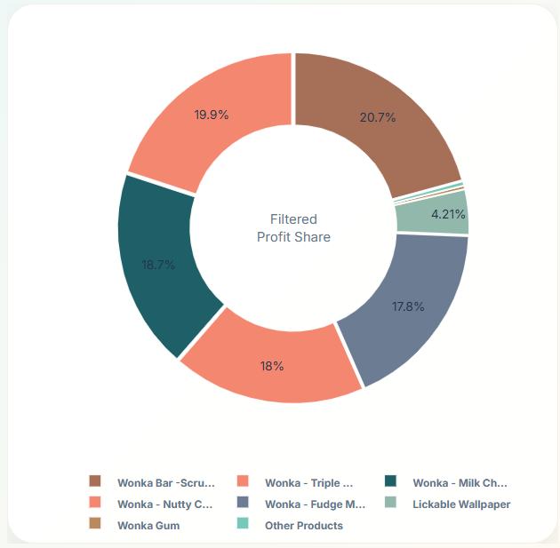
Figure 7. Filtered profit share donut chart
The profit share donut reinforces the concentration pattern. Several products hold large profit shares, while long-tail products occupy very small slices. This visual is useful for executives because it converts product ranking into portfolio share. A product can be high ranking, but the share view shows how much of the portfolio depends on it. In this case, multiple top products contribute meaningful shares, which creates moderate dependency rather than single-product dependency.

11.3 Division Performance Analysis
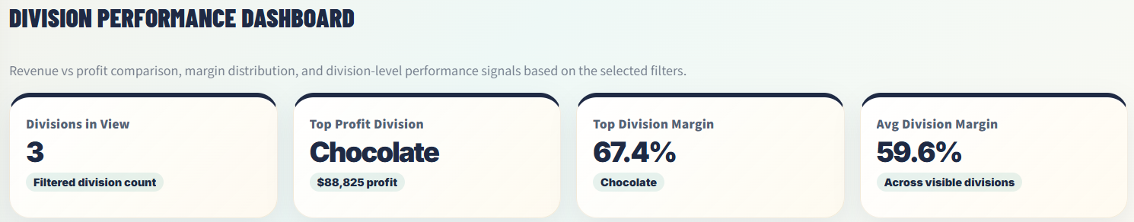
Figure 8. Division Performance Dashboard KPI cards
The division KPI cards show 3 divisions in view, with Chocolate identified as the top profit division. Chocolate generates approximately $88,825 in profit and records the strongest division-level financial contribution. The top division margin is 67.4%, and the average division margin is 59.6%. This establishes Chocolate as the core profit division and creates a clear strategic priority for management.
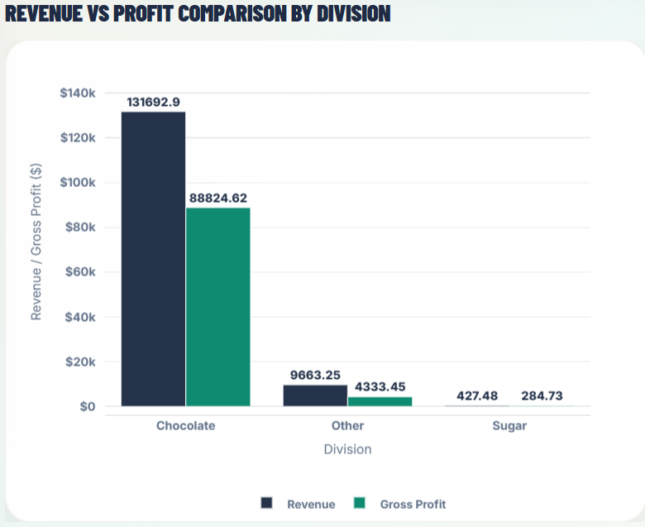
Figure 9. Revenue vs gross profit comparison by division
The revenue vs profit comparison shows that Chocolate has approximately $131.7K in revenue and $88.8K in gross profit, while Other and Sugar are much smaller. This visual confirms that division-level profitability is not evenly distributed. Chocolate is not simply larger by revenue; it also converts that revenue into significant gross profit. From a management perspective, this division should be treated as a strategic profit anchor.
Supporting evidence table: division-level financial interpretation.
Division | Revenue / Profit Evidence | Margin Interpretation | Decision Implication
Chocolate | $131.7K revenue and $88.8K gross profit | Strongest division by scale and contribution. | Treat as the core profit engine and review monthly.
Other | $9.7K revenue and $4.3K gross profit | Smaller scale with wider margin dispersion. | Identify products with growth or improvement potential.
Sugar | $427 revenue and $285 gross profit | Very small contribution in the current view. | Evaluate as niche, support, or rationalization category.
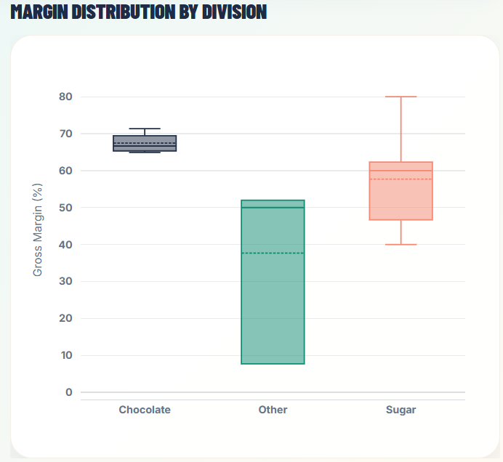
Figure 10. Margin distribution by division
The margin distribution chart adds nuance to the revenue and profit comparison. Chocolate appears to have a relatively strong and stable margin profile, while Other shows wider margin dispersion and Sugar shows a different margin spread. This indicates that division-level analysis should not rely only on total profit; margin variability and distribution matter because they show whether a division is consistently profitable or only profitable because of a few products.

11.4 Cost vs Margin Diagnostics
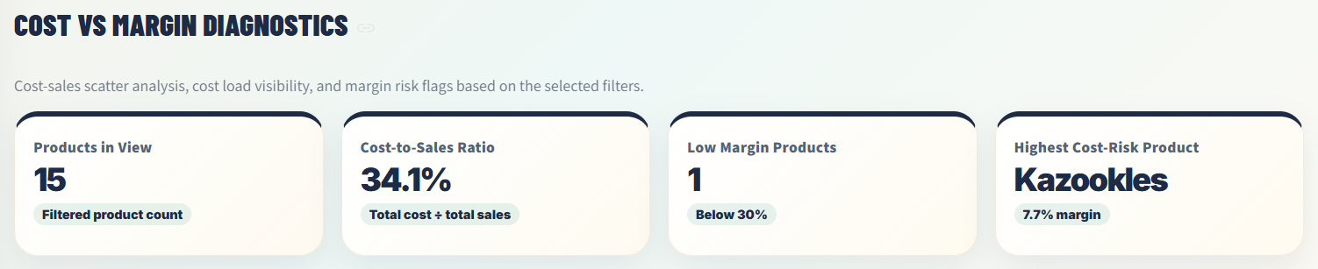
Figure 11. Cost vs Margin Diagnostics KPI cards
The cost diagnostics KPI cards report a cost-to-sales ratio of 34.1%, one low-margin product, and Kazookles as the highest cost-risk product. This confirms that overall cost load is controlled, but a specific product requires attention. The distinction between portfolio-level cost efficiency and product-level cost risk is important because management should avoid broad cost-cutting when the evidence points to a localized margin issue.
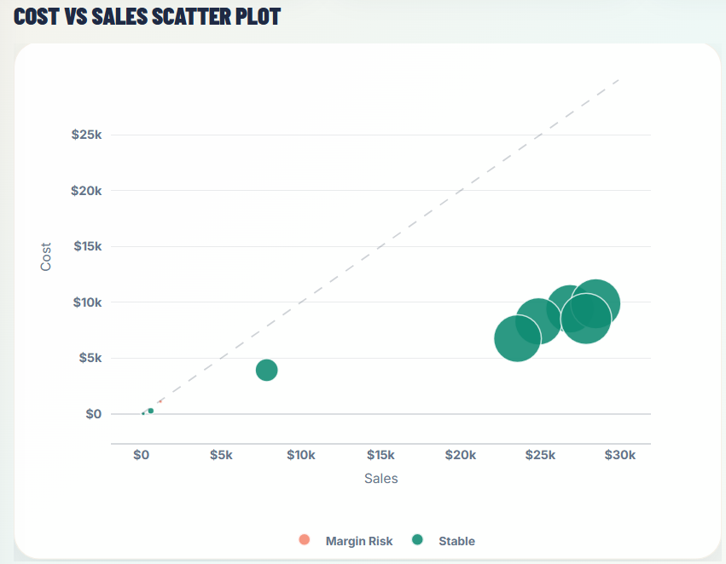
Figure 12. Cost vs Sales Scatter Plot
The cost vs sales scatter plot visualizes cost behavior relative to sales. Products positioned closer to the cost-sales reference line consume a larger share of sales value through cost. Products below the reference line generally retain stronger margin. This chart supports diagnostic analysis because it helps distinguish high-sales/high-cost products from products with healthier cost structures. It also provides an intuitive way to identify whether cost pressure is isolated or widespread.
Supporting evidence table: cost-to-sales diagnostic reading guide.
Diagnostic Signal | How to Read It | Risk Meaning | Recommended Action
Products below the reference line | Sales are materially higher than cost. | Generally healthier cost structure. | Maintain cost discipline and protect margin.
Products close to the reference line | Cost absorbs a large share of sales. | Potential margin pressure. | Review supplier terms, pricing, and packaging cost.
Kazookles risk flag | Gross margin is 7.7% under the 30% benchmark. | Localized product-level margin weakness. | Run focused price/cost recovery review.
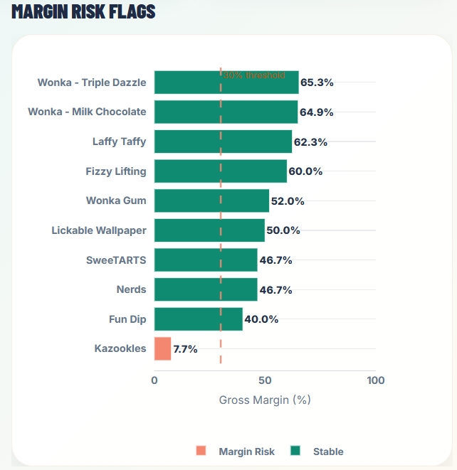
Figure 13. Margin Risk Flags by Product
The margin risk flags chart identifies Kazookles as the only product below the selected 30% threshold, with a gross margin of 7.7%. Other products remain above the threshold and are classified as stable. This is a highly actionable result because it identifies a specific product requiring cost or pricing review. However, because the profit at risk is only $93, the recommendation should be targeted and proportionate rather than disruptive.

11.5 Profit Concentration and Dependency Analysis
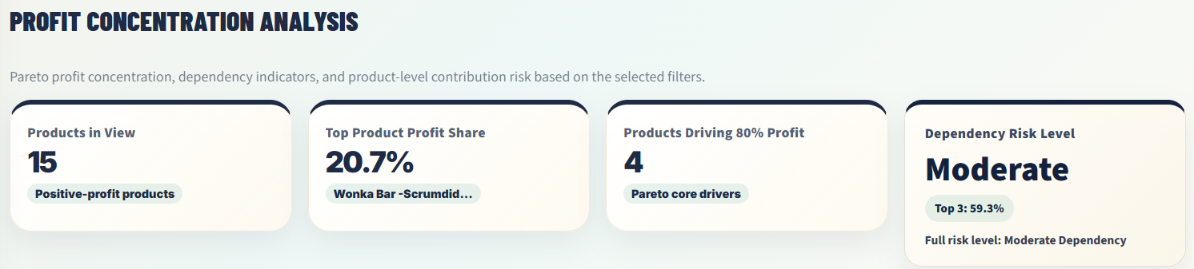
Figure 14. Profit Concentration Analysis KPI cards
The profit concentration KPI cards summarize the portfolio dependency structure. The dashboard shows 15 positive-profit products, top product profit share of 20.7%, 4 products driving 80% of profit, and a dependency risk level of Moderate. This is a senior-level insight because it goes beyond profitability and evaluates resilience. A profitable portfolio can still be vulnerable when profit depends heavily on a small group of products.
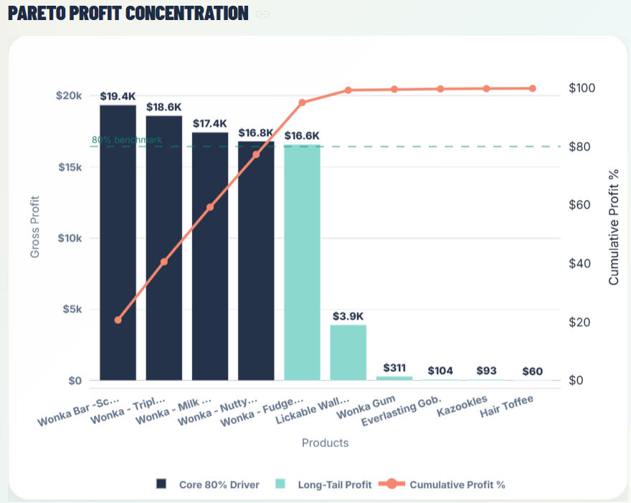
Figure 15. Pareto Profit Concentration
The Pareto chart demonstrates that a few products generate most of the gross profit. The first four products cross the core 80% contribution zone, and the top five products account for 95.1% of profit. This concentration means that product availability, demand volatility, pricing errors, or supplier disruption affecting the top products could materially affect total profitability. The business should therefore protect these core drivers while developing secondary contributors.
Supporting evidence table: Pareto contribution and resilience implications.
Concentration Measure | Observed Value | Meaning | Governance Response
Top product share | 20.7% | No single product dominates the majority of profit. | Monitor but avoid overreaction.
Top 3 product share | 59.3% | A small core group drives more than half of profit. | Protect supply, pricing, and demand continuity.
Top 5 product share | 95.1% | Most profit is concentrated in a narrow product set. | Develop secondary profit drivers and contingency plans.
Products driving 80% profit | 4 products | Core profit base is compact. | Use monthly Pareto governance review.
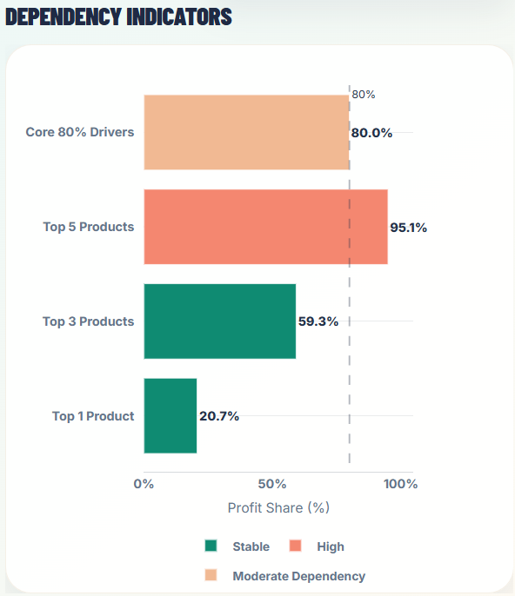
Figure 16. Dependency Indicators showing product profit concentration thresholds
The dependency indicators translate Pareto logic into executive risk language. The top product contributes 20.7%, the top three contribute 59.3%, and the top five contribute 95.1%. The risk is not extreme single-product dependency because no single item controls the majority of profit; however, the business is clearly dependent on a narrow group of products. This supports the dashboard classification of Moderate dependency risk.

11.6 Integrated Result Interpretation
The results show a portfolio with strong profitability but concentrated value creation. Aggregate margin is healthy, cost-to-sales ratio is controlled, and only one product is below the selected threshold. At the same time, profit concentration is high, Chocolate dominates financial performance, and Kazookles requires targeted review. The correct business response is therefore balanced: protect top profit products, govern Chocolate as the profit anchor, investigate Kazookles, and build secondary product drivers to reduce concentration risk.

12. Findings and Insights
This section converts the dashboard evidence into senior data analyst insights. The purpose is to move from observation to interpretation. A dashboard can show values, but a research paper must explain what those values imply for management, risk governance, and future decision-making.
Finding | Evidence | Insight | Business Meaning
Overall portfolio profitability is strong. | Gross margin is 65.9%; profit per unit is $2.42. | The current portfolio retains strong value after cost deduction. | The business has a healthy profitability base and should focus on optimization rather than emergency correction.
Profit is concentrated in a small product group. | Top 5 products contribute 95.1% of profit. | High profit concentration creates dependency risk even when total margin is strong. | Management should protect core profit drivers and reduce reliance over time.
Chocolate is the financial anchor. | Chocolate generates approximately $88.8K gross profit. | The division dominates both revenue and gross profit. | Inventory, procurement, and promotional planning should prioritize Chocolate.
Kazookles is the primary margin-risk product. | Kazookles has 7.7% gross margin and falls below the 30% threshold. | The product has weak unit economics relative to the benchmark. | Review pricing, cost, packaging, supplier terms, and product role.
Margin risk is financially contained. | Revenue at risk is $1,206; profit at risk is $93. | The low-margin issue is localized, not systemic. | Action should be targeted rather than broad or disruptive.
Cost efficiency is generally controlled. | Cost-to-sales ratio is 34.1%. | The visible portfolio is not cost-heavy overall. | Use product-level cost monitoring rather than portfolio-wide cost reduction.
Dashboard interactivity improves decision quality. | Filters include date range, division, threshold, and product search. | Stakeholders can evaluate profitability under multiple business scenarios. | Monthly dashboard review can become a governance process.

The most important insight is that strong profitability and high concentration can exist together. A superficial review might conclude that the portfolio is healthy and requires no action. A deeper data analytics review shows a more strategic reality: the business is profitable, but it should actively manage product dependency and margin exceptions. This is exactly where exploratory data analysis creates decision value.
A second major insight is that not every risk has the same level of urgency. Kazookles is clearly below the margin threshold, but the financial exposure is small. This means the product should be reviewed, but it should not distract management from protecting the high-profit products that drive most of the business value. Senior decision-making requires both risk detection and risk prioritization.
A third insight is that division-level analysis should be treated as a strategic planning tool. Chocolate is not merely one division among three; it is the financial center of the visible portfolio. The company should ensure that Chocolate products have stable supply, reliable inventory coverage, disciplined promotion planning, and regular margin review. The Other and Sugar divisions should be assessed for their strategic role, contribution potential, and product-level improvement opportunities.

13. Actionable Business Insights and Recommendations
Recommendations in this section are linked directly to empirical findings. The objective is not to provide generic business advice but to translate product profitability analysis into concrete actions. Each recommendation is based on dashboard evidence and includes an expected decision impact.
Priority | Evidence | Recommendation | Owner / Function | Expected Impact
High | Top 5 products generate 95.1% of profit. | Protect core products through inventory availability, supplier continuity, pricing discipline, and promotional governance. | Category Management, Supply Planning, Sales Leadership | Reduces disruption risk and safeguards the majority of gross profit.
High | Kazookles has 7.7% margin below the 30% threshold. | Conduct a focused margin recovery review covering price, cost, supplier terms, packaging, and product role. | Pricing, Procurement, Product Management | Improves margin quality or supports rationalization if economics cannot be improved.
High | Chocolate generates approximately $88.8K gross profit. | Treat Chocolate as the strategic profit anchor and monitor its top products monthly. | Executive Team, Category Management | Protects the largest financial contributor and improves planning discipline.
Medium | Top 3 products account for 59.3% of profit. | Develop secondary profit drivers through margin improvement, bundling, product placement, or targeted promotions. | Marketing, Sales, Product Strategy | Reduces concentration risk and improves portfolio resilience.
Medium | Cost-to-sales ratio is 34.1%. | Create a monthly cost-to-sales review by product and division. | Finance, Analytics, Procurement | Detects early cost pressure before it becomes a margin issue.
Medium | Only one product is below threshold but monitoring is dynamic. | Maintain a margin threshold dashboard review cadence and test alternative thresholds such as 25%, 30%, and 35%. | Analytics, Finance, Category Owners | Improves scenario planning and prevents static benchmark dependence.
Low | Long-tail products contribute small profit shares. | Classify long-tail products as strategic support, improvement candidates, or rationalization candidates. | Product Management, Sales | Clarifies whether low-profit products justify their portfolio complexity.

Recommended Product Governance Framework
The portfolio should be classified into five management categories: Protect, Grow, Improve, Monitor, and Rationalize. Protect products are high-profit items that must receive operational priority. Grow products show strong margin and potential scale. Improve products are below target but have strategic or revenue potential. Monitor products are stable but require periodic review. Rationalize products are low-margin and low-strategic-value candidates that may be reduced or removed if improvement is not possible.
Classification | Typical Metric Signal | Management Action
Protect | High gross profit, high contribution, strategic category role. | Maintain supply, pricing discipline, and promotion quality.
Grow | Strong margin with room for higher sales contribution. | Increase visibility, bundles, or targeted campaigns.
Improve | Below or near threshold but meaningful strategic role. | Review price, cost, packaging, supplier terms, or marketing approach.
Monitor | Stable margin and moderate contribution. | Track monthly and review if margin deteriorates.
Rationalize | Low margin, low profit, limited strategic role. | Consider discontinuation, replacement, or repositioning.

The recommended operating rhythm is a monthly margin governance meeting. The meeting should review KPI movement, below-threshold products, cost-to-sales changes, top product dependency, and division performance. This turns the dashboard from a one-time project deliverable into a recurring decision-support system.

90-Day Implementation Roadmap
The recommendations should be implemented in a staged manner so that management can act without overwhelming business teams. The first 30 days should focus on validation and ownership. The next 30 days should focus on targeted action for Kazookles and core product protection. The final 30 days should institutionalize dashboard governance and define recurring review responsibilities.
Time Horizon | Action Focus | Expected Output
Days 1-30 | Validate metric definitions, confirm product and division mappings, and assign dashboard owners. | Approved KPI dictionary, clean data mapping, and owner accountability.
Days 31-60 | Review Kazookles economics and protect top-profit products through inventory and supply checks. | Margin recovery decision for Kazookles and continuity plan for core products.
Days 61-90 | Launch recurring profitability governance meeting and create product classification review. | Monthly dashboard review cadence and product action register.

This roadmap keeps the recommendations practical. It avoids treating the research paper as a one-time academic output and instead converts it into an operating model for product profitability governance. The expected business impact is stronger margin discipline, lower dependency risk, improved product review quality, and better alignment between analytics, finance, sales, and category management.

14. Dashboard Implementation
The dashboard is implemented as a Streamlit application using Python, Pandas, NumPy, and Plotly. The application uses a wide layout, imports processed CSV files through a data file registry, applies filters, recalculates KPIs dynamically, and displays product, division, cost, margin, Pareto, and dependency visuals. The dashboard is designed to support live analytics rather than static reporting.
The application architecture contains a clear separation between assets, data files, helper functions, filter controls, KPI calculations, visual modules, and tables. This separation improves maintainability because the dashboard can be updated with new data files or additional metrics without rewriting the entire application. It also improves research traceability because each dashboard output can be mapped to a specific section of this research paper.
Dashboard Component | Implementation Role | Research Paper Section Supported
KPI Cards | Display gross margin, profit per unit, contribution, and margin volatility. | Section 9: Key Performance Indicators
Margin Threshold Risk Monitor | Uses selected margin threshold to identify below-benchmark products. | Sections 9, 10, 11, 13
Product Profitability Overview | Shows top profit product, product counts, and average margin. | Sections 10, 11, 12
Top Profit Product Chart | Ranks products by gross profit. | Sections 10 and 11
Profit Share Donut | Shows product contribution share. | Sections 10, 11, 12
Division Performance Dashboard | Compares revenue, profit, and margin by division. | Sections 10, 11, 12
Cost vs Sales Scatter | Diagnoses cost load relative to sales. | Sections 10, 11, 13
Margin Risk Flags | Highlights products below threshold. | Sections 10, 11, 13
Pareto Profit Concentration | Calculates cumulative profit and 80% drivers. | Sections 10, 11, 12
Dependency Indicators | Summarizes top product, top 3, top 5, and dependency risk. | Sections 10, 11, 12

The dashboard includes user capabilities required by the project guidelines: date range selector, division filter, margin threshold slider, and product search. These controls are essential because they transform the analysis from a static report into an interactive business intelligence tool. Stakeholders can test how profitability changes under different time windows, division views, product selections, and risk thresholds.
From a data governance perspective, the dashboard should be maintained with a version-control discipline. Each published research paper version should correspond to a specific dashboard version, dataset version, and code version. If the dashboard or data changes after publication, a new version should be created rather than silently replacing the analytical evidence.

15. Data Interpretation Governance
Data interpretation governance defines how stakeholders should read and use the metrics in this paper. Without interpretation governance, dashboards can create false confidence because users may treat every visual as a direct decision rule. In this study, metrics should be interpreted as evidence signals that require business context, not as automatic instructions.
The first rule is to separate correlation from causation. A product with low margin is associated with weak profitability, but the dataset alone does not prove the cause. The cause may be cost structure, price point, supplier terms, promotion effects, packaging, operational handling, or strategic role. Therefore, margin risk should trigger investigation rather than immediate discontinuation.
The second rule is to separate aggregate performance from product-level performance. A 65.9% gross margin indicates strong portfolio-level performance, but it does not mean every product is strong. Product-level charts and margin risk flags must be reviewed alongside the aggregate KPI to avoid hidden outliers.
The third rule is to interpret thresholds as governance tools, not universal truth. A 30% margin benchmark is useful for identifying products needing review, but the appropriate threshold may vary by category, season, strategic role, and market conditions. The dashboard should therefore be used to compare multiple thresholds and evaluate sensitivity.
Governance Rule | Reason | Practical Application
Do not rely on revenue alone. | Revenue can hide low-margin or high-cost products. | Review gross profit, margin, and cost-to-sales ratio together.
Use thresholds as alerts, not final verdicts. | Benchmarks identify risk but do not explain cause. | Investigate below-threshold products before action.
Review concentration risk monthly. | High profit dependency can create operational vulnerability. | Track top 1, top 3, top 5, and 80% driver metrics.
Interpret averages with caution. | Portfolio averages can conceal product-level outliers. | Combine KPI cards with detailed product visuals.
Maintain version control. | Published results should match a defined data and dashboard version. | Document dataset, app.py, and report version together.

A disciplined interpretation process makes the dashboard more valuable. It prevents overreaction to small risks, underreaction to concentration risks, and misuse of aggregate KPIs. The governance approach recommended here is suitable for ongoing product portfolio review and public research documentation.

16. Conclusion
This research paper demonstrates how a product-line profitability dashboard can be converted into a structured data analytics report for Nassau Candy Distributor. The study shows that the visible portfolio is profitable, with a gross margin of 65.9%, profit per unit of $2.42, and cost-to-sales ratio of 34.1%. At the same time, it identifies important strategic risks: profit is concentrated in a small group of products, Chocolate is the dominant profit division, and Kazookles is the primary margin-risk product below the selected 30% threshold.
The central conclusion is that product portfolio management should not rely on revenue alone. Gross margin, profit contribution, cost-to-sales ratio, margin risk, and Pareto concentration provide a more accurate view of business performance. The dashboard evidence indicates that the business should protect its top profit drivers, monitor dependency risk, review low-margin products, and formalize a monthly profitability governance process.
The research contribution is applied rather than purely theoretical. It provides a repeatable framework for product profitability analysis using Python, Pandas, NumPy, Plotly, Streamlit, and processed CSV datasets. The framework can be reused for other distributor or retail product portfolios where product-level financial performance, margin quality, and dependency risk need to be evaluated.
Future research should expand the analysis with customer profitability, supplier-level cost modeling, promotion and discount analytics, inventory carrying cost, price elasticity modeling, product lifecycle analytics, and predictive margin-risk modeling. With these additional variables, the dashboard could move from descriptive and diagnostic analytics toward predictive and prescriptive profitability management.
Final Conclusion Area | Evidence | Implication
Profitability | 65.9% gross margin and $2.42 profit per unit. | The portfolio is financially strong in the current view.
Margin risk | One product below 30%; Kazookles at 7.7%. | Risk is targeted and should be reviewed at product level.
Division strength | Chocolate contributes approximately $88.8K profit. | Chocolate should be governed as the core profit division.
Dependency | Top 5 products contribute 95.1% of profit. | Profit concentration requires portfolio resilience planning.
Dashboard value | Interactive filters and modular analytics. | The application supports recurring business intelligence review.

17. References
The following references support the project context, analytical tools, and methodological concepts used in this research paper. The references are formatted in a practical APA-style structure suitable for a professional data analytics report and public repository upload.
- Unified Mentor. (2026). Product Line Profitability & Margin Performance Analysis for Nassau Candy Distributor: Project Guidelines and Submission Requirements.
- Nassau Candy Distributor Dataset. (2026). Product, sales, cost, units, gross profit, division, and order-level fields used for profitability analysis.
- Python Software Foundation. (n.d.). Python documentation. https://docs.python.org/
- The pandas development team. (n.d.). pandas documentation. https://pandas.pydata.org/docs/
- NumPy Developers. (n.d.). NumPy documentation. https://numpy.org/doc/
- Plotly Technologies Inc. (n.d.). Plotly Python graphing library documentation. https://plotly.com/python/
- Streamlit. (n.d.). Streamlit documentation. https://docs.streamlit.io/
- Pareto, V. (1896). Cours d’économie politique. Lausanne: F. Rouge. Conceptual foundation for Pareto distribution and concentration analysis.
- Kaplan, R. S., & Norton, D. P. (1992). The balanced scorecard: Measures that drive performance. Harvard Business Review, 70(1), 71–79.
- Davenport, T. H., & Harris, J. G. (2007). Competing on analytics: The new science of winning. Harvard Business School Press.
- Few, S. (2006). Information dashboard design: The effective visual communication of data. O'Reilly Media.
- Kotler, P., & Keller, K. L. (2016). Marketing management (15th ed.). Pearson.
- Simchi-Levi, D., Kaminsky, P., & Simchi-Levi, E. (2008). Designing and managing the supply chain: Concepts, strategies, and case studies (3rd ed.). McGraw-Hill.
- Laursen, G. H. N., & Thorlund, J. (2016). Business analytics for managers: Taking business intelligence beyond reporting (2nd ed.). Wiley.
Source Integrity Note: This report uses the supplied project guidelines, dashboard screenshots, app.py evidence, and dashboard output values as the analytical evidence base. The report avoids unsupported causal claims and interprets dashboard outputs within the documented scope and limitations.

18. Appendix

Appendix A: KPI Formula Register
Metric | Formula / Logic | Purpose
Gross Margin (%) | Gross Profit ÷ Sales | Measures product or portfolio profitability after cost deduction.
Profit per Unit | Gross Profit ÷ Units | Measures unit-level contribution.
Revenue Contribution | Filtered Sales ÷ Total Sales | Measures share of revenue represented by the current view.
Profit Contribution | Filtered Profit ÷ Total Profit | Measures share of profit represented by the current view.
Cost-to-Sales Ratio | Cost ÷ Sales | Measures the proportion of sales absorbed by cost.
Margin Risk Flag | Gross Margin < Selected Threshold | Identifies products requiring margin review.
Pareto Contribution | Cumulative product profit share | Identifies core profit drivers and dependency risk.

Appendix B: Figure Register
Figure | Description | Location
Figure 1 | Dashboard header and KPI overview | Cover page
Figure 2 | Key Performance Indicators | Section 9
Figure 3 | Margin Threshold Risk Monitor | Section 9
Figure 4 | Full dashboard overview | Section 11
Figure 5 | Product Profitability Overview | Section 11
Figure 6 | Top products by gross profit | Section 11
Figure 7 | Profit share donut chart | Section 11
Figure 8 | Division KPI cards | Section 11
Figure 9 | Revenue vs gross profit by division | Section 11
Figure 10 | Margin distribution by division | Section 11
Figure 11 | Cost vs Margin Diagnostics KPI cards | Section 11
Figure 12 | Cost vs Sales Scatter Plot | Section 11
Figure 13 | Margin Risk Flags | Section 11
Figure 14 | Profit Concentration KPI cards | Section 11
Figure 15 | Pareto Profit Concentration | Section 11
Figure 16 | Dependency Indicators | Section 11

Appendix C: Recommended Repository Metadata
Metadata Field | Recommended Entry
Title | Product Line Profitability and Margin Performance Analysis for Nassau Candy Distributor
Creator | Mohit Gupta
Resource Type | Publication / Report
Keywords | Product profitability analysis; gross margin analytics; margin risk monitoring; cost-to-sales ratio; Pareto profit concentration; Streamlit dashboard; exploratory data analysis; business intelligence.
Version | v1.0
License | Creative Commons Attribution 4.0 International, if public sharing and reuse are intended.
Description | A dashboard-supported data analytics research paper evaluating product profitability, division performance, cost efficiency, margin risk, and profit concentration for Nassau Candy Distributor.

Appendix D: Publication Readiness Checklist
- All primary sections are included: executive summary, methodology, data governance, limitations, EDA, findings, recommendations, implementation, conclusion, references, and appendix.
- All dashboard and visualization screenshots are included as large figures with captions and analytical interpretation.
- The paper uses a simple, clean, professional layout with readable headings, body text, and table content.
- The report avoids unsupported causal claims and clearly states data limitations and scope boundaries.
- Repository metadata is ready for Zenodo or similar public publishing platforms.
Final public-upload control: before the paper is uploaded to Zenodo, GitHub, LinkedIn, or another repository, the final PDF and DOCX should be checked against the following publication controls. These controls ensure that the report is not only visually complete, but also discoverable, citeable, and version-safe.
Publication Control | Required Check | Completion Standard
File quality | Open the DOCX and exported PDF and verify every page visually. | No blank pages, no broken images, no clipped tables, and readable charts.
Metadata | Confirm title, author, keywords, version, and description. | Mohit Gupta listed as creator; title matches repository title.
DOI readiness | Reserve or assign DOI only after the final file is locked. | Uploaded file, title, abstract, keywords, and license are final.
Version control | Match report version with dataset and dashboard version. | Use v1.0 for the first public upload and create new versions for changes.
Citation quality | Use a stable citation format and include the DOI after publication. | Repository citation can be copied into GitHub, LinkedIn, and portfolio pages.
Recommended upload keywords: product profitability analysis; gross margin analytics; margin risk monitoring; cost-to-sales ratio; Pareto profit concentration; Streamlit dashboard; exploratory data analysis; business intelligence; product portfolio governance; data-driven decision-making.
Repository Field | Recommended Final Entry | Reason
Resource type | Publication / Report | Matches the analytical report format.
Creator | Mohit Gupta | Ensures correct attribution and citation.
Version | v1.0 | Marks the first stable public release.
License | CC BY 4.0, if reuse is intended | Allows public sharing while preserving attribution.
Final quality position: after these controls are satisfied, the research paper is suitable for professional portfolio submission, public repository upload, and data analytics project documentation. Peer-reviewed journal submission would require a separate literature review, formal hypothesis design, and statistical validation layer beyond the current dashboard-based project scope.
Post-publication use plan: after upload, the report should be connected to the Streamlit app, GitHub repository, and LinkedIn portfolio post so that readers can move from published paper to interactive dashboard evidence.
Post-Publication Step | Purpose | Recommended Action
Zenodo / repository record | Create DOI-backed public proof of work. | Add final PDF/DOCX, abstract, keywords, license, and version v1.0.
GitHub portfolio linkage | Connect research paper with dashboard code and project README. | Add DOI link and paper citation in the repository README.
LinkedIn portfolio visibility | Convert the research output into professional credibility. | Share a short evidence-led post with dashboard visuals and DOI link.

