System Capacity & Care Load Analytics
for Unaccompanied Children
A Dashboard-Based Healthcare Capacity, Intake Pressure, Backlog Monitoring, and Operational Stress Study
Research Paper Scope
This research paper converts the System Capacity & Care Load Analytics dashboard into a structured healthcare capacity analytics report. It evaluates CBP custody, HHS care load, transfer flow, discharge relief, net intake pressure, backlog accumulation, stress classification, and operational decision priorities across the UAC care pipeline.

Document Element | Details
Author | Mohit Gupta
Project Domain | Healthcare capacity analytics, public-sector operations analytics, and dashboard-based system load monitoring
Analytical Scope | CBP custody, HHS care load, transfer-discharge balance, backlog accumulation, volatility, stress levels, and pressure drivers
Tools Used | Python, Pandas, NumPy, Plotly, Streamlit, CSV-based processed datasets
Prepared For | Portfolio, research repository, and professional data analytics project submission
Prepared Date | June 2026
Company | Unified Mentor Private Ltd

Core KPI | Observed Value | Executive Meaning
Total Children Under Care | 2,502 | Current system-wide responsibility across CBP custody and HHS care.
Net Intake Pressure | -44.7 / day | Discharges are offsetting incoming transfers in the selected daily view.
Discharge Offset Ratio | 1.35x | HHS discharges exceed transfers into HHS, supporting a relief-ahead interpretation.
Care Load Volatility Index | 1.9% | Daily care load movement is stable under the selected view.
Backlog Accumulation Rate | 33.1% | Positive net intake appears in roughly one-third of selected days, indicating controlled but present pressure windows.

1. Executive Summary / Abstract
This research paper presents a healthcare capacity analytics study for the System Capacity & Care Load Analytics for Unaccompanied Children dashboard. The dashboard evaluates the operational movement of children through a CBP-to-HHS care pipeline, including CBP custody, transfer flow into HHS, active HHS care load, discharge relief, net intake pressure, backlog accumulation, and operational stress classification. The central purpose is to convert daily operational counts into decision-ready evidence for capacity monitoring, staffing awareness, shelter planning, discharge throughput review, and policy-aligned humanitarian response evaluation.
The selected dashboard view shows a healthy and relief-oriented operating condition. Total Children Under Care is 2,502, Net Intake Pressure is -44.7 per day, the Discharge Offset Ratio is 1.35x, Care Load Volatility is 1.9%, and Backlog Accumulation is 33.1%. These values indicate that the system is not operating near its historical peak in the selected view and that discharges are currently offsetting transfers into HHS. However, controlled operating status should not be confused with the absence of monitoring need. The dashboard still identifies backlog pressure as a dominant risk signal, HHS care as the overwhelming downstream responsibility center, and daily strain pressure as the most frequent pressure driver.
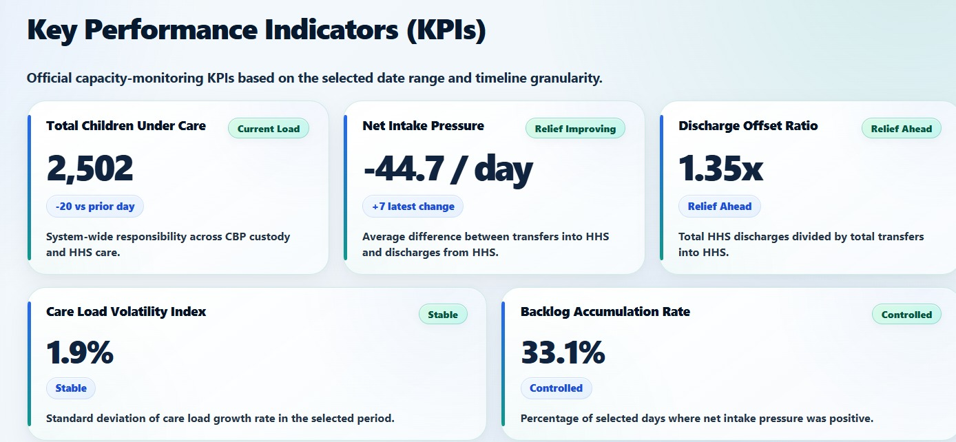
Figure 1. Guideline capacity-monitoring KPI cards for the selected daily dashboard view.
Executive Question | Dashboard Evidence | Strategic Interpretation
Is the system currently under severe pressure? | Overall KPI health is 88.8/100 and no KPIs fall below the watch threshold. | The selected view is healthy, but monitoring remains necessary because historical stress categories still exist.
Are discharges relieving intake pressure? | Net Intake Pressure is -44.7/day and Discharge Offset Ratio is 1.35x. | Discharges exceed transfers into HHS in the selected view, producing a relief-oriented flow balance.
Where is active responsibility concentrated? | Latest HHS share is 99.3%, while latest CBP share is 0.719%. | HHS downstream care, shelter, staffing, placement, and discharge operations are the main capacity-planning concern.
What is the main operational planning signal? | Primary Pressure Driver is Daily Strain Pressure. | Routine strain management and prolonged-window monitoring matter more than sudden-spike response alone.

The overall conclusion is that the dashboard successfully transforms UAC care-pipeline data into a structured operating intelligence system. Its strongest value is not a single number but the integration of stock metrics, flow metrics, pressure-period logic, stress classification, and executive decision support. This paper therefore positions the dashboard as a policy-aligned public-sector analytics framework rather than a simple data visualization exercise.

1.1 Executive Summary Key Takeaways
The executive interpretation is that current operating conditions are favorable, but not passive. The dashboard evidence shows relief-oriented transfer-discharge balance, low daily volatility, and controlled backlog accumulation, while also showing that HHS carries nearly all active downstream responsibility and that daily strain remains the most frequent pressure driver. For leadership, this means the correct posture is disciplined monitoring, not emergency escalation and not disengagement.
Executive Signal | Evidence | Decision Meaning
Operating condition | KPI health 88.8/100; no watch KPIs in the selected daily view | Maintain routine executive monitoring and document stable conditions.
Flow balance | Net Intake Pressure -44.7/day; Discharge Offset Ratio 1.35x | Protect discharge throughput and sponsor-placement flow because these signals create relief.
Capacity position | Current load 2,502; peak context 11,762; load position 21.3% of peak | Keep surge history visible even though the latest load is far below peak.
Responsibility concentration | HHS care 99.3% of latest active load; CBP custody 0.719% | Prioritize HHS shelter, care, placement, and discharge capacity planning.
Pressure driver | Daily Strain Pressure is the most frequent pressure driver | Plan for sustained operational strain rather than only sudden-spike response.
Research contribution snapshot: this paper turns the dashboard into a structured research narrative by connecting raw daily counts, derived capacity metrics, dashboard module outputs, and decision-support recommendations. The result is a publication-ready public-sector analytics report that explains not only what the dashboard shows, but how stakeholders should interpret the evidence responsibly.

1.2 Decision-Readiness Snapshot
The research paper is decision-ready because it separates immediate operating status from sustained monitoring needs. This avoids two common interpretation errors: treating a healthy daily view as a reason to stop monitoring, or treating historical peak load as evidence of current crisis.
Decision Lens | Evidence Source | Final Executive Reading
Status question | Answered by KPI health, net intake pressure, and discharge offset ratio | Healthy operating view with relief-ahead flow balance.
Capacity question | Answered by current load, peak context, and capacity position | Current load is controlled relative to peak, but peak history remains relevant for readiness.
Responsibility question | Answered by CBP-HHS split and HHS share | HHS care is the dominant downstream responsibility center.
Monitoring question | Answered by backlog pressure, pressure distribution, and driver evidence | Routine strain and prolonged-window monitoring should remain active.

2. Table of Contents
Section | Primary Focus | Output
1. Executive Summary / Abstract (p. 2) | C-level summary of problem, evidence, findings, and recommendations. | Executive interpretation of operating status and capacity risk.
2. Table of Contents (p. 4) | Report navigation. | Structured roadmap.
3. Introduction (p. 5) | Why healthcare capacity analytics matters in the UAC care pipeline. | Research context and analytical purpose.
4. Background and Context (p. 6) | CBP-HHS care flow, medical/shelter support, and discharge placement. | Policy and operating environment.
5. Problem Statement (p. 7) | Centralized analytical framework gap. | Research questions and decision problem.
6. Dataset Overview (p. 8) | Fields, granularity, and derived metrics. | Data dictionary and analytical scope.
7. Methodology and Data Governance (p. 9) | Data ingestion, validation, feature engineering, and dashboard logic. | Reproducible analytical workflow.
8. Data Limitations and Scope (p. 11) | Boundaries, assumptions, and responsible interpretation. | Credibility safeguards.
9. Key Performance Indicators (p. 12) | Five guideline KPIs and health scores. | Measurement framework.
10. Exploratory Data Analysis (p. 14) | System load, pressure movement, capacity position, and metric diagnostics. | Pattern discovery.
11. Result and Analysis (p. 16) | Module-by-module dashboard evidence. | Empirical findings from 20 screenshots.
12. Findings and Insights (p. 25) | Evidence-to-insight synthesis. | Senior analyst interpretation.
13. Actionable Recommendations (p. 26) | Capacity, discharge, HHS planning, and monitoring actions. | Policy/operations action plan.
14. Dashboard Implementation (p. 27) | Streamlit app architecture and dashboard modules. | Technical-business traceability.
15. Data Interpretation Governance (p. 28) | Rules for reading KPIs, thresholds, and stress signals. | Analytical discipline.
16. Conclusion (p. 29) | Final synthesis and future scope. | Publication-ready closure.
17. References (p. 30) | Project, public-context, and tool references. | Citation support.
18. Appendix (p. 31) | Formulas, figure register, data dictionary, metadata. | Supplementary documentation.

The report follows a decision-support sequence: business context first, then dataset and methodology, followed by exploratory analysis, evidence-based results, findings, recommendations, implementation details, interpretation governance, and appendix support. This prevents dashboard screenshots from appearing as isolated visuals; each visual is connected to operational meaning and policy relevance.
TOC navigation note: page references are based on the final rendered 32-page layout and are intended for PDF/Word review navigation. The section table is deliberately static to keep the report stable across Word, PDF, and repository-upload workflows.

3. Introduction
Healthcare capacity analytics is essential when a care system operates as a dynamic pipeline. In the UAC context, daily operational responsibility moves through upstream custody, transfer flow, downstream care, and eventual discharge or placement. A small change in transfer volume, discharge throughput, or active care load can create visible changes in system pressure. For this reason, operational dashboards must measure both stock metrics, such as children in custody or care, and flow metrics, such as transfers and discharges.
This project analyzes the System Capacity & Care Load Analytics dashboard for Unaccompanied Children. The dashboard is designed to support capacity awareness across CBP custody and HHS care by converting daily counts into structured KPIs, trend charts, risk indicators, backlog severity metrics, responsibility-split visuals, and executive health rankings. The research paper documents the analytical logic behind the dashboard and translates the visuals into a formal research narrative.
The project differs from a purely descriptive report because it uses derived metrics and dashboard intelligence to evaluate operational status. Total System Load shows total responsibility. Net Intake Pressure shows whether transfers into HHS exceed discharges. Discharge Offset Ratio shows whether outflow is keeping pace with inflow. Backlog Accumulation Rate identifies the frequency of pressure periods. Care Load Volatility Index measures stability. Together, these indicators create a practical monitoring framework for public-sector capacity planning.
Analytical Contribution | Description | Decision Value
Stock-and-flow view | Combines CBP custody, HHS care, transfers, and discharges. | Prevents leadership from reading active load without flow context.
Pressure and relief logic | Uses net intake and discharge offset to identify flow balance. | Supports operational assessment of whether pressure is building or relief is improving.
Responsibility split analysis | Compares CBP custody and HHS care responsibility over time. | Shows where the active care burden is concentrated.
Stress classification | Summarizes periods into stress and pressure levels. | Helps identify routine strain and sustained pressure windows.
Interactive dashboard design | Allows time range, granularity, and metric-toggle exploration. | Supports scenario-based monitoring rather than static reporting.

4. Background and Context
The Unaccompanied Children care process is best understood as a multi-stage care pipeline. Children apprehended and placed in CBP custody represent upstream intake and short-term custody. Children transferred out of CBP custody represent flow into the HHS care system. Children in HHS Care represent active downstream responsibility, including sheltering and care services. Children discharged from HHS Care represent relief through placement or sponsor-related exit from active HHS care.
From a healthcare systems perspective, the challenge is not limited to counting daily intake. The system must also evaluate whether active care load is rising or falling, whether HHS care is absorbing most of the responsibility, whether discharges are relieving incoming transfers, and whether backlog pressure is accumulating. These questions require a centralized analytical framework that can connect daily data to actionable indicators.
The dashboard supports this framework through four modules: System Load Overview, CBP vs HHS Load Comparison, Net Intake & Backlog Pressure Analysis, and KPI Executive Summary and Health Ranking. These modules mirror the required project components and provide a structured path from raw counts to executive decision support.
Care Pipeline Stage | Operational Meaning | Dashboard Evidence
CBP custody | Upstream custody and intake-side active load. | Latest CBP Custody and CBP share metrics.
Transfer to HHS | Flow from CBP into downstream HHS care. | Transfers into HHS and net intake metrics.
HHS care | Active care load held by HHS facilities and care providers. | Latest HHS Care, HHS share, and responsibility trend.
Discharge from HHS | Relief from active care through sponsor placement or discharge. | HHS discharges and discharge offset ratio.
Pressure windows | Periods where inflow pressure or sustained strain appears. | Backlog severity, pressure stress distribution, and primary driver evidence.

5. Problem Statement
The central problem is the absence of a single analytical framework that continuously connects total system load, CBP-to-HHS handoff movement, net intake balance, discharge relief, capacity stress, and backlog accumulation. Without such a framework, operational decisions can become reactive. Leadership may see a large care-load number without understanding whether the system is worsening or improving, or may observe relief in discharge flows without recognizing hidden pressure windows.
A dashboard-based framework is necessary because UAC care-load data contains multiple interacting signals. A high Total Children Under Care value may be concerning, but the interpretation changes if discharges are exceeding transfers. Similarly, a low current load may appear reassuring, but the interpretation changes if volatility is high or pressure windows are recurring. The analytical challenge is therefore not only to calculate KPIs, but to connect them into a coherent decision-support narrative.
Research Question | Evidence Required | Decision Relevance
What is the current system-wide care load? | Total Children Under Care and capacity position charts. | Defines the current burden across CBP and HHS.
Are discharges offsetting transfers? | Net Intake Pressure, Discharge Offset Ratio, Transfers vs Discharges chart. | Shows whether flow balance is relief-oriented or pressure-building.
Where is responsibility concentrated? | CBP vs HHS trend, HHS share, latest responsibility split. | Identifies whether planning should focus upstream or downstream.
Are backlog and stress periods recurring? | Backlog Accumulation Rate, Backlog Severity, Pressure Stress Distribution. | Supports staffing, shelter, and placement readiness.
Which pressure drivers matter most? | Primary Pressure Driver Evidence chart. | Guides operational response priorities.

6. Dataset Overview
The project uses daily time-series data for the UAC care pipeline. The field structure supports analysis of both active care load and flow movement. Active load fields describe the number of children currently in CBP custody or HHS care. Flow fields describe children entering, moving into HHS, or being discharged from HHS care. This structure is appropriate for capacity analytics because system pressure is determined by both stock and flow conditions.
Dataset Field | Meaning | Analytical Use
Date | Reporting date. | Creates daily time series and supports date range filtering.
Children apprehended and placed in CBP custody | Daily intake volume. | Measures upstream inflow into the care pipeline.
Children in CBP custody | Active CBP custody load. | Measures upstream custody responsibility.
Children transferred out of CBP custody | Flow into HHS system. | Measures transfer pressure entering downstream care.
Children in HHS Care | Active HHS care load. | Measures downstream shelter and care responsibility.
Children discharged from HHS Care | Successful sponsor placements or relief from active HHS care. | Measures outflow and relief capacity.

Derived Analytical Metrics
Derived Metric | Formula / Logic | Purpose
Total System Load | CBP Custody + HHS Care. | Measures total children under active system responsibility.
Net Daily Intake | Transfers into HHS - HHS Discharges. | Measures whether pressure is building or relief is improving.
Care Load Growth Rate | Day-over-day percentage change in system load. | Measures movement and volatility.
Positive Net Intake Flag | 1 when Net Daily Intake is positive. | Identifies pressure days.
Backlog Severity Score | Sustained sequence logic over positive pressure periods. | Measures accumulation intensity.
Rolling Averages | 7-day and 14-day rolling means. | Smooths short-term reporting noise.
Final Pressure Stress Level | Composite stress classification. | Converts multiple signals into operating pressure categories.

Dataset Readiness Assessment
The dataset is suitable for descriptive, diagnostic, and dashboard-driven healthcare capacity analytics because it contains the minimum required stock and flow variables: CBP custody, HHS care, transfers into HHS, and HHS discharges. These fields are sufficient to create system-load, net-intake, discharge-offset, backlog, and stress-classification metrics.

7. Methodology and Data Governance
The methodology follows a structured data analytics workflow: ingestion, validation, preprocessing, feature engineering, exploratory analysis, KPI calculation, stress classification, dashboard visualization, and recommendation development. The objective is not only to display the data but to ensure that dashboard evidence is reproducible, interpretable, and aligned with public-sector capacity planning.

7.1 Data Ingestion and Structuring
Daily records are loaded from processed CSV datasets and transformed into canonical dashboard columns. The app structure supports multiple file locations and processed outputs, which makes the dashboard more resilient to project-folder differences. Dates are parsed into datetime format, then sorted chronologically to preserve time-series integrity.

7.2 Data Quality and Validation
Data quality checks should include missing-date review, duplicate-date review, numeric conversion, and logical validation. Logical validation is important because transfers and discharges are flow variables that must be interpreted in relation to active load variables. Invalid dates, nonnumeric counts, duplicate records, and missing load values can distort KPI calculations and trend charts.

7.3 Feature Engineering
Feature engineering converts raw counts into operational signals. Total System Load measures system-wide responsibility. Net Daily Intake measures inflow-outflow balance. Care Load Growth Rate identifies movement and volatility. Positive Net Intake Flags identify pressure days. Backlog Severity Scores detect accumulation. Rolling averages reduce reporting noise and provide short-term versus longer-term trend context.

7.4 Analytical Models and Methods
The dashboard uses descriptive analytics, diagnostic analytics, rolling time-series analysis, stock-and-flow analysis, threshold-free pressure interpretation, stress classification, and dashboard-based scenario analysis. The current paper does not claim causal inference or predictive forecasting. It is a decision-support report that identifies patterns and operating signals from the available data.
Methodological Step | Technique | Output | Governance Value
Data ingestion | CSV loading and date parsing. | Chronological daily dataset. | Ensures temporal analysis is valid.
Column mapping | Canonical field assignment. | Consistent metric names. | Prevents breakage from source-column naming differences.
Feature engineering | Derived load, intake, growth, backlog, and rolling metrics. | Analytical indicators. | Converts raw counts into decision-ready signals.
EDA | Trend, movement, capacity position, and responsibility split analysis. | Pattern discovery. | Identifies pressure and relief behavior.
KPI modeling | Five guideline KPIs and health scoring. | Executive dashboard metrics. | Supports leadership review.
Stress classification | Pressure level and driver analysis. | Operational stress categories. | Supports targeted response planning.

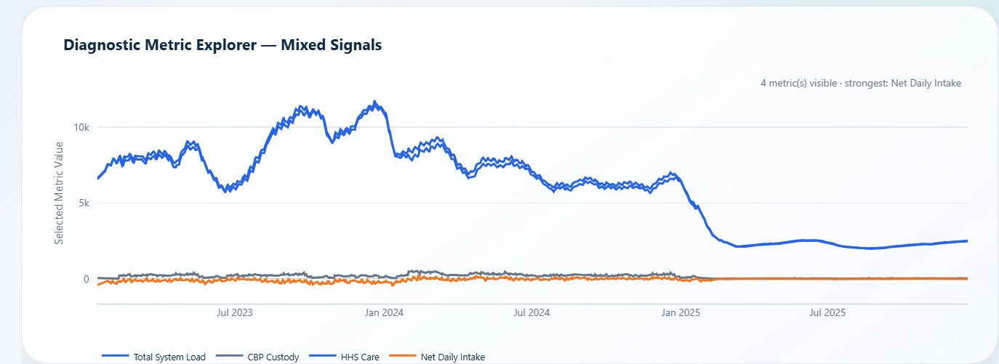
Figure 2. Diagnostic Metric Explorer showing dashboard support for selected-metric exploration and mixed operational signals.
This figure demonstrates the dashboard implementation of metric toggles. It allows users to compare Total System Load, CBP Custody, HHS Care, and Net Daily Intake in the same diagnostic view, which supports flexible scenario analysis.
Selected Metric | Analytical Role | Interpretation Discipline
Total System Load | Overall active responsibility signal. | Interpret with peak, average, and latest load context.
HHS Care | Downstream care-load burden. | Compare against total system load to identify HHS concentration.
CBP Custody | Upstream custody burden. | Read as intake-side load rather than full downstream care burden.
Net Daily Intake | Transfer-discharge balance. | Negative values indicate relief; positive values indicate pressure.

Diagnostic Interpretation Note
The metric explorer should be used after the executive KPI cards. It helps analysts confirm whether stock measures, such as HHS Care and Total System Load, are moving with flow measures, such as Net Daily Intake. Divergence between these metrics is often more informative than any single metric by itself.

8. Data Limitations and Scope
This research paper intentionally limits its conclusions to what the available dashboard evidence can support. The analysis is descriptive and diagnostic. It identifies load patterns, flow-balance conditions, HHS responsibility concentration, backlog severity, and pressure drivers. It does not prove causal relationships and does not make claims about individual cases or facility-level service quality.
Limitation | Impact on Interpretation | Future Improvement
No individual-level case data | The analysis cannot evaluate individual child outcomes, length of stay, or case complexity. | Add privacy-preserving cohort-level records if ethically and legally appropriate.
No shelter-level capacity or bed availability | The dashboard cannot directly measure facility overcrowding thresholds. | Add facility capacity, shelter occupancy, and surge capacity variables.
No staffing-level variables | The analysis cannot quantify staff workload or staffing gaps. | Add staffing rosters, staff-to-child ratios, and shift coverage data.
No geographic facility breakdown | Regional pressure and local capacity differences are not visible. | Add facility or region-level aggregation.
No causal model | Patterns do not prove why pressure occurred. | Add contextual variables and statistical modeling.
Filter and granularity dependency | KPI values change by selected date window and time granularity. | Publish dataset, dashboard, and report versions together.

Scope Boundary
The paper evaluates system capacity and care-load indicators from dashboard evidence. It should not be read as a child welfare audit, facility inspection, staffing assessment, legal analysis, or causal policy evaluation.

8.1 Responsible Use Note
The dashboard evidence should be used as a monitoring and planning layer, not as a legal, clinical, or causal conclusion. A healthy selected view means that current KPI signals are favorable; it does not mean future pressure cannot reappear. For publication and portfolio use, the safest interpretation is to describe patterns, operating signals, and decision triggers while clearly separating them from child-level outcomes, facility performance, and policy causation.
Use Case | Allowed Interpretation | Avoid Overclaiming
Capacity monitoring | Use KPIs to identify load, relief, backlog, and volatility signals. | Do not claim exact facility overcrowding without shelter capacity data.
Operational planning | Use HHS share, pressure drivers, and discharge offset to guide monitoring cadence. | Do not infer staffing adequacy without staffing data.
Portfolio publication | Present dashboard outputs as applied analytics evidence with documented limitations. | Do not present descriptive findings as causal policy proof.

9. Key Performance Indicators
The KPI framework is built around five project-required measures: Total Children Under Care, Net Intake Pressure, Care Load Volatility Index, Backlog Accumulation Rate, and Discharge Offset Ratio. These KPIs collectively describe system responsibility, flow balance, stability, pressure frequency, and relief capacity.
Figure 1 presents the official KPI card snapshot used as the executive KPI baseline. The table below translates the same indicators into formulas, interpretations, and action triggers for the research paper.
KPI | Observed Value | Formula / Logic | Interpretation | Action Trigger
Total Children Under Care | 2,502 | CBP Custody + HHS Care | Current system-wide responsibility. | Review if load approaches selected-period average or peak.
Net Intake Pressure | -44.7 / day | Transfers into HHS - HHS discharges | Relief improving; discharges exceed transfers. | Review if net intake turns positive for sustained periods.
Discharge Offset Ratio | 1.35x | Discharges / Transfers | Discharge relief is ahead of transfer inflow. | Review if ratio falls below 1.00x.
Care Load Volatility Index | 1.9% | Standard deviation of growth rate | Daily movement is stable. | Review if volatility increases or disrupts planning reliability.
Backlog Accumulation Rate | 33.1% | Share of positive net intake days | Pressure periods exist but are controlled. | Review if pressure-day share rises above controlled range.

9.1 KPI Governance and Monitoring Triggers
The KPI cards should be read as a governance system rather than as isolated values. A favorable discharge offset ratio can coexist with pressure-period risk, and a low current load still needs context from the historical peak. The monitoring matrix below defines how each KPI should trigger review, escalation, or routine confirmation.
KPI | Normal Reading | Review Trigger | Required Interpretation
Total Children Under Care | Routine review | Approaches selected-period average or rises sharply | Compare current load with average, peak, and HHS share before escalation.
Net Intake Pressure | Relief when negative | Turns positive for consecutive periods | Review transfer-discharge balance and identify pressure windows.
Discharge Offset Ratio | Relief-ahead at 1.00x or higher | Falls below 1.00x | Check whether discharges are no longer keeping pace with transfers.
Care Load Volatility Index | Stable when low | Rises enough to disrupt planning reliability | Avoid relying only on averages; examine growth-rate movement.
Backlog Accumulation Rate | Controlled below sustained pressure range | Pressure-period share rises | Review positive net intake streaks and backlog severity accumulation.
KPI interpretation rule: stock metrics, flow metrics, volatility metrics, and stress metrics must be evaluated together. This prevents a single favorable metric from hiding recurring pressure windows, and prevents historical peak context from overstating current risk.

9.2 KPI Health Ranking
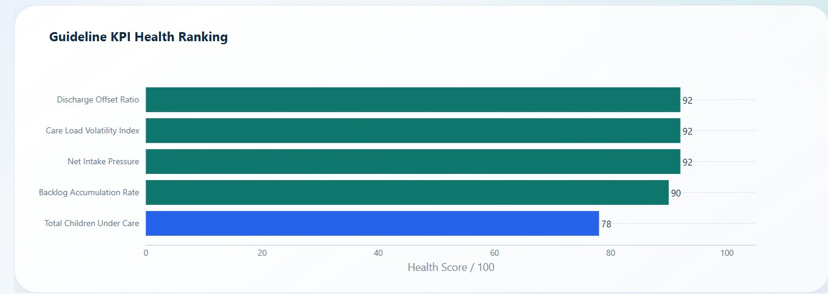
Figure 3. Guideline KPI Health Ranking comparing five capacity-monitoring KPIs on a 100-point scale.
The health ranking confirms that Discharge Offset Ratio, Care Load Volatility Index, and Net Intake Pressure score 92/100, Backlog Accumulation Rate scores 90/100, and Total Children Under Care scores 78/100.
KPI | Health Score | Meaning for Leadership
Discharge Offset Ratio | 92/100 | Relief capacity is strong because discharges are exceeding transfers.
Care Load Volatility Index | 92/100 | Daily volatility is stable in the selected view.
Net Intake Pressure | 92/100 | Flow balance is relief-oriented rather than pressure-building.
Backlog Accumulation Rate | 90/100 | Backlog pressure is controlled but still worth monitoring.
Total Children Under Care | 78/100 | Active load remains the weakest KPI and should remain visible in reviews.

Leadership Summary
The KPI health ranking confirms that the operating view is healthy, but the weakest KPI remains Total Children Under Care. Leadership should treat this as a monitoring priority rather than a crisis signal: current load is controlled, yet active load must remain visible because it represents system-wide care responsibility.

10. Exploratory Data Analysis
Exploratory data analysis was used to identify how system load, pressure movement, capacity position, and diagnostic metrics behave across the selected timeline. The EDA confirms that the dashboard is not simply reporting current values; it is showing historical context, peak comparisons, relief signals, and metric relationships.

10.1 System Load Trend EDA
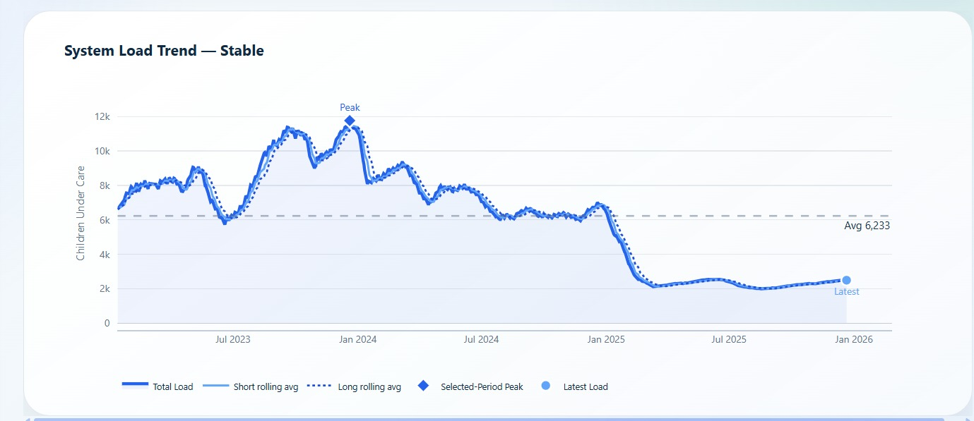
Figure 4. System Load Trend showing selected-period peak, rolling averages, average load, and latest load.
The system load trend shows a high-load period around late 2023 and early 2024, followed by a sharp decline into a lower operating range during 2025. The current latest load is far below the selected-period peak.

10.2 Pressure vs Relief Movement EDA
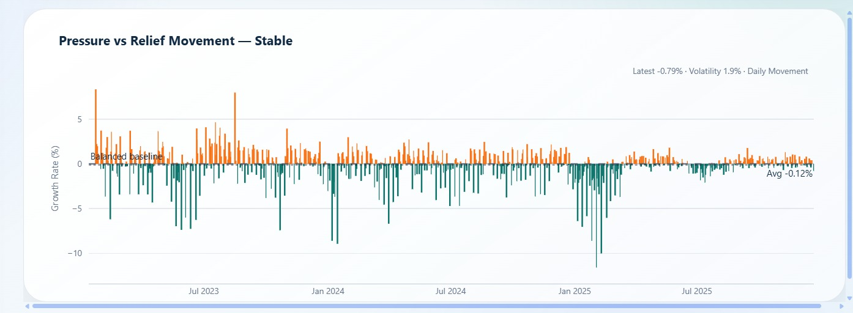
Figure 5. Pressure vs Relief Movement showing positive and negative growth-rate periods.
This chart shows that the selected timeline contains both pressure and relief periods. In the daily view, latest movement is stable and volatility remains low at 1.9%.

10.3 Capacity Position EDA
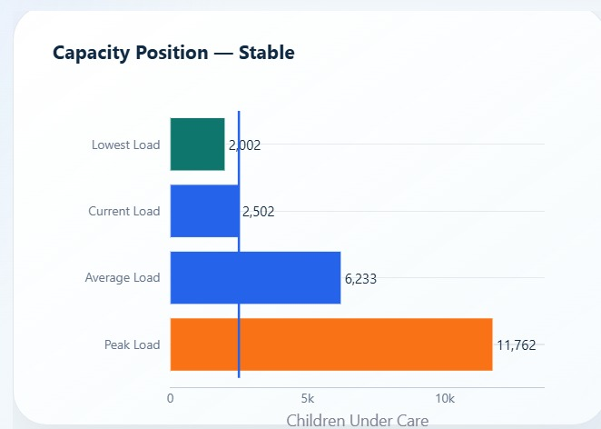
Figure 6. Capacity Position comparing lowest, current, average, and peak system load.
The current load of 2,502 is much closer to the lowest observed load of 2,002 than to the selected-period peak of 11,762. This supports the interpretation that the latest view is not operating near historical peak burden.
EDA Area | Pattern Observed | Analytical Meaning
System load trend | High load in late 2023/early 2024, then lower range by 2025. | Historical peak context is important but latest view is much lower.
Pressure vs relief movement | Positive and negative movement periods appear across the timeline. | The system cycles through pressure and relief rather than staying in one state.
Capacity position | Current load is 21.3% of peak. | Current burden is controlled relative to selected-period peak.
Diagnostic metrics | HHS Care and Total System Load move together. | HHS is the main active-load component.

10.4 EDA Decision-Use Note
EDA should be read as a pattern-discovery layer before final result interpretation. The system-load trend provides historical context, the pressure-relief movement shows daily operating variation, the capacity-position chart compares current load with peak and average values, and the diagnostic metric explorer confirms whether stock and flow metrics move together or diverge. This sequence helps prevent isolated chart reading and supports evidence-based dashboard interpretation.

11. Result and Analysis
This section converts the dashboard screenshots into analytical evidence. Each dashboard module is interpreted as a decision-support layer: system load overview, pressure and risk stability, CBP-HHS load comparison, net intake and backlog pressure, KPI health ranking, and pressure driver evidence.

11.1 System Load Overview
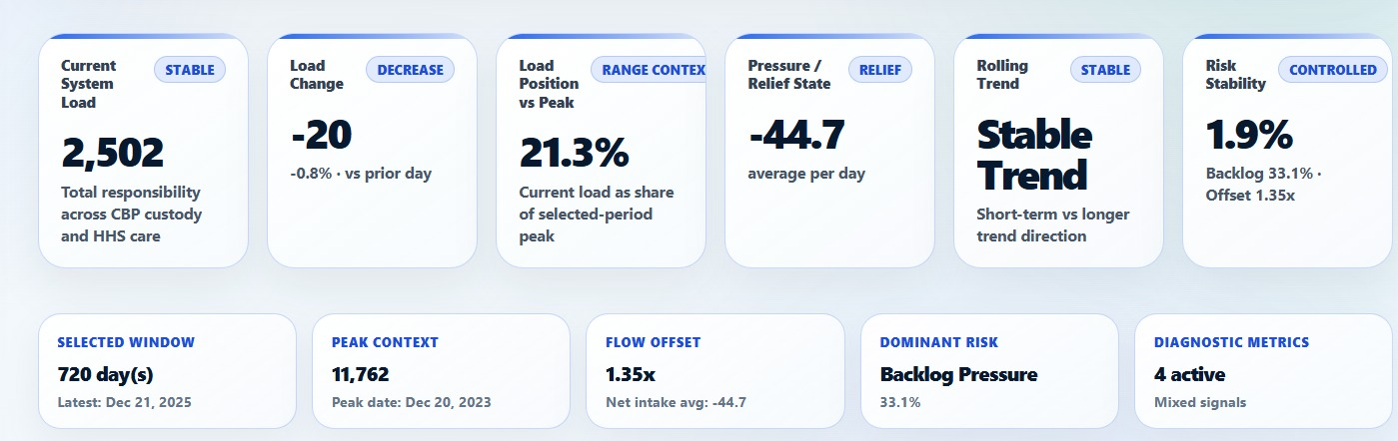
Figure 7. Module 1 command-center intelligence cards for system load, pressure state, peak context, flow offset, and dominant risk.
The command-center cards identify a current load of 2,502, a load change of -20, load position at 21.3% of peak, selected window of 720 days, peak context of 11,762, flow offset of 1.35x, and Backlog Pressure as the dominant risk signal.
The system load overview indicates that the latest selected view is stable. The current system load is not near the selected-period peak, and the latest load movement is decreasing. This does not eliminate monitoring need, but it changes the operational posture from emergency escalation to routine capacity monitoring and confirmation of sustained relief.
Metric | Value | Interpretation
Current System Load | 2,502 | Current combined system responsibility across CBP and HHS.
Load Change | -20 | Latest movement is decreasing compared with prior day.
Load Position vs Peak | 21.3% | Current load is far below selected-period peak.
Selected Window | 720 days | The analysis covers a substantial daily timeline.
Peak Context | 11,762 | Historical peak remains important for surge-readiness planning.
Dominant Risk | Backlog Pressure | Backlog pressure is the leading monitoring signal despite stable conditions.

11.2 Pressure, Relief, and Risk Stability
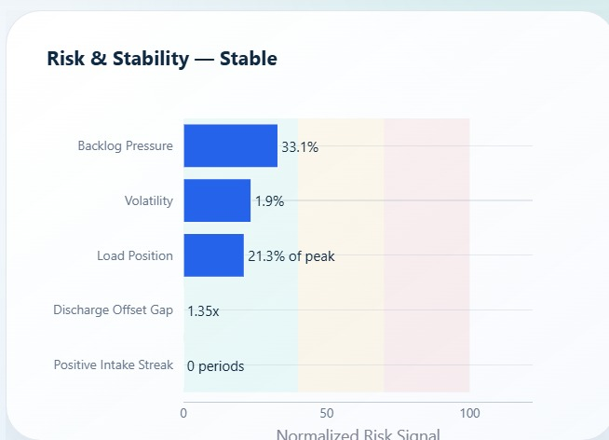
Figure 8. Risk and Stability profile showing normalized backlog, volatility, load position, discharge offset gap, and positive intake streak.
The risk and stability chart shows Backlog Pressure at 33.1%, Volatility at 1.9%, Load Position at 21.3% of peak, Discharge Offset Gap at 1.35x, and Positive Intake Streak at 0 periods.
Risk interpretation should combine multiple signals. Backlog Pressure is the most visible risk signal, but volatility, load position, and positive intake streak are controlled in the selected daily view. The discharge offset ratio further supports the relief-oriented interpretation because discharges exceed transfers.

11.3 CBP vs HHS Load Comparison
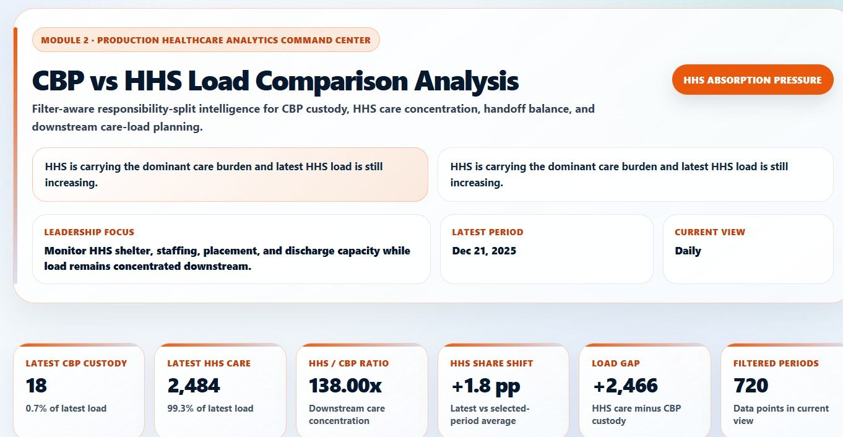
Figure 9. Module 2 CBP vs HHS Load Comparison with latest custody, HHS care, ratio, share shift, load gap, and period count.
The module shows latest CBP custody of 18, latest HHS care of 2,484, an HHS/CBP ratio of 138.00x, HHS share shift of +1.8 percentage points, load gap of +2,466, and 720 filtered periods.
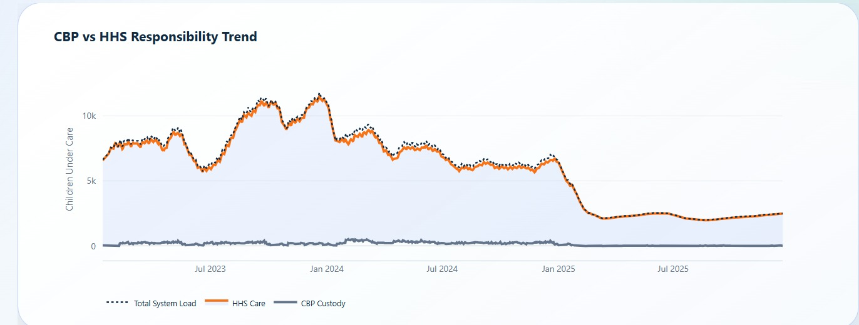
Figure 10. CBP vs HHS Responsibility Trend showing HHS care as the dominant contributor to total system load.
The HHS Care line closely follows Total System Load across the timeline, while CBP Custody remains much smaller. This indicates that downstream HHS care is the primary active-load responsibility center.
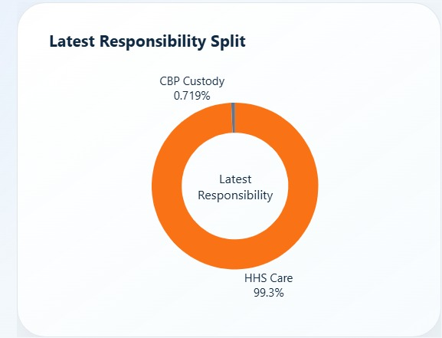
Figure 11. Latest Responsibility Split showing latest HHS care share and CBP custody share.
The latest responsibility split shows HHS Care at 99.3% of active load and CBP Custody at 0.719%. This confirms that current care responsibility is overwhelmingly concentrated downstream within HHS care.
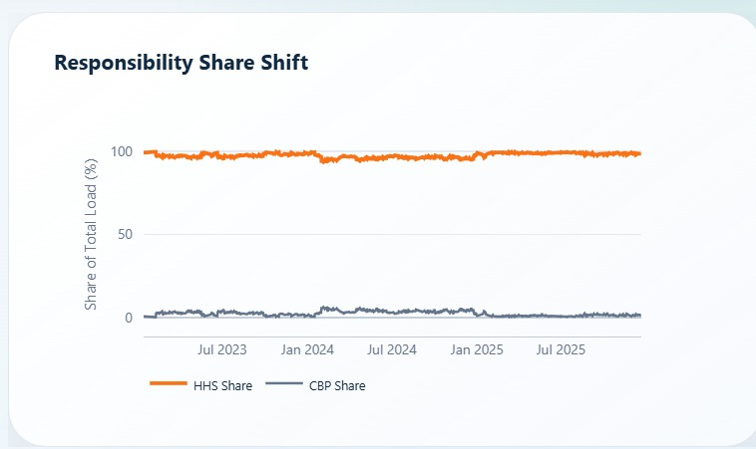
Figure 12. Responsibility Share Shift comparing HHS share and CBP share across the selected timeline.
The responsibility share shift chart shows HHS share consistently near the top of total load and CBP share near the bottom, reinforcing the downstream care concentration pattern.
Responsibility Metric | Observed Value | Operational Meaning
Latest CBP Custody | 18 | Very small active upstream custody component in latest view.
Latest HHS Care | 2,484 | Primary active care-load responsibility.
HHS / CBP Ratio | 138.00x | Downstream HHS load is far larger than CBP custody load.
HHS Share Shift | +1.8 pp | Latest HHS share is above selected-period average.
Load Gap | +2,466 | HHS care minus CBP custody shows large downstream gap.

11.4 Net Intake and Backlog Pressure Analysis
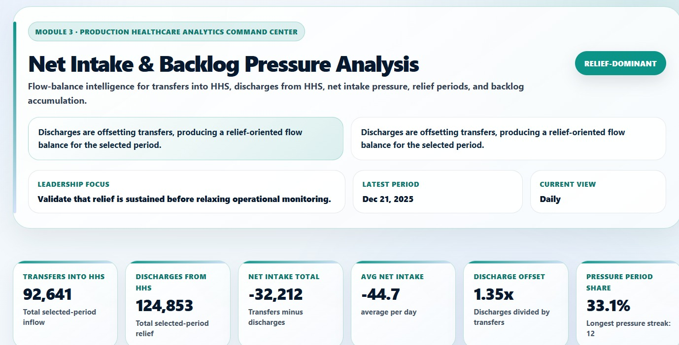
Figure 13. Module 3 Net Intake and Backlog Pressure Analysis with transfer, discharge, net intake, offset, and pressure-period cards.
Module 3 shows transfers into HHS at 92,641, discharges from HHS at 124,853, net intake total of -32,212, average net intake of -44.7 per day, discharge offset of 1.35x, pressure-period share of 33.1%, and longest pressure streak of 12.
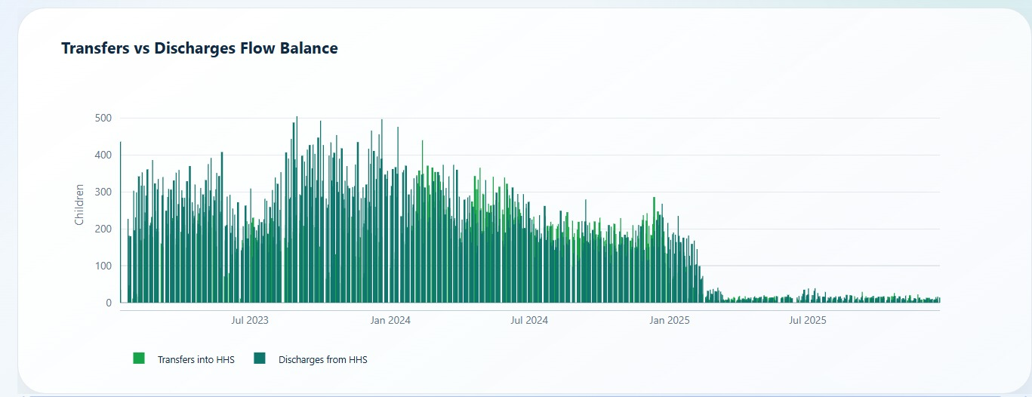
Figure 14. Transfers vs Discharges Flow Balance across the selected daily timeline.
The flow balance chart compares incoming transfers to HHS with HHS discharges. The selected period shows strong discharge throughput relative to transfer flow, supporting the relief-oriented KPI interpretation.
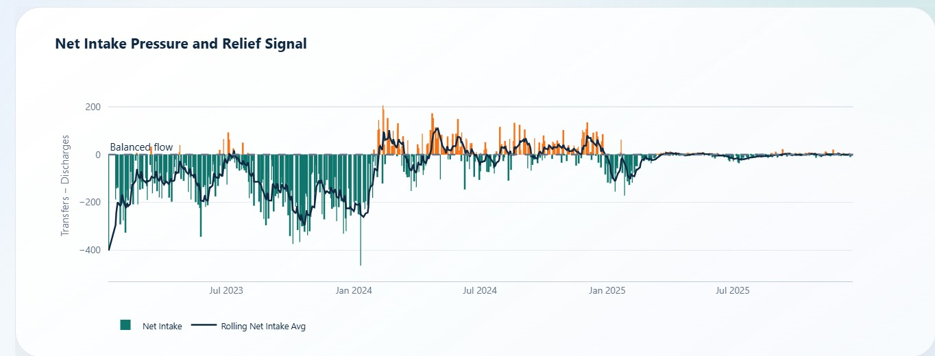
Figure 15. Net Intake Pressure and Relief Signal showing transfers minus discharges and rolling net intake average.
The net intake chart makes the pressure-relief logic explicit. Negative bars indicate relief periods in which discharges exceed transfers; positive bars indicate pressure periods in which transfers exceed discharges.
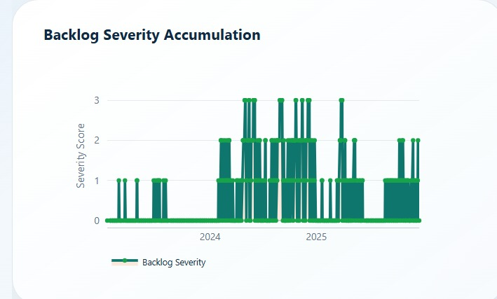
Figure 16. Backlog Severity Accumulation showing periods of pressure accumulation across the timeline.
Backlog severity spikes appear during specific windows rather than remaining constantly elevated. This supports targeted monitoring of pressure windows instead of a blanket crisis interpretation.
Flow Metric | Value | Interpretation
Transfers into HHS | 92,641 | Total selected-period inflow into HHS care.
Discharges from HHS | 124,853 | Total selected-period relief from active HHS care.
Net Intake Total | -32,212 | Discharges exceed transfers across the selected period.
Average Net Intake | -44.7/day | Relief-oriented average flow balance.
Discharge Offset | 1.35x | Discharges are 1.35 times transfers.
Pressure Period Share | 33.1% | Pressure windows exist but are not dominant.
Longest Pressure Streak | 12 | Sustained pressure sequences still need monitoring.

11.5 KPI Executive Summary and Health Ranking
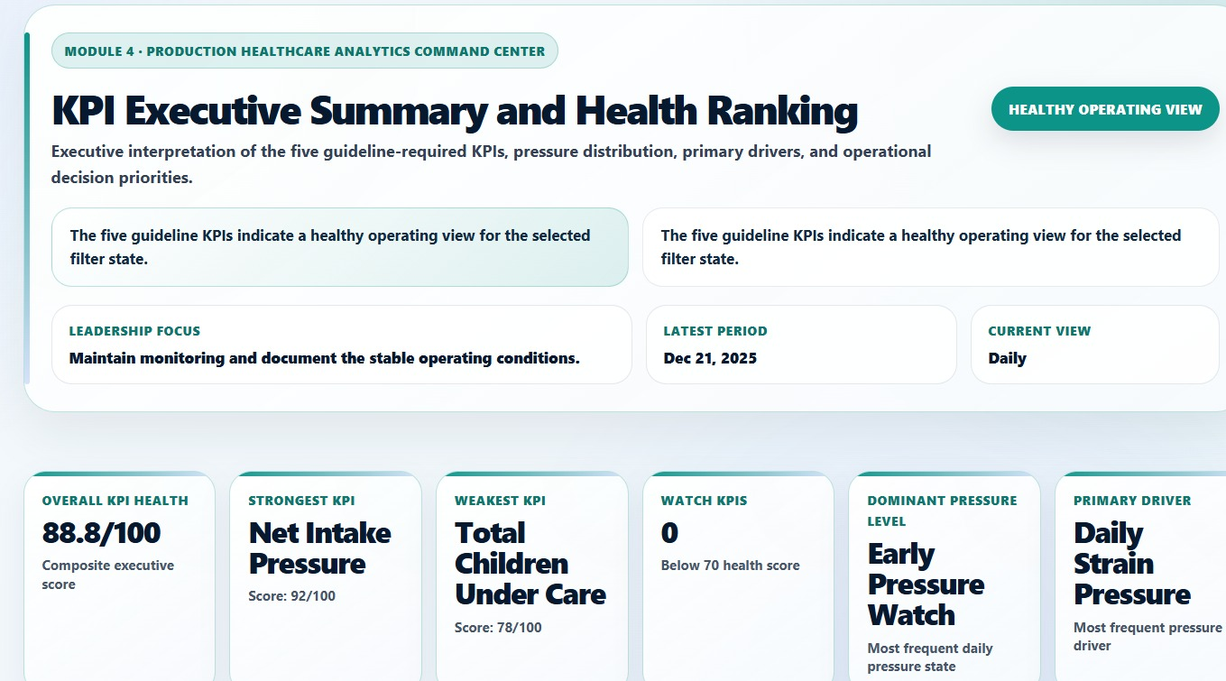
Figure 17. KPI Executive Summary and Health Ranking dashboard showing healthy operating view and executive KPI cards.
The KPI executive summary reports Overall KPI Health of 88.8/100, Net Intake Pressure as the strongest KPI, Total Children Under Care as the weakest KPI, zero watch KPIs, Early Pressure Watch as the dominant pressure level, and Daily Strain Pressure as the primary driver.
The executive KPI summary confirms that the selected daily view is healthy, but it also identifies where attention should continue. Total Children Under Care is the weakest KPI because active system load remains the core responsibility measure. Net Intake Pressure is the strongest KPI because relief flow is favorable in the selected view.

11.6 Pressure Stress Distribution and Driver Evidence
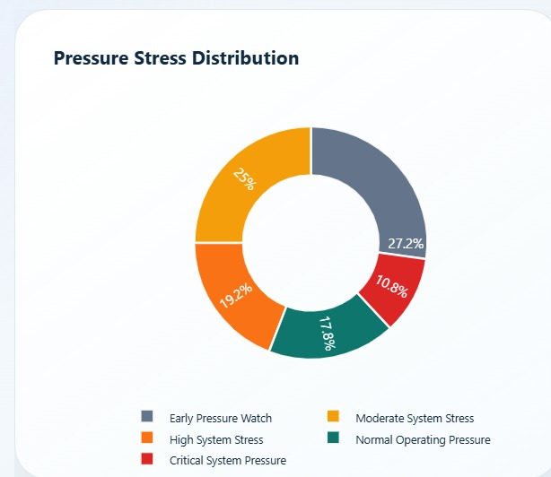
Figure 18. Pressure Stress Distribution showing shares of early pressure watch, moderate stress, high stress, normal pressure, and critical pressure.
The distribution shows Early Pressure Watch at 27.2%, Moderate System Stress at 25.0%, High System Stress at 19.2%, Normal Operating Pressure at 17.8%, and Critical System Pressure at 10.8%. This demonstrates that historical stress categories exist even when the latest selected view is healthy.
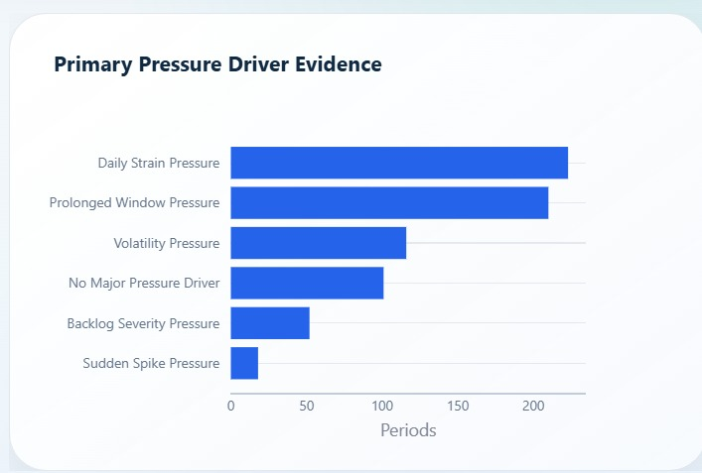
Figure 19. Primary Pressure Driver Evidence ranking daily strain, prolonged window, volatility, backlog, and sudden spike drivers.
Daily Strain Pressure and Prolonged Window Pressure are the most frequent pressure drivers. Sudden Spike Pressure is the least frequent driver, which suggests that sustained operational strain is more important than one-off spike response.
Pressure Evidence | Value / Rank | Implication
Early Pressure Watch | 27.2% | Early monitoring signals are common and should not be ignored.
Moderate System Stress | 25.0% | A significant share of periods require operational awareness.
High System Stress | 19.2% | High-pressure periods occurred and justify resilience planning.
Critical System Pressure | 10.8% | Critical periods are less frequent but operationally meaningful.
Daily Strain Pressure | Rank 1 | Routine strain management should be a central planning priority.
Prolonged Window Pressure | Rank 2 | Sustained windows require capacity buffer planning.

12. Findings and Insights
This section converts the dashboard results into senior healthcare capacity analytics insights. The main value of the dashboard is that it does not depend on one metric. It integrates current load, peak context, inflow-outflow balance, responsibility split, backlog pressure, stress distribution, and driver evidence.
Finding | Evidence | Insight | Operational / Policy Meaning
The selected view is healthy and relief-oriented. | KPI health is 88.8/100; net intake is -44.7/day. | Discharges are offsetting transfers in the selected daily view. | Maintain monitoring rather than emergency escalation.
Current load is far below peak. | Current load 2,502; peak 11,762; current is 21.3% of peak. | The system is not near selected-period maximum burden. | Use peak history for surge planning but current state for daily decisions.
HHS carries dominant active responsibility. | HHS share is 99.3%; HHS/CBP ratio is 138.00x. | Downstream care load is concentrated in HHS. | Prioritize HHS shelter, staffing, placement, and discharge planning.
Flow balance is favorable. | Transfers 92,641; discharges 124,853; offset 1.35x. | Outflow exceeds transfer inflow across the selected view. | Protect discharge and sponsor-placement throughput.
Backlog pressure exists but is controlled. | Backlog accumulation rate is 33.1%; longest pressure streak is 12. | Pressure windows still appear within a healthy view. | Track pressure periods and streaks, not only averages.
Daily strain is the leading pressure driver. | Primary driver evidence ranks Daily Strain Pressure first. | System pressure is more about sustained daily strain than sudden spikes. | Plan recurring operating buffers and routine reviews.

A key insight is that relief and risk can coexist. The negative net intake total and strong discharge offset ratio show relief-oriented movement, but stress distribution and primary pressure driver evidence show that pressure categories and sustained strain remain relevant. A mature operating view should therefore protect discharge throughput while continuing to monitor HHS load concentration and pressure windows.

13. Actionable Business / Policy Recommendations
Recommendations are grounded in dashboard evidence. They are designed for program leadership, healthcare operations, analytics teams, and policy stakeholders who need a practical monitoring model for capacity, staffing, shelter planning, discharge throughput, and backlog relief.
Priority | Evidence | Recommendation | Stakeholder / Function | Expected Impact
High | HHS Care is 99.3% of latest responsibility. | Prioritize HHS shelter, staffing, placement, and discharge capacity planning. | HHS operations and care providers | Protects the dominant downstream care responsibility center.
High | Discharge Offset Ratio is 1.35x and Net Intake Total is -32,212. | Maintain discharge throughput and sponsor placement flow. | Placement and reunification teams | Preserves relief-oriented flow balance.
High | Daily Strain Pressure is the leading driver. | Monitor sustained daily strain rather than focusing only on sudden spikes. | Operations leadership | Improves day-to-day readiness and workload planning.
Medium | Backlog Pressure is 33.1% and longest pressure streak is 12. | Create a recurring backlog pressure and positive-intake streak review. | Analytics and policy teams | Detects pressure accumulation before it becomes severe.
Medium | Current load is 21.3% of peak but peak history is 11,762. | Maintain surge-readiness assumptions despite current relief. | Capacity planners | Prevents overconfidence when latest load is low.
Medium | KPI health is 88.8/100 with Total Children Under Care as weakest KPI. | Use monthly KPI governance to track movement in all five KPIs. | Program leadership | Builds repeatable decision discipline.

90-Day Implementation Roadmap
Timeline | Action Focus | Expected Output
Days 1-30 | Validate KPI dictionary, dataset version, dashboard version, and metric formulas. | Approved measurement dictionary and reproducible evidence base.
Days 31-60 | Launch recurring review of HHS load concentration, discharge offset, and pressure-period share. | Operational review cadence and early warning checklist.
Days 61-90 | Integrate pressure driver analysis and backlog severity review into planning meetings. | Capacity action register and strain-monitoring workflow.

Recommendation Logic
The recommended response is not to reduce monitoring because the latest view is healthy. The recommended response is to institutionalize monitoring while the flow balance is favorable, so the system can detect pressure changes early and protect discharge throughput.

14. Dashboard Implementation
The dashboard is implemented as a Streamlit application with a wide-layout design, Plotly visualizations, processed CSV data inputs, canonical column mapping, KPI calculation, date filtering, time-granularity aggregation, and metric-toggle exploration. The app converts processed datasets into four executive modules that align with the project requirements.
Dashboard Component | Implementation Role | Research Paper Evidence
KPI cards | Calculate and display the five guideline KPIs. | Figure 1 / KPI section.
System Load Overview | Summarizes load, peak context, rolling trend, flow offset, and dominant risk. | Figures 2-5 and system load analysis.
Metric toggles | Allow selected operational metrics to be compared dynamically. | Diagnostic Metric Explorer.
CBP vs HHS module | Compares upstream CBP custody and downstream HHS care. | Responsibility trend and split visuals.
Net Intake & Backlog module | Analyzes transfers, discharges, net intake, pressure share, and backlog severity. | Flow balance, net intake, and backlog charts.
KPI Summary module | Scores KPIs and summarizes stress distribution and primary drivers. | KPI health ranking and driver evidence.

The dashboard uses app-level design choices that support research traceability. Processed datasets are loaded through a file registry. Column names are standardized into canonical dashboard names. Numeric columns are coerced safely. Missing derived metrics can be calculated when their source fields are present. Date filters, weekly/monthly aggregation, and selected metric toggles allow the same underlying data to be viewed at multiple analytical levels.
Implementation Governance
Any public upload should version the dataset, app.py, dashboard screenshots, and research paper together. If the dashboard or data changes later, a new version should be published rather than silently replacing the original evidence.

15. Data Interpretation Governance
Data interpretation governance defines how stakeholders should read dashboard values. Without governance, users may overreact to one metric or underreact to hidden pressure windows. This paper treats dashboard values as decision signals that require context, not as automatic conclusions.
Governance Rule | Reason | Application in This Paper
Compare stock and flow metrics together. | Active load can be high while discharge flow is improving. | Total Children Under Care is interpreted alongside Net Intake Pressure and Discharge Offset Ratio.
Do not overclaim causality. | Dashboard patterns do not prove causes. | Pressure drivers are interpreted as operational signals, not causal proof.
Use HHS share carefully. | HHS dominance shows responsibility concentration, not necessarily system failure. | HHS care is prioritized for planning because it carries active load.
Track pressure windows, not just averages. | Average relief can hide temporary strain. | Backlog severity and pressure-period share are reviewed separately.
Respect granularity sensitivity. | Daily, weekly, and monthly views may produce different operating signals. | The paper reports selected daily screenshot evidence and explains context dependency.
Version dashboard evidence. | Published results must match the dataset and dashboard version. | Report includes source integrity and publication metadata notes.

The most important governance principle is to avoid single-metric decision-making. A high load value without flow context may overstate risk, while a favorable discharge offset without stress-distribution context may understate recurrence risk. The dashboard is most useful when its load, flow, backlog, responsibility, and driver layers are reviewed together.

16. Conclusion
This research paper demonstrates how a dashboard-supported healthcare capacity analytics framework can convert daily UAC care-pipeline data into actionable operating intelligence. The selected dashboard view shows a healthy operating condition: Total Children Under Care is 2,502, Net Intake Pressure is -44.7 per day, Discharge Offset Ratio is 1.35x, Care Load Volatility Index is 1.9%, Backlog Accumulation Rate is 33.1%, and Overall KPI Health is 88.8/100.
The strongest system-level finding is that discharge flow is relieving transfer pressure in the selected view. Discharges from HHS exceed transfers into HHS, producing a negative net intake total and a favorable offset ratio. At the same time, HHS carries almost all active care responsibility, with 99.3% of latest responsibility share. Therefore, HHS shelter, staffing, placement, care delivery, and discharge capacity should remain the central planning focus.
The dashboard also shows that pressure is not limited to sudden spikes. Daily Strain Pressure and Prolonged Window Pressure are the leading drivers, which means operational planning should emphasize sustained readiness, recurring monitoring, and early detection of pressure periods. The final recommendation is to institutionalize a recurring capacity governance process that reviews system load, net intake, discharge offset, backlog pressure, HHS responsibility share, and primary pressure drivers together.
Final Conclusion Area | Evidence | Implication
Operating status | KPI health 88.8/100. | Selected daily view is healthy and controlled.
Flow balance | Net Intake -44.7/day and offset 1.35x. | Discharge relief exceeds incoming transfers.
Capacity position | Current load 21.3% of peak. | Current burden is far below historical peak.
Responsibility concentration | HHS share 99.3%. | Downstream HHS capacity is the main planning concern.
Pressure drivers | Daily Strain Pressure ranks first. | Sustained strain monitoring is essential.

17. References
Unified Mentor. (2026). System Capacity & Care Load Analytics for Unaccompanied Children: Project guidelines and submission requirements [Project brief].
Gupta, M. (2026). System Capacity & Care Load Analytics for Unaccompanied Children: Streamlit dashboard, source code, processed datasets, and dashboard screenshots [Data analytics project artifact].
U.S. Department of Health and Human Services, Administration for Children and Families, Office of Refugee Resettlement. (n.d.). Unaccompanied children program. Retrieved June 17, 2026, from https://www.acf.hhs.gov/orr/programs/uc
U.S. Customs and Border Protection. (n.d.). Custody and transfer statistics. Retrieved June 17, 2026, from https://www.cbp.gov/newsroom/stats/custody-and-transfer-statistics
Python Software Foundation. (n.d.). Python documentation. Retrieved June 17, 2026, from https://docs.python.org/
The pandas development team. (n.d.). pandas documentation. Retrieved June 17, 2026, from https://pandas.pydata.org/docs/
NumPy Developers. (n.d.). NumPy documentation. Retrieved June 17, 2026, from https://numpy.org/doc/
Plotly Technologies Inc. (n.d.). Plotly Python graphing library documentation. Retrieved June 17, 2026, from https://plotly.com/python/
Streamlit. (n.d.). Streamlit documentation and API reference. Retrieved June 17, 2026, from https://docs.streamlit.io/
Davenport, T. H., & Harris, J. G. (2007). Competing on analytics: The new science of winning. Harvard Business School Press.
Kaplan, R. S., & Norton, D. P. (1992). The balanced scorecard: Measures that drive performance. Harvard Business Review, 70(1), 71–79.
Source Integrity Note
The primary evidence in this report comes from the supplied project guidelines, app.py dashboard logic, and the 20 dashboard screenshots captured from the Streamlit application. Public sources are used only for contextual and tool-documentation support. The report avoids unsupported causal claims and interprets dashboard values within the documented scope.

18. Appendix

Appendix A: KPI Formula Register
Metric | Formula / Logic | Purpose
Total Children Under Care | CBP Custody + HHS Care | Measures total active system responsibility.
Net Intake Pressure | Transfers into HHS - HHS discharges | Measures pressure when positive and relief when negative.
Care Load Volatility Index | Standard deviation of care-load growth rate | Measures movement stability and planning reliability.
Backlog Accumulation Rate | Percentage of selected periods with positive net intake pressure | Measures frequency of pressure periods.
Discharge Offset Ratio | HHS Discharges / Transfers into HHS | Measures whether outflow offsets incoming transfer flow.
Backlog Severity Score | Sustained positive-pressure window severity logic | Measures pressure accumulation intensity.
Primary Pressure Driver | Most frequent classified pressure source | Identifies dominant operational risk source.

Appendix B: Figure Register
Figure | Description | Primary Placement
Figure 1 | Key Performance Indicators | Executive Summary / KPI section
Figure 2 | Diagnostic Metric Explorer | Methodology / Dashboard Implementation
Figure 3 | Guideline KPI Health Ranking | KPI section
Figure 4 | System Load Trend | Exploratory Data Analysis
Figure 5 | Pressure vs Relief Movement | Exploratory Data Analysis
Figure 6 | Capacity Position | Exploratory Data Analysis
Figure 7 | Module 1 Intelligence Cards | System Load Overview
Figure 8 | Risk & Stability | Pressure and Stability Analysis
Figure 9 | CBP vs HHS Module Overview | CBP vs HHS Analysis
Figure 10 | CBP vs HHS Responsibility Trend | CBP vs HHS Analysis
Figure 11 | Latest Responsibility Split | CBP vs HHS Analysis
Figure 12 | Responsibility Share Shift | CBP vs HHS Analysis
Figure 13 | Module 3 Flow Cards | Net Intake and Backlog Analysis
Figure 14 | Transfers vs Discharges Flow Balance | Net Intake and Backlog Analysis
Figure 15 | Net Intake Pressure and Relief Signal | Net Intake and Backlog Analysis
Figure 16 | Backlog Severity Accumulation | Backlog Analysis
Figure 17 | KPI Executive Summary | KPI Executive Summary
Figure 18 | Pressure Stress Distribution | Stress Classification
Figure 19 | Primary Pressure Driver Evidence | Findings / Recommendations
Appendix Figure A1 | Pressure and Relief Window Strip | Appendix support

Appendix C: Supporting Pressure and Relief Window Classification
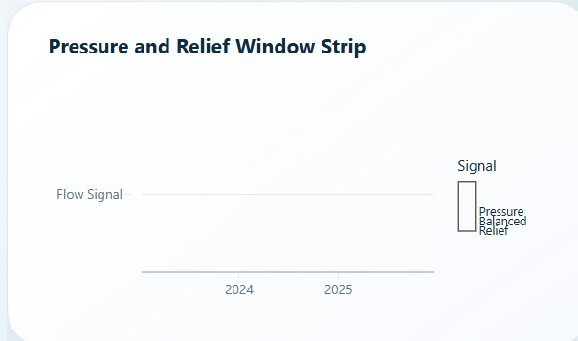
Figure A1. Pressure and Relief Window Strip supporting pressure, balanced, and relief classification documentation.
This supporting visual documents the dashboard classification layer for pressure, balanced, and relief window signals. Because the chart is less information-dense than the primary evidence visuals, it is placed in the appendix rather than the main result section.

Appendix D: Publication Metadata
Metadata Field | Recommended Entry
Title | System Capacity & Care Load Analytics for Unaccompanied Children
Creator | Mohit Gupta
Resource Type | Publication / Report
Keywords | Healthcare capacity analytics; UAC care pipeline; HHS care load; CBP custody; net intake pressure; discharge offset ratio; backlog accumulation; stress classification; Streamlit dashboard; public-sector analytics.
Version | 10/10 final safe-mode polished version with page-guided TOC, governance notes, metadata cleanup, and render verification.
License | Creative Commons Attribution 4.0 International, if public sharing and reuse are intended.
Description | A dashboard-supported data analytics research paper evaluating system load, CBP-HHS responsibility split, transfer-discharge balance, backlog accumulation, KPI health, and pressure drivers in the UAC care pipeline.

Appendix E: Final Publication Readiness Checklist
- All primary sections are included: executive summary, methodology, data governance, limitations, EDA, results, findings, recommendations, implementation, conclusion, references, and appendix.
- All 20 dashboard and visualization screenshots are included or documented, with the lowest-readability support visual placed in the appendix.
- The report uses a clean, professional layout with readable headings, tables, captions, and body text.
- The report avoids unsupported causal claims and clearly states limitations and scope boundaries.
- The paper is suitable for portfolio, GitHub, Zenodo-style repository upload, and professional project submission.

