Project Visibility Plan :
The team is to deliver visibility on all project aspects, including status, progress, issues, iterations, resource loads, deadlines, critical paths, and so on.

The team must have an insight into the available resources and current workloads. All anticipated resource overload situations are to be identified and team members are to be issued their updated workloads.

The communication with the stakeholder (customer) is strictly necessary. The customer is to be regularly informed of all the decisions taken, risks identified, issues (if any), progress so far, and any delays (encountered or speculated) in the completion of the increment (project).
The mode of communication for such reports is through electronic mails.

Incase additional information about the project is required, or clarification about any aspect of the assignment is needed, the customer is to be contacted through phone for lightweight information or clarifications. Should the requirement be heavy, a meeting at a convinient location is to be arranged and the customer should be informed of the rendezvous. Any change requests by the customer are also handled the same way.

Version control is maintained by github. All team members are to upload their works in the git repository. Team members are regularly in contact through phone. For major decisions, the team is to assemble at a convinient location where the decisions are taken.

Undertaken Task Statement :
The goal of the project is to develop a software with a sufficiently rich GUI to find an optimal path on the map for the users to travel. The software is to run on client side and work using the map data provided by the server/s. The software should be able to run on Windows based environment. The core functionality shall be delivered in the first increment, while other auxiliary features and optimizations are to be added in the following increments.

Outline Plan :
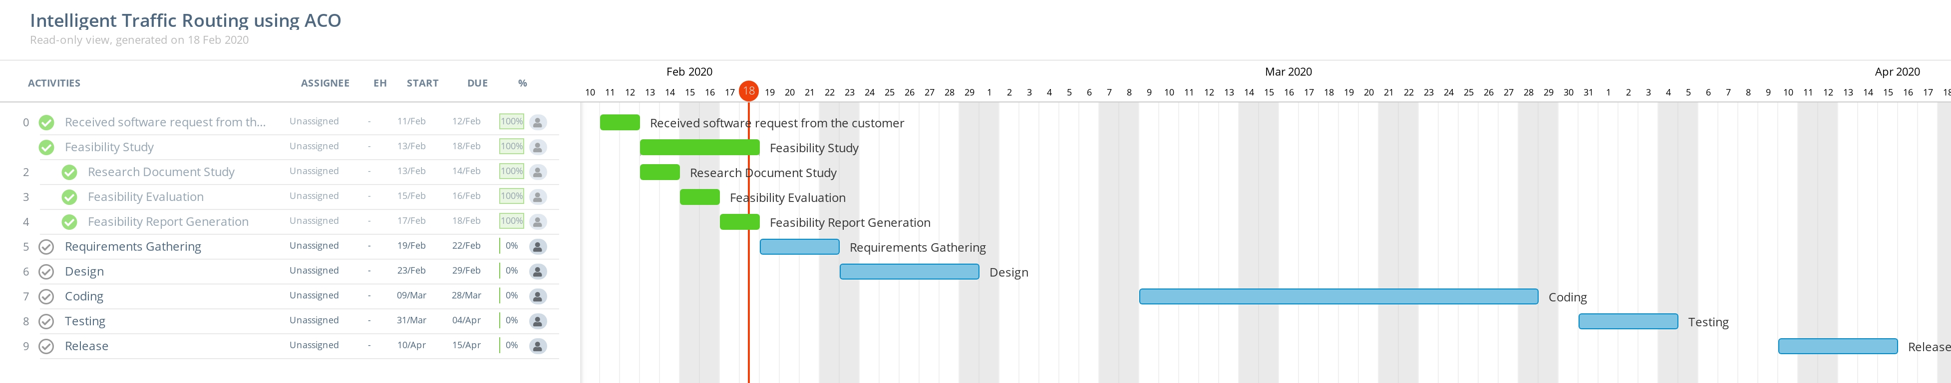
The software request was received on February 11th.
A Feasibility study was conducted from February 13th to February 18th. The conducted feasibility study included researching on the Ant Colony Optimization algorithm, the evaluation of the feasibility of the project and the generation of this report.
The events following this report include :

Requirements Gathering : All sorts of requirements to be gathered and analyzed.

Design : The software is designed in this phase. A prototype is to be used to help understanting the project.
Coding : The software is to be coded in accordance to the design. Also, self-testing approach is to be followed within the coding phase.

Testing : A thorough testing is to be held to verify the code. Any errors encountered should be resolved.

Release : The core product of the first increment is to be released. The team is to prepare for the next increment for auxiliary features and optimization.

