Expense Tracker Application
User Flow Diagram & Documentation
Frontend Web Application — Personal Finance Management
Technology Stack: HTML5, CSS3, JavaScript (ES6) | Optional: localStorage, Chart.js

1. Introduction
This document presents the complete User Flow Diagram for the Expense Tracker Application, a client-side, single-page web application built for personal finance management. The flow is derived strictly from the project's Software Requirements Specification (SRS) and Project Synopsis, and covers the Core Features (transaction entry, validation, listing, editing, deleting, and automatic calculation) along with the four Optional Enhancements defined in the requirements: data persistence with localStorage, filtering, data visualization with Chart.js, and a dark mode toggle.
No login, authentication, backend API, database, payment gateway, admin panel, or cloud synchronization is included, as these fall outside the scope of the base project requirements.

2. Visual Flowchart
The diagram below follows standard flowchart conventions: ovals mark Start/End, rectangles mark process/action steps, diamonds mark decision points, and parallelograms mark user input/output. Optional features (localStorage persistence, filtering, visualization, and dark mode) are shown in dashed pink nodes, clearly separated from the core required flow.
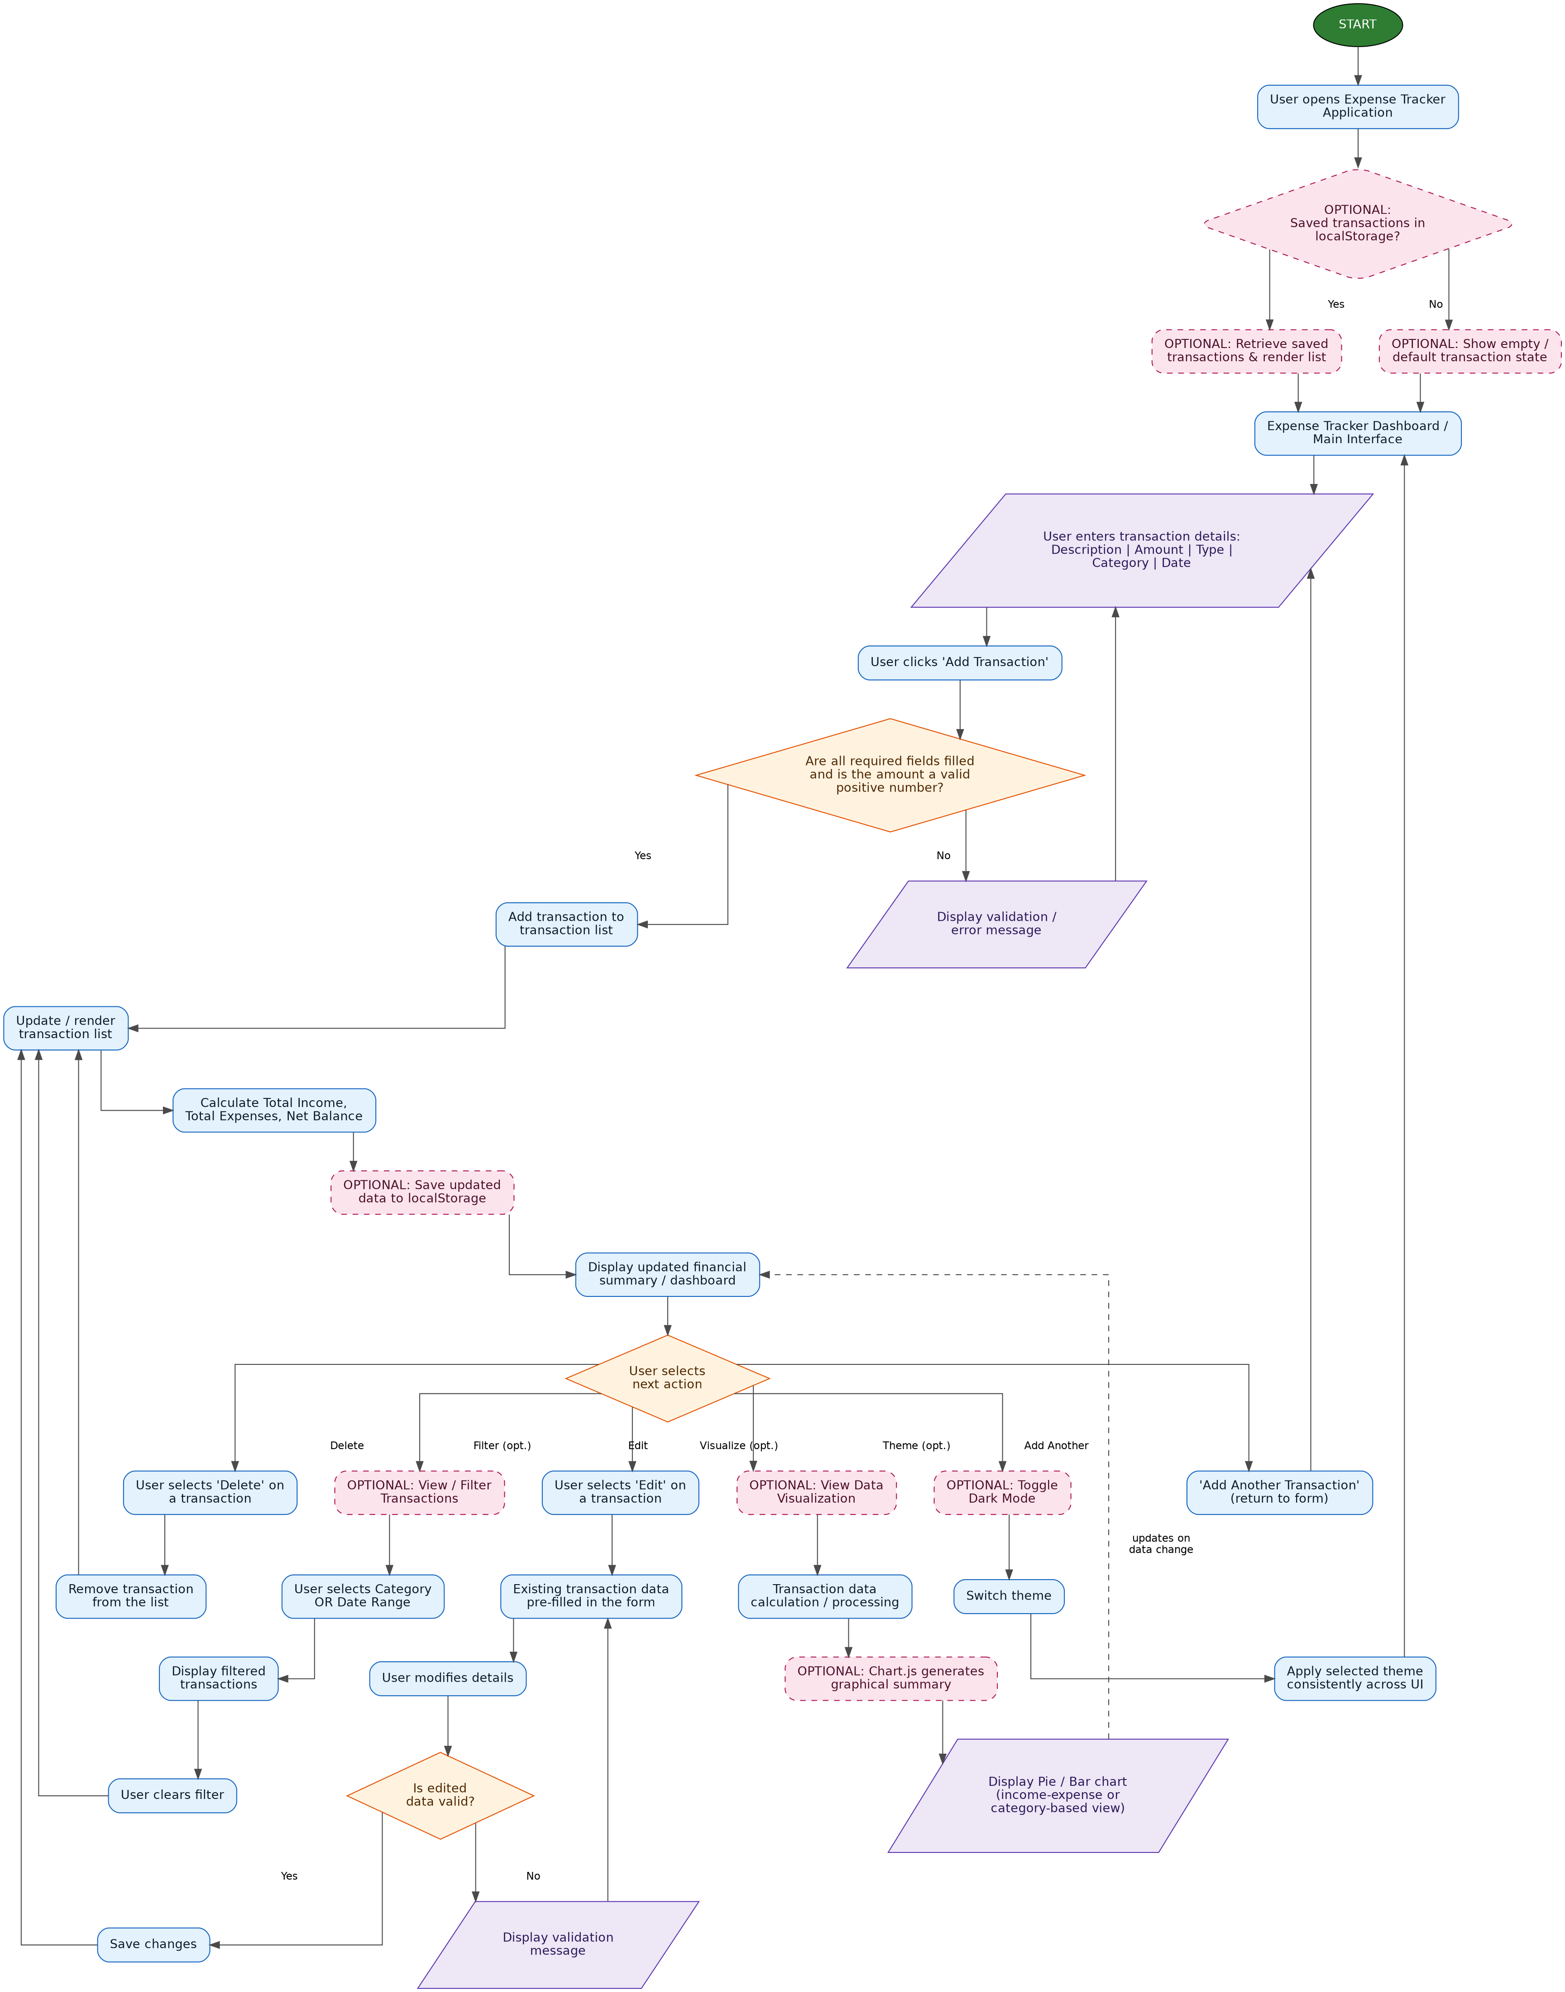
Figure 1: Complete User Flow Diagram — Expense Tracker Application

3. Explanation of the User Flow

3.1 Application Load
When the user opens the application, the system optionally checks localStorage for previously saved transactions. If saved data exists, it is retrieved and rendered into the transaction list and totals are calculated; otherwise the dashboard is shown in its default, empty state. Either path leads to the Expense Tracker Dashboard, the application's main interface.

3.2 Adding a Transaction
From the dashboard, the user enters the transaction Description, Amount, Type (Income or Expense), Category, and Date, then clicks ‘Add Transaction’. The system validates that all required fields are filled and that the amount is a valid positive number. If validation fails, an error message is displayed and the user returns to the form to correct the input. If validation succeeds, the transaction is added to the internal list, the transaction list is re-rendered, and Total Income, Total Expenses, and Net Balance are recalculated and displayed. If localStorage is implemented, the updated list is also saved at this point.

3.3 Editing a Transaction
Selecting ‘Edit’ on a transaction pre-fills the form with its existing values. After the user modifies the details, the same validation rules apply. Invalid data returns the user to the pre-filled form with a validation message; valid data is saved, the transaction list is updated, and totals are recalculated.

3.4 Deleting a Transaction
Selecting ‘Delete’ removes the transaction from the internal list. The transaction list is re-rendered and Total Income, Total Expenses, and Net Balance are recalculated to reflect the updated dashboard.

3.5 Optional Filtering
From the transaction list, the user may filter entries by Category or by Date Range. The filtered results are displayed, and the user can clear the filter at any time to return to the complete transaction list.

3.6 Optional Data Visualization
Transaction data can be processed and passed to Chart.js to generate a Pie or Bar chart summarizing income and expenses, or spending by category. The chart automatically updates whenever the underlying transaction data changes.

3.7 Optional Dark Mode
From the dashboard, the user can toggle Dark Mode. The selected theme is switched and applied consistently across the entire interface.
Throughout the flow, the user can always loop back to the Dashboard or the Transaction Form — after adding another transaction, after clearing a filter, after changing the theme, or after correcting a validation error — keeping the experience continuous and non-linear where the requirements call for it.

4. Major Screens, Pages & Components
The application is a single-page interface composed of the following functional components (per SRS Section 4.1, External Interface Requirements):

Screen / Component | Type | Purpose
Expense Tracker Dashboard | Main Interface | Central screen showing the transaction list and financial summary.
Transaction Entry Form | Input Component | Captures Description, Amount, Type, Category, and Date; reused for Add and Edit.
Transaction List / Table | Display Component | Structured view of all recorded transactions with Edit and Delete controls.
Financial Summary Panel | Display Component | Shows Total Income, Total Expenses, and Net Balance in real time.
Validation / Error Message | Feedback Component | Displayed inline when required fields are missing or the amount is invalid.
Filter Controls (Optional) | Input Component | Allows filtering the transaction list by Category or Date Range.
Chart Display Area (Optional) | Visualization Component | Renders a Pie or Bar chart via Chart.js, based on current transaction data.
Dark Mode Toggle (Optional) | UI Control | Switches and applies the light/dark theme across the interface.

5. Core Features vs. Optional Features

5.1 Core Features (per SRS Section 3, FR-1 to FR-5)
Feature | Description
Add Transaction (FR-1) | User adds an income or expense entry with description, amount, type, category, and date through a validated form.
View Transactions (FR-2) | All entries are displayed in a structured, readable list or table view.
Edit Transaction (FR-3) | Existing transactions can be modified; the form is pre-filled and re-validated on save.
Delete Transaction (FR-4) | Unwanted or incorrect entries can be removed, updating the list and totals.
Automatic Calculations (FR-5) | Total Income, Total Expenses, and Net Balance are computed and updated in real time.

5.2 Optional Enhancements (per SRS Section 3, FR-6 to FR-9)
Feature | Description
Data Persistence — localStorage (FR-6) | Transaction data is saved to and retrieved from the browser's localStorage so it survives page refreshes and browser restarts.
Filter Transactions (FR-7) | Displayed transactions can be filtered by Category or by a Date Range, with the ability to clear the filter.
Data Visualization — Chart.js (FR-8) | A Pie or Bar chart summarizes income/expense or category-based data and updates automatically as data changes.
Dark Mode Toggle (FR-9) | A theme switch applies a light or dark interface consistently across all components.
Explicitly excluded from scope: login/registration, user authentication, backend API, database, payment gateway, admin panel, and cloud synchronization — none of these appear anywhere in the flow above, consistent with SRS Sections 1.2 and 2.5.

6. Mermaid Flowchart Source
The Mermaid definition below reproduces the same flow digitally. Paste it into the Mermaid Live Editor (mermaid.live), a Markdown renderer that supports Mermaid, or any Mermaid-compatible tool to view and edit the diagram.
flowchart TD
Start([START]) --> Open[User Opens Expense Tracker Application]
Open --> LSCheck{"OPTIONAL: Saved transactions<br/>available in localStorage?"}
LSCheck -->|Yes| LoadData[Retrieve saved transactions<br/>and render transaction list]
LSCheck -->|No| EmptyState[Show empty / default<br/>transaction state]
LoadData --> Dashboard[Expense Tracker Dashboard /<br/>Main Interface]
EmptyState --> Dashboard

Dashboard --> Form[/User enters transaction details:<br/>Description, Amount, Type,<br/>Category, Date/]
Form --> AddBtn[User clicks 'Add Transaction']
AddBtn --> Validate{Are all required fields filled<br/>and is the amount a valid<br/>positive number?}
Validate -->|No| ErrorMsg[/Display validation /<br/>error message/]
ErrorMsg --> Form
Validate -->|Yes| AddTxn[Add transaction to<br/>transaction list]
AddTxn --> UpdateList[Update / render<br/>transaction list]
UpdateList --> Calc[Calculate Total Income,<br/>Total Expenses, Net Balance]
Calc --> SaveLS{{"OPTIONAL: Save updated<br/>transaction list to localStorage"}}
SaveLS --> UpdatedDash[Display updated<br/>financial summary / dashboard]

UpdatedDash --> Choice{User selects an action}

Choice -->|Edit| Edit[Select 'Edit' on a transaction]
Choice -->|Delete| Delete[Select 'Delete' on a transaction]
Choice -->|Filter - OPTIONAL| Filter[View / Filter Transactions]
Choice -->|Visualize - OPTIONAL| Viz[View Data Visualization]
Choice -->|Theme - OPTIONAL| Dark[Toggle Dark Mode]
Choice -->|Add Another| AddAnother[Return to Transaction Form]

Edit --> PrefillForm[Existing transaction data<br/>pre-filled in the form]
PrefillForm --> ModifyDetails[User modifies details]
ModifyDetails --> ValidateEdit{Is edited data valid?}
ValidateEdit -->|No| EditError[/Display validation message/]
EditError --> PrefillForm
ValidateEdit -->|Yes| SaveEdit[Save changes]
SaveEdit --> UpdateList

Delete --> RemoveTxn[Remove transaction<br/>from the list]
RemoveTxn --> UpdateList

Filter --> SelectFilter[User selects Category<br/>OR Date Range]
SelectFilter --> ShowFiltered[Display filtered<br/>transactions]
ShowFiltered --> ClearFilter[User clears filter]
ClearFilter --> UpdateList

Viz --> ProcessData[Transaction data<br/>calculation / processing]
ProcessData --> ChartJS[Chart.js generates<br/>graphical summary]
ChartJS --> DisplayChart[Display Pie / Bar chart:<br/>income-expense or<br/>category-based view]
DisplayChart -.chart updates when data changes.-> UpdatedDash

Dark --> SwitchTheme[Switch theme]
SwitchTheme --> ApplyTheme[Apply selected theme<br/>consistently across UI]
ApplyTheme --> Dashboard

AddAnother --> Form

classDef startEnd fill:#2E7D32,stroke:#1B5E20,color:#fff,stroke-width:2px
classDef process fill:#E3F2FD,stroke:#1565C0,color:#0D1B2A,stroke-width:1.5px
classDef decision fill:#FFF3E0,stroke:#E65100,color:#4E2600,stroke-width:1.5px
classDef io fill:#EDE7F6,stroke:#5E35B1,color:#2A1858,stroke-width:1.5px
classDef optional fill:#FCE4EC,stroke:#AD1457,color:#4A0E28,stroke-width:1.5px,stroke-dasharray: 5 3

class Start startEnd
class Open,Dashboard,AddBtn,AddTxn,UpdateList,Calc,UpdatedDash,PrefillForm,ModifyDetails,SaveEdit,RemoveTxn,SelectFilter,ShowFiltered,ClearFilter,ProcessData,SwitchTheme,ApplyTheme,AddAnother,Edit,Delete process
class Validate,Choice,ValidateEdit decision
class Form,ErrorMsg,EditError,DisplayChart io
class LSCheck,LoadData,EmptyState,SaveLS,Filter,Viz,Dark,ChartJS optional

