PROJECT -1

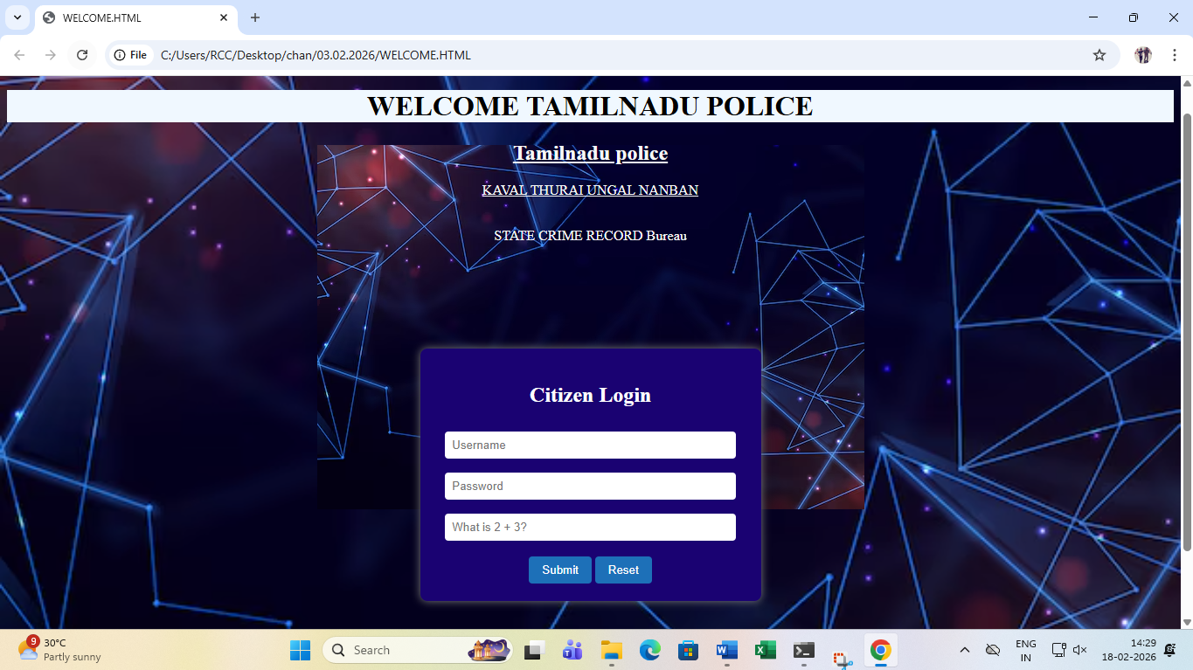
It looks like a police department citizen portal login page — possibly for:
- Filing complaints
- Viewing crime records
- Accessing public services
So, the image is showing a Tamil Nadu Police citizen login webpage design.

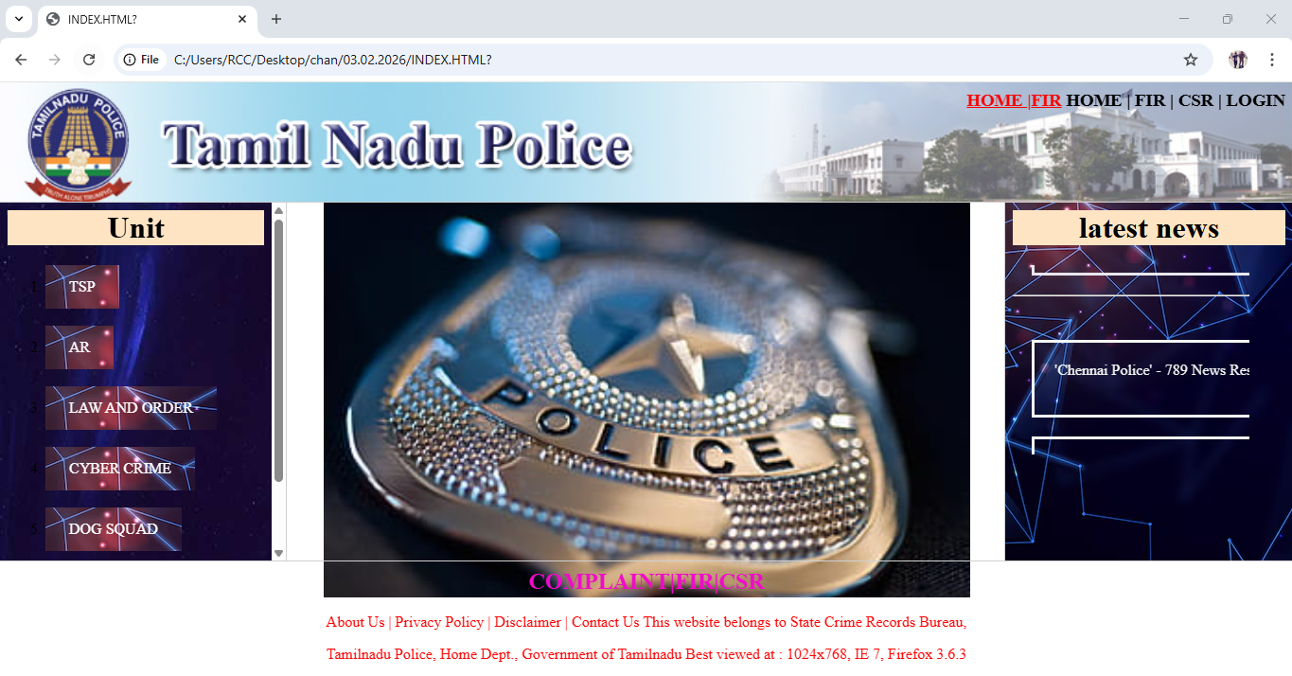

This image shows a Tamil Nadu Police official website homepage design.
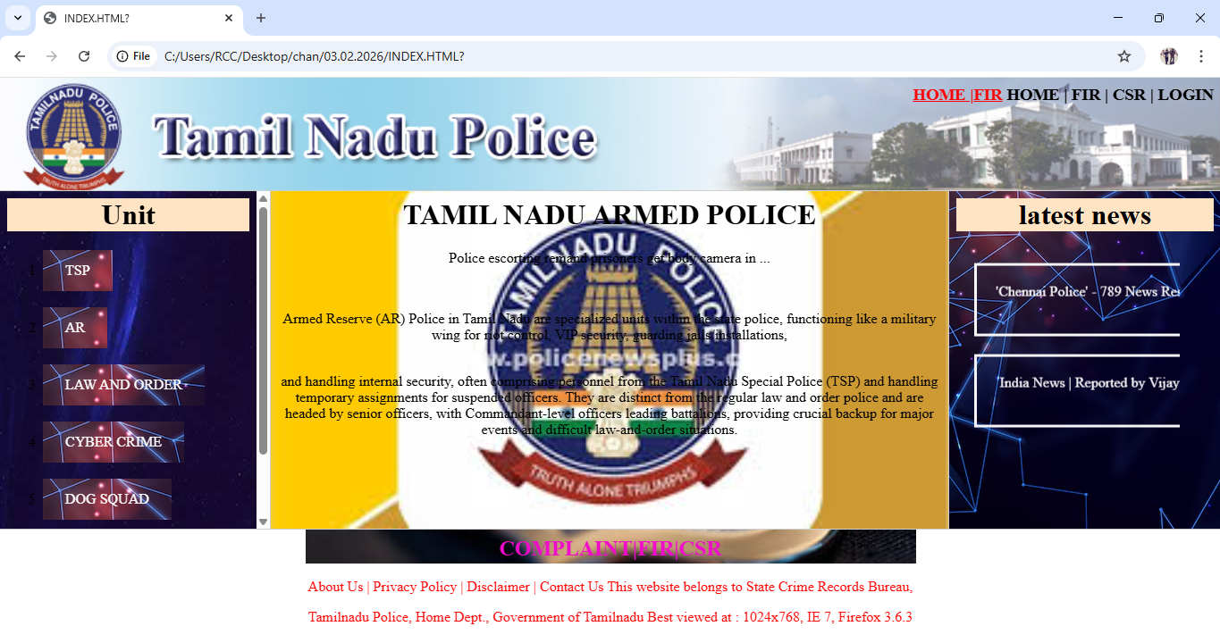
🎯 Overall Meaning
This image shows the Armed Reserve (AR) information page inside a Tamil Nadu Police website.
It explains:
👉 What AR is
👉 Their duties
👉 Their role in maintaining law and order

PROJECT -2
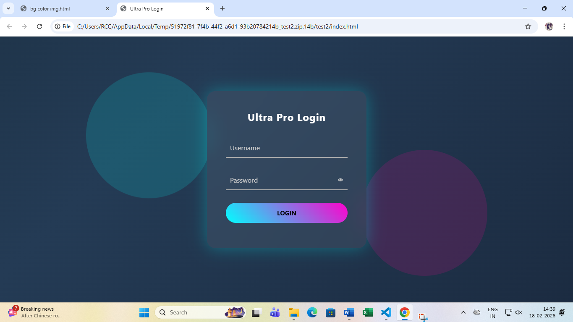

📌 What the page says:
Ultra Pro Login
Below it:
- Username (input field)
- Password (input field with eye icon to show/hide password)
- A colorful gradient LOGIN button
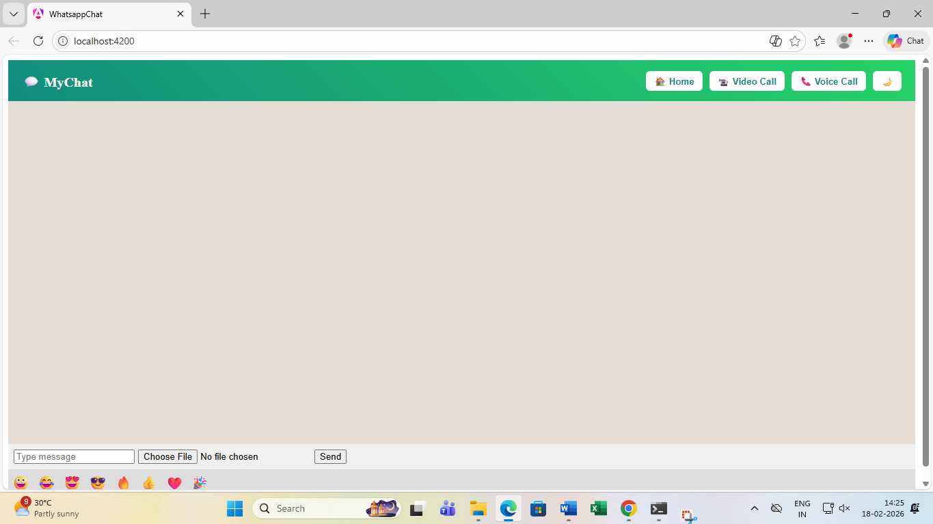

🎯 Overall Meaning:
This is a custom WhatsApp clone chat UI created using Angular. It supports:
- Text messaging
- File upload
- Emoji selection
- Video call button (UI only)
- Voice call button (UI only)
- Dark mode toggle
Right now, it looks like:

PROJECT -3

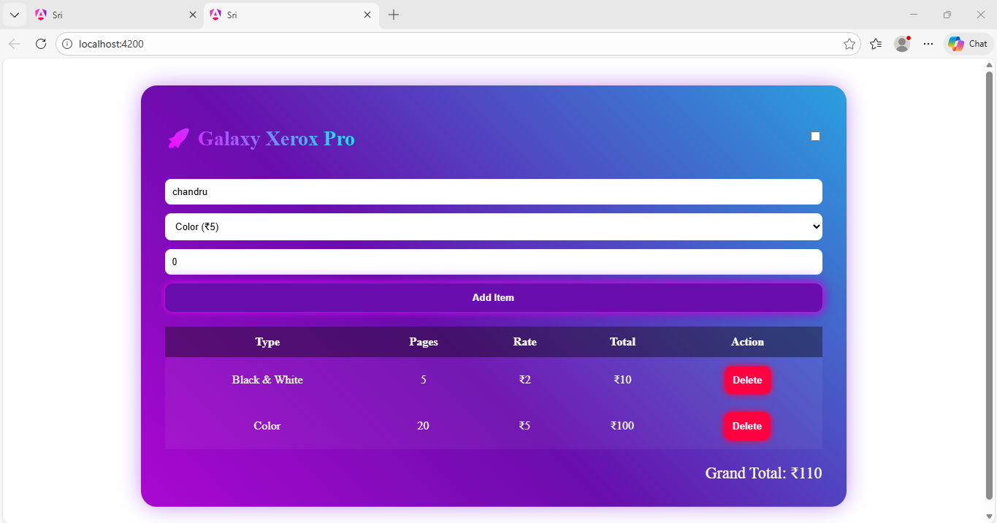

🎯 Final Overall Meaning
👉 It is a modern Xerox shop billing software UI
👉 Built for shop owners to manage print billing easily
👉 Calculates totals automatically
👉 Designed with a professional gradient interface

PROJECT-4

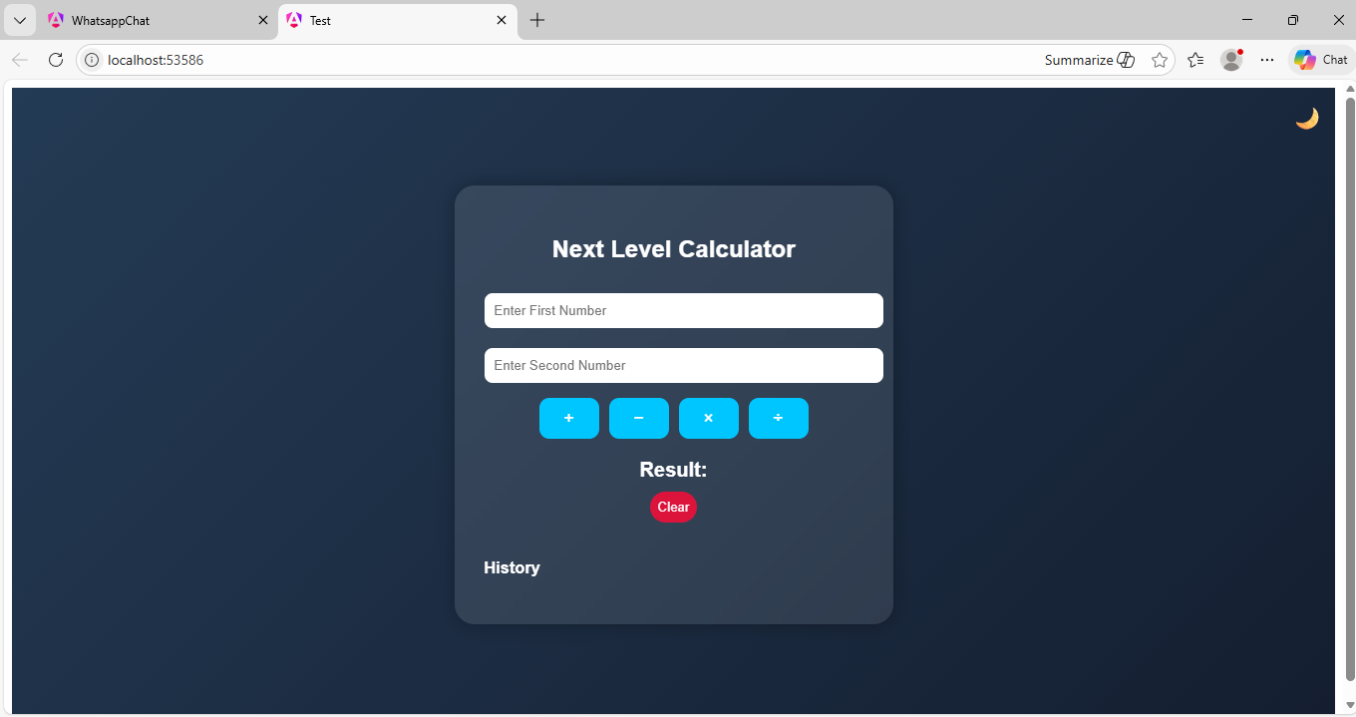

🎯 Overall Meaning:
It is a stylish calculator web application that:
✔ Takes two numbers
✔ Performs basic arithmetic operations
✔ Displays result
✔ Stores calculation history
✔ Has clear/reset functionality
It looks like an advanced UI version of a simple calculator project.

PROJECT-5

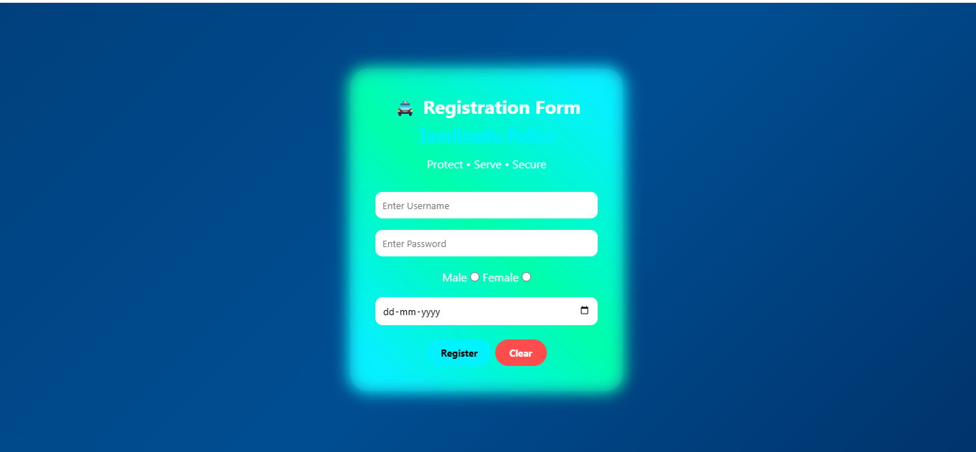

🎯 Overall Meaning:
It is a Tamil Nadu Police styled registration page UI, likely for:
✔ Citizen registration
✔ Police portal signup
✔ Complaint system account creation
✔ Web application user registration

