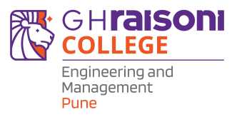 | G H RAISONI COLLEGE OF ENGINEERING & MANAGEMENT  (An Autonomous Institute Affiliated to SPPU, Pune | NAAC "A+" Grade)  Gat No. 1200, Domkhel Road, Wagholi, Pune - 412207  Web: https://ghrcem.raisoni.net | Email: ghrcem.pune@raisoni.net

Department of Computer Science and Engineering
(Cyber Security & Data Science)
Date: 21/08/2026
Caption of News: Session on Engineering Your Future: Career Pathways, Skills and Emerging Opportunities
Photograph of the event:
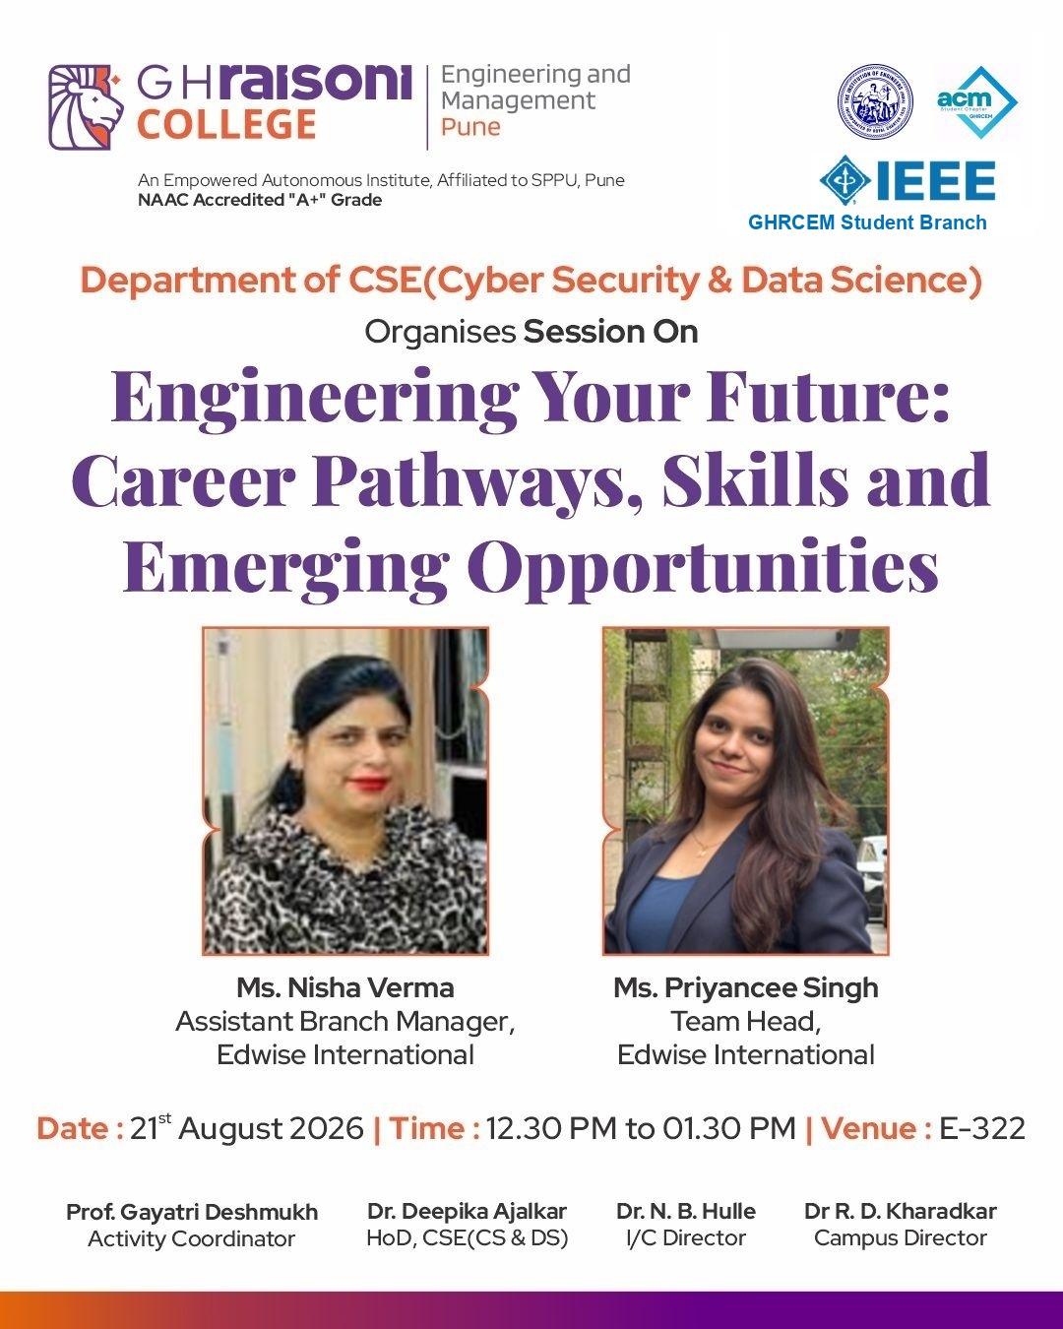 | 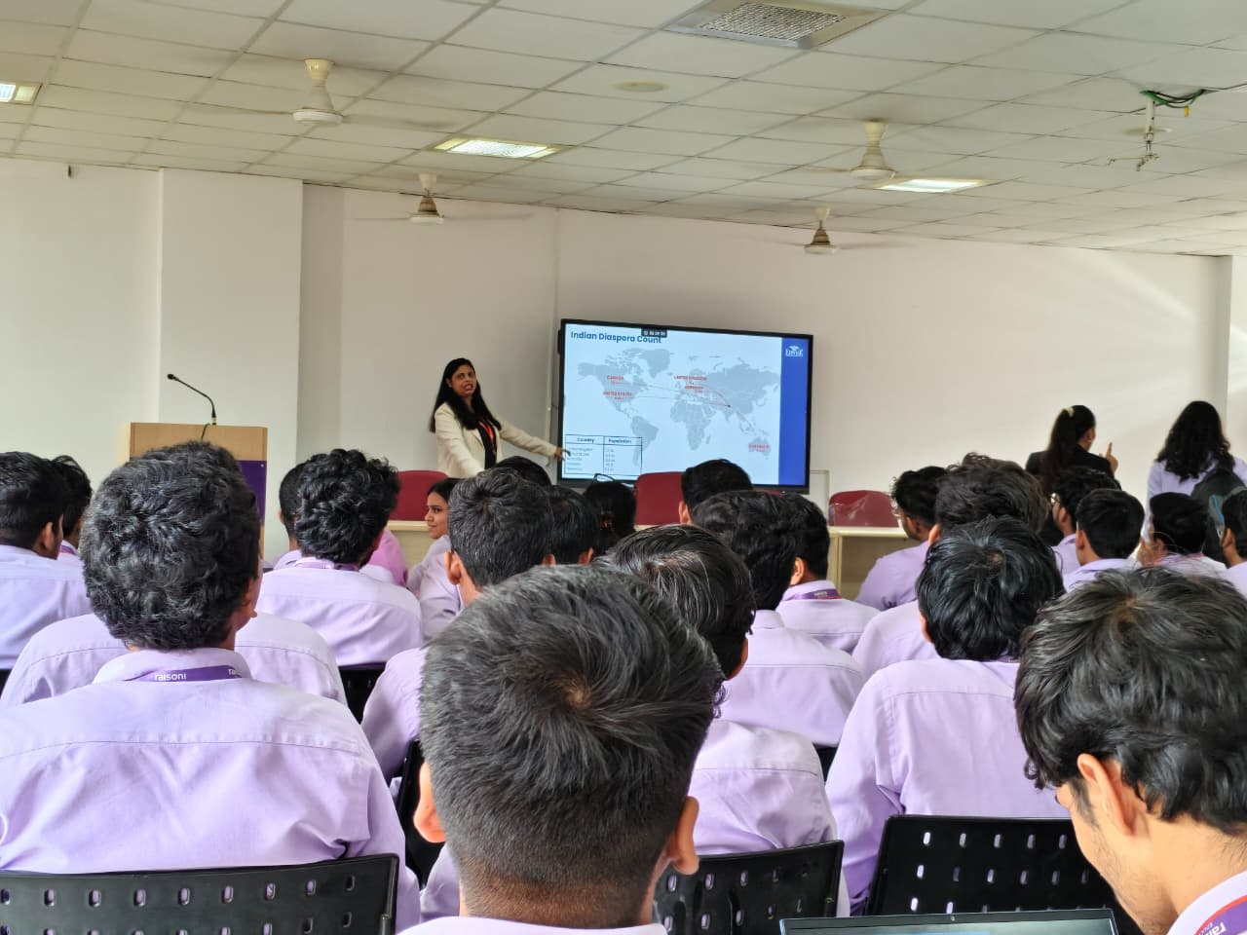
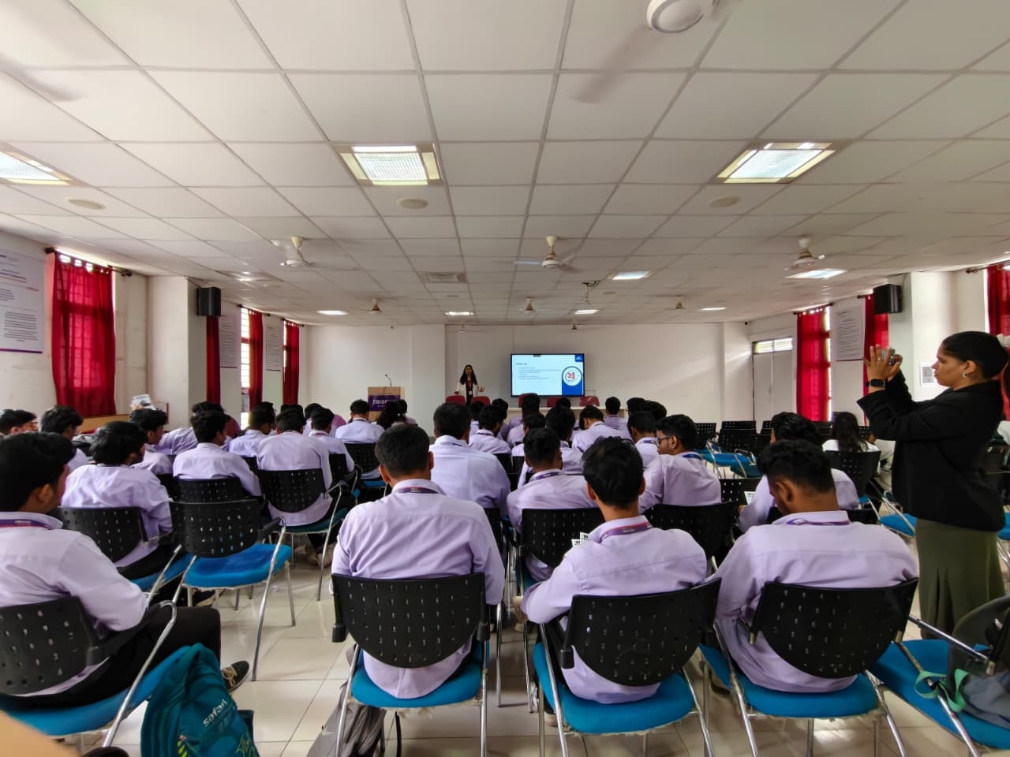 | 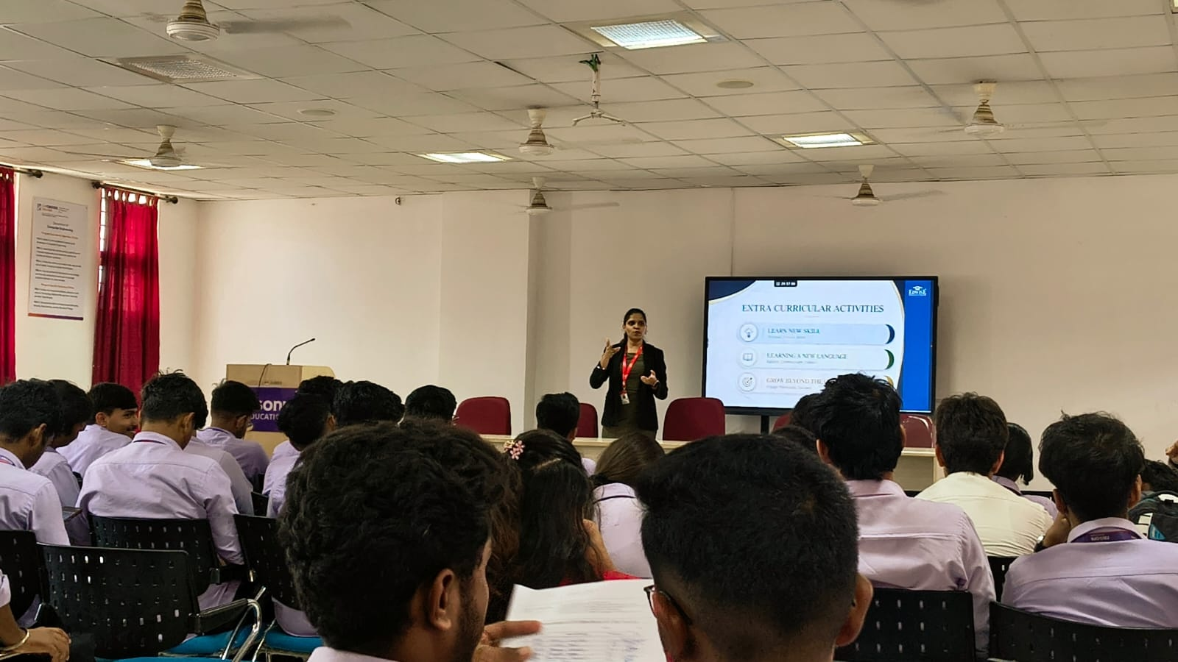

- Description: Session on Engineering Your Future: Career Pathways, Skills and Emerging Opportunities
- An inspiring career orientation session titled "Engineering Your Future: Career Pathways, Skills and Emerging Opportunities" was organized by the Department of Computer Science and Engineering (Data Science & Cyber Security) at G H Raisoni College of Engineering and Management (GHRCEM), Pune on 21st August 2026 in E-322, under the leadership of Campus Director Dr. R. D. Kharadkar and I/C Director Dr. N. B. Hulle.
- The session was conducted by distinguished experts Ms. Nisha Verma (Assistant Branch Manager) and Ms. Priyancee Singh (Team Head) from Edwise International. The speakers provided valuable insights into evolving global engineering career avenues, higher education strategies, and skill sets required for international academic and professional success.
- Interactive presentations guided students through mapping global education destinations, understanding international admission timelines, preparing competitive standardized profiles, and structuring impactful application credentials including Statement of Purpose (SOP) and Letters of Recommendation (LOR).
- Key topics highlighted included global market trends, emerging tech domains, scholarship opportunities, demographic distribution of the Indian student diaspora, resume building, and essential soft skills needed to thrive in multinational environments.
- The informative session actively engaged over 120 student engineers. The program concluded with an interactive Q&A session, followed by a formal vote of thanks delivered by Activity Coordinator Prof. Gayatri Deshmukh and commendations from Dr. Deepika Ajalkar, HOD CSE (CS & DS).

Details of the Event Coordinator:  Name: Prof. Gayatri Deshmukh  Designation: Activity Coordinator  Department: CSE (CS & DS)  Date: 21/08/2026 | Dr. Deepika Ajalkar  HOD CSE (CS & DS)

Sr. No. | Name of Programme | Date | Department | Coordinators | Target Audience | Expert Name
1 | Session on Engineering Your Future: Career Pathways, Skills and Emerging Opportunities | 21st August 2026 | CSE(CS & DS) | Prof. Gayatri Deshmukh | Engineering Students (120 Participants) | Ms. Nisha Verma & Ms. Priyancee Singh

