The Institution of Engineers (India)
(ESTABLISHED 1920, INCORPORATED BY ROYAL CHARTER 1935)
8 GOKHALE ROAD, KOLKATA – 700 020
PROFORMA OF REPORT FROM STUDENTS’ CHAPTER
(1 April 2026 - 31 March 2027)
Details of Technical Activity
(Lecture /Paper presentation/Seminar//Workshop/Conference/Technical/Project Demonstration/Model competition/Poster Competition/Group Discussion/Technical Quiz/Aptitude Test/Technical Visit/Film show/Display of Technical Information/Short term course)
Title /Theme: Session on Engineering Your Future: Career Pathways, Skills and Emerging Opportunities
Date: 21st August 2026
Duration: 1 Hour

No of Students Participated: 120

Photographs:

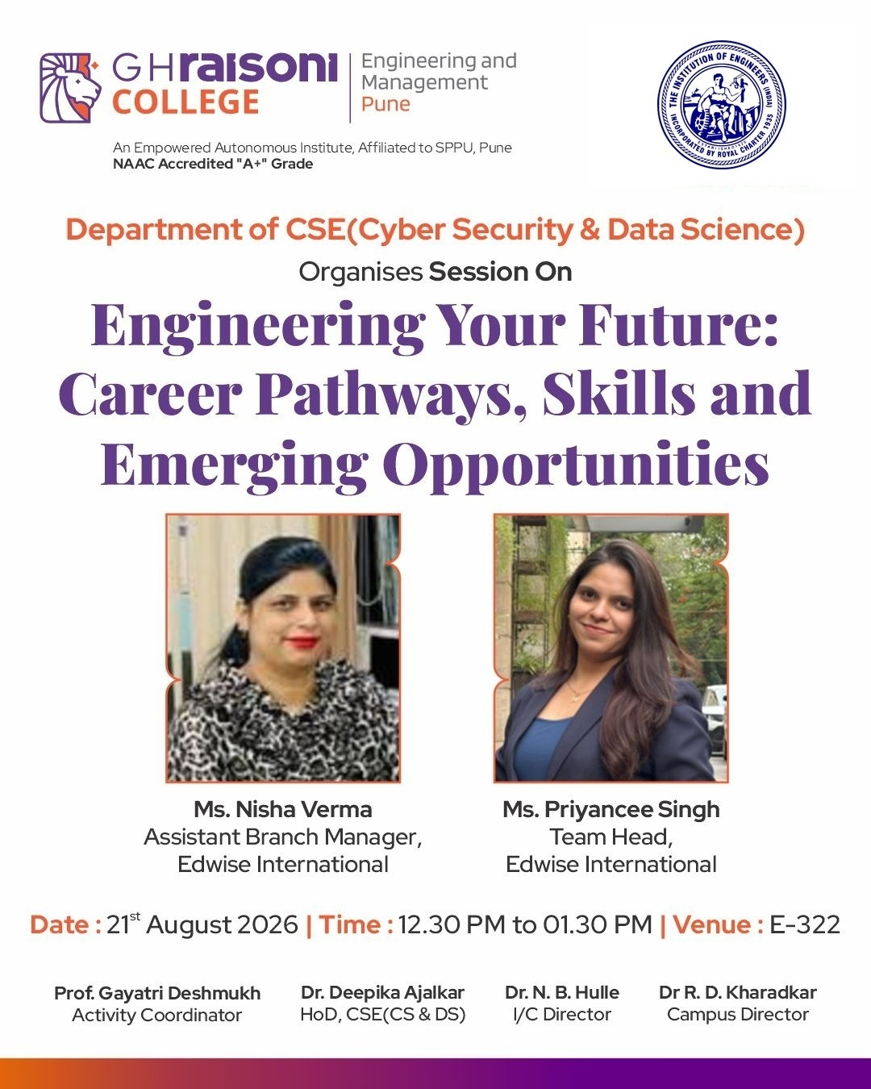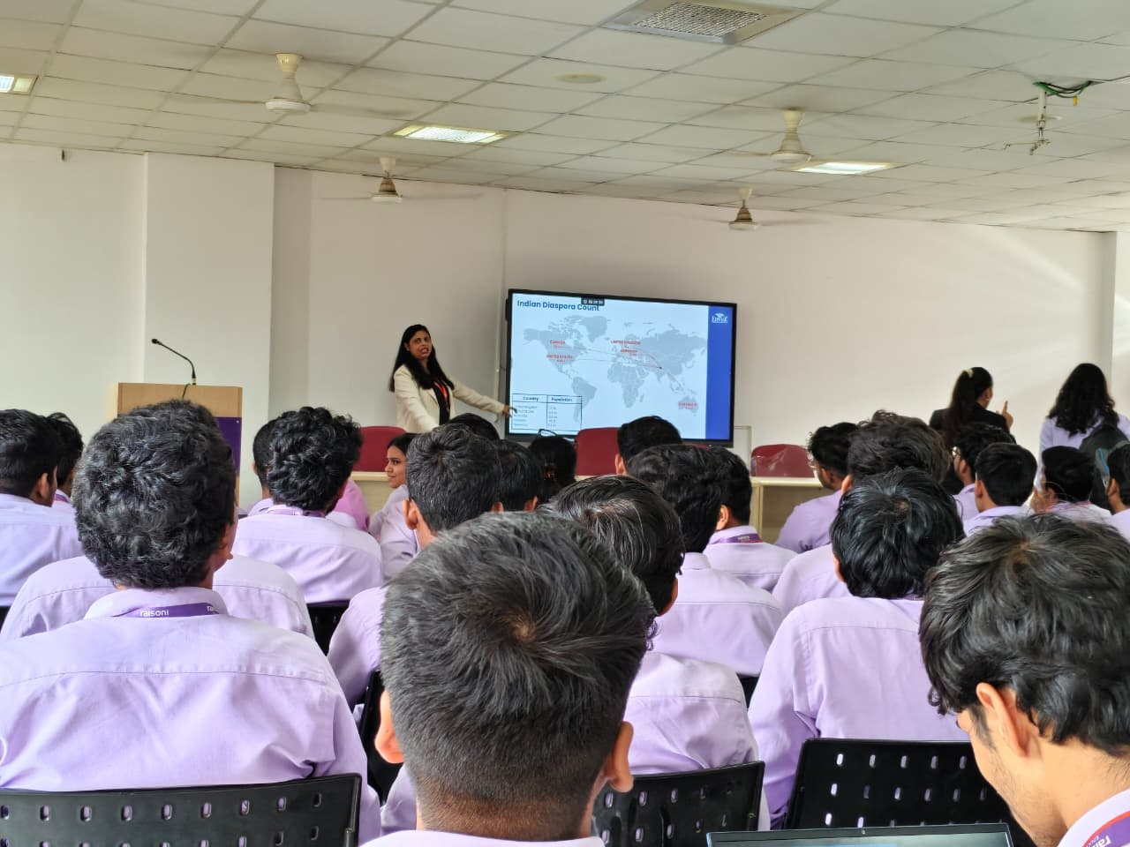
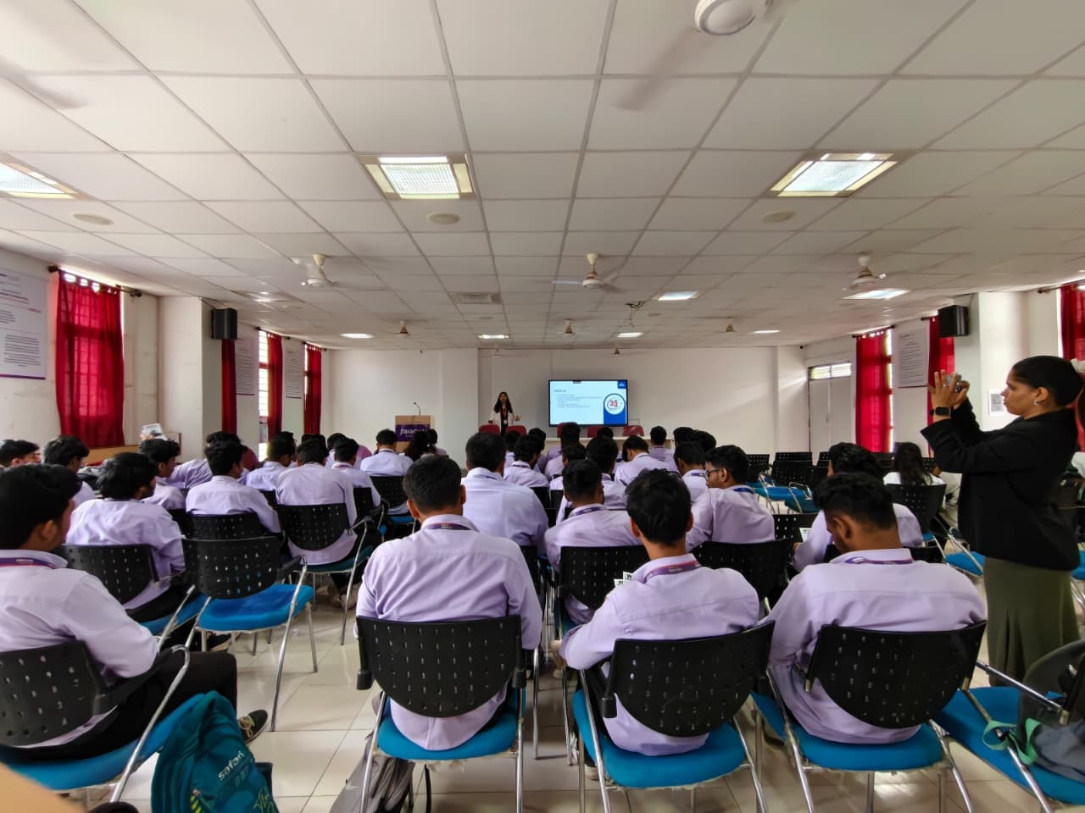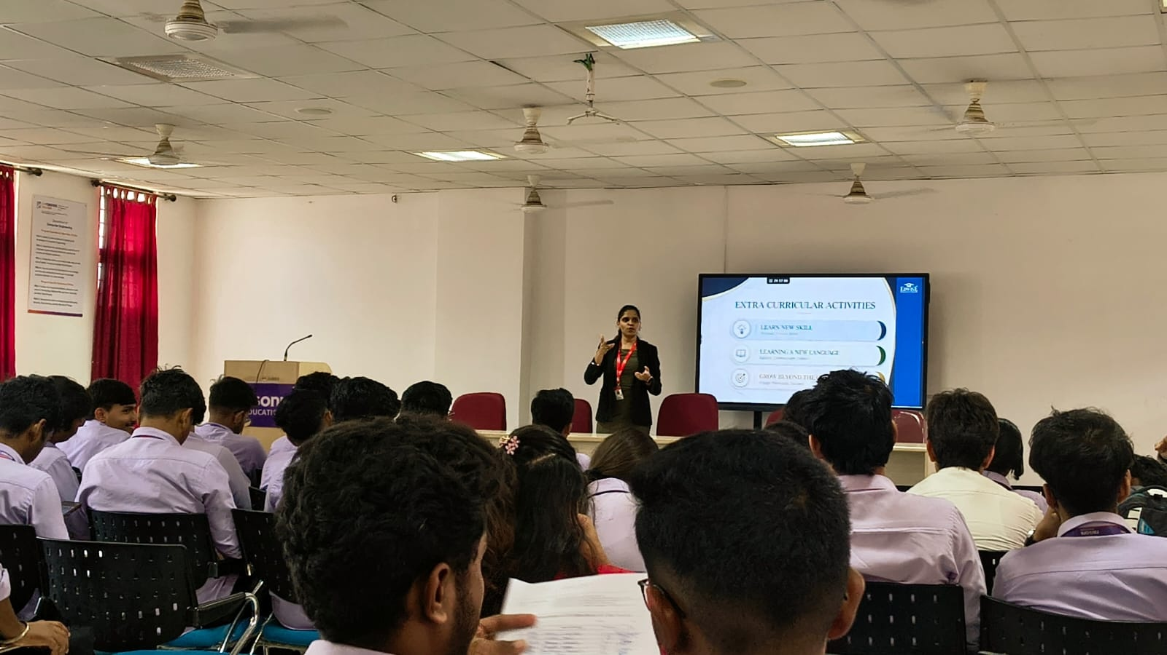

Description: Report on "Session on Engineering Your Future: Career Pathways, Skills and Emerging Opportunities"

The Department of Computer Science and Engineering (Data Science & Cyber Security) at G H Raisoni College of Engineering and Management (GHRCEM), Pune successfully organized an expert career guidance session titled "Engineering Your Future: Career Pathways, Skills and Emerging Opportunities" on 21st August 2026 in E-322 under the esteemed aegis of the IEI Student Chapter, supported by Campus Director Dr. R. D. Kharadkar and I/C Director Dr. N. B. Hulle.
The session was jointly delivered by eminent career counselors and overseas education mentors Ms. Nisha Verma, Assistant Branch Manager, and Ms. Priyancee Singh, Team Head at Edwise International. The resource persons presented a comprehensive breakdown of global higher education ecosystems, emerging engineering specializations, international research fellowships, and strategic career planning methodologies tailored for computer science and cybersecurity undergraduates.
Attendees participated in an engaging technical dialogue surrounding global talent mobility, demographic analytics of the Indian engineering diaspora, admission timelines, standardized examination requirements, and profile enhancement strategies. The speakers emphasized the critical importance of crafting persuasive Statements of Purpose (SOP), securing strong Letters of Recommendation (LOR), publishing research papers, and building extra-curricular portfolios alongside university engineering coursework to maximize global academic and career prospects.
A total of 120 aspiring student engineers attended the session, gaining actionable clarity on global career pathways and higher education opportunities. The event concluded with an interactive clinic resolving student queries regarding scholarship applications and visa procedures, followed by a felicitation ceremony for the guest speakers and a formal vote of thanks presented by Activity Coordinator Prof. Gayatri Deshmukh.

________________
Signature of the Faculty Advisor
with date affixed with seal

