**REPORT**

Submitted by: HIMANSHI ARORA

Registration Number:12306250

Section: K23UP

Roll no: 37

Date: 29-04-2025

Course Code: CSE 307

Course Title:

**Internetworking Essentials**

Submitted to: MR. SIMARJIT SINGH MALHI

School of Computer Science and Engineering

Lovely Professional University

Phagwara, Punjab



**GITHUB REPOSITORY:**

[**https://github.com/techyhimanshi2023/Internetworkinglab.git**](https://github.com/techyhimanshi2023/Internetworkinglab.git)

**Introduction**

HP Infotech, a mid-sized technology enterprise, operates in a five-floor office building, requiring a robust network to support efficient communication and scalability. Each floor hosts multiple devices, including PCs and servers (Email, FTP, HTTP, DNS, DHCP), with specific host requirements: 5551 hosts on Floor 1, 999 on Floor 2, 13000 on Floor 3, 91 on Floor 4, and 5 on Floor 5. This report outlines the network design, including a hybrid topology (mesh for Floors 1–3, star for Floors 4–5), VLSM-based IP addressing, dynamic routing with RIP, and device configurations. The design ensures seamless inter-floor communication, fault tolerance, and support for critical services, implemented in Cisco Packet Tracer.

**Network Design Requirements**

**1. Topology Selection**

The network uses a **hybrid topology**:

* **Floors 1–3**: A **mesh topology** connects three routers (R1, R2, R3) for inter-floor communication, ensuring high fault tolerance and redundancy.
* **Floors 4–5**: A **star topology** centers around routers (R4, R5), providing simplicity and scalability for smaller floors.

**Key Benefits**:

* **Fault Tolerance**: Mesh topology on Floors 1–3 ensures multiple paths for data, reducing downtime.
* **Scalability**: Star topology on Floors 4–5 allows easy addition of devices.
* **Localized Control**: Each floor’s star topology isolates intra-floor traffic.

**Router Assignments**:

* R1: Floor 1 (Email Server)
* R2: Floor 2 (FTP Server)
* R3: Floor 3 (HTTP Server)
* R4: Floor 4 (No Server)
* R5: Floor 5 (DNS and DHCP Servers)

**2. VLSM Calculations and IP Addressing Scheme**

The network uses **VLSM** to allocate IP addresses efficiently based on host requirements, using **1.0.0.0/8** (Class A public IPs for Floors 1–3) and **10.0.0.0/8** (Class A private IPs for Floors 4–5). Below are the VLSM calculations and IP assignments for each floor.

**2.1 Floor 1 (5551 Hosts)**

* **Hosts Required**: 5553 (5551 PCs + 1 Email Server + 1 Router Interface)
* **Subnet Size**: 2^13 = 8192 IPs (8190 usable)
* **Subnet Mask**: /19 (255.255.224.0)
* **Network Address**: 1.0.0.0
* **Usable IP Range**: 1.0.0.1–1.0.31.254
* **Broadcast Address**: 1.0.31.255
* **Default Gateway**: 1.0.0.1 (R1, FastEthernet0/0)
* **Assignments**:
  + Gateway: 1.0.0.1
  + Email Server: 1.0.0.2
  + PCs (7 for simulation): 1.0.0.3–1.0.0.9 (static)

**2.2 Floor 2 (999 Hosts)**

* **Hosts Required**: 1001 (999 PCs + 1 FTP Server + 1 Router Interface)
* **Subnet Size**: 2^10 = 1024 IPs (1022 usable)
* **Subnet Mask**: /22 (255.255.252.0)
* **Network Address**: 2.0.32.0
* **Usable IP Range**: 2.0.32.1–1.0.35.254
* **Broadcast Address**: 2.0.35.255
* **Default Gateway**: 2.0.32.1 (R2, FastEthernet0/0)
* **Assignments**:
  + Gateway: 2.0.32.1
  + FTP Server: 2.0.32.2
  + PCs (7 for simulation): 2.0.32.3–2.0.32.9 (static)

**2.3 Floor 3 (13000 Hosts)**

* **Hosts Required**: 13002 (13000 PCs + 1 HTTP Server + 1 Router Interface)
* **Subnet Size**: 2^14 = 16384 IPs (16382 usable)
* **Subnet Mask**: /18 (255.255.192.0)
* **Network Address**: 3.0.36.0
* **Usable IP Range**: 3.0.36.1–3.0.99.254
* **Broadcast Address**: 3.0.99.255
* **Default Gateway**: 3.0.36.1 (R3, FastEthernet0/0)
* **Assignments**:
  + Gateway: 3.0.36.1
  + HTTP Server: 3.0.36.2
  + PCs (7 for simulation): 3.0.36.3–3.0.36.9 (static)

**2.4 Floor 4 (91 Hosts)**

* **Hosts Required**: 92 (91 PCs + 1 Router Interface)
* **Subnet Size**: 2^7 = 128 IPs (126 usable)
* **Subnet Mask**: /25 (255.255.255.128)
* **Network Address**: 10.0.0.0
* **Usable IP Range**: 10.0.0.1–10.0.0.126
* **Broadcast Address**: 10.0.0.127
* **Default Gateway**: 10.0.0.1 (R4, FastEthernet0/0)
* **Assignments**:
  + Gateway: 10.0.0.1
  + PCs (7 for simulation): 10.0.0.2–10.0.0.8 (static)

**2.5 Floor 5 (5 Hosts)**

* **Hosts Required**: 8 (5 PCs + 1 DNS Server + 1 DHCP Server + 1 Router Interface)
* **Subnet Size**: 2^4 = 16 IPs (14 usable)
* **Subnet Mask**: /28 (255.255.255.240)
* **Network Address**: 10.0.0.128
* **Usable IP Range**: 10.0.0.129–10.0.0.142
* **Broadcast Address**: 10.0.0.143
* **Default Gateway**: 10.0.0.129 (R5, FastEthernet0/0)
* **Assignments**:
  + Gateway: 10.0.0.129
  + DNS Server: 10.0.0.130
  + DHCP Server: 10.0.0.131
  + PCs (5): 10.0.0.132–10.0.0.136 (DHCP)

**IP Allocation Table**

|  |  |  |  |
| --- | --- | --- | --- |
| **Floor** | **Network Address** | **Usable IP Range** | **Default Gateway** |
| Floor 1 | 1.0.0.0/19 | 1.0.0.1–1.0.31.254 | 1.0.0.1 |
| Floor 2 | 1.0.32.0/22 | 1.0.32.1–1.0.35.254 | 1.0.32.1 |
| Floor 3 | 1.0.36.0/18 | 1.0.36.1–1.0.99.254 | 1.0.36.1 |
| Floor 4 | 10.0.0.0/25 | 10.0.0.1–10.0.0.126 | 10.0.0.1 |
| Floor 5 | 10.0.0.128/28 | 10.0.0.129–10.0.0.142 | 10.0.0.129 |

**3. Routing Strategy for Inter-Floor Communication & Connectivity**

**Dynamic Routing Approach (RIP)**

A **dynamic routing** approach using RIP (Routing Information Protocol) is implemented for inter-floor communication, as required by the project, due to:

* **Adaptability**: RIP automatically updates routes if network changes occur.
* **Scalability**: Suitable for a multi-router setup with 5 floors.
* **Ease of Configuration**: Minimal setup compared to other dynamic protocols.

**SNAPSHOTS:**

**OVERALL SCENARIO:**

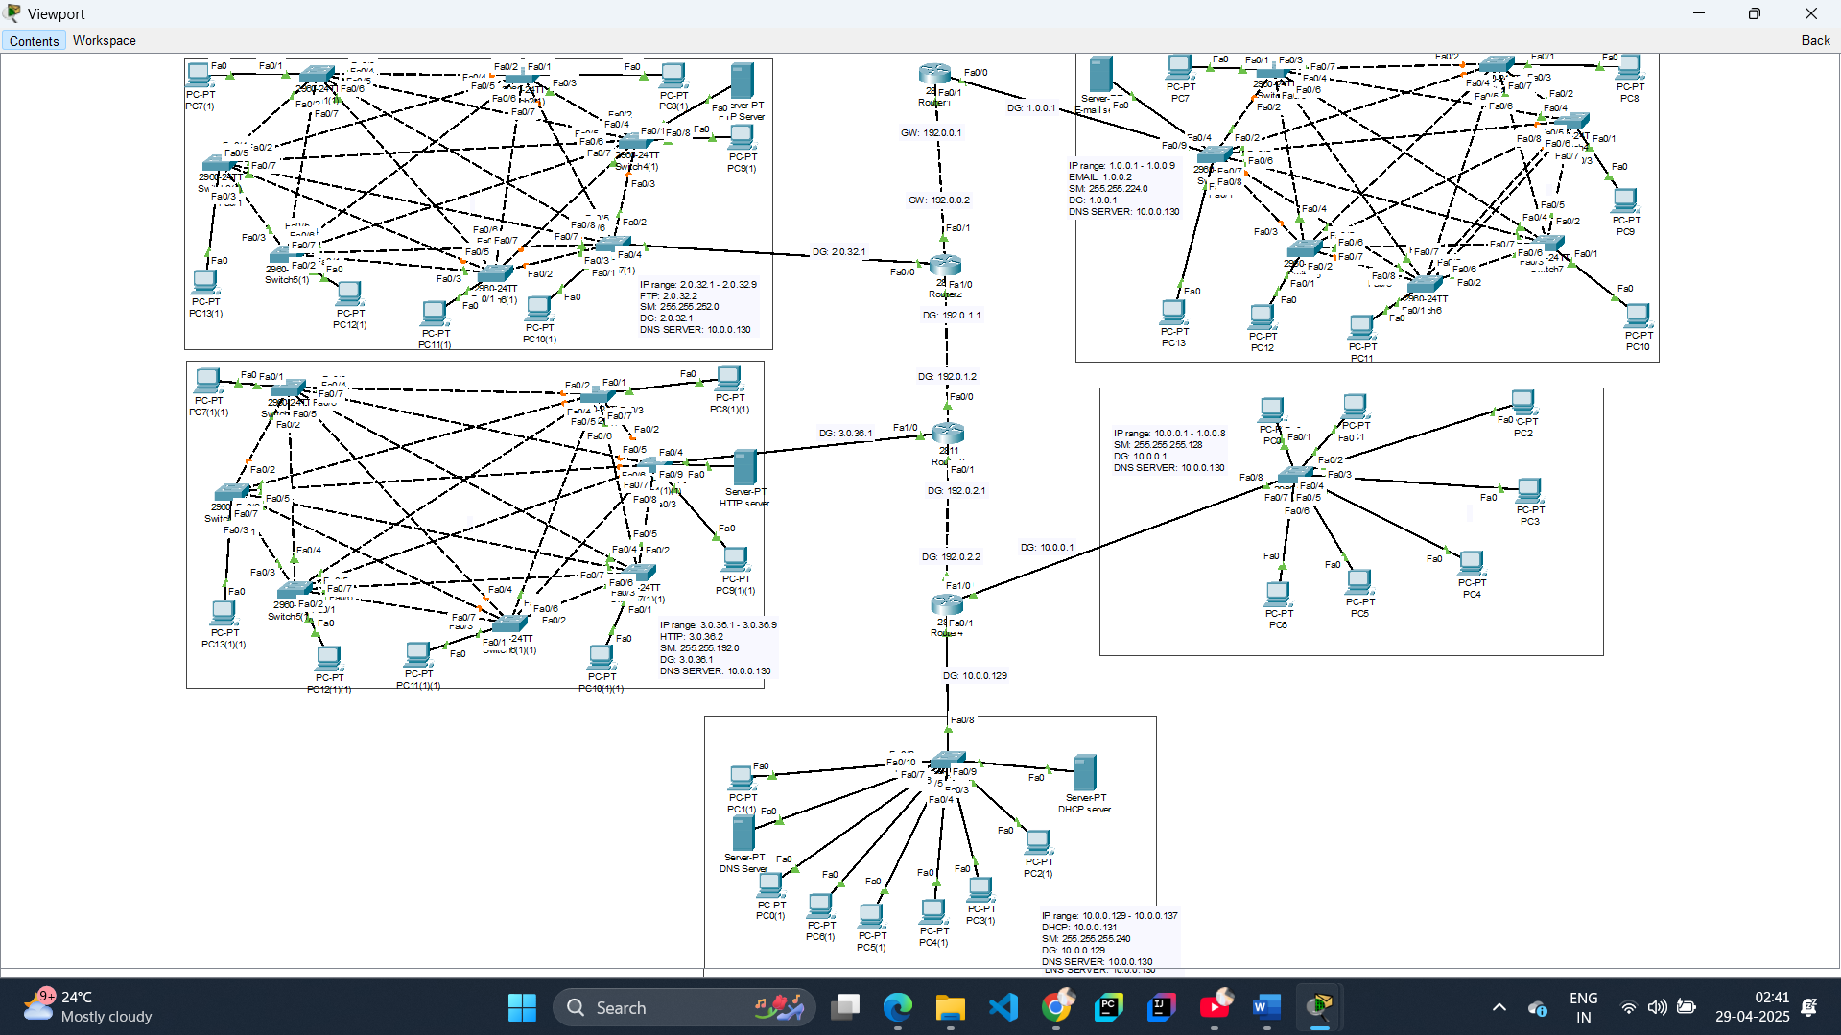

**FLOOR 1: E-MAIL SERVER**

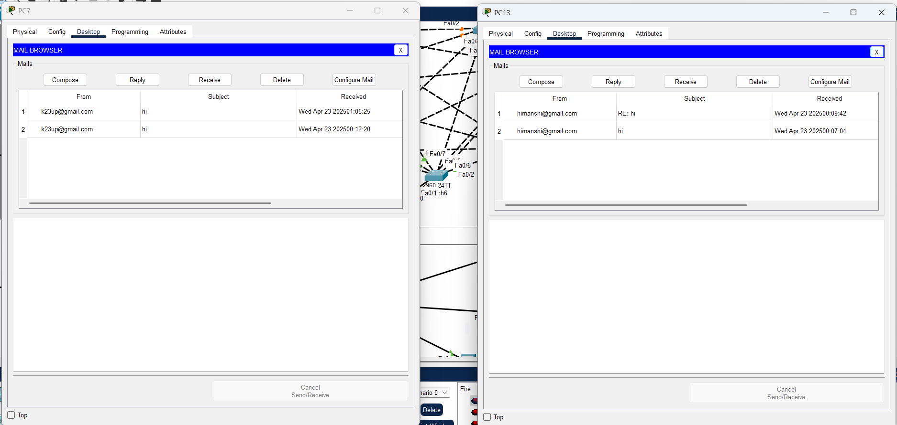

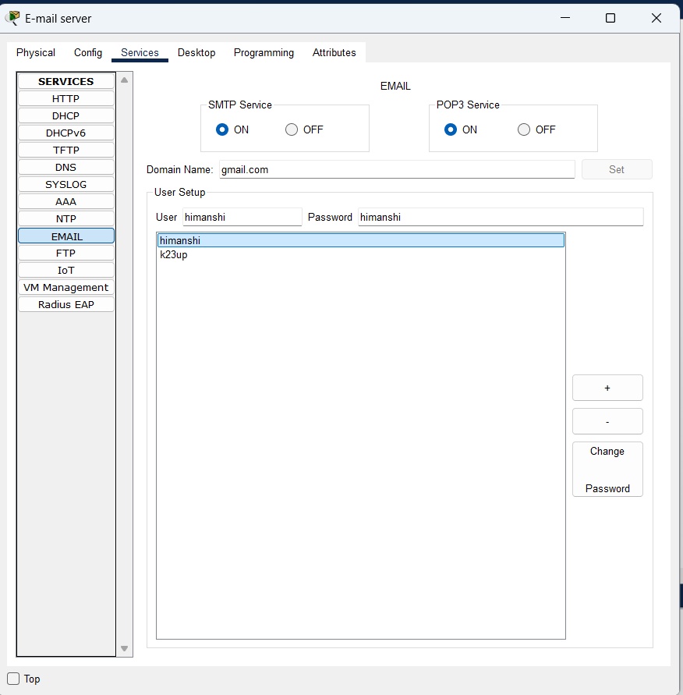

**FLOOR 2: FTP SERVER**

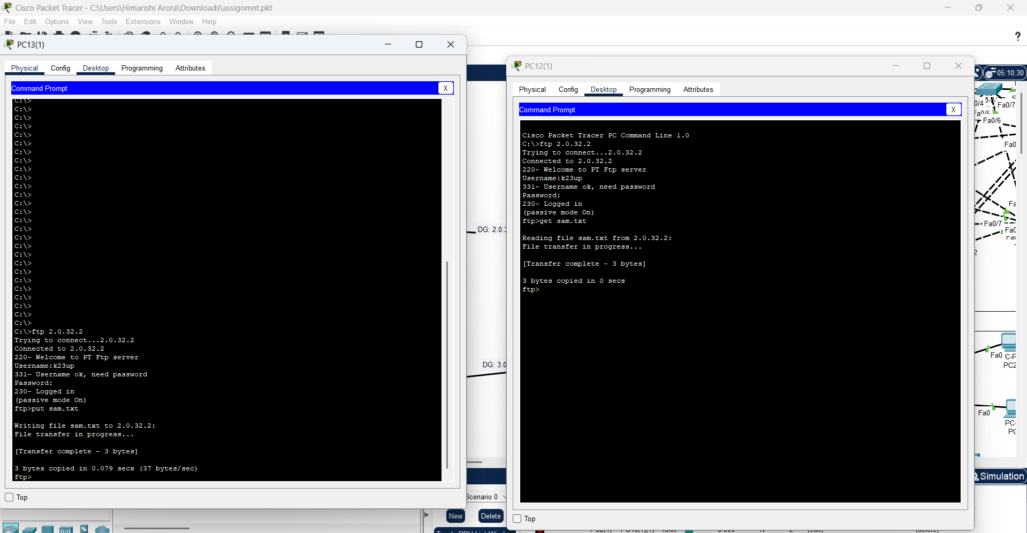

**FLOOR 3: HTTP SERVER**

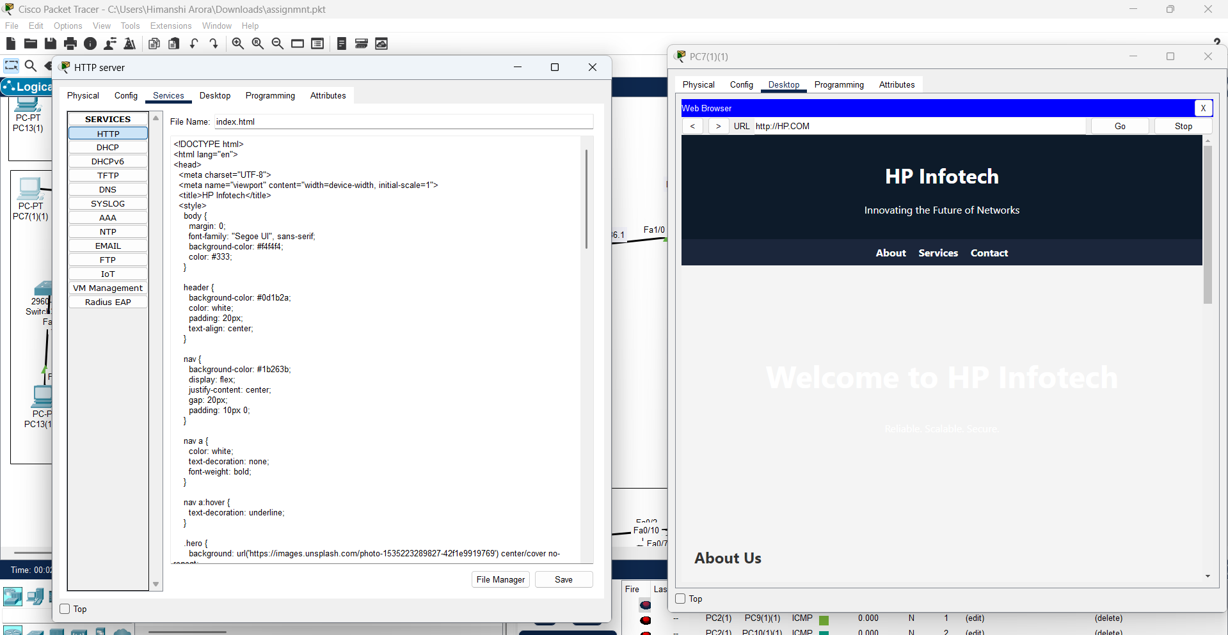

**FLOOR 4: (NO SERVER)**

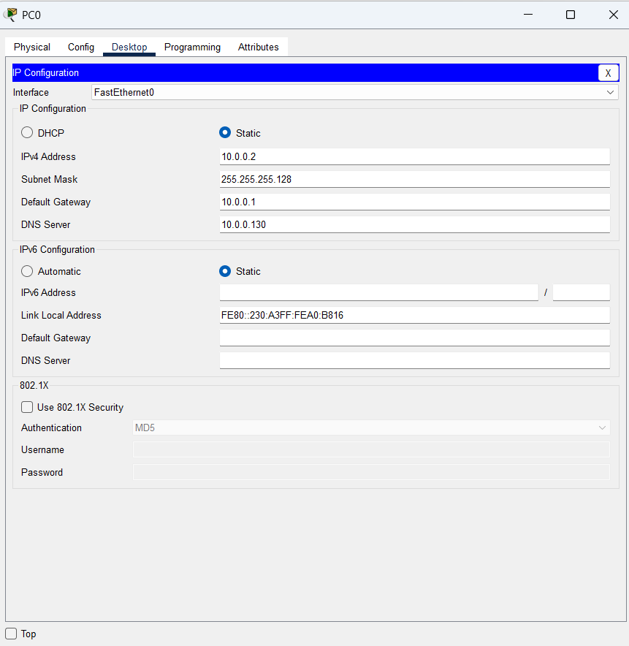

**FLOOR5: DNS AND DHCP SERVER**

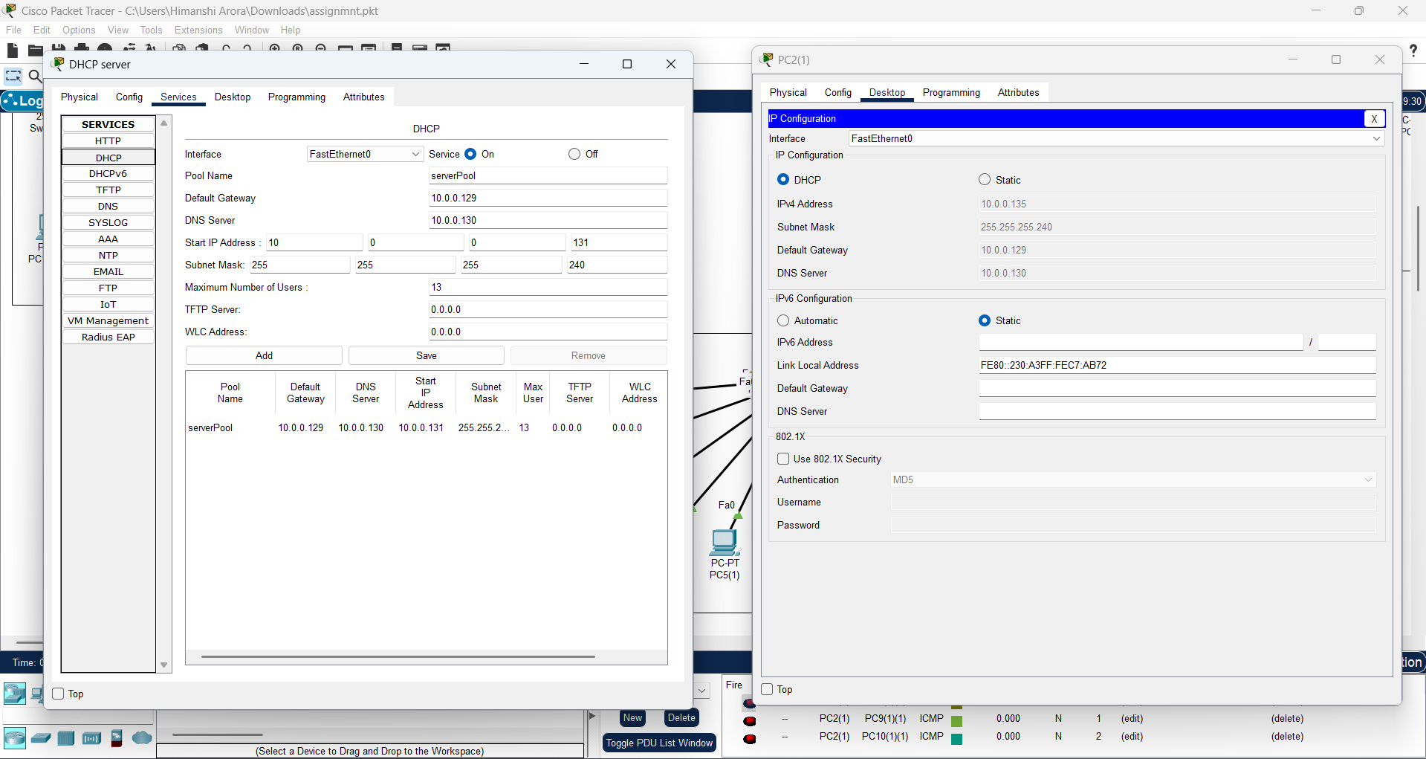

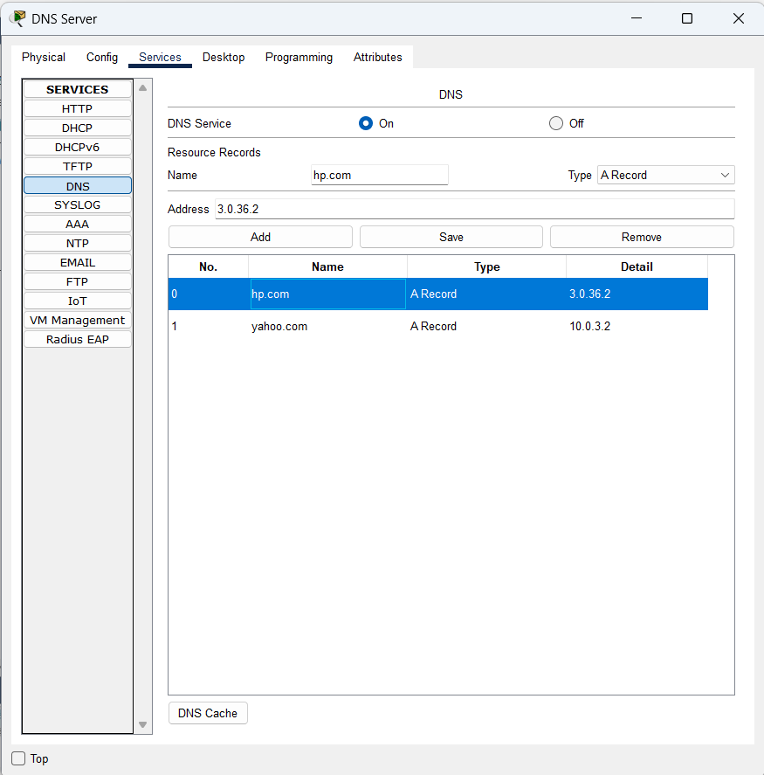

**ROUTING:**

**From 2nd to 3rd 4th and 5th floor**

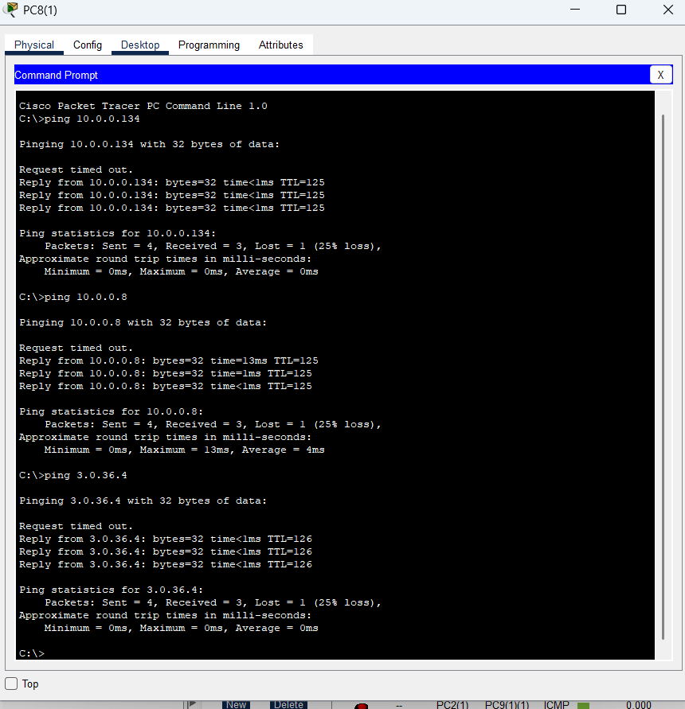

**IP ADDRESSING: (COMPUTER & ROUTER)**

