**REPORT**

Submitted by: HIMANSHI ARORA

Registration Number:12306250

Section: K23UP

Roll no: 37

Date: 03-03-2025

Course Code: CSE 307

Course Title:

**Internetworking Essentials**

Submitted to: MR. SIMARJIT SINGH MALHI

School of Computer Science and Engineering

Lovely Professional University

Phagwara, Punjab



**Introduction**

Edutech, a mid-sized enterprise, operates in a six-floor office building. Each floor is equipped with 8 computers, requiring a well-structured network to ensure efficient communication, scalability, and fault tolerance. This report outlines the network design, including topology selection, IP addressing, routing strategy, and device placement. The design adheres to the organization's requirements and ensures a robust and scalable network infrastructure.

**Network Design Requirements**

**1. Topology Selection**

A **ring topology** has been selected for each floor due to its advantages in performance and fault tolerance:

* **Performance**: Data packets travel in a single direction, reducing collisions and improving efficiency.
* **Fault Tolerance**: If one node fails, the network can still operate using the alternate path in the ring.
* **Scalability**: Adding new devices to the ring is straightforward.

Each floor will have its own ring topology, ensuring localized fault tolerance and efficient intra-floor communication.

**2. IP Addressing Scheme**

The organization has opted for **Class C private IPv4 addresses** (192.168.0.0 to 192.168.255.255). The IP addressing scheme is designed to ensure uniqueness and scalability.

**IP Allocation per Floor**

* Each floor is assigned a unique subnet to ensure efficient address management.
* The subnet mask for each floor is **255.255.255.0** (/24), allowing 254 usable IP addresses per floor.

Floor Network Address Usable IP Range Default Gateway

Floor 1 192.168.1.0/24 192.168.1.1 - 192.168.1.8 192.168.1.1

Floor 2 192.168.2.0/24 192.168.2.1 - 192.168.2.8 192.168.2.1

Floor 3 192.168.3.0/24 192.168.3.1 - 192.168.3.8 192.168.3.1

Floor 4 192.168.4.0/24 192.168.4.1 - 192.168.4.8 192.168.4.1

Floor 5 192.168.5.0/24 192.168.5.1 - 192.168.5.8 192.168.5.1

Floor 6 192.168.6.0/24 192.168.6.1 - 192.168.6.8 192.168.6.1

**3. Routing Strategy for Inter-Floor Communication & Connectivity**

**Static Routing Approach**

A **static routing** approach is recommended for inter-floor communication due to the following reasons:

* **Simplicity**: The network is relatively small, and static routes are easy to configure and manage.
* **Predictability**: Static routes provide consistent and predictable data paths.
* **Low Overhead**: No additional bandwidth is consumed by routing protocol updates.

**SNAPSHOTS:**

**OVERALL SCENARIO:**

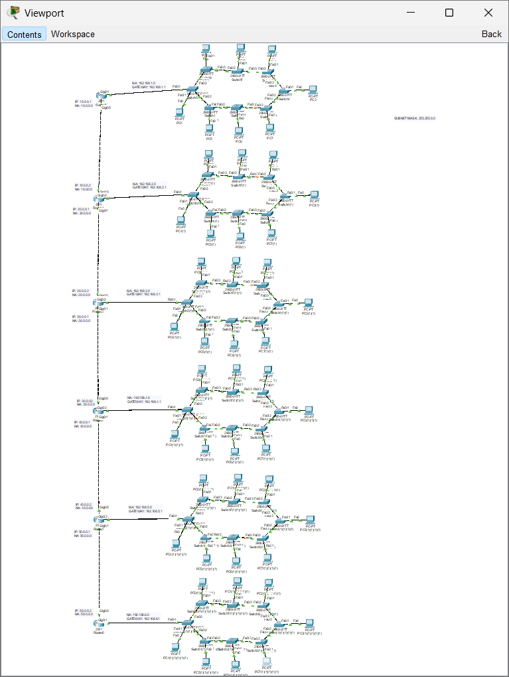

**IP ADDRESSING:**

**COMPUTER: 4TH COMPUTER IN 1ST FLOOR**

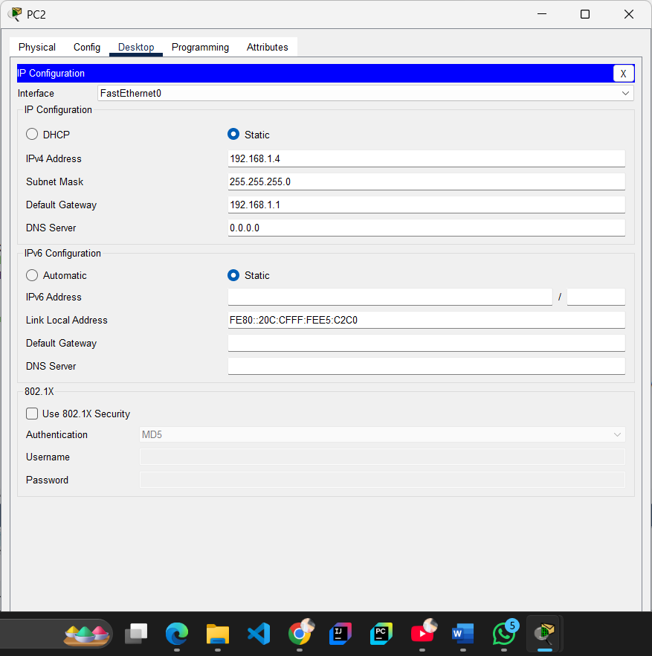

**ROUTER: 1ST FLOOR**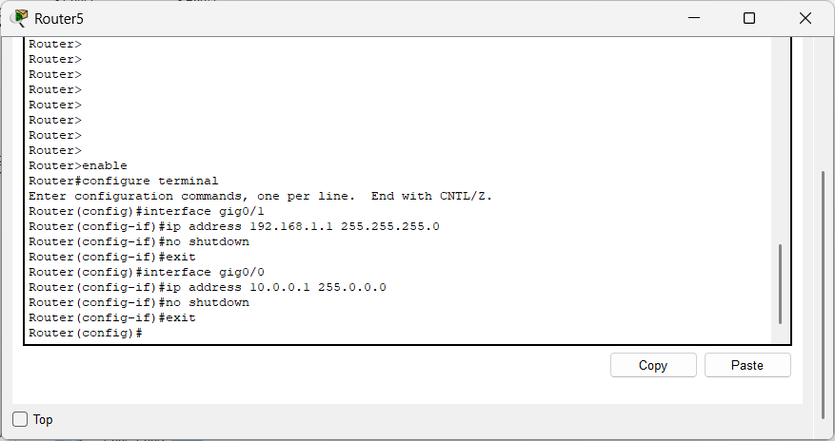

**ROUTING: STATIC ROUTING (SUCCESSFUL)**

**(floor 1)**

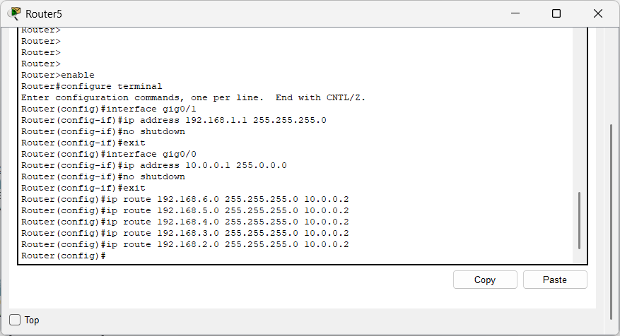

**INTER-FLOOR COMMUNICATION:**

**From 1st to 6th 3rd and 5th floor: (SUCCESSFUL)**

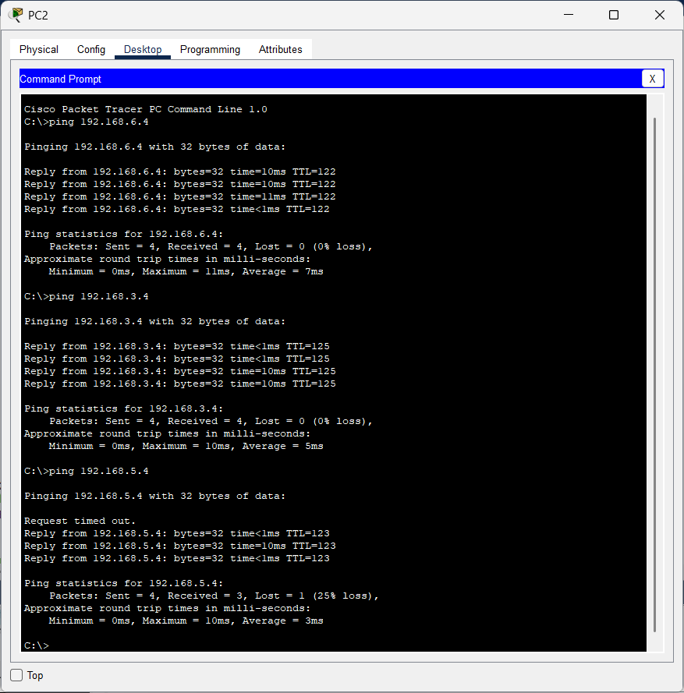

**From 6th floor to 3rd 4th and 1st floor: (SUCCESSFUL)**

