1. Can your program display a circle in the centre of the frame, if not, why?

***Ans****:* Yes, my program is able to display a circle in the centre of frame.

1. Can your program display three points on the circle, if not, why?

***Ans****:* Yes, my program can display three points on the circle.

1. Can your program draw a triangle using these three points, if not, why?

***Ans****:* Yes, it can draw a triangle using these three points.

1. Can your program compute the angles in the triangle, if not, why?

***Ans****:* Yes, it can compute the angles.

1. Can your program display the angles in the triangle, if not, why?

***Ans****:* Yes, angles can be displayed.

1. Note that three points are three small circles. Can your program detect which small circle is pressed by the mouse, if not, why?

***Ans****:* Yes, it can be detected.

1. Can your program drag a small circle that has been pressed, if not, why?

***Ans****:* Yes, the small circle can be dragged when pressed.

1. Can your program drag a small circle along the perimeter of the circle, if not, why? (Hint: Ignore the mouse drag if it is not along the perimeter of the circle.)

***Ans****:* Yes, it can drag a small circle along the perimeter.

**SCREENSHOTS**

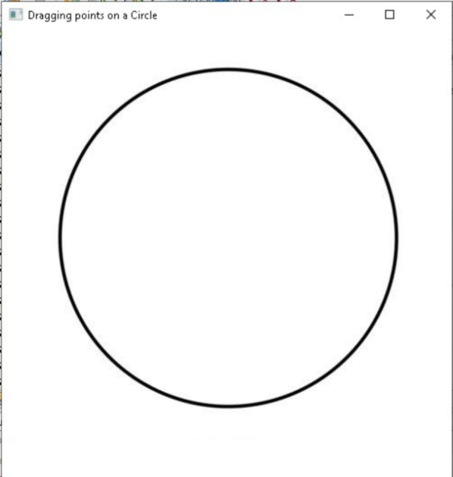

Figure Displaying Circle

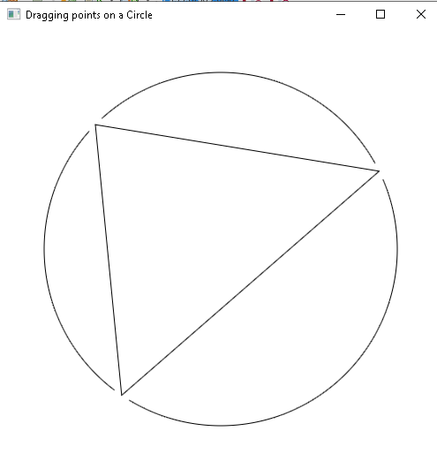

Figure Points not showing

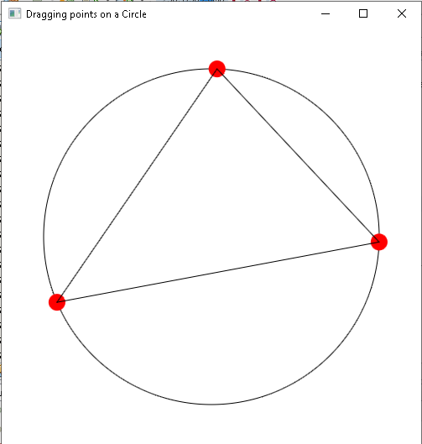

Figure Angles not computed

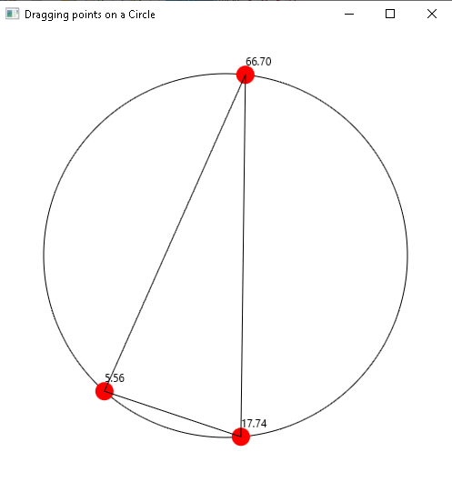

Figure Wrong angle computation

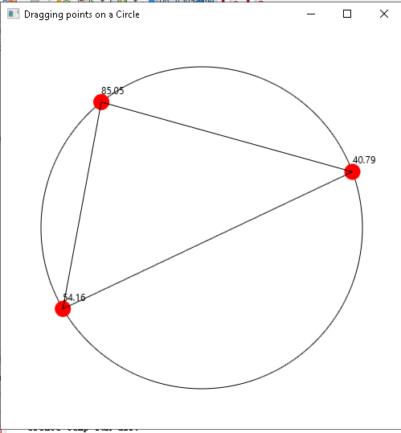

Figure Final Output