

INTERNSHIP / STUDENT JOB
NANCY MICHEALS

DIPLOMAS Y HOBBIES

Formaciones : Diplomados, Congresos, xxxxxxxxxx xxxxxx xxxxxxxxx xxxxxxxxxxxxxxxxx
Hobbies: xxxxxxxxxxxxxxxxxxxxxxxxxxxxxx
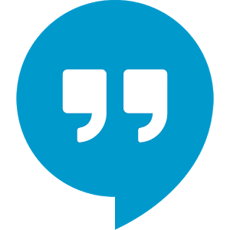

EDUCATION




English
French
Italian
CONTACT
+1 212 06 06 060

name@email.com

LA, California

HOSPITALITY & TOURISM, B.S.

California State University | 20XX – 20XX


      - F&B management
      - Travel and tourism
      - Revenue management
      - Law and ethics

INTERESTS

CAREER OBJECTIVE
PROFESSIONAL EXPERIENCE
      - Graduated with honors
      - Class valedictorian
      - National debate team
      - Captain of basketball team

HIGH SCHOOL DIPLOMA
CATER2U, LA | July 20XX

      - Taking inventory
      - Assisting in kitchen duties
      - Serving event attendees
CATERING SERVICES
POPEYE’S | July 20XX

FRY COOK
High school summer job | Junior year

      - Prepared and executed dishes
      - Kept an organized workstation
      - Prepared food for Alzheimer patients
      - Food distribution
      - Provided emotional support when needed
VOLUNTEER
SOUP KITCHEN
Leeza’s Care Connection | December 20XX

Los Angeles High School | 20XX

Passionate and enthusiastic 3rd year student with excellent interpersonal skills and a high interest in foreign languages. Looking for a student job as a hostess in a hotel or a catering company.



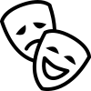


©AZURIUS - My-resume-templates.com
SKILLS
LANGUAGES
- Team work
- Creativity
- Open-mindedness
- Punctuality
- Photoshop
- Video
We’ve added some more icons for you to copy/paste to your student resume:









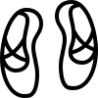












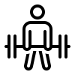
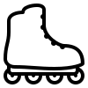








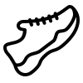


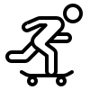













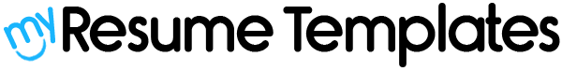

Dear Job Seeker,

If you're having difficulty composing your resume, here are some free resources available that can assist you in creating a strong resume that highlights your suitability for the position to potential employers:

- How to Make a Good Resume
- Skills to Put on a Resume
- Resume Objective Examples

Also discover other free downloadable and ready-to-fill CV templates in Word format:

- Basic Resume Templates
- Modern Resume Templates
- Creative Resume Templates
- Professional Resume Templates
- Europass CV

Best regards,

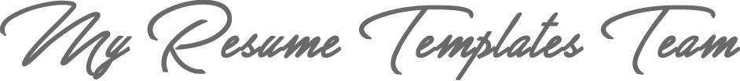

www.my-resume-templates.com

COPYRIGHT - PLEASE READ THIS MESSAGE
©These examples of free resume templates are the property of Azurius S.L. You may download and modify them without any problem if they are for personal use.
Do not forget to remove this copyright notice before modifying and printing your CV.
You cannot resell these examples or their derivatives. You cannot make them available on other websites without our consent. For any related questions, please write to us at contact@my-resume-templates.com
Discover more resume templates at www.my-resume-templates.com

