
NAME SURNAME







Character Design

Concept Development

Digital Art
Illustration

Spanish: Intermediate (B2)
French: Beginner (A2)
©AZURIUS - My-resume-templates.com
surname.name@mail.com
email

+1 222 222 222
NY, USA
EDUCATION

PROFESSIONAL EXPERIENCE

- Contributed to the visual development of characters and environments for a critically acclaimed video game.
- Worked closely with the art director to ensure alignment.
- Refined concepts based on feedback from development.
- Led a team of artists in developing visual concepts for a series of children's books, resulting in a 20% increase in sales.
- Collaborated with marketing and design teams to create promotional materials, enhancing brand visibility.
- Conducted workshops on illustration techniques, fostering a collaborative and skill-sharing environment.
Creative and versatile artist with a passion for bringing imagination to life through various mediums. Proficient in both traditional and digital art, with a strong foundation in illustration and design. Committed to delivering visually compelling and conceptually rich artwork. Adept at collaborating with diverse teams to meet project goals and deadlines.

LANGUAGES
PROFILE

JOB TITLE
SKILLS
FREELANCE ILLUSTRATOR | Self Employed

CONCEPT ARTIST | ImagiNation Games

Jan 20XX - Dec 20XX | NY
Master of Fine Arts in Visual Arts
20XX - 20XX | NY
- Collaborated with authors to create cover art and illustrations.
- Managed client communication and deliverables.
- Developed a strong online presence through social media.
BA Fine Arts – XYZ University
Sept. 20XX – Present | NY
- Feb. 2018
Jan. 20XX – June 20XX | NY
- Feb. 2018
SENIOR ILLUSTRATOR | Artistry Studios
June 20XX - Nov 20XX | NY
HOBBIES
English: Bilingual
CONTACT

More Icons:



















































Dear Job Seeker,

If you're having difficulty composing your resume, here are some free resources available that can assist you in creating a strong resume that highlights your suitability for the position to potential employers:
- How to Make a Good Resume
- Skills to Put on a Resume
- Resume Objective Examples

Also, discover other free downloadable and ready-to-fill CV templates in Word format:
- Basic Resume Templates
- Modern Resume Templates
- Creative Resume Templates
- Professional Resume Templates
- Europass CV

Best regards,
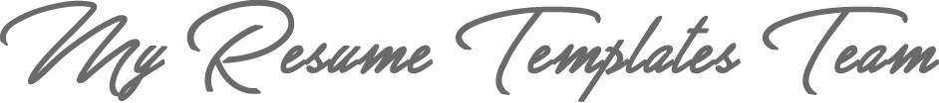

www.my-resume-templates.com

COPYRIGHT - PLEASE READ THIS MESSAGE
©These examples of free resume templates are the property of Azurius S.L. You may
download and modify them without any problem if they are for personal use.
Do not forget to remove this copyright notice before modifying and printing your CV.
You cannot resell these examples or their derivatives. You cannot make them available on other websites without our consent. For any related questions, please write to us at contact@my-resume-templates.com
Discover more resume templates at www.my-resume-templates.com

