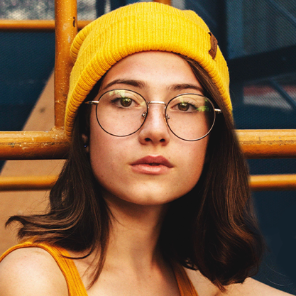
Surname NAME

Creative and innovative fashion designer with a passion for translating trends into unique and marketable designs. Proven ability to conceptualize and execute designs that resonate with target audiences. Adept at collaborating with cross-functional teams and skilled in utilizing industry-leading software to bring designs to life.

POSTE RECHERCHÉ
- Donec turpis mauris, auctor vitae sollicitudin in, elementum efficitur tellus.
- Aenean nec turpis tortor. Ut placerat varius vivera vestibulum eu dictum purus.
- Ut lacinia commodo erat id vulputate. Orci varius natoque penatibus et magnis dis parturient montes, nascetur ridiculus mus.





©AZURIUS - My-resume-templates.com
EDUCATION
Relevant courses: Fashion Illustration Techniques - Pattern Making and Draping - Textile Science - Fabric Selection
September 20XX - May 20XX | NY, USA
- Feb. 2018
September 2016 - June 20XX | NY, USA
- Feb. 2018
Class Valedictorian
BS Fashion Design - NYU
High School Diploma - NY City School
/ COURS OBTENU

- Conceptualized and executed designs for the Fall/Winter 2018 collection, receiving positive reviews in major fashion publications.
- Coordinated with overseas manufacturers to oversee the production process, ensuring quality control and timely delivery of finished products.
- Mentored junior designers, fostering a collaborative and innovative design environment within the team.
- .
SENIOR FASHION DESIGNER – Luxe Designs
Sustainable Fashion
Global Textile
Vintage Fashion
Fashion History

INTERESTS
English (native)
French (bilingual)
LANGUAGES

Adobe Creative Suite
CorelDRAW
Sketch
Figma
Affinity Designer

SOFTWARE
Creativity & Innovation
Attention to Detail
Team Collaboration
Time Management
Trend Forecasting
SKILLS
CONTACT
ASSISTANT DESIGNER – Trendy Threads
- Conceptualized designs for the Fall/Winter collection.
- Coordinated with overseas manufacturers to oversee the production process, ensuring quality control and timely delivery of finished products.
- Mentored junior designers, fostering a collaborative and innovative design environment within the team.

- Spearheaded the design team for the Spring/Summer collection.
- Collaborated with the marketing department to create visually stunning promotional materials, contributing to a 20% growth in brand visibility.
- Conducted market research and trend analysis to inform design decisions, ensuring alignment with the target demographic.
- .
June 20XX – Dec 20XX | NY, USA

FASHION DESIGN LEAD – Urban Chic Apparel Provence
Feb 20XX - May 20XX | NY, USA

PROFESSIONAL EXPERIENCE
Jan 20XX – Present | NY, USA

/linkedin/in/surname.name
surname.name@mail.com
+1 222 222 222
NY, USA


Dear Job Seeker,
If you're having difficulty composing your resume, here are some free resources available that can assist you in creating a strong resume that highlights your suitability for the position to potential employers:
- How to Make a Good Resume
- Skills to Put on a Resume
- Resume Objective Examples

Also discover other free downloadable and ready-to-fill CV templates in Word format:
- Basic Resume Templates
- Modern Resume Templates
- Creative Resume Templates
- Professional Resume Templates
- Europass CV

Best regards,
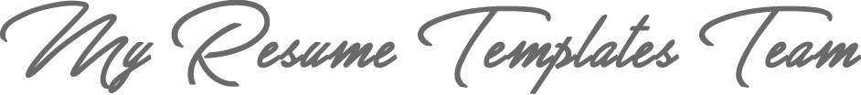

www.my-resume-templates.com

COPYRIGHT - PLEASE READ THIS MESSAGE
©These examples of free resume templates are the property of Azurius S.L. You may
download and modify them without any problem if they are for personal use.
Do not forget to remove this copyright notice before modifying and printing your resume or CV.
You cannot resell these examples or their derivatives. You cannot make them available on other websites without our consent. For any related questions, please write to us at contact@my-resume-templates.com
Discover more resume templates at www.my-resume-templates.com

