
NAME SURNAME
z
+1 22 22 22 22
sn.name@mail.en
City, Country
JOB TITLE

Enthusiastic and creative recent graduate with a passion for digital marketing and social media content creation. Possesses a strong understanding of current social media trends and platforms, coupled with excellent communication and organizational skills. Proven ability to develop engaging content that drives audience interaction and brand awareness.

INTERESTS
French
English
LANGUAGES
Analytics & Reporting
SKILLS
BA Communication
20XX – 20XX

NY, USA

NYU
EDUCATION
20XX – 20XX

NY, USA

NYU
MA Communication
- Managed the company's social media accounts, increasing overall engagement by 30% through consistent and creative content.
- Coordinated influencer partnerships, negotiating collaborations that resulted in a 15% boost in product visibility.
DEF Startup
Marketing Assistant
- Developed and executed a content calendar for Instagram, resulting in a 25% growth in followers and increased brand visibility.
- Utilized analytics tools to track performance metrics and adjusted content strategy accordingly to optimize reach and engagement.
ABC Company
Content Creator
XYZ Marketing
Social Media Intern
PROFESSIONAL EXPERIENCE

May 20XX - Present

- Collaborated with a team to create and implement social media strategies for clients, resulting in a 20% increase in follower engagement.
- Conducted market research to identify industry trends and competitor strategies, contributing to the development of successful social media campaigns.
Content Management
Content Creation
NY, USA

Copywriting
Jan 20XX - May 20XX

NY, USA

May 20XX – Dec. 20XX

NY, USA

Spanish

Photography
Digital Art
Travel

- Relevant coursework: Digital Media Strategies, Social Media Marketing, Content Creation

- Relevant coursework: Digital Media Strategies, Social Media Marketing, Content Creation

©AZURIUS - My-resume-templates.com
©AZURIUS – my-resume-templates,com
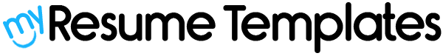

Dear Job Seeker,

If you're having difficulty composing your resume, here are some free resources available that can assist you in creating a strong resume that highlights your suitability for the position to potential employers:
- How to Make a Good Resume
- Skills to Put on a Resume
- Resume Objective Examples

Also, discover other free downloadable and ready-to-fill CV templates in Word format:
- Basic Resume Templates
- Modern Resume Templates
- Creative Resume Templates
- Professional Resume Templates
- Europass CV

Best regards,
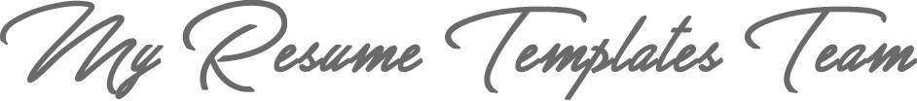

www.my-resume-templates.com

COPYRIGHT - PLEASE READ THIS MESSAGE
©These examples of free resume templates are the property of Azurius S.L. You may
download and modify them without any problem if they are for personal use.
Do not forget to remove this copyright notice before modifying and printing your CV.
You cannot resell these examples or their derivatives. You cannot make them available on other websites without our consent. For any related questions, please write to us at contact@my-resume-templates.com
Discover more resume templates at www.my-resume-templates.com

