
Software Engineer
SURNAME NAME

Summary
To secure a challenging position as a software engineer in a dynamic organization, utilizing my strong technical skills, problem-solving for creating innovative software solutions to contribute to the success of the company.




Contact
Software
Languages
/surname.name/
+1 222 222 222
NY, USA

Experience
sn.name@gmail.com

Feb. 20XX - Sept. 20XX
SOFTWARE ENGINEER
FULL-STACK DEVELOPER

INTERNSHIP

XYZ Company

- Developed and maintained a robust and scalable web application used by thousands of users, resulting in improved user experience.
- Collaborated with cross-functional teams to gather requirements, design architecture, and implement features.

March 20XX - Feb. 20XX
ABC Development

- Led the development of a mobile application from concept to release, incorporating intuitive user interfaces, seamless navigation, and integration with backend services.
- Utilized database technologies to store and retrieve data efficiently.

Sept. 20XX - March 20XX
DEF Technology

- Assisted in the development and optimization of an e-commerce platform, contributing to increased page load speed and enhanced user experience.
- Identified and fixed performance bottlenecks and implemented code refactoring techniques for improved code quality.

Education

Sept. 20XX - Jul. 20XX
Coursework related to position
DEGREE / MAJOR

University

DEGREE / MAJOR
University

Coursework related to position
Sept. 20XX - Jul 20XX

English: Native
French: Beginner

Spanish: Advanced
- Adaptable
- Self-motivated
- Teamwork
Qualities
Interests
©AZURIUS - My-resume-templates.com
©AZURIUS – Modeles-de-cv,com
- MMA
- World of Warcraft
- League of Legends


Dear Job Seeker,
If you're having difficulty composing your resume, here are some free resources available that can assist you in creating a strong resume that highlights your suitability for the position to potential employers:

- How to Make a Good Resume
- Skills to Put on a Resume
- Resume Objective Examples

Also discover other free downloadable and ready-to-fill CV templates in Word format:

- Basic Resume Templates
- Modern Resume Templates
- Creative Resume Templates
- Professional Resume Templates
- Europass CV

Best regards,

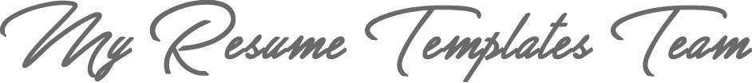

www.my-resume-templates.com

COPYRIGHT - PLEASE READ THIS MESSAGE
©These examples of free resume templates are the property of Azurius S.L. You may
download and modify them without any problem if they are for personal use.
Do not forget to remove this copyright notice before modifying and printing your resume or CV.
You cannot resell these examples or their derivatives. You cannot make them available on other websites without our consent. For any related questions, please write to us at contact@my-resume-templates.com
Discover more resume templates at www.my-resume-templates.com

