ssh-keygen -t ed25519 -C "techninja50@outlook.com"

git remote set-url origin git@github.com:USERNAME/REPOSITORY.git

git@github.com:techyninja/GitHubtraining.git

git remote set-url origin git@github.com:techyninja/GitHubtraining.git

id_ed25519

ssh-keygen -p -f id_ed25519

ssh-keygen -p -f C:\Users\MAHESH-PC\.ssh\id_ed25519.pub

ssh-keygen -p -f C:\Users/MAHESH-PC/.ssh/id_ed25519

ssh-keygen -p -f /c/Users/MAHESH-PC/.ssh/id_ed25519

/c/Users/MAHESH-PC/.ssh

git clone git@github.com:techyninja/GitHubtraining.git

OR

--Checkout single branch ---

git clone --single-branch --branch testbranch git@github.com:techyninja/GitHubtraining.git

cd <folder_name>

git checkout -b testbranch

git branch --set-upstream-to=origin/testbranch testbranch

or if branch exists in local only :

To push the current branch and set the remote as upstream, use

git push --set-upstream origin testbranch

to Check past commit history ::

git branch

master

* testbranch

MAHESH-PC (testbranch) New folder (3)

$ git log -1

commit 7a8247ea47d7b7d97ad39f7776cc8cd7bcf54e4a (HEAD -> testbranch, origin/testbranch, origin/master, master)

Author: techninja50 <techninja50@outlook.com>

Date: Mon Feb 21 19:50:28 2022 +0530

Updated git status file

MAHESH-PC (testbranch) New folder (3)

$ git log --oneline -1

7a8247e (HEAD -> testbranch, origin/testbranch, origin/master, master) Updated git status file

MAHESH-PC (testbranch) New folder (3)

$

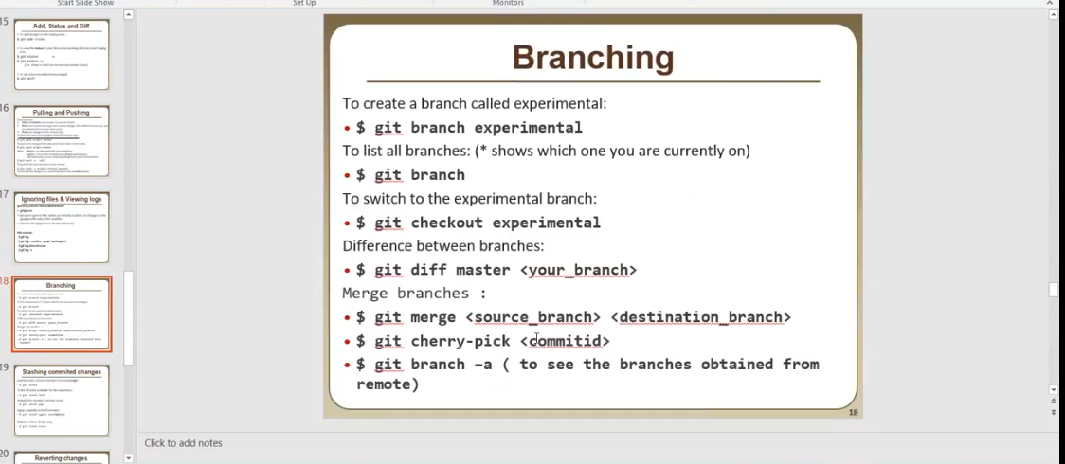

Git cherry-pick :: to merge specific commit id ..a specific commit id is merged in checked out branch

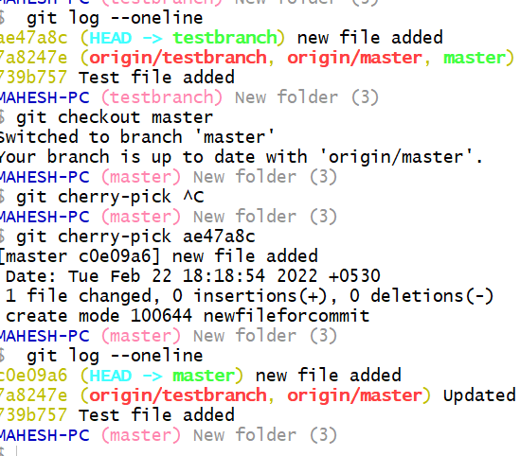

------

**Git merge conflict ::**

MAHESH-PC (testbranch) New folder (3)

$ git checkout master

Switched to branch 'master'

Your branch is ahead of 'origin/master' by 1 commit.

(use "git push" to publish your local commits)

MAHESH-PC (master) New folder (3)

$ git merge testbranch master

Auto-merging confile

CONFLICT (add/add): Merge conflict in confile

Automatic merge failed; fix conflicts and then commit the result.

MAHESH-PC (master *+|MERGING) New folder (3)

$ cat confile

<<<<<<< HEAD ( Destination Branch)

abc

=======

xyz

>>>>>>> testbranch (Source branch)

MAHESH-PC (master *+|MERGING) New folder (3)

$

**Forking a Repository in Github ::**

**Do in Github**

**Git Log ::**

**Git log :; Show all commits with full SHA**

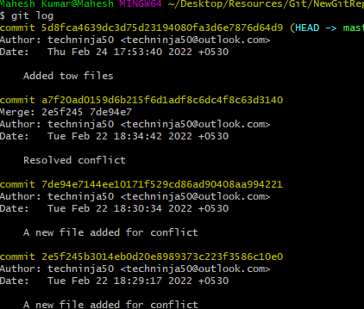

**Git Show <CommitId>**

**What is added in a commid Id**

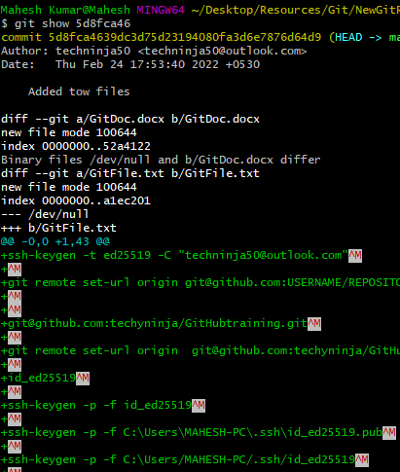

**Git Show HEAD --also give recent commit information**

**Git show HEAD~1, Hit Show HEAD~2**

**Also do Git Diff HEAD~1 HEAD~2**

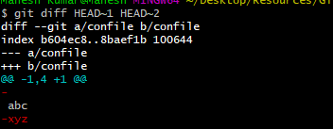

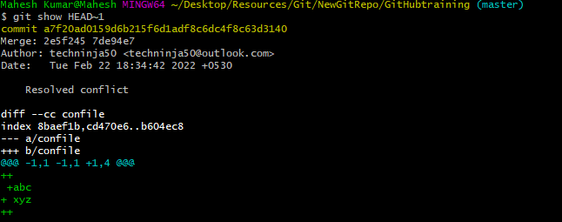

**Git Annotate Command :**

**Show all the linear changes in file commit wise and date wise**

git annotate nfile.txt

7a8247ea (techninja50 2022-02-21 19:50:28 +0530 1)First check ssh keys :

7a8247ea (techninja50 2022-02-21 19:50:28 +0530 2)

7a8247ea (techninja50 2022-02-21 19:50:28 +0530 3)https://docs.github.com/en/authentication/connecting-to-github-with-ssh/checking-for-existing-ssh-keys

7a8247ea (techninja50 2022-02-21 19:50:28 +0530 4)

7a8247ea (techninja50 2022-02-21 19:50:28 +0530 5)Generate ssh keys :

7a8247ea (techninja50 2022-02-21 19:50:28 +0530 6)

7a8247ea (techninja50 2022-02-21 19:50:28 +0530 7)https://docs.github.com/en/authentication/connecting-to-github-with-ssh/

7a8247ea (techninja50 2022-02-21 19:50:28 +0530 8)generating-a-new-ssh-key-and-adding-it-to-the-ssh-agent

7a8247ea (techninja50 2022-02-21 19:50:28 +0530 9)

7a8247ea (techninja50 2022-02-21 19:50:28 +0530 10)Add keys to gitgub account :

7a8247ea (techninja50 2022-02-21 19:50:28 +0530 11)

7a8247ea (techninja50 2022-02-21 19:50:28 +0530 12)https://docs.github.com/en/authentication/connecting-to-github-with-ssh/adding-a-new-ssh-key-to-your-github-account

7a8247ea (techninja50 2022-02-21 19:50:28 +0530 13)

7a8247ea (techninja50 2022-02-21 19:50:28 +0530 14)Add remote to your account

7a8247ea (techninja50 2022-02-21 19:50:28 +0530 15)

7a8247ea (techninja50 2022-02-21 19:50:28 +0530 16)set remote :

7a8247ea (techninja50 2022-02-21 19:50:28 +0530 17)

7a8247ea (techninja50 2022-02-21 19:50:28 +0530 18)git remote set-url origin git@github.com:techyninja/GitHubtraining.git

7a8247ea

**Adding and Commiting in one command :**

git commit -a -m"Added commit and file commands entry"

**Added checkout file**

**If you have changed file and already staged , u need to checkout first and then reset the head to previous commit :**

**To unstage last staged**

git checkout -- GitDoc.docx

git reset HEAD GitDoc.docx