**JAVASCRIPT Basics**

What is JavaScript?

* Scripting language, low level programming language.
* Dynamically typed language.
* Scripts are basically some functions which tells how to do and what to do?
* Client-side language, which can be run in browser.
* Developed by Netscape (in just 10 days, in 1995), initially Mocha was named.
* Some developer adds this into C++ and it became Node.js so that we can use it outside the browser server – side.

What can we do with JS?

* Webapp / mobile app / network apps
* CLI tools
* Games

Do we need compiler?

* We need only JS Engine.
* Like in firefox Spider Monkey, Google V8.

Simple way to run a JS Code in Browser.

* Open any browser.
* Right click on anywhere on the screen.
* Click on inspect
* Find the console window.

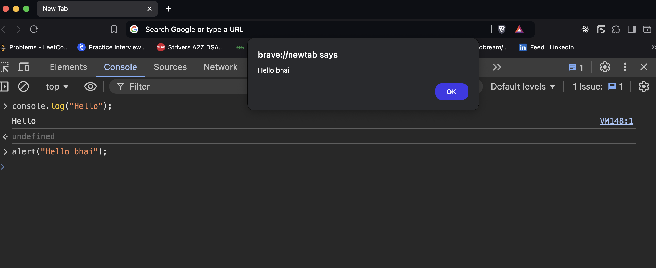

JS Setup?

* VS Code
* Node js

Adding JS Code in HTML + CSS + File

* Check file in JS_BASIC_1
* String – sequence of characters
* console.log() – use to print something in the console.
* ; - is used to end the line.
* // - is used to add comment in the JS Code.
* Create a separate file for the JS code.
* Lower ss is telling about how we can run code in terminal

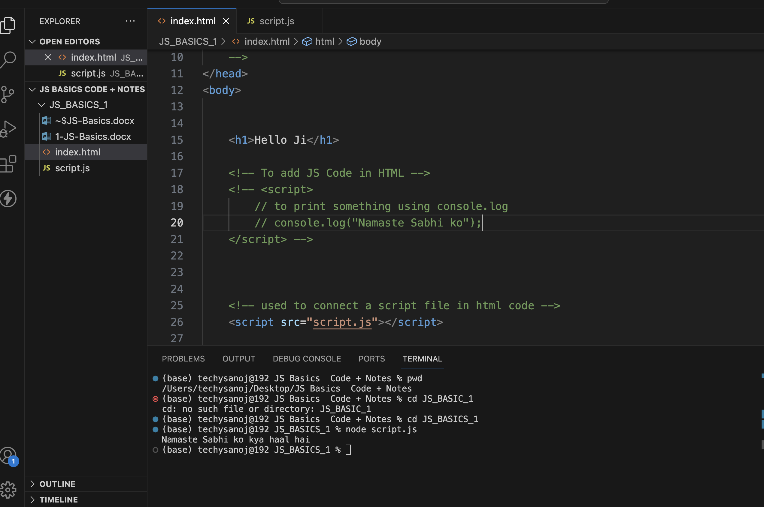

Variable

* Named memory location is called as variable
* Can be created using “let” and “var” keyword. Some of the example
  + let a = 5;
  + let name = “Sanoj”;
  + let status = true;
  + var check = false;
  + var name = “Sanoj”;
* Difference between var and let are simple scoping of the variables.
  + let are basically scoped in the closed curly bracket, var are basically global variable.
  + Example:
    - {

let a = 5; // here ‘a’ is only scoped in these curly bracket

var b = 5; // but ‘b’ can be accessed outside these bracket

}

* + let cannot be redeclared but var can be redeclared.

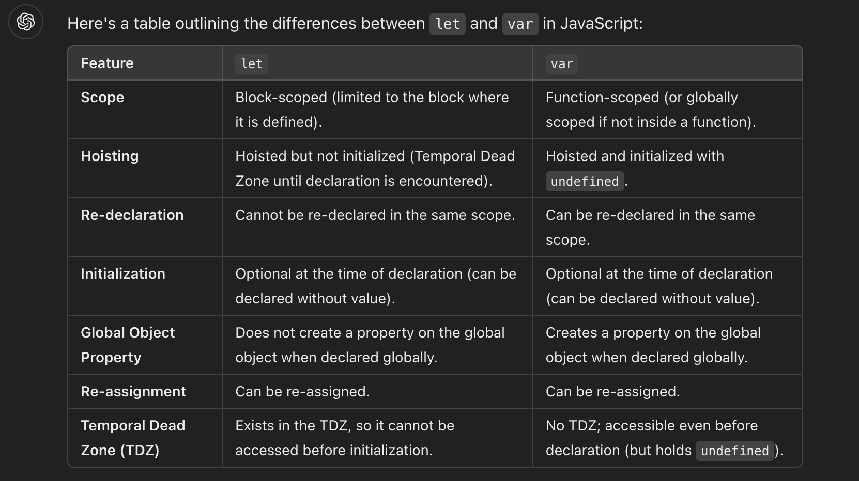

Constant

* fixed value which cannot be changed further