**ReactJS Basics**

* JS Library
* Main function to create UI.
* React is all about components. We deal in component-based architecture.
* Component – A reusable piece of code.
* Here component is similar to function in other programming level language.
* Why do we need ReactJS?
  + Because normal JS is based on imperative approach (line by line) means we need to fetch each and every element to do some functionality but in ReactJS we only need once.
  + Basically, ReactJS is easier to do. We only need to tell End State (means Declarative Approach).
* It follows Single Page Applications means we have only Single HTML Page we do not have multiple ones and we do dynamically change.
* Alternatives to ReactJS: Angular, Vue.

**Components**:

* A kind of custom HTML elements.
* Reusable piece of code.
* It is not mandatory that piece of code can be reused.
* Why?
  + Reusability
  + DRY
  + Readability
  + Separation of concern.
  + Maintainability.
* A kind of functions also.

Go to ReactJS documentation to know how to create a React App.

To start the app use npm start and to end this we will use ctrl + c.

Now what are the files in ReactJS.

* package.json: dependencies and scripts are written, like what are the things needed to run the react app.
* index.js: first file which will load, and it is getting element root which is present at public folder in index.html file.
* Then index.js creating that root element as ReactDOM element then in this it renders app.js (every component from that).
* We only need three files which are needed: app.js, index.css, index.js and also sometimes index.html.
* React root code are user friendly but it is then converted by browser JS engine so that it will become browser friendly.
* All codes are basically here written as JSX (HTML code inside JS).
* For every component we need to create a separate file.

Steps to create a component:

1. First create a JS file (give name accordingly)
2. Then inside that JS file create a function (same name as the file name).
3. Then at last export default (fun_name).

Use of Props(Properties):

1. If we want to add dynamic data in our component not the hard coded ones there we use Props. We send the data while adding the component.
2. 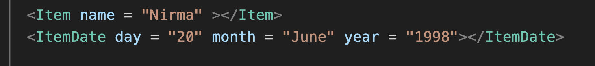
3. Like here I have sent Nirma (name) and so on.
4. 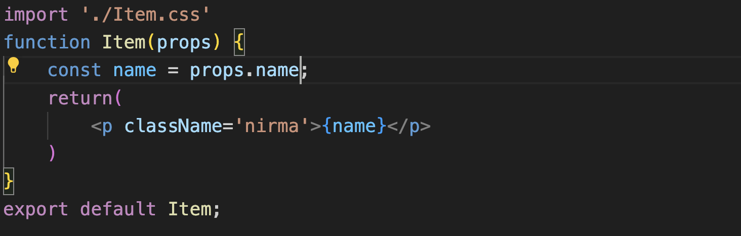
5. To use this we are using props keyword.
6. Other method to send props.
7. 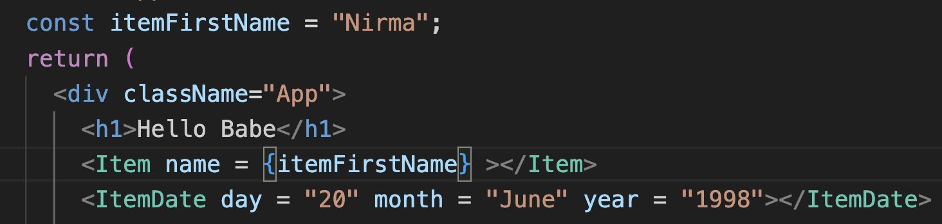
8. Like here I have sent the Nirma name as the new variable.
9. Another method we can use in form of array of object.
10. 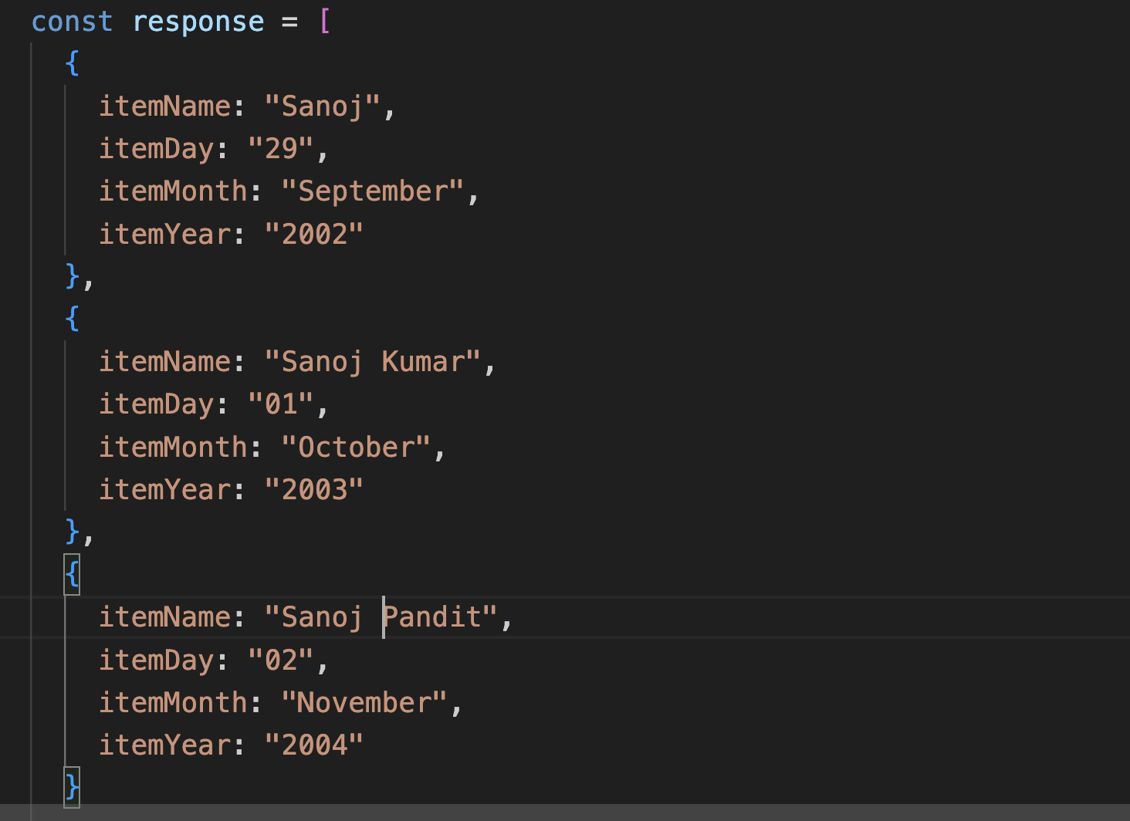
11. Here we have made an array then we can simply use this
12. 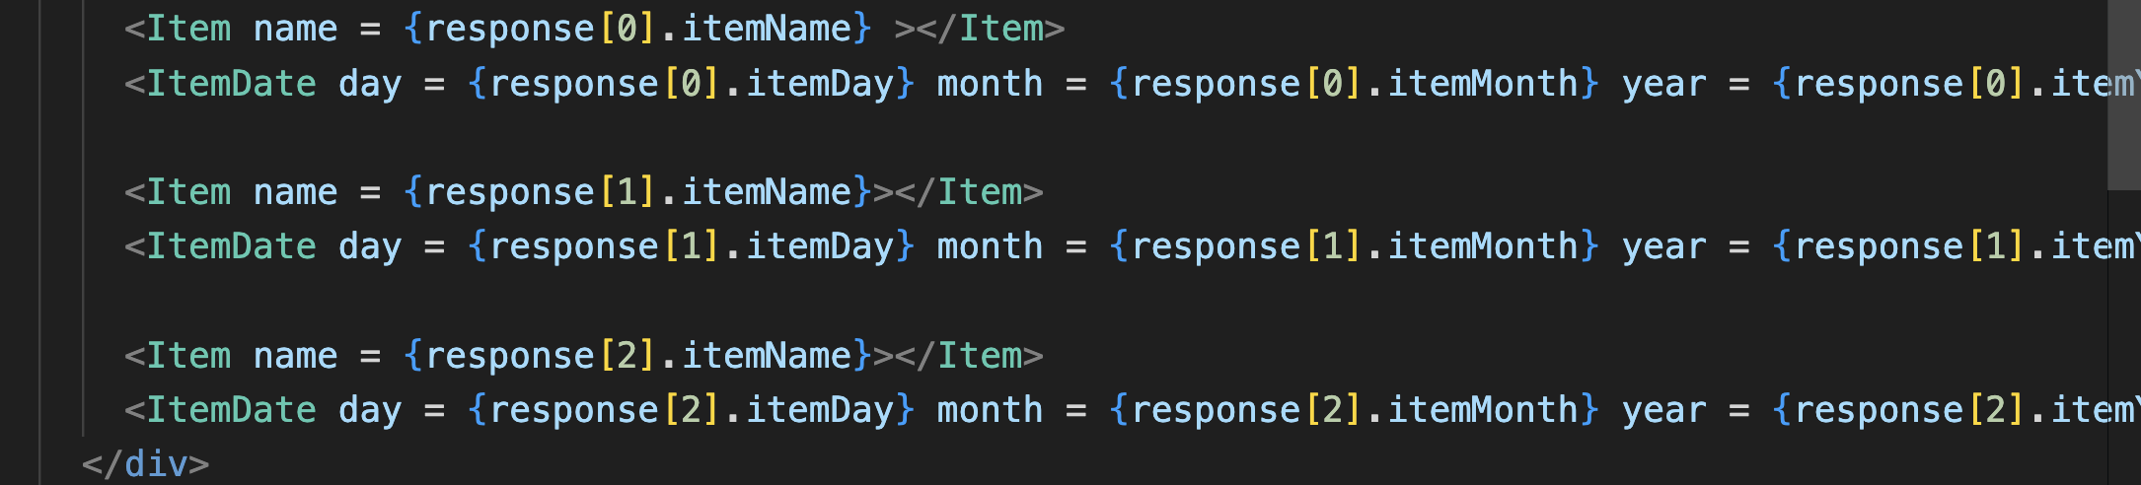

If we want to make visible whatever we are writing between the opening and closing tag then there we need to use props.children.

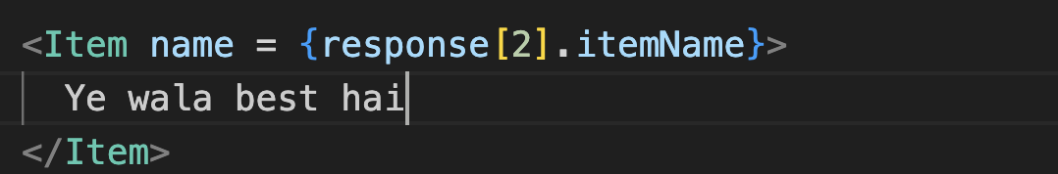

Like here “Ye wala best hai” it will not show on the web because it has not been used to to make it visible we will write

