**ReactJS Basics**

Event Handling using Props:

* Every events starts with on
* Like onClick, onDoubleClick and so on.
* 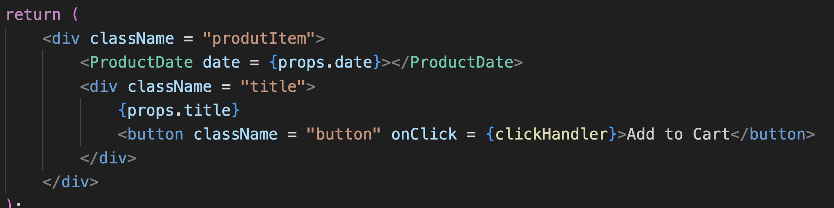
* If we want to change when UI changes then we need to do something else because React only renders it one time.
* There we need to use **State**.
* Now we want to use React Hook (some kind of utility Functions).

**useState:**

* + here we have two things first tells about the variable and other is function which updates the variable.
  + 
  + title variable will be initialize with props.title.
  + and then to change the variable name we use setTitle function.
  + After calling setTitle then React renders the component.
  + Here setTitle or any set function is schedule it is not on time changing function.

**Value Change:**

* onChange = {function name}
* to get current value: an event object is default passed in that function so we can use event.target.value. (but this is for only one state field).
* For multiple state field: we can create multiple useState.
* There is another way to handle all the parameter. We can use object.
* 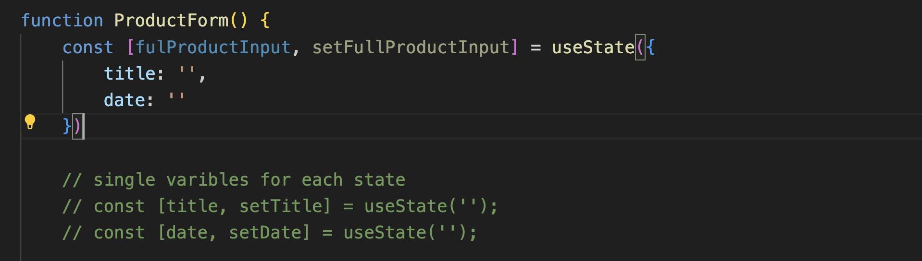
* We can also get previous state using prevState keyword.
* 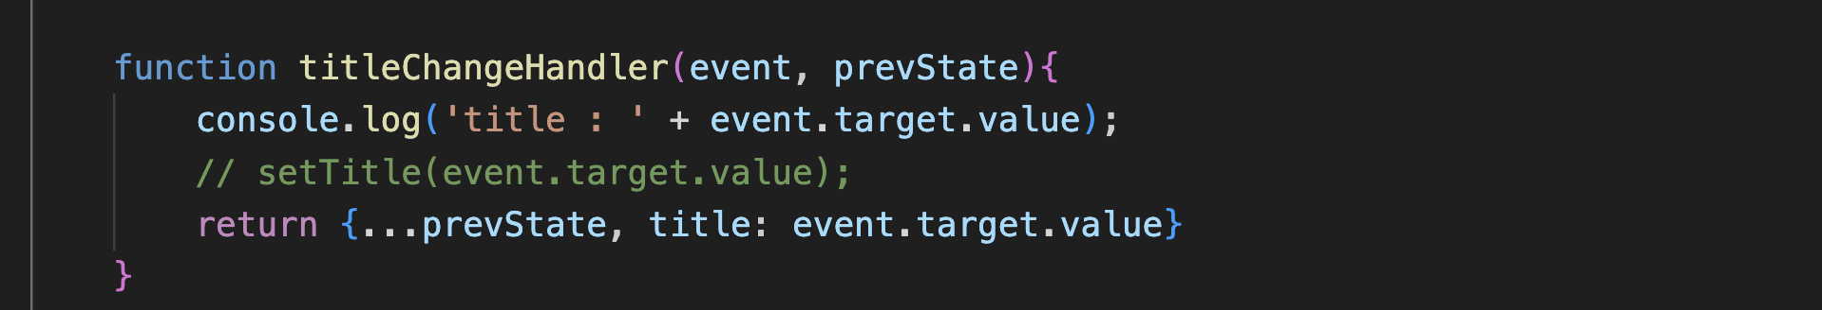
* Here we have used prevState and spread operator.

Note: Check the code also

**Interview Question asked**

Do two separate components at same level communicate?

* No

How to communicate child to parent component?

* Using props function, lifting up.
* Parent will create a function which is using an object (initially empty) after that this function will be passed as object to child and then child will call this function using any object (which can be used) and now it can be accessed in the parent.