# **ORM Querying Lab**

## **Introduction**

Object-Relational Mappers (ORM) give software developers the tools to interact with databases purely through the applications object-oriented programming language (such as Python). Rather than writing raw SQL queries with our applications we can instead interact through class objects called “models”. This project is an exercise in becoming familiar and comfortable using ORMs such as Django’s ORM (Django covered soon!). In this project we will be interacting with multiple models to query data in unique was and inspect what SQL is actually being executed “under-the-hood”.

## **Technologies**

Python, MySQL

## **Learning Objective**

The objective of this project is to get more comfortable using the Django ORM query methods to retrieve data from a MySQL database. Many of your future projects, including the capstone, will require you to use similar Django ORM queries that you will be introduced to here. Your proficiency will grow with each project.

## **Resources**

**PowerPoints**

* Querying Using an ORM

**Other Resources**

* Basic Github Operations Document
* Official Django ORM Documentation:
* <https://docs.djangoproject.com/en/4.0/topics/db/queries/>
* <https://docs.djangoproject.com/en/4.0/ref/models/querysets/>

## **Tasks**

Work with your team to complete the query lab using a paired programming approach.

1. **Complete the required queries in each view.py function.**
2. **Print your query results to the terminal and attempt to match the provided “Expected Terminal Result” as shown in the comments under each function. (Also shown in the browser)**
3. **Utilize the Django Debug Toolbar to view the actual SQL that is executed by your ORM queries.**
4. **Use the web page’s navigation buttons to execute the corresponding functions**

## **Setup Steps:**

Work with your team to complete project setup.

1. Each member creates their own github repo, select Python gitignore.
2. Each member downloads and unzips the starter code and pushes it to their own repo.
3. 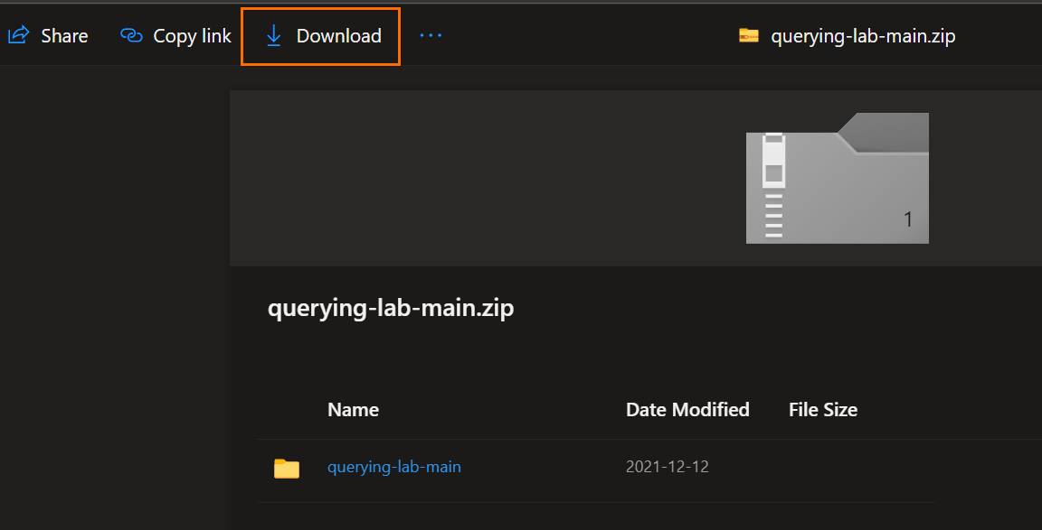
4. VERY IMPORTANT! When opening the project, make sure to open the folder that contains the pipfile as the top level. Should look exactly like this:
5. 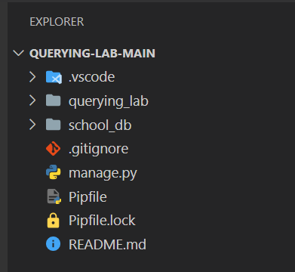
6. All members create a new database in MySQL Workbench named ‘school_db’ by running the SQL command

CREATE DATABASE school_db

1. All members update the password in local_settings.py to reflect their personal MySQL password.
2. All members enter ‘pipenv install’ command.
3. All members enter ‘pipenv shell’ command.
4. All members change VS Code’s python interpreter to reflect newly created venv (see ORM Query Lab Setup video – **minute mark: 3:29**)
5. All members enter ‘python manage.py migrate’ in the correct directory.
6. All members can now start the application with the VS Code debugger by pressing F5 or selecting Run > Start Debugging
7. Open up the URL as shown in the terminal (http://127.0.0.1:8000/)