1. Experience Location is misspelled wherever it comes up on the map.

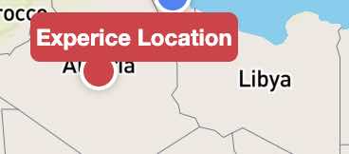

1. The filters sometimes do not appear. Please troubleshoot. They should always appear, whether logged in or not.

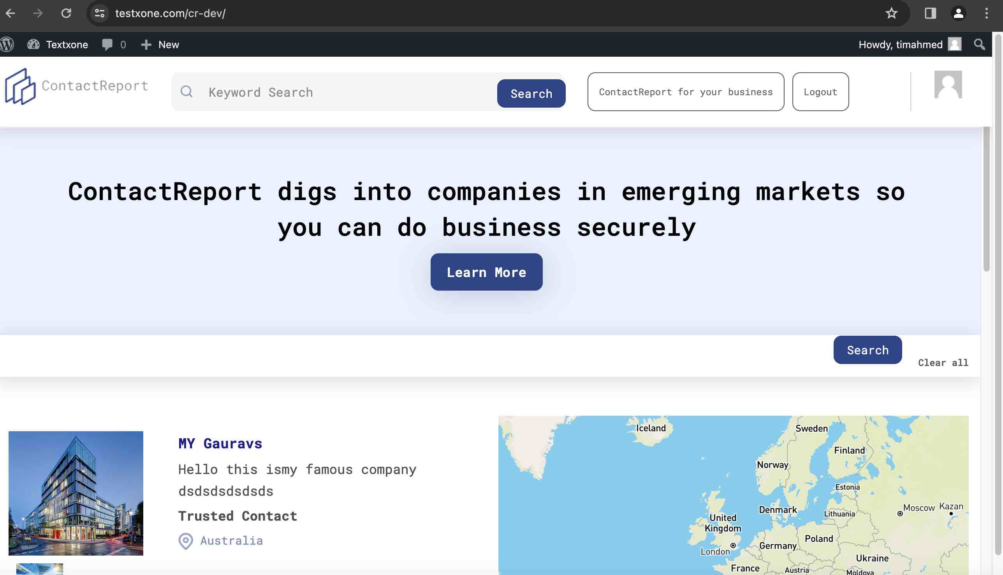

1. We put Up and Comer in our test profile, and it showed up correctly in the homepage, but when you click on the profile, it says Trusted Contact. Please make it consistent and accurate in all instances.

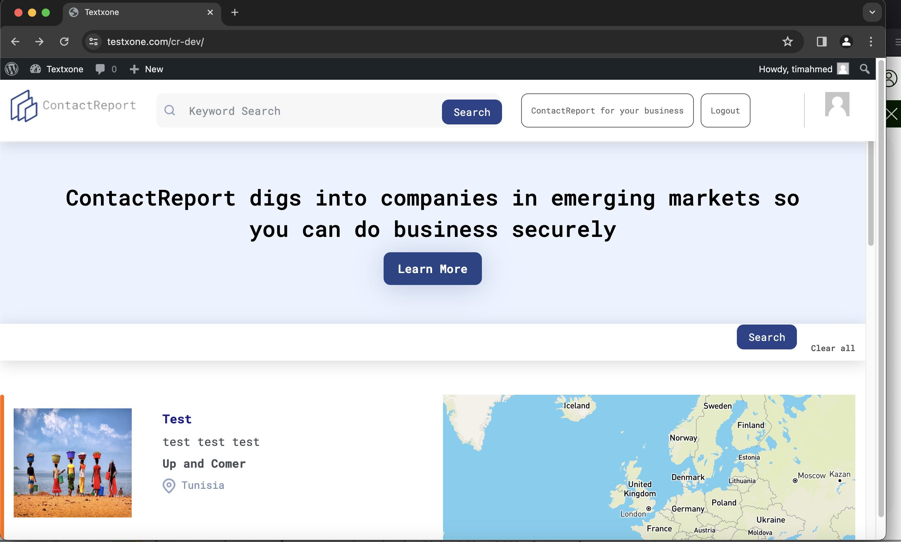

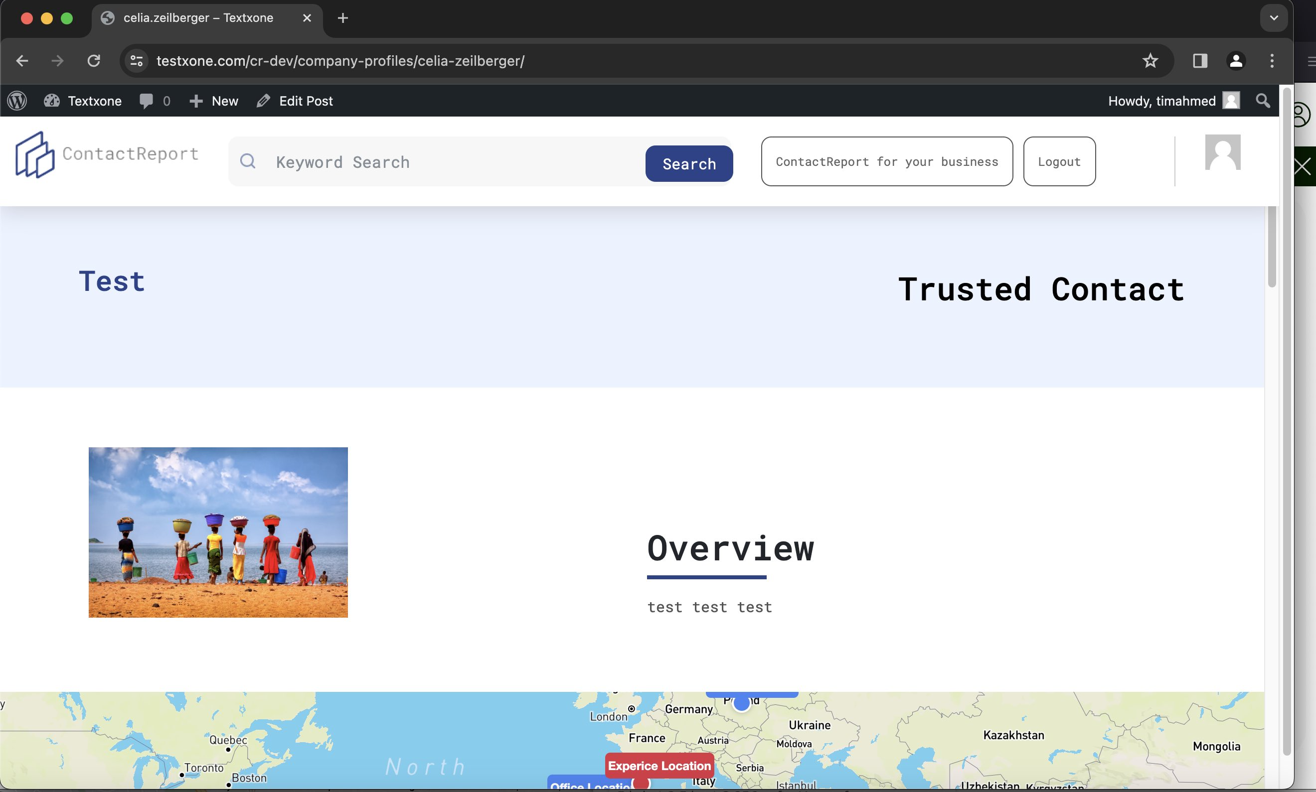

1. The URL name for each profile is the name of the individual user who uploads it, not the company. This name should be private, the URL should have the company name instead.



1. Is there any way to make the company pictures fill the space available? So, if there is only one photo, it would show up bigger to fill the space.



1. Please add, both on the input page and on the profile, spaces for company website, contact email, and contact phone number.