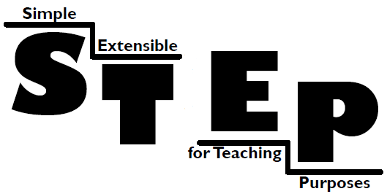 A short introduction

The STEP Framework is an open-source, multi-layer, Java enterprise application framework, with support for Web Applications (Servlet/JSP) and Web Services.
The main design goals of STEP are simplicity and extensibility, and it's been designed for teaching purposes.
It is hosted at SourceForge.net, in the following address: http://sourceforge.net/projects/stepframework

What is a framework?
A framework is a basic conceptual structure used to solve or address complex issues.
More specifically, a software framework is a re-usable design for a software system. A software framework may include support programs, code libraries, a scripting language, or other software to help develop and glue together the different components of a software project. Various parts of the framework may be exposed through an Application Programming Interface (API).
More information at:
http://en.wikipedia.org/wiki/Framework

What makes STEP unique?
The STEP framework source code is intended to be small and simple enough to allow any developer to read it and understand it thoroughly, seeing how the multiple layers are implemented in practice.
The STEP Framework is also novel in the way it combines the features of a Web Application framework with a distributed application model, using different domains and crossing physical and trust boundaries.
STEP leverages other open-source projects, like Hibernate (http://www.hibernate.org) for data persistence, Stripes (http://www.stripesframework.org/) for the web interface, Sun's JAX-WS reference implementation (https://jax-ws.dev.java.net/) for Web Services, etc.
STEP also relies on Apache Ant (http://ant.apache.org/) and ImportAnt (http://import-ant.sourceforge.net/) for application configuration and building.

The STEP framework aims to be a learning step towards more complete and powerful application frameworks, like some of the following:
- Java Enterprise Edition (the official Java framework): http://java.sun.com/javaee/
- Spring: http://www.springframework.org/
- Google Web Toolkit: http://code.google.com/webtoolkit/
- Click: http://click.sourceforge.net/
- Echo: http://echo.nextapp.com/site/echo2
- Thinwire: http://www.thinwire.com/
- Wicket: http://wicket.apache.org/
- WingS: http://wingsframework.org/cms/
- ZK Framework: http://www.zkoss.org/
- Etc.

Where to start?
To get started with the STEP framework, you can download the source code and try out the Trip Planner example. See the readme.txt file for installation instructions.
For developing new applications, you can refer to the cookbooks.

