Abstract—These Organizations expect Web Services to make their information systems more agile so they can better adapt to changes in business requirements. Hence, this technology's design principles focus on interoperability and flexibility to give developers the ability to customize, reuse and enhance functionalities as well as non-functionalities such as security, transactions and reliable messaging.
Customizing Web Services with Extensions
in the STEP framework
Miguel Pardal, Sérgio Miguel Fernandes, Jorge Martins and Joana Paulo Pardal
In particular, an effective Web Services customization must strike a delicate balance in providing developers a programming model that is both simple and expressive i.e. application developers don't want to re-implement complex standards but they want to do the changes they need.
We propose customization with Web Services Extensions. We present the concept, its core mechanisms and its implementation on the STEP Framework, an open-source multi-layer Java enterprise application framework.

Index Terms—About four key words or phrases in alphabetical order, separated by commas.

INTRODUCTION
THE internet allows an open and dynamic business environment, where information and communication technologies enable new and innovative ways to work and create value. In this value web, Organizations use sophisticated software to connect to their partners [1].
Enterprise applications for the Internet have heavy-duty requirements: users in high numbers and diverse profiles, large volumes of complex data, unsettled business rules, and several integration interfaces with other applications [2].
The main challenge of Enterprise applications is change: the needs of the customers change, businesses must change accordingly and so do their systems. Because of this, Enterprise applications benefit from being agile i.e., adapting more easily to requirement changes.
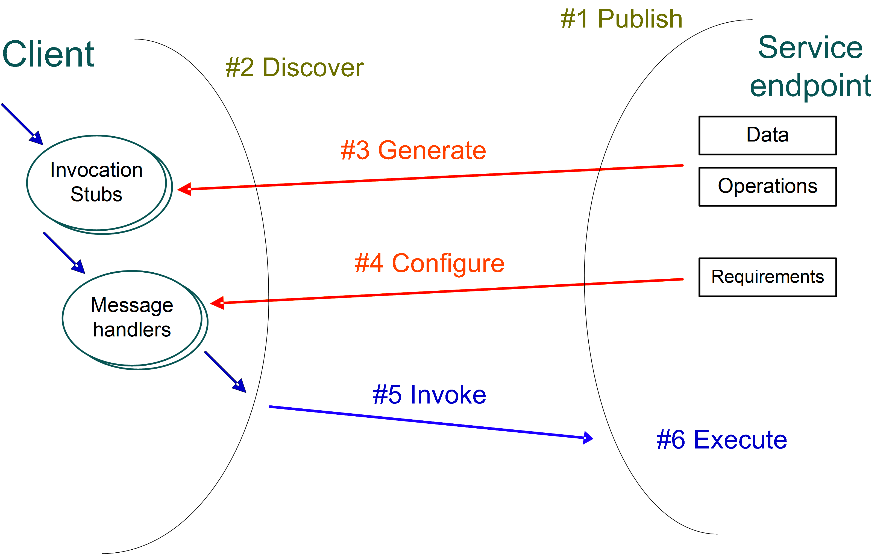

Fig. 1. Web Services client-server interaction.

Web Services (WS) [3] and Service-Oriented Architectures (SOA) [4] address the need for agility at the technology and architecture levels, respectively.

Web Services
WS technology is designed for the implementation of Enterprise applications guided by service-oriented principles [5]: Formal contract; Loose coupling; Encapsulation; Composability; Reusability; Autonomy; Discoverability.
Abiding to all these principles during Enterprise application development is a significant investment in future reuse. The single most important principle is using formal contracts to ensure correct client-server integration.
A WS is an access endpoint to data and functional resources of Enterprise applications. Fig. 1 illustrates how a client application interacts with a WS.
The WS endpoint is published in an UDDI [6] directory. The client discovers the WS location. The available data and operations are described in XSD (XML Schema Definition) [7] and WSDL (Web Services Description Language) [8]. The client generates invocation stubs that perform run-time data conversion to SOAP [9] message format. Additional requirements are described in WS-Policy [10]. Libraries have to be engaged to satisfy these requirements both on the client and on the server, and control data is added to the SOAP message headers. The client invokes the service (using a transport protocol, like HTTP [11] for example) and the service is executed.
XSD, WSDL, WS-Policy and SOAP all use XML [12] as their foundation for data representation.

Standards
WS technology is defined by standards that leverage Internet network protocols and other open standards. Fig. 2 shows WS-Map [13], a broad and vendor-independent standards index.
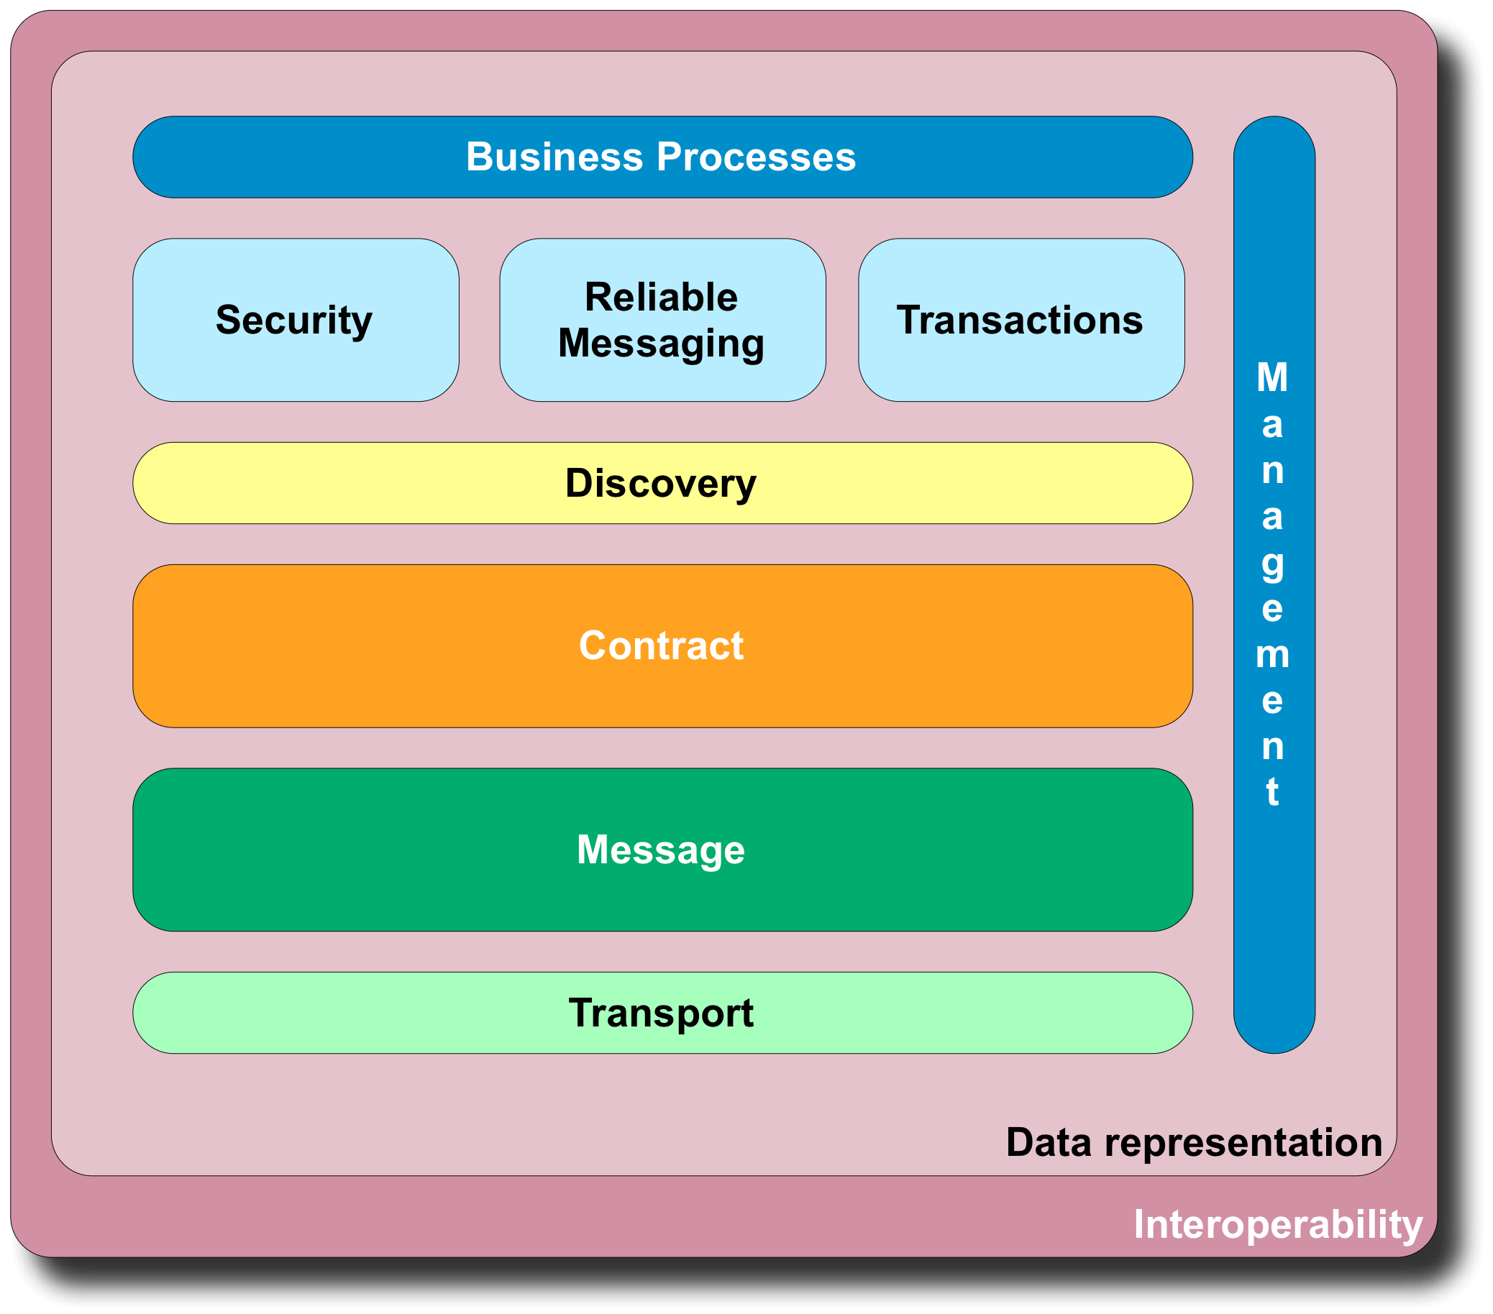
Fig. 2. Web Services standards map.

WS-Map categorizes WS standards in a set of categories that give a sense of the technology's broad scope: Data representation; Transport; Message; Contract; Discovery; Security; Transactions; Management; Interoperability.
The data representation standards address the problem of heterogeneous data representation i.e., how to represent data in a format that is equally understood by everyone. XML is at the base of all other WS standards.
The transport standards define ways to establish a communication channel between a client and a WS. The communication can be synchronous or asynchronous, meaning that the client blocks waiting for an answer from the remote WS or not, respectively.
The message standards define the structure of the communication units and the ways they can be exchanged between services. SOAP is also another fundamental standard, as it enables message level extension using SOAP headers.
The contract standards accurately describe the data, functions, policy and resources of a WS. They are used for client-server binding.
The discovery standards define ways to publish and discover services. UDDI [6] defines a WS directory. WS-MEX [14] is a protocol for WS self-description and meta-data access.
The main concerns for security standards are message protection, access control and configuration flexibility. WS-Security [15] states how to protect SOAP messages with XML Signature [16] and XML Encryption [17] and how to transport security-related tokens, like cryptographic keys, digital certificates, assertions, etc.
The reliable messaging standards address the reliability of message exchanges in a transport independent way. WS-Reliability [18] and WS-ReliableMessaging [19] are two proposals for assured delivery, duplicate elimination and correct ordering in WS messaging.
The transactions standards address the problem of providing well-defined semantics for the combined result of a group of WS operations on distributed resources. There are two proposals for transactions: WS-Coordination [20] and WS-CompositeApplicationFramework [21].
The business process standards define development concepts and tools at an abstraction level closer to the needs of business people. An example is WS-BPEL [22] for composing orchestrations of existing services.
The management standards address the problem of keeping a Web Services infrastructure up-and-running.
Finally, the interoperability profiles are necessary because of the ambiguities in the standards that result in implementation differences. Each profile defines implementation guidelines, example applications and compatibility test toolkits. The WS-Interoperability organization [23] brings together the main vendors of WS tools in defining interoperability profiles for basic interaction [24] and security [25].

Web Services customization challenges
A custom requirement is an application-specific variation on a general requirement. Most of the implementation code required to satisfy it is the same as the general case, except for small tweaks.
For instance, consider a digital signature library that performs document signature and verification. A custom requirement would be to have the verification require the signing principal to belong to a subset of entities.
An effective customization tool must:
- Support functional and non-functional requirements;
- Allow configuration flexibility.

Functional and non-functional requirements
WS requirements can be classified as functional or non-functional.
Informally, functional requirements say what a WS can do. Non-functional requirements say what properties hold when the WS is executed. Non-functional requirements include: security, transactions, reliable messaging, management, usability, and performance. The non-functional requirements of a WS can be contradictory, so they must be balanced during implementation.
Let's consider an example WS that gives access to an on-line inventory. A functional requirement is “The service allows reading data from the product inventory”. A non-functional requirement is “The service interface must be simple to use” and another one is “The service must assure data is kept secret from non-authorized users”. There is a non-functional requirement conflict here, as the service would be easier to use if it didn't need a password, but it would be less secure.
The functional requirements should be implemented as components that can be structured and composed as generic procedures. The non-functional requirements should be implemented as aspects that allow additional procedures to be executed around or inside components.
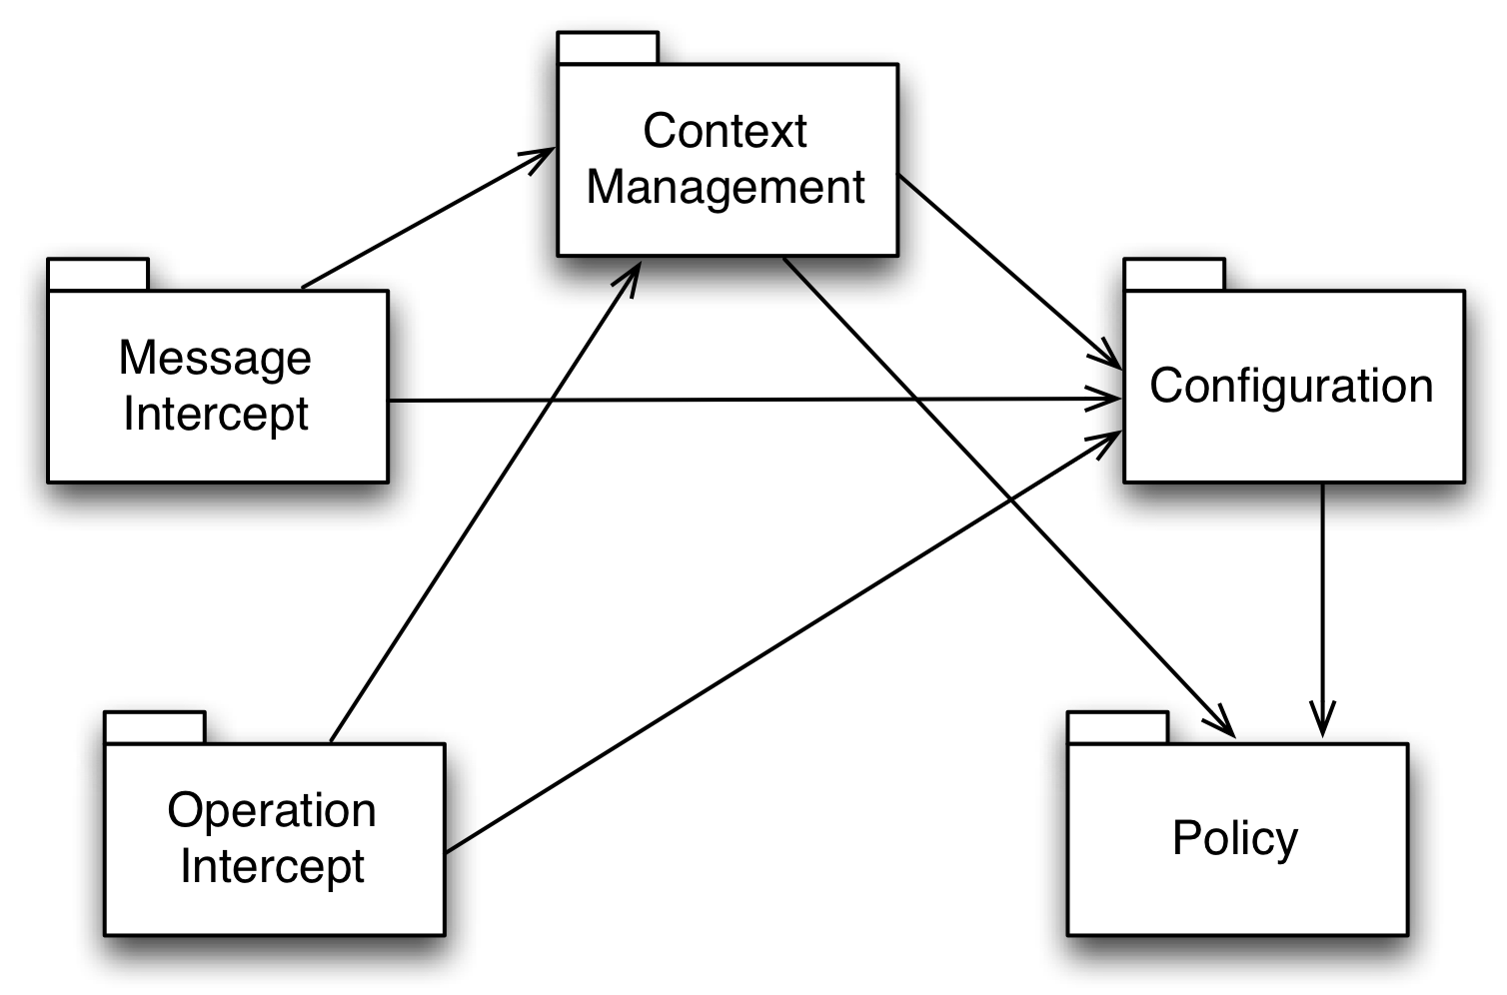
Fig. 3. Extension mechanisms package diagram.

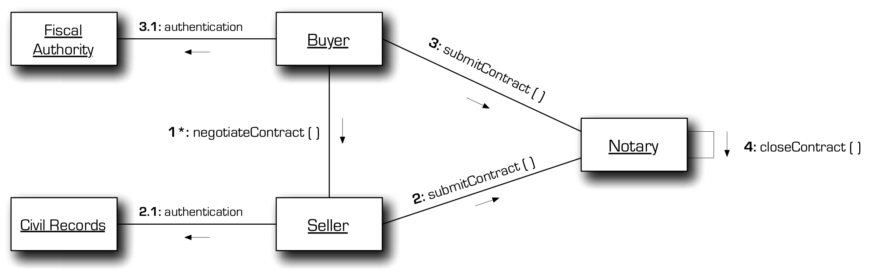
ig. 3. Extension mechanisms package diagram.

This can be achieved with design patterns [26] that improve relations between components and overall program structure, or with new programming language paradigms, like AOP (Aspect Oriented Programming) [27].

Configuration flexibility
Another issue is configuration flexibility when supporting non-functional requirements. For instance, service protection can be adjusted to data value: low value messages can use a weaker cipher algorithm than high value messages. Also, service protection can be adjusted to invocation circumstances: a request made from a client inside the corporate network can use a local security credential whereas an external client must use a cross-domain security credential.

Web Service Extensions
WS Extensions are a customization mechanism that provides interception points where application developers can add custom code and leverage the underlying WS implementation's capabilities.
First we describe a WS Extension example, then the core mechanisms required for it and finally the proof-of-concept implementation.

Security Report Extension
The security report is an example of a useful WS Extension.
Some applications prefer not to know about security, they just want it to be guaranteed. But others need to know what has been done, for instance, to store audit information in a database.
A security report is produced during WS security processing, containing all performed actions and all used parameters, in a simple, easy-to-use data schema. This effectively leverages the security implementation and enables context sharing through a meaningful abstraction, delegating security decisions in a simple and effective way.

Core mechanisms
The following mechanisms are required for WS Extensions:
- Configuration;
- Contexts management;
- Message interception;
- Operation interception.
Requirements declaration (Policy) is optional.
Fig. 3 shows the dependencies between packages.

Requirements declaration
The (non-functional) requirements declaration is done with a policy.
The policy states additional requirements that must be fulfilled by the client and by the WS so that the interaction between them can occur as required.
This capability is needed, for instance, to declare that a WS can be invoked with transport security or with message security. It can also be used to declare an operation with transactional properties or reliable messaging needs.
The standard for policy declaration is WS-Policy [10]. A WS-Policy states a set of configuration alternatives supported by a service. The client has to support at least one of the alternatives.
WS Extensions can be a means to satisfy specific requirements stated by a policy.

Configuration
The configuration selects the extension to engage and the parameters to use or to request from the application in run-time (e.g., which digital certificate will be used to securely sign messages). This capability is needed to control the behavior of the extensions.
Ideally this configuration should be generated automatically from the client and server policies, after a negotiation. However, a simpler approach is to perform the configuration off-line and then rebuild both the client and the server. This approach also yields better performance, because the policy negotiation is performed in advance.

Contexts management
Execution contexts are an abstraction to organize state variables related to the WS. Contexts enable data sharing between the extension library and the rest of the application. Some relevant context scopes are: Application, Session, Operation and Thread.
For instance, the session context allows the storing of a cryptographic key used to store the set of messages in the same security scope. It can also be used to store distributed transaction state, like: id, coordinator location, etc.

Operation interception
The operation execution interception allows interception points before the domain logic is actually executed. The business objects, data objects, stubs and other objects are created in factories that can be customized to return different implementations according to the desired behavior.
Using this feature it's possible, for instance, to implement generic security authorization mechanisms. It's also possible to transparently return transactional or reliable transport implementations of remote WS stubs to a client application.
Fig. 4. Prototype collaboration diagram.

Message interception
The message flow interception provides access to the message's routing and contents (headers and body).
This capability allows, for instance, the forwarding of a rejected incoming message, sending it to a security node for reporting. It can also be used to retry sending a lost message, to achieve reliable messaging.
The message flows are usually sequential, but there are proposals, like SPEF (SOAP Profile Enabling Framework) [28], for more elaborate flows.

Proof-of-concept
The presented mechanisms for WS Extensions were drafted from the results and evaluation of a study [29] about the following implementations:
- WSE 3 (Web Services Enhancements 3) for Microsoft .NET 2 [30];
- WSS4J (Web Services Security for Java) for Apache Axis2, for Java [31];
- XWSS (XML and Web Services Security) for JAX-WS 2, for Java [32].
The study included extensive tests for each implementation and the development of a prototype for a business case-study.
The selected implementations were biased towards security, but additional tests were performed for transactions and reliable messaging usage scenarios.
After the conclusion of the prototype, an Extensions proof-of-concept implementation was developed for testing and further evaluation in a laboratory project for a Distributed Systems course.

Case-study
The chosen case-study was “real-estate contracts” and the main functionality supported by the prototype was “signing of sale agreement between seller and buyer”.
The full business process and informational entities were modeled using a service-oriented methodology [33] for enterprise architecture. The prototype use-cases and interaction diagrams were modeled using UML [34]. The prototype specification and development explicitly accounted for binding, invocation and key distribution, as briefly illustrated in Fig. 4, and detailed in [29].

Implementation
The WS extension mechanisms were implemented leveraging existing open-source libraries, primarily JAX-WS (Java API for Web Services) 2 [32].
Requirements declaration was implemented with WS-Policy provided by Apache Commons Policy 1.0 [31].
Message interception was based on JAX-WS handlers.
Configuration, execution contexts and operation interception were implemented using singleton and factory design patterns [26] with additional custom coding.

Field tests
The WS extension proof-of-concept implementation was used by 300+ students in a Distributed Systems course's laboratory project, requiring the implementation of a WS application and extension libraries for security and transactions.
The security extension library supported encryption, MAC (Message Authentication Code) and digital signature [35].
The distributed transactions extension library implemented a “two-phase commit” consensus protocol for transactions with relaxed isolation [36].
The final results were compared with results from a previous course, with similar goals and contents, but without Extensions.
The new projects were better at separating the application specific code from the customization code.
The field tests showed that the identified mechanisms were necessary and sufficient for the development of WS Extensions.

Extensions in the STEP Framework
After the proof-of-concept implementation, a more complete implementation was deemed necessary to further develop customization using WS Extensions, so a more complete implementation was built on top of the STEP Framework.
The Extension concept makes sense in an application context. To properly intercept an application's messages and operation execution, we need a framework that provides a common architecture for applications.

Framework
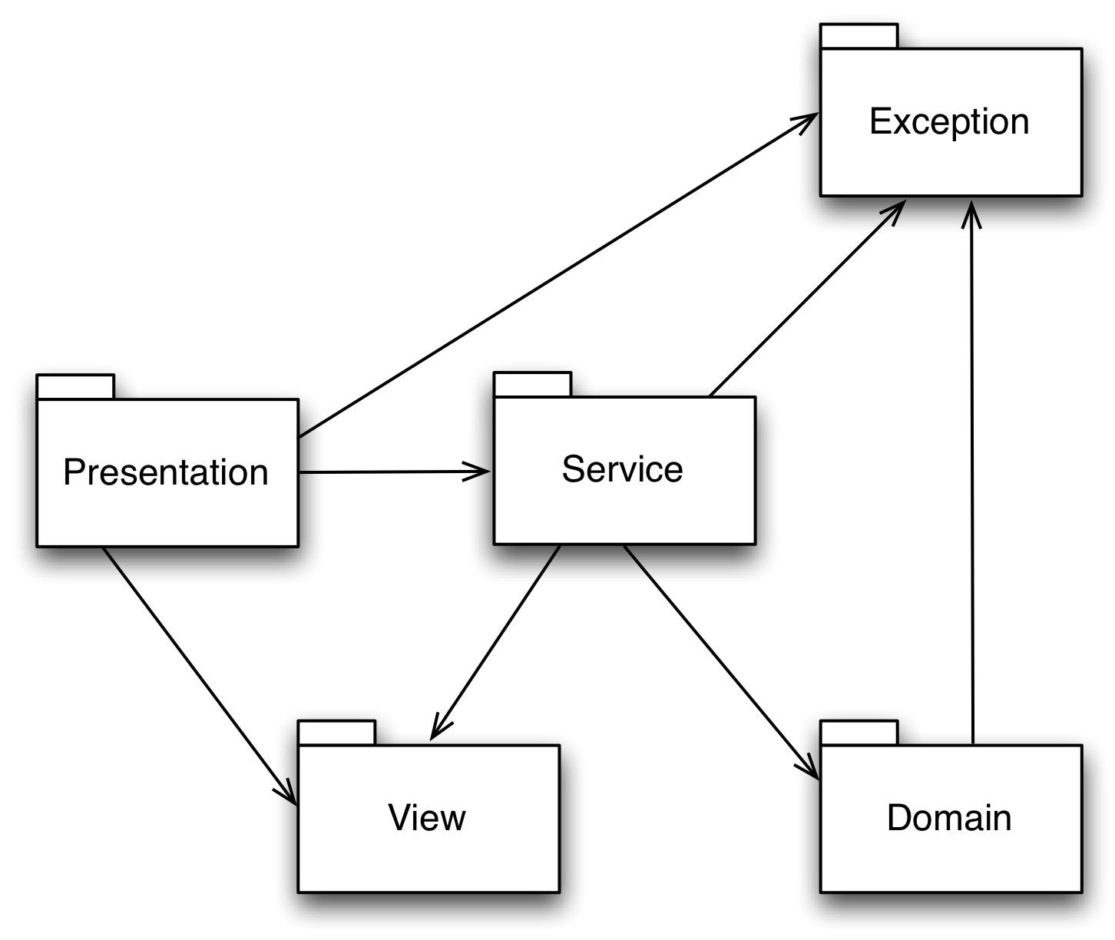
Fig. 6. STEP Framework application layers package diagram

The STEP Framework is an open-source, multi-layer Java enterprise application framework with support for Web Applications (Servlet/JSP) and Web Services.
The main design goals of STEP are simplicity and extensibility, and it's been designed for teaching purposes.
The STEP framework source code is intended to be small and simple enough to allow any developer to read it and understand it thoroughly, seeing how the multiple layers are implemented in practice.
In its layers, STEP leverages other open-source projects, like Hibernate for data persistence, Stripes for the web layer, Sun's JAX-WS reference implementation for Web Services, etc. These specific libraries are used in the current version, but different ones have been used before (e.g. Struts, OJB and different ones will probably be used in the future.
The framework aims to be a learning step towards more complete and powerful application frameworks, like Java Enterprise Edition itself, Spring, etc.
The STEP Framework is also novel in the way it combines the features of a Web Application framework with a distributed application model, using different domains and crossing physical and trust boundaries.

Application layers
The STEP Framework layers are the following (illustrated in Fig. 5): Domain; Service; View; Presentation.
There are also, Web Service (server and client) layers.
Fig. 6 shows the layer's package diagram, highlighting the dependencies.
The main application layers are Domain and Service.
Fig. 7 shows a sequence diagram for a STEP Framework application when a request is processed.
The client request is received at the presentation layer, then it is directed towards a service. The presentation doesn't access the domain directly, only through services and views. Each service has a unit-of-work [2] associated with it. The current implementation of the unit-of-work using Hibernate relies on the underlying database transaction.

Domain layer
The domain layer is where an object-oriented solution for an application's problem is modeled.
Persistence of the domain objects is essential to ensure the state of an application is properly stored (i.e. data must survive the application instance that created it). We are currently leveraging the Java Persistence API to provide the persistence model for object-relational mapping, using Hibernate as the service provider.
An application should have a single root domain object that represents the application itself and acts as the single entry point to the domain objects.
This allows for a seamless navigation through the entire object graph without the need to explicitly query the underlying persistence mechanism. The domain root is typically implemented as a Singleton [26] object.

Service layer
The service layer (not to be confused with Web Service) mediates the access of presentation to the domain layer.
A service is a class that implements a certain functionality through invocation of domain objects. The architecture mandates that all functionality must be provided by services, isolating the domain model from upper layers. Services are where non-functional requirements (that aren't relevant to the domain logic itself) should be added.
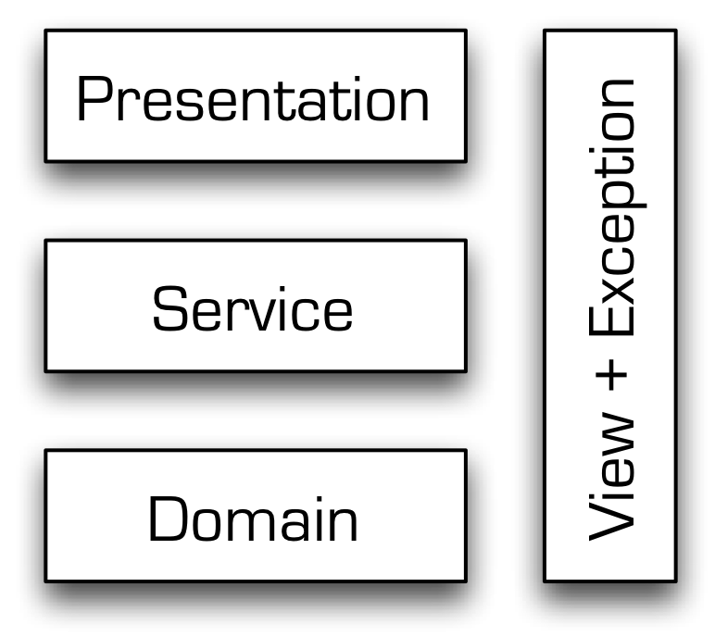
Fig. 5. STEP Framework application layers.

In order to invoke a service, the invoker must first create a new instance of the service and pass all the necessary data to its constructor. When the service is invoked (through its execute() method), the service performs its work within a unit-of-work context. If exceptions occur during service execution, the unit-of-work is always aborted.
Services can be domain-bound, if they only invoke domain classes from a single domain, or they can be multi-domain, if they use one or more domain-bound services from different domains. Multi-domain services can also be called orchestrator services.
Services can execute on a local domain or they can use a remote domain, using WS stubs.

View layer
The view layer provides a set of Data Transfer Objects (DTO) that are used to provide/return information to/from services.
The view layer is a read-only set of classes that are mapped to and from the domain. These can be safely returned to a presentation layer, because they don't give direct access to the domain and the underlying database.
Views are described in XSD and the corresponding classes are generated through automated tools. This guarantees the DTO has no logic and simplifies their use in the context of Web Services, as a WSDL can easily import the definitions and reuse them.

Presentation layer
The presentation layer is responsible for maintaining user interaction i.e. convert user intents into service executions, report errors in meaningful ways, organize information clearly for humans to understand.

Web Service layer
The WS layer is akin to a presentation layer, but its purpose is to allow a domain to be accessed remotely by another application and not by a human user.
For each application service there will be a WS operation declared in the WSDL.
Fig. 8 shows a sequence diagram for a WS, highlighting the interception points used by Extensions. The inbound and outbound SOAP messages are intercepted. The WS operations (i.e., services) are intercepted before and after their execution.

Extensions implementation
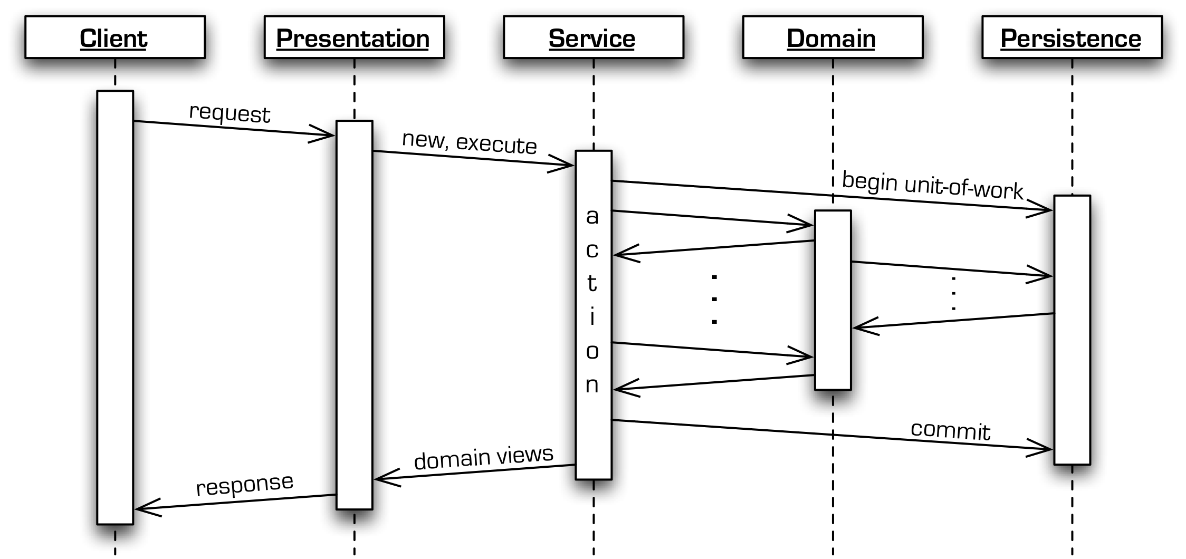
Fig. 7. STEP application layers interaction during a request processing.

The Extensions implementation was tested on the platform supported by the current release of the STEP Framework:
- Java 5 (programming language and libraries);
- JWSDP 2.0 (additional XML and Web Services libraries);
- Tomcat 5.5 (Web Application Container);
- Apache Ant 1.7 (build tool);
- ImportAnt 5.5 (build tool library).

The application extension points (including the ones represented in Fig. 8) are the following:
- The Service super-class that calls a service interceptor manager before and after the main action for all services;
- A JAX-WS Handler is used to intercept all SOAP messages and invoke the web service interceptor manager;
- A Web Application ContextListener is used to perform the extension engine configuration loading on deploy time.
The Extensions Application Programming Interface (API) was designed to use the extension points. Three kinds of objects can be declared in an Extension:
- Service Interceptor;
- Web Service Interceptor;
- Listener.
A Service Interceptor is executed before and after the service's main action. The extension itself is executed within the same unit-of-work scope as the service it is extending, and can influence its outcome.
A Web Service Interceptor is executed when messages arrive or leave the WS. The extension can influence the message flow.
Finally, a Listener is executed when the extension is initialized and destroyed, allowing for resource allocation and release, respectively.

Requirements declaration
Policy support was dropped from the implementation and left for a later version. Its implementation was considered premature before the underlying configuration mechanism was evaluated and thoroughly tested in practical use.

Configuration
The main configuration artifacts are the properties files. The main file is called extensions.properties and an example is presented in Fig. 9.
The enabled option is the main on/off switch. This allows a quick and easy way to disable extensions entirely.
The list is where the extension instances are declared. An extension instance is known only after being listed here. The engine initializes the extensions according to the declared sequence. In the example, there are three extension instances declared with identifiers: hello, trace, and errors.
After being properly declared, extensions can be used to intercept services and web services.
The intercept service properties can have a specifier inside square brackets. It can be:
- Empty – all services will be intercepted;
- Package name – all service classes inside the package will be intercepted;
- Class name – the specific service class will be intercepted.
The property can be specified several times with different specifiers, and the most specific configuration will be selected at run-time. For instance, if a class and package select the same service class, then the class definition is chosen, as it is more specific than the package one.
The intercept list order defines before processing sequence and inverted after processing sequence.
The web intercept service properties also can have a specifier inside square brackets. It can be:
- Empty – all web services will be intercepted;
- Namespace – all web services in the namespace will be intercepted;
- Service, Port – the specific web service will be intercepted.
The property can also be specified several times and the most specific configuration will be selected at run-time.
The intercept list order defines outbound processing sequence and inverted inbound processing sequence.
For each declared extension, a extension-id.properties file is expected to exist, with additional extension configuration. The id is replaced with the declared name of the extension. An example hello extension file is shown in Fig. 10.
The enabled option applies only to the current extension.
The service interceptor property allows specifying the extension's service interceptor class name. It is optional.
The web service interceptor property allows specifying the extension's web service interceptor class name. It is also optional.
The listener property allows specifying an extension listener's class name. It is also optional.
Using this configuration flexibility, an extension can combine the following useful capabilities:
- Service interceptor only;
- Web Service interceptor only;
- Service and Web Service interceptor team.
Custom properties can be specified both in extensions.properties and in extension-id.properties.

Contexts management
Execution contexts help to store state variables according to its scope. Extensions have two types of contexts:
- Extension engine context – can be used to share data globally between extensions;
- Extension instance context – can be used to share data inside the same extension team of service interceptor and web service interceptor.
There is no explicit support for contexts with request scope. However, a custom solution can be developed using the existing contexts by using a request-specific identifier as a map key. The Framework also has generic context management classes, with scopes: Application (global), Session (externally managed identifier) and Thread (thread identifier is used implicitly to distinguish between contexts).

Operation interception
The WS operations are mapped to services for their actual execution. A Service Interceptor (SI) intercepts service executions as illustrated in Fig. 11.
A Service Interceptor can access the service instance data by using Java Reflection or by casting the service instance to a known type.
The error behaviors for a service interceptor are the following.
Throw a DomainException
The unit-of-work is aborted and the presentation layer receives a domain exception that is indistinguishable from one thrown by the service itself.
Throw a ServiceInterceptorException
The unit-of-work is aborted and a ServiceException is thrown to report a system condition.
Throw a RuntimeException or Error
The unit-of-work also aborts.

Message interception
The message interception gives access to the SOAP message's header and body. A Web Service interceptor (WSI) intercepts all web service messages as illustrated in Fig. 12. The SOAP message context enables the interceptor to access the SOAP message.
The message situation can also be queried:
- Is it outbound or inbound?
- Is it a fault message?
- Is it being intercepted on the server-side or on the client-side?
To modify the message flow, a WSI can:
Return false
If the message is moving towards the server, it is reversed to go back to the client, as illustrated in Fig. 13.
This can be used to implement a message cache. The WSI is responsible for setting the message contents appropriately.
Throw a SOAPFaultException
If the message is moving towards the server, it is reversed to go back to the client, as illustrated in Fig. 14.
The message body is replaced with the SOAP fault provided by the exception.
Throw a WebServiceInterceptorException
If the message is moving towards the server, it is reversed to go back to the client, as illustrated also in Fig. 14.
The message body is replaced with a SOAP fault that is created automatically containing the text message specified in the exception.
Throw a RuntimeException or Error
The message processing is interrupted, as illustrated in Fig. 15. If the error occurs on the server-side, a SOAP fault message will be sent to the client.

Conclusions and future work
The main goal of Web Services tools should be to simplify XML programming. Development tools should focus on Web Service contracts, with direct specification of data schemas, functions and policy, rather than Java or .NET centric approaches that map their own concepts to XML, making the contracts less explicit and therefore more difficult to manage and maintain.
We presented an approach to customization based on interception: Web Services Extensions.
The clear identification of the core mechanisms and its mapping to different WS implementations makes it simpler for developers to focus on the extension's added value and to abstract the platform (e.g. Java, .NET) specifics.
Extensions support both functional and non-functional requirements, and have flexible configuration support. Whenever possible, custom requirements should be implemented by Extensions that share context with applications through meaningful abstractions, to delegate decisions in a simple and effective way.
This makes Extensions a very attractive tool for teaching purposes, because students can focus on the more advanced technological aspects, leveraging an easy-to-use configuration mechanism.
Future work on Extensions in the STEP Framework will be directed towards supporting customization of more capabilities available in the underlying platform as the current implementation uses only the core Services and Web Services stack. Policy support is also a future concern. Interoperability aspects like message transports beyond HTTP and a .NET platform implementation are also planned.
Extensions decrease the “cost-of-entry” into WS customization, broaden the number of developers that can try new ideas and encourage competition and best-of-breed selections that can help practitioners to further advance the state of the art of Web Services technology.
References
- K. Laudon and J. Laudon, Management Information Systems, Pearson Prentice-Hall, 2002.
- M. Fowler, D. Rice, M. Foemmel, E. Hieatt, R. Mee, and R. Stafford, Patterns of Enterprise Application Architecture, Addison Wesley, 2002.
- F. Curbera, F. Leymann, T. Storey, D. Ferguson, and S. Weerawarana, Web Services Platform Architecture: SOAP, WSDL, WS-Policy, WS-Addressing, WS-BPEL, WS-Reliable Messaging and More, Prentice Hall, 2005.
- D. Krafzig, K. Banke, and D. Slama, Enterprise SOA: Service-Oriented Architecture Best Practices, Prentice Hall PTR, November 2004.
- T. Erl, Service-Oriented Architecture: Concepts, Technology, and Design, Prentice Hall, 2005.
- L. Clement, A. Hately, C. von Riegen, and T. Rogers “UDDI version 3.0.2” OASIS, Systinet, IBM, SAP AG, Computer Associates, 2004. http://uddi.org/pubs/uddi-v3.0.2-20041019.htm.
- D. C. Fallside and P. Walmsley, “XML Schema part 0: Primer second edition”, W3C, October 2004. http://www.w3.org/TR/2004/REC-xmlschema-0-20041028/.
- D. Booth and C. K. Liu, “Web services description language (WSDL) version 2.0”, W3C, Hewlett-Packard, SAP Labs, 2005. http://www.w3.org/TR/2005/WD-wsdl20-primer-20050803.
- M. Gudgin, M. Hadley, N. Mendelsohn, J.-J. Moreau, and H. F. Nielsen, “SOAP version 1.2 part 1: Messaging framework”, W3C, Microsoft, Sun Microsystems, IBM, Canon, June 2003. http://www.w3.org/TR/2003/REC-soap12-part1-20030624/.
- J. Schlimmer, “Web services policy framework (WSPolicy) version 1.2”, Microsoft, IBM, VeriSign, Sonic Software, SAP, BEA Systems, March 2006, editor.
- R. Fielding, J. Gettys, J. Mogul, H. Frystyk, L. Masinter, P. Leach, and T. Berners-Lee, “Hypertext transfer protocol – HTTP/1.1”, IETF, June 1999. http://www.w3.org/Protocols/rfc2616/rfc2616.txt.
- T. Bray, J. Paoli, C. M. Sperberg-McQueen, E. Maler, and F. Yergeau, “Extensible markup language (XML) 1.0 (3rd edition)”, W3C, Textuality and Netscape, Microsoft, Sun Microsystems, 2004. http://www.w3.org/TR/2004/REC-xml-20040204.
- M. Pardal, “WS-Map: Web services standards map”, http://web.ist.utl.pt/miguel.pardal/ws-map, November 2006.
- F. Curbera and J. Schlimmer, „Web services metadata exchange (WS-MetadataExchange)”, MSDN, Microsoft, IBM, Computer Associates, SAP, BEA Systems, Sun Microsystems, webMethods, September 2004. http://msdn.microsoft.com/ws/2004/09/ws-metadataexchange/.
- A. Nadalin, C. Kaler, P. Hallam-Baker, and R. Monzillo, “Web services security: SOAP message security 1.0 (WS-Security 2004)”, OASIS, IBM, Microsoft, Verisign, Sun, March 2004. http://www.oasis-open.org/committees/tc_home.php?wg_abbrev=wss.
- D. Eastlake, J. Reagle, and D. Solo, “XML-Signature syntax and processing”, W3C, February 2002. http://www.w3.org/TR/2002/REC-xmldsig-core-20020212/.
- D. Eastlake and J. Reagle, “XML encryption syntax and processing”, W3C, December 2002. http://www.w3.org/TR/2002/REC-xmlenc-core-20021210/.
- K. Iwasa, “Web services reliable messaging TC WS-Reliability 1.1”, OASIS, Fujitsu Limited, Novell, Inc., Oracle Corporation, Sun Microsystems, November 2004. http://docs.oasis-open.org/wsrm/ws-reliability/v1.1.
- C. Ferris and D. Langworthy, “Web services reliable messaging protocol (WS-ReliableMessaging)”, Microsoft, IBM, BEA, TIBCO Software, February 2005, editors.
- M. Feingold, “Web services coordination (WS-Coordination) version 1.0”, IBM, Microsoft, Hitachi, Arjuna Technologies, IONA, August 2005, editor.
- M. Little, “Web services composite application framework (WS-CAF) version 1.0”, Sun, Oracle, IONA, Arjuna, Fujitsu, July 2003, editor.
- S. Thatte, “Business process execution language for web services version 1.1”, Microsoft, IBM, Siebel Systems, BEA, SAP, May 2003, editor.
- WSI, “Interoperability: Ensuring the success of web services – an overview of WS-I”, WS-I Web Site, 2005. http://www.ws-i.org/about/Default.aspx.
- C. Ferris, C. K. Liu, M. Nottingham, P. Yendluri, M. Gudgin, K. Ballinger, and D. Ehnebuske, “WS-I basic profile version 1.1”, WS-I, Microsoft, IBM, SAP, BEA Systems, webMethods, August 2004. http://www.ws-i.org/Profiles/BasicProfile-1.1-2004-08-24.html.
- A. Barbir, M. Gudgin, M. McIntosh, and K. S. Morrison, “WS-I basic security profile version 1.0”, WS-I, Nortel Networks, Microsoft, IBM, Layer 7, August 2005. http://www.ws-i.org/Profiles/BasicSecurityProfile-1.0.html.
- E. Gamma, R. Helm, R. Johnson, and J. Vlissides, Design Patterns: Elements of Reusable Object-Oriented Software, Addison-Wesley, 1995.
- G. Kiczales, J. Lamping, A. Mendhekar, C. Maeda, C. V. Lopes, J.-M. Loingtier, and J. Irwin, “Aspect-oriented programming”, in Proceedings of the European Conference on Object-Oriented Programming (ECOOP), Finland, volume LNCS 1241, Springer-Verlag, June 1997. http://www2.parc.com/csl/groups/sda/publications/papers/Kiczales-ECOOP97/for-web.pdf.
- H. B. Malek and J. Durand, “A SOAP container model for e-Business messaging requirements”, in M. Kitsuregawa, editor, Proceedings of WISE 2005, volume LNCS 3806, page 643–652, Springer-Verlag, 2005.
- M. Pardal, Security of enterprise applications in service architectures, Master's thesis, Instituto Superior Técnico, September 2006. http://mflpar.googlepages.com/MScMflp20060908.pdf.
- Microsoft, “Microsoft web services enhancements (WSE) 3.0 documentation”, 2005. http://msdn.microsoft.com/webservices/webservices/building/wse/default.aspx.
- Apache, “Securing SOAP messages with WSS4J”, 2006. http://ws.apache.org/axis2/modules/rampart/1_0/security-module.html.
- Sun, “Java web services developer pack”, Sun Microsystems Web Site, 2006. http://java.sun.com/webservices/.
- M. Guerra, M. Pardal, and M. M. da Silva, “An integration methodology based on the enterprise architecture”, in Proceedings of the 2004 Conference of the UK Academy for Information Systems (UKAIS 2004), May 2004. http://mflpar.googlepages.com/GuerraPardalUkais2004.pdf.
- M. Fowler and K. Scott, UML Distilled, Addison-Wesley, 1999.
- R. E. Smith, Internet Cryptography, Addison Wesley, 1997.
- A. S. Tanenbaum and M. van Steen, Distributed Systems – principles and paradigms, Prentice Hall, 2003.

Miguel Pardal (SM'2007) became a Student Member (SM) of IEEE in 2007.

Sérgio M. Fernandes () and.

Jorge Martins (SM'2004) became a Student Member (SM) of IEEE in 2004.


Joana Paulo Pardal was born in Lisbon, Portugal back in 1978. She got a "Licenciatura" in informatics and computer science engineering (a 5 year full-time degree), artificial intelligence in 2001 from Instituto Superior Técnico (IST), Technical University of Lisbon, Portugal. She received an MSc degree in 2004 also from IST. In 2006 she started her PhD work also at IST on "Dynamic Integration of Ontologies in Practical Spoken Dialogue Systems", with Nuno J. Mamede, H. Sofia Pinto and James F. Allen as advisors.
She is a researcher at the Spoken Language Systems Laboratory (L²F) of INESC-ID since 2001. She participates on «Dialogs on Dialogs» Reading Group at CMU. She is a Lecturer at IST since 2002, teaching object-oriented programming and design patterns, knowledge representation, artificial intelligence, autonomous agents and multi-agent systems, and distributed systems. She participated in several national projects. In 2004 she was invited for a training period at GRIL, at Université Blaise Pascal, Clermont Ferrand, France. In 2006 she spent the Fall term at the Computer Science Department, University of Rochester, NY, USA as part of the Continuous Understanding project. In 2001 she received an MSc fellowship from FCT (Portuguese National Science Foundation). In 2007 she received a fellowship from ACL to added a Doctoral Consortium at Rochester, NY, USA. She holds a PhD fellowship from FCT. She has authored 1 book chapter and 16 papers. Her main research interests include spoken dialogue systems, natural language processing, machine translation, ontologies, semantic web services, distributed systems and software engineering.
Eng. Joana Paulo Pardal is a student member of ISCA (International Speech Communication Association), ACL (The Association for Computational Linguistics) and AAAI (Association for the Advancement of Artificial Intelligence) since 2007. Celso Melo, Rui Prada, Guilherme Raimundo, Joana Paulo Pardal, H. Sofia Pinto, Ana Paiva, "Mainstream Games in the Multi-agent Classroom", In Proceeding of IEEE/WIC/ACM International Conference on Intelligent Agent Technology - IAT 2006, IEEE Computer Society, pp. 757-761, December, 2006..

 Manuscript received June 6, 2008. Joana Paulo Pardal is supported by SFRH/BD/30791/2006 PhD fellowship from FCT. Sérgio Miguel Fernandes is supported by SFRH/BD/41857/2007 PhD fellowship from FCT. M. Pardal is a Lecturer at Department of Computer Science and Engineering (DEI) of Instituto Superior Técnico (IST), Technical University of Lisbon (UTL), Av. Rovisco Pais, 1049-001 Lisboa, Portugal; phone: +351 919 473 933; fax: +351 213 145 843; (e-mail: miguel.pardal@ist.utl.pt). S. Miguel Fernandes is a Researcher at Software Engineering Group of INESC-ID and a Lecturer at DEI (e-mail: sergio.fernandes@inesc-id.pt). J. Martins is a Researcher at Software Engineering Group of INESC-ID and a Lecturer at DEI (e-mail: jorge.b.martins@inesc-id.pt). J. Paulo Pardal is a Researcher at Spoken Language Systems Laboratory (L²F) of INESC-ID and a Lecturer at DEI (e-mail: joana.pardal@l2f.inesc-id.pt).
http://sourceforge.net/projects/stepframework
The STEP name stands for “Simple, Extensible for Teaching Purposes” (you have to read from left to right and step down and up to form STEP and not SEPT).
http://www.hibernate.org
http://www.stripesframework.org/
https://jax-ws.dev.java.net/
http://struts.apache.org/
http://db.apache.org/ojb/
http://java.sun.com/javaee/
http://www.springframework.org/
Organizations (or organization units) have trust boundaries in the sense that they don't fully trust others for all purposes but just for a limited set of interactions and with defined and previously agreed-upon purposes.
http://java.sun.com/javaee/technologies/persiste nce.jsp
http://java.sun.com/blueprints/patterns/Transfer Object.html
The Service class hierarchy could be outlined differently if we wanted services that could not be extended, by creating an ExtensibleService base class, to make the extensibility explicit.
It is useful to report immediately if the extensions' configuration was properly initiated but it isn't required, as the extension engine has the capability to initialize itself on demand, when the first interceptor is executed.

