**Configuration for pollution sensor POC.**

1. Install USB driver for Wemos:

<https://wiki.wemos.cc/downloads>

1. Install Arduino IDE:

<https://www.arduino.cc/en/Main/Software>

1. In Preferences add “Additional board URL controller”: <http://arduino.esp8266.com/stable/package_esp8266com_index.json>

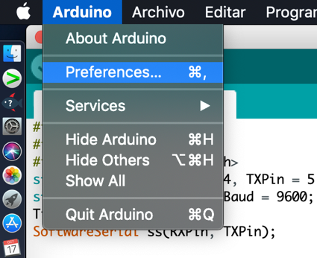



1. Restart Arduino IDE
2. Download additional board controller for Wemos:

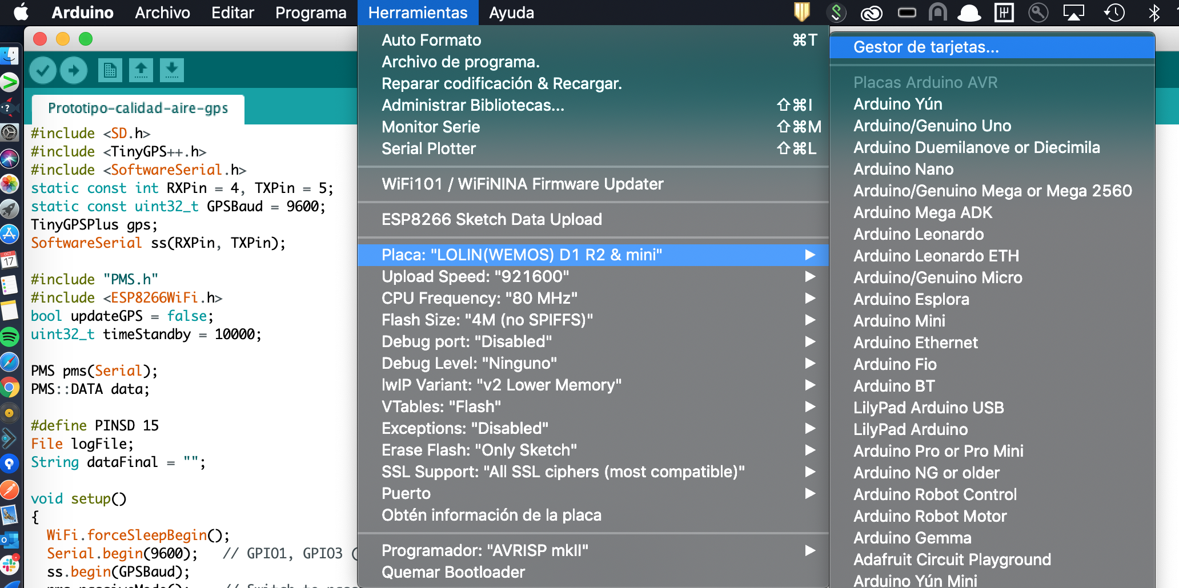

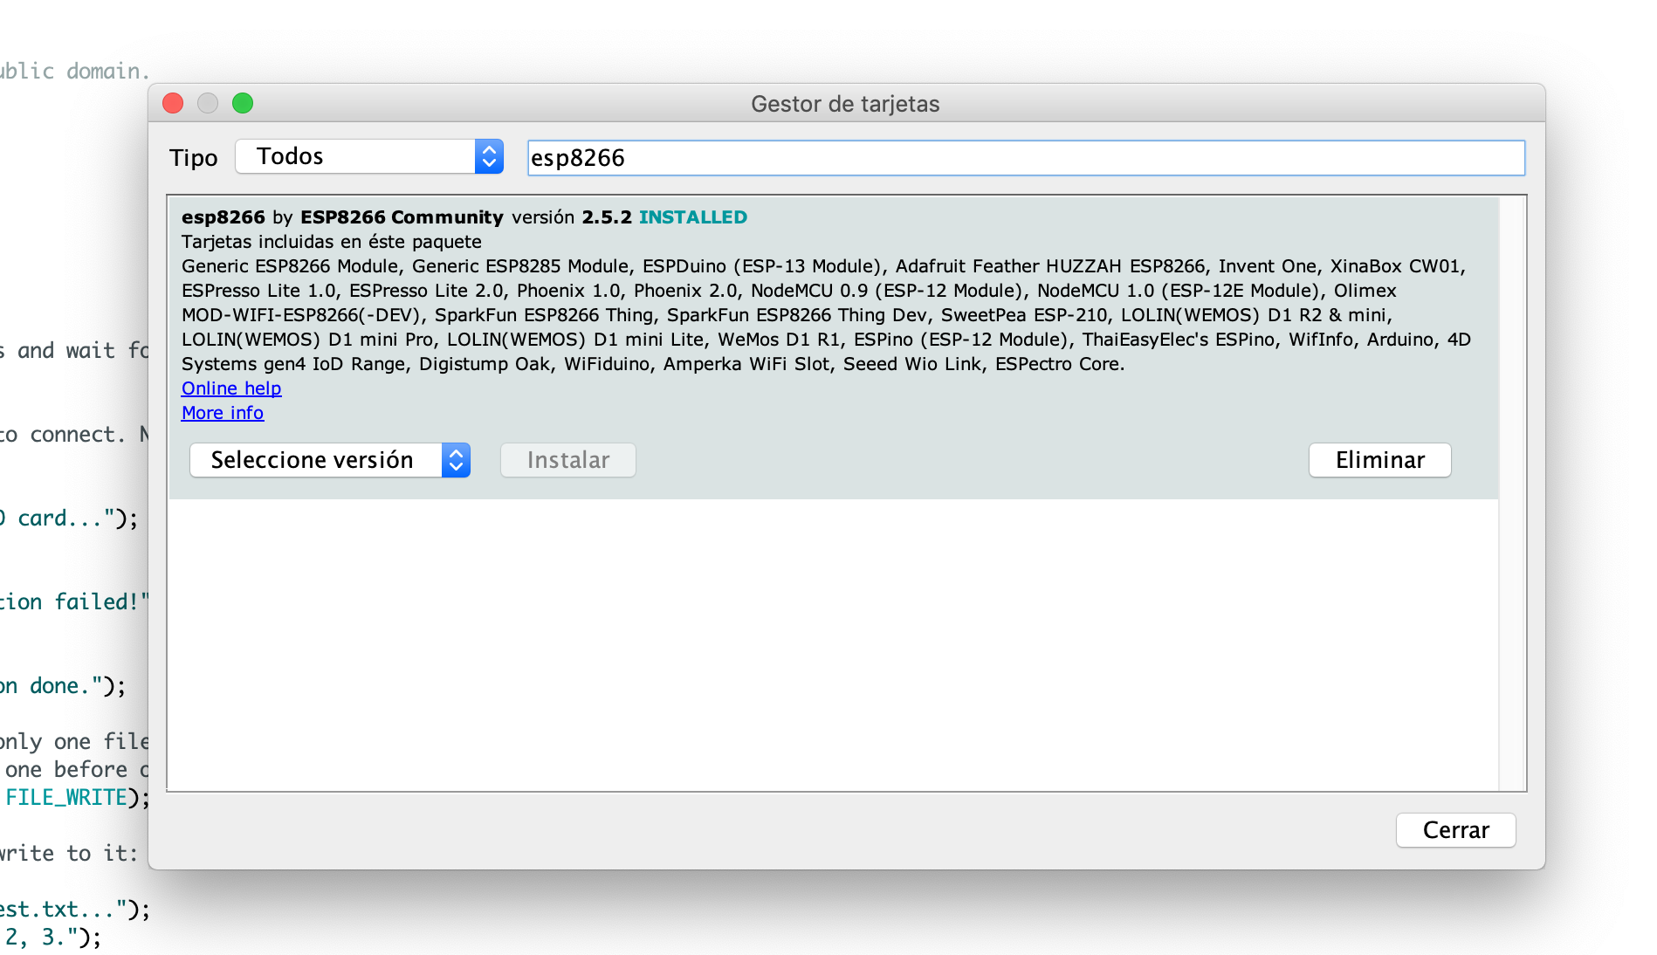

1. Restart Arduino IDE.
2. Add additional libraries for GPS and PMS sensor:

<https://github.com/mikalhart/TinyGPSPlus/releases/tag/v1.0.2b>

<https://github.com/fu-hsi/PMS>

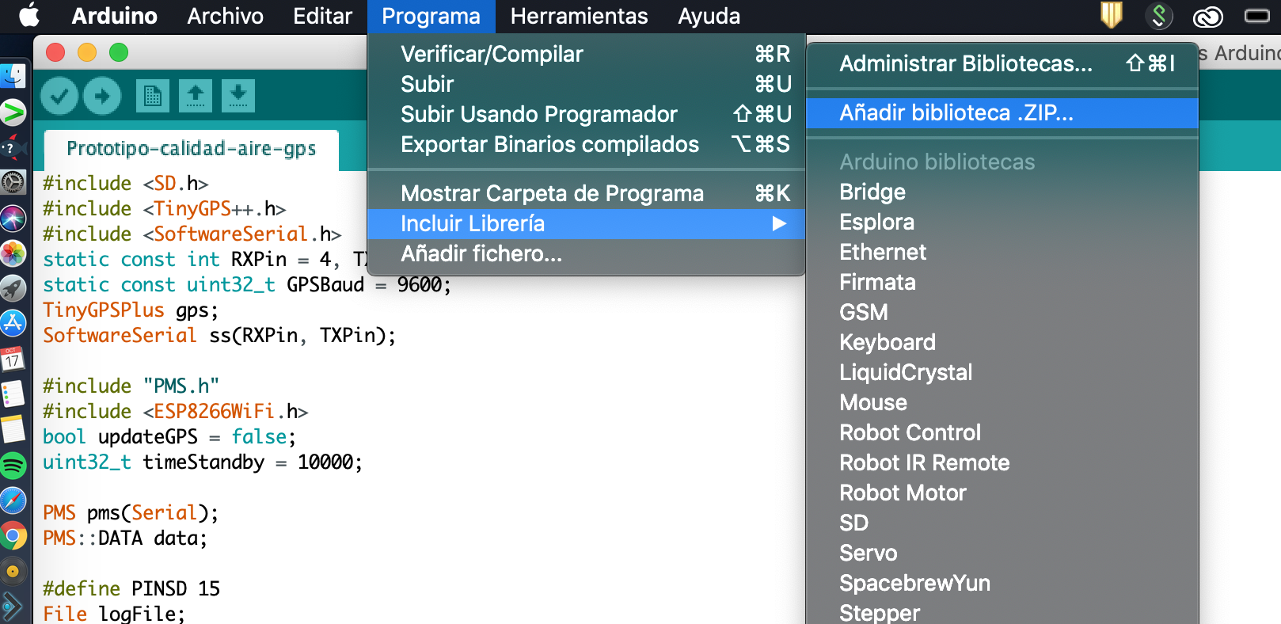

1. Once connected, it should appear in Tools/port the name of the board serial port:

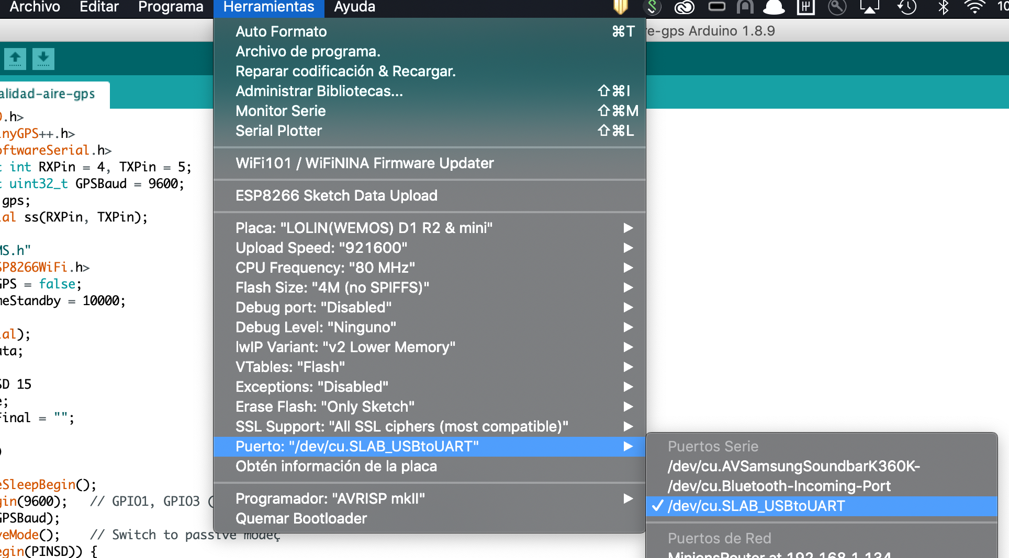

Top right there is a button to monitor serial port and check everything is correct.

