Multi-Turn AI Chatbot with LLaMA 3

Project Domain / Category
Artificial Intelligence / Natural Language Processing / Conversational AI

Functional Requirements:
PHASE 1: Chatbot System Development (Frontend + Backend Setup)

FR1: System Initialization
- The system shall initialize all core modules at startup:
  - LLaMA 3 local model loading
  - Backend server initialization
  - Database connection setup
  - Analytics module initialization

FR2: Frontend Chat Interface Development
- The system shall provide a web-based chat UI including:
  - Google OAuth login page
  - Chat interface (user input + response display)
  - Feedback panel (rating, correctness, length type)

FR3: Backend Server Development
- The system shall implement a backend using Flask/FastAPI.
- The backend shall handle:
  - User authentication
  - Session creation and management
  - Message routing to model
  - Data storage operations

FR4: LLaMA 3 Model Integration
- The system shall integrate LLaMA 3 as the core chatbot engine.
- The system shall process user queries locally through the model.

FR5: Service Connectivity
- The system shall connect:
  - Frontend UI
  - Backend API
  - LLaMA 3 model inference engine
  - Database
  - Analytics module
Phase 1 Work FLow Chart:
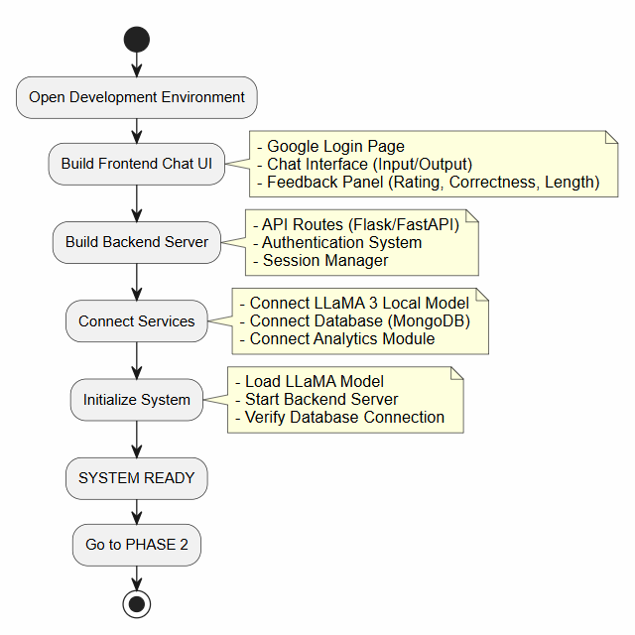
Tools:
- Python – Free and open-source programming language used for backend development, chatbot logic, and analytics.
- LLaMA 3 – Free/open-source large language model used as the core chatbot engine for generating responses locally.
- Flask / FastAPI – Free and open-source Python web frameworks used to build backend APIs and manage chatbot requests.
- HTML, CSS, JavaScript – Standard web technologies for building the chatbot user interface.
- MongoDB / Firebase – Free-tier cloud databases used for storing chat logs, sessions, and feedback data.
- pandas – Open-source Python library used for data processing and analytics.
- matplotlib / seaborn / plotly – Open-source libraries used for generating graphs and visual analytics.
- scikit-learn – Open-source machine learning library used for topic classification and analytics support.
- Ollama (optional) – Free tool used to run LLaMA 3 locally and serve it as an API.
- Google OAuth 2.0 – Free authentication system used for secure Gmail login integration.
- VS Code / Jupyter Notebook – Free development environments used for coding, testing, and experimentation.
Instructions to Submit:
1. Develop function requirement and make a part of project.
2. Submission on LMS:
1. Make a zip file of developed project and submit it on LMS.(if folder size exceeds then compress folder to reduce size)
3. This is not SRS so make sure you read above given functional requirements and develop a part of project inseated of making a word file of SRS.

Supervisor:
Name: Neelam Alam
Email ID: neelam.alam@vu.edu.pk
Skype ID: neelam-cs

