Semantifying CFIHOS Standard

Document Version | 0.1
Document Date | 04.02.2026

Contents
Introduction 3
Background 3
Capital Facilities Information Handover Specification (CFIHOS) 3
Ontologies and the Web Ontology Language (OWL) 3
Industrial Data Ontology (IDO) 4
Source Data: CFIHOS Excel Specification 4
Overview of the CFIHOS Excel Structure 4
Implicit Semantics and Modeling Limitations 5
Worksheets 5
Methodology 6
Equipment and tags 7
Units of measurements 9
Properties 10
Property groupings 12
Property picklist 13
Equipment properties 15
Disciplines 16
Document type 17
Discipline document type 18
Tag equipment relationship 19
Source standard 20
Tag or equipment standards 21
Document required per class 22
Jip33 info required spec 23
CFIHOS object equivalent mapping 23
RDL Master Object 24
IDO alignment 24

Introduction
This document describes the semantification process of the CFIHOS standard, in particular, its conversion to an OWL ontology.
The Capital Facilities Information Handover Specification (CFIHOS) is a widely adopted standard for the structured exchange of asset information in capital-intensive industries. While CFIHOS provides a comprehensive and well-defined information model, its primary distribution in spreadsheet form limits its ability to support machine reasoning, semantic interoperability, and automated integration with other industrial data standards.
This work addresses these limitations by transforming the CFIHOS specification into a formal OWL ontology and aligning it with the Industrial Data Ontology (IDO). The resulting ontology enables explicit semantics, reuse of shared industrial concepts, and integration within a broader semantic ecosystem.

Background

Capital Facilities Information Handover Specification (CFIHOS)
The Capital Facilities Information Handover Specification (CFIHOS) is an open, industry-driven standard developed to support the structured handover of information across the lifecycle of capital facilities. It is widely used in asset-intensive sectors such as oil and gas, energy, chemicals, and infrastructure, where consistent and reliable information exchange between engineering, procurement, construction, and operations stakeholders is critical.
CFIHOS defines a comprehensive information model covering asset types, attributes, documentation, and relationships required for effective asset information management. The standard promotes a common vocabulary and structure to reduce ambiguity, improve data quality, and facilitate interoperability between organizations and information systems. In practice, the CFIHOS specification is primarily delivered through a collection of spreadsheet-based templates, which formally describe classes, properties, allowed values, and constraints.
While this spreadsheet-based approach provides accessibility and ease of adoption, it also introduces limitations. The semantics of the information model are often implicit rather than formally defined, constraints are not machine-enforceable, and integration with other data models or standards requires significant manual interpretation. These limitations restrict the use of CFIHOS in automated data validation, reasoning, and semantic integration scenarios.

Ontologies and the Web Ontology Language (OWL)
Ontologies provide a formal and explicit specification of the concepts and relationships within a domain. In contrast to informal data models, ontologies enable machine-interpretable semantics, allowing software systems to perform reasoning, consistency checking, and advanced querying. Ontologies are particularly well suited for domains that require interoperability across heterogeneous systems and organizational boundaries.
The Web Ontology Language (OWL), standardized by the World Wide Web Consortium (W3C), is a widely adopted language for defining ontologies on the Semantic Web. OWL enables the representation of classes, properties, individuals, and constraints with well-defined logical semantics. By leveraging description logic foundations, OWL supports automated reasoning over domain models, enabling the detection of inconsistencies and the inference of implicit knowledge.
Representing industrial information standards such as CFIHOS in OWL allows the semantics of the model to be made explicit, unambiguous, and machine-actionable. This transformation facilitates integration with other ontology-based standards and provides a foundation for advanced use cases such as semantic validation, data integration, and knowledge-based analytics.

Industrial Data Ontology (IDO)
The Industrial Data Ontology (IDO) is a foundational ontology designed to support semantic interoperability across industrial domains. It provides a set of core concepts and patterns for representing physical assets, processes, properties, documents, and their relationships in a consistent and reusable manner. IDO is intended to act as a semantic backbone, enabling the alignment of domain-specific ontologies and data models within a shared conceptual framework.
IDO follows best practices in ontology engineering, emphasizing modularity, reuse, and alignment with upper-level ontologies where appropriate. By defining generic industrial concepts at an abstract level, IDO allows domain ontologies to specialize these concepts while maintaining semantic compatibility with other aligned models.
Aligning a domain-specific ontology derived from CFIHOS with IDO enables interoperability beyond the boundaries of the CFIHOS ecosystem. It allows asset information modeled according to CFIHOS to be integrated with other industrial datasets and ontologies, supporting cross-domain reasoning and data exchange. As a result, IDO compliance enhances the long-term usability, extensibility, and integration potential of the CFIHOS-derived ontology.

Source Data: CFIHOS Excel Specification

Overview of the CFIHOS Excel Structure
The CFIHOS Excel specification captures several categories of information relevant to capital facility asset data, including:
- Classes and object types, representing physical assets, systems, components, and other domain entities.
- Attributes and properties, describing characteristics such as identifiers, technical parameters, and descriptive metadata.
- Enumerations and code lists, defining controlled vocabularies and permissible values for certain attributes.
- Hierarchical relationships, such as type–subtype or parent–child structures between asset classes.
- Associations and references, linking assets to documents, systems, or other related entities.
Although these elements collectively form a coherent information model, their semantics are expressed primarily through naming conventions, textual descriptions, and implicit assumptions rather than formal logic.

Implicit Semantics and Modeling Limitations
While the Excel specification provides a detailed and well-organized description of the CFIHOS information model, several limitations were identified during analysis:
- Implicit semantics: Relationships between entities are often implied by column names or textual descriptions, without a formally defined meaning.
- Ambiguous cardinalities: Constraints such as optionality or multiplicity are not always explicitly or consistently specified.
- Lack of formal constraints: Business rules and domain restrictions cannot be automatically validated using the spreadsheet format alone.
- Limited extensibility: Extending or integrating the model with other standards requires manual interpretation and mapping.
These characteristics make the Excel specification suitable for human-guided data exchange but challenging to use directly for automated reasoning, semantic validation, or interoperability with other formal models.

Worksheets
Several worksheets define reference data that form the semantic backbone of the specification:
- RDL master object. This worksheet defines the primary object types recognized by CFIHOS. Each row corresponds to a conceptual object, providing identifiers, names, and descriptions. These objects represent high-level industrial concepts such as assets, tags, equipment classes, documents, and events.
In ontological terms, this sheet serves as the primary source for identifying candidate OWL classes.
- data dictionary. The data dictionary provides textual definitions and clarifications for concepts and attributes used throughout the specification. While not directly enforceable as constraints, these descriptions are essential for interpreting the intended semantics of classes and properties.
- CFIHOS object equivalent mapping. This worksheet captures equivalences or correspondences between CFIHOS objects and concepts from other standards or representations.
Properties and their values are represented by the following worksheets:
- property. This worksheet defines individual properties independently of the objects to which they apply. Each property includes an identifier, name, description, and reference to a data type or unit of measure. These entries naturally correspond to OWL datatype properties or object properties, depending on their intended use.
- property picklist values. Controlled vocabularies and enumerations are defined in this worksheet. Properties referencing picklists are constrained to predefined sets of values. In the ontology, these were interpreted as enumerations or value restrictions.
- unit of measure. Units of measure are defined as reference entities and linked to properties where applicable. This explicit modeling of units supports semantic clarity and interoperability, particularly when integrating with other industrial ontologies.
- property groupings. Properties are organized into logical groupings, reflecting conceptual cohesion rather than strict structural constraints. These groupings informed modularization and annotation strategies in the ontology.
Equipment and tags are defined in the following worksheets:
- equipment class. Defines standardized equipment classes used across projects. These classes represent abstract types rather than individual assets and serve as classification categories.
- equipment class property. Associates properties with equipment classes, specifying which attributes are applicable to which types of equipment. This indirection allows properties to be reused across multiple classes.
- tag class. Defines tag classifications, which represent labeled instances or identifiers used in engineering and operations contexts.
- tag class property. Specifies properties applicable to tag classes, analogous to equipment class property but scoped to tag semantics.
- tag equipment class relationship. Defines the relationships between tag classes and equipment classes, making explicit how tags correspond to classified equipment types.

The specification also includes extensive modeling of documentation and lifecycle context through the following spreadsheets:
- discipline. Defines engineering and organizational disciplines relevant to capital projects.
- document type. Enumerates standardized document categories used during engineering, construction, and operations.
- discipline document type. Establishes valid combinations of disciplines and document types, effectively encoding domain constraints.
- document required per class. Specifies documentation requirements associated with particular classes, supporting compliance and handover use cases.
- handover event. Represents lifecycle milestones at which information exchange is required. These events contextualize when specific data and documents must be provided.
Several worksheets support traceability to external standards and specifications:
- source standard. Identifies external standards referenced by CFIHOS, enabling provenance tracking.
- tag or equipment class source standard. Links classification elements to their originating standards.
- tag equipment class property source standard. Provides traceability between properties and their external standard definitions.
- JIP33 info required specification. Captures requirements derived from the JIP33 initiative, reinforcing the role of CFIHOS as an integrative standard.

Methodology
The following worksheets were considered for creating the OWL version of CFIHOS from the Excel file specification:
- equipment class
- tag class
- tag equipment class relationship
- property
- property picklist values
- equipment class property
- tag class property
- discipline
- document type
- discipline document type
- source standard
- tag or equip class src standard
- document required per class
- unit of measure
- property groupings
In general, each CFIHOS entity was created by using its CFIHOS code to generate an IRI identifying that entity. Tags and equipment entities share CFIHOS codes however, from an ontological point of view, a tag is not an equipment, thus a different namespace was used to differentiate tags and equipment although they have the same code.

Equipment and tags
Tags and equipment entities share CFIHOS codes however, from an ontological point of view, a tag is not an equipment, thus a different namespace was used to differentiate tags and equipment although they have the same code.
CFIHOS equipment was created as a hierarchy of OWL classes as they were defined in the corresponding Excel sheet. The name, the definition, and the synonyms of the corresponding equipment were included as annotations in the class through rdfs:label, iao:0000115, and skos:altLabel properties. The CFIHOS code, although already present in the IRI of the classes, was included as an annotation to the class as well. The next figure shows part of the hierarchy created, showing the names of the classes:
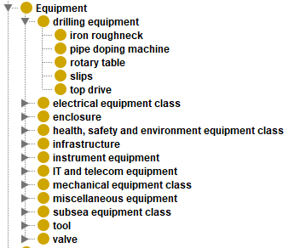
The next figure shows the class corresponding to the equipment “gas-blast circuit-breaker” as an example of the information contained in the class:
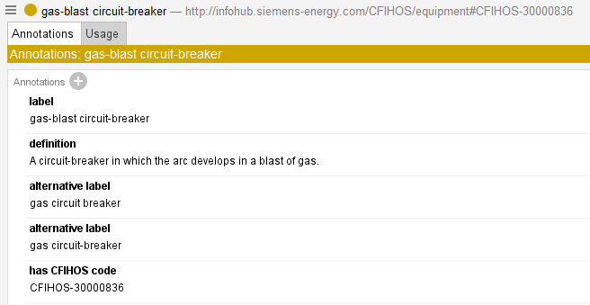
CFIHOS tags were created similarly to equipment since the corresponding excel sheets are similar:
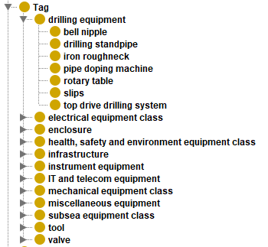
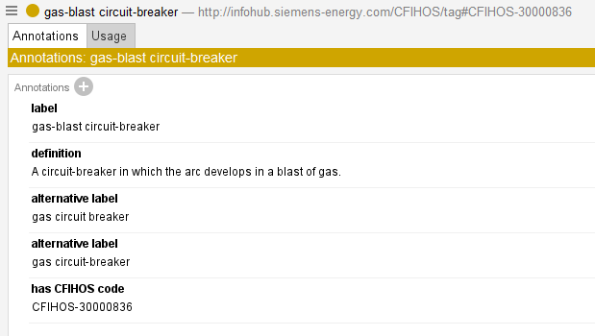

Units of measurements
Units of measurements were created by using the information from the worksheet “unit of measure”. This sheet contains:
- CFIHOS code
- Unit name
- Unit symbol
- CFIHOS code of the dimension related with the unit of measurement
- Dimension code
- Dimension name
- CFIHOS code of the measurement system related to the unit of measurement
- Measurement system code
- Possible synonyms for the unit of measurement
Thus, from this information, the following type of ontology entities were created and linked:
- Unit of measurement
- Dimension
- Measurement system
In particular, a class representing units of measurement was created by using de CFIHOS code CFIHOS-00000073 (unit of measure) and, analougsly, a class representing dimensions was createdby using the CFIHOS code CFIHOS-00000072 (unit of measure dimension). Then both units and dimensions were created as instances of the corresponding class. Measurement systems were created as instances of http://infohub.siemens-energy.com/CFIHOS#CFIHOS-50000120, which is the CFIHOS class representing this kind of entities. Additionally, classes representing the imperial system and the international system units were created to classify the units of measurements.
Finally, the unit of measurements are classified in imperial or international system:
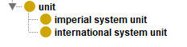
Next figure depicts an example of the “cubic metre” unit of measurement.
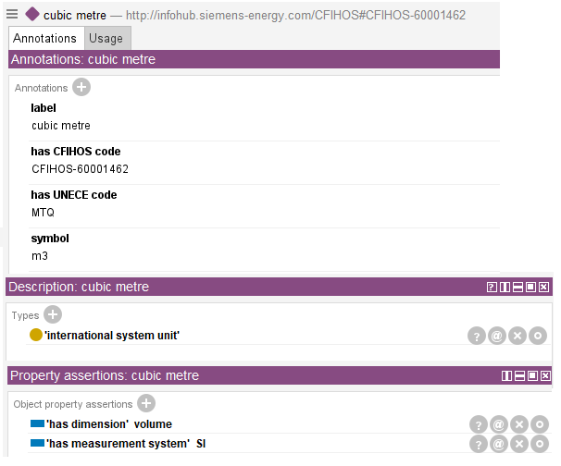

Properties
We used the following data from the worksheet “property”:
- CFIHOS code of the property
- Name of the property
- Definition of the property
- Data type related to the property (number, text)
- Dimension measured with the property
- Picklist for the property
From this, owl entities were created for properties and picklists.
All CFIHOS properties were modelled as sub object properties of property (CFIHOS-00000029) and were classified as qualitative (CFIHOS-00000071) and quantitative properties (CFIHOS-00000070):
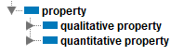
The rationale to classify properties were the following:
- If the property has a picklist assigned, the property is classified as qualitative
- If the property has a dimension assigned, the property is classified as quantitative
- If the property does not have picklist nor dimension
  - If the data type is “number”, the property is classified as quantitative
  - If the data type is not “number”, the property is classified as qualitative
The ranges of quantitative properties were defined as a measure that has a unit of the corresponding dimension. For example, the property “actual length” is shown in the following picture:
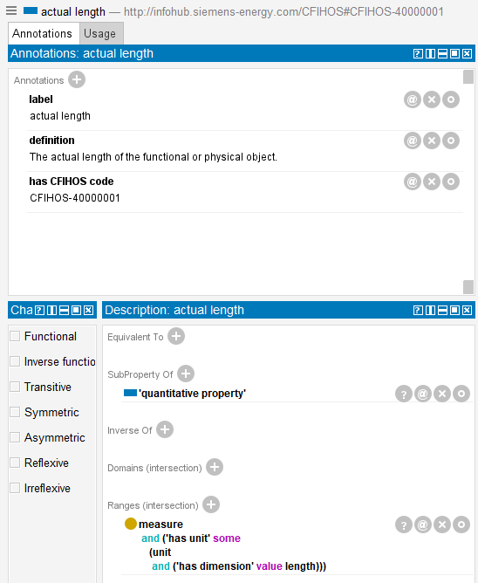
For their part, the ranges of qualitative properties are set by the corresponding picklist, as depicted in the following figure that shows the property “actuator seal material”:
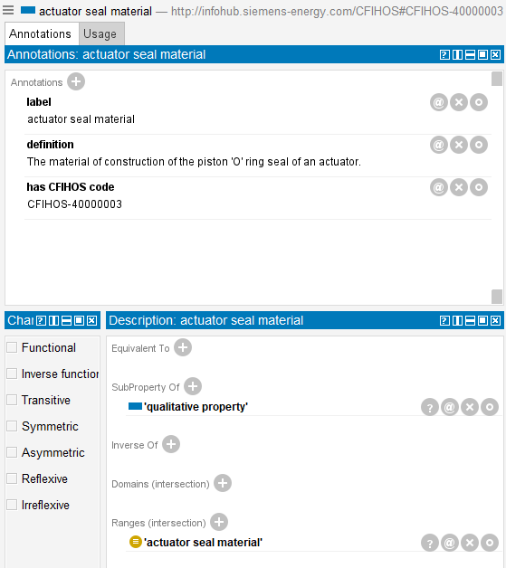

Property groupings
The following data from the worksheet “property groupings” were considered:
- CFIHOS code of the property group
- Code of the property group
- Description of the property group
- CFIHOS code of the property
Property groups were created as OWL classes in the ontology as subclasses of CFIHOS-00000141 (property group):
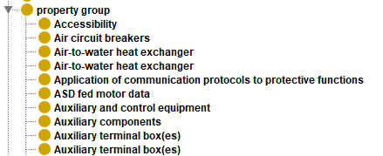
Then, properties were annotated with the corresponding group through schema:category, as depicted in the following figure that describes the property “accelerometers requirements”, which belongs to the category “instrumentation”:
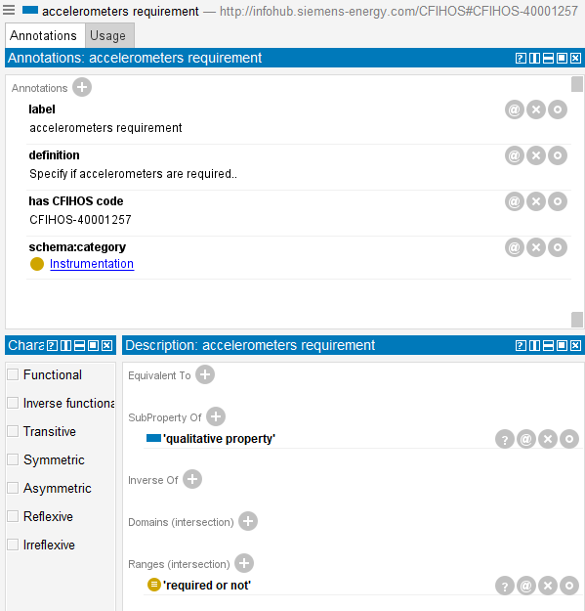

Property picklist
Property picklist is an enumeration of valid elements for that property.
The worksheet “property picklist values” contains the following data:
- CFIHOS code of the picklist
- Name of the picklist
- CFIHOS codes of the values belonging to the picklist
- Codes of the values belonging to the picklist
- Definition of the values belonging to the picklist
- Standard related to the picklist
Here, each picklist was modelled as an OWL class, subclass of property picklist (CFIHOS-00000019), and each value belonging to that picklist was modelled as an instance of the corresponding picklist class. Then, the class is set as equivalent to the list of individuals belonging to that class, which is the OWL pattern to define enumerations, as depicted in the following figure for the picklist “actuator seal material”:
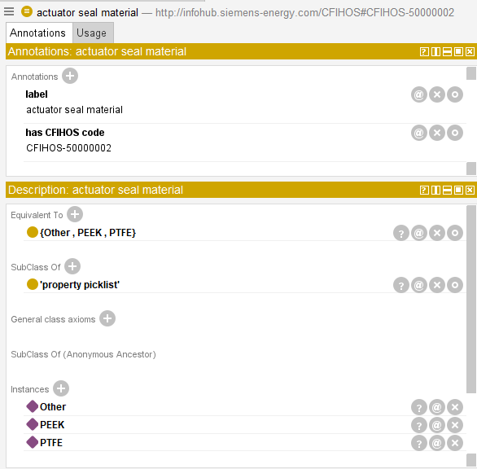

The standards were also linked to the corresponding picklist class through the annotation http://infohub.siemens-energy.com/CFIHOS#hasSourceStandard :
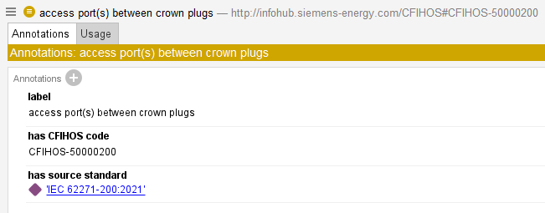

Equipment properties
The worksheet “equipment class property” relates equipment with properties. These relationships were included as subclass of axioms for the corresponding equipment class. For example, the qualitative property “ATEX category” is related with the equipment class “air circuit-breaker”, thus an axiom indicating that air circuit-breaker is subclass of {“ATEX category” some “ATEX category picklist.”}. In case of quantitative properties, the subclass of axiom considers the measure, its unit and its dimension. Next figure shows some subclass of definitions for the equipment “air circuit-breaker”:
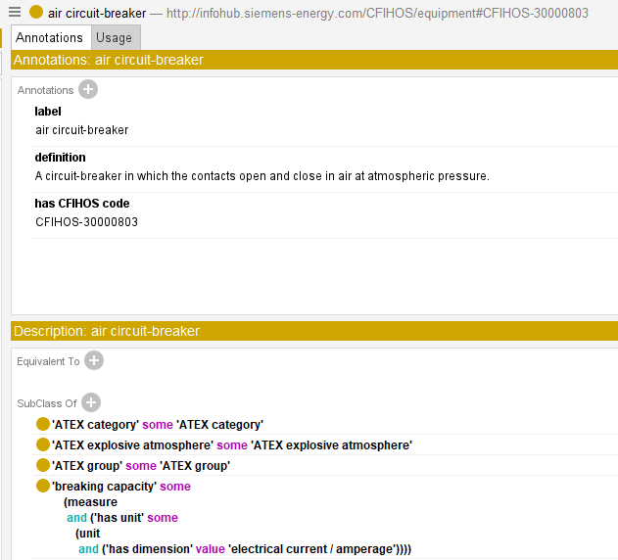

Disciplines
The Excel worksheet “discipline” contains:
- CFIHOS code for the discipline
- Code of the discipline
- Name of the discipline
- Description of the discipline
Disciplines were modelled as OWL classes, creating under the parent class http://infohub.siemens-energy.com/CFIHOS#CFIHOS-00000021 (discipline):
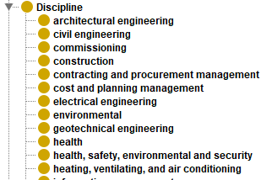
An example of discipline is
“architectural engineering”, depicted next:

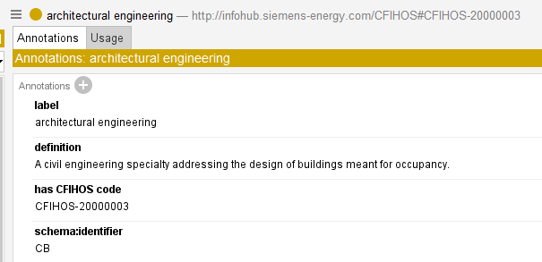

Document type
The following data from the worksheet “document type” were used:
- CFIHOS code of the document type
- Short code of the document type
- Name of the document type
- Description of the document type
- Synonyms for the document type
The document types were created as OWL classes, subclasses of the classhttp://infohub.siemens-energy.com/CFIHOS#CFIHOS-00000032 (document type), as depicted in the figure below:
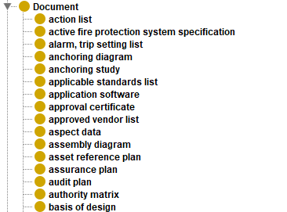
Each document class was annotated with the name, definition, synonyms, CFIHOS code and short code. An example of the document type “action list” is showed next:
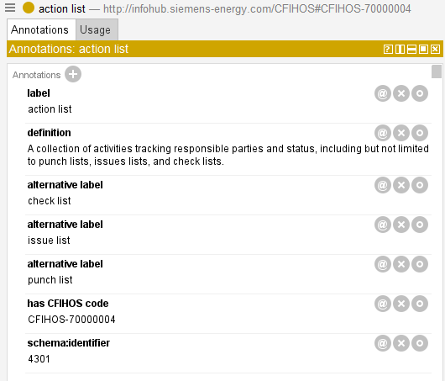

Discipline document type
The Excel worksheet “discipline document type” relates disciplines with document types and includes the following data:
- Asset type
- Representation type
- Discipline document CFIHOS code
- Discipline document type short code
This relationship between document types and disciplines could be related by adding axioms to the existing entities. Nonetheless, since in CFIHOS the entity discipline document type exists and it has its own CFIHOS identifier, we have decided to create dedicated classes to stablish these relationships.
Each discipline document type class is a subclass of http://infohub.siemens-energy.com/CFIHOS#CFIHOS-00000027 (discipline document type), and it is related to a discipline and to a document type through subclass of axioms, and it is annotated with the asset type reference, the CFIHOS code, the representation type, and the code. Next an example is depicted:
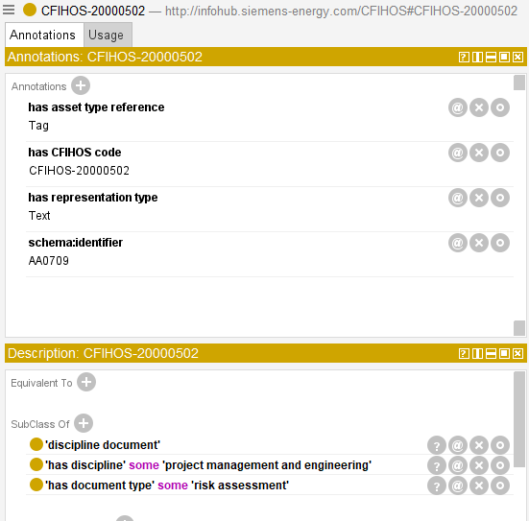

Tag equipment relationship
The worksheet “tag equipment class relationship” contains the relationships between tags and equipment. This relationship was modelled by using the object property http://infohub.siemens-energy.com/CFIHOS#hasTag, which links an equipment with a tag in subclass of axioms. Next, the equipment “drilling equipment” is showed as an example:
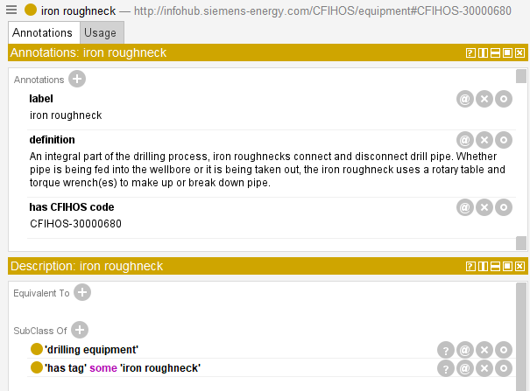

Source standard
The worksheet “source standard” contains:
- CFIHOS code for the standard
- Textual code of the standard
- Description of the standard
Standards have been modelled as instances of the type http://infohub.siemens-energy.com/CFIHOS#CFIHOS-00000061 (source standard), and they have been annotated with name, definition, and CFIHOS code. The next figure shows the standard “AC 150/5345-27E:2013” as an example:
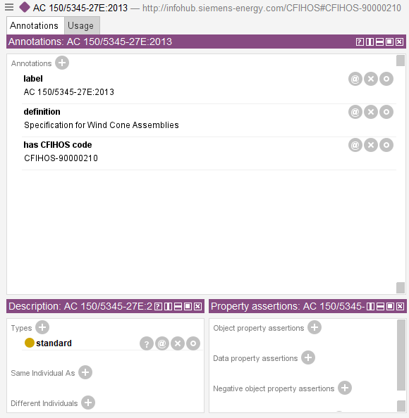

Tag or equipment standards
The Excel worksheet “tag or equip class src standard” defines relationships between tags or equipment and standards. These relationships have been modelled by annotating the corresponding equipment with the associated standard through the annotation property http://infohub.siemens-energy.com/CFIHOS#hasSourceStandard. Next, the equipment “battery back-up power supply unit” is shown as an example:
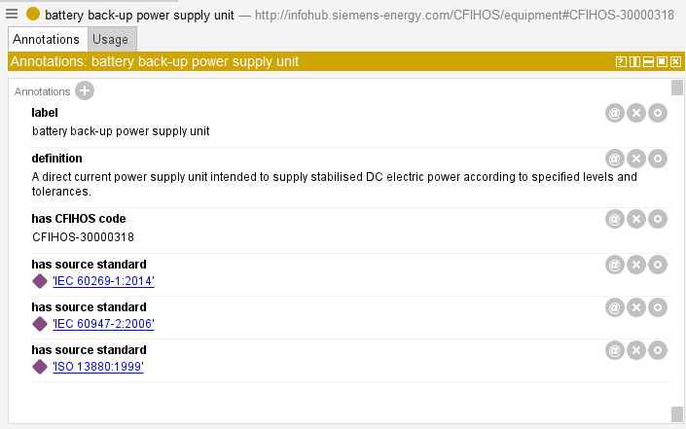

Document required per class
The worksheet “document required per class” relates documents to tags or equipment. This relationship is modelled as an entity called “Source standard document and data requirement CFIHOS unique code” in CFIHOS. Therefore, we have maintained this decision in the OWL version. The worksheet contains the following data:
- CFIHOS identifier for the entity “Source standard document and data requirement”
- CFIHOS code of the tag or equipment class.
- CFIHOS code of the source standard.
- CFIHOS code of the document type.
Each entity of “document required per class” has been translated into an OWL class, subclass of http://infohub.siemens-energy.com/CFIHOS#CFIHOS-00000132 (source standard document and data requirement), where the source standard has been attached through the property http://infohub.siemens-energy.com/CFIHOS#hasSourceStandard, and the document type, equipment, and tag have been included in the class definition using the corresponding subclass of axioms. For this, the object properties http://infohub.siemens-energy.com/CFIHOS#hasDocumentType, http://infohub.siemens-energy.com/CFIHOS#hasEquipment, http://infohub.siemens-energy.com/CFIHOS#hasTag were used. Next, an example is shown:
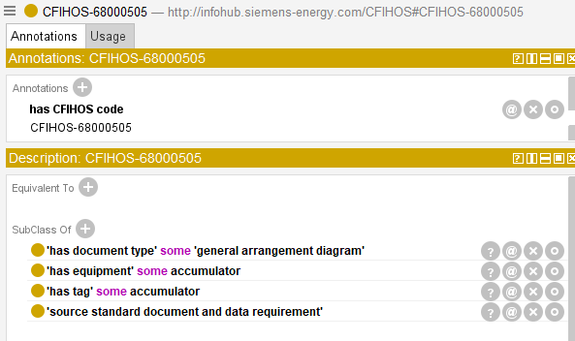

Jip33 info required spec
This worksheet is similar to “document required per class” since it contains a CFIHOS code representing “Source standard document and data requirement”, and it links tags, source standards, and document types. The data here has been treated as the data in “document required per class”, generating subclasses of http://infohub.siemens-energy.com/CFIHOS#CFIHOS-00000132 (source standard document and data requirement) that links all this information.

CFIHOS object equivalent mapping
This worksheet contains equivalences between CFIHOS codes and other standards. It contains the following columns:
- CFIHOS unique code: the CFIHOS code of the source entity (e.g. CFIHOS-20000001)
- Coding source code: the corresponding standard (e.g. posc caesar)
- CFIHOS code equivalent value: the equivalent code in the corresponding standard (e.g. RDS2227295).
Here, the CFIHOS entities were annotated with the equivalent code in the external standard through the annotation property http://infohub.siemens-energy.com/CFIHOS#CFIHOS-00000052 (CFIHOS object equivalent mapping). Then, this annotation was also annotated with the corresponding standard.
For example, next is shown the equipment “accumulator”, which are linked to 3 external standards:
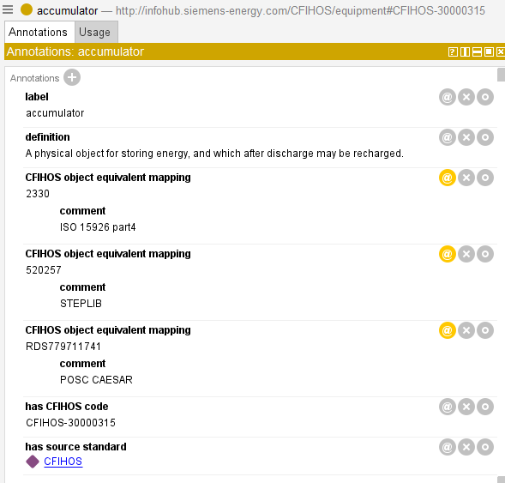

RDL Master Object
The worksheet entitled “RDL Master Object” contains, for each CFIHOS existing code, its name, its description, and its definition file. Since names and descriptions are usually included in the other sheets as well, we used this worksheet to include the name and the description of entities that do not contain them yet.

IDO alignment
The following direct alignments were proposed between the generated CFIHOS ontology and IDO:
CFIHOS Entity | IDO integration
Equipment  http://infohub.siemens-energy.com/CFIHOS/equipment#CFIHOS-30000311 | Subclass of physical artefact  Subclass of inanimate physical object
Tag  http://infohub.siemens-energy.com/CFIHOS/tag#CFIHOS-30000311 | Subclass of functional object
Document type  http://infohub.siemens-energy.com/CFIHOS#CFIHOS-00000032 | Subclass of information object
Discipline document type  http://infohub.siemens-energy.com/CFIHOS#CFIHOS-00000027 | Subclass of information object
Source Standard  http://infohub.siemens-energy.com/CFIHOS#CFIHOS-00000061 | Subclass of information object
Property Picklist  http://infohub.siemens-energy.com/CFIHOS#CFIHOS-00000019 | Subclass of information object
Source Standard Document And Data Requirement  http://infohub.siemens-energy.com/CFIHOS#CFIHOS-00000132 | Subclass of information object
Discipline  http://infohub.siemens-energy.com/CFIHOS#CFIHOS-00000021 | Subclass of Role
Unit of measure  http://infohub.siemens-energy.com/CFIHOS#CFIHOS-00000073 | Subclass of information object  Equivalent to Unit Of Measure
Unit of Measure Dimension  http://infohub.siemens-energy.com/CFIHOS#CFIHOS-00000072 | Subclass of information object
Measure  http://www.ontology-of-units-of-measure.org/resource/om-2/Measure | Equivalent to scalar quantity datum
Has unit  http://www.ontology-of-units-of-measure.org/resource/om-2/hasUnit | Equivalent to datumUOM
Has Numerical Value  http://www.ontology-of-units-of-measure.org/resource/om-2/hasNumericalValue | Equivalent to datumValue
In the case of CFIHOS properties, they should be modelled as subclasses of IDO quality. For each property, a quality was created by concatenating the string “Quality” to the IRI of the corresponding property, and all new quality classes created were annotated with the source object property they were derived. Quantitative properties were translated into subclasses of physical quantity, whereas the qualitative ones were translated into subclasses of quality. Then, subclass of axioms included in tag classes that make use of properties were translated into the IDO form. For example, the following axiom involving a qualitative property:
Was translated into:
Where the latest “explosion protection zone” is a quality defined as depicted next:
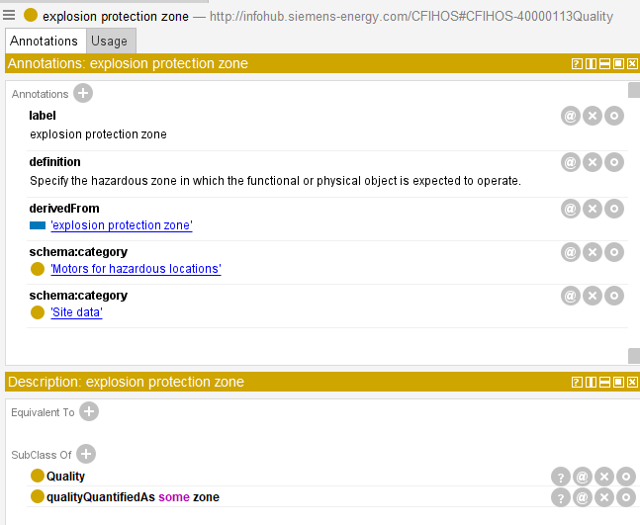
The first axiom was also annotated with the conversion performed
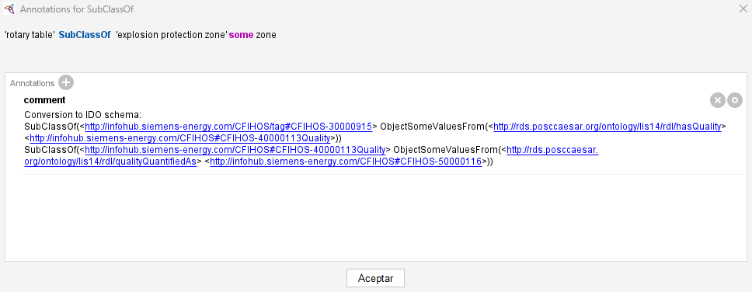
In case of quantitative properties, the axioms of type
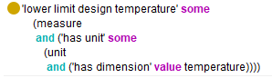
Were translated into
Where “lower limit design temperature” is defined as follows:
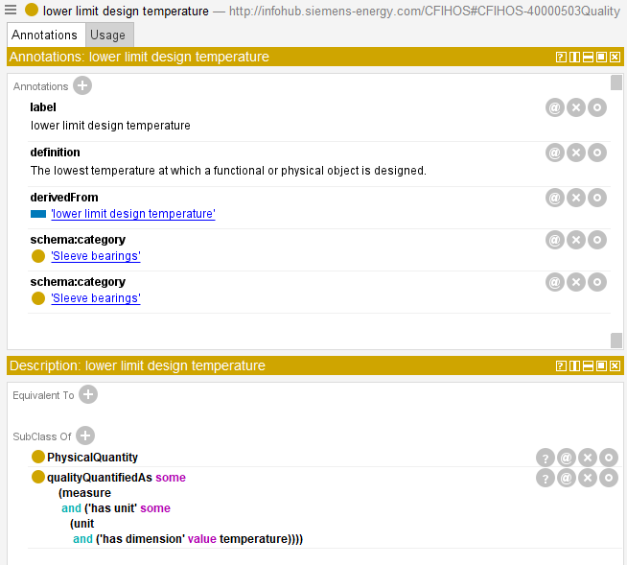
The original axiom is annotated with the conversion:
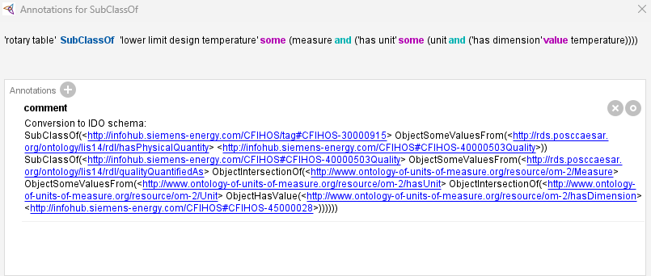
The ontology aligning CFIHOS and IDO provides both mechanisms to define data.

Examples
Here we provide several examples. Each one can be modelled by using quality classes, or use object properties as a shortcut as defined in the IDO alignment section.

Example 1: power cable 1 has a length of 30 meters
This example describes how to represent a power cable that has a length of 30 meters, which makes use of the quantitative property “length”. The first option is to use an object property representing the length, which is already present in CFIHOS. Next, the example is depicted as a graph, where ontology classes are represented as blue ellipses, instances are represented as purple ellipses, and primitive types are represented in green rectangles:

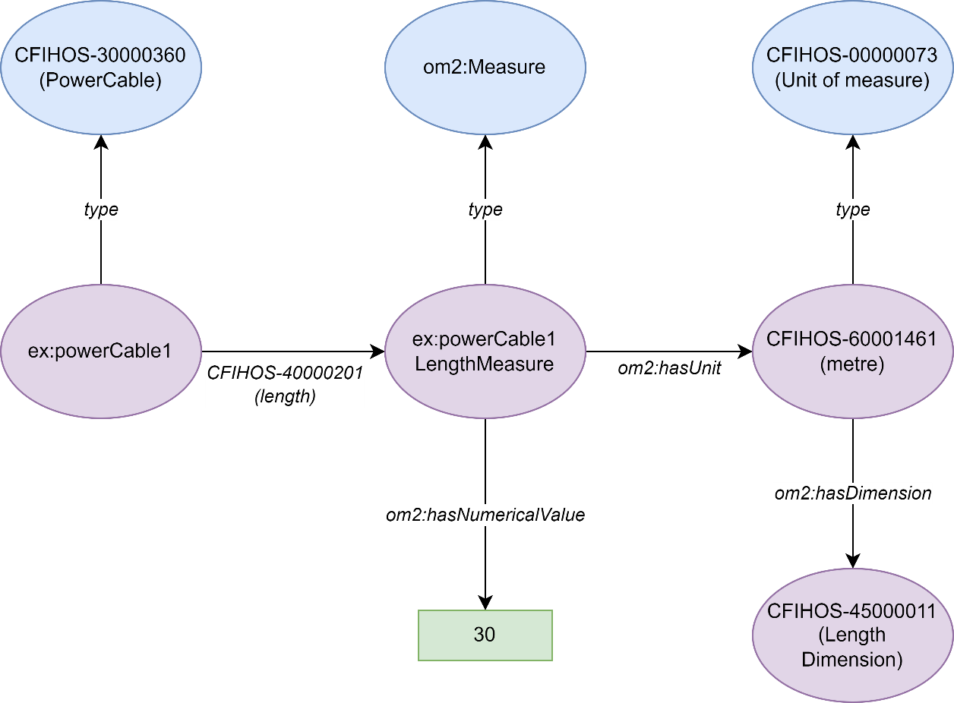
This example can also be modelled by using qualities classes representing properties instead of using object properties, being compliant with the IDO patterns. The resulting modelling is described in the following figure:
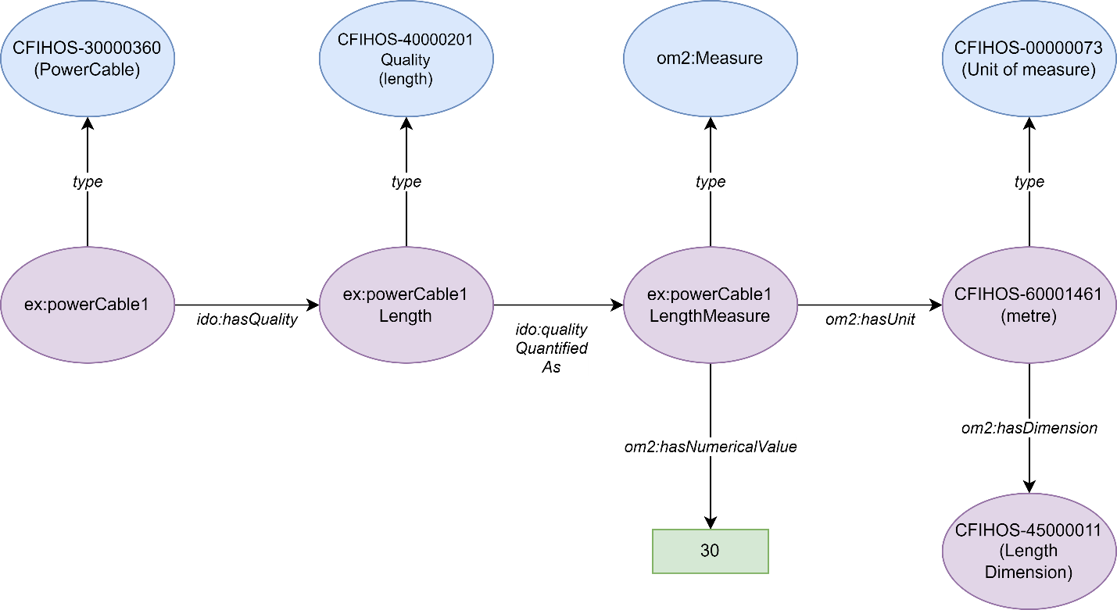

Example 2: power cable 1 has an explosion protection temperature class of T1
This example describes how to model a power cable that has an explosion protection temperature class of T1, which makes use of the qualitative property “explosion protection temperature class”, whose possible values are defined in the corresponding picklist. The next figure shows how to model this scenario by using an object property:
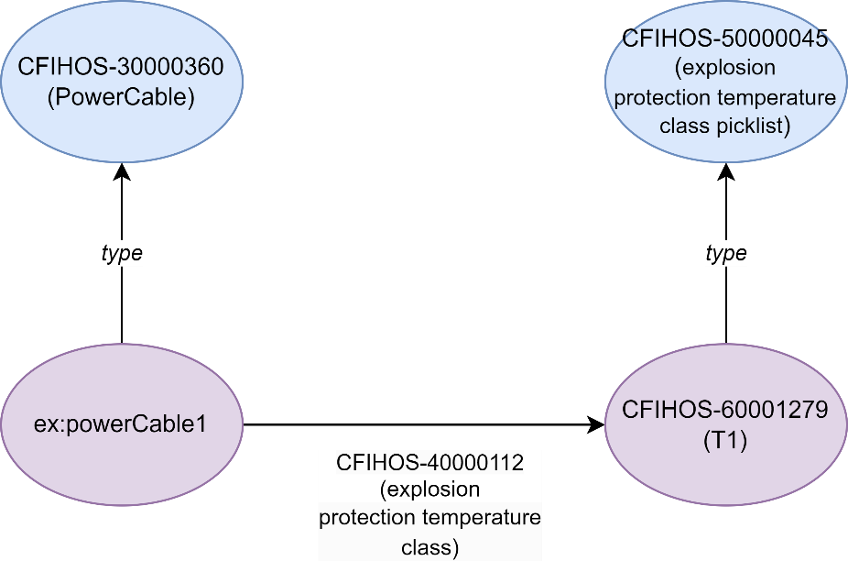
The following figure shows the same information modelled according to the IDO patterns by using quality classes:
