CQ1: How many classes does it have?

Response: 4960

SPARQL query:

PREFIX rdf: <http://www.w3.org/1999/02/22-rdf-syntax-ns#>
PREFIX owl: <http://www.w3.org/2002/07/owl#>
SELECT (count(distinct ?class) as ?classCount) WHERE {
?class rdf:type owl:Class .
}
CQ2: How many properties does it have?

Response: 1400

SPARQL query:

PREFIX rdf: <http://www.w3.org/1999/02/22-rdf-syntax-ns#>
PREFIX owl: <http://www.w3.org/2002/07/owl#>
SELECT (count(distinct ?property) AS ?propertyCount) WHERE {
{
SELECT ?property WHERE {
?property rdf:type owl:ObjectProperty
}
}
UNION
{
SELECT ?property WHERE {
?property rdf:type owl:DatatypeProperty
}
}
UNION
{
SELECT ?property WHERE {
?property rdf:type owl:AnnotationProperty
}
}
}

CQ3: What are the instances of class “discipline”) covered by CFIHOS? List them with their codes.

Response:
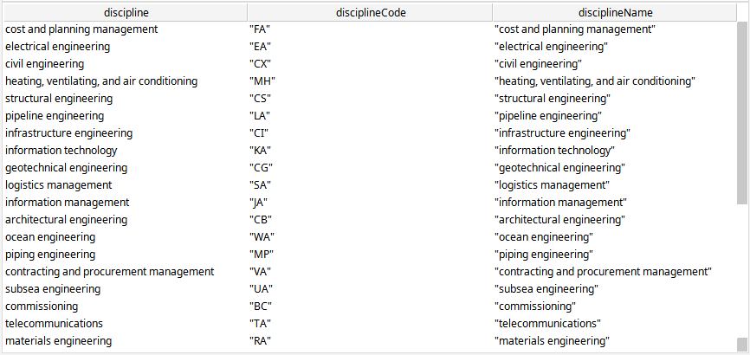

SPARQL query:

PREFIX rdf: <http://www.w3.org/1999/02/22-rdf-syntax-ns#>
PREFIX rdfs: <http://www.w3.org/2000/01/rdf-schema#>
PREFIX owl: <http://www.w3.org/2002/07/owl#>
PREFIX cfihos: <http://infohub.siemens-energy.com/CFIHOS#>
PREFIX schema: <http://schema.org/>
SELECT * WHERE {
?discipline rdfs:subClassOf cfihos:CFIHOS-00000021 .
?discipline schema:identifier ?disciplineCode .
?discipline rdfs:label ?disciplineName .
}

CQ4: What are the properties of class “discipline document type”?

Response:
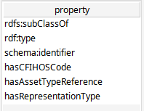

SPARQL query:

PREFIX rdfs: <http://www.w3.org/2000/01/rdf-schema#>
PREFIX cfihos: <http://infohub.siemens-energy.com/CFIHOS#>
SELECT distinct ?property WHERE {
?disciplineDocument rdfs:subClassOf cfihos:CFIHOS-00000027 .
?disciplineDocument ?property ?value .
}

CQ5: How many “tag or equipment class” instances apply to tags only? Please count only active (not TERMINATED) instances.

NOTE:
In the ontology model, tags and equipments are different things with different identifiers; however, in CFIHOS tags and equipments can be the same thing with the same identifier. These queries against the ontology are being solved by checking the CFIHOS code instead of using the identifiers of equipments and tags since they differ This is applicable to CQ5, CQ6 and CQ7.

Response: 30

SPARQL query:

PREFIX rdf: <http://www.w3.org/1999/02/22-rdf-syntax-ns#>
PREFIX owl: <http://www.w3.org/2002/07/owl#>
PREFIX rdfs: <http://www.w3.org/2000/01/rdf-schema#>
PREFIX cfihos: <http://infohub.siemens-energy.com/CFIHOS#>
PREFIX equipment: <http://infohub.siemens-energy.com/CFIHOS/equipment#>
PREFIX tag: <http://infohub.siemens-energy.com/CFIHOS/tag#>
SELECT (count (distinct ?tag) as ?uniqueTagCount) WHERE {
?tag rdfs:subClassOf* tag:CFIHOS-30000311 .
?tag cfihos:hasCFIHOSCode ?tagCode .
FILTER NOT EXISTS {
?equipment rdfs:subClassOf* equipment:CFIHOS-30000311 .
?equipment cfihos:hasCFIHOSCode ?tagCode .
}
}

CQ6: How many “tag or equipment class” instances apply to equipment only? Please count only active (not TERMINATED) instances.

Response: 14

SPARQL query:

PREFIX rdf: <http://www.w3.org/1999/02/22-rdf-syntax-ns#>
PREFIX owl: <http://www.w3.org/2002/07/owl#>
PREFIX rdfs: <http://www.w3.org/2000/01/rdf-schema#>
PREFIX cfihos: <http://infohub.siemens-energy.com/CFIHOS#>
PREFIX equipment: <http://infohub.siemens-energy.com/CFIHOS/equipment#>
PREFIX tag: <http://infohub.siemens-energy.com/CFIHOS/tag#>
SELECT (count (distinct ?equipment) as ?uniqueEquipmentCount) WHERE {
?equipment rdfs:subClassOf* equipment:CFIHOS-30000311 .
?equipment cfihos:hasCFIHOSCode ?equipmentCode .
FILTER NOT EXISTS {
?tag rdfs:subClassOf* tag:CFIHOS-30000311 .
?tag cfihos:hasCFIHOSCode ?equipmentCode .
}
}

CQ7: How many “tag or equipment class” instances apply to both tags and equipment? Please count only active (not TERMINATED) instances.

Response: 818

SPARQL query:

PREFIX rdf: <http://www.w3.org/1999/02/22-rdf-syntax-ns#>
PREFIX owl: <http://www.w3.org/2002/07/owl#>
PREFIX rdfs: <http://www.w3.org/2000/01/rdf-schema#>
PREFIX xsd: <http://www.w3.org/2001/XMLSchema#>
PREFIX cfihos: <http://infohub.siemens-energy.com/CFIHOS#>
PREFIX equipment: <http://infohub.siemens-energy.com/CFIHOS/equipment#>
PREFIX tag: <http://infohub.siemens-energy.com/CFIHOS/tag#>
SELECT (count (distinct ?tag) as ?uniqueTagCount) WHERE {
?tag rdfs:subClassOf* tag:CFIHOS-30000311 .
?tag cfihos:hasCFIHOSCode ?tagCode .
FILTER EXISTS {
?equipment rdfs:subClassOf* equipment:CFIHOS-30000311 .
?equipment cfihos:hasCFIHOSCode ?tagCode .
}
}

CQ8: List of entities (classes) with count of number of instances

Response:
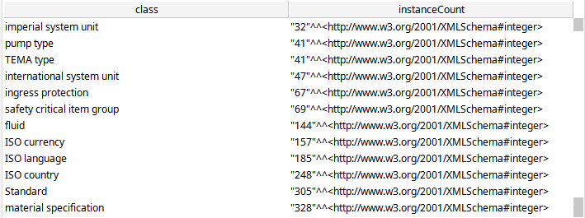

SPARQL query:

PREFIX rdf: <http://www.w3.org/1999/02/22-rdf-syntax-ns#>
PREFIX owl: <http://www.w3.org/2002/07/owl#>
SELECT ?class (count(distinct ?instance) as ?instanceCount) WHERE {
?class rdf:type owl:Class .
?instance rdf:type ?class .
} group by ?class

NOTE:
The ontology modelling is based on classes and subclasses. The unique instances included are units of measurement, standards, and property picklists. If the goal of this CQ is to know how many documents, equipments, tags, and disciplines are present in the ontology, the query would be class-oriented, as follows:

Response:

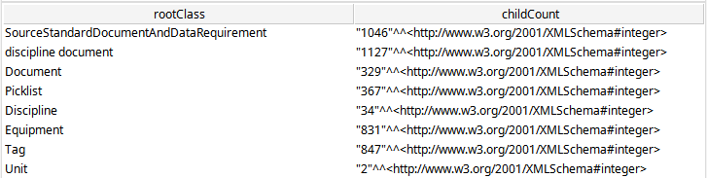

SPARQL query:

PREFIX rdf: <http://www.w3.org/1999/02/22-rdf-syntax-ns#>
PREFIX owl: <http://www.w3.org/2002/07/owl#>
PREFIX rdfs: <http://www.w3.org/2000/01/rdf-schema#>
SELECT ?rootClass (count (distinct ?class) as ?childCount) WHERE {
?rootClass rdf:type owl:Class .
FILTER NOT EXISTS {
?rootClass rdfs:subClassOf ?parentClass .
}
?class rdfs:subClassOf+ ?rootClass .
} groupBy ?rootClass

CQ9: Which entities are free-standing (have own PK) and which are associative?
NOTE:
If PK means primary key here, this competency question should be answered against a relational model. Models based on ontologies do not work with primary keys.

CQ10: What are the name and definition of the property CFIHOS-40000002?
Response:

SPARQL query:
PREFIX rdf: <http://www.w3.org/1999/02/22-rdf-syntax-ns#>
PREFIX owl: <http://www.w3.org/2002/07/owl#>
PREFIX rdfs: <http://www.w3.org/2000/01/rdf-schema#>
PREFIX iao: <http://purl.obolibrary.org/obo/IAO_>
PREFIX cfihos: <http://infohub.siemens-energy.com/CFIHOS#>
SELECT * WHERE {
cfihos:CFIHOS-40000002 rdfs:label ?name .
cfihos:CFIHOS-40000002 iao:0000115 ?definition .
}

CQ11: What are the possible values for the property CFIHOS-40000002?
Response:
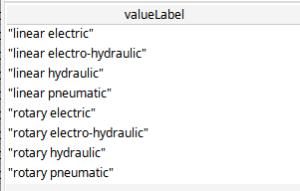

SPARQL query:
PREFIX rdf: <http://www.w3.org/1999/02/22-rdf-syntax-ns#>
PREFIX owl: <http://www.w3.org/2002/07/owl#>
PREFIX rdfs: <http://www.w3.org/2000/01/rdf-schema#>
PREFIX cfihos: <http://infohub.siemens-energy.com/CFIHOS#>
SELECT ?valueLabel WHERE {
cfihos:CFIHOS-40000002 rdfs:range ?range .
?range owl:equivalentClass [
owl:oneOf ?valueList
] .
?valueList rdf:rest*/rdf:first ?item .
?item rdfs:label ?valueLabel .
}

CQ12: What are the codes, the names and the possible values for all the properties
Response:
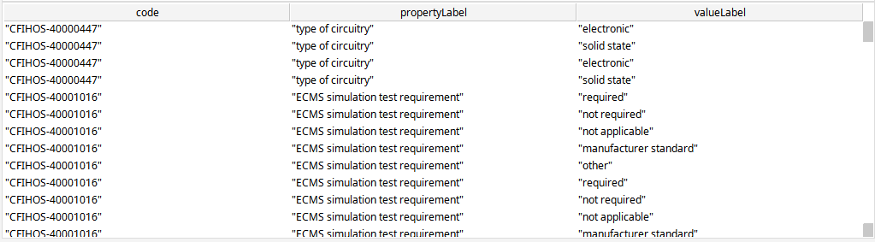

SPARQL query:
PREFIX rdf: <http://www.w3.org/1999/02/22-rdf-syntax-ns#>
PREFIX owl: <http://www.w3.org/2002/07/owl#>
PREFIX rdfs: <http://www.w3.org/2000/01/rdf-schema#>
PREFIX cfihos: <http://infohub.siemens-energy.com/CFIHOS#>
SELECT ?code ?propertyLabel ?valueLabel WHERE {
?property rdf:type owl:ObjectProperty .
?property rdfs:label ?propertyLabel .
?property cfihos:hasCFIHOSCode ?code .
?property rdfs:range ?range .
?range owl:equivalentClass [
owl:oneOf ?valueList
] .
?valueList rdf:rest*/rdf:first ?item .
?item rdfs:label ?valueLabel .
}

CQ13: Which documents are required for commissioning a pump
Note:
There are no information in the excel sheet that relates a pump with documents. I have used a subclass of pump as an example (vacuum pump).

Response:
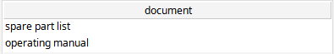

SPARQL query:
PREFIX rdf: <http://www.w3.org/1999/02/22-rdf-syntax-ns#>
PREFIX owl: <http://www.w3.org/2002/07/owl#>
PREFIX rdfs: <http://www.w3.org/2000/01/rdf-schema#>
PREFIX xsd: <http://www.w3.org/2001/XMLSchema#>
PREFIX cfihos: <http://infohub.siemens-energy.com/CFIHOS#>
SELECT ?document ?documentLabel WHERE {
?requirements rdfs:subClassOf cfihos:CFIHOS-00000132.
?requirements rdfs:subClassOf [
rdf:type owl:Restriction ;
owl:onProperty cfihos:hasTag ;
# vacuum pump. With pump there is no data
owl:someValuesFrom <http://infohub.siemens-energy.com/CFIHOS/tag#CFIHOS-30001032>
] .
?requirements rdfs:subClassOf [
rdf:type owl:Restriction ;
owl:onProperty cfihos:hasDocumentType ;
owl:someValuesFrom ?document
] .
?document rdfs:label ?documentLabel .

}

CQ14: What discipline is responsible for document type 0505?
Response:

SPARQL query:
PREFIX rdf: <http://www.w3.org/1999/02/22-rdf-syntax-ns#>
PREFIX owl: <http://www.w3.org/2002/07/owl#>
PREFIX rdfs: <http://www.w3.org/2000/01/rdf-schema#>
PREFIX xsd: <http://www.w3.org/2001/XMLSchema#>
PREFIX cfihos: <http://infohub.siemens-energy.com/CFIHOS#>
PREFIX schema: <http://schema.org/>
SELECT ?document_label ?discipline_label WHERE {
?document rdfs:subClassOf cfihos:CFIHOS-00000032.
?document schema:identifier "0505" .
?document rdfs:label ?document_label .
?disciplineDocument rdfs:subClassOf cfihos:CFIHOS-00000027 .
?disciplineDocument rdfs:label ?discipline_label .
?disciplineDocument rdfs:subClassOf [
rdf:type owl:Restriction ;
owl:onProperty cfihos:hasDocumentType ;
owl:someValuesFrom ?document
] .

?disciplineDocument rdfs:subClassOf [
rdf:type owl:Restriction ;
owl:onProperty cfihos:hasDiscipline ;
owl:someValuesFrom ?discipline
] .
}

CQ15: What are the tags that have the quality “cable type”?
Response:
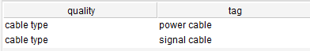

SPARQL query:
PREFIX owl: <http://www.w3.org/2002/07/owl#>
PREFIX rdfs: <http://www.w3.org/2000/01/rdf-schema#>
PREFIX cfihos: <http://infohub.siemens-energy.com/CFIHOS#>
PREFIX tag: <http://infohub.siemens-energy.com/CFIHOS/tag#>
PREFIX ido: <http://rds.posccaesar.org/ontology/lis14/rdl/>

SELECT * WHERE {
VALUES ?quality { cfihos:CFIHOS-40000034Quality } .
?tag rdfs:subClassOf* tag:CFIHOS-30000311 .
?tag rdfs:subClassOf [
rdf:type owl:Restriction ;
owl:someValuesFrom ?quality ;
owl:onProperty ido:hasQuality
] .
}

