The ontology can be accessed through the documentation site here: http://semantics.inf.um.es/resqplus_ontology/
In the following we show the notation used for describing the OWL representation of each of the database elements provided, corresponding to the RES-Q form fields.

Prefixes:
resqplus: http://resqplus-resources/ontologies/resqplus#
sct: http://snomed.info/id/
scdm: http://www.semanticweb.org/catimc/SemanticCommonDataModel#
btl2: http://purl.org/biotop/btl2.owl#

Notation:
OWL Manchester Syntax
Classes in Italics
Object/datatype properties in bold

First, we will show the representation in the RES-Q+ ontology of the Brain imaging type information, together with the date time in which the imaging was performed. The datetime of the imaging is interpreted as the date time in which any kind of the provided imaging procedures was performed. This differs from the graphical form above, but according to the database schema we have interpreted it in that way. The graphical form and the database schema are slightly different at the moment (we think that due to lack of updating the former one).

This is the OWL representation of each of the form data elements required for representing the information shown above:

Database identifier | Associated label | Ontology Class URI
diagnosis.imaging.imaging_type | Brain imaging | resqplus:DiagnosisImaging and scdm:representsProcedure some  sct:441986001 and scdm:procedureContext some sct:385658003
diagnosis.imaging.imaging_type.ct | Non-contrast CT | resqplus:DiagnosisImaging and scdm:representsProcedure some  sct:396205005 and scdm:procedureContext some sct:385658003
diagnosis.imaging.imaging_type.cta | Non-contrast CT + CT angiography | resqplus:DiagnosisImaging and scdm:representsProcedure some  resqlus:NonContrastCT&CTAngiography and scdm:procedureContext some sct:385658003
diagnosis.imaging.imaging_type.cta_perf | Non-contrast CT + CT angiography + CT perfusion | resqplus:DiagnosisImaging and scdm:representsProcedure some  resqlus:NonContrastCT&CTAngiography&CTPerfusion and scdm:procedureContext some sct:385658003
diagnosis.imaging.imaging_type.mr | MR DWI/FLAIR | resqplus:DiagnosisImaging and scdm:representsProcedure some  resqplus:MRDWIOrFLAIR and scdm:procedureContext some sct:385658003
diagnosis.imaging.imaging_type.mra | MR DWI/FLAIR + MR angiography | resqplus:DiagnosisImaging and scdm:representsProcedure some  resqplus:MRDWIOrFLAIR&MRangiography and scdm:procedureContext some sct:385658003
diagnosis.imaging.imaging_type.mra_perf | MR DWI/FLAIR + angiography + MR perfusion | resqplus:DiagnosingImaging and scdm:representsProcedure some resqplus:MRDWIOrFLAIR&MRangiography&MRPerfusion and scdm:procedureContext some sct:385658003
diagnosis.imaging.imaging_type.elsewhere | Imaging done in another hospital | Not mapped
diagnosis.imaging.imaging_type.not_done | Imaging not done | resqplus:DiagnosisImaging and scdm:representsProcedure some  sct:441986001 and scdm:procedureContext some  sct:385660001
diagnosis.imaging.imaging_timestamp | Imaging done at what time? | resqplus:DiagnosingImaging and scdm:temporalContext some (sct:410512000 and btl2:hasPart some (scdm:hasValue some xsd:DateTime))**
** these triples will be added to the specific brain imaging type

The following table shows the FSN for each of the SNOMED CT concepts used:

SCT ID | FSN
165197003 | Diagnostic assessment (procedure)
410512000 | Current or specified time (qualifier value)
396205005 | Computed tomography of brain without radiopaque contrast (procedure)
419949007 | Computed tomography angiography of intracranial artery with contrast (procedure)
433111008 | Computed tomography of brain perfusion (procedure)
431999000 | Diffusion weighted magnetic resonance imaging of brain (procedure)
431225005 | Magnetic resonance imaging of cerebrospinal fluid flow (procedure)
417936006 | Magnetic resonance angiography of vascular structure of head (procedure)
419059006 | Magnetic resonance imaging cerebral perfusion study (procedure)
441986001 | Imaging of brain (procedure)
385658003 | Done (qualifier value)
385660001 | Not done (qualifier value)

The following describes in more detail the classes from the above tables according to the RES-Q+ ontology.
resqplus:DiagnosingImaging
rdfs:subClassOf scdm:ClinicalProcedureStatement and
scdm:isResultOf some sct:165197003 and
scdm:representsProcedure some resqplus:ImagingTypeProcedureValueSet and
scdm:procedureContext some resqplus:StatementProcedureQualifierValueSet and
scdm:temporalContext some (sct:410512000 and
btl2:hasPart some (scdm:hasValue some xsd:DateTime))

resqplus:ImagingTypeProcedureValueSet
rdfs:subClassOf sct:396205005 or resqlus:NonContrastCT&CTAngiography or
resqlus:NonContrastCT&CTAngiography&CTPerfusion or resqplus:MRDWIOrFLAIR or
resqplus:MRDWIOrFLAIR&MRangiography or resqplus:MRDWIOrFLAIR&MRangiography&MRPerfusion

resqlus:NonContrastCT&CTAngiography
rdfs:subClassOf sct:396205005 and sct:419949007

resqlus:NonContrastCT&CTAngiography&CTPerfusion
rdfs:subClassOf sct:396205005 and sct:419949007 and sct:433111008

resqplus:MRDWIOrFLAIR
rdfs:subClassOf sct:431999000 or sct:431225005

resqplus:MRDWIOrFLAIR&MRangiography
rdfs:subClassOf (sct:431999000 or sct:431225005) and sct:417936006

resqplus:MRDWIOrFLAIR&MRangiography&MRPerfusion
rdfs:subClassOf (sct:431999000 or sct:431225005) and sct:417936006 and sct:419059006

resqplus:StatementProcedureQualifierValueSet
rdfs:subClassOf sct:385658003 or sct:385660001
Next, an example of RDF data instance for representing:

“Non-Contrast CT, 12/01/23”

PREFIX:
resqplus-data: http://resqplus-resources/ontologies/resqplus-data#

resqplus-data:diagnosis-imaging-c1-p123
rdf:type resqplus:DiagnosisImaging
scdm:representsProcedure resqplus-data:noncontrast-ct-c1-p123
scdm:procedureContext sct:385658003
scdm:temporalContext resqplus-data:CurrentOrSpecifiedTime-diagnosis-imaging-c1-p123
scdm:isResultOf resqplus-data:diagnostic-assessment-c1-p123

resqplus-data:diagnostic-assessment-c1-p123
rdf:type sct:165197003

resqplus-data:noncontrast-ct-c1-p123
rdf:type sct:396205005

resqplus-data:CurrentOrSpecifiedTime-diagnosis-imaging-c1-p123
rdf:type sct:385658003
btl2:hasPart resqplus-data:DateTimeDatatype-CurrentOrSpecifiedTime-diagnosis-imaging-c1-p123

resqplus-data:DateTimeDatatype-CurrentOrSpecifiedTime-diagnosis-imaging-c1-p123
rdf:type scdm:DateTimeDatatype
btl2:hasValue value “12/01/23”^^xsd:DateTime

Graphically:
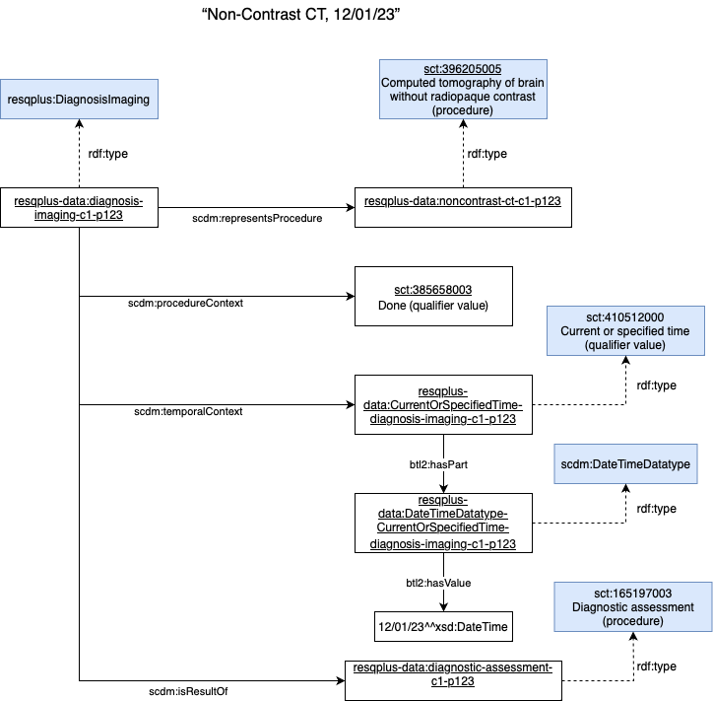

Next, we will show the representation in the RES-Q+ ontology of the CT / MR Perfusion deficit, that is related with the corresponding brain imaging type, CT or MR perfusion imaging previously represented.

Database identifier | Associated label | Ontology Class URI
diagnosis.imaging.perfusion.perfusion_deficit | CT/MR perfusion deficit | resqplus:CT/MRPerfusionDeficit
diagnosis.imaging.perfusion.perfusion_deficit.medial | Medial | resqplus:CT/MRPerfusionDeficit  and scdm:representsSituation some resqplus:MedialPerfusionDeficit
diagnosis.imaging.perfusion.perfusion_deficit.anterior | Anterior | resqplus:CT/MRPerfusionDeficit  and scdm:representsSituation some resqplus:AnteriorPerfusionDeficit
diagnosis.imaging.perfusion.perfusion_deficit.posterior | Posterior | r resqplus:CT/MRPerfusionDeficit  and scdm:representsSituation some esqplus:PosteriorPerfusionDeficit
diagnosis.imaging.perfusion.perfusion_deficit.carotid | Carotid | resqplus:CT/MRPerfusionDeficit  and scdm:representsSituation some resqplus:CarotidPerfusionDeficit
diagnosis.imaging.perfusion.perfusion_deficit.bilateral_stenosis | No, analysis not reliable due to bilateral stenosis | resqplus:UnknownPerfusionDeficitAndBilateralStenosis
diagnosis.imaging.perfusion.perfusion_deficit.no_deficit | No deficit | resqplus:CT/MRPerfusionDeficit  and scdm:representsSituation some resqplus:PerfusionDeficit and scdm:situationContext some sct:410516002
diagnosis.imaging.perfusion.perfusion_core_volume | CT/MR perfusion deficit core volume | resqplus:CT/MRPerfusionDeficitCorePerfusionVolume
diagnosis.imaging.perfusion.hypoperfusion_volume | CT/MR perfusion deficit hypoperfusion volume | resqplus:CT/MRPerfusionDeficitHypoperfusionVolume

The following table shows the FSN for each of the SNOMED CT concepts used:

SCT ID | FSN
165197003 | Diagnostic assessment (procedure)
410511007 | Current or past (actual) (qualifier value)
410515003 | Known present (qualifier value)
410516002 | Known absent (qualifier value)
419059006 | Magnetic resonance imaging cerebral perfusion study (procedure)
419059006 | Computed tomography of brain perfusion (procedure)
17232002 | Structure of middle cerebral artery (body structure)
60176003 | Structure of anterior cerebral artery (body structure)
70382005 | Structure of posterior cerebral artery (body structure)
69105007 | Carotid artery structure (body structure)
787044009 | Stenosis of bilateral carotid arteries (disorder)
16086006 | Blood volume (observable entity)
371863001 | Perfusion finding (finding)
363698007 | Finding site (attribute)
21762000 | Decreased vascular flow (finding)
261665006 | Unknown (qualifier value)
16086006 | Blood volume (observable entity)
787044009 | Stenosis of bilateral carotid arteries (disorder)

The following describes in more detail the above tables according to the RES-Q+ ontology.

resqplus:CT/MRPerfusionDeficit
rdfs:subClassOf scdm:ClinicalSituationStatement and
scdm:isResultOf some sct:165197003 and
scdm:representsSituation some resqplus:PerfusionDeficitValueSet and
scdm:situationContext some resqplus:StatementFindingQualifierValueSet and
scdm:temporalContext some sct:410511007

resqplus:PerfusionDeficitValueSet
rdfs:subClassOf resqplus:MedialPerfusionDeficit or resqplus:AnteriorPerfusionDeficit or
resqplus:PosteriorPerfusionDeficit or
resqplus:CarotidPerfusionDeficit or
resqplus:PerfusionDeficit

resqplus:PerfusionDeficit
rdfs:subClassOf sct:371863001 and sct:21762000

resqplus:MedialPerfusionDeficit
rdfs:subClassOf resqplus:PerfusionDeficit and sct:363698007 some sct:17232002

resqplus:AnteriorPerfusionDeficit
rdfs:subClassOf resqplus:PerfusionDeficit and sct:363698007 some sct:60176003

resqplus:PosteriorPerfusionDeficit
rdfs:subClassOf resqplus:PerfusionDeficit and sct:363698007 some sct:70382005

resqplus:CarotidPerfusionDeficit
rdfs:subClassOf resqplus:PerfusionDeficit and sct:363698007 some sct:69105007

resqplus:UnknownPerfusionDeficit
rdfs:subClassOf resqplus:CT/MRPerfusionDeficit
and scdm:representsSituation some resqplus:PerfusionDeficit
and scdm:situationContext some sct:61665006

resqplus:UnknownPerfusionDeficitAndBilateralStenosis
rdfs:subClassOf resqplus:UnknownPerfusionDeficit
and (scdm:ClinicalSituationStatement
and scdm:representsSituation some sct:787044009
and scdm:situationContext some sct:410515003)

resqplus:HypoperfusionVolume
rdfs:subClassOf sct:16086006

resqplus:CorePerfusionVolume
rdfs:subClassOf sct:16086006

resqplus:StatementFindingQualifierValueSet
rdfs:subClassOf sct:385658003 or sct:410516002 or sct:261665006

resqplus:CT/MRPerfusionDeficitCorePerfusionVolume
rdfs:subClassOf scdm:ObservationResultStatement and
scdm:hasObservable some resqplus:CorePerfusionVolume

resqplus:CT/MRPerfusionDeficitHypoperfusionVolume
rdfs:subClassOf scdm:ObservationResultStatement and
scdm:hasObservable some resqplus:HypoperfusionVolume

Next, an example of RDF data instance for representing:

“CT/MR Anterior Perfusion Deficit, perfusion volume X ml, hypoperfusion volume Y ml”

PREFIX:
resqplus-data: http://resqplus-resources/ontologies/resqplus-data#

resqplus-data:diagnosis-imaging-perfusion-c1-p123
rdf:type
resqplus:CT/MRPerfusionDeficit
and scdm:representsSituation resqplus-data:AnteriorPerfusionDeficit-c1-p123
and scdm:situationContext sct:410515003
and scdm:temporalContext sct:410511007
and scdm:isResultOf resqplus-data:noncontrast-ct-c1-p123

resqplus-data:diagnosis-imaging-perfusion-core-volume-o1-p123
rdf:type resqplus:CT/MRPerfusionDeficitCorePerfusionVolume
and scdm:isResultOf resqplus-data:noncontrast-ct-c1-p123
and scdm:hasObservableValue resqplus-data:QuantitativeResultValue-diagnosis-imaging-perfusion-core-volume-o1-p123
and scdm:situationContext sct:410515003
and scdm:temporalContext sct:410511007

resqplus-data:AnteriorPerfusionDeficit-c1-p123
rdf:type resqplus:AnteriorPerfusionDeficit

resqplus-data:noncontrast-ct-c1-p123
rdf:type sct:396205005

resqplus-data:QuantitativeResultValue-diagnosis-imaging-perfusion-core-volume-o1-p123
rdf:type scdm:QuantitativeResultValue
and btl2:hasPart sct:258773002
and btl2:hasValue value 7878^^xsd:Integer

Graphically: (TO DO)

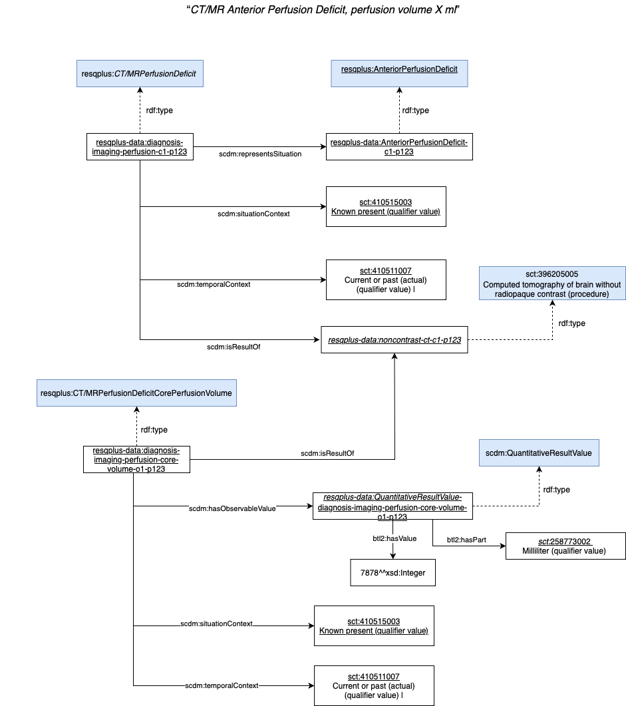
Next, the representation in the RES-Q+ ontology of the arterial occlusion observed by the CT / MRA Brain imaging

Database identifier | Associated label | Ontology Class URI
diagnosis.imaging.occlusion.any_occlusion | Was arterial occlusion detected on CTA/MRA? | resqplus:ArterialOcclusion
diagnosis.imaging.occlusion.any_occlusion.yes | Yes | resqplus:ArterialOcclusion and scdm:representsSituation some sct:410515003 and scdm:situationContext some sct:410515003
diagnosis.imaging.occlusion.any_occlusion.no | No | resqplus:ArterialOcclusion and scdm:representsSituation some sct:410516002 and scdm:situationContext some sct:410516002
diagnosis.imaging.occlusion.mca_m1_left | MCA M1 – Middle cerebral artery M1 (LEFT) | resqplus:ArterialOcclusion and scdm:representsSituation some resqplus:MCAM1LeftOcclusion
diagnosis.imaging.occlusion.mca_m1_left.yes | yes | resqplus:ArterialOcclusion and scdm:representsSituation some resqplus:MCAM1LeftOcclusion and scdm:situationContext some sct:410515003
diagnosis.imaging.occlusion.mca_m1_left.no | no | resqplus:ArterialOcclusion and scdm:representsSituation some resqplus:MCAM1LeftOcclusion and scdm:situationContext some sct:410516002
diagnosis.imaging.occlusion.mca_m2_left | MCA M2 – Middle cerebral artery M2 (LEFT) | resqplus:ArterialOcclusion and scdm:representsSituation some resqplus:MCAM2LeftOcclusion
diagnosis.imaging.occlusion.mca_m2_left.yes | yes | resqplus:ArterialOcclusion and scdm:representsSituation some resqplus:MCAM2LeftOcclusion and scdm:situationContext some sct:410515003
diagnosis.imaging.occlusion.mca_m2_left.no | no | resqplus:ArterialOcclusion and scdm:representsSituation some resqplus:MCAM2LeftOcclusion and scdm:situationContext some sct:410516002
diagnosis.imaging.occlusion.mca_m3_left | MCA M3 – Middle cerebral artery M3 (LEFT) | resqplus:ArterialOcclusion and scdm:representsSituation some resqplus:MCAM3LeftOcclusion
diagnosis.imaging.occlusion.mca_m3_left.yes | yes | resqplus:ArterialOcclusion and scdm:representsSituation some resqplus:MCAM3LeftOcclusion and scdm:situationContext some sct:410515003
diagnosis.imaging.occlusion.mca_m3_left.no | no | resqplus:ArterialOcclusion and scdm:representsSituation some resqplus:MCAM3LeftOcclusion and scdm:situationContext some sct:410516002
diagnosis.imaging.occlusion.cerebral_artery_left | Anterior cerebral artery (LEFT) | resqplus:ArterialOcclusion and scdm:representsSituation some resqplus:AnteriorCerebralArteryLeftOcclusion
diagnosis.imaging.occlusion.cerebral_artery_left.yes | yes | resqplus:ArterialOcclusion and scdm:representsSituation some resqplus:AnteriorCerebralArteryLeftOcclusion and scdm:situationContext some sct:410515003
diagnosis.imaging.occlusion.cerebral_artery_left.no | no | resqplus:ArterialOcclusion and scdm:representsSituation some resqplus:AnteriorCerebralArteryLeftOcclusion and scdm:situationContext some sct:410516002
diagnosis.imaging.occlusion.pca_p1_left | PCA P1 – Posterior cerebral artery P1 (LEFT) | resqplus:ArterialOcclusion and scdm:representsSituation some resqplus:PCAP1LeftOcclusion
diagnosis.imaging.occlusion.pca_p1_left.yes | yes | resqplus:ArterialOcclusion and scdm:representsSituation some resqplus:PCAP1LeftOcclusion and scdm:situationContext some sct:410515003
diagnosis.imaging.occlusion.pca_p1_left.no | no | resqplus:ArterialOcclusion and scdm:representsSituation some resqplus:PCAP1LeftOcclusion and scdm:situationContext some sct:410516002
diagnosis.imaging.occlusion.pca_p2_left | PCA P2 – Posterior cerebral artery P2 (LEFT) | resqplus:ArterialOcclusion and scdm:representsSituation some resqplus:PCAP2LeftOcclusion
diagnosis.imaging.occlusion.pca_p2_left.yes | yes | resqplus:ArterialOcclusion and scdm:representsSituation some resqplus:PCAP2LeftOcclusion and scdm:situationContext some sct:410515003
diagnosis.imaging.occlusion.pca_p2_left.no | no | resqplus:ArterialOcclusion and scdm:representsSituation some resqplus:PCAP2LeftOcclusion and scdm:situationContext some sct:410516002
diagnosis.imaging.occlusion.artery_extracranial_left | Carotid artery extracranial (LEFT) | resqplus:ArterialOcclusion and scdm:representsSituation some resqplus:CarotidArteryExtLeftOcclusion
diagnosis.imaging.occlusion.artery_extracranial_left.yes | yes | resqplus:ArterialOcclusion and scdm:representsSituation some resqplus:CarotidArteryExtLeftOcclusion and scdm:situationContext some sct:410515003
diagnosis.imaging.occlusion.artery_extracranial_left.no | no | resqplus:ArterialOcclusion and scdm:representsSituation some resqplus:CarotidArteryExtLeftOcclusion and scdm:situationContext some sct:410516002
diagnosis.imaging.occlusion.artery_intracranial_left | Carotid artery intracranial (LEFT) | resqplus:ArterialOcclusion and scdm:representsSituation some resqplus:CarotidArteryIntLeftOcclusion
diagnosis.imaging.occlusion.artery_intracranial_left.yes | yes | resqplus:ArterialOcclusion and scdm:representsSituation some resqplus:CarotidArteryIntLeftOcclusion and scdm:situationContext some sct:410515003
diagnosis.imaging.occlusion.artery_intracranial_left.no | no | resqplus:ArterialOcclusion and scdm:representsSituation some resqplus:CarotidArteryIntLeftOcclusion and scdm:situationContext some sct:410516002
diagnosis.imaging.occlusion.mca_m1_right | MCA M1 – Middle cerebral artery M1 (RIGHT) | resqplus:ArterialOcclusion and scdm:representsSituation some resqplus:MCAM1RightOcclusion
diagnosis.imaging.occlusion.mca_m1_right.yes | yes | resqplus:ArterialOcclusion and scdm:representsSituation some resqplus:MCAM1RightOcclusion and scdm:situationContext some sct:410515003
diagnosis.imaging.occlusion.mca_m1_right.no | no | resqplus:ArterialOcclusion and scdm:representsSituation some resqplus:MCAM1RightOcclusion and scdm:situationContext some sct:410516002
diagnosis.imaging.occlusion.mca_m2_right | MCA M2 – Middle cerebral artery M2 (RIGHT) | resqplus:ArterialOcclusion and scdm:representsSituation some resqplus:MCAM2RightOcclusion
diagnosis.imaging.occlusion.mca_m2_right.yes | yes | resqplus:ArterialOcclusion and scdm:representsSituation some resqplus:MCAM2RightOcclusion and scdm:situationContext some sct:410515003
diagnosis.imaging.occlusion.mca_m2_right.no | no | resqplus:ArterialOcclusion and scdm:representsSituation some resqplus:MCAM2RightOcclusion and scdm:situationContext some sct:410516002
diagnosis.imaging.occlusion.mca_m3_right | MCA M3 – Middle cerebral artery M3 (RIGHT) | resqplus:ArterialOcclusion and scdm:representsSituation some resqplus:MCAM3RightOcclusion
diagnosis.imaging.occlusion.mca_m3_right.yes | yes | resqplus:ArterialOcclusion and scdm:representsSituation some resqplus:MCAM3RightOcclusion and scdm:situationContext some sct:410515003
diagnosis.imaging.occlusion.mca_m3_right.no | no | resqplus:ArterialOcclusion and scdm:representsSituation some resqplus:MCAM3RightOcclusion and scdm:situationContext some sct:410516002
diagnosis.imaging.occlusion.cerebral_artery_right | Anterior cerebral artery (RIGHT) | resqplus:ArterialOcclusion and scdm:representsSituation some resqplus:AnteriorCerebralArteryRightOcclusion
diagnosis.imaging.occlusion.cerebral_artery_right.yes | yes | resqplus:ArterialOcclusion and scdm:representsSituation some resqplus:AnteriorCerebralArteryRightOcclusion and scdm:situationContext some sct:410515003
diagnosis.imaging.occlusion.cerebral_artery_right.no | no | resqplus:ArterialOcclusion and scdm:representsSituation some resqplus:AnteriorCerebralArteryRightOcclusion and scdm:situationContext some sct:410516002
diagnosis.imaging.occlusion.pca_p1_right | PCA P1 – Posterior cerebral artery P1 (RIGHT) | resqplus:ArterialOcclusion and scdm:representsSituation some resqplus:PCAP1RightOcclusion
diagnosis.imaging.occlusion.pca_p1_right.yes | yes | resqplus:ArterialOcclusion and scdm:representsSituation some resqplus:PCAP1RightOcclusion and scdm:situationContext some sct:410515003
diagnosis.imaging.occlusion.pca_p1_right.no | no | resqplus:ArterialOcclusion and scdm:representsSituation some resqplus:PCAP1RightOcclusion and scdm:situationContext some sct:410516002
diagnosis.imaging.occlusion.pca_p2_right | PCA P2 – Posterior cerebral artery P2 (RIGHT) | resqplus:ArterialOcclusion and scdm:representsSituation some resqplus:PCAP2RightOcclusion
diagnosis.imaging.occlusion.pca_p2_right.yes | yes | resqplus:ArterialOcclusion and scdm:representsSituation some resqplus:PCAP2RightOcclusion and scdm:situationContext some sct:410515003
diagnosis.imaging.occlusion.pca_p2_right.no | no | resqplus:ArterialOcclusion and scdm:representsSituation some resqplus:PCAP2RightOcclusion and scdm:situationContext some sct:410516002
diagnosis.imaging.occlusion.artery_extracranial_right | Carotid artery extracranial (RIGHT) | resqplus:ArterialOcclusion and scdm:representsSituation some resqplus:CarotidArteryExtRightOcclusion
diagnosis.imaging.occlusion.artery_extracranial_right.yes | yes | resqplus:ArterialOcclusion and scdm:representsSituation some resqplus:CarotidArteryExtRightOcclusion and scdm:situationContext some sct:410515003
diagnosis.imaging.occlusion.artery_extracranial_right.no | no | resqplus:ArterialOcclusion and scdm:representsSituation some resqplus:CarotidArteryExtRightOcclusion and scdm:situationContext some sct:410516002
diagnosis.imaging.occlusion.artery_intracranial_right | Carotid artery intracranial (RIGHT) | resqplus:ArterialOcclusion and scdm:representsSituation some resqplus:CarotidArteryIntRightOcclusion
diagnosis.imaging.occlusion.artery_intracranial_right.yes | yes | resqplus:ArterialOcclusion and scdm:representsSituation some resqplus:CarotidArteryIntRightOcclusion and scdm:situationContext some sct:410515003
diagnosis.imaging.occlusion.artery_intracranial_right.no | no | resqplus:ArterialOcclusion and scdm:representsSituation some resqplus:CarotidArteryIntRightOcclusion and scdm:situationContext some sct:410516002
diagnosis.imaging.occlusion.basilar_artery | Basilar artery | resqplus:ArterialOcclusion and scdm:representsSituation some sct:195180004
diagnosis.imaging.occlusion.basilar_artery.yes | yes | resqplus:ArterialOcclusion and scdm:representsSituation some sct:195180004 and scdm:situationContext some sct:410515003
diagnosis.imaging.occlusion.basilar_artery.no | no | resqplus:ArterialOcclusion and scdm:representsSituation some sct:195180004 and scdm:situationContext some sct:410516002
diagnosis.imaging.occlusion.vertebral_artery | Vertebral artery | resqplus:ArterialOcclusion and scdm:representsSituation some sct:195182007
diagnosis.imaging.occlusion.vertebral_artery.yes | yes | resqplus:ArterialOcclusion and scdm:representsSituation some sct:195182007 and scdm:situationContext some sct:410515003
diagnosis.imaging.occlusion.vertebral_artery.no | no | resqplus:ArterialOcclusion and scdm:representsSituation some sct:195182007 and scdm:situationContext some sct:410516002

SCT ID | FSN
165197003 | Diagnostic assessment (procedure)
410511007 | Current or past (actual) (qualifier value)
410515003 | Known present (qualifier value)
410516002 | Known absent (qualifier value)
2929001 | Occlusion of artery (disorder)
414722000 | Structure of middle cerebral artery M1 segment (body structure)
272741003 | Laterality (attribute)
7771000 | Left (qualifier value)
414723005 | Structure of middle cerebral artery M2 segment (body structure)
772219006 | Structure of middle cerebral artery M3 segment (body structure)
369299002 | Structure of left anterior cerebral artery (body structure)
415144009 | Structure of posterior cerebral artery P1 segment (body structure)
415145005 | Structure of posterior cerebral artery P2 segment (body structure)
22286001 | External carotid artery structure (body structure)
261098002 | Entire cerebral portion of internal carotid artery (body structure)
261665006 | Unknown (qualifier value)
24028007 | Right (qualifier value)
369298005 | Structure of right anterior cerebral artery (body structure)
195180004 | Basilar artery occlusion (disorder)
195182007 | Vertebral artery occlusion (disorder)
The following describes in more detail the above tables according to the RES-Q+ ontology.
resqplus:ArterialOcclusion
rdfs:subClassOf scdm:ClinicalSituationStatement and
scdm:isResultOf some sct:165197003 and
scdm:representsSituation some resqplus:ArterialOcclusionValueSet and
scdm:situationContext some resqplus:StatementFindingQualifierValueSet and
scdm:temporalContext some sct:410511007

resqplus:ArterialOcclusionValueSet
rdfs:subClassOf 2929001 | Occlusion of artery (disorder) | or
resqplus:MCAM1LeftOcclusion or
resqplus:MCAM2LeftOcclusion or
resqplus:MCAM3LeftOcclusion or
resqplus:AnteriorCerebralArteryLeftOcclusion or
resqplus:PCAP1LeftOcclusion or
resqplus:PCAP2LeftOcclusion or
resqplus:CarotidArteryExtLeftOcclusion or
resqplus:CarotidArteryIntLeftOcclusion or
195180004 | Basilar artery occlusion (disorder) | or
195182007 | Vertebral artery occlusion (disorder) | or
resqplus:MCAM1RightOcclusion or
resqplus:MCAM2RightOcclusion or
resqplus:MCAM3RightOcclusion or
resqplus:AnteriorCerebralArteryRightOcclusion or
resqplus:PCAP1RightOcclusion or
resqplus:PCAP2RightOcclusion or
resqplus:CarotidArteryExtRightOcclusion or
resqplus:CarotidArteryIntRightOcclusion

resqplus:MCAM1LeftOcclusion
rdfs:subClassOf sct:2929001
and sct:363698007 some (sct:414722000
and sct:272741003 some sct:7771000)

resqplus:MCAM2LeftOcclusion
rdfs:subClassOf sct:2929001
and sct:363698007 some (sct:414723005
and sct:272741003 some sct:7771000)

resqplus:MCAM3LeftOcclusion
rdfs:subClassOf sct:2929001
and sct:363698007 some (sct:772219006
and sct:272741003 some sct:7771000)

resqplus:AnteriorCerebralArteryLeftOcclusion
rdfs:subClassOf sct:2929001
and sct:363698007 some sct:369299002

resqplus:PCAP1LeftOcclusion
rdfs:subClassOf sct:2929001
and sct:363698007 some (sct:415144009
and sct:272741003 some sct:7771000)

resqplus:PCAP2LeftOcclusion
rdfs:subClassOf sct:2929001
and sct:363698007 some (sct:415145005
and sct:272741003 some sct:7771000)

resqplus:CarotidArteryExtLeftOcclusion
rdfs:subClassOf sct:2929001
and sct:363698007 some (sct:22286001
and sct:272741003 some sct:7771000)

resqplus:CarotidArteryIntLeftOcclusion
rdfs:subClassOf sct:2929001
and sct:363698007 some (sct: 261098002
and sct:272741003 some sct:7771000)

resqplus:MCAM1RightOcclusion
rdfs:subClassOf sct:2929001
and sct:363698007 some (sct:414722000
and sct:272741003 some sct: 24028007)

resqplus:MCAM2RightOcclusion
rdfs:subClassOf sct:2929001
and sct:363698007 some (sct:414723005
and sct:272741003 some sct:24028007)

resqplus:MCAM3RightOcclusion
rdfs:subClassOf sct:2929001
and sct:363698007 some (sct:772219006
and sct:272741003 some sct:24028007)

resqplus:AnteriorCerebralArteryRightOcclusion
rdfs:subClassOf sct:2929001
and sct:363698007 some sct:369298005)

resqplus:PCAP1RightOcclusion
rdfs:subClassOf sct:2929001
and sct:363698007 some (sct:415144009
and sct:272741003 some sct:24028007)

resqplus:PCAP2RightOcclusion
rdfs:subClassOf sct:2929001
and sct:363698007 some (sct:415145005
and sct:272741003 some sct:24028007)

resqplus:CarotidArteryExtRightOcclusion
rdfs:subClassOf sct:2929001
and sct:363698007 some (sct:22286001
and sct:272741003 some sct:24028007)

resqplus:CarotidArteryIntRightOcclusion
rdfs:subClassOf sct:2929001
and sct:363698007 some (sct: 261098002
and sct:272741003 some sct:24028007)

Next, an example of RDF data instance for representing:

“Occlusion of the left anterior cerebral artery”

PREFIX:
resqplus-data: http://resqplus-resources/ontologies/resqplus-data#

resqplus-data:diagnosis-imaging-occlusion-c1-p123
rdf:type resqplus:ArterialOcclusion
and scdm:representsSituation resqplus-data:AnteriorCerebralArteryLeftOcclusion-c1-p123
and scdm:situationContext sct:410515003
and scdm:temporalContext sct:410511007
and scdm:isResultOf resqplus-data:noncontrast-ct-c1-p123

resqplus-data:AnteriorCerebralArteryLeftOcclusion-c1-p123
rdf:type resqplus:AnteriorCerebralArteryLeftOcclusion

resqplus-data:noncontrast-ct-c1-p123
rdf:type sct:396205005

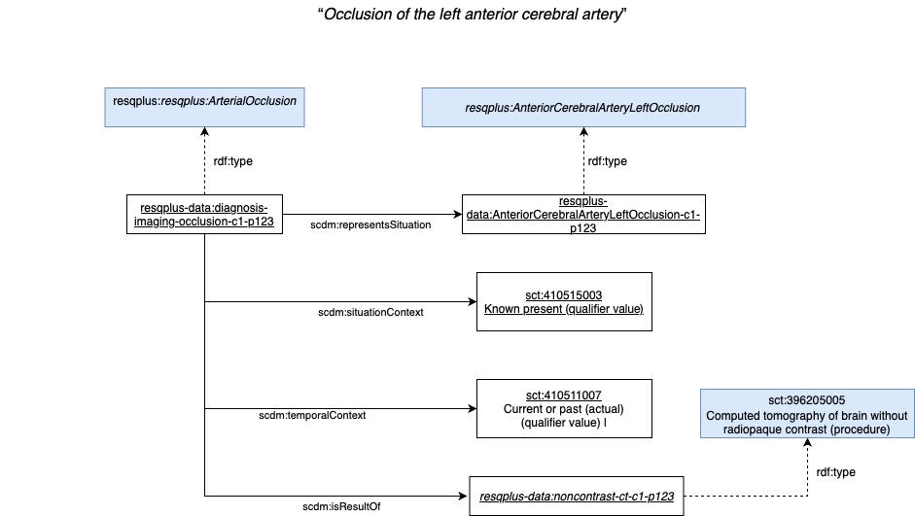

Next, the representation in the RES-Q+ ontology of the post stroke complications

Database identifier | Associated label | Ontology Class URI
post_acute_care.post_stroke_complications.any_post_stroke_complication | Any post-stroke complication? | resqplus:PostStrokeComplications
post_acute_care.post_stroke_complications.any_post_stroke_complication.yes | Yes | resqplus:PostStrokeComplications and scdm:situationContext some sct:410515003
post_acute_care.post_stroke_complications.any_post_stroke_complication.no | No | resqplus:PostStrokeComplications and scdm:situationContext some sct:410516002
post_acute_care.post_stroke_complications.pneumonia | Pneumonia | resqplus:PostStrokeComplications and  scdm:representsSituation some resqplus:PneumoniaPostStrokeComplication
post_acute_care.post_stroke_complications.pneumonia.yes | yes | resqplus:PostStrokeComplications and  scdm:representsSituation some resqplus:PneumoniaPostStrokeComplication and scdm:situationContext some sct:410515003
post_acute_care.post_stroke_complications.pneumonia.no | no | resqplus:PostStrokeComplications and  scdm:representsSituation some resqplus:PneumoniaPostStrokeComplication and scdm:situationContext some sct:410516002
post_acute_care.post_stroke_complications.dvt | Deep vein thrombosis (DVT) | resqplus:PostStrokeComplications and  scdm:representsSituation some resqplus:DVTPostStrokeComplication and scdm:situationContext some sct:410516002
post_acute_care.post_stroke_complications.dvt.yes | yes | resqplus:PostStrokeComplications and  scdm:representsSituation some resqplus:DVTPostStrokeComplication and scdm:situationContext some sct:410515003
post_acute_care.post_stroke_complications.dvt.no | no | resqplus:PostStrokeComplications and  scdm:representsSituation some resqplus:DVTPostStrokeComplication and scdm:situationContext some sct:410516002
post_acute_care.post_stroke_complications.pulmonary_embolism | Pulmonary embolism | resqplus:PostStrokeComplications and  scdm:representsSituation some resqplus:PulmonaryEmbolismPostStrokeComplication
post_acute_care.post_stroke_complications.pulmonary_embolism.yes | yes | resqplus:PostStrokeComplications and  scdm:representsSituation some resqplus:PulmonaryEmbolismPostStrokeComplication and scdm:situationContext some sct:410515003
post_acute_care.post_stroke_complications.pulmonary_embolism.no | no | resqplus:PostStrokeComplications and  scdm:representsSituation some resqplus:PulmonaryEmbolismPostStrokeComplication and scdm:situationContext some sct:410516002
post_acute_care.post_stroke_complications.urinary_infection | Urinary tract infection | resqplus:PostStrokeComplications and  scdm:representsSituation some resqplus:UrunaryTractInfectionPostStrokeComplication
post_acute_care.post_stroke_complications.urinary_infection.yes | yes | resqplus:PostStrokeComplications and  scdm:representsSituation some resqplus:UrunaryTractInfectionPostStrokeComplication and scdm:situationContext some sct:410515003
post_acute_care.post_stroke_complications.urinary_infection.no | no | resqplus:PostStrokeComplications and  scdm:representsSituation some resqplus:UrunaryTractInfectionPostStrokeComplication and scdm:situationContext some sct:410516002
post_acute_care.post_stroke_complications.pressure_sores | Pressure sores | resqplus:PostStrokeComplications and  scdm:representsSituation some resqplus:PressureSoresPostStrokeComplication
post_acute_care.post_stroke_complications.pressure_sores.yes | yes | resqplus:PostStrokeComplications and  scdm:representsSituation some resqplus:PressureSoresPostStrokeComplication and scdm:situationContext some sct:410515003
post_acute_care.post_stroke_complications.pressure_sores.no | no | resqplus:PostStrokeComplications and  scdm:representsSituation some resqplus:PressureSoresPostStrokeComplication and scdm:situationContext some sct:410516002
post_acute_care.post_stroke_complications.drip_site_sepsis | Drip site sepsis | resqplus:PostStrokeComplications and  scdm:representsSituation some resqplus:DripSiteSepsisPostStrokeComplication
post_acute_care.post_stroke_complications.drip_site_sepsis.yes | yes | resqplus:PostStrokeComplications and  scdm:representsSituation some resqplus:DripSiteSepsisPostStrokeComplication and scdm:situationContext some sct:410515003
post_acute_care.post_stroke_complications.drip_site_sepsis.no | no | resqplus:PostStrokeComplications and  scdm:representsSituation some resqplus:DripSiteSepsisPostStrokeComplication and scdm:situationContext some sct:410516002
post_acute_care.post_stroke_complications.recurrence_or_extension | Reccurence/Extension of stroke | resqplus:PostStrokeComplications and  scdm:representsSituation some reqplus:Recurrence/ExtensionOfStroke
post_acute_care.post_stroke_complications.recurrence_or_extension.yes | yes | resqplus:PostStrokeComplications and  scdm:representsSituation some reqplus:Recurrence/ExtensionOfStroke and scdm:situationContext some sct:410515003
post_acute_care.post_stroke_complications.recurrence_or_extension.no | no | resqplus:PostStrokeComplications and  scdm:representsSituation some reqplus:Recurrence/ExtensionOfStroke and scdm:situationContext some sct:410516002
post_acute_care.post_stroke_complications.other | Other | resqplus:PostStrokeComplications and  scdm:representsSituation some resqplus:OtherPostStrokeComplication
post_acute_care.post_stroke_complications.other.yes | yes | resqplus:PostStrokeComplications and  scdm:representsSituation some resqplus:OtherPostStrokeComplication and scdm:situationContext some sct:410515003
post_acute_care.post_stroke_complications.other.no | no | resqplus:PostStrokeComplications and  scdm:representsSituation some resqplus:OtherPostStrokeComplication and scdm:situationContext some sct:410516002

SCT ID | FSN
165197003 | Diagnostic assessment (procedure)
410511007 | Current or past (actual) (qualifier value)
410515003 | Known present (qualifier value)
410516002 | Known absent (qualifier value)
233604007 | Pneumonia (disorder)
128053003 | Deep venous thrombosis (disorder)
59282003 | Pulmonary embolism (disorder)
68566005 | Urinary tract infectious disease (disorder)
1163215007 | Pressure injury (disorder)
91302008 | Sepsis (disorder)
281240008 | Extension of cerebrovascular accident (disorder)
230690007 | Cerebrovascular accident (disorder)
404684003 | Clinical finding (finding)
255234002 | After (attribute)
446340009 | Infection of catheter exit site (disorder)
263502005 | Clinical course (attribute)|
255227004 | Recurrent (qualifier value)

resqplus:PostStrokeComplications
rdfs:subClassOf scdm:ClinicalSituationStatement and
scdm:isResultOf some sct:165197003 and
scdm:representsSituation some resqplus:PostStrokeComplicationsValueSet and
scdm:situationContext some resqplus:StatementFindingQualifierValueSet and
scdm:temporalContext some sct:410511007

resqplus:PostStrokeComplicationsValueSet
rdfs:subClassOf resqplus:PneumoniaPostStrokeComplication or
resqplus:DVTPostStrokeComplication or
resqplus:PulmonaryEmbolismPostStrokeComplication or
resqplus:UrunaryTractInfectionPostStrokeComplication or
resqplus:PressureSoresPostStrokeComplication or
resqplus:DripSiteSepsisPostStrokeComplication or
resqplus:Recurresnce/ExtensionPostStrokeComplication or
resqplus:OtherPostStrokeComplication

resqplus:PneumoniaPostStrokeComplication
rdfs:subClassOf sct:233604007 and sct:255234002 some sct:230690007

resqplus:DVTPostStrokeComplication
rdfs:subClassOf sct:128053003 and sct:255234002 some sct:230690007

resqplus:PulmonaryEmbolismPostStrokeComplication
rdfs:subClassOf sct:59282003 and sct:255234002 some sct:230690007

resqplus:UrunaryTractInfectionPostStrokeComplication
rdfs:subClassOf sct:68566005 and sct:255234002 some sct:230690007

resqplus:PressureSoresPostStrokeComplication
rdfs:subClassOf sct:1163215007 and sct:255234002 some sct:230690007

resqplus:DripSiteSepsisPostStrokeComplication
rdfs:subClassOf resqplus:DripSiteSepsis and sct:255234002 some sct:230690007

resqplus:Recurresnce/ExtensionPostStrokeComplication
rdfs:subClassOf reqplus:Recurrence/ExtensionOfStroke and sct:255234002 some sct:230690007

resqplus:DripSiteSepsis
rdfs:subClassOf sct:91302008 and sct:446340009

reqplus:Recurrence/ExtensionOfStroke
rdfs:subClassOf sct:81240008 or
sct:230690007 sct:230690007 sct:255227004

resqplus:OtherPostStrokeComplication
rdfs:subClassOf sct:404684003 and sct:255234002 some sct:230690007

Next, an example of RDF data instance for representing:

“Drip site sepsis post stroke complication”

PREFIX:
resqplus-data: http://resqplus-resources/ontologies/resqplus-data#

resqplus-data:diagnosis-imaging-occlusion-c1-p123
rdf:type resqplus:PostStrokeComplications
and scdm:representsSituation resqplus:DripSiteSepsisPostStrokeComplication
and scdm:situationContext sct:410515003
and scdm:temporalContext sct:410511007
and scdm:isResultOf resqplus-data:post-stroke-diagnostic-assessment-c1-p123

resqplus-data:post-stroke-diagnostic-assessment-c1-p123
rdf:type sct:165197003

Graphically:
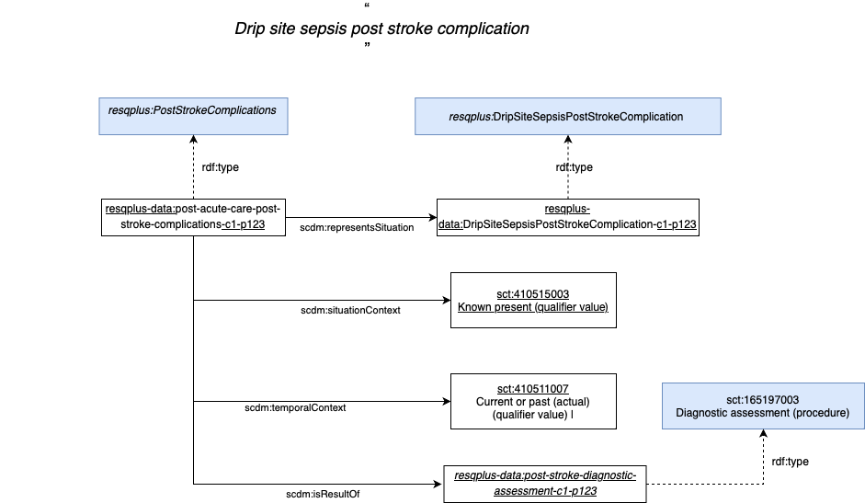
Next, the representation in the RES-Q+ ontology

Database identifier | Associated label | Ontology Class URI
post_acute_care.post_recanalization_imaging.imaging_type | Was CT/MR performed after IVT/MT | resqplus:DiagnosisImaging and scdm:representsProcedure some  resqplus:CT/MRPerformedAfterIVT/MT
post_acute_care.post_recanalization_imaging.imaging_type.ct | Yes, CT | resqplus:DiagnosisImaging and scdm:representsProcedure some  resqplus:CTPerformedAfterIVT/MT and scdm:procedureContext some sct:385658003
post_acute_care.post_recanalization_imaging.imaging_type.mr | Yes, MR | resqplus:DiagnosisImaging and scdm:representsProcedure some  resqplus:MRPerformedAfterIVT/MT  scdm:procedureContext some sct:385658003
post_acute_care.post_recanalization_imaging.imaging_type.no | No | resqplus:DiagnosisImaging and scdm:representsProcedure some  resqplus:CT/MRPerformedAfterIVT/MT and scdm:procedureContext some sct:385660001
post_acute_care.post_recanalization_imaging.brain_infarct | Brain infarct | scdm:ClinicalSituationStatement and  scdm:representsSituation some sct:422504002
post_acute_care.post_recanalization_imaging.brain_infarct.yes | yes | scdm:ClinicalSituationStatement and  scdm:representsSituation some sct:422504002 and scdm:situationContext some sct:410515003
post_acute_care.post_recanalization_imaging.brain_infarct.no | no | scdm:ClinicalSituationStatement and  scdm:representsSituation some sct:422504002 and scdm:situationContext some sct:410516002
post_acute_care.post_recanalization_imaging.no_bleeding | No bleeding | scdm:ClinicalSituationStatement and  scdm:representsSituation some sct:131148009
post_acute_care.post_recanalization_imaging.no_bleeding.yes | yes | scdm:ClinicalSituationStatement and  scdm:representsSituation some sct:131148009 and scdm:situationContext some sct:410515003
post_acute_care.post_recanalization_imaging.no_bleeding.no | no | scdm:ClinicalSituationStatement and  scdm:representsSituation some sct:131148009 and scdm:situationContext some sct:410516002
post_acute_care.post_recanalization_imaging.remote | Remote bleeding in the brain | We do not find a SNOMED CT concept to express remote bleeding in the brain. Only the following:  230706003 | Hemorrhagic cerebral infarction (disorder) |  274100004 | Cerebral hemorrhage (disorder) |
post_acute_care.post_recanalization_imaging.remote.yes | yes | We do not find a SNOMED CT concept to express remote bleeding in the brain. Only the following:  230706003 | Hemorrhagic cerebral infarction (disorder) |  274100004 | Cerebral hemorrhage (disorder) |
post_acute_care.post_recanalization_imaging.remote.no | no | We do not find a SNOMED CT concept to express remote bleeding in the brain. Only the following:  230706003 | Hemorrhagic cerebral infarction (disorder) |  274100004 | Cerebral hemorrhage (disorder) |
post_acute_care.post_recanalization_imaging.bleeding_hi_1 | Bleeding at the site of infarction hemorrhage HI type 1 | We do not find a SNOMED CT concept to express Bleeding at the site of infarction hemorrhage HI type 1. Only the following:  230706003 | Hemorrhagic cerebral infarction (disorder) |  274100004 | Cerebral hemorrhage (disorder) |
post_acute_care.post_recanalization_imaging.bleeding_hi_1.yes | yes | We do not find a SNOMED CT concept to express Bleeding at the site of infarction hemorrhage HI type 1. Only the following:  230706003 | Hemorrhagic cerebral infarction (disorder) |  274100004 | Cerebral hemorrhage (disorder) |
post_acute_care.post_recanalization_imaging.bleeding_hi_1.no | no | We do not find a SNOMED CT concept to express Bleeding at the site of infarction hemorrhage HI type 1. Only the following:  230706003 | Hemorrhagic cerebral infarction (disorder) |  274100004 | Cerebral hemorrhage (disorder) |
post_acute_care.post_recanalization_imaging.bleeding_hi_2 | Bleeding at the site of infarction hemorrhage HI type 2 | We do not find a SNOMED CT concept to express Bleeding at the site of infarction hemorrhage HI type 2. Only the following:  230706003 | Hemorrhagic cerebral infarction (disorder) |  274100004 | Cerebral hemorrhage (disorder) |
post_acute_care.post_recanalization_imaging.bleeding_hi_2.yes | yes | We do not find a SNOMED CT concept to express Bleeding at the site of infarction hemorrhage HI type 2. Only the following:  230706003 | Hemorrhagic cerebral infarction (disorder) |  274100004 | Cerebral hemorrhage (disorder) |
post_acute_care.post_recanalization_imaging.bleeding_hi_2.no | no | We do not find a SNOMED CT concept to express Bleeding at the site of infarction hemorrhage HI type 2. Only the following:  230706003 | Hemorrhagic cerebral infarction (disorder) |  274100004 | Cerebral hemorrhage (disorder) |
post_acute_care.post_recanalization_imaging.bleeding_ph_1 | Bleeding at the site of infarction parenchymal hemorrhage PH type 1 | We do not find a SNOMED CT concept to express Bleeding at the site of infarction parenchymal hemorrhage PH type 1 Only the following:  230706003 | Hemorrhagic cerebral infarction (disorder) |  274100004 | Cerebral hemorrhage (disorder) |
post_acute_care.post_recanalization_imaging.bleeding_ph_1.yes | yes | We do not find a SNOMED CT concept to express Bleeding at the site of infarction parenchymal hemorrhage PH type 1 Only the following:  230706003 | Hemorrhagic cerebral infarction (disorder) |  274100004 | Cerebral hemorrhage (disorder) |
post_acute_care.post_recanalization_imaging.bleeding_ph_1.no | no | We do not find a SNOMED CT concept to express Bleeding at the site of infarction parenchymal hemorrhage PH type 1 Only the following:  230706003 | Hemorrhagic cerebral infarction (disorder) |  274100004 | Cerebral hemorrhage (disorder) |
post_acute_care.post_recanalization_imaging.bleeding_ph_2 | Bleeding at the site of infarction parenchymal hemorrhage PH type 2 | We do not find a SNOMED CT concept to express Bleeding at the site of infarction parenchymal hemorrhage PH type 2 Only the following:  230706003 | Hemorrhagic cerebral infarction (disorder) |  274100004 | Cerebral hemorrhage (disorder) |
post_acute_care.post_recanalization_imaging.bleeding_ph_2.yes | yes | We do not find a SNOMED CT concept to express Bleeding at the site of infarction parenchymal hemorrhage PH type 2 Only the following:  230706003 | Hemorrhagic cerebral infarction (disorder) |  274100004 | Cerebral hemorrhage (disorder) |
post_acute_care.post_recanalization_imaging.bleeding_ph_2.no | no | We do not find a SNOMED CT concept to express Bleeding at the site of infarction parenchymal hemorrhage PH type 2 Only the following:  230706003 | Hemorrhagic cerebral infarction (disorder) |  274100004 | Cerebral hemorrhage (disorder) |

SCT ID | FSN
165197003 | Diagnostic assessment (procedure)
410512000 | Current or specified time (qualifier value)
396205005 | Computed tomography of brain without radiopaque contrast (procedure)
419949007 | Computed tomography angiography of intracranial artery with contrast (procedure)
433111008 | Computed tomography of brain perfusion (procedure)
431999000 | Diffusion weighted magnetic resonance imaging of brain (procedure)
431225005 | Magnetic resonance imaging of cerebrospinal fluid flow (procedure)
417936006 | Magnetic resonance angiography of vascular structure of head (procedure)
419059006 | Magnetic resonance imaging cerebral perfusion study (procedure)
441986001 | Imaging of brain (procedure)
385658003 | Done (qualifier value)
385660001 | Not done (qualifier value)
255234002 | After (attribute)
21710002 | Removal of thrombus from intracranial artery (procedure)
472191000119101 | Thrombolysis of cerebral artery by intravenous infusion (procedure)
422504002 | Ischemic stroke (disorder)
1141705002 | No bleeding (situation)
274100004 | Cerebral hemorrhage (disorder)
131148009 | Bleeding (finding)

The following describes in more detail the classes from the above tables according to the RES-Q+ ontology.
resqplus:DiagnosingImaging
rdfs:subClassOf scdm:ClinicalProcedureStatement and
scdm:isResultOf some sct:165197003 and
scdm:representsProcedure some resqplus:ImagingTypeProcedureValueSet and
scdm:procedureContext some resqplus:StatementProcedureQualifierValueSet and
scdm:temporalContext some (sct:410512000 and
btl2:hasPart some (scdm:hasValue some xsd:DateTime))

resqplus:CT/MRPerformedAfterIVT/MT
rdfs:subClassOf resqplus:ImagingTypeProcedureValueSet sct:255234002 resqplus:Thrombolysis/MechanicalThrombectomy

resqplus:CTPerformedAfterIVT/MT
rdfs:subClassOf (sct: 396205005
or resqlus:NonContrastCT&CTAngiography
or resqlus:NonContrastCT&CTAngiography&CTPerfusion) sct:255234002 resqplus:Thrombolysis/MechanicalThrombectomy

resqplus:MRPerformedAfterIVT/MT
rdfs:subClassOf (resqplus:MRDWIOrFLAIR or resqplus:MRDWIOrFLAIR&MRangiography or resqplus:MRDWIOrFLAIR&MRangiography&MRPerfusion) sct:255234002 resqplus:Thrombolysis/MechanicalThrombectomy

resqplus:Thrombolysis/MechanicalThrombectomy
rdfs:subClassOf sct:21710002 or sct:472191000119101

resqplus:ImagingTypeProcedureValueSet
rdfs:subClassOf sct:396205005 or resqlus:NonContrastCT&CTAngiography or
resqlus:NonContrastCT&CTAngiography&CTPerfusion or resqplus:MRDWIOrFLAIR or
resqplus:MRDWIOrFLAIR&MRangiography or resqplus:MRDWIOrFLAIR&MRangiography&MRPerfusion

resqlus:NonContrastCT&CTAngiography
rdfs:subClassOf sct:396205005 and sct:419949007

resqlus:NonContrastCT&CTAngiography&CTPerfusion
rdfs:subClassOf sct:396205005 and sct:419949007 and sct:433111008

resqplus:MRDWIOrFLAIR
rdfs:subClassOf sct:431999000 or sct:431225005

resqplus:MRDWIOrFLAIR&MRangiography
rdfs:subClassOf (sct:431999000 or sct:431225005) and sct:417936006

resqplus:MRDWIOrFLAIR&MRangiography&MRPerfusion
rdfs:subClassOf (sct:431999000 or sct:431225005) and sct:417936006 and sct:419059006

resqplus:StatementProcedureQualifierValueSet
rdfs:subClassOf sct:385658003 or sct:385660001

Next, an example of RDF data instance for representing:

“CT performed after IVT/MT, No bleeding”

PREFIX:
resqplus-data: http://resqplus-resources/ontologies/resqplus-data#

resqplus-data:post-acute-post-recanalization-c1-p123
rdf:type resqplus:DiagnosisImaging
and scdm:representsProcedure resqplus-data:CTPerformedAfterIVT/MT-p1-p123
and scdm:procedureContext sct:385658003
and scdm:temporalContext sct:410511007

resqplus-data:CTPerformedAfterIVT/MT-p1-p123
rdf:type resqplus:CTPerformedAfterIVT/MT
and scdm:hasResult resqplus-data:post-acute-post-recanalization-no-bleeding-c1-p123

resqplus-data:post-acute-post-recanalization-no-bleeding-c1-p123
rdf:type scdm:ClinicalSituationStatement
and scdm:representsSituation resqplus-data:Bleeding-post-acute-post-recanalization-no-bleeding
and scdm:situationContext sct:410516002
and scdm:temporalContext sct:410511007

resqplus-data:Bleeding-post-acute-post-recanalization-no-bleeding
rdf:type sct:131148009

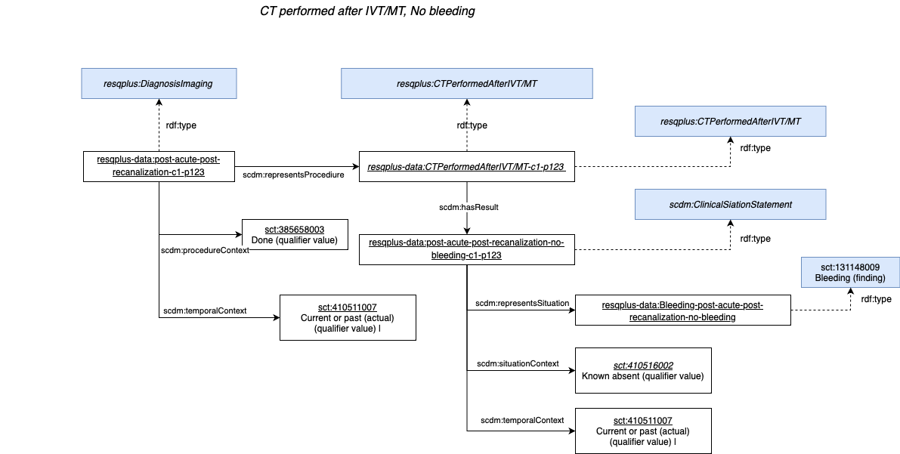
Next, the representation in the RES-Q+ ontology of the discharge destination and treatment prescribed on discharged

Database identifier | Associated label | Ontology Class URI
discharge.destination.discharge_destination | Discharge destination | resqplus:DischargeDestination
discharge.destination.discharge_destination.home | Home | resqplus:DischargeDestination and  scdm:representsProcedure some sct:306689006 and  scdm:procedureContext some sct:385658003
discharge.destination.discharge_destination.same_center | Trasferred within the same center
discharge.destination.discharge_destination.another_center | Trasferred to another center | resqplus:DischargeDestination and  scdm:representsProcedure some sct:306699001 and  scdm:procedureContext some sct:385658003
discharge.destination.discharge_destination.social_care | Social care facility | resqplus:DischargeDestination and  scdm:representsProcedure some sct:306697004 and  scdm:procedureContext some sct:385658003
discharge.destination.discharge_destination.dead | Patient died | resqplus:DischargeDestinationDead
discharge.destination.same_center_department | Discharge destination within the same facility | resqplus:DischargeDestination and  scdm:representsProcedure some sct:306706006 and  scdm:procedureContext some sct:385658003
discharge.destination.same_center_department.rehab | Acute rehabilitation
discharge.destination.same_center_department.post_care | Post-care bed
discharge.destination.same_center_department.another_department | Another department
discharge.destination.another_center_type | Discharged to another facility
discharge.destination.another_center_type.primary_center | Primary stroke center
discharge.destination.another_center_type.comprehensive_center | Comprehensive stroke center
discharge.destination.another_center_type.standard_hospital | Another standard hospital
discharge.destination.another_center_department | Discharged to another facility - department
discharge.destination.another_center_department.rehab | Acute rehabilitation
discharge.destination.another_center_department.post_care | Post-care bed
discharge.destination.another_center_department.neurology | Neurology
discharge.destination.another_center_department.another_department | Another department
discharge.discharge_date | Date of discharge | resqplus:DischargeDate
discharge.discharge_date | Date of discharge | resqplus:DischargeDate
discharge.mrs_score | Modified Rankin Scale (mRS) score on discharge | resqplus:ModifiedRankinScaleOnDischargeValue
discharge.mrs_score | Modified Rankin Scale (mRS) score on discharge | resqplus:ModifiedRankinScaleOnDischargeValue
discharge.nihss | NIHSS score on discharge | resqplus:NIHSSOnDischargeValue
discharge.nihss | NIHSS score on discharge | resqplus:NIHSSOnDischargeValue
discharge.medication.any_treatment_prescribed | Was any treatment prescribed at discharge? | resqplus:DischargeMedicationPrescribed
discharge.medication.any_treatment_prescribed.yes | Yes | resqplus:DischargeMedicationPrescribed and  scdm:procedureContext some sct:385658003
discharge.medication.any_treatment_prescribed.no | No | resqplus:DischargeMedicationPrescribed and  scdm:procedureContext some sct:385660001
discharge.medication.antidiabetics | Antidiabetics | resqplus:DischargeMedicationPrescribed and  scdm:representsProcedure some
discharge.medication.antidiabetics.yes | yes | resqplus:DischargeMedicationPrescribed and  scdm:representsProcedure some and  scdm:procedureContext some sct:385658003
discharge.medication.antidiabetics.no | no | resqplus:DischargeMedicationPrescribed and  scdm:representsProcedure some and  scdm:procedureContext some sct:385660001
discharge.medication.antihypertensives | Antihypertensives | resqplus:DischargeMedicationPrescribed and  scdm:representsProcedure some
discharge.medication.antihypertensives.yes | yes | resqplus:DischargeMedicationPrescribed and  scdm:representsProcedure some and  scdm:procedureContext some sct:385658003
discharge.medication.antihypertensives.no | no | resqplus:DischargeMedicationPrescribed and  scdm:representsProcedure some and  scdm:procedureContext some sct:385660001
discharge.medication.antiplatelets | Antiplatelets | resqplus:DischargeMedicationPrescribed and  scdm:representsProcedure some
discharge.medication.antiplatelets.yes | yes | resqplus:DischargeMedicationPrescribed and  scdm:representsProcedure some and  scdm:procedureContext some sct:385658003
discharge.medication.antiplatelets.no | no | resqplus:DischargeMedicationPrescribed and  scdm:representsProcedure some and  scdm:procedureContext some sct:385660001
discharge.medication.anticoagulants | Anticoagulants | resqplus:DischargeMedicationPrescribed and  scdm:representsProcedure some
discharge.medication.anticoagulants.yes | yes | resqplus:DischargeMedicationPrescribed and  scdm:representsProcedure some and  scdm:procedureContext some sct:385658003
discharge.medication.anticoagulants.no | no | resqplus:DischargeMedicationPrescribed and  scdm:representsProcedure some and  scdm:procedureContext some sct:385660001
discharge.medication.statin | Statin | resqplus:DischargeMedicationPrescribed and  scdm:representsProcedure some
discharge.medication.statin.yes | yes | resqplus:DischargeMedicationPrescribed and  scdm:representsProcedure some and  scdm:procedureContext some sct:385658003
discharge.medication.statin.no | no | resqplus:DischargeMedicationPrescribed and  scdm:representsProcedure some and  scdm:procedureContext some sct:385660001
discharge.medication.other | Other | resqplus:DischargeMedicationPrescribed and  scdm:representsProcedure some
discharge.medication.other.yes | yes | resqplus:DischargeMedicationPrescribed and  scdm:representsProcedure some and  scdm:procedureContext some sct:385658003
discharge.medication.other.no | no | resqplus:DischargeMedicationPrescribed and  scdm:representsProcedure some and  scdm:procedureContext some sct:385660001
discharge.medication.antiplatelet_substances.asa | ASA (aspirin) | resqplus:DischargeMedicationPrescribed and  scdm:representsProcedure some
discharge.medication.antiplatelet_substances.asa.yes | yes | resqplus:DischargeMedicationPrescribed and  scdm:representsProcedure some and  scdm:procedureContext some sct:385658003
discharge.medication.antiplatelet_substances.asa.no | no | resqplus:DischargeMedicationPrescribed and  scdm:representsProcedure some and  scdm:procedureContext some sct:385660001
discharge.medication.antiplatelet_substances.cilostazol | Cilostazol | resqplus:DischargeMedicationPrescribed and  scdm:representsProcedure some
discharge.medication.antiplatelet_substances.cilostazol.yes | yes | resqplus:DischargeMedicationPrescribed and  scdm:representsProcedure some and  scdm:procedureContext some sct:385658003
discharge.medication.antiplatelet_substances.cilostazol.no | no | resqplus:DischargeMedicationPrescribed and  scdm:representsProcedure some and  scdm:procedureContext some sct:385660001
discharge.medication.antiplatelet_substances.clopidogrel | Clopidogrel | resqplus:DischargeMedicationPrescribed and  scdm:representsProcedure some
discharge.medication.antiplatelet_substances.clopidogrel.yes | yes | resqplus:DischargeMedicationPrescribed and  scdm:representsProcedure some and  scdm:procedureContext some sct:385658003
discharge.medication.antiplatelet_substances.clopidogrel.no | no | resqplus:DischargeMedicationPrescribed and  scdm:representsProcedure some and  scdm:procedureContext some sct:385660001
discharge.medication.antiplatelet_substances.ticagrelor | Ticagrelor | resqplus:DischargeMedicationPrescribed and  scdm:representsProcedure some
discharge.medication.antiplatelet_substances.ticagrelor.yes | yes | resqplus:DischargeMedicationPrescribed and  scdm:representsProcedure some and  scdm:procedureContext some sct:385658003
discharge.medication.antiplatelet_substances.ticagrelor.no | no | resqplus:DischargeMedicationPrescribed and  scdm:representsProcedure some and  scdm:procedureContext some sct:385660001
discharge.medication.antiplatelet_substances.ticlopidine | Ticlopidine | resqplus:DischargeMedicationPrescribed and  scdm:representsProcedure some
discharge.medication.antiplatelet_substances.ticlopidine.yes | yes | resqplus:DischargeMedicationPrescribed and  scdm:representsProcedure some and  scdm:procedureContext some sct:385658003
discharge.medication.antiplatelet_substances.ticlopidine.no | no | resqplus:DischargeMedicationPrescribed and  scdm:representsProcedure some and  scdm:procedureContext some sct:385660001
discharge.medication.antiplatelet_substances.prasugrel | Prasugrel | resqplus:DischargeMedicationPrescribed and  scdm:representsProcedure some
discharge.medication.antiplatelet_substances.prasugrel.yes | yes | resqplus:DischargeMedicationPrescribed and  scdm:representsProcedure some and  scdm:procedureContext some sct:385658003
discharge.medication.antiplatelet_substances.prasugrel.no | no | resqplus:DischargeMedicationPrescribed and  scdm:representsProcedure some and  scdm:procedureContext some sct:385660001
discharge.medication.antiplatelet_substances.dipyridamole | Dipyridamole, slow release | resqplus:DischargeMedicationPrescribed and  scdm:representsProcedure some
discharge.medication.antiplatelet_substances.dipyridamole.yes | yes | resqplus:DischargeMedicationPrescribed and  scdm:representsProcedure some and  scdm:procedureContext some sct:385658003
discharge.medication.antiplatelet_substances.dipyridamole.no | no | resqplus:DischargeMedicationPrescribed and  scdm:representsProcedure some and  scdm:procedureContext some sct:385660001
discharge.medication.antiplatelet_substances.other | Other antiplatelet | resqplus:DischargeMedicationPrescribed and  scdm:representsProcedure some
discharge.medication.antiplatelet_substances.other.yes | yes | resqplus:DischargeMedicationPrescribed and  scdm:representsProcedure some and  scdm:procedureContext some sct:385658003
discharge.medication.antiplatelet_substances.other.no | no | resqplus:DischargeMedicationPrescribed and  scdm:representsProcedure some and  scdm:procedureContext some sct:385660001
discharge.medication.anticoagulant_substances.warfarin | Vitamin K antagonist, e.g. Warfarin | resqplus:DischargeMedicationPrescribed and  scdm:representsProcedure some
discharge.medication.anticoagulant_substances.warfarin.yes | yes | resqplus:DischargeMedicationPrescribed and  scdm:representsProcedure some and  scdm:procedureContext some sct:385658003
discharge.medication.anticoagulant_substances.warfarin.no | no | resqplus:DischargeMedicationPrescribed and  scdm:representsProcedure some and  scdm:procedureContext some sct:385660001
discharge.medication.anticoagulant_substances.heparin | Low molecular weight Heparin/Heparin | resqplus:DischargeMedicationPrescribed and  scdm:representsProcedure some
discharge.medication.anticoagulant_substances.heparin.yes | yes | resqplus:DischargeMedicationPrescribed and  scdm:representsProcedure some and  scdm:procedureContext some sct:385658003
discharge.medication.anticoagulant_substances.heparin.no | no | resqplus:DischargeMedicationPrescribed and  scdm:representsProcedure some and  scdm:procedureContext some sct:385660001
discharge.medication.anticoagulant_substances.dabigatran | Dabigatran | resqplus:DischargeMedicationPrescribed and  scdm:representsProcedure some
discharge.medication.anticoagulant_substances.dabigatran.yes | yes | resqplus:DischargeMedicationPrescribed and  scdm:representsProcedure some and  scdm:procedureContext some sct:385658003
discharge.medication.anticoagulant_substances.dabigatran.no | no | resqplus:DischargeMedicationPrescribed and  scdm:representsProcedure some and  scdm:procedureContext some sct:385660001
discharge.medication.anticoagulant_substances.rivaroxaban | Rivaroxaban | resqplus:DischargeMedicationPrescribed and  scdm:representsProcedure some
discharge.medication.anticoagulant_substances.rivaroxaban.yes | yes | resqplus:DischargeMedicationPrescribed and  scdm:representsProcedure some and  scdm:procedureContext some sct:385658003
discharge.medication.anticoagulant_substances.rivaroxaban.no | no | resqplus:DischargeMedicationPrescribed and  scdm:representsProcedure some and  scdm:procedureContext some sct:385660001
discharge.medication.anticoagulant_substances.apixaban | Apixaban | resqplus:DischargeMedicationPrescribed and  scdm:representsProcedure some
discharge.medication.anticoagulant_substances.apixaban.yes | yes | resqplus:DischargeMedicationPrescribed and  scdm:representsProcedure some and  scdm:procedureContext some sct:385658003
discharge.medication.anticoagulant_substances.apixaban.no | no | resqplus:DischargeMedicationPrescribed and  scdm:representsProcedure some and  scdm:procedureContext some sct:385660001
discharge.medication.anticoagulant_substances.edoxaban | Edoxaban | resqplus:DischargeMedicationPrescribed and  scdm:representsProcedure some
discharge.medication.anticoagulant_substances.edoxaban.yes | yes | resqplus:DischargeMedicationPrescribed and  scdm:representsProcedure some and  scdm:procedureContext some sct:385658003
discharge.medication.anticoagulant_substances.edoxaban.no | no | resqplus:DischargeMedicationPrescribed and  scdm:representsProcedure some and  scdm:procedureContext some sct:385660001
discharge.medication.anticoagulant_substances.other | Other anticoagualant | resqplus:DischargeMedicationPrescribed and  scdm:representsProcedure some
discharge.medication.anticoagulant_substances.other.yes | yes | resqplus:DischargeMedicationPrescribed and  scdm:representsProcedure some and  scdm:procedureContext some sct:385658003
discharge.medication.anticoagulant_substances.other.no | no | resqplus:DischargeMedicationPrescribed and  scdm:representsProcedure some and  scdm:procedureContext some sct:385660001
discharge.medication.no_anticoagulant_reasons | Main reason for not prescribing any anticoagulant at discharge
discharge.medication.no_anticoagulant_reasons.allergy | Allergy to or complication r/t warfarin or heparins
discharge.medication.no_anticoagulant_reasons.mental | Mental status
discharge.medication.no_anticoagulant_reasons.consent | Patient/family refused
discharge.medication.no_anticoagulant_reasons.bleeding | Risk for bleeding or discontinued due to bleeding
discharge.medication.no_anticoagulant_reasons.falls | Risk of falls
discharge.medication.no_anticoagulant_reasons.sideeffects | Serious side effect to medication
discharge.medication.no_anticoagulant_reasons.terminal | Terminal illness/Comfort Measures Only
discharge.medication.no_anticoagulant_reasons.planned | Planned to prescribe with a delay

SCT ID | FSN
165197003 | 306685000 |Discharge to establishment (procedure)|
410512000 | 58000006 | Patient discharge (procedure) |
396205005 | 306689006 |Discharge to home (procedure)|
419949007 | 306699001 |Discharge to hospital (procedure)|
433111008 | 306697004 |Discharge to sheltered housing (procedure)|
431999000 | 371828006 |Patient deceased during stay (discharge status = dead) (finding)|
431225005 | 442864001 |Date of discharge (observable entity)|
417936006 | 840318003 |Assessment using Modified Rankin Scale (procedure)|
419059006 | 1255866005 |Modified Rankin Scale score (observable entity)|
441986001 | 450742003 |Assessment using National Institutes of Health stroke scale (procedure)|
385658003 | Done (qualifier value)
385660001 | Not done (qualifier value)
255234002 | After (attribute)
21710002 | 450743008 |National Institutes of Health stroke scale score (observable entity)|
472191000119101 | 308283009 |Discharge from hospital (procedure)|
422504002 | 33633005 |Prescription of drug (procedure)|
1141705002 | 372586001 |Hypotensive agent (substance)|
274100004 | 387458008 | Aspirin (substance) |
131148009 | 116087001 | Cilostazol (substance) |
 | 386952008 | Clopidogrel (substance) |
 | 698805004 | Ticagrelor (substance) |
 | 386950000 | Ticlopidine (substance) |
 | 443129001 | Prasugrel (substance) |
 | 387371005 | Dipyridamole (substance) |
 | 771452004 | Substance with platelet aggregation inhibitor mechanism of action (substance) |
 | 373294004 | Low molecular weight heparin (substance) |
 | 698871007 | Dabigatran (substance) |
 | 442031002 | Rivaroxaban (substance) |
 | 698090000 | Apixaban (substance) |
 | 712778008 | Edoxaban (substance) |
 | 372862008 | Anticoagulant (substance) |
 | 294881007 |Allergy to warfarin (finding)|
 | 36456004 |Mental state finding (finding)|
 | 182895007 |Drug declined by patient (situation)|
 | 704348005 |At increased risk of hemorrhage (finding)|
 | 129839007 |At increased risk for falls (finding)|
 | 704417003 |At increased risk of medication side effect (finding)|
 | 133918004 |Comfort measures (regime/therapy)|
 | 372912004 | Substance with 3-hydroxy-3-methylglutaryl-coenzyme A reductase inhibitor mechanism of action (substance) |
 | 372877000 | Heparin (substance) |

resqplus:DischargeDate
rdfs:subClassOf scdm:ObservationResultStatement and
scdm:isResultOf some sct: 308283009 and
scdm:hasObservable some sct:442864001 and
scdm:hasObservableValue some (scdm:hasValue some xsd:DateTime)
scdm:situationContext some sct:410515003 and
scdm:temporalContext some sct:410511007

resqplus:ModifiedRankinScaleOnDischargeValue
rdfs:subClassOf scdm:ObserationResultStatement and
scdm:isResultOf some resqplus:ModifiedRankinScaleOnDischarge and
scdm:hasObservable some sct:1255866005 and
scdm:hasObservableValue some (scdm:hasValue some xsd:Integer)and
scdm:situationContext some sct:410515003 and
scdm:temporalContext some sct:410511007

resqplus:ModifiedRankinScaleOnDischarge
rdfs:subClassOf sct:840318003 and sct:363702006 some sct:308283009

resqplus:NIHSSOnDischargeValue
rdfs:subClassOf scdm:ObserationResultStatement and
scdm:isResultOf some resqplus:NIHSSSOnDischarge and
scdm:hasObservable some sct:450743008 and
scdm:hasObservableValue some (scdm:hasValue some xsd:Integer)and
scdm:situationContext some sct:410515003 and
scdm:temporalContext some sct:410511007

resqplus:NIHSSOnDischarge
rdfs:subClassOf sct:450742003 and sct:363702006 some sct:308283009

resqplus:DischargeDestination
rdfs:subClassOf scdm:ClinicalProcedureStatement and
scdm:isResultOf some sct:308283009 and
scdm:representsProcedure some resqplus:DischargeDestinationProcedureValueSet and scdm:procedureContext some resqplus:StatementProcedureQualifierValueSet and scdm:temporalContext some sct:410511007

resqplus:DischargeDestinationProcedureValueSet
rdfs:subClassOf sct:306689006 or sct:306699001 or sct:306697004 or sct:306706006

resqplus:DischargeDestinationDead
rdfs:subClassOf scdm:ClinicalSituationStatement and
scdm:isResultOf some sct:308283009 and
scdm:representsSituation some sct:371828006 and
scdm:situationContext some sct:410515003 and
scdm:temporalContext some sct:410511007

resqplus:DischargeMedicationPrescribed
rdfs:subClassOf scdm:ClinicalProcedureStatement and
scdm:isResultOf some sct:308283009 and
scdm:representsProcedure some resqplus:DischargeMedicationValueSet and scdm:procedureContext some resqplus:StatementProcedureQualifierValueSet and scdm:temporalContext some sct:410511007

resqplus:AntihypertensivesAdminProcedure
rdfs:subClassOf sct:18629005 and sct:609096000 some (sct:363701004 some sct:372586001)

resqplus:AntiPlateletsAdminProcedure
rdfs:subClassOf sct:18629005 and sct:609096000 some (sct:363701004 some sct:771452004)

resqplus:AnticoagulantsAdminProcedure
rdfs:subClassOf sct:18629005 and sct:609096000 some (sct:363701004 some sct:372862008)

resqplus:StatinAdminProcedure
rdfs:subClassOf sct:18629005 and sct:609096000 some (sct:363701004 some sct:372912004)

resqplus:AspirinAdminProcedure
rdfs:subClassOf sct:18629005 and sct:609096000 some (sct:363701004 some sct:387458008)

resqplus:CilostazolAdminProcedure
rdfs:subClassOf sct:18629005 and sct:609096000 some (sct:363701004 some sct:116087001)

resqplus:ClopidrogrelAdminProcedure
rdfs:subClassOf sct:18629005 and sct:609096000 some (sct:363701004 some sct:386952008)

resqplus:TicagrelorAdminProcedure
rdfs:subClassOf sct:18629005 and sct:609096000 some (sct:363701004 some sct:698805004)

resqplus:TiclopidineAdminProcedure
rdfs:subClassOf sct:18629005 and sct:609096000 some (sct:363701004 some sct:386950000)

resqplus:PrasugrelAdminProcedure
rdfs:subClassOf sct:18629005 and sct:609096000 some (sct:363701004 some sct:443129001)

resqplus:DipyridamoleAdminProcedure
rdfs:subClassOf sct:18629005 and sct:609096000 some (sct:363701004 some sct:387371005)

resqplus:LMWHeparin/HeparinAdminProcedure
rdfs:subClassOf sct:18629005 and sct:609096000 some (sct:363701004 some sct:373294004 or sct:372877000)

resqplus:DabigatranAdminProcedure
rdfs:subClassOf sct:18629005 and sct:609096000 some (sct:363701004 some sct:698871007)

resqplus:RivaroxabanAdminProcedure
rdfs:subClassOf sct:18629005 and sct:609096000 some (sct:363701004 some sct:442031002)

resqplus:ApixabanAdminProcedure
rdfs:subClassOf sct:18629005 and sct:609096000 some (sct:363701004 some sct:698090000)

resqplus:EdoxabanAdminProcedure
rdfs:subClassOf sct:18629005 and sct:609096000 some (sct:363701004 some sct:712778008)

resqplus:DischargeMedicationValueSet
rdfs:subClassOf resqplus:AntihypertensivesAdminProcedure or resqplus:AntiPlateletsAdminProcedure or resqplus:AnticoagulantsAdminProcedure or
resqplus:StatinAdminProcedure or resqplus:AspirinAdminProcedure
or resqplus:CilostazolAdminProcedure or resqplus:ClopidrogrelAdminProcedure
or resqplus:TicagrelorAdminProcedure or resqplus:TiclopidineAdminProcedure
or resqplus:PrasugrelAdminProcedure or resqplus:DipyridamoleAdminProcedure
or resqplus:LMWHeparin/HeparinAdminProcedure or resqplus:DabigatranAdminProcedure
or resqplus:RivaroxabanAdminProcedure or resqplus:ApixabanAdminProcedure or
resqplus:EdoxabanAdminProcedure

