**Teste de imagens do fundo**

<title>Teste de imagens do fundo</title>

    <style>

        body{

            background-image: url('imagens/wallpaper001.jpg');

        }

        div.quadrado{

            display:inline-block;

            border : 2px solid black;

            border-radius: 10px;

            background-color:lightgray;

            width: 200px;

            height: 200px;

        }

        div#q1{

            background-color: skyblue;

        }

        div#q2{

            background-image:linear-gradient(to bottom, yellow, red);

        }

        div#q3{

            background-image: url('imagens/pattern003.png');

        }

    </style>

</head>

<body>

    <div class="quadrado" id="q1">

    </div>

    <div class="quadrado" id="q2">

    </div>

    <div class="quadrado" id="q3"></div>

</body>

</html>

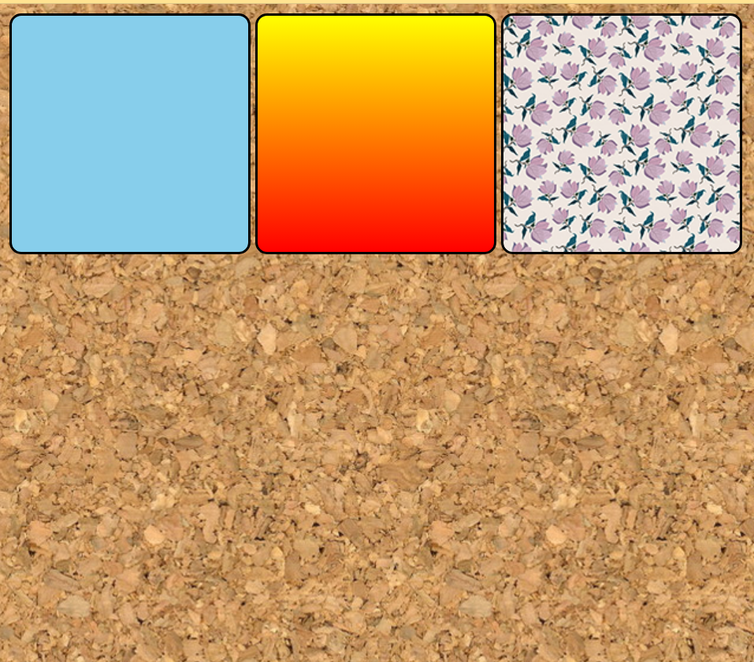

**Personalização dos fundos**

    <style>

        body{

            background-image: url('https://github.com/gustavoguanabara/html-css/blob/master/imagens/mascote.png?raw=true');

            background-size: 100px 100px;

            background-repeat: repeat-y;

        }

 background-repeat: repeat-y;



background-repeat: repeat-x;



 background-repeat: no-repeat;

background-size: 100px 100px; ( para personalizar o tamanho das fotos.)

**Posicionamento**

<style>

        body{

            height: 98vh;

            background-image: url('imagens/wallpaper003.jpg');

            background-repeat:no-repeat;

            background-position: center center;

        }



<style>

        body{

            height: 98vh;

            background-image: url('https://github.com/gustavoguanabara/html-css/blob/master/imagens/mascote.png?raw=true');

            background-size: 100px 100px;

            background-repeat: no-repeat;

            background-position: right top;

        }

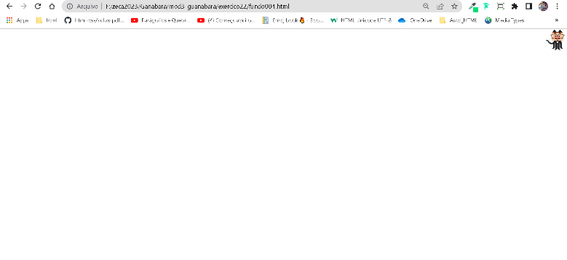

**Teste de imagem de fundo**

<style>

body{

    height: 100vh;

    background-color: black;

    background-image: url('imagens/wallpaper002.jpg');

    background-position: center center;

    background-repeat: no-repeat;

    background-size: cover;

}

main{

    background-color: white;

    width: 400px;

    padding: 10px;

    margin: auto;

    border: 1px solid darkblue;

    border-radius: 15px;

}

</style>

</head>

<body>

    <main>

        <h1>Teste de imagem de fundo    </h1>

        <p> Lorem ipsum dolor sit amet consectetur adipisicing elit. Neque quia vel earum dolores at hic, iste dolorum harum eveniet autem quod, voluptatum iure molestiae vero nobis alias? Cumque, similique delectus.

        Lorem, ipsum dolor sit amet consectetur adipisicing elit. Doloribus maxime alias dicta laboriosam. Magnam pariatur, deserunt dolorum, delectus earum eveniet expedita et, eius molestiae commodi voluptatibus ullam quam esse optio?

        </p>



Para continuar a imagem tem que colocar no eixo y

background-repeat:repeat-y;

**Fundo fixo de tela**

 <title> </title>

<style>

body{

    height: 100vh;

     /*

    background-color: black;

    background-image: url('imagens/wallpaper002.jpg');

    background-position: center center;

    background-repeat:no repeat;

    background-attachment: fixed;

   shorthand - backgroud

    color > image > position > repeat > [size] > attachment

   */

   background: black url('imagens/wallpaper002.jpg') center center no-repeat  fixed;

   background-size: cover;

}

main{

    background-color: white;

    max-width: 400px;

    padding: 10px;

    margin: auto;

    border: 1px solid darkblue;

    border-radius: 15px;

}

</style>

----------------------------------------------------------------------------------------------------------------------------

**Alinhamento vertical**

    <style>

        #container{

            background-image: url('imagens/target001.png');

            background-size: 100% 100%;

            position: relative;

            height: 96vh;

            height: 500px;

            padding: 10px;

            background-color: purple;

        }

        #conteudo{

            background-image: url('imagens/target001.png');

            background-size: 100% 100%;

            position: absolute;

            height: 200px;

            width: 400px;

            background-color: yellow;

            left: 50%;

            top: 50%;

            transform: translate(-50%, -50%);

        }

    </style>

