**Technical Feasibility Report**

**Health Fitness**

The aim of the project is to create an application that would facilitate users to find nearby best Health Fitness Centre which listed according to the category of the services, ratings etc..,. A mobile application is best suited to meet all the requirements of the stated problem. The feedback collected from the users facilitates the future users to select the best Fitness Centers.

**Minimum System Requirements:**

* **RAM:** 512MB and above
* **Processor Speed:** 1.5 ghz and above
* **Operating System:** Windows 7/8 and Android Kitkat
* **Hard Disk Space:** 2GB

**Technologies to be used in development:**

* **Front-end Design:** HTML5, CSS3, JavaScript, Bootstrap.
* **Development Language:** PHP5.
* **Database:** MySql.

The above technologies are Free and open source and hence there is no Cost for any of the software which reduces the initial investments.

**More on open source:**

Open-source software (OSS) is [computer software](https://en.wikipedia.org/wiki/Computer_software) with its [source code](https://en.wikipedia.org/wiki/Source_code) made available with a [license](https://en.wikipedia.org/wiki/Open-source_license) in which the [copyright](https://en.wikipedia.org/wiki/Copyright) holder provides the rights to study, change, and distribute the software to anyone and for any purpose.

**Initial User Interface Designs:**

Home Page Design and Direct Search design:

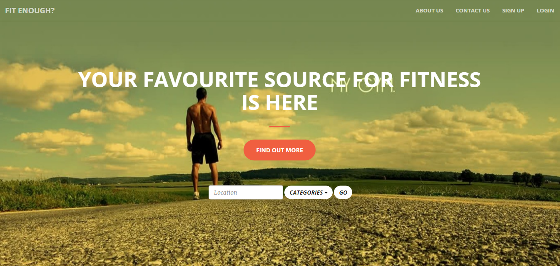

fig1:The above fig depicts Home page of the application, Direct Search is provided for new users who has not signed up.

Login Design:

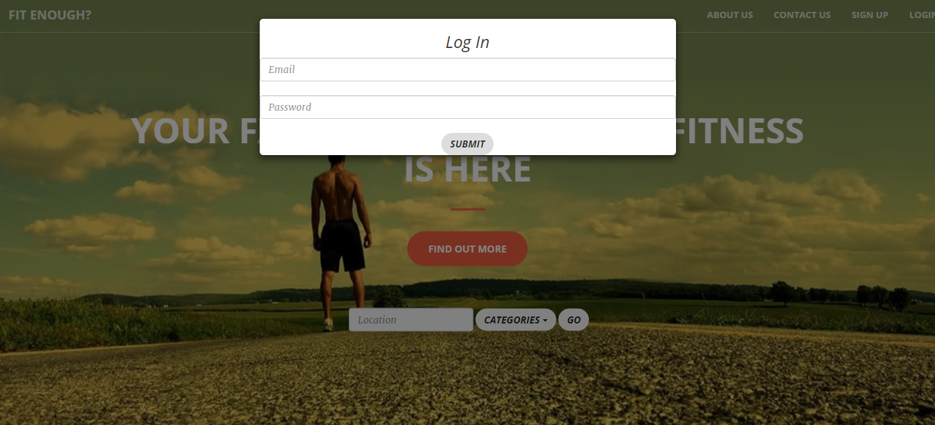

fig2:The above fig depicts Login page of the application. A pop up window appears when the Login option is chosen.

Contact Us Design:



fig3:The above fig depicts contact us page which is scrolled down when clicked.

Search Results page Design:

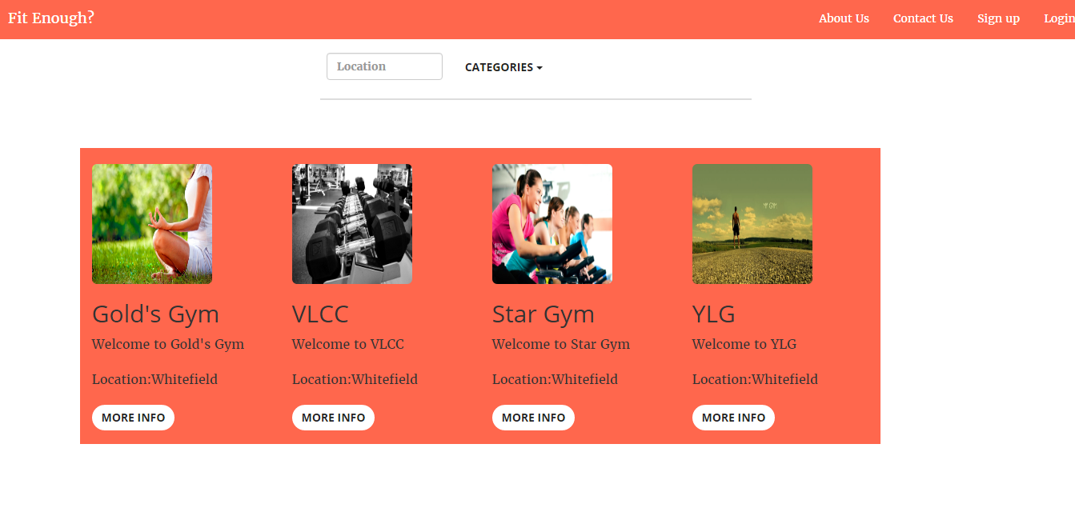

fig3:The above fig depicts Search Results page for the application. The Gym details are created dynamically based on the Location and categories as Parameters. The more info option will provide the route map and ratings.

Further the filter and sort option will also be provided in result page to provide ease of accsess.