Recursive Self-Improvement, Literature Review
Tom Cunningham
2026-04-08
 Important
- This is a draft report on what we know about RSI, it covers:
  - Basic introduction to the problem
  - Survey of data: training expenditure (3X/year); training efficiency (4X/year); R&D effort (2X/year).
  - An overview of ~10 different models of RSI.
- Still missing:
  - Survey of evidence on speedup & autonomous optimization ability.
  - Crisper statement of the balance of evidence.

Summary.
AI capabilities are growing very rapidly, in large part due to R&D by AI researchers:
$$\xymatrix@C=3em@R=1.4em{
*++[F]{\text{R\&D}}\ar[r]|(0.4)r
& *++[F]{\text{AI Capabilities}}
}
$$
We are now beginning to see signs of feedback, where AI is sufficiently capable to accelerate progress in R&D:
$$
\xymatrix@C=3em@R=1.4em{
*++[F]{\text{R\&D}}\ar[r]|(0.4)r
& *++[F]{\text{AI Capabilities}}\ar@{.>}@/_3em/[l]|{?}
}
$$
We have reason to believe that capability progress is very sensitive to the quantity of R&D input ($r≈1$), but there is a great deal of uncertainty on how capabilities will affect R&D.
We can break the effects into two types, and make some very tentative guesses as of March 2026:
- Augmentation: agents are multiplying AI R&D worker effectiveness by 10%-100%.
- Automation: agents are autonomously able to increase the efficiency of human-optimized algorithms by 1%-10%.
The critical uncertainty is how these effects scale. If R&D acceleration continues to scale with capabilities growth then we would expect an imminent substantial acceleration over the historical rate of capabilities growth.

Argument
AI capabilities are growing very rapidly.
There’s no consensus on an appropriate scale for AI capabilities, however we see steady and rapid growth across many metrics:
- METR’s time horizon has been doubling at around 7 months.
- Effective compute has been growing at around 9X/year.
- Average benchmark scores (ECI) have been growing steadily for 4 years.
In each of these metrics there are signs of a recent acceleration.
Much of the growth in capabilities is due to R&D progress.
AI researchers have been making a very consistent series of discoveries, typically estimated at increasing compute efficiency by around 4X/year (with many qualifications, discussed below).
The 4X/year increase in algorithmic efficiency seems to be coming from a roughly 2X/year growth in AI researchers.
We are seeing signs of AI accelerating R&D.
Until recently AI R&D was mostly done without significant help from AI, but we now see evidence for two channels:
- Augmenting AI researchers: AI researchers self-report big efficiency gains, e.g. Anthropic (2025) self-report approximately 50% productivity gains, and Anthropic (2026) estimate 100% productivity gains.
- Automating AI research: E.g. AlphaEvolve, TTT-Discover, autoresearch.
Both of these effects are hard to measure, & we have a great deal of uncertainty.
Algorithmic progress is sensitive to research input.
Much of the literature on recursive self-improvement has estimated the effect of R&D inputs on algorithmic progress:
source | $r=λ/β$
Erdil, Besiroglu, and Ho (2024) | 0.8-3.5
Ho and Whitfill (2025) | 0.96-1.89
Davidson and Houlden (2025) | 1.2
Davidson et al. (2026) | 1 ($r_{s}$)
There are two basic mechanisms used in the literature.
Multiplying robots. Some papers assume that the effective R&D workforce will be directly proportional to a measure of AI algorithmic progress, e.g. algorithmic efficiency. This would be true in a simple model where we have invented a perfect substitute for a human R&D worker, and then further algorithmic progress allows us to multiply the number of automated R&D workers. This assumption makes the problem very tractable: we can estimate the relationship between R&D and capabilities ($r$) then we can predict whether automating AI R&D would kick off an intelligence explosion.
$$
\xymatrix@C=3em@R=1.4em{
*++[F]{\text{R\&D}}\ar[r]|(0.4)r
& *++[F]{\text{AI Capabilities}}\ar@{.>}@/_3em/[l]|1
}
$$
This basic mechanism is used by Davidson (2021), Davidson and Houlden (2025), Ho and Whitfill (2025), Eth and Davidson (2025), Davidson et al. (2026).
Automating tasks. Instead we could assume that, as AI progresses, it can progressively replace labor with capital in certain tasks. Humans will still be required but they will be sped-up, in proportion to the fraction of task automated, the substitutability between tasks, and the cost of automated tasks. This is the model in Aghion, Jones, and Jones (2019), B. F. Jones (2025), Kwa (2026). The difficulty is that the relationship between AI capabilities and the automation or uplift rate is very difficult to estimate, here represented as $f\left(a\right)$:
$$
\xymatrix@C=3em@R=1.4em{
*++[F]{\text{R\&D}}\ar[r]|(0.4)r
& *++[F]{\text{AI Capabilities}}\ar@{.>}@/_3em/[l]|{f(a)}
}
$$
Models which do not fall into these buckets: Kokotajlo et al. (2025), David Rein’s model, Tom and Manish’s apple-picking model.
In this note we are focussing on near-term acceleration.
For this note we are focussing on whether the progress in AI capabilities will significantly accelerate over a short period, e.g. compressing 3 years into 1 year of progress, which would imply going from 4X/year to 64X/year compute efficiency.
We thus leave aside questions of the ceiling on AI capability growth, e.g. discussed in Davidson and Houlden (2025), Cotra (2020).
An implication of this constraint is also that if we achieve an AI research agent that is a perfect substitute for a human researcher (ASARA) then there will likely be an immediate jump in AI research, and would satisfy the criteria for acceleration. E.g. Davidson and Houlden (2025) predict that when an ASARA is first possible, AI capabilities will jump by 8X.

Important Qualifications
Training expenditure is likely to grow more slowly.
We can decompose frontier capabilities progress into two parts: (1) increased training expenditure; (2) progress in efficiency given training expenditure: algorithms, data collection, and other cost efficiencies in other parts of the AI stack.
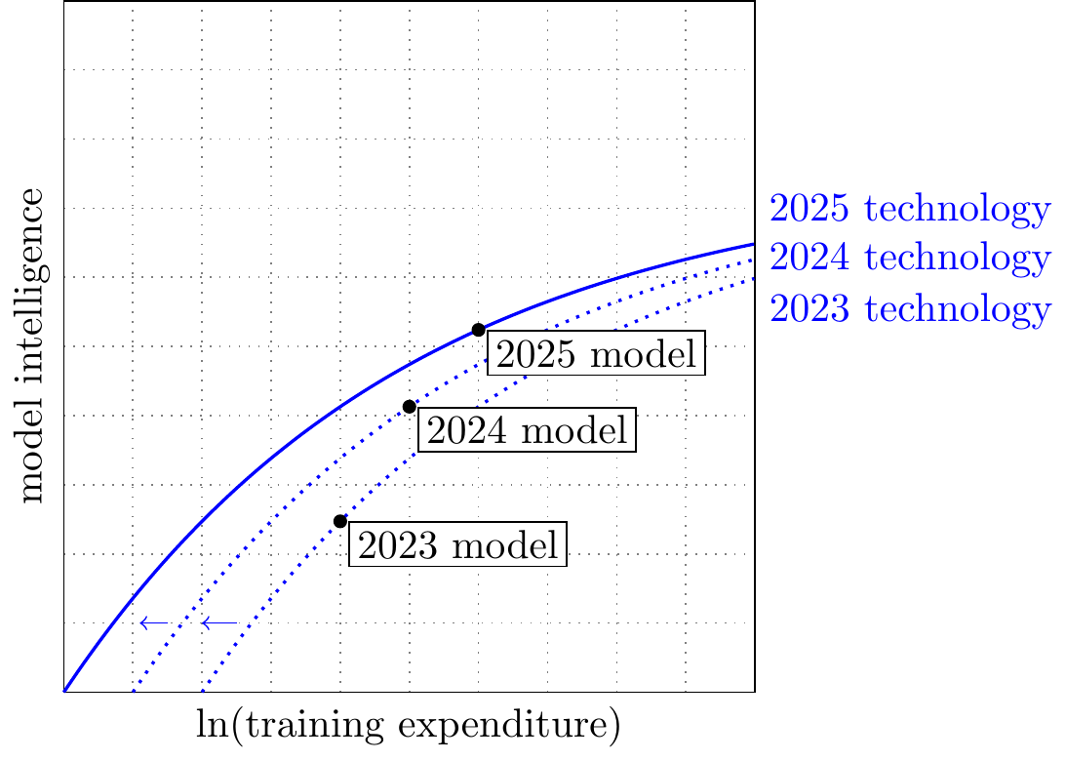
We estiamte below that training expenditure is growing around 3X/year, and training efficiency at around 4X/year, for a net growth of 12X/year.
Most people expect the growth rate of training expenditure will fall over the next few years, from 3X to around 1.2X.
AI R&D may be bottlenecked on experiment compute.
Erdil and Barnett (2025) argue that experimental compute could be important:
“AI is the [domain] that has seen both the fastest experimental compute scaling and the fastest rate of software progress, with both of them currently being around 3-4x per year. This coincidence suggests that using experimental compute to generate data is at least important for software progress, though we can’t tell on this basis alone to what extent it’s a complementary input to researcher effort.
Whitfill and Wu (2025) estimate the relative contribution of experiment compute and R&D workers, but their findings are inconclusive.
Leibowich, Jurkovic, and Davidson (2025), based on interviews with AI researchers, say:
“AI cognitive labor could probably extract significantly more research insights out of limited compute.”
The contribution of AI R&D may be overstated.
Gundlach et al. (2025) argue that previous estimates have overstated algorithmic progress, they estimate a 1.5X growth per year instead of 2.5X (more details below).
I find this estimate hard to reconcile with other estimates, which show ~2.5X growth even in small models.
AI R&D may be bottlenecked on data.
It is possible that data is an important input to capability growth, which could cause us to overstate our estimate of algorithmic advances. Two relevant arguments:
- Berren Millidge, “Most Algorithmic Progress is Data Progress”, and he notes that data has been growing slower than compute.
- Werra (2025) argues that LLM capabilities are mostly determined by data coverage, and so implicitly growth is determined by the ability to collect more data.

Training Expenditure ≈ 3X/year
Best estimates.
- Training compute expenditure has been growing around 3X/year, but expected to gradually fall to 1.1X/year over 2026-2030.
- Training compute (FLOP) has been growing around 4X/year, but will fall to around 1.5X/year.
source | scope | growth | years | quantity
Amodei and Hernandez (2018) | largest AI training runs | 10X | 2012-2018 | training compute (FLOP)
Epoch AI (2025a) | notable models | 4.1X | 2010-May 2024 | training compute (FLOP)
Epoch AI (2025a) | frontier models | 5.3X | 2010-May 2024 | training compute (FLOP)
Epoch AI (2025a) | recent frontier models | 4.2X | ~2018-May 2024 | training compute (FLOP)
Epoch AI (2025a) | frontier language models | 5.0X | mid-2020-May 2024 | training compute (FLOP)
Epoch AI (2025a) | notable language models | 9.5X | Jun 2017-May 2024 | training compute (FLOP)
Epoch AI (2026a) | notable models | 4.4-4.7X | 2010-2026 | training compute (FLOP)
Epoch AI (2025b) | notable models graph | ~4.6X | 2020-Jul 2025 | training compute (FLOP)
Epoch AI (2026b) | frontier language models | 5X | 2020- | training compute (FLOP)
Epoch AI (2026b) | installed NVIDIA compute stock | 2.3X | 2019- | compute stock (FLOP/s)
Efrati and Muppidi (2025) | OpenAI training compute spend | 2.3X->1.1X | 2025-2030 | training compute ($)
Epoch AI (2026b) | frontier language model training cost | 3.5X | 2020- | training compute ($)
Edelman and Ho (2025) | OpenAI compute spend / compute stock | 2.2X | 2024-2025 | compute spend / stock ($)
Efrati and Muppidi (2025) | OpenAI compute spend | 2.3X->1.1X | 2025-2030 | total compute (training+inference) ($)
Amodei and Hernandez (2018) “AI and compute”
“since 2012, the amount of compute used in the largest AI training runs has been increasing exponentially with a 3.4-month doubling time”
“The trend represents an increase by roughly a factor of 10 each year.”
Epoch AI (2026b) “Trends in Artificial Intelligence”
As of March 2026, but they say “These trends appear set to continue through 2030.”
- Compute stock growth: 2.3X/year (2.2X-2.5X), “the total computing power of the stock of NVIDIA chips”
- Training compute: 5X/year (4X-6X)
- FLOP/s per dollar: 1.37X/year (1.30X-1.45X)
- Algorithmic progress: 3X/year (2.8X-4.4X) (“pre-training compute efficiency”)
- Training cost: 3.5X/year (2.8X-4.4X)
- LLM inference prices: 40X/year (10X-900X) “the cost to inference an LLM at a fixed level of performance has fallen rapidly, but unevenly across tasks”
Edelman and Ho (2025) “Compute scaling will slow down due to increasing lead times”
“OpenAI currently likely has over $15 billion worth of compute, and this compute stock has been growing by around 2.2× each year. At that pace, current trends would predict a trillion dollar cluster around 2030 — but longer lead times would delay this to around 2035.”
“OpenAI’s compute spend in mid-2024 was around $6 billion, compared to roughly $13 billion mid-2025. This leads to a factor increase of around 2.2×
Efrati and Muppidi (2025) “OpenAI’s $350 Billion Computing Cost Problem”
They have leaked data on OpenAI compute expenditure forecasts, as of late 2025:
Year | R&D Compute | Inference Compute | R&D% | Revenue
2025 | ~$8B | ~$6B | 57% | ~$12B
2026 | ~$18B (+125%) | ~$14B (+133%) | 56% | ~$30B (+150%)
2027 | ~$32B (+78%) | ~$20B (+43%) | 62% | ~$60B (+100%)
2028 | ~$40B (+25%) | ~$28B (+40%) | 59% | ~$100B (+67%)
2029 | ~$45B (+13%) | ~$35B (+25%) | 56% | ~$145B (+45%)
2030 | ~$50B (+11%) | ~$50B (+43%) | 50% | ~$200B (+38%)
Epoch AI (2025a) “Training compute of frontier AI models grows by 4-5x per year”
“compute growth in recent years is currently best described as increasing by a factor of 4-5x/year.”
More granular estimates from the same post:
- notable models: 4.1x/year (90% CI: 3.7x to 4.6x) between 2010 and May 2024
- frontier models: 5.3x/year (90% CI: 4.9x to 5.7x) between 2010 and May 2024
- recent frontier models: 4.2x/year (90% CI: 3.6x to 4.9x) after ~2018
- frontier language models: 5.0x/year (90% CI: 3.1x to 7.3x) after mid-2020
- notable language models overall: 9.5x/year (90% CI: 7.4x to 12.2x) between June 2017 and May 2024
“recent frontier growth since 2018 is better described as a 4x/year trend.”
“notable language models overall … have grown as fast as 9x/year between June 2017 and May 2024.”
Epoch AI (2026a) “The training compute of notable AI models has been doubling roughly every six months”
“Since 2010, the training compute used to create AI models has been growing at a rate of 4.4x per year.”
Historical: 2010 onward. The same page’s regression table gives 4.7x / year (4.3x to 5.2x), so the safest summary is probably “roughly 4.5x/year.”
Whitfill, Snodin, and Becker (2025) “Forecasting AI Time Horizon Under Compute Slowdowns”
They use OpenAI’s own compute-spend forecasts up to 2030, as reported in journalism.
The annualized growth rates I wrote above (~2.5X/year for 2026-2028, ~1.5X/year for 2028-2030) are only rough chart reads from the figure, not direct textual claims in the paper.
Epoch AI (2025b) “Data on AI Models”
“Our comprehensive database of over 3200 models tracks key factors driving machine learning progress.”
The interactive graph currently shows about 4.6x/year growth in FLOPs of notable models, over 2020 - July 2025 (the latest datapoint).
You (2025) “Most of OpenAI’s 2024 compute went to experiments”
- $5B total research compute
- $2B inference compute
- only a minority of R&D compute appears to have gone to the final training runs of released models
- GPT-4.5 final training run was only a modest share of the total R&D bucket

Training Efficiency ≈ 4X/year
Best estimates.
- Around 4X/year, including the entire stack (GPU, pretraining, posttraining, elicitation).
source | scope | progress | years | quantity
Epoch AI (2026b) | AI hardware price-performance | 1.37X | 2012-2025 | FLOP/s per dollar
Ho et al. (2024) | pre-training compute efficiency | 3X | 2012-2023 | compute to reach a fixed performance threshold
Whitfill, Snodin, and Becker (2025) | broad software progress implied by the time-horizon model | 3.5X | 2019-2025 | effective software progress
Ho (2026) | broad all-in software progress | 10X (2X-50X) | recent LLM era | inclusive of training + post-training
Byrnes (2026) | narrow core learning algorithm improvements | 1.3X | 2018-2026 | excludes data/setup-specific gains
Gundlach et al. (2025) | small-scale algorithmic progress | 1.5X | 2012-2023 | FLOPs required to achieve benchmark scores at small scale
Gundlach et al. (2025) | frontier-scale algorithmic progress | 2.5X | 2012-2023 | FLOPs required to achieve benchmark scores at large scale
Eth and Davidson (2025) | training efficiency |  | 2X
Epoch AI (2026b) | pre-training compute efficiency | 3X | 2026- | forward-looking pre-training compute efficiency
Whitfill (2026) | GPT-2 replication case study: fewer FLOPs | 1.72X | 2019-2026 | FLOP efficiency in training GPT-2
Whitfill (2026) | GPT-2 replication case study: fewer GPUs | 2.5X | 2019-2026 | GPU required to train GPT-2
Thompson, Ge, and Manso (2022) “The Importance of (Exponentially More) Computing Power”
“we assemble direct quantitative evidence of the impact that computing power has had on five domains: two computing bellwethers (Chess and Go), and three economically important applications (weather prediction, protein folding, and oil exploration). Computing power explains 49%-94% of the performance improvements in these domains.”
[Not a direct estimate for LLM training efficiency, but useful outside-view background for the broader compute-versus-algorithms debate.]
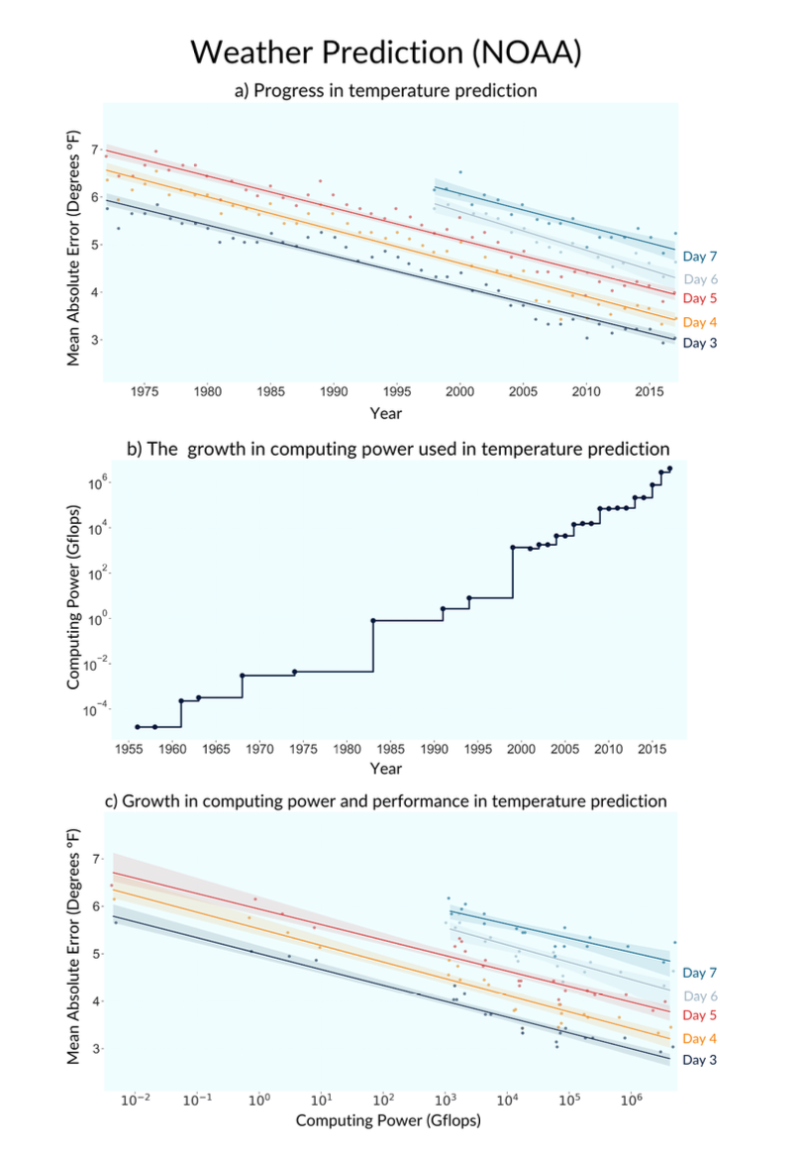
Ho et al. (2024) “Algorithmic progress in language models”: 3X/year
“the compute required to reach a set performance threshold has halved approximately every 8 months, with a 95% confidence interval of around 5 to 14 months”, i.e. about 2.8X/year.
Gundlach et al. (2025) “On the Origins of Algorithmic Progress in AI”: 1.5X/year.
“Our results indicate that algorithmic progress for small models has been far slower than previously assumed, and that measures of algorithmic efficiency are strongly reference-dependent.”
“We find two strongly scale-dependent algorithmic innovations: LSTMs to Transformers, and Kaplan to Chinchilla re-balancing. Together, these account for 91% of total efficiency gains when extrapolating to the 2025 compute frontier.”
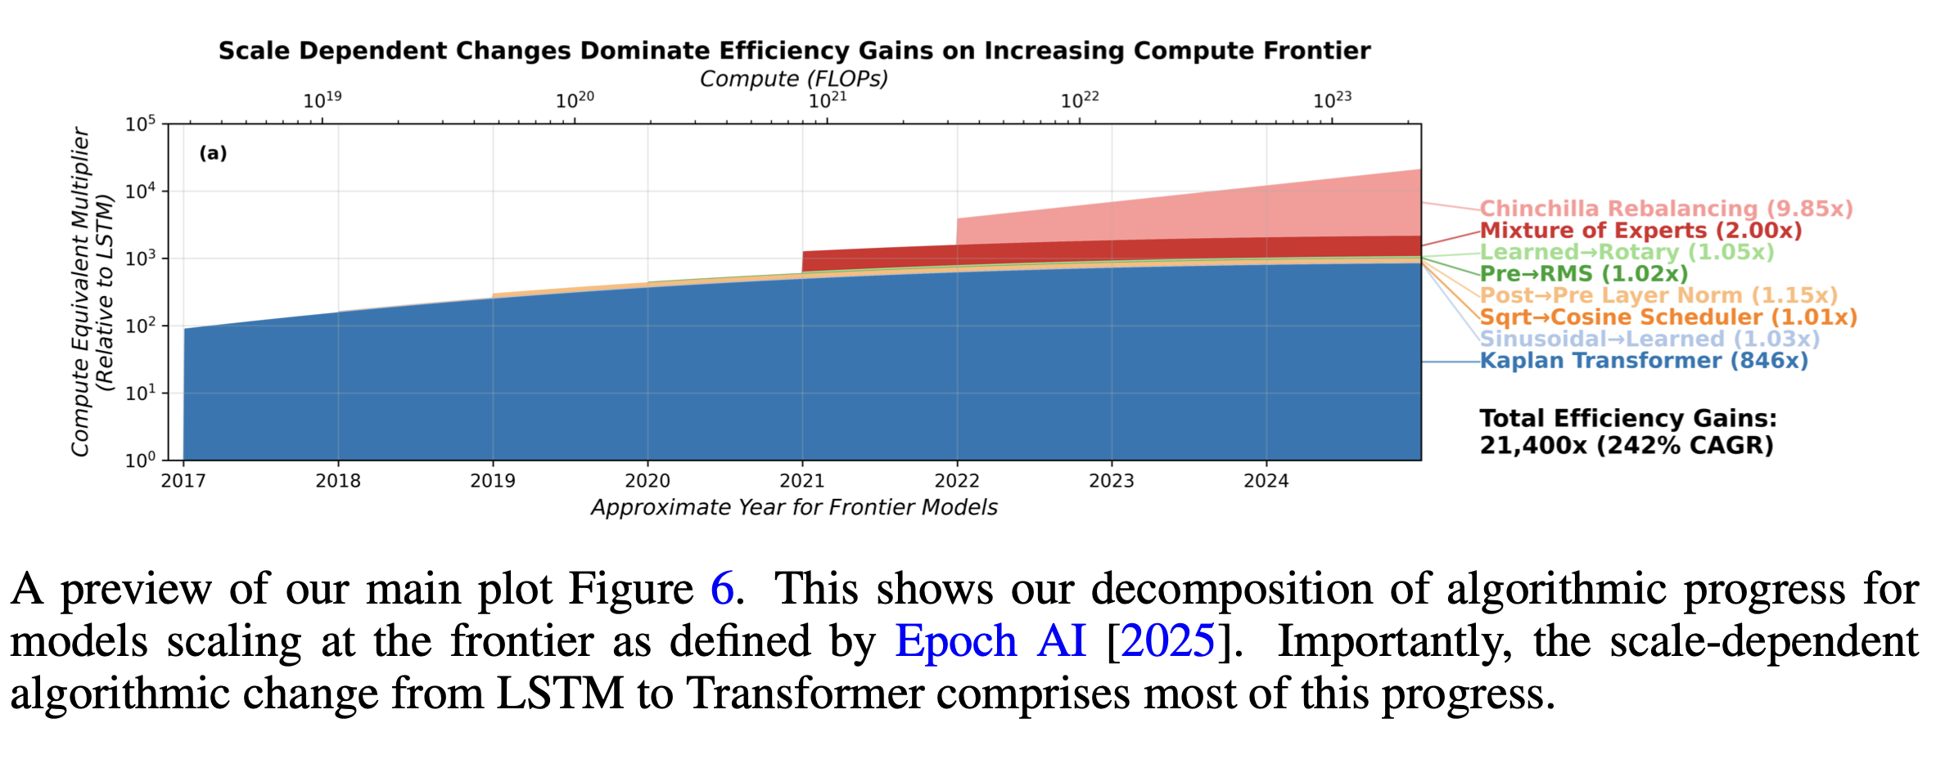
Figure
Estimates over 2012-2023:
- 21,000X total (2.5X/year)
- 100X at small scale (1.5X/year), i.e. if we hadn’t scaled compute we’d only be increasing at 1.5X/year.
Eth and Davidson (2025)
They survey the speed of algorithmic progress in a lot of domains, in summary they say for LLMs “We believe it’s reasonable to … conclude that both training efficiency and runtime efficiency have a ~6 month doubling time.”
Ho (2026) “The least understood driver of AI progress”: 10X/year.
“So here’s my best guess: after accounting for all training compute (including post-training), I think we’re seeing software progress at around 10x per year, and my 80% credible interval would probably range from 2x to 50x per year.”
Byrnes (2026) “The nature of LLM algorithmic progress (v2)”: 1.3X/year.
“apart from [transformers] the field has produced probably <10x of training efficiency improvements in this category in the entire period from 2018 to today (approx. 30%/year).”
He says he is deliberately restricting attention to core “learning algorithm” improvements, excluding data-related improvements and setup-specific optimizations.
Whitfill (2026) “Post on GPT-2 to nanoGPT efficiency gains”: 2.5X/year
He estimates GPT-2 efficiency improvement was 700X over 2019-2026. Important to note that this is all at relatively small scale, so I think it is best treated as a case study rather than an estimate for frontier models.
- Current nanogpt SOTA is 707x faster (2.5X/year)
- 15x faster FLOP per second (on fixed hardware) (1.5X/year)
- 46x less FLOPs to reach the same val loss (1.7X/year)
Also notable from nanoGPT (Jordan and contributors (2026)):
- Wall clock time: 30X lower (May 2024 was 45 minutes; Feb 2026 was 1.5 minutes; 5 doublings over 21 months so doubling every 4 months).
- Cost: 2500X lower (Karpathy says his 2024 nanoGPT costs ~$20 to train the model to get GPT-2 Karpathy (2024), a 2019 blog post estimated GPT-2 training cost was $50K).

R&D Workers ≈ 2X/year
- Whitfill and Wu (2025) estimate headcount growth rates of 2-3X/year for Anthropic and OpenAI, over 2022-2024:
- 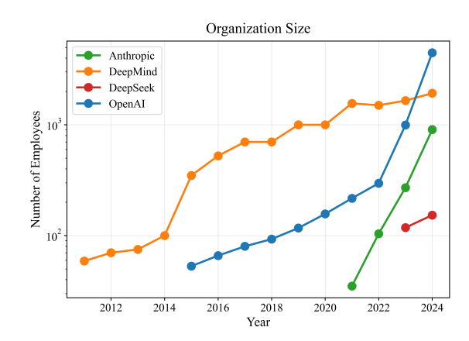
- Epoch estimate growth rates of 1.6X-3.2X/year in total staff.
- Ho and Whitfill (2025) estimate the growth in AI-related publications, as a proxy for R&D effort, however they do not report the growth rate as far as I can tell.

Review of RSI Models

Summary
Model | Summary
Charles I. Jones (1995) “R&D-Based Models of Economic Growth.” | Standard endogenous growth model: (1) diminishing returns to R&D effort; (2) positive spillovers from knowledge.
Aghion, Jones, and Jones (2019) “Artificial Intelligence and Economic Growth” | They model gradual automation of research tasks; in the limit, AI replaces people in idea production.
Davidson (2021) “Could Advanced AI Drive Explosive Economic Growth” | An AI robot perfectly substitutes for a worker, & then they model the quantity increase of AI workers.
Ho and Whitfill (2025) | effective R&D is proportional to algorithmic efficiency (i.e. assumes multiplying robots)
Kokotajlo et al. (2025) “AI Futures Model: Dec 2025 Update” | Stagewise automation of AI R&D: coding first, then research taste / direction-setting; eventual full automation at SAR.
Eth and Davidson (2025) “Will AI R&D Automation Cause a Software Intelligence Explosion?” | An AI robot (ASARA) perfectly substitutes for a researcher, then model the quantity increase of AI workers.
Erdil et al. (2025) “GATE: An Integrated Assessment Model for AI Automation” | They model both which tasks AI can do, and the quantity of digital workers.
B. F. Jones (2025) “Artificial Intelligence in Research and Development” | AI progress causes both (1) a larger share of tasks to be automated; (2) cost to drop for already-automated tasks.
Davidson et al. (2026) “When Does Automating AI Research Produce Explosive Growth?” | AI progress automates some fraction of tasks, multiplying the value of human labor; they also model multiple sectors with spillovers. Task automation is exogenous in this model.
Kwa (2026) “Research Note: A Simpler AI Timelines Model Predicts 99% AI r&d Automation in ~2032” | A simplification of Kokotajlo et al. (2025), AI automates a fraction $f$ of R&D tasks asymptotically approaching 1, assumes zero substitutability so speedup is $\frac{1}{1−f}$.

Charles I. Jones (1995) “R&D-Based Models of Economic Growth”
I’ll use the notation from Charles I. Jones (2022):
$$\begin{matrix}Y_{t} & =A_{t}^{σ}L_{yt} & & \text{(final good)} \\ \frac{\dot{A_{t}}}{A_{t}} & =R_{t}^{λ}A_{t}^{−β} & & \text{(ideas)} \\ R_{t}+L_{yt} & =L_{t} & & \text{(resource constraint)} \\ L_{t} & =L_{0}e^{nt} & & \text{(population growth)} \\ R_{t} & =\overset{‾}{s}L_{t} & & \text{(allocation)}\end{matrix}$$
Balanced-growth implications:
$$\begin{matrix}g_{A} & =\frac{λ}{β}n \\ g_{y} & =σg_{A}=\frac{λσ}{β}n=γn\end{matrix}$$
Parameters:
$β≈3$ | how fast proportional improvements are getting harder to find. Jones writes that aggregate data are roughly consistent with $β≈3$ if $λ=1$.
$λ≈1$ | elasticity of idea production with respect to research effort. $λ=1$ means no duplication effect; $λ<1$ allows duplication/congestion.
$σ>0$ | how strongly nonrival ideas raise final output; this is the degree of increasing returns in goods production. He doesn’t separately calibrate.
$γ≡\frac{λσ}{β}≈1/3$ | the overall degree of increasing returns in this simple semi-endogenous setup. Jones says $γ=1/3$ is consistent with data when research intensity has been rising.
Visually:
- Basic model with research effort but no knowledge term. If $R$ is constant, then $\dot{A}$ is constant, so $A$ rises linearly and the growth rate $g_{A}=\dot{A}/A$ declines toward zero:
$$\begin{gathered}
\dot{A}=R^\lambda\\
\xymatrix{*++[F]{R\&D} \ar[r]|(0.4)\lambda & *++[F]{\Delta knowledge}\ar[r] & *++[F]{knowledge}}
\end{gathered}
$$
- Add the knowledge term:
$$\begin{gathered}
\dot{A}=R^\lambda A^{1-\beta}\\
\xymatrix{*++[F]{R\&D} \ar[r]|(0.4)\lambda & *++[F]{\Delta knowledge}\ar[r] & *++[F]{knowledge}\ar@/^2em/[l]|{1-\beta}}
\end{gathered}
$$
- Then $g_{A}=\frac{\dot{A}}{A}=R^{λ}A^{−β}.$
- So if $R$ is constant, $g_{A}$ declines as $A$ rises. If $R$ grows at rate $g_{R}$ along a balanced growth path, then $g_{A}=\frac{λ}{β}g_{R}.$
- Recursive self-improvement, where knowledge directly raises research input:
$$\begin{gathered}
R=A^\kappa\\
\dot{A}=(A^\kappa)^\lambda A^{1-\beta}=A^{\lambda\kappa+1-\beta}\\
\xymatrix{*++[F]{R\&D} \ar[r]|(0.4)\lambda & *++[F]{\Delta knowledge}\ar[r] & *++[F]{knowledge}\ar@/^2em/[l]|{1-\beta}\ar@/^4em/[ll]|\kappa}
\end{gathered}
$$
- This yields:
  - if $λκ<β$, growth slows over time;
  - if $λκ=β$, you get constant exponential growth;
  - if $λκ>β$, the model implies a finite-time singularity.

Aghion, Jones, and Jones (2019)
Setup:
$$\begin{matrix}Y_{t} & =A_{t}^{σ}K_{t}^{α}L^{1−α} \\ {\dot{A}}_{t} & =K_{t}^{β}S^{λ}A_{t}^{ϕ}\end{matrix}$$
Implications / thresholds:
- In this notation, $α$ is the capital exponent in goods production and $β$ is the capital exponent in idea production; the “ideas getting harder to find” term is $ϕ<1$, not Jones’s $β$.
- In the paper’s task-automation framing, more automation raises the role of capital in both sectors, which can raise the long-run growth rate by making research effort more accumulable.
- The paper distinguishes Type I growth explosions, where growth rates rise without bound but remain finite at each date, from Type II explosions, where output becomes infinite in finite time.
- Type I condition in their examples: full automation of goods production. Once all goods tasks are automated, the goods sector becomes an AK-style economy, $Y_{t}=A_{t}K_{t}$, and with ongoing technological progress the growth rate $g_{Y}=g+sA_{t}$ rises without bound.
- Type II condition in their Example 2: full automation of ideas production. In their one-dimensional analogue this becomes ${\dot{A}}_{t}=A_{t}^{1+ϕ}$, so explosive growth requires $ϕ>0$.
- Type II can also arise without full automation in their Cobb-Douglas Example 3, where a key “constant returns to accumulable factors” parameter exceeds one.
$α$ | capital exponent in goods production.
$β$ | capital exponent in idea production.
$λ$ | elasticity of idea production with respect to research labor.
$ϕ$ | standing-on-shoulders term in the paper’s notation, with Jones-style harder-to-find parameter $β_{\text{Jones}}=1−ϕ$.
$σ$ | role of nonrival ideas in final output.

Davidson (2021) “Could Advanced AI Drive Explosive Economic Growth.”
Davidson writes idea production in $ϕ$-notation rather than Jones $β$-notation, so the mapping is $β=1−ϕ$.
- Aggregate innovation: $ϕ=−2.1⇒β≈3.1$.
- Hardware: $ϕ=0.8⇒β≈0.2$.
- ML software: $ϕ=0.85⇒β≈0.15$.

Erdil and Besiroglu (2024) “Explosive growth from AI automation: A review of the arguments”
“Bloom et al. 2020, which provides us perhaps with the best estimates of the extent to which ideas get “harder to find”, estimates that λ/ϕ ≈ 0.32 for total factor productivity in the US economy. Based on this, we find that hyperbolic growth occurs with values of β as low as 1 − 0.32 = 0.68. Hence, hyperbolic growth with AI is predicted by R&D-based growth models even if we do not strictly accept the conclusion of the replication argument that β = 1. This point, that avoiding increasing returns to scale is difficult to avoid even when ideas get “harder to find” over time, has been noted elsewhere, notably by Davidson 2021. Indeed, this outcome is consistent with fairly conservative assumption on there being decreasing returns on inputs to final goods production.”

Erdil, Besiroglu, and Ho (2024) “Estimating Idea Production: A Methodological Survey”
$$\begin{matrix}Y & =AK^{α} \\ \dot{K} & ∝Y & & \text{(constant savings rate)} \\ \dot{A}/A & ∝A^{−β}K^{λ} & & \text{(productivity growth)}\end{matrix}$$
Parameters:
$α$ | capital elasticity in final output.
$λ$ | elasticity of productivity growth with respect to R&D input.
$β$ | ideas-get-harder-to-find parameter.
$r=λ/β≃1$ | the object the paper argues is usually identified more robustly than either numerator or denominator on its own.
Implications / thresholds:
- The paper’s main methodological lesson is that much of this literature identifies $r=λ/β$ more cleanly than it identifies $β$ itself.
- In their simple growth setup, you get steady-state growth if and only if $λ/β+α=1$.
- You get hyperbolic growth if $λ/β+α>1$.
domain | doubling time | median $r=λ/β$ | β | λ
Stockfish |  | 0.83
Computer vision, 2012-2022 | 9 months | 1.44 | 0.985 (0.224 to 4.050) | 1.410 (0.290 to 6.021)
RL sample efficiency, 2015-2019 | 11 months | 1.58 | 1.023 (0.212 to 3.914) | 1.482 (0.266 to 6.650)
SAT solvers, 1997-2018 | 2 years | 3.54 | 0.648 (0.139 to 2.891) | 2.143 (0.387 to 11.312)
Linear programming, 1998-2018 | 6 years | 1.08 | 1.290 (0.254 to 4.953) | 1.259 (0.222 to 5.772)

Ho and Whitfill (2025) “The software intelligence explosion debate needs experiments”
Equations:
$$\begin{matrix}\dot{A} & =A^{1−β}F{\left(L,K\right)}^{λ} & & \text{(algorithmic progress depends on prior progress and R\&D)} \\ F\left(L,K\right) & ∝cA & & \text{(R\&D is proportional to algorithmic progress)}\end{matrix}$$
Implications:
$$\dot{A}∝A^{λ+1−β}.$$
- Let $r≡\frac{λ}{β}$, then you get super-exponential growth if $r>1$.
- In their domain-level estimates, the NLP / language-model proxy is the strongest case for $r>1$, but the uncertainty intervals are still very wide.
- In their OpenAI 2022-2025 back-of-the-envelope exercise, the central estimate is $r≈0.96$, and under a Cobb-Douglas bottleneck story the relevant object becomes $\left(1−ϵ_{K}\right)λ/β$, which pushes the effective value further below $1$.
- The proxies for software quality are based on measures of training compute efficiency. They note that if $A$ is inference compute efficiency, the augmentation equation holds exactly; if $A$ is training compute efficiency, it requires an additional linearity assumption connecting training efficiency to effective AI researchers.
 | computer vision | reinforcement learning | natural language processing proxy | OpenAI 2022-2025 back-of-envelope
$β$ | 1.302 (90% CrI 0.269-5.571) | 1.299 (0.241-5.581) | 1.586 (0.322-7.148) | not separately identified
$r=λ/β$ | 1.262 | 1.201 | 1.892 | about 0.96

$β$ | the ideas-get-harder-to-find parameter for AI software.
$λ$ | the elasticity of progress with respect to effective research input.
$ϵ_{K}$ | the elasticity of research input with respect to experiment compute in the Cobb-Douglas bottleneck variant.

Erdil and Barnett (2025) “Most AI value will come from broad automation, not from R&D”
They give arguments for why AI R&D will be bottlenecked by experiment compute:
“By default, a software-only or software-biased singularity should be treated as an unlikely outcome rather than a likely one.”
“If the two inputs are indeed complementary, any software-driven acceleration could only last until we become bottlenecked on compute and end up having to do the physical work of obtaining more GPUs in order to run more experiments.”
“Just as one example, Oberfield and Raval (2014) estimate that the elasticity of substitution between labor and capital in the US manufacturing sector is 0.7, and this is already strong enough for any “software-only singularity” to fizzle out after less than an order of magnitude of improvement in efficiency.”

Eth and Davidson (2025) “Will AI R&D Automation Cause a Software Intelligence Explosion?”
- They don’t give a formal model, but argue that critical threshold is $r>1$. I think basically the same model as in Davidson and Houlden (2025).
- The analysis is based around developing an autonomous AI researcher (AI System for AI R&D Automation, ASARA).
- Once an autonomous system is created then any future progress will multiply the efficiency of those researchers, thus we only need to estimate $r$, the effect of R&D on efficiency (“r gives the number of times software doubles for each time the cumulative work on software R&D doubles … There are a few reasons to think that r is currently above 1”)
- Estimates:
  - Doubling time for inference-efficiency is around 6 months.
  - r>1 (“There are a few reasons to think that r is currently above 1”):
domain | estimated r
image recognition | 1.4
computer chess | 0.8
RL training data effiency | 1.6
SAT solvers | 3.5
Linear programming | 1.1
Algorithms in general | ~4?

Davidson and Houlden (2025) “How Quick and Big Would a Software Intelligence Explosion Be?”
- They base their analysis around an autonomous AI researcher (ASARA), and progress translates into the quantity of AI researchers we can deploy for a given cost.
- They predict an initial speed-up when ASARA is first deployed (“Compared to progress in 2020-2024, software progress will be faster by a factor of 2 - 32, with a median of 8”).
- Conclusion: “averaged over one year, AI progress could easily be >3X faster, could potentially be >10X faster, but won’t be 30X faster absent a major paradigm shift.”
$$\begin{matrix}\dot{S}\left(L,C\right) & =a{\left[R\left(L,C\right)\right]}^{λ}S^{1−β} & & \text{(Software L.O.M.)} \\ R\left(L,C\right) & ={\left(bL\right)}^{α}{\left(cC\right)}^{1−α} & & \text{(Research Input)} \\ L & =dS & & \text{(Cognitive Labour)}\end{matrix}$$
Parameters:
$S$ | is the level of AI software.
$L$ | is the cognitive labour used for improving software.
$C$ | is compute for experiments, assumed to be constant.
$λ≈0.6$ | captures “stepping on toes,” whereby there are diminishing returns to applying more research effort in parallel (“nine women can’t make a baby in a month”).
$β≈0.25$ | captures the idea that software improvements get harder to find as software improves.
$α≈0.5$ | captures the diminishing returns of cognitive labour in improving software.
$r≡\frac{λα}{β}≈$ 1.2 | “We estimate 0.4 < 4 < 3.6, with a median of r=1.2”

Kokotajlo et al. (2025) “AI Futures Model: Dec 2025 Update”
“Davidson and Houlden focuses primarily on trends of how much more efficiently AIs have been able to achieve the same performance when determining whether there will be an SIE. Meanwhile, we focus on estimates of the quality of AIs’ research taste, i.e. how good the AI is at choosing research directions, selecting and interpreting experiments, etc. We think that focusing on research taste quality is a more useful lens from which to view a potential SIE. If there’s an SIE we expect that it will primarily be driven by improvements in research taste.”
Superhuman AI Researcher = “An AI system that can do the job of the best human AI researcher but 30x faster and with 30x more agents, as defined above in the superhuman coder milestone. It must have enough diversity of expertise to on average do the same for other top researchers with complementary skills.”

B. F. Jones (2025)
“This paper shows that three features—the share of research tasks AI performs, the productivity of AI at those tasks, and the strength of bottlenecks—are key determinants of AI’s implications in any area, from cancer therapeutics to software design.”
$$\dot{Z}=ζZ^{ϕ}[γ{\left(Mx\right)}^{θ}+\left(1−γ\right){\left(Hℓ\right)}^{θ}]^{1/θ}, θ<0$$
subject to a fixed R&D budget
$$μx+wℓ=D.$$
Symbol | Meaning
$Z$ | the stock of ideas.
$γ∈\left[0,1\right]$ | share of research tasks AI can do.
$1−γ$ | share still done by humans.
$M$ | AI productivity on the tasks it can do.
$H$ | human productivity on the tasks humans do.
$x$ | spending on AI / compute / machines.
$ℓ$ | spending on human research labor.
$μ$ | price of AI / compute / machines.
$w$ | wage of researchers.
$D$ | total R&D budget.
$θ<0$ | bottlenecks / complementarity across tasks.

Davidson et al. (2026) “When Does Automating Research Produce Explosive Growth?”
Two important additions to the standard modeling framework:
- Automating tasks: If you automate some share of tasks then you get closer to an explosive scenario.
- Spillovers: If there are spillovers in innovation between sectors, this will bring the explosive growth threshold closer (they include software, hardware, & the general economy).
Derived critical condition for explosive growth with automation:
$$
\utt{f_Y}{share output}{tasks automated} +
\utt{f_S}{share software}{tasks automated}\frac{1}{\beta_S} +
\utt{f_H}{share hardware}{tasks automated}\frac{1}{\beta_H} +
\utt{f_A}{share innovation}{tasks automated}\frac{1}{\alpha}\frac{1}{\beta_A}
>1
$$
Parameters:
$β_{S}≈1$ | software ideas-get-harder-to-find parameter, citing Ho and Whitfill (2025) and Erdil, Besiroglu, and Ho (2024).
$β_{H}≈0.2$ | hardware ideas-get-harder-to-find parameter.
$β_{A}≈3.1$ | aggregate innovation ideas-get-harder-to-find parameter.
$α≈0.6$ | labor share in production.
$λ$ | stepping-on-toes / parallelization parameter.
$r_{S}≈1$
$r_{H}≈5$
$r_{A}≈0.32$

Kwa (2026) “Research Note: A Simpler AI Timelines Model Predicts 99% AI R&D Automation in ~2032.”
Model:
$$\begin{matrix}S′\left(t\right) & =R\left(t\right)S^{1−β}={\left(\frac{L}{1−f}\right)}^{α}C^{ζ}S^{1−β} & & \text{(accumulation of software ideas)} \\ f\left(t\right) & =σ\left(v\left(logC\left(t\right)S\left(t\right)−logE_{hac}\right)\right) & & \text{(automation of tasks)}\end{matrix}$$
Automating a fraction $f$ of R&D tasks multiplies effective R&D labor by $1/\left(1−f\right)$ (i.e. tasks are perfect complements).
$$\begin{matrix}\dot{S} & =L^{α}C^{γ}S^{1−β} \\ \end{matrix}$$
Parameters:
$β∈\left[0.3,1\right]$ | software-difficulty exponent.
$α$ | not pinned down separately; together with $ζ$, Kwa uses $α/\left(α+ζ\right)∈\left[0.12,0.35\right]$ and $α+ζ∈\left[0.8,1\right]$, implying roughly $α∈\left[0.10,0.35\right]$.
$ζ$ | not pinned down separately; implied by the same calibration above, roughly $ζ∈\left[0.52,0.88\right]$.
$f\left(t\right)$ | fraction of R&D tasks automated; Kwa sets current $f$ in Jan 2026 to lie in $\left[0.25,0.5\right]$.
$v$ | automation velocity; Kwa uses $1/v∈\left[1.5,4.2\right]$, so $v∈\left[0.24,0.67\right]$.
$E_{hac}$ | effective compute level of the half-automated coder; not directly estimated here, but defined as the point where automation reaches 50%.
Relevant notes on interpretation / sources:
“$E_{hac}$ is the effective compute level of the half-automated coder”
“v is the automation velocity: S must increase by factor of e^(1/v) to get from 50% to 73% automation”
“alpha/(alpha + zeta) is between 0.12 and 0.35 … This range is based on Yafah’s (Epoch) recommendation to calibrate from lab spending ratios of labor vs capital.”

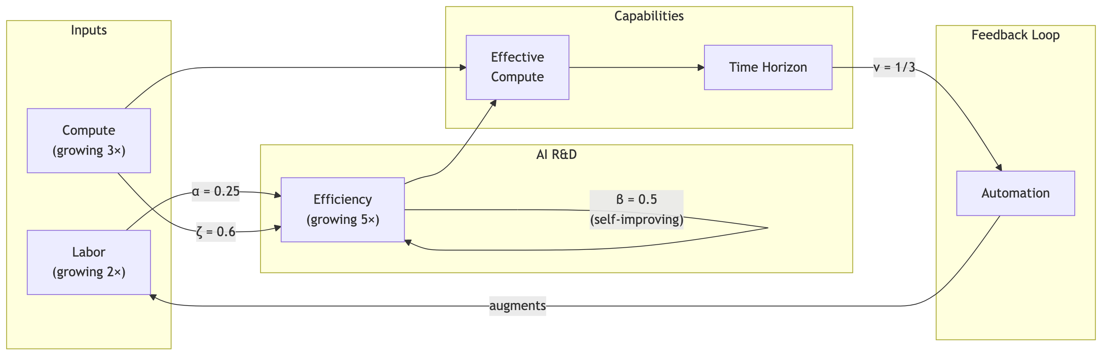

David Rein (2025) “Modeling an Intelligence Explosion”
The core idea: idea production depends on quality (source):
$$\begin{matrix}dA & =Q^{q}A^{1−β} & & \text{(idea production depends on quality of cognitive labor)} \\ Q & =cA & & \text{(quality depends on ideas)}\end{matrix}$$
Parameters:
$Q$ | quality of cognitive labour, measured in units of time horizon; this is our AI researcher (e.g. Opus 4.5, GPT-5.2, Gemini 3).
$A$ | current level of algorithms, also measured in units of time horizon (e.g. GPT-2, GPT-3, Pythia, etc.).
$q$ | elasticity of idea production with respect to cognitive-labor quality.
$β$ | ideas-get-harder-to-find parameter.
Implications / thresholds:
- The explosion condition is $q>β$.
Aghion, Philippe, Benjamin F. Jones, and Charles I. Jones. 2019. “Artificial Intelligence and Economic Growth.” In The Economics of Artificial Intelligence: An Agenda, edited by Ajay Agrawal, Joshua Gans, and Avi Goldfarb, 237–90. Chicago: University of Chicago Press. https://doi.org/10.7208/9780226613475-011.
Amodei, Dario, and Danny Hernandez. 2018. “AI and Compute.” https://openai.com/index/ai-and-compute/.
Anthropic. 2025. “Claude at Work: How Anthropic Uses Claude Code Internally.” https://assets.anthropic.com/m/6cd21f7d4f82afcb/original/Claude-at-Work-Survey.pdf.
———. 2026. “Anthropic Risk Report (February 2026).” Anthropic. https://www-cdn.anthropic.com/08eca2757081e850ed2ad490e5253e940240ca4f.pdf.
Byrnes, Steven. 2026. “The Nature of LLM Algorithmic Progress (V2).” https://www.lesswrong.com/posts/sGNFtWbXiLJg2hLzK/the-nature-of-llm-algorithmic-progress-v2.
Cotra, Ajeya. 2020. “Forecasting Transformative AI with Biological Anchors.” Open Philanthropy. https://www.openphilanthropy.org/research/forecasting-transformative-ai-with-biological-anchors/.
Davidson, Tom. 2021. “Could Advanced AI Drive Explosive Economic Growth.” Open Philanthropy 25. https://www.openphilanthropy.org/research/could-advanced-ai-drive-explosive-economic-growth.
Davidson, Tom, Basil Halperin, Thomas Houlden, and Anton Korinek. 2026. “When Does Automating AI Research Produce Explosive Growth?” https://www.basilhalperin.com/papers/shs.pdf.
Davidson, Tom, and Tom Houlden. 2025. “How Quick and Big Would a Software Intelligence Explosion Be?” https://www.forethought.org/research/how-quick-and-big-would-a-software-intelligence-explosion-be.
Edelman, Yafah, and Anson Ho. 2025. “Compute Scaling Will Slow down Due to Increasing Lead Times.” https://epoch.ai/gradient-updates/compute-scaling-will-slow-down-due-to-increasing-lead-times/.
Efrati, Amir, and Sri Muppidi. 2025. https://www.theinformation.com/articles/openais-350-billion-computing-cost-problem.
Epoch AI. 2025a. “Training Compute of Frontier AI Models Grows by 4-5x Per Year.” https://epoch.ai/blog/training-compute-of-frontier-ai-models-grows-by-4-5x-per-year.
———. 2025b. “Data on AI Models.” https://epoch.ai/data/ai-models/.
———. 2026a. “The Training Compute of Notable AI Models Has Been Doubling Roughly Every Six Months.” https://epoch.ai/data-insights/compute-trend-post-2010.
———. 2026b. “Trends in Artificial Intelligence.” https://epoch.ai/trends.
Erdil, Ege, and Matthew Barnett. 2025. “Most AI Value Will Come from Broad Automation, Not from r&d.” https://epoch.ai/gradient-updates/most-ai-value-will-come-from-broad-automation-not-from-r-d.
Erdil, Ege, and Tamay Besiroglu. 2024. “Explosive Growth from AI Automation: A Review of the Arguments.” https://arxiv.org/abs/2309.11690.
Erdil, Ege, Tamay Besiroglu, and Anson Ho. 2024. “Estimating Idea Production: A Methodological Survey,” May. https://doi.org/10.2139/ssrn.4814445.
Erdil, Ege, Andrei Potlogea, Tamay Besiroglu, Edu Roldan, Anson Ho, Jaime Sevilla, Matthew Barnett, Matej Vrzla, and Robert Sandler. 2025. “GATE: An Integrated Assessment Model for AI Automation.” arXiv Preprint arXiv:2503.04941. https://arxiv.org/pdf/2503.04941.pdf.
Eth, Daniel, and Tom Davidson. 2025. “Will AI r&d Automation Cause a Software Intelligence Explosion?” https://www.forethought.org/research/will-ai-r-and-d-automation-cause-a-software-intelligence-explosion.
Gundlach, Hans, Alex Fogelson, Jayson Lynch, Ana Trisovic, Jonathan Rosenfeld, Anmol Sandhu, and Neil Thompson. 2025. “On the Origin of Algorithmic Progress in AI.” https://arxiv.org/abs/2511.21622.
Ho, Anson. 2026. “The Least Understood Driver of AI Progress.” https://epoch.ai/gradient-updates/the-least-understood-driver-of-ai-progress.
Ho, Anson, Tamay Besiroglu, Ege Erdil, David Owen, Robi Rahman, Zifan Carl Guo, David Atkinson, Neil Thompson, and Jaime Sevilla. 2024. “Algorithmic Progress in Language Models.” https://doi.org/10.48550/arXiv.2403.05812.
Ho, Anson, and Parker Whitfill. 2025. “The Software Intelligence Explosion Debate Needs Experiments.” https://epoch.ai/gradient-updates/the-software-intelligence-explosion-debate-needs-experiments.
Jones, Benjamin F. 2025. “Artificial Intelligence in Research and Development.” NBER Working Paper 34312. National Bureau of Economic Research. https://doi.org/10.3386/w34312.
Jones, Charles I. 1995. “R&d-Based Models of Economic Growth.” Journal of Political Economy 103 (4): 759–84. https://doi.org/https://doi.org/10.1086/262002.
Jones, Charles I. 2022. “The Past and Future of Economic Growth: A Semi-Endogenous Perspective.” Annual Review of Economics 14 (1): 125–52. https://doi.org/10.1146/annurev-economics-080521-012458.
Jordan, Keller, and contributors. 2026. “Modded-Nanogpt.” https://github.com/KellerJordan/modded-nanogpt.
Karpathy, Andrej. 2024. “Llm.c Discussion: Reproducing GPT-2 in 90 Minutes for $20.” https://github.com/karpathy/llm.c/discussions/481.
Kokotajlo, Daniel, Eli Lifland, Brendan Halstead, and Alex Kastner. 2025. “AI Futures Model: Dec 2025 Update.” https://blog.ai-futures.org/p/ai-futures-model-dec-2025-update.
Kwa, Thomas. 2026. “Research Note: A Simpler AI Timelines Model Predicts 99% AI r&d Automation in ~2032.” https://www.lesswrong.com/posts/uy6B5rEPvcwi55cBK/research-note-a-simpler-ai-timelines-model-predicts-99-ai-r.
Leibowich, Jared, Nikola Jurkovic, and Tom Davidson. 2025. “Could Advanced AI Accelerate the Pace of AI Progress? Interviews with AI Researchers.” https://www.forethought.org/research/could-advanced-ai-accelerate-the-pace-of-ai-progress-interviews-with-ai.
Thompson, Neil C., Shuning Ge, and Gabriel F. Manso. 2022. “The Importance of (Exponentially More) Computing Power.” https://doi.org/10.48550/arXiv.2206.14007.
Werra, Leandro von. 2025. “The Jagged AI Frontier Is a Data Frontier.” 2025. https://huggingface.co/spaces/lvwerra/jagged-data-frontier.
Whitfill, Parker. 2026. “Post on GPT-2 to NanoGPT Efficiency Gains.” https://x.com/whitfill_parker/status/2028515815268491592.
Whitfill, Parker, Ben Snodin, and Joel Becker. 2025. “Forecasting AI Time Horizon Under Compute Slowdowns.” https://arxiv.org/abs/2511.19492.
Whitfill, Parker, and Cheryl Wu. 2025. “Will Compute Bottlenecks Prevent an Intelligence Explosion?” https://arxiv.org/abs/2507.23181.
You, Josh. 2025. “Most of OpenAI’s 2024 Compute Went to Experiments.” https://epoch.ai/data-insights/openai-compute-spend.

“Productivity uplift estimates ranged from 30% to 700%, with a mean of 152% and median of 100%.”
Charles I. Jones (1995) introduced diminishing returns to knowledge, whereas Romer (1990) had assumed no diminishing returns to knowledge, $β=0$.

