VisionFund International

Insurance Impact Report — Global Portfolio, 2026 Q2
Covering 2,111 client responses across the VisionFund insurance portfolio.
Generated: 14 July 2026

Part 1: Product Understanding & Awareness

Coverage Understanding
Across the global portfolio, 76.6% of the 2,104 surveyed clients understood what their insurance covers. Understanding was broadly comparable between women (75.5%) and men (79.4%). The sharpest divide emerged by claims experience: 94.8% of clients who had filed a claim understood their coverage, compared with 61.9% of those who had not. This gap suggests that the claims journey itself teaches clients how their product works, and that clients who never engage with a claim remain considerably less clear about what their policy protects.
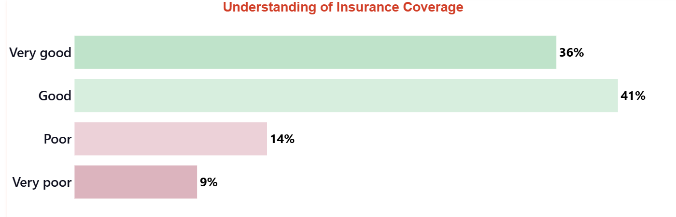
Coverage Understanding by Segment

Claim Process Understanding
Among the 2,104 surveyed clients, 68.2% understood how to file a claim. Understanding was almost identical for women (67.9%) and men (68.9%), showing no meaningful gender divide. As with coverage understanding, experience made the difference: 90.2% of clients who had filed a claim understood the process, against just 49.0% of those who had not. This wide gap indicates that fewer than half of clients without a claims experience feel confident navigating the process, pointing to a clear opportunity to strengthen upfront education before a claim ever arises.
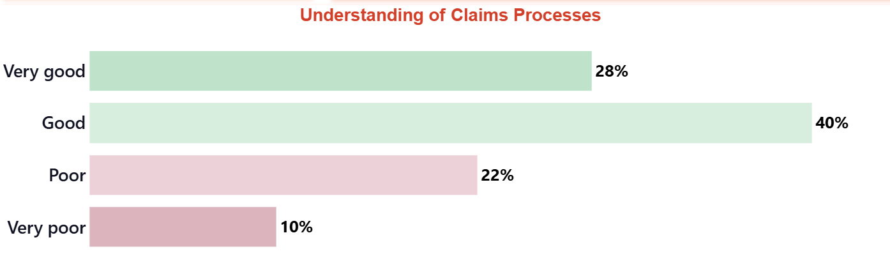
Claims Process Understanding by Segment

Preferred Claims Channel
Asked which channel they would prefer for submitting a claim, the 2,111 respondents most often chose having an MFI officer collect their documents (63.1%). WhatsApp or other messaging applications followed at 16.4%, and submitting directly at a VisionFund office or counter at 15.4%. Smaller shares preferred other channels (2.8%) or the insurer's smartphone application (1.7%). These preferences reflect a strong reliance on personal, officer-led support.

Product Value and Renewal Intent
Among health and credit-life clients across the African country programmes (n=1,957), 89.5% considered their insurance worth the premium they paid, signalling strong perceived value where clients contribute directly to coverage. Separately, among Vietnam's crop-insurance clients (n=147), for whom coverage is grant-subsidized and carries no premium, 58.5% expressed an intention to renew. These two figures describe entirely distinct client groups and product types, each offering its own reading of client commitment within its context.

Key Qualitative Insights
Clients across Malawi voiced a consistent message: they value the security insurance provides, but want deeper understanding of how it works. One caregiver in Mulanje explained that "the officer focused more on loans, and the insurance was not well explained," calling for "special training of insurance for us to understand." A male client in Ntcheu echoed that the product "gives confidence regarding loan repayment," yet stressed "a need for more training for our awareness regarding the claim processes." A third Mulanje caregiver described how insurance gave her group "a sense of security we didn't have before," while pleading for "more financial literacy training, especially around the insurance scheme." Their appreciation and their appetite for clearer guidance go hand in hand.
"We did not understand the claim insurance processes,the officer focused more on loans , and the insurance was not well explained. We need special training of insurance for us to understand."
— Female | age 41 | MULANJE, Malawi | caregiver
"Before joining VisionFund, our group often struggled with the financial pressure that came with unexpected emergencies. I remember a time when one of our members fell seriously ill, and we had no choice but to dip into our shared group funds money we had carefully set aside for other urgent needs. That experience made us realize how vulnerable we were without proper support systems in place.
When the VisionFund officer later introduced the insurance scheme, we immediately saw its value. Combined with their relatively low and affordable interest rates, it felt like a practical and sustainable solution for our group. The insurance gives us a sense of security we didn’t have before, knowing that we won’t always have to rely on our limited savings when challenges arise.
This support has also made it easier for us to manage and grow our businesses. With better access to financing and guidance, we are improving our financial literacy learning how to plan, save, and use loans more effectively. In the past, keeping consistent group savings was a challenge, but now we have more structure and discipline, which is helping us stay on track.
Because of these benefits, I would confidently recommend VisionFund to others. It not only supports business growth but also equips groups like ours with the knowledge and systems needed to manage money wisely, build savings, and stay resilient in times of need.
However, my plea to VisionFund would be for more financial literacy training, especially around the insurance scheme. While we appreciate the support and understand its importance, more guidance would help us fully understand how it works, how to maximize its benefits, and how it fits into our overall financial planning, with more knowledge, we would feel even more confident using these services, making better decisions for our businesses, and strengthening both our individual livelihoods and our group as a whole"
— Female | age 38 | MULANJE, Malawi | caregiver
"In a village setting like where I am Vision Fund insurance offers a great opportunity to insure our lives for uncertainty that may happen during the loan period. It gives confidence regarding loan repayment. However there a need for more training for our awareness regarding the claim processes and other things involved in the insurance"
— Male | age 50 | Ntcheu, Malawi | caregiver

Part 2: Claims Experience

Claims Funnel
Across the global portfolio, 2,111 clients were surveyed, of whom 363, or 17.2 percent, experienced an insurable event during the coverage period. Among those who faced such an event, 153 clients, representing 42.1 percent, went on to file a claim. This left a leakage rate of 57.9 percent, meaning nearly six in ten clients who suffered a loss did not file. Of the 153 claims filed, 58, or 37.9 percent, had been approved and paid at the time of surveying. The gap between events experienced and claims paid indicates that many eligible clients are not yet converting coverage into realised protection.
Stage | N | Rate
Experienced insured event | 363 | 17.2%
Filed a claim | 153 | 42.1%
Claim paid | 58 | 37.9%
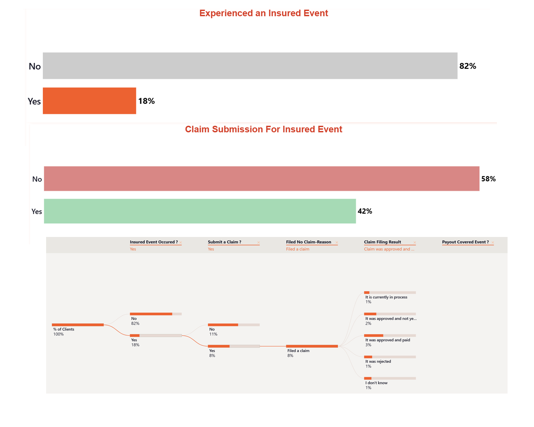
Claims Funnel

Reasons for Not Claiming
Among the 210 clients who experienced an event but did not file, 34.3 percent said they were not covered at that time and 32.9 percent did not know how to file. A further 23.8 percent gave other reasons, most often a broader lack of knowledge about insurance (20 mentions) or not meeting eligibility (5). Smaller shares cited an insignificant loss (5.7 percent) or a cumbersome process (2.9 percent).
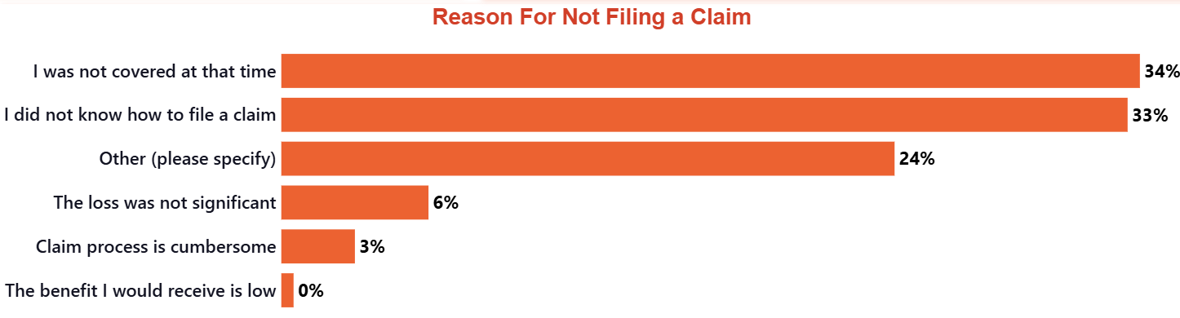
Reasons for Not Claiming

Claim Challenges
Among the 85 clients who filed and reported challenges, 51.8 percent struggled to track their claim's status after submitting documents, 36.5 percent found documents hard to collect from hospitals or authorities, and 35.3 percent waited a long time for payment. Some 18.8 percent lacked adequate support. Concerningly, 22 protection flags surfaced, including high-severity accounts of an officer refusing to process a request and, in one case, responding to a sick member by telling them to "just die" — issues warranting immediate follow-up.
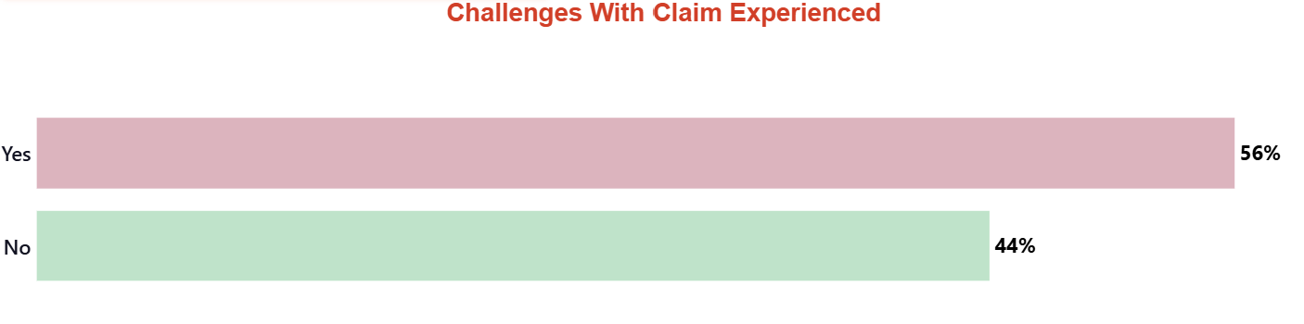
Top Claims Challenges (% of claimants who challenged)

Client Protection Signals
The following client-reported concerns were identified for follow-up by the client protection team.
High severity
- Staff misconduct: Client alleges the 'officer did not want to process our request for her own reasons that we do not know.' (client ref. #18)
- Staff misconduct: Client reports that when a member reported being sick, the officer responded rudely and told them to 'just die.' (client ref. #210)
- Unfair claim denial: Client states 'VFR didnot pay insurance claims' and wants to go back to their mutual insurance. (client ref. #577)
- Unfair claim denial: Client suggests to 'stop this insurance or change the way used to refund the insurance claims or pay on time, very discouraging.' (client ref. #578)
- Unfair claim denial: Client states, 'We submitted a request document for claim, but we did not receive any compensation.' (client ref. #715)
- Unfair claim denial: Client states, 'My group members have been claiming for their insurance but nothing has been done so far. I find it so discouraging.' (client ref. #1164)
- Premium deducted without consent: Client states that a lot of money is 'deducted without our knowledge.' (client ref. #1394)
- Staff misconduct: After a group leader died, the officer was informed but never visited the family or followed up on the claim. (client ref. #1678)
- Mis-selling: A claim for a child was denied because the 'child name was not part of the policy mean while the child name was given out.' The child later died. (client ref. #1762)
- Staff misconduct: The officer 'never pick your call when you are in the hospital.' (client ref. #1762)
Medium severity
- Staff misconduct: Officer promised to visit and help with a claim but never did. (client ref. #11)
- Staff misconduct: Officer did not come to assist the group in submitting a claim. (client ref. #12)
- False information: Client states they were given 'false promises' and requests for claims to be processed on time. (client ref. #18)
- Staff misconduct: Client's group member was admitted to hospital twice but 'did not get straight answers' from the officer when following up. (client ref. #343)
- Staff misconduct: Client reported their situation to the officer, 'but she did nothing, I am still waiting for the help.' (client ref. #486)
- Unfair claim denial: Client states that members in their group have not been paid for claims submitted 5 months ago. (client ref. #535)
- Staff misconduct: Client was hospitalized for over 3 days but was not assisted by the officer who had promised to help. (client ref. #600)
- Staff misconduct: Client 'informed officer but no form for claim has been filled.' (client ref. #806)
- Unfair claim denial: Client's claim was rejected because they did not have a National ID. (client ref. #1153)
- Unfair claim denial: Client states, 'l went to the hospital and brought my claim for payment but it was not paid.' (client ref. #1423)
- Staff misconduct: After a member's husband died, claim documents were submitted but there has been no feedback for two months. (client ref. #1509)
- Unfair claim denial: Client's claim for a broken leg was rejected because they had already been discharged from the hospital. (client ref. #1660)

Payout Outcomes
Of the 153 claims filed, 37.9 percent were approved and paid and a further 22.9 percent were approved but not yet paid, while 15.0 percent were rejected. Notably, 13.7 percent of claimants did not know their claim's outcome, and 10.5 percent remained in process — pointing to gaps in status communication. Among the 58 clients whose claims were paid, coverage was strong: 63.8 percent reported that the payout covered all of their cost, 24.1 percent said some of the cost, and 12.1 percent most of it. For most paid claimants, the product delivered meaningful financial relief.

Key Qualitative Insights
Client voices show that trust hinges on how VisionFund responds in moments of crisis. A caregiver in Mulanje, Malawi, having left a former insurer whose claims went unpaid, described a group member hospitalised after losing both parents to cholera and said VisionFund's handling of this case would ultimately shape their confidence — "we remain hopeful." Another Mulanje caregiver affirmed that insurance "is a relief to members because it helps us pay our medical bills." Yet a caregiver in Yendi Zone, Ghana, recounted an unresponsive officer, a claim rejected because a child's name was allegedly missing, and the loss of that child. These accounts suggest reliable, responsive claims support is the decisive driver of trust.
"Before joining VisionFund, I was a member of NEEF, where they also offered insurance schemes. However, my experience there was quite disappointing. When difficult situations arose and members needed support the most, the insurance failed to deliver. Claims were not paid out as expected, which created frustration and a lack of trust among us. Because of those challenges, I made the decision to leave NEEF and eventually joined VisionFund when I was introduced to their services.
Since this is still my first experience with VisionFund, I feel it would be too early to give them a perfect rating, such as 10 out of 10. We simply have not yet gone through enough challenging situations to fully evaluate how reliable and effective they are—especially when it comes to their insurance support.
At the moment, we are facing a very serious situation within our group. One of our members has recently lost both parents due to cholera, which has been devastating. To make matters worse, he himself has been hospitalized and has now been in the hospital for four days since Monday. This is exactly the kind of difficult circumstance where insurance support is crucial.
We are currently in the process of contacting VisionFund to see how they will handle this case. Their response and willingness to support our member during this time will play a major role in shaping our overall opinion of them. If they are able to come through and provide meaningful assistance, it will certainly increase our confidence in them and improve the rating we would give.
For now, it is still early days, but we remain hopeful. We want to see whether VisionFund will truly be different from NEEF and other institutions we have experienced in the past. Their actions in moments like this will ultimately determine the level of trust we place in them going."
— Male | age 41 | MULANJE, Malawi | caregiver
"Insurance is good, especially when all procedures are followed . Insurance is a relief to members because it helps us pay our medical bills."
— Female | age 27 | MULANJE, Malawi | caregiver
"We never enjoyed the insurance, now that they have changed us an officer, I do not know how it will be but the old officer never pick your call when you are in the hospital my brother was in the hospital with a child for three weeks and when we submitted a claim the officer finally told us the child name was not part of the policy mean while the child name was given out, finally we lost that child too, so to me it is good the insurance policy was not there. As for the loan it is good and I have not seen a credit institution than Visionfund."
— Male | age 30 | YENDI ZONE, Ghana | caregiver

Part 3: Financial Inclusion

Reaching Clients with No Prior Insurance Access
For most surveyed clients, VisionFund was their very first insurer. Among the 2,104 clients surveyed, 85.7 percent had no insurance of any kind before joining, extending financial protection to previously uninsured households. This reach was consistent across gender, with 86.0 percent of women and 84.8 percent of men reporting no prior access. This suggests VisionFund is opening the door to formal protection for households the insurance market had not reached before.

Financial Stress and Coping
Among clients who experienced an insured event in the last 12 months (n=363), 20.1 percent turned to negative coping strategies, on a scale where lower reflects better coping. Separately, across all 2,104 surveyed clients, just 1.7 percent reported high financial stress, an independent measure of the client base as a whole. Also across the full sample, 69.8 percent said accessing alternative financial protection would be difficult without this insurance, underlining how central VisionFund's cover has become to their resilience.
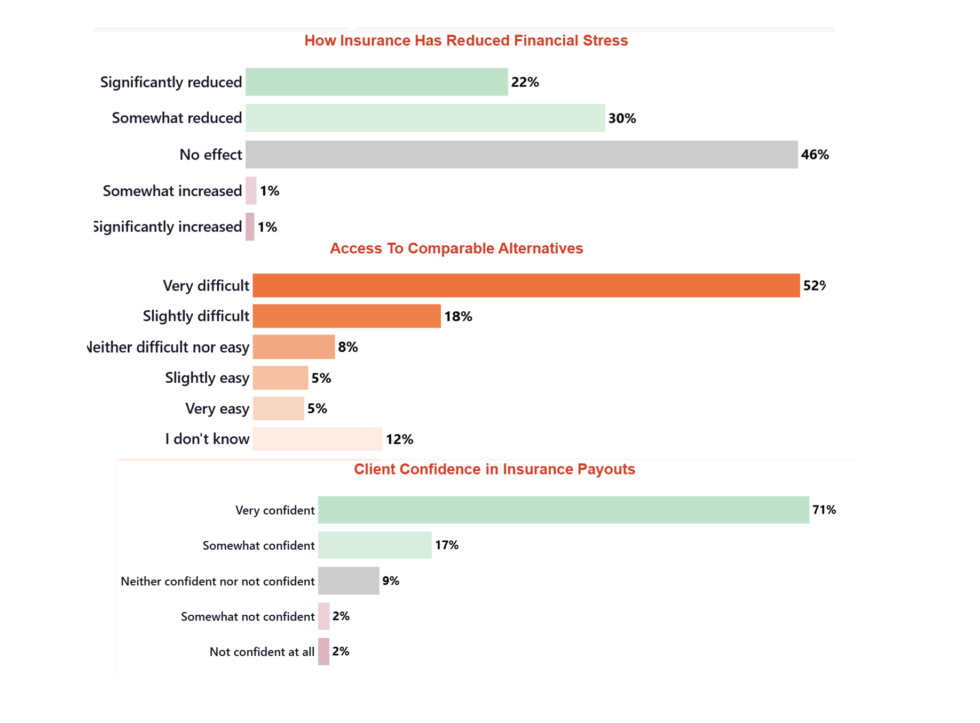
Financial Protection Indicators

Confidence in Payout
Confidence that VisionFund will honour a valid claim ran high across the portfolio. Among the 2,104 surveyed clients, 87.7 percent expressed confidence that VisionFund would pay out when a genuine claim arose. This trust in the promise behind the product indicates that clients view the cover as dependable, which suggests the protection VisionFund offers translates into real reassurance rather than paper commitments.

Key Qualitative Insights
Clients across Malawi described VisionFund insurance as a dependable safety net that lets them plan and invest with confidence. A 32-year-old caregiver in Ntcheu rated the cover ten out of ten, valuing the peace of mind that comes from having a fallback when illness or accidents strike. A 50-year-old woman in Mulanje contrasted this with a previous provider that offered no insurance support, explaining that she no longer fears a hospital visit could set back her business. A 45-year-old client in Mzuzu, now on his third loan, praised how VisionFund pairs financial support with genuine care, guidance, and flexible repayment, showing concern for clients' well-being rather than repayments alone.
"Insurance from VisionFund is extremely important because it provides a reliable safety net when unexpected emergencies arise. Life is unpredictable, and challenges such as illness, accidents, or financial shocks can happen at any time. Having insurance ensures that you are not left vulnerable during these difficult moments, as it offers financial support and stability when you need it most.
What makes it even more valuable is the peace of mind it brings, you can plan your life and investments knowing that there is a fallback plan in place. Instead of worrying about how to recover from sudden problems, you can focus on moving forward with confidence. Because of this strong sense of security and preparedness, I would confidently rate VisionFund insurance a 10 out of 10."
— Male | age 32 | NTCHEU, Malawi | caregiver
"I would strongly recommend VisionFund to others because of the security and peace of mind it provides. Before joining, I had experience with other organizations like FINCA, but they did not offer any form of insurance support. That meant whenever a health issue came up, I had to rely entirely on my business income, which created a lot of fear and uncertainty.
With VisionFund, things are different. Their insurance initiative has made a real impact on my life. I no longer worry as much about what will happen if I or a family member needs medical attention. Knowing that there is support in place allows me to focus on growing my business without constantly fearing that a hospital visit could set me back financially.
This initiative has given me confidence and stability. It feels like I am not alone in facing life’s challenges, and that kind of support is invaluable."
— Female | age 50 | MULANJE, Malawi | caregiver
"My wife is part of another microloan group, and from what I have seen, there is a clear difference compared to VisionFund. VisionFund goes beyond just offering loans they provide insurance to ensure the well-being and security of their clients, not only in business but also in times of personal difficulty. Many other institutions do not offer this kind of support and can be unfair in how they deal with customers.
This is now our third time taking a loan with VisionFund, and we have not experienced any problems so far. It has been a very positive experience. Our businesses have improved, and we are now in a better position to afford important needs such as school fees for our children. We can confidently speak from experience about the impact it has had on our lives.
VisionFund is also a Christian based organization, and their values are clearly reflected in how they treat their clients. They show genuine concern for our well-being, not just our repayments. They regularly visit us, guide us in making better decisions, and motivate us to grow. In contrast, many other microfinance institutions seem to prioritize business first and customers second.
Another advantage is their low interest rates and flexible repayment approach. They are understanding and give us time and space to repay in a way that is manageable. With some other institutions, the approach can be very harsh, with aggressive follow-ups even after a short delay. Overall, VisionFund stands out because they combine financial support with care, understanding, and a focus on improving their clients’ lives."
— Male | age 45 | MZUZU, Malawi | caregiver

Part 4: Client Voice

Net Promoter Score
The portfolio's Net Promoter Score reached 16.8 among 2,104 surveyed clients, with 43.9% acting as promoters, 28.9% passive, and 27.1% detractors. Among clients who felt the premium was not worth it, two themes dominated their reasoning. Many cited high premiums or poor value, feeling the cost was wasted if no claim was made, or that deductions occurred without their knowledge. Others pointed to unpaid or unfulfilled claims, expressing frustration when promises went unmet or claims were rejected. Together these concerns show that perceived value hinges on transparent pricing and reliable claims delivery.
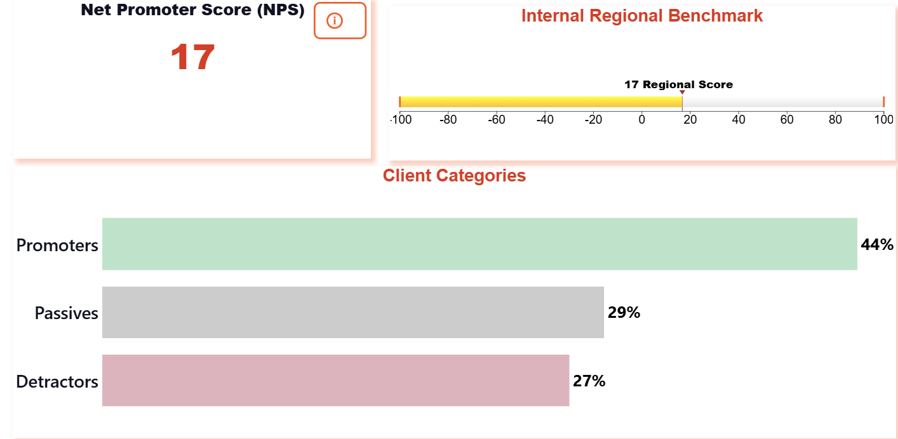
Net Promoter Score

Promoter and Detractor Themes
Promoters most often praised financial relief, mentioned 366 times, followed by general satisfaction with 168 mentions and product understanding with 73 mentions, showing that clients who value the product connect it to tangible security and clarity. Detractors told a different story. Their leading theme was product understanding, cited 338 times, far ahead of complaint or grievance at 83 mentions and improvement suggestions at 68 mentions. The prominence of product understanding among detractors indicates that gaps in client knowledge, rather than the product itself, drive much dissatisfaction, suggesting stronger onboarding and education could meaningfully shift sentiment.
[VISUAL PENDING: part4_themes.png — Top NPS Theme Drivers]

Wellbeing Outcomes
Wellbeing outcomes revealed encouraging but uneven progress. Among the 1,928 clients answering, 35.0% reported improvements in child wellbeing, indicating that insurance coverage helps households protect their children during difficult periods. Healthcare access improved for 15.8% of the 1,672 clients responding on that measure, a more modest figure that suggests coverage supports some families in reaching care but leaves considerable room to strengthen this pathway. Together these results show insurance beginning to translate into everyday household resilience.

Key Qualitative Insights
Client voices bring these numbers to life. A 36-year-old caregiver in Ntcheu, Malawi, described how insurance once felt like a burden, money leaving every month for something uncertain, until his group faced the sudden, violent loss of a member and confronted costs none had planned for. That experience convinced him insurance is a lifeline for moments you never see coming. A fellow Ntcheu caregiver echoed this, valuing the peace of mind that lets families focus on recovery rather than hospital bills. Yet a 30-year-old caregiver in Mzuzu remained unconvinced, struggling to justify the cost when benefits felt neither visible nor immediate. Her doubt mirrors the detractor and pricing themes above, reminding us that trust and clarity, not just coverage, determine perceived value.
"Paying for insurance has never felt easy to us, it often feels like a burden money going out every month for something you’re not even sure you’ll ever need. I questioned whether it was really worth it. But everything changed last year, and that experience completely shifted my perspective.Before we started our insurance initiative as a group, we went through a tragic and unexpected loss. One of our members was found murdered. It was a shocking and painful moment for all of us, something none of us had prepared for emotionally or financially. In the middle of grief and confusion, we also faced the harsh reality of being completely unprepared to handle the situation. There were costs, responsibilities, and pressures that none of us had planned for, and we felt stranded.It was during that difficult time that I truly understood the importance of insurance. I realized that while it may feel like a burden in the present, it becomes a lifeline in moments you never see coming. That experience pushed me to think differently—not just for myself, but for the entire group. I became convinced that we needed to take action, to protect ourselves from the uncertainties of the future.That is what led me to advocate for starting our insurance initiative. It wasn’t just about finances anymore; it was about security, preparedness, and peace of mind. Now, when I think about paying for insurance, I no longer see it as a burden. I see it as a necessary step toward safeguarding our future against the unexpected."
— Male | age 36 | NTCHEU , Malawi | caregiver
"I strongly believe that insurance is an important initiative and something I would confidently recommend to others. In life, there is always a level of uncertainty you never truly know what may happen tomorrow. Unexpected events such as illness, accidents, loss of income, or damage to property can occur at any time, often without warning. Because of this, it is always wise to be prepared, not only for the good times but also for the challenging moments that can disrupt our lives.
This is where VisionFund plays a valuable role. Through its loan services, it already supports individuals in building and improving their livelihoods, whether through small businesses, farming, or other income-generating activities. Now, with the addition of insurance, it goes a step further by helping people protect what they have worked so hard to build. Insurance provides a safety net, ensuring that when difficulties arise, clients are not forced to start over or fall deeper into financial hardship.
One of the biggest benefits of insurance is peace of mind. When you are covered, you do not have to panic or stress about how you will handle financial burdens during a crisis. Instead of worrying about hospital bills, repairing damage, or repaying loans during tough times, you can focus on recovery and moving forward. This sense of security is especially important for families and small business owners who rely on stable finances to survive and grow.
In addition, insurance encourages better financial planning and responsibility. It allows individuals to manage risks more effectively and avoid setbacks that could otherwise take years to recover from. By combining loans and insurance, VisionFund is helping people not only to grow financially but also to remain resilient when faced with unexpected challenges.
In conclusion, because troubles can come at any time, having insurance is not just an option it is a smart and necessary step toward financial stability. Being prepared makes all the difference, and with the support of VisionFund, individuals can face both good and difficult times with greater confidence and security."
— Male | age 34 | NTCHEU, Malawi | caregiver
"I’ve heard positive feedback from others who say the insurance can be helpful in times of need, which suggests it does provide some value in certain situations. However, I personally struggle to see its necessity, as I’m not fully convinced that it would make a meaningful difference when I actually need support, In addition, the cost of maintaining the insurance feels difficult to justify, especially when the benefits are not clearly visible or immediately impactful. Because of this uncertainty and lack of trust in its overall value, I find it hard to fully support or rely on it."
— Female | age 30 | MZUZU, Malawi | caregiver

Part 5: Child Wellbeing

Child Wellbeing Drivers
Across the portfolio, 35.0% of clients reported positive child wellbeing (n=1,928). Higher financial stress showed the strongest link to lower wellbeing (rho=-0.434, p<0.0001), while stronger loyalty helped: a higher Net Promoter Score tracked with better wellbeing (rho=+0.220, p<0.0001). Among Vietnam's crop-insurance clients only, renewal intent related most strongly of all (rho=-0.492, p<0.0001, n=127). Weaker coverage understanding, lower payout confidence, and unclear claim processes each accompanied lower wellbeing. Among health and credit-life clients only, doubting the premium's worth also mattered (rho=-0.164, p<0.0001, n=1,801).
Driver | ρ (Spearman) | p-value | N
Renewal Intent | -0.492 | 0.0000 | 127
Financial Stress (High) | -0.434 | 0.0000 | 1928
Net Promoter Score | +0.220 | 0.0000 | 1928
Coverage Understanding | -0.206 | 0.0000 | 1928
Worth Premium | -0.164 | 0.0000 | 1801
Confidence in Payout | -0.162 | 0.0000 | 1928
Claim Process Understanding | -0.154 | 0.0000 | 1928
[VISUAL PENDING: part5_drivers.png — Child Wellbeing Drivers (Spearman Correlation)]

Healthcare Access and Medical Cost
Among clients who needed care, 15.8% said access to healthcare improved (n=1,672). Separately, among health-insurance clients who needed medical care, 54.0% reported their medical costs decreased (n=926). This cost measure reflects the whole group who needed care, not only those who filed a claim, and it indicates that insurance eased medical burdens broadly across families rather than solely at the moment of a payout.
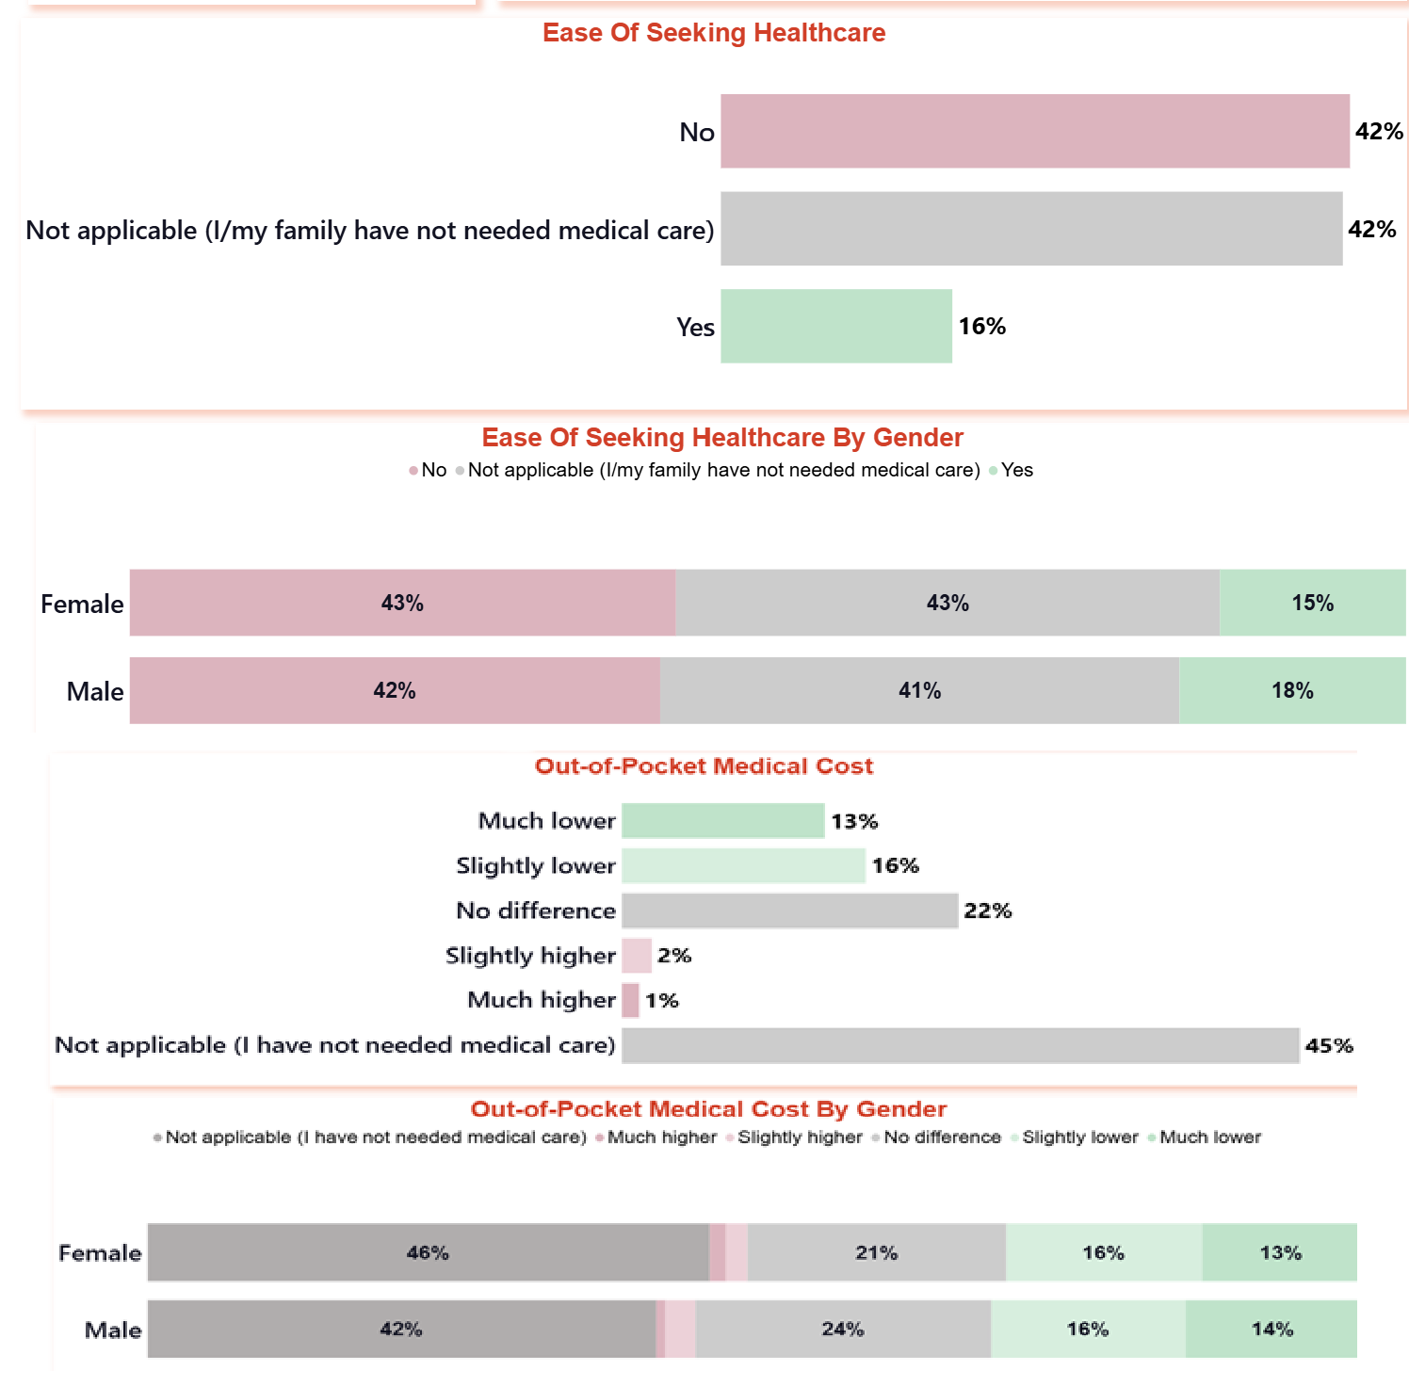
Healthcare Access and Medical Cost Impact

Caregivers vs Non-Caregivers
Metric | Caregiver | Non-Caregiver | Sig.*
High Financial Stress † | 3.2% | SUPPRESSED
Healthcare Access Improved † | 16.0% | 13.2%
* p < 0.05 (chi-squared or Fisher's exact test)
† High Financial Stress: Clients who experienced an insured event in the last 12 months (same base as Part 3's financial stress metric)
† Healthcare Access Improved: Health-insurance clients who needed care (same base as Part 4's healthcare access metric)
Comparing caregivers with non-caregivers highlights two measures independent of child wellbeing itself. Among clients who experienced an insured event, 3.2% of caregivers reported high financial stress, while the non-caregiver figure was suppressed due to small sample size. Among health-insurance clients who needed care, 16.0% of caregivers said healthcare access improved versus 13.2% of non-caregivers, a difference that is not meaningful (p=0.4215).

Key Qualitative Insights
Caregivers' own words reveal how insurance steadies families through hard moments. One Malawian mother valued the peace of mind of coverage during illness and emergencies, yet wished it extended to her children, recalling times she needed help buying medication and covering transport when they fell sick. Another caregiver described how savings promote children's health and school spending, while a third explained that when a member is sick, loan repayment continues smoothly, and when a member dies, their children receive benefits that ease repayment and other financial burdens. Together these voices suggest that clients experience insurance as protection for the whole household, and that expanding coverage to family members would make the support more meaningful.
"What stands out for me about VisionFund is that there is no deposit required to access loans, which makes it very easy for people like me to start or grow a business without needing large upfront capital. Their interest rates are also low and affordable, allowing me to repay comfortably while still managing my household and reinvesting in my business.
Another important benefit is the insurance they offer alongside the loans. This provides support during unexpected situations, such as illness or other emergencies, giving me peace of mind knowing that I am not alone during difficult times.
However, I would really appreciate it if the insurance coverage could be extended to include family members. I have children, and there have been times when they have fallen sick. In such moments, I wished the insurance could also assist with buying medication and covering transport to the hospital. Expanding the coverage in this way would greatly benefit families like mine and make the support even more meaningful."
— Female | age 30 | MZUZU, Malawi | caregiver
"It helps to increase savings that promote childrens health and school expenditures"
— Male | age 41 | MULANJE, Malawi | caregiver
"This is because when someone is sick loan repayment continues without challenges and when a member dies the children of the member will receive the benefits which will enable them to repay the loan and assist in other financial problems"
— Female | age 22 | Mzuzu, Malawi | caregiver

Part 6: Claimant vs. Non-Claimant Outcomes
Metric | Claimant | Non-Claimant | Sig.*
Coverage Understanding | 94.8% | 61.9% | *
Claim Process Understanding | 90.2% | 49.0% | *
Worth Premium † | 85.6% | 87.1%
Renewal Intent † | SUPPRESSED | SUPPRESSED
Negative Coping (↓ better) | 11.8% | 26.2% | *
High Financial Stress (↓ better) | 5.2% | 1.9%
Confidence in Next Premium Payment | 86.3% | 83.8%
* p < 0.05 (chi-squared or Fisher's exact test)
† Worth Premium: Health & credit-life clients only, within each claimant/non-claimant group — Vietnam's crop-insurance clients were not asked this question
† Renewal Intent: Vietnam's crop-insurance clients only, within each claimant/non-claimant group — not asked of health or credit-life clients in any country
[VISUAL PENDING: part6_scorecard.png — Key Metrics: Claimants vs. Non-Claimants]

Findings
Claimants who experienced the insurance in action understood their coverage far better than non-claimants, with 94.8 percent grasping their coverage against 61.9 percent, and 90.2 percent understanding the claims process against 49.0 percent — differences that are meaningful (p=0.0000). Claimants also drew on harmful coping strategies less often, at 11.8 percent versus 26.2 percent among non-claimants (p=0.0007). Confidence in paying the next premium showed no meaningful difference between the groups (p=0.5178). These findings suggest that living through a claim deepens clients' understanding of their protection and helps shield households from damaging financial shocks.

Key Qualitative Insights
The experience of making a claim appears to build lasting understanding: claimants understood their coverage and the claims process far better than non-claimants, and they leaned on harmful coping strategies less often — 11.8 percent against 26.2 percent, noting these coping and stress figures rest on the claimant base rather than both groups equally. Rwandan claimants described the reassurance of timely payment, one noting "they paid claims on time and give support if you need," and another that VisionFund "give guidance to the claims process easily." Yet the experience is not uniform: a claimant in Agago, Uganda, reported that "it does take long to claim the insurance benefits after submitting the required documents," pointing to processing speed as a priority for improvement.
"They paid claims on time and give support if you need"
— Female | age 45 | Huye, Rwanda | claimant, caregiver
"VFR paid claims on time and give guidance to the claims process easily."
— Female | age 46 | Huye, Rwanda | claimant, caregiver
"it does take long to claim the insurance benefits after submitting the required documents"
— Male | age 42 | Agago, Uganda | claimant, caregiver

Part 7: Gender Analysis
Metric | Female | Male | Sig.*
Coverage Understanding | 75.5% | 79.4%
Claim Process Understanding | 67.9% | 68.9%
Worth Premium † | 88.9% | 90.8%
Renewal Intent † | 57.9% | SUPPRESSED
Negative Coping (↓ better) | 17.9% | 24.8%
Child Wellbeing Improved | 34.7% | 35.9%
Confidence in Next Premium Payment | 87.1% | 89.4%
* p < 0.05 (chi-squared or Fisher's exact test)
† Worth Premium: Health & credit-life clients only, within each gender group — Vietnam's crop-insurance clients were not asked this question
† Renewal Intent: Vietnam's crop-insurance clients only, within each gender group — not asked of health or credit-life clients in any country
[VISUAL PENDING: part7_scorecard.png — Key Metrics by Gender]

Findings
Across the global portfolio, women and men reported broadly similar insurance experiences, with no gender gap reaching statistical significance. Coverage understanding came closest, at 75.5 percent among women and 79.4 percent among men (p=0.0611), though the difference remains suggestive rather than conclusive. Women reported lower reliance on negative coping strategies, 17.9 percent against 24.8 percent for men, but this gap was not meaningful (p=0.1253). Among Vietnam's crop-insurance clients, 57.9 percent of women expressed renewal intent, while the male figure was suppressed due to small sample size. The female sample dominated this portfolio (roughly 1,518 women against 586 men).

Key Qualitative Insights
The numbers show near-parity between women and men, but client voices reveal a shared vulnerability that coverage boundaries do not yet address: the health of a spouse. A 51-year-old caregiver in Assin, Ghana was hospitalised yet did not claim, fearing her husband would learn she had taken a loan — a reminder that household dynamics can block access even when protection exists. A 36-year-old member in Mulanje, Malawi valued VisionFund's health focus over her former property-only SACCO cover, yet urged extending insurance to spouses, having watched a fellow member's business falter during her husband's hospitalisation. A 60-year-old man in Angurai, Kenya echoed this exactly, selling nearly everything to pay his wife's hospital bill. Spousal cover emerges as a resilience priority.
"was hospitalised but did not make a claim because i did not want my husband to know i have taken a loan but i know the insurance would have paid my medical expenses"
— Female | age 51 | Assin, Ghana | caregiver
"I have found VisionFund to be very helpful, especially when it comes to injecting capital into my business and supporting me during difficult times. Access to financial assistance has allowed me to sustain and grow my business even when challenges arise, which is something I truly value.
When I compare the insurance offered by VisionFund to what I previously had with my SACCO, I see a meaningful difference. The SACCO insurance mainly focused on property, which, while useful, did not address personal health needs. VisionFund’s insurance, on the other hand, feels more practical because it considers situations where I may fall sick something that directly affects my ability to work and run my business.
That said, I would strongly encourage VisionFund to consider extending insurance coverage to include spouses. In many households, both partners contribute to the business or the overall income. If one spouse becomes seriously ill, it can disrupt not only the family’s wellbeing but also the business itself. When both breadwinners are affected, it becomes even more difficult to manage daily responsibilities and maintain income.
I have seen this situation firsthand within our group. One of our members has a husband who has been hospitalized for several weeks, and this has significantly impacted her business. It made us realize that this could happen to any of us, and in such cases, the current insurance coverage would not provide enough support.
Including spouses in the insurance plan would make a big difference. It would provide greater security for families, help stabilize businesses during health crises, and ultimately strengthen the resilience of members as a whole."
— Female | age 36 | MULANJE, Malawi | caregiver
"It could be better if this insurance supported even our children and spouses. My wife was admitted in hospital but I ended up selling almost everything to pay for the bill."
— Male | age 60 | Angurai, Kenya | caregiver

