

A Semantic Web Application

Phase IV

Submitted to

Mr. Ben Strauss

**12th January 2011**



**Openwave Computing LLC, 1220 Broadway, Suite #703, New York, NY 10001**

Confidentiality Statement

**The data contained herein shall not be disclosed, duplicated, or used in whole or in part for any purpose other than to evaluate the report, provided that if a contract is awarded to this offer as a result of, or in connection with, the submission of these data, the propose shall have the right to duplicate, use or disclose the data to the extent provided in the agreement. The restriction does not limit the right to use information contained in the data if it is obtained from another source without restriction.**

Openwave Computing Code of Conduct

We, in our dealings, are self-regulated by a code of conduct as enshrined in the “Openwave Code of Conduct”. We request your support in helping us adhere to the code in letter and spirit. We request that any violation or potential violation of the code by any person be promptly brought to the notice of the President of Openwave Computing LLC. All communication received in this regard will be treated and kept as confidential**.**

# Our Understanding of Requirement

## In-Scope Requirement

### Functionalities to be upgraded

# US 199 - Better User Notifications

Description:

We need to find a better user notification than the current one - because the current one changes the layout of the page by shifting everything down.

Is there a simple little popup that we can replace it with that will go away after 5 seconds?

I would like to move these notifications to where the red loading action is happening. Please look at how gmail shows the notifications when sending an email.

Can you please send me a list of all of the notifications we display this way. I don’t think we need all of the notifications and I want to give you the text for each one.

ex:

"Thank you, Your Answer has been changed successfully!"

**Code Impact**

Entire system notification reflect For both ajax pages and normal pages

Uses: --

**Estimated Hours:** 12 hrs

**OPENWAVE REPLY:**

**Notification incidents.**

***Issue***

Thank you, Your Answer has been changed successfully!

Thank you, Your Answer has been saved successfully!

Thank you, Question added successfully!

Resource added successfully!

Debate Posted Successfully!

Debate reply Posted successfully! Have a nice day

You Have Flagged successfully !

You have already flagged the issue

You Cannot Vote Your Answer!

Your Answer Posted Successfully !

Sorry Only Registered User Can Suggest Answer!

Sorry You Not Have Sufficient User Points To Flag !

Sorry Only Logged in user can post Debate

Kindly login to do this action [debate, reply, flag, suggest answer]

***Profile***

Profile Updated Successfully!

Message sent successfully!

Thank you, Question added successfully!

You are already following username.

Category follows added successfully!

**Note:** We are expecting the content for the above notification messages.

**US196 - New First Time Use Case and Profile Wiazard**

Description:

After the user first vote and navigates away from his first issue load in a shadow box the profile wizard.

If the user closes the finishes his session at Heard Mentality after the first vote, the wizard will appear after he navigates away from a second issue in another session.

When the user first logs in with Gigya, just a username is created and the user can continue doing what he was doing.

Wizard will be 3-4 pages long.

<http://legendthemes.com/2010/04/10/designing-modern-web-forms-with-html-5-and-css3/>

**Code Impact**

a) Issue Full

b) Edit Profile

c) Login System

**DB Impact**

* User profile

**Estimated Hours:** 29 hrs

**OPENWAVE REPLY :**

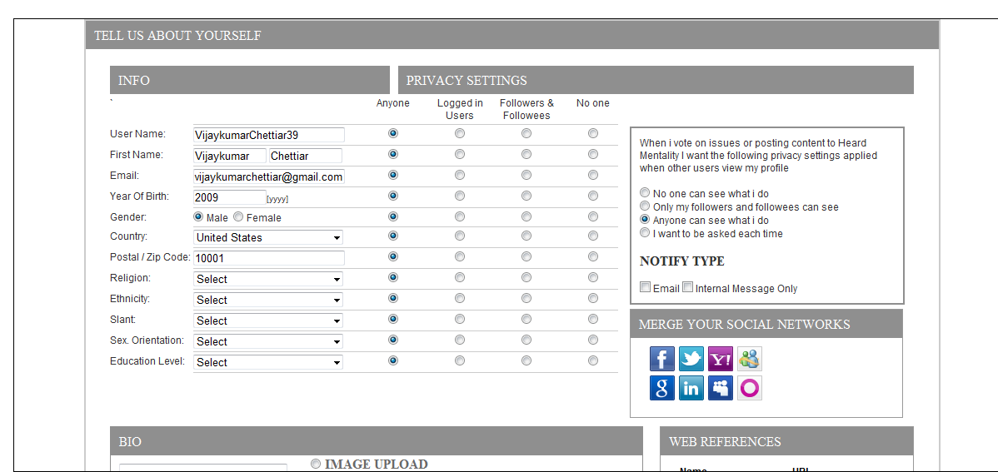

**US215 - Add Issue Interface revamp**

Description:

Remove the Categories and Location inputs from the User Interface

(This will now be done by the moderator).

**Code Impact**

a) Issue Full,

b) Search

c) Pundits

d) Related Issues

e) Top & hot & Local List

f) Admin

g) Notification

**Estimated Hours:** 8 hrs

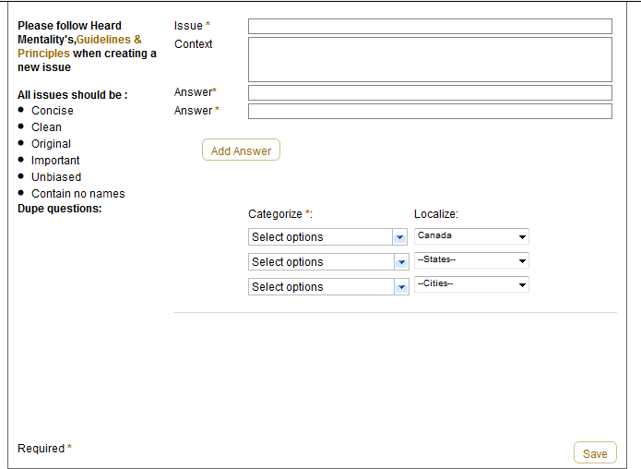

**US205 - Moderator Revamp**

Description:

I need the moderator to be set up like I originally specified in the Requirements document from Phase 1. This should load into Heard Mentalities theme and not in the admin console. We need to make it open for us to recruit users from around the world to assist with moderating.

On the left panel (where the top hot boxes are -but one column wider) there should be a large tabbed box that contains issues that need moderating: New Questions, Flagged Questions, Flagged Postings.

When an issue is clicked on in the left list, it loads in the center panel. We will need to add also 2 new tabs that contains the input controls for the metadata as well as the sections/categories input and the geography input (multi select required)

A new question will stay in the list until 3 moderators have saved it. There will be indication of how many moderators have looked at it on the category/section input screen.

For the metadata, each moderator enters what he thinks is correct without seeing what the other moderators input. The final metadata values are an average of the 3 moderator values.

**Code Impact:**

Admin

**DB Impact:**

User profile

Issue

Flag

**Estimated Hours:** 55 hrs

**OPENWAVE REPLY:**

.

**US198 - Edit Profile Redo**

Description:

Open From:

When the user is viewing his own profile and presses "edit Profile" button OR selected from the top right box under Account dropdown.

Load as a shadowbox

If selected while on his own profile (which should be loaded as a shadow box as well - shrink this shadowbox at the same time as growing this shadowbox.

If Country is required to make the postal/zip code to be accurate, add the dropdown prior to the code input field. BUT if we can accurately identify location (to the city in any country) then no need for this drop down Make sure we confirm the accuracy of the postal code with the user by displaying after loosing focus to the input.

Make sure the last level of privacy on the mockup is implemented. This was supposed to be phase 1 but was misinterpreted as issues posting - but it should be all interactions. I have removed the need to have the user confirm after each action.

If the user presses the Pick a Sheep Avitar button, then load a little popup (Preferably looking like the popup that gigya gives on the merge social networks feature. Load half of the avitats on 1 page.

For the Personal Links drop downs. These should be the values (social netwoks) that we ave presented today in the long list. The sequence would be:

the user selects Flickr from the dropdown and then enters the URL

the user selects another network and then enters the URL

if 2 have been completed add one more row, etc... grow the box if required. On save and return another time to the profile, display these as the logo of the social network..

**Code Impact**

a)Personal link custom module

b) Avatar change

c)subscription change

**DB Impact**

User Profile

**OPENWAVE REPLY:**

We implement the about us page based on the above requirements.

**Estimated Hours:** 18 hrs

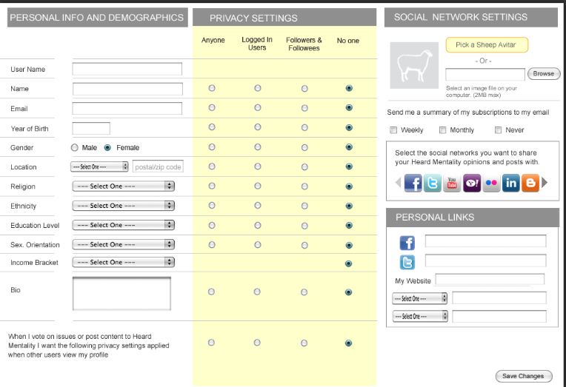

# US214 - About Us Page

Description:

Create the About Us page.

Note: I want to call this "Readme" If we can change the navigation panel to reflect this...cool.

I will provide the content for this.

Load as a shadowbox

**Code Impact**

a) Admin

b) About us

**DB Impact :**

content change based on new about us design

**OPENWAVE REPLY:**

We implment the about us page based on the above requirements.

**Estimated Hours:** 12 hrs

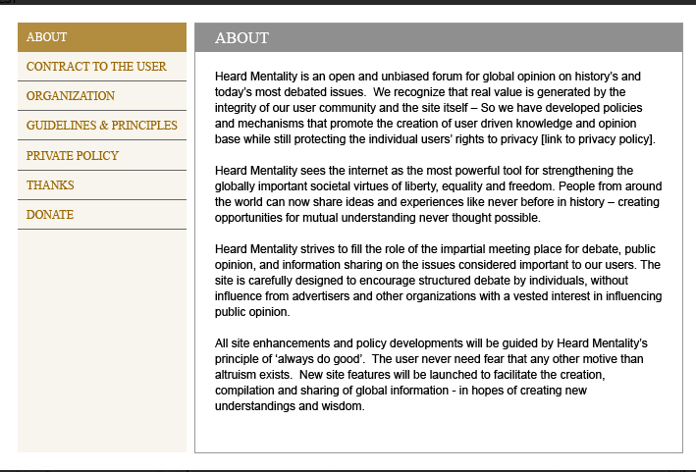

# US207 -Summary Email

**Description**:

# Create a nicely formatted html (and text version) of all of the HeartBeat notifications and send them as an email to the user.

This option is selected from the edit profile screen and has 2 frequency options (weekly and monthly or never)

If the user tries to save with weekly or monthly select and the email address is not complete, advise that email address is required and set focus to the email address input box.

Uses: --

**Code Impact :**

a) template build

b) cron mail

c) Summary mail build

**Ben Reply :**

EmailTemplate system looks like Linkedin.com

**OPENWAVE REPLY:**

We implement the email template system based on the frequencies.

**Estimated Hours:** hrs

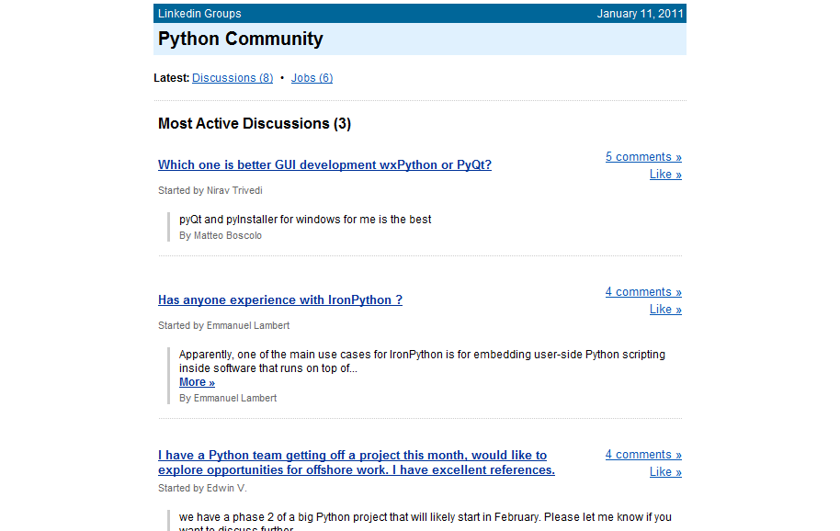

# US201 - Cron of data extract for BI

**Description**:

I will need several csv extracts of views of the data that I will build reports for the Analysis pages.

There will be the following views of the data:

1. Who are the user of HM

2. How are HM Users voting

3. Report using Metadata

4. Political District Report

I will define the requirements for the extracts with your inputs into the SQL.

We may need to ftp the extracts somewhere or upload them depending on how the reporting tool will work.

Uses: --

**Code Impact :**

a) admin

**DB Impact :**

New db design for cron jobs data extract.

**Ben Reply :**

Based on the exported csv files which has to process for analysis page with <http://www.tableausoftware.com/> [which has to be take care for future phases]

**OPENWAVE REPLY:**

We estimated only for extracting data as csv files and save it one of local server folders.

**Estimated Hours:** hrs

# US216 - Click Section/SubSection in Issue Info tab

**Description:**

When the user clicks on one of the ovals in the issue details/info tab, launch the category search results page.

Uses: --

**Code Impact :**

a) Search

b) Issue info Tab

**OPENWAVE REPLY:**

**Estimated Hours:** hrs

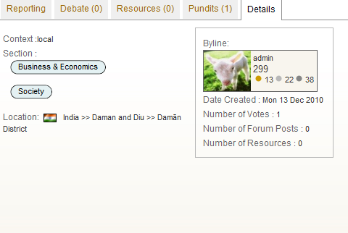

### Page Design Requirement

All pages are to be designed based on design provided by the customer.

* All pages should have AJAX implementation without refreshing whole page.
* The custom GUI integrating with Drupal Theme.

### Coding Requirement

* The website will have to written in LAMP (Linux, Apache Web Server, My Sql 5(Database), PHP 5(Server Side Scripting)), Drupal Content Management System (CMS), Jquery & Ajax (Client Side Scripting) has full programming of the specification.
* Drupal API will be installed and configured to check the coding standards dynamically.
* The code should be commented clearly in English and meaningful variable names should be used.

### Interface Requirement

The website should be able to interface with Gigya Api for the user registration and login and the purpose of social network sharing and posting and Facebook Application.

### Performance Requirement

* The site will be optimized for effective memory usage.
* Database will be optimized in order to achieve the fast retrieval and search functionality.

### Load Test Requirement

* Load test will be performed, to improve the performance, efficient & scalable.
* Site will be scalable to work across a load balanced environment with several application servers.

### Installation Requirement

Installation and set-up of web site at Production Server will be done by Openwave, if customer provides hosting details.

### Other Detailed Requirement

* The design for home & inner pages as per the image file (provided by customer) is to be followed.
* Icons needs to be changed as per the image file (provided by customer).
* All code must pass validator.w3c.org with no errors and no warnings.

### Website Quality Assurance and Testing

Functional, Usability, Interface, Compatibility, Cross platform, Sql Injection, and quality assurance testing will be performed for the Customer Website, along with form submission testing, and database content capture. The Customer Website will be tested and made compliant with the latest browser software versions available for download from their developer's website at the time of development of the website. The following is a list of the browsers and operating systems that will be used during the Website Quality Assurance testing phase:

**Functional Testing:**

* Checking all the links
* Testing forms in all pages
* Cookies testing
* Validate HTML/CSS
* Database Testing
* Usability Testing:
* Testing for Navigation
* Content Checking

**Interface**

* Web server and Application Server interface
* Application Server and Database Server Interface

**Compatibility**

* Browser Compatibility
* Operating System Compatibility

## Out of Scope

### Out of Scope activities (not included in scope)

The following are the items that are not covered in the scope of work.

* Design work in the admin panel
* The content updates and manages the site in the post-launch session. That will be included in another maintenance contract.
* US191 - Replace Tabs with Slider
* US185 - Unlimited Category Levels

## Assumptions

The following are the assumptions that are made by Openwave for executing this project. The customer is requested to clarify if these assumptions are acceptable.

All posted in Rally Dev

## Questions & Answers

All posted in Rally Dev

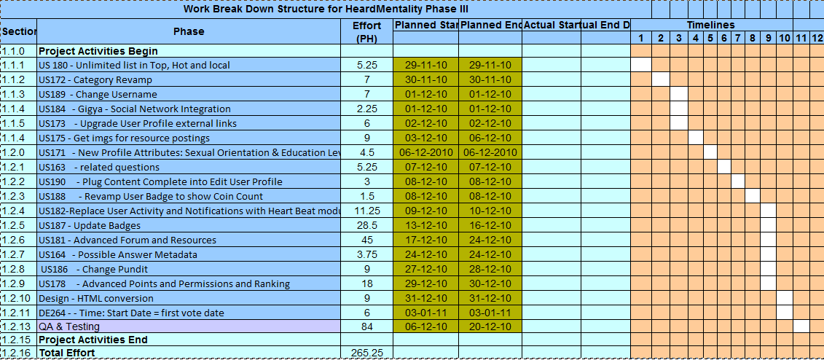

## Quality Plan

Openwave always has a focus on process quality and product quality to ensure that high-quality; milestone-driven deliverables are made, on time, within budget to its customers. Towards achieving this objective, Openwave will prepare a quality plan that covers a set of web design process steps and tracks some key software metrics such as

* On-Time-Delivery
* On-Budget-Delivery
* Defect-Free-Delivery.

Effective review mechanisms are in place at every stage of the project cycle to ensure process compliance and defect free deliverables. Tools like Checklists and Standards are used to conduct internal reviews, peer reviews, final inspections, etc., Project Management Reviews are conducted by the Openwave senior management periodically to ensure project is on track and issues & concerns are addressed expeditiously.

Openwave will use the PLAN-DO-CHECK-ACT (PDCA) methodology and Defect Prevention techniques during the development process. Our plans and schedules are based on customer deadlines and continuous refinement of our effort estimation models.

## Staffing Plan

The following table depicts a high-level view of the deployment of the project team across various phases of the project, as we follow the Agile/xp methodology everybody from the team will be involved actively in the creation of project from the start to the end.

|  |  |  |
| --- | --- | --- |
| **Phase** | **Role** | **# No of People** |
| Project Activities – Begin | Project Manager | 1 |
| Analysis Phase | Business Analyst | 1 |
| Design Phase | Technical Designer | 2 |
| Construction Phase | Developer | 2 |
| Testing Phase | Tester | 2 |
| Implementation Phase | Implementer | 1 |
| Project Activities – End |  |  |

## Communication Plan

The communication plan to be adopted for this project is described as follows:

### Internal Communication

Communication will happen within the project team using various modes of communication that include face-to-face meetings, email, phone calls and instant messaging systems. Project teams will also formally communicate with Openwave senior management team through emails and conference-room meetings to discuss project progress, concern areas, mitigation plans, etc.,

### External Communication

Communication with customer regarding project status, issues & queries, problem resolution, etc., will happen through emails and teleconferences.

# Financials

## Pricing

This project is priced based on analysis of the total effort required for executing this project. Openwave has done this analysis using an effort estimation model, developed based on the previous experience of executing similar projects.

This project will be executed on a Fixed Price basis.

Project Location : Offshore Service – at ODC, Chennai, India.

The total cost for this project is USD XXXX

The final price (after offering a discount of USD 1,875) for this project is USD XXXX

Any additional new requirements or change requests over and above the agreed scope of work will be charged at USD XX per hour.

## Payment Terms

The following are the terms of payment for executing this project:

* ?% After agreement to commence work and project plan has been agreed
* ?% on reaching Milestone 1 (as given in Section 5.3 – Project Schedule)
* ?% on reaching Milestone 2 (as given in Section 5.3 – Project Schedule)
* ?% on reaching Milestone 3 (as given in Section 5.3 – Project Schedule)
* ?% on reaching Milestone 5 (as given in Section 5.3 – Project Schedule)
* ?% on reaching Milestone 5(as given in Section 5.3 – Project Schedule) and after deployment and all documented requirements have been met and final testing has been completed on the live environment

## Warranty

The deliverables made will be covered for a warranty against critical fixes and bugs for a period of 3 months from the date of delivery.

**Agreed & Accepted**

By: _________________________________

Title: _______________________________

Dated: ______________________________

Company: ___________________________

Address: ____________________________

___________________________________