|  |  |
| --- | --- |
|  | CAB302 Assignment 2 Vector Design Tool – Team188 |
|  |  |
|  | Subject Name: Software Development  Unit ID: CAB302  Unit Coordinator: Dr Timothy Chappell  Group members: Johnson KaiZhi Foo (N9915931)  Wei Zhao Wu (N10192701)  Yung Han Lin (N10094881)  MinHo Kim (N8051381)  Due Date: 02/06/2019 11:59p.m. |
|  |  |

Table of Contents

**Completeness of Functionality** 2

**Basic Functionality** 2

**Additional Functionality** 10

**Communication & Team Works** 12

**Team member Contribution:** 13

**Software Architecture** 14

**Advanced Object-Oriented Programming Principles** 17

• **Abstraction** 17

• **Encapsulation** 17

• **Inheritance** 17

• **Polymorphism** 17

**User Guide** 20

Example Screenshot 1

# **Completeness of Functionality**

In this paragraph, all the basic function and additional function will be explained here. There are two section in order to clearly explain the functionality for the users. Basic Functionality shows all the basic function like draw, colour and save file, etc. Additional function shows all the extra features for the project such as grid and multi-image support, etc.

## **Basic Functionality**

1. Draw

Above shows the properties for the drawing part.

* 1. Point

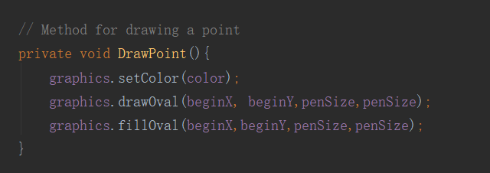

The function of draw point is to draw a dot shape on the page screen. Above screenshot shows the Java code of the dot point. The first screenshot is the code of that able to draw the dot on the drawing screen. The second screenshot is to create the pen for the dot point to draw.

* 1. Line

The function of Line is to draw a straight line from pointed a to pointed b. Above screenshots shows all the codes of drawing a line. The first screenshot shows the codes that create the pen for the line to draw and the second screenshot is to shows the codes of letting the pen able to draw it into the drawing screen.

* 1. Rectangle

The function of rectangle is to draw the shape of a long version of square into the drawing screen. The function also able to change the pen and internal parts colour. Above shows the screenshots of all codes about the rectangle. The first screenshot explained the methods of creating the pen for the rectangle and other shape like circle, and ellipse. The second screenshot cover all the methods for how the pen able to draw and colour fill.

* 1. Ellipse

The function for ellipse is to allow users to draw an oval shape of object into the drawing screen. Above screenshots shows all the code about the ellipse function. The first screenshot explained about how the pen is create for the ellipse function to draw. Second screenshot covered all the method of how it able to draw and colour on the drawing screen.

* 1. Polygon

The function of polygon is to draw a polygon shape of object into the drawing screen by point out placing multiple of pointed location in order to link it together.

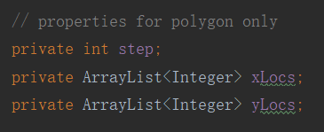

Above screenshot show the properties for the polygon only.

This is the methods for the polygon of creating a pen for only the function itself.

Here is the method for letting the pen able to draw a polygon shape on the drawing screen. It also able to fill its solid colour and change the brush colour.

1. **Able to save into a VEC file**

1. **Brush colour selection**

The function of the brush colour selection is for the user to select any possible pen colour in a new window. Users able to choose colour by clicking the button of line colour and choose whatever colour the user likes. After the user selected, the colour will show in a square panel where just below the button.

(Here show the properties for the button)

(Above two screenshots covered all the method of creating the colour button. In here, the first screenshot explained creating the button with its font and visual background. The second screenshot will set the button location into the right-hand side for users’ convenience. The last 4 codes are the function of enable users to trigger the button and make it work.)

(This screenshot shows the method of triggering the button. By pressing the line colour button, the system will pop out a new window for users to choose and the last two code is to show the selected colour in a square panel just right below the button.)

1. **Flood fill tool**

The function of flood fill is to allow users to select any possible colour for the internal parts of shapes. At first, users press the fill colour button. Secondly, users selected their desired colour.

(Here show the properties for the button)

(Above two screenshots covered all the method of creating the colour fill button. In here, the first screenshot explained creating the button with its font and visual background. The second screenshot will set the button location into the right-hand side for users’ convenience. The last 4 codes are the function of enable users to trigger the button and make it work.)

(This screenshot proves the method of triggering the fill button. By pressing the fill colour button, the system will pop out a new window for users to choose and the last two code is to show the selected colour in a square panel just right below the button.)

1. **Undo button**

The function of undo is to revert the object back to the screen that never appear before.

(This screenshot showed all the code for the function of undo.)

1. **VEC file import**

## **Additional Functionality**

1. Grid

1. Multi-image support

1. Clean/ Eraser

1. Redo

1. Pen Size

# **Communication & Team Works**

**Communication tools**

* Discord
* Facebook
* GitBucket
* Google Document
* Intellij IDEA

**Agile Software Development**

|  |  |  |  |
| --- | --- | --- | --- |
| ***CAB302 Group 188*** | | | |
| **Team Members No.** | **Name** | **Position** | **Colour** |
| 1.n9915931 | Johnson KaiZhi Foo | Report Writing & Project Management |  |
| 2.n10094881 | Yung Han Lin | Report & Coding |  |
| 3.n10192701 | Wei Zhao Wu | Coding & Unit Testing |  |
| 4.n8051381 | MinHo Kim | Coding & GUI Design |  |

***Project Management:***

|  |  |  |  |  |  |  |
| --- | --- | --- | --- | --- | --- | --- |
| ***Work Distribution*** | | | | | | |
| **Mission** | **Responsible** | | | | | |
| Research |  |  | |  | |  |
| Design |  | |  | |  | |
| GUI Function |  | | |  | | |
| Shape Function |  | | | | | |
| Undo Function |  | | | | | |
| Clean Function |  | | | | | |
| Colour Selection Function |  | | | | | |
| Drop Down Window (File Menu) |  | | | | | |
| Additional Function |  | | |  | | |
| Import/ Open |  | | |  | | |
| Export/ Save |  | | |  | | |
| Unit Testing |  | | |  | | |
| JAVA Doc |  | | | | | |
| Report |  | | |  | | |

## **Team member Contribution:**

|  |  |  |  |  |
| --- | --- | --- | --- | --- |
| **Names** | **Report Writing** | **Coding** | **Creation of unit test** | **Timetable management** |
| Johnson KaiZhi, Foo | Checkmark | Checkmark |  | Checkmark |
| Wei Zhao, Wu | Checkmark | Checkmark | Checkmark |  |
| Minho, Kim | Checkmark | Checkmark | Checkmark |  |
| Yung Han, Lin | Checkmark | Checkmark |  | Checkmark |

***Meeting Schedule:***

|  |  |  |  |  |  |  |  |  |  |  |  |  |
| --- | --- | --- | --- | --- | --- | --- | --- | --- | --- | --- | --- | --- |
| **#Semester 1- 2019** | | | | | | | | | | | | |
| **Week 8** | Looking for group members | | | | | | | | | | | |
| **Week 9** | Group 188 formed | | | Criteria Review | | | | | | Research | | |
| **Week 10** | Work Distribution | | Start paint project | | | | Project Design | | | | Window Drop Down | |
| **Week 11** | PLOT | LINE | | | | Rectangle | | | Ellipse | | | Polygon |
| **Week 12** | Undo | Import | | | | Export | | | Unit Testing | | | |
| **Week 13** | Additional Functionality | | | | Report | | | Criteria Review again | | | | |

***Group meeting record:***

|  |  |  |
| --- | --- | --- |
| **Week No.** | **Meeting No.** | **Date** |
| 8 | 1 | 17/04/2019 |
| 9 | 2 | 01/05/2019 |
| 10 | 3 | 06/05/2019 |
| 10 | 4 | 10/05/2019 |
| 11 | 5 | 15/05/2019 |
| 11 | 6 | 18/05/2019 |
| 12 | 7 | 21/05/2019 |
| 12 | 8 | 25/05/2019 |
| 12 | 9 | 26/05/2019 |
| 13 | 10 | 28/05/2019 |
| 13 | 11 | 31/05/2019 |
| 13 | 12 | 01/06/2019 |
| 13 | 13 | 02/06/2019 |

# **Software Architecture**

The project initially began by running the class of Frame Design. The main class (java file) is the execution point and the it is also as the controller as this is a standard Java Swing.

* 1. Public class FrameDesign

Is to create a frame and button to draw the shapes. It also has a buttons and tools for the brush and fill colour in order to draw appointed object in the default white background. It is the only class which have the main method to run the program and build the GUI application out. This class included the method of creating the frame, menubar, buttons, tools, colour buttons and core component for the GUI to appear.

* 1. Private class ShapeBtnTrigger implements ActionListener

The class of ShapeBtnTrigger is for the button of any shapes to allow the system to detect which button we pressed and check if the user is clicked on a new button. If the users did not press a new colour button for the shape, the colour for the shape will be the same as the default one.

* 1. Private class ToolBtnTrigger implements ActionListener

The class of ToolBtnTrigger is to detect the users which tool button he chooses. By using the if statement to check whether the users will choose clean, undo, line colour selection, fill colour selection, quick line colour selection, and quick fill colour selection. The system will check the users whether he press the button to open the colour palette by using the method of for loop statement.

* 1. Private class MenuItemTrigger implements ActionListener

This class is a method for the users to use any item in the file menu. the system will detect whether the users chooses which items in the menu by using the if statement. There are four items in the file menu such as create new file, import existing file, save current file and exit the application.

* 1. Private class MouseTrigger implements MouseListener, MouseMotionListener

The class of MouseTrigger is a method for the users to draw the selected shape using mouse. It able to record the shape users had drawn and draw it out when the users release the mouse click. All the trigger for the canvas panel will return its value to the private method of CreateFrame in the public class FrameDesign.

* 1. Public class Tool

The Tool class is to set up all tools method and make it usable. The Tool class have the undo, clean, choose line and fill colour function. This class will return back to the private class of ToolBtnTrigger in order to make it functionable in the Jframe.

* 1. Public class Pen

This class is to create a pen for all the shape to be able to draw in the Drawing screen. This methods inside this class is basically all the methods for creating the shape and received the colour for the line and fill that the users had chosen.

* 1. Public class VecConverter

This class is significant for the project as it required this class to be able to read the Vec file inside or outside the application. This class will initiate the converter and select a Vec file from a pop out window to import or export. In the process of import or export, the program will start beginning a conversion to the text, pen type, colour, and coordinates to generate a Vec format file. After convert is finished, it will return its value to the class of VecReader to be able to show in the application.

* 1. Public class VecReader

The main function of VecReader is to analyse the imported Vec file and show it visible in the application. The method of Draw is to record the default graphics and colour. Secondly, the system will clean the drawing screen and start to draw the imported Vec file. Lastly, all the things that we draw will save it in a new graphics and array list. The private method of DrawEverySingleShape is to create an array list and get all the detail of shapes to be able to draw.

* 1. Public class VecWriter

This class of VecWriter is to create a list of variables and scan every pen’s graphics to write the file in the variable of FileWriter. The method of ScanForObjs is to scan every single pen’s graphic in the drawing screen and store it into the list. The method of InsertObjInfoIntoList is to convert the pen’s graphic that scan from the method of ScanForObjs into a string value. Lastly, the method of WriteInInFile is to use the variable of FileWriter to write the string value into the array list that created in the method of Export to export the Vec file.

**Screenshot for all the Class**

# **Advanced Object-Oriented Programming Principles**

## **Abstraction**

There is three main folders for our paint project. You will be able to find the abstraction by looking each class in every folder. The diagrams are presented in a UML diagram in order to allow user to understand easily.

## **Encapsulation**

By looking the important stuff for encapsulation. In every class diagram, there is a symbol for each method and the symbol of minus(-) is all the private method for the paint project.

## **Inheritance**

The only inheritance in our code are public class FrameDesign extends JFrame, and public class VecConverter extends JFrame.



## **Polymorphism**

All the polymorphism operation able to find in the class of ShapeBtnTrigger, ToolBtnTrigger, MenuItemTrigger, MouseTrigger. All this class is supported by method of overriding.

**UML Diagrams**

# **User Guide**

1. **First Step:** Open the application tool by running the class of FrameDesign.
2. **Second Step:** The right up corner grid button will show the grid on or off. If you turn on the grid function, the icon will change into a slash grid icon and the drawing screen will appear a grid panel. If you turn off the grid function, the icon will return to normal grid icon and the panel will disappear.
3. **Third Step:** You will be able to open the colour palette window by pressing the button of line and fill colour. You also able to select quick colour selection at the bottom left corner.
4. **Forth Step:** You will be able to draw point by pressing the button of Point.
5. **Fifth Step:** Press the Circle button to draw a circle shape.
6. **Sixth Step:** You can draw a rectangle shape by pressing the button of rectangle
7. **Seventh Step:** The ellipse button is a function for you to draw an oval shape.
8. **Eighth Step :** Press the polygon and start point the drawing screen of at least three point to form a polygon shape.
9. **Ninth Step:** The eraser icon at the top right is the function of cleaning all object in the drawing screen.
10. **Tenth Step:** The undo button is the middle one beside the pen thickness area. Using the undo function will allows you to revert to the previous screen.
11. **Eleventh Step:** The redo button is to restore your screen to the latest ahead.
12. **Twelfth Step:** You able to save your current drawing stuff into the format of VEC file by pressing the button of save in the file setting.
13. **Thirteenth Step:** You able to import other VEC file into your current drawing screen too.
14. **Fourteenth Step:** You able to open a new window of application and choose any vec file to import or cancel to continue your new window.
15. **Fifteen Step:** Press the cross button at the right-hand corner side or go to the file and choose the exit to terminate the application.

**Screenshot**

Grid appear in the draw screen

Grip turn on

Grid gone after it is turn off

Grip turn off

Press to make the fill colour disable

Reset to the beginning colour

Press ok to confirm

Select any colour

Press these two buttons to open the colour paletttes

Change the pen’s thickness 10 ~30

Point Function

Line Function

Rectangle Function

Ellipse Function

Polygon Function

Open File Menu

Cancel to continue on new window

New window when u press new

Select and open to import in the current window when u press opens in the file menu

Type your new file name and save it in vec format file

# Example Screenshot

* Example 1

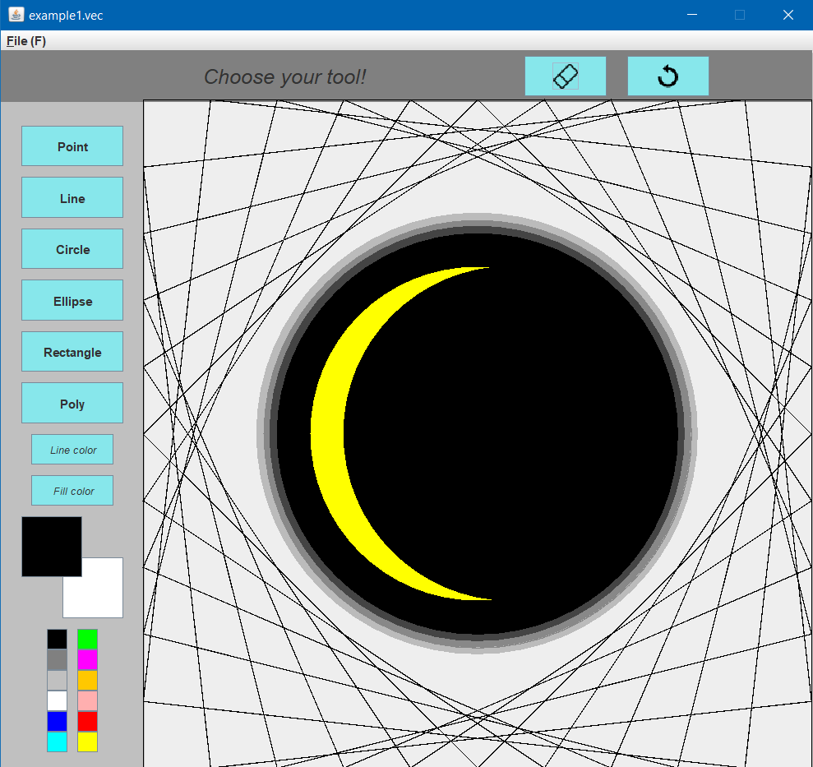

**Vec Code:**

* Example 2

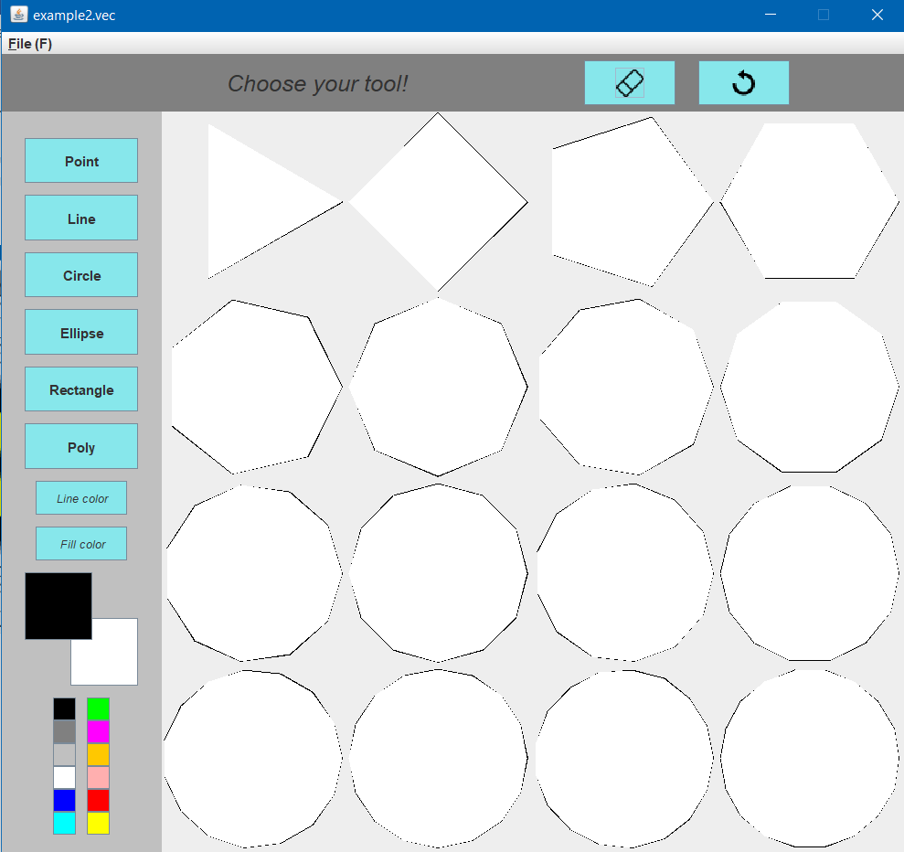

**Vec Code:**

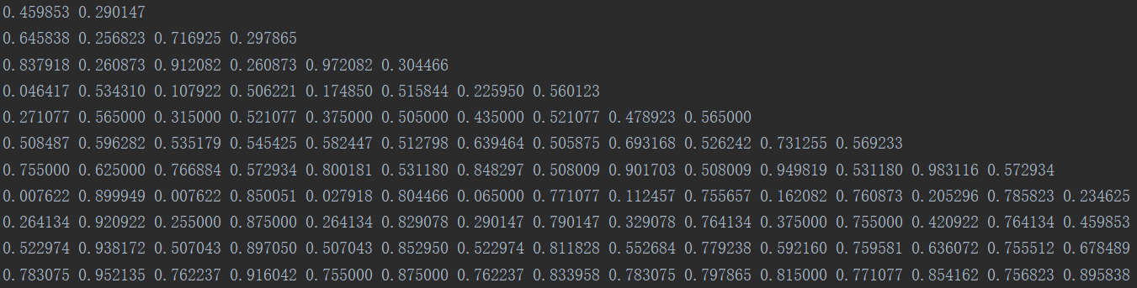

* Example 3

**Vec Code:**

* Example 4

**Vec Code:**

* Example 5

**Vec Code:**

* Example 6

**Vec Code:**

* Example 7

**Vec Code:**

* Example 8

**Vec Code:**

* Example 9

**Vec Code:**

* Example 10

**Vec Code:**

* Example 11

**Vec Code:**

* Example 12

**Vec Code:**

* Example 13

**Vec Code:**

* Example 14

**Vec Code:**

* Example 15

**Vec Code:**

* Example 16

**Vec Code:**

* Example 17

**Vec Code:**

