**NOISE POLLUTION MONITORING**

**TEAM MEMBER**

**SABARI SRIRAM V - 310521104099**

**PHASE 2 DOCUMENTATION**

**Innovative Solution: Data-Driven Noise Pollution Management**

**Introduction**

Noise pollution is a growing concern in urban areas, affecting the well-being of residents and contributing to various health problems. To address this issue, we propose an innovative solution that leverages data analytics to identify noise pollution patterns, high-noise areas, and potential sources. This data-driven approach will enable more effective management and mitigation of noise pollution.

**Problem Statement**

Noise pollution poses several challenges:

* Health Impact: Prolonged exposure to high noise levels can lead to stress, sleep disturbances, and various health problems.
* Quality of Life: Excessive noise can reduce the quality of life for residents, affecting their comfort and productivity.
* Environmental Impact: Noise pollution can harm wildlife, disrupt ecosystems, and even contribute to climate change.

**Solution Overview**

Our innovative solution involves the following components:

* Data Collection: We will deploy a network of noise sensors in key areas of the city to continuously monitor noise levels. These sensors will collect data on noise intensity, frequency, and duration.
* Data Analytics: The collected data will be processed using advanced data analytics techniques, including machine learning algorithms. The analytics will help us identify noise pollution patterns, high-noise areas, and potential sources.
* Visualization: The results of the data analysis will be presented through interactive and user-friendly visualizations. This will allow city officials and residents to easily understand noise pollution trends and take informed actions.
* Alert System: An automated alert system will be implemented to notify relevant authorities and residents when noise levels exceed acceptable thresholds in specific areas.
* Public Engagement: To encourage public participation, we will develop a mobile application that allows residents to report noise disturbances, view noise pollution data, and access educational resources about noise pollution.

**Benefits**

Implementing this data-driven approach to noise pollution management offers several benefits:

* Improved Decision-Making: City officials can make informed decisions about noise pollution mitigation strategies based on data-driven insights.
* Efficient Resource Allocation: Resources can be allocated more efficiently to address noise pollution in high-priority areas.
* Community Engagement: Involving residents in noise pollution reporting and awareness campaigns fosters a sense of community involvement and responsibility.
* Healthier Urban Environment: By addressing noise pollution, we contribute to a healthier and more livable urban environment.

**Data Analytics for Noise Pollution: Uncovering Patterns, High-Noise Areas, and Sources**

**Identifying Noise Pollution Patterns**

Data Analytics: By analyzing historical noise data collected from sensors placed throughout the city, we can identify noise pollution patterns. These patterns might include:

Temporal Patterns: Discovering when noise pollution is most prevalent, whether it's during certain times of the day or on specific days of the week.

Seasonal Patterns: Identifying noise variations that coincide with different seasons, weather conditions, or holidays.

Event-Related Patterns: Recognizing noise spikes during specific events or activities, such as festivals, construction projects, or sporting events

**Noise Monitoring**

The proposed noise monitoring system comprises smart sensors which are connected through wireless uplink to the cloud service. The overview of the system is illustrated below. The smart sensor consists of a measurement microphone and a single-board computer with a wireless transmission unit. To alleviate the privacy issues concerning the continuous audio capturing and storage, the most of the analysis and processing is done already in the sensor and only analyzed data is transferred and stored in the default setting. This approach will also lower the amount of transferred data from a sensor to the cloud service, and enable placing sensors to areas with lower quality wireless uplinks. In the sensor, A-weighted 10-min equivalent sound pressure level values are calculated continuously, and predominant noise sources are detected within the measurement time segment. This information is used to decide whether the actual acoustic signal is needed for further inspection in the cloud service. For example, segments exceeding the legal maximum allowed sound level can be saved for manual inspection. All the extracted measurements are transmitted from the smart sensor to the cloud service for further analysis. The cloud service stores the data in the measurement database, and audio segments marked for later inspection are stored in the disk server. End-users access the measurement data and analysis of the measurements through a web-based portal.

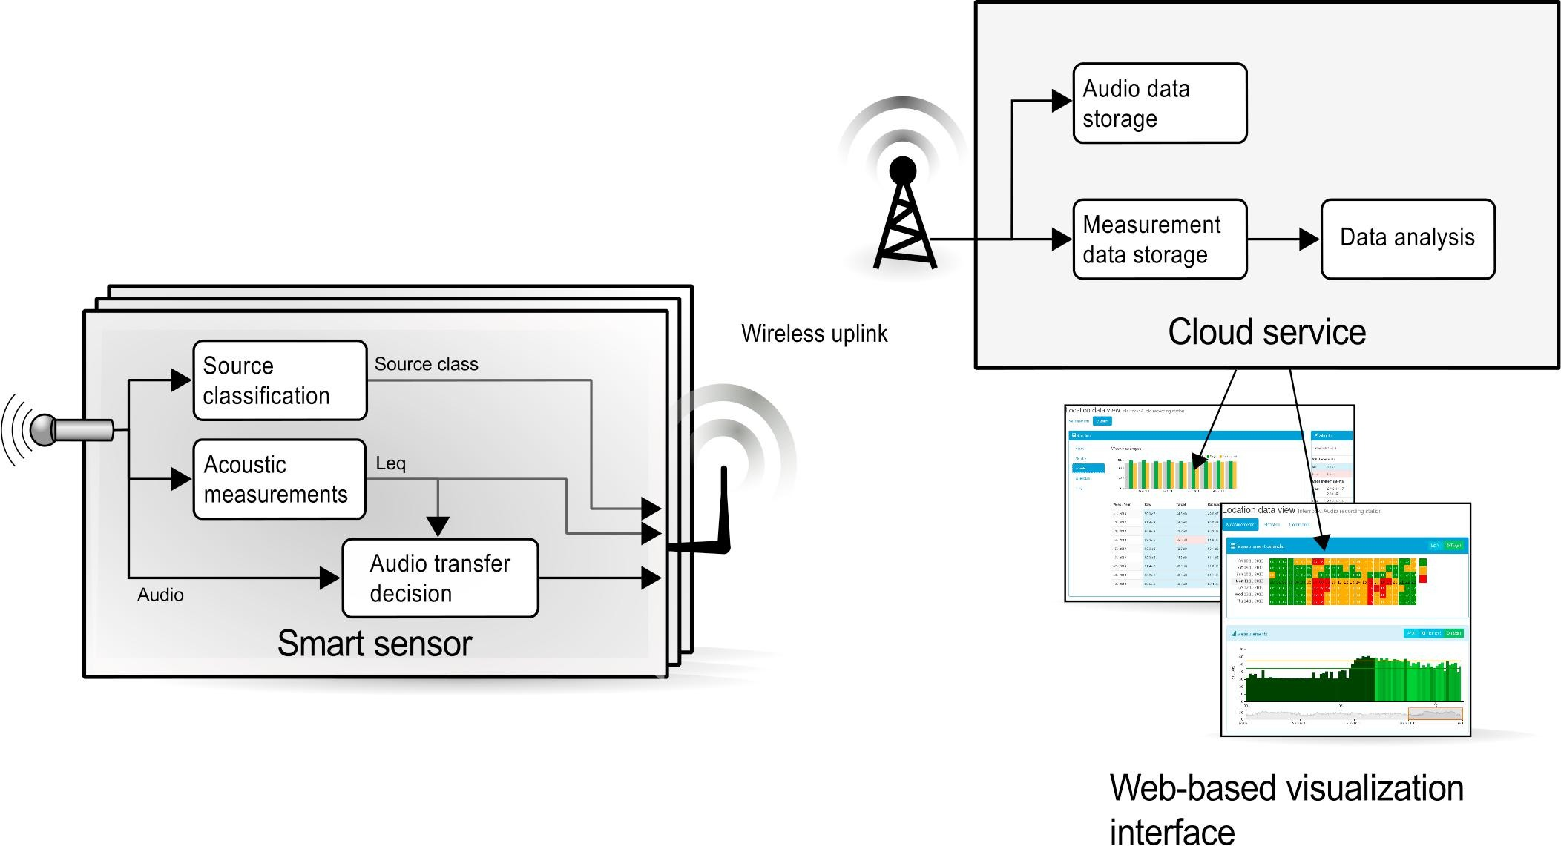

**Smart Sensors**

For the prototype, the credit-card-sized RPi (Raspberry Pi) developed by the Raspberry Pi Foundation was selected mainly due to its excellent support network and general usability. RPi1, the first generation model was used in the prototype because it was the only available model in 2012 when the implementation was made. Additional functionality was added by an audio codec (a 24-bit multi-bit sigma delta ADC converter), a smart power management board with an uninterruptible power supply feature, and mobile connectivity. The selection of the microphones ended up with two models: one covering the audible range dynamics from 14 dB to 119 dB, and another from 20 dB to 140 dB (A-weighted).

Based on preliminary tests, solar power was selected to allow totally wireless sensors. The electronics and batteries were built inside a solar panel frame. Whenever the 60 W panel gets solar energy, the batteries start charging, the system is powered up, a secure cloud service connection is established, and pre-processed real-time noise data flow to the online service is initiated. It is also possible to access the sensor unit remotely through the online service. The batteries, when fully charged, will keep the system running during the dark hours. The total cost of the components is about 150 €, the solar panel being the most expensive component, but the price could be reduced in mass production, or using an external power source.

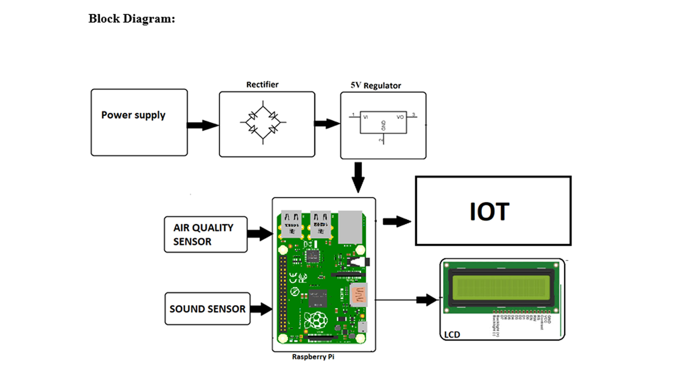**Conclusion**

The integration of data analytics into noise pollution management represents a proactive and innovative approach to tackle this pressing issue. By continuously monitoring, analyzing, and visualizing noise data, we empower city officials, residents, and businesses to work together in reducing noise pollution and improving the quality of urban life.

Incorporating data analytics to uncover noise pollution patterns, high-noise areas, and potential sources is a forward-thinking approach to addressing this pressing urban issue. It empowers city planners, policymakers, and residents with valuable insights, allowing for more effective noise pollution management and ultimately contributing to a healthier and quieter urban environment.