**NOISE POLLUTION MONITORING**

**TEAM MEMBER**

**SABARI SRIRAM V - 310521104099**

**PHASE 5 DOCUMENTATION**

**Phase 5 : Project Description: Noise Pollution Monitoring**

**Objectives:**

The Noise Pollution Monitoring project is designed to tackle the issue of noise pollution in urban areas. The primary objectives are:

**Real-Time Noise Monitoring:** Deploy IoT noise sensors in strategic locations to continuously measure and collect real-time noise data. This aims to gather accurate and up-to-the-minute information on noise levels.

**Data Processing and Analysis:** Develop a comprehensive Noise Pollution Information Platform for the reception, processing, and analysis of collected noise data. This includes cleaning and filtering the data and extracting meaningful insights.

**Interactive Data Visualization:** Create a user-friendly and interactive platform for presenting noise pollution data to both authorities and the public. This includes noise level patterns, high-noise areas, and potential sources.

**Mobile App for Public Engagement:** Develop a mobile application for Android and iOS platforms to provide residents with access to real-time noise data, enabling them to report disturbances and engage in noise reduction efforts.

**Alert System:** Implement an automated alert system that sends notifications to relevant authorities and the public when noise levels exceed predefined thresholds.

**IoT Sensor Deployment:**

**Sensor Placement Strategy:**

* IoT noise sensors are strategically placed in various urban areas, including residential neighborhoods, commercial districts, industrial zones, and transportation hubs.
* Sensor placement considers factors like population density, noise sources, and areas of high noise complaints.
* The sensors are carefully positioned to ensure accurate data collection and coverage of the urban environment.

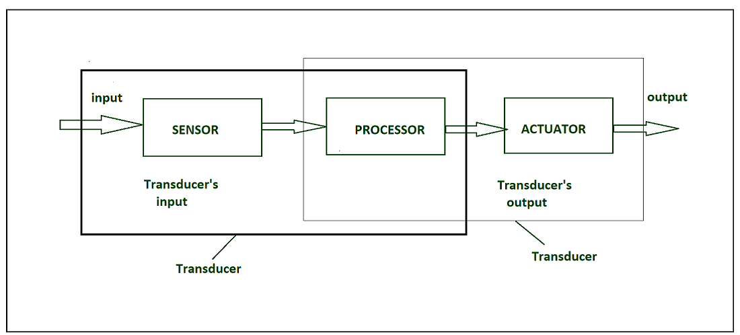

**Data Collection:**

* The IoT noise sensors are equipped with high-quality microphones and other relevant sensors to measure noise levels accurately.
* The sensors continuously collect data, providing a real-time stream of noise information.
* Data collected includes noise levels in decibels (dB), timestamps, and location information.

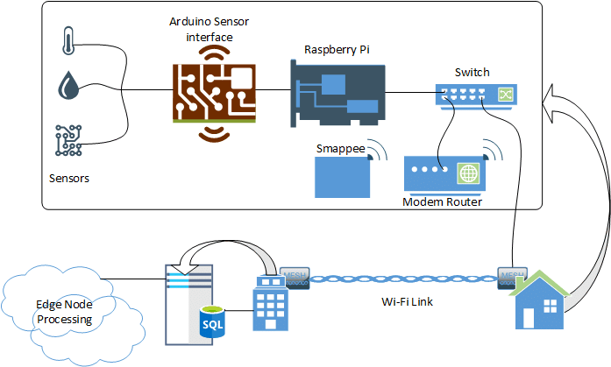

**Noise Pollution Information Platform Development:**

**Key Components and Features:**

**Data Reception:** The platform is equipped to receive real-time noise data from the deployed IoT sensors. It provides a seamless data ingestion process.

**Data Processing:** The platform hosts data processing pipelines that clean, filter, and prepare incoming noise data. This ensures data quality and reliability.

**Data Storage:** A robust database system is established to store both historical and real-time noise data efficiently. This data repository supports long-term analysis.

**Data Analysis:** Data analytics tools and algorithms are implemented to identify noise pollution patterns, high-noise areas, and potential sources. This includes trend analysis and noise source identification.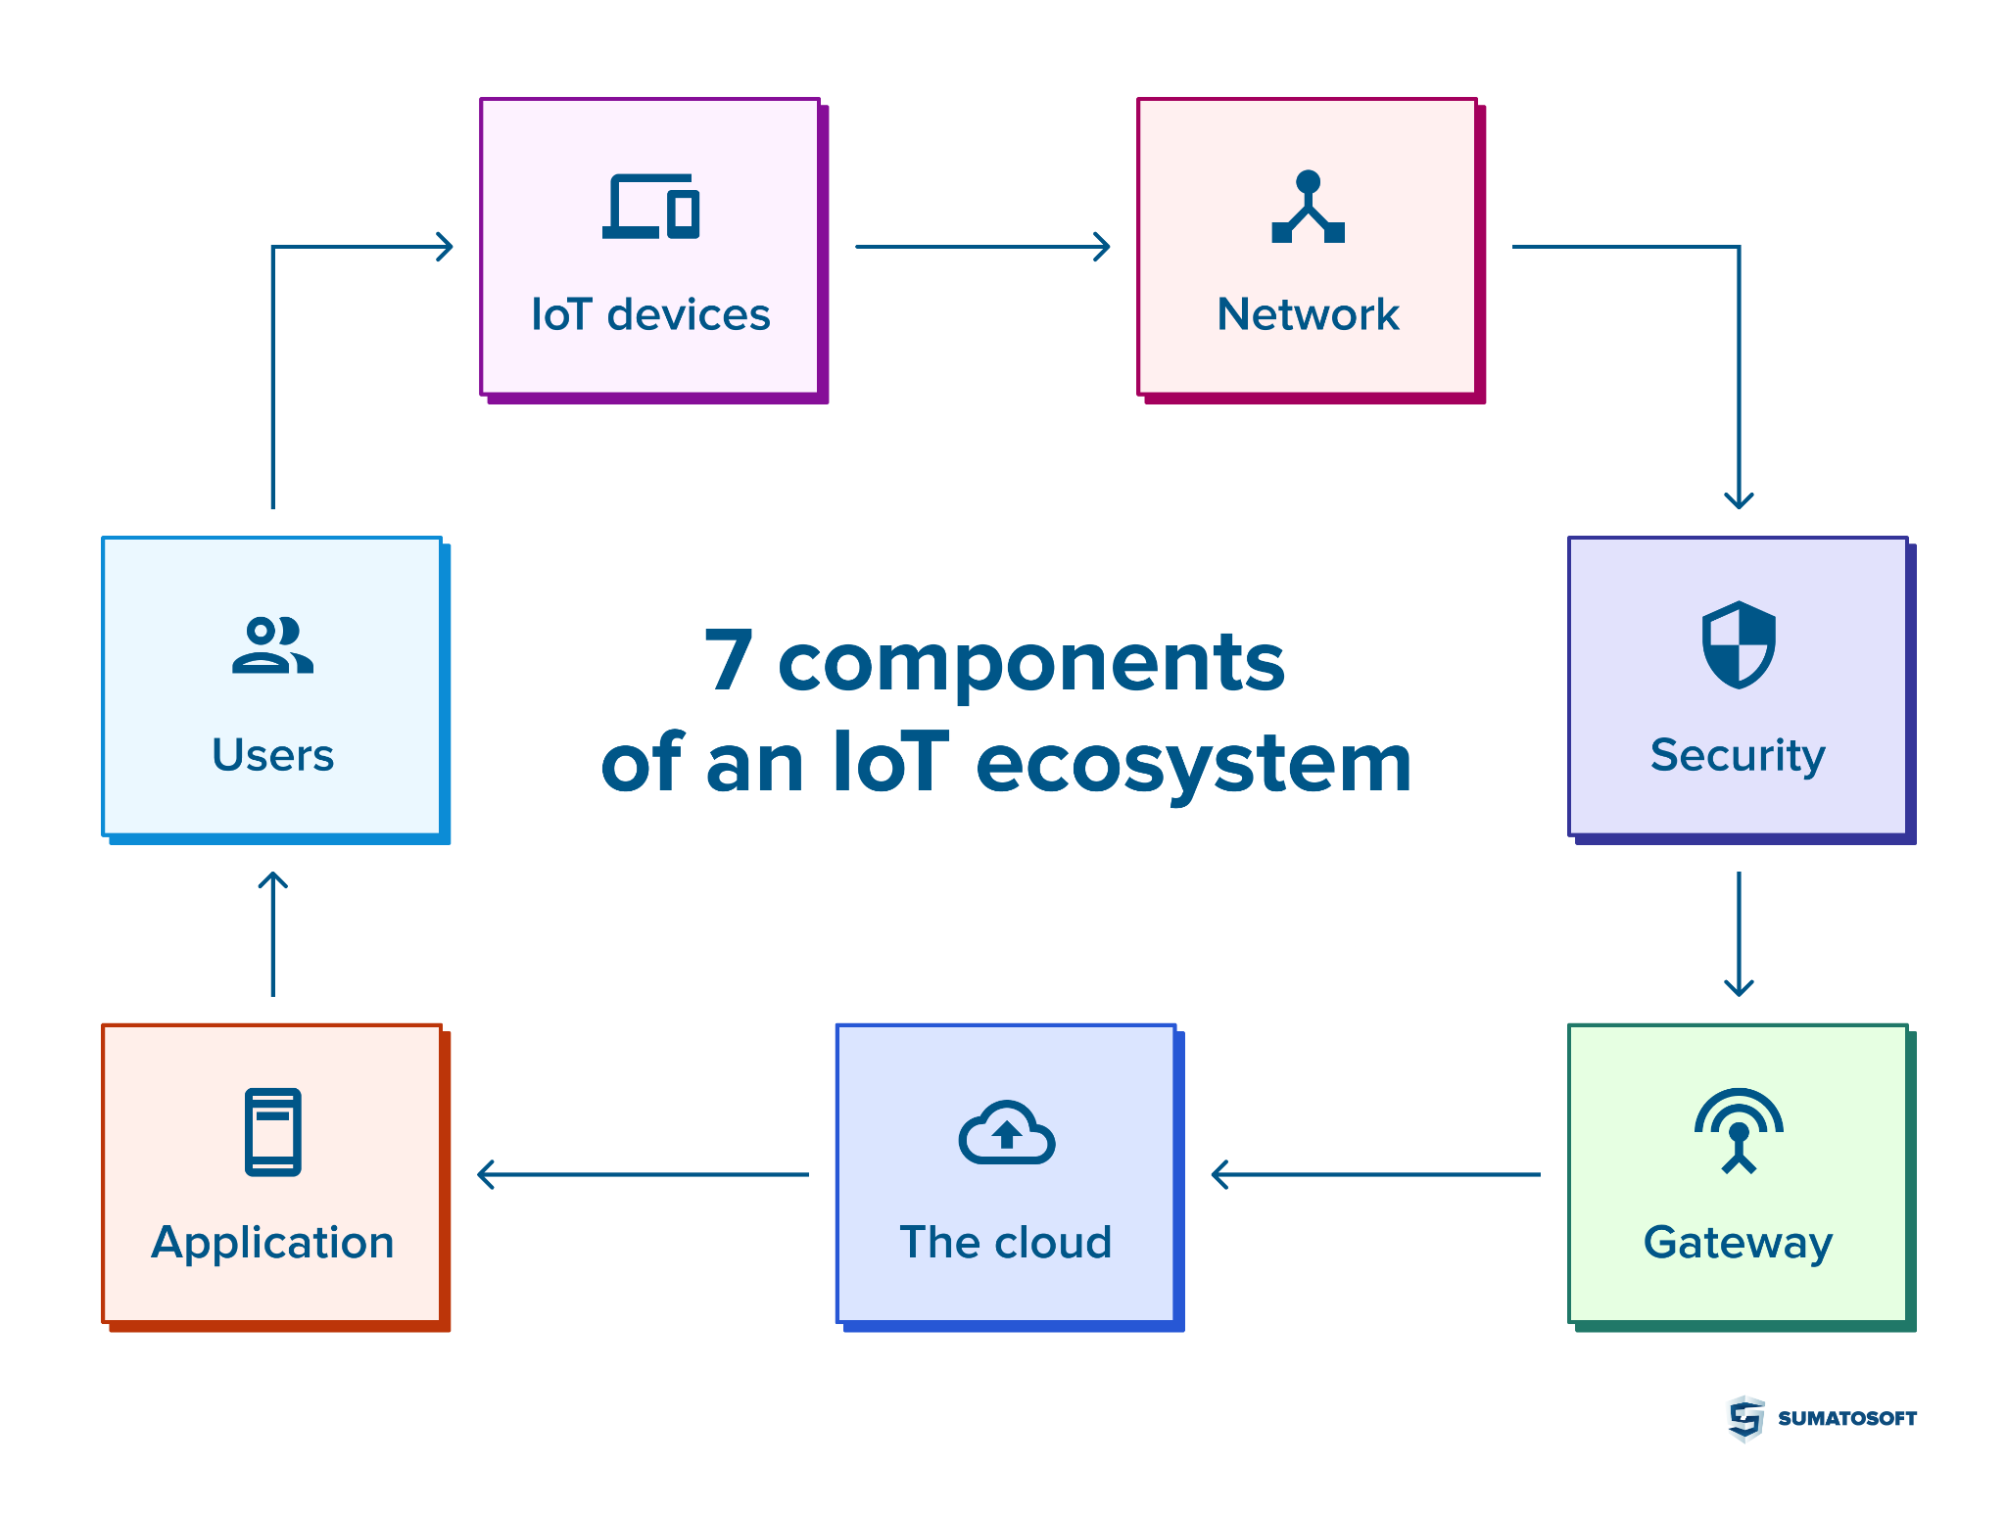

**Data Visualization:** Interactive and user-friendly visualizations and dashboards are created to present noise pollution data to users. This includes charts, maps, and graphical representations of noise levels.

**Alert System:** An automated alert system is integrated to notify authorities and the public when noise levels exceed predefined thresholds. Alerts are issued in real-time.

**Reporting:** The platform generates reports and summaries based on analyzed noise data. These reports serve various stakeholders, including city officials, researchers, and the public.

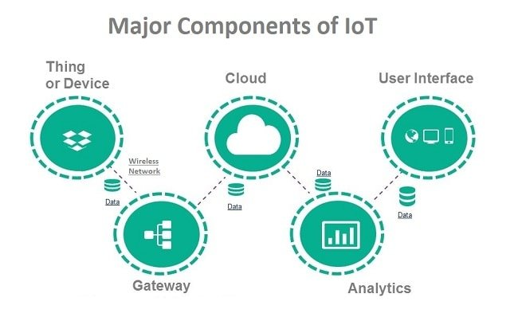

**Technologies Used:**

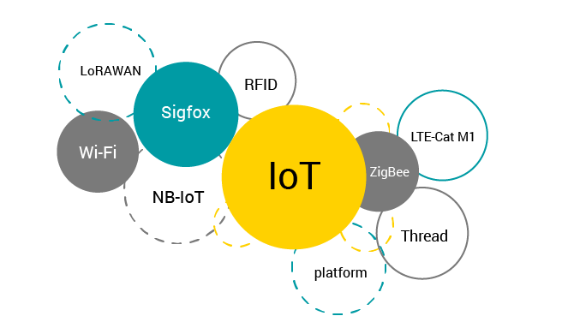

**Data Processing and Analysis:** Python is utilized for data processing and analysis, including data cleaning, filtering, and algorithm implementation.

**Data Storage:** The platform employs a database system, which may include PostgreSQL or NoSQL databases, for efficient data storage.

**Data Visualization:** Data is presented through interactive visualizations created using libraries such as Matplotlib or JavaScript frameworks like D3.js.

**Mobile App Development:**

**Key Features:**

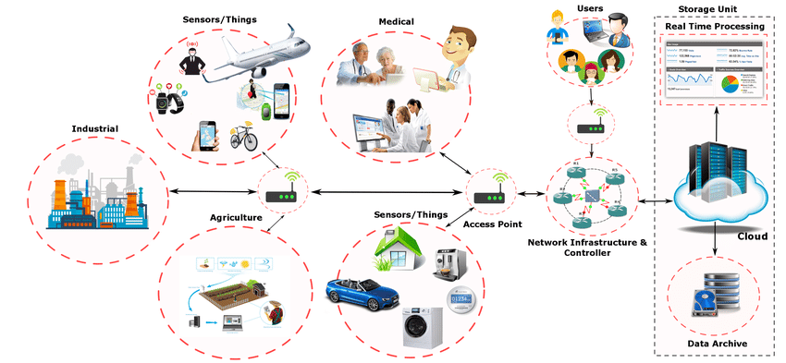

**Real-Time Data Access:** The mobile app offers residents real-time access to noise pollution data from their immediate vicinity.

**Noise Level Alerts:** Users receive push notifications when noise levels exceed acceptable limits in their area.

**Disturbance Reporting:** Users can report noise disturbances through the app, contributing to crowd-sourced data.

**Historical Data:** Historical noise data is accessible, allowing users to track trends and changes in their area.

**User Engagement:** The app's user interface is intuitive and engaging, encouraging active participation and public awareness.

**Technologies Used:**

* The mobile app is built using React Native, which enables cross-platform development for both Android and iOS.
* JavaScript, combined with React Native, is used for logic and user interface development.

**Code Implementation:**

* The code implementation involves several components, including the IoT sensor data collection and transmission, the Noise Pollution Information Platform for data reception and analysis, and the mobile app for public engagement.
* Code is written in various programming languages, including Python, JavaScript, and languages specific to the IoT sensor hardware.

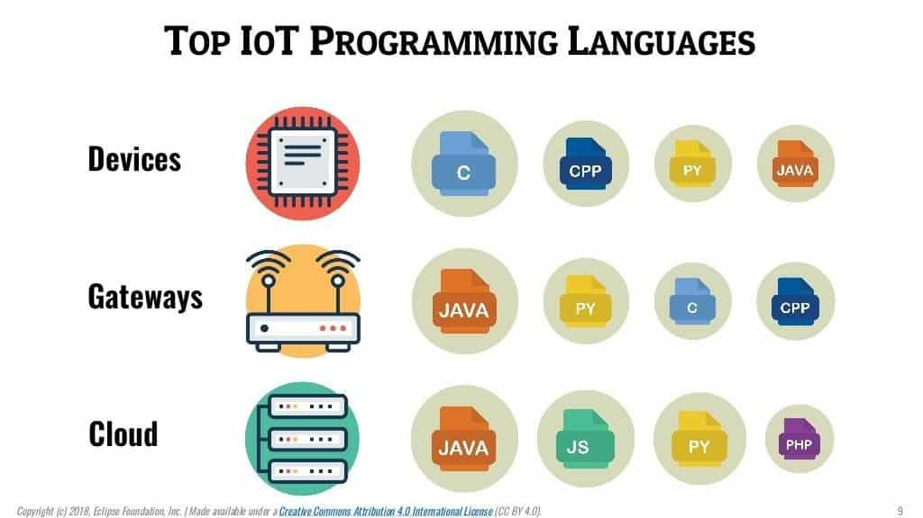

* Communication protocols, such as MQTT, are used to exchange data between IoT sensors and the Noise Pollution Information Platform.
* In conclusion, the Noise Pollution Monitoring project is a comprehensive initiative aimed at addressing and mitigating noise pollution in urban areas. By deploying IoT sensors, developing a data processing platform, creating a mobile app, and implementing an alert system, the project seeks to engage the public, raise awareness, and promote noise reduction efforts. Detailed planning, careful sensor deployment, and thoughtful code implementation are pivotal to achieving the project's objectives.

**A real-time noise level monitoring system plays a pivotal role in promoting public awareness and significantly contributes to noise pollution mitigation.**

Its impact on public awareness and noise reduction is extensive and multi-faceted:

**1. Real-Time Noise Data Accessibility**

One of the primary ways in which the system contributes to public awareness is by providing real-time access to noise data. This information empowers the public to stay informed about the noise levels in their surroundings, leading to several positive outcomes:

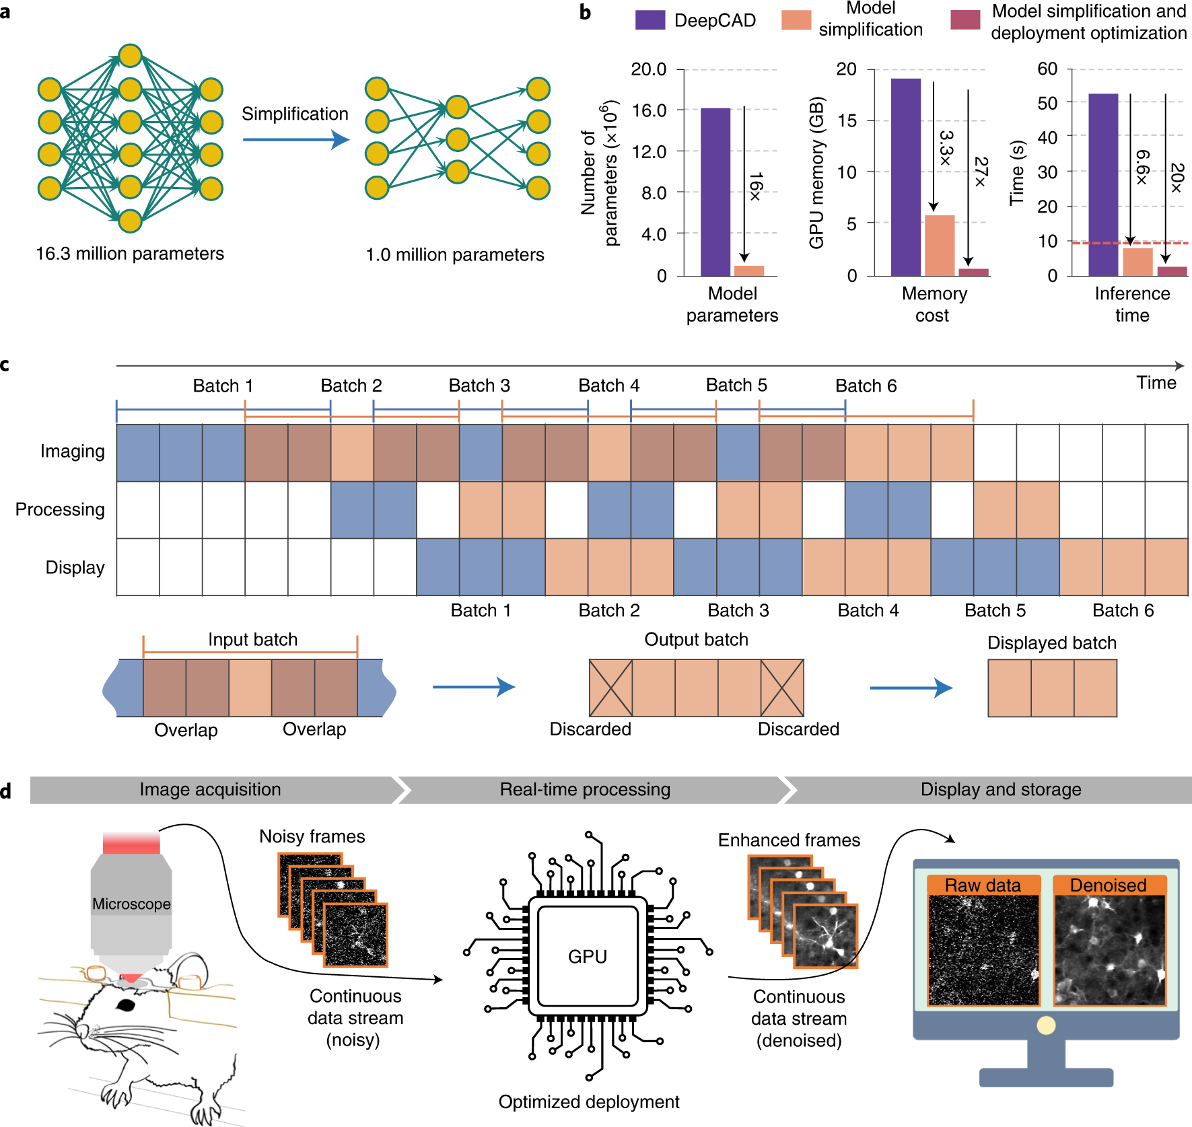

**Immediate Feedback:** Residents and businesses receive immediate feedback on their noise-related activities. When they see that their actions result in high noise levels, they are more likely to adjust their behavior.

**Awareness:** Continuous access to real-time noise data fosters awareness. People become conscious of the noise they generate and its impact on their quality of life and the environment.

**Community Engagement:** Communities become more engaged in addressing noise pollution issues, as they can collectively monitor and analyze data related to noise levels. This leads to a sense of shared responsibility.

**2. Disturbance Reporting**

The real-time noise level monitoring system typically includes a feature that allows users to report noise disturbances. This aspect amplifies its impact on noise pollution mitigation:

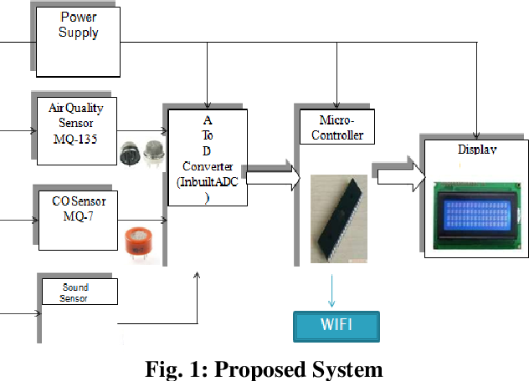

**Immediate Response:** Users can report disturbances as they occur, and relevant authorities can respond promptly to address the issue. This quick response can deter continuous disturbances.

**Data Collection:** The reports collected from users serve as valuable data for identifying persistent noise issues and potential sources. Authorities can use this information to focus their noise reduction efforts.

**Community Collaboration:** Reporting noise disturbances encourages community collaboration in identifying problem areas and holding responsible parties accountable.

**3. Noise Threshold Alerts**

The system often includes an automated alert mechanism that notifies both authorities and the public when noise levels exceed predefined thresholds:

**Timely Intervention:** Alerts ensure that noise disturbances are addressed in a timely manner. This can lead to a reduction in prolonged noise pollution.

**Noise Reduction:** Knowing that their actions trigger alerts, individuals and businesses are more likely to take steps to reduce noise emissions and maintain compliance with noise regulations.

**Public Engagement:** Alerts engage the public in noise pollution mitigation efforts. As residents become more informed, they are more likely to participate in community initiatives to reduce noise.

**4. Data-Driven Decision Making**

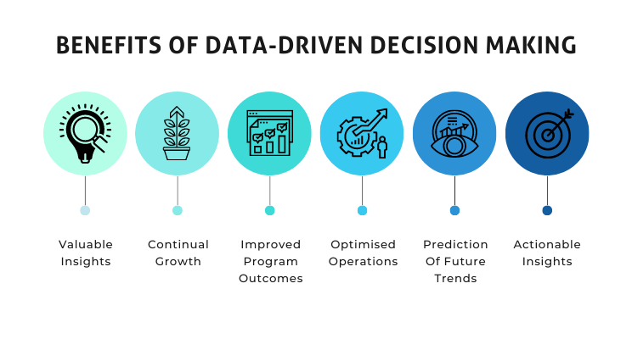The data collected by the monitoring system provides a solid foundation for data-driven decision making:

**Policy Development:** Authorities can use the data to develop noise abatement policies and regulations. These policies are more effective when they are based on real data and tailored to specific noise patterns.

**Urban Planning:** The data aids in urban planning, helping cities and municipalities identify high-noise areas and make informed decisions about zoning and development.

**Noise Source Identification:** By analyzing data patterns, it becomes easier to pinpoint noise sources and address them strategically. This proactive approach is instrumental in noise pollution mitigation.

**5. Public Education and Advocacy**

The real-time noise level monitoring system serves as an educational tool:

**Awareness Campaigns:** The system can be part of public awareness campaigns. Residents can access data illustrating the impact of noise pollution on health and well-being.

**Behavior Change:** When residents understand the adverse effects of noise pollution, they are more likely to change their behavior. They may support initiatives for quieter communities and advocate for noise reduction measures.

**6. Transparent Governance**

The system fosters transparency in governance:

**Accountability:** Authorities are held accountable for noise regulation enforcement. Transparency in noise data and responses builds trust with the public.

**Compliance Checks:** Businesses and industries are more likely to comply with noise regulations when they know that their operations are under constant scrutiny.

**7. Continuous Improvement**

The system allows for continuous improvement in noise management:

**Data Analysis:** Over time, the system accumulates extensive data. Analysis of this data enables better decision making and more effective noise reduction strategies.

**Adaptive Policies:** Policies and regulations can be adapted based on the trends and patterns observed in the data, ensuring they remain effective and relevant.

In conclusion, a real-time noise level monitoring system has the potential to revolutionize the way we address noise pollution. By providing real-time access to noise data, enabling disturbance reporting, issuing noise threshold alerts, and promoting data-driven decision making, it empowers the public, authorities, and businesses to actively participate in noise pollution mitigation efforts. Public awareness is raised, behavior is influenced, and data-driven policies are developed, ultimately leading to quieter and healthier communities.