Statistics for Data Science

Unit 3 Homework Submission

Ted Pham

1. P(R) = 0.4, P(M) = 0.35, P(P) = 0.25

P(F|R) = 0.3, P(F|M) = 0.6, P(F|P) = 0.5

P(R F) = P(F|R)\*P(R) = 0.12

P(M F) = P(F|M)\*P(M) = 0.21

P( P F) = P(F|P)\*P(P) = 0.125

1. P(R F) = 0.12
2. P(F) = P(R F) + P(M F) + P( P F) = 0.455

because P(R) + P(M) + P(P) = 1

1. P(R|F) = P(R F)/P(F) = 0.12/0.455 = 0.263
2. P(R) = 1/2

P(W) = 1/2

P(C) = 1/3

P(R W) = 1/4

P(R C) = 1/6

P(W C ) = 1/6

P(R’ W’ C’) = P(R U W U C)’ = 1/6

P(R U W U C) = 1 – P(R U W U C)’ = 5/6

1. Left: probability to scale, Right: Venn Diagrams not to scale

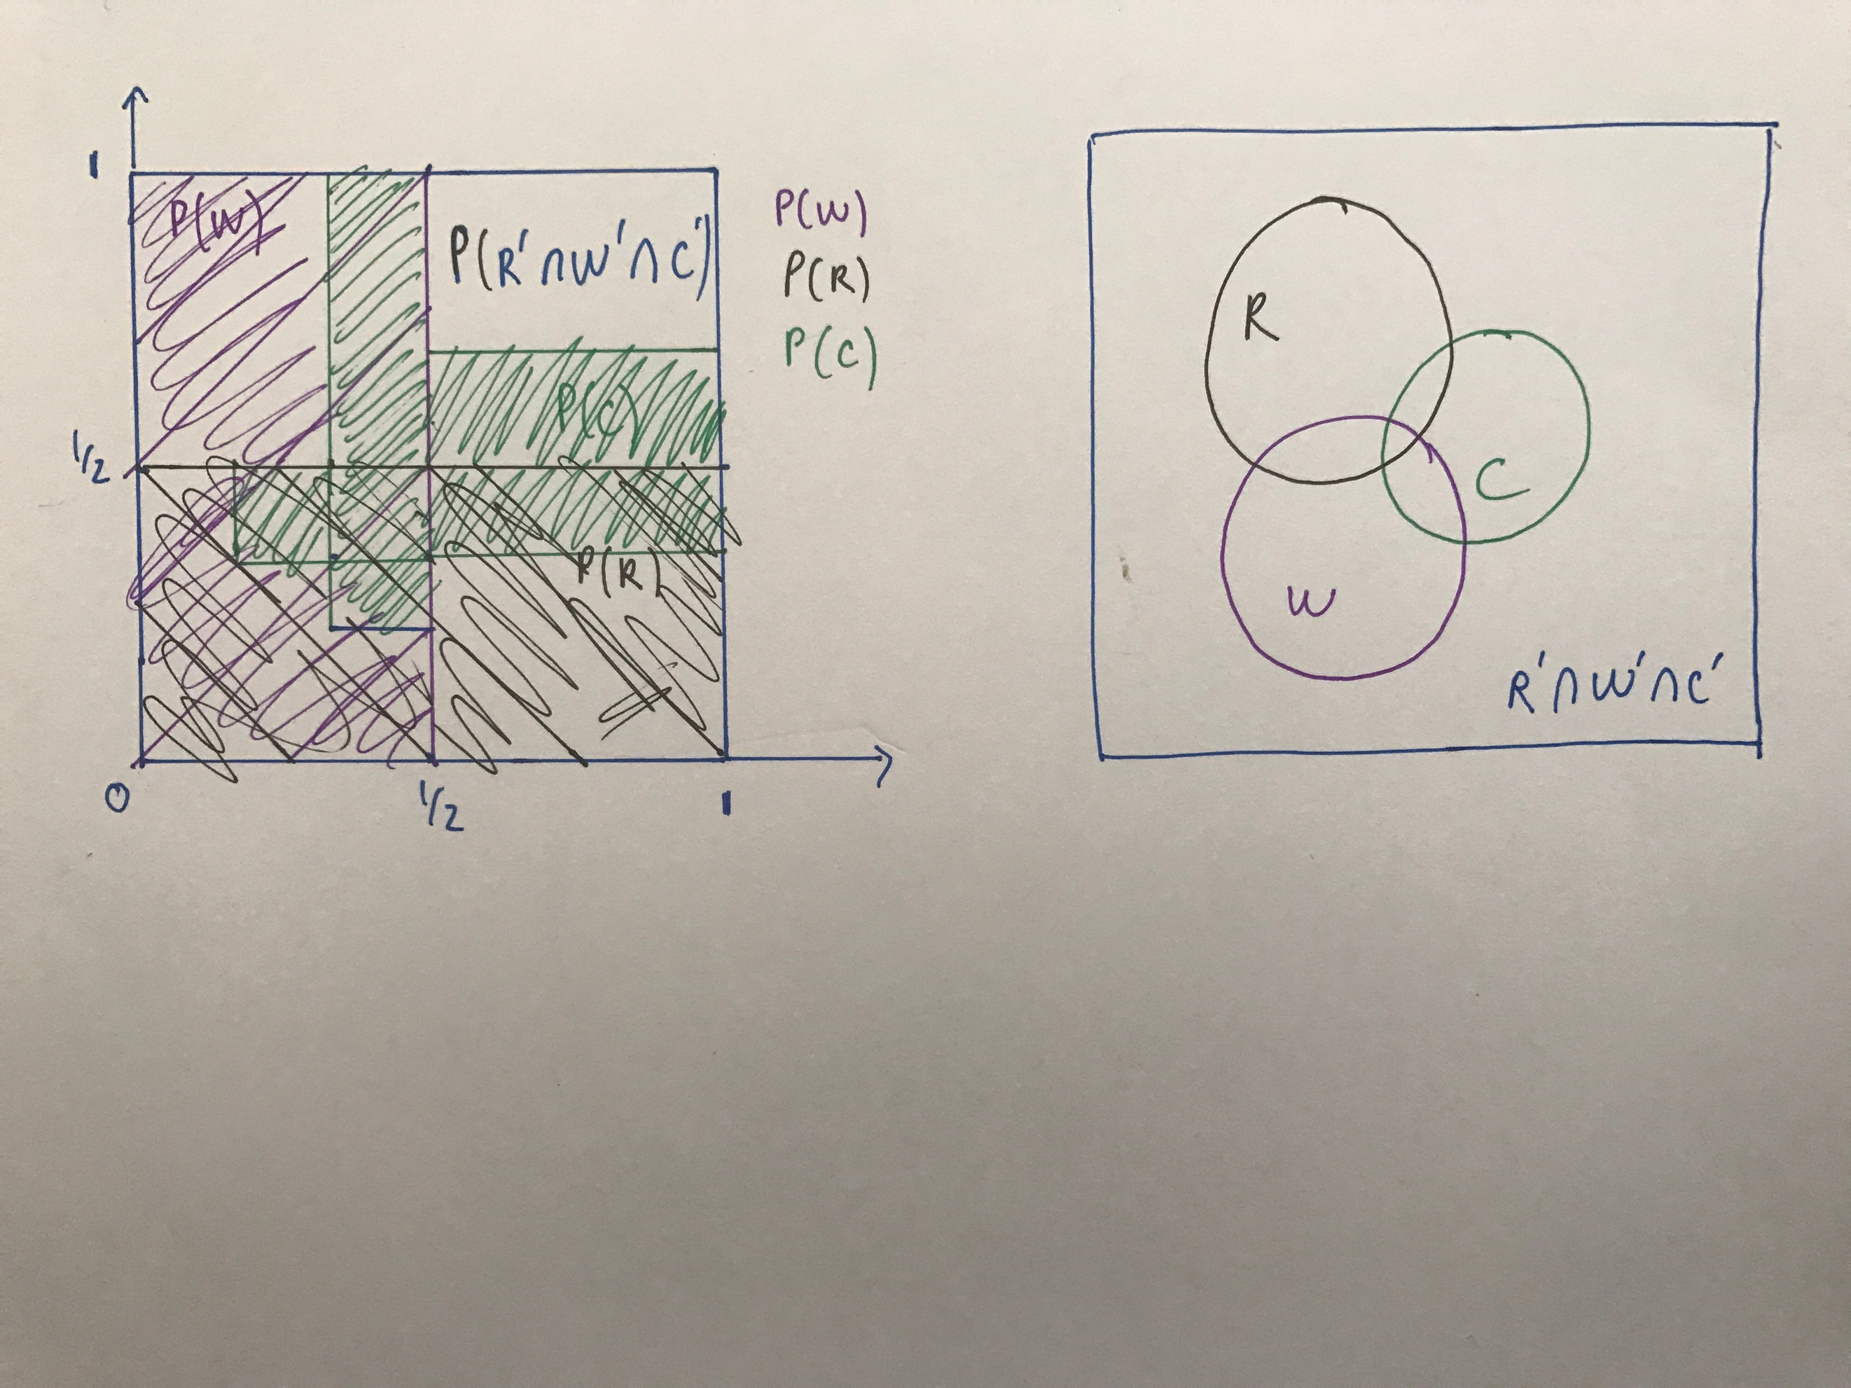

1. From set theory:

P( R U W U C) = P(R) + P(W) + P(C) - P(R W) - P(R C) - P(W C ) + P(R W C )

* P(R W C ) = P( R U W U C) - P(R) - P(W) - P(C) + P(R W) + P(R C) +P(WC )
* P(R W C ) = 1/12

1. P(C’ | R) = 1 – P(C | R)

= 1 – P(C R)/ P(R) = 1 – (1/6)/(1/2)

* P(C’ | R) = 2/3

1. P(C | (W U R) ) = P( C (W U R) ) / P(W U R)

= { P(C) + P(W U R) - P(C U W U R) } / {P(W) + P(R) – P(W R) }

= { 1/3 + 3/4 – 5/6)/(3/4) = 1/3

=> P(C | (W U R)) = 1/3

1. (a)

(because A & B might not belong in a set) 0 =< P(A B) =< 1/2 = min (P(A),P(B))

(b) from (a) we get 0 <= P(A|B) <= (1/2)/P(B) = 3/4

4. Let P(S) be the probability of students that like Statistics and P(C) the probability that students complete w203.

then from the given information

P(S|C) = 3/4

P(S|C’) = 1/4

P(C) = 1/100

P(C’) = 99/100

P(S) = P(S|C)\*P(C) + P(S|C’)\*P(C’)

= 102/400

P(C S) = P(S|C)\*P(C) = 3/400

P(C|S) = P(CS) / P(S) = 3/102

P(C|S) = 1/34 = 0.029