Contents
Abstract 1
Introduction 1
Motivation for Actor Critic Method 1
Background / Theoretical Foundation 2
Problem formulation (MDP + objective) 2
Policy-Gradient basis 3
Actor–Critic concept (actor + critic structure) 4
On-Policy and Off-policy 4
Advantages and disadvantages of AC methods in continuous and high-dimensional environments 4
Individual Algorithms 5
Actor Critic 5
A2C 5
DDPG 5
TRPO 5
PPO 5
SAC 5
Ablation 5
Appendix 6
A 6
Reading list 6

Abstract
IN this technical report, I will look through all the actor critic framework of policy based methods in RL/.

Introduction

Motivation for Actor Critic Method
Value-based reinforcement learning methods, including Q learning, Sarsa, and Deep Q-network (DQN) variants, use the value function of the algorithm (typically the action-value function $Q(s,a)$) and derive a policy by selecting the action with the highest estimated value. While this approach has been successful in many discrete control tasks, it encounters fundamental challenges as the state-action space grows large, becomes continuous, or when the optimal behaviour is inherently stochastic.
Policy-based methods address these limitatinos by directly parameterizing the policy $π_{θ}\left(a_{t} \right| s_{t})$, outputting the probability of actions given the current state. The policy parameters $θ$ are optimized to maximize the expected discounted return:
$$J\left(θ\right)=V^{π_{θ}}\left(S_{0}\right)=E_{π_{θ}}\left[\sum_{t=0}^{T}{γ^{t}R_{t+1}|S_{0}=s_{0}}\right]-\left(1\right)$$

Although both value-based and policy-based methods aim to maximize expected return over an episode, they differ fundamentally in how policies are represented and optimized.
Key difference
- Continuous action space:
Value-based methods rely on an argmax operator over actions, which becomes intractable in continuous action spaces. In contrast, policy-based methods can directly output continuous actions or parameterize distributions (e.g., Gaussian mean and variance), enabling efficient optimization in continuous domains.
- Stochastic Policies:
Value based methods learn deterministic policies (by probability $1- ε$ choosing the greedy action) while policy-based methods learn explicitly stochastic policies by sampling action from policy.
- Simpler representations:
By separating policy and value estimation, actor–critic methods reduce the complexity of each approximation task. The policy network focuses on action selection, while the value network estimates expected returns, often leading to more stable and scalable learning.

Background / Theoretical Foundation

Problem formulation (MDP + objective)
The reinforcement learning problem is viewed as a Markov Decision Process defined by the tuple $(S,A,P,R,γ)$, where:
- $S$ is the state space
- $A$ is the action space
- $P\left(s^{'}\right|s, a)$ is the state transition probability
- $R$ is the reward function
- $γ ∈[0,1)$the discount factor
A policy $π_{θ}(a∣s)$defines a probability distribution over actions given a state. The goal is to learn a policy that maximizes the expected discounted return from an initial state distribution $p_{0}$.
$$J\left(θ\right)=E_{S_{0}\sim p_{0}}\left[V_{π_{θ}}\left(S_{0}\right)\right]=E_{π_{θ}}\left[\sum_{t=0}^{T}{γ^{t}R_{t+1}|S_{0}\sim p_{0}}\right]-\left(2\right)$$
Note: The difference between Equation (1) and Equation (2) is that in Equation (1), the initial state $S_{0}$is fixed, whereas in Equation (2), $S_{0}$is drawn from the initial state distribution $p_{0}$

Policy-Gradient basis
As mentioned, policy-based methods are particularly suitable for continuous or large state-action spaces. The main challenge in optimizing a parameterized policy $π_{θ}(a|s)$is that changing the policy also changes the distribution of states the agent visits. Directly differentiating the expected return w.r.t policy parameters would therefore require computing derivatives through the state distribution $d^{π}\left(s\right)$ [See Appendix A], which is intractable in practice.
The Policy Gradient Theorem provides an analytic form of the gradient that avoids this issue:
Theorem 3.1. (Policy Gradient Theorem) For a given MDP, let πθ be differentiable w.r.t. θ and ∇θ πθ be bounded, let Qπθ be differentiable w.r.t. θ and ∇θ Qπθ be bounded for all s ∈ S and a ∈ A. Then, there exists a constant η such that
$$∇_{θ}J\left(θ\right)= ηE_{S\sim d^{π}θ,A\sim π_{θ}}\left[Q_{π_{θ}}\left(S,A\right)∇_{θ}\ln{π_{θ}\left(A | S\right)}\right]-\left(3\right)$$
By taking the expectation over $S∼d^{π_{θ}}$, we avoid computing the derivative of the state distribution and instead average the effect of policy changes across the states the agent is likely to encounter. This makes gradient estimation tractable.
One of the earliest and simplest policy gradient algorithms is REINFORCE, which estimates $Q^{π_{θ}}(s,a)$using Monte Carlo returns from complete episodes. REINFORCE updates the policy parameters in the direction of sampled returns weighted by $∇_{θ}ln⁡π_{θ}(a∣s)$, following Equation (3).
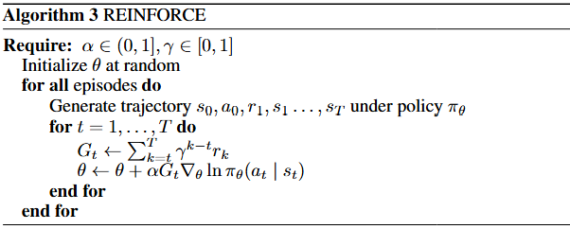
While REINFORCE provides a simple and unbiased way to perform policy-based learning, it suffers from several practical limitations.
- High variance due to stochastic policies
The policy is inherently stochastic, meaning that taking the same action in the same state can lead to different outcomes. As a result, gradient estimates can fluctuate significantly between episodes, leading to unstable and slow learning.
- Variance amplification in long trajectories
REINFORCE relies on Monte Carlo estimates of returns over entire trajectories. In long episodes, randomness compounds over time, causing the final return to exhibit high variance, which further degrades gradient quality.
- Credit assignment problem
A high-return trajectory does not imply that all actions taken within it were beneficial. However, Monte Carlo policy gradient methods assign the same return signal to all actions in a trajectory, making it difficult to identify which actions truly contributed to improved performance.

Actor–Critic concept (actor + critic structure)
These challenges motivate the Actor–Critic framework, which introduces a separate value function estimator (the critic) to provide a lower-variance learning signal for the policy (the actor). By decoupling policy optimization from value estimation, Actor–Critic methods reduce variance, improve credit assignment, and enable more stable and efficient learning.
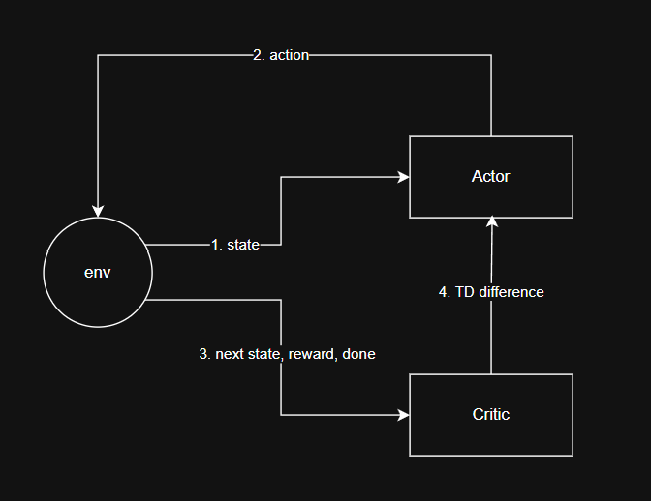
The general interaction between the actor, critic, and environment proceeds as follows:
- At time step $t$, the environment outputs the current state $s_{t}$, which is fed into the actor network to sample an action $a_{t}∼π_{θ}(a_{t}∣s_{t})$.
- The selected action is executed in the environment, producing the next state $s_{t+1}$and reward $r_{t+1}$.
- The tuple $\left(s_{t} , a_{t} , r_{t+1} , s_{t+1}\right)$is passed to the critic, which estimates the state values $V_{ϕ}(s_{t})$and $V_{ϕ}(s_{t+1})$.
- A temporal-difference (TD) error is computed as:
$$δ_{t}=r_{t+1}+γV_{ϕ}(s_{t+1})-V_{ϕ}(s_{t})$$
- The actor is updated using the TD error as an advantage estimate, reinforcing actions that lead to higher-than-expected returns.
- The critic is updated by minimizing the mean squared TD error between the predicted and target values.

On-policy and Off-policy

Definition-level distinction?
On-policy methods train the policy using data sampled from the same policy being optimized, meaning that state–action pairs are drawn from the distribution induced by the current policy.
Off-policy methods optimize a target policy using data generated by a different behavior policy, allowing learning from state–action pairs that do not follow the current policy.

Why vanilla policy gradient is on-policy?>
Vanilla policy gradient methods are inherently on-policy because the policy gradient theorem expresses the gradient of the expected return as an expectation over state–action pairs sampled from the current policy from Equation (2). When data is generated by a different behaviour policy, this expectation no longer matches the required distribution, resulting in biased gradient estimates.
Importance sampling can, in principle, correct this distribution mismatch by reweighting samples according to the ratio between the target and behavior policies [see Appendix]. However, this correction typically introduces high variance, making it impractical for vanilla policy gradient methods. Consequently, most policy gradient algorithms rely on on-policy data collection.
what makes off policy possible?
To make off-policy learning possible, the gradient must be decoupled from the state distribution of the current policy. In practice:
- Off-policy actor-critic methods estimate:
$$∇_{θ}J(θ)=E_{s∼d^{μ},a∼μ}[∇_{θ}log⁡π_{θ}(a∣s)Q_{w}(s,a)]$$
- Here:
  - $d^{μ}$is the behavior policy distribution (from replay buffer)
  - $Q_{w}(s,a)$is a critic trained off-policy (approximates $Q^{π_{θ}}(s,a)$)
- The key trick is using a parameterized critic $Q_{w}$to replace $Q^{π_{θ}}$and decouple from $d^{π_{θ}}$.
- Another perspective: reparameterization trick (in continuous actions) allows you to write:
$$a=f_{θ}(s,ϵ),ϵ∼\text{Noise}$$
so that the gradient can be computed with respect to $θ$independently of the current state distribution, enabling off-policy updates.

Table of on and off policy

Baselines
Importance sampling
Deadly tripad of rl
Off policy, bootstrapping and functional apromximate

Advantages and disadvantages of AC methods in continuous and high-dimensional environments

Individual Algorithms

A2C / (A3C)
The core idea of A2C / A3C , on policy methods, is to leverage multiple agents or parallel environments to explore the environment efficiently while performing on-policy updates using bootstrapped targets. Each agent collects rollouts, which are used to compute a TD target for the critic by estimating the value of the next state:
$$y_{t}=r_{t}+γV_{ϕ}(s_{t+1})$$
The critic is trained by minimizing the mean squared error between the TD target and the current value estimate, while the actor is trained using the advantage function $A_{t}=y_{t}-V_{ϕ}(s_{t})$to scale the policy gradient:
$$L_{\text{actor}}=-log⁡π_{θ}(a_{t}∣s_{t}) A_{t}$$

By combining these losses and performing gradient descent, A2C/A3C update both policy and value networks simultaneously, enabling efficient and stable learning from on-policy trajectories.
The computational cost of A2C is dominated by forward and backward passes through the actor and critic networks. For a rollout length T and N parallel environments, the per-update complexity scales as
$$O(N ∙T∙\left(C_{actor}+C_{critic}\right))$$
Memory complexity
A2C stores only on-policy rollouts of length T, resulting in memory usage proportional to $O\left(N∙T\right)$, significantly lower than off-policy methods that maintain large replay buffers.
Practical scalability
While A2C scales efficiently with parallel environments on CPUs, it is less sample-efficient than off-policy methods due to the inability to reuse past experience.
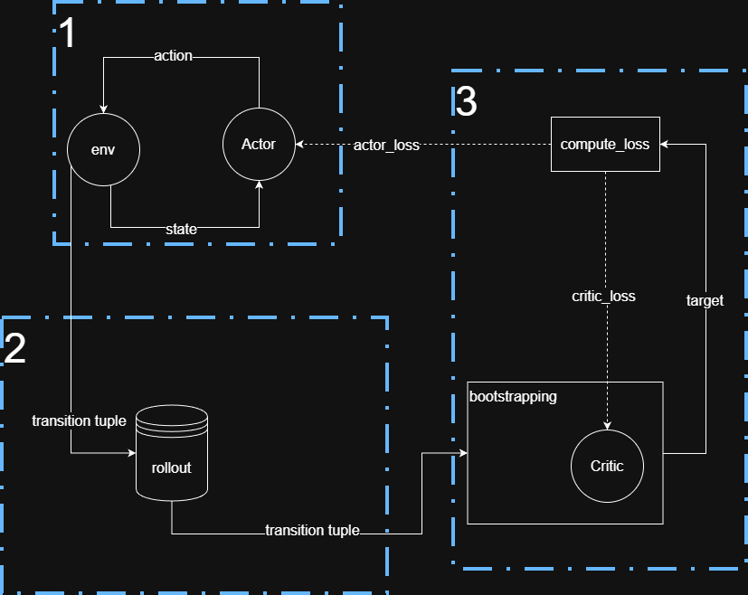

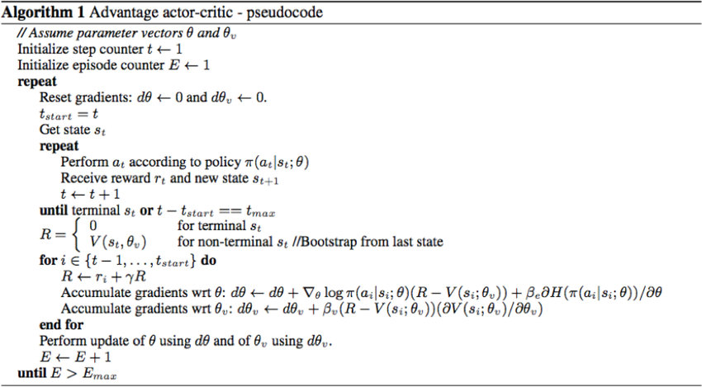

While A3C
- Core idea / innovation
- Key equations or update rules (brief, intuitive)
- Type: on-policy / off-policy, discrete / continuous
- Implementation notes (what you coded, buffers, tricks, etc.)
- Strengths and limitations

DDPG
The idea behind DDPG is to adapt DQN-style value-based learning to continuous action spaces without discretizing actions, since discretization introduces severe limitations such as the curse of dimensionality and loss of precision.
DDPG introduces an actor network that represents the policy explicitly and deterministically maps states to actions, enabling direct optimization in continuous action spaces. This leads to the Deterministic Policy Gradient (DPG) framework.
Because the policy is deterministic, there is no expectation over actions in either the policy gradient or the Bellman target. The only remaining expectation is over the environment dynamics (state transitions).
To enable exploration despite the deterministic policy, DDPG adds temporally correlated noise (e.g., Ornstein–Uhlenbeck noise) to the actor’s output during data collection. This noise affects the behavior policy but not the target policy, allowing off-policy learning with stable deterministic targets.

TRPO
Most reinforcement learning algorithms are highly sensitive to hyperparameters, and optimal settings often vary across environments or even across different phases of training within the same environment. In particular, large policy updates can lead to performance collapse due to destructive policy changes.
Trust Region Policy Optimization (TRPO) addresses this issue by explicitly constraining the policy update, preventing overly large deviations from the previous policy.
TRPO builds on Conservative Policy Iteration (CPI), which considers a mixture policy of the form
$$π_{\text{new}}=(1-α) π_{\text{old}}+α π_{\text{candidate}}$$
and provides a theoretical lower bound on performance improvement. Under small update assumptions, CPI shows that policy improvement is guaranteed as long as the update step is sufficiently conservative.
Using this result, the TRPO paper derives a surrogate objective function that approximates the expected return while keeping the state distribution fixed under the old policy. The discrepancy between the surrogate objective and the true objective is bounded by a term proportional to the KL divergence between the old and new policies.
By constraining the KL divergence, TRPO ensures that each policy update stays within a trust region, leading to monotonic policy improvement and significantly reduced sensitivity to hyperparameter choices.
In practice, TRPO maximizes the surrogate objective subject to a KL constraint:
$$\underset{θ}{max⁡} L(θ)\text{s.t.}E_{s∼π_{\text{old}}}[D_{KL}(π_{\text{old}}(⋅∣s) ∥ π_{θ}(⋅∣s))]≤δ$$
thereby controlling the policy step size in a principled, geometry-aware manner.

PPO
Proximal Policy Optimization (PPO) can be viewed as a simplified and practical approximation of TRPO. While TRPO enforces a hard trust-region constraint using a KL-divergence bound and requires second-order optimization with the Fisher Information Matrix, PPO replaces this constraint with a first-order surrogate objective that approximately limits policy updates.
Instead of explicitly constraining the KL divergence, PPO introduces a clipped probability ratio:
$$r_{t}(θ)=\frac{π_{θ}(a_{t}∣s_{t})}{π_{θ_{\text{old}}}(a_{t}∣s_{t})}$$
and defines the clipped objective:
$$L^{\text{CLIP}}(θ)=E_{t}\left[min⁡(r_{t}(θ) {\hat{A}}_{t}, \text{clip}(r_{t}(θ),1-ϵ,1+ϵ) {\hat{A}}_{t})\right]$$
The clipping mechanism prevents the probability ratio from moving too far away from 1, effectively penalizing overly large policy updates in a way that mimics TRPO’s trust region.
By using this clipped surrogate objective, PPO eliminates the need for explicit KL constraints, Fisher Information Matrix computation, and conjugate-gradient optimization, while retaining much of TRPO’s stability and robustness. This results in a simpler, more scalable, and easier-to-tune algorithm that performs well across a wide range of environments.

SAC
Soft Actor-Critic (SAC) is an off-policy actor–critic algorithm designed to achieve high sample efficiency and training stability in continuous control tasks. Unlike earlier on-policy actor–critic methods, SAC can leverage replay buffers and off-policy data, significantly improving data efficiency.
SAC uses a stochastic actor that outputs a probability distribution over actions rather than a deterministic action. The policy is trained to maximize both expected return and entropy, encouraging exploration and robustness.
To improve stability and reduce overestimation bias, SAC employs two Q-function (critic) networks and uses the minimum of their estimates when computing targets. Target networks are used for bootstrapping, further stabilizing learning.
The critic is updated using a soft Bellman backup, while the actor is updated by minimizing the KL divergence between the policy and an energy-based distribution induced by the Q-function. Together, these design choices allow SAC to combine the stability of entropy-regularized learning with the sample efficiency of off-policy methods.

Experiment

Fair Experimental Setup
To ensure a fair and reproducible comparison across reinforcement learning algorithms, all experiments were conducted under a unified and controlled protocol. This section outlines the experimental requirements and design choices.
Environment and Task
All agents were evaluated on the same environment with identical dynamics, observation space, action space, reward function, termination conditions, and maximum episode length. The environment version and random seeds were fixed to ensure consistency across runs.
Training Budget
Each agent was trained using the same total number of environment interactions. Performance is reported as a function of environment steps rather than gradient updates, ensuring a fair comparison between on-policy and off-policy methods. Evaluation was performed at fixed intervals using the same number of evaluation episodes.
Randomness and Seeds
To account for stochasticity in environment dynamics, policy initialization, and exploration, each configuration was evaluated using multiple random seeds (3–5). The same set of seeds was used across all algorithms. Results are reported as the mean and standard deviation across seeds.
Observation and Action Processing
Observation normalization was applied consistently across all agents using a running mean and standard deviation. Action outputs were normalized to the environment’s action bounds, with consistent scaling and squashing functions (e.g., tanh) applied where required. These preprocessing steps were either enabled for all agents or disabled for all agents.
Reward Handling
All agents received the same raw reward signal from the environment. No algorithm-specific reward shaping was applied. If reward scaling was used, the same scaling factor was applied uniformly across all agents.
Network Architecture
All agents employed multilayer perceptron (MLP) architectures with the same depth and activation functions. While actor and critic structures differed according to algorithmic requirements (e.g., deterministic vs. stochastic actors), the overall architectural style and representational capacity were kept consistent. Network initialization schemes were also identical across agents.
Hyperparameter Tuning
To ensure fairness, each algorithm was allocated the same hyperparameter tuning budget. Random search was used to sample hyperparameter configurations from algorithm-specific ranges. The best-performing configuration for each algorithm was selected based on average return across seeds.
Exploration Strategy
Exploration mechanisms were consistent with each algorithm’s design. Stochastic policies were used for on-policy and entropy-regularized methods, while action noise was applied for deterministic off-policy methods. No additional exploration techniques were introduced for individual agents.
Evaluation Protocol
Evaluation was conducted without exploration noise to measure the performance of the learned policies. All agents were evaluated using the same protocol, metrics, and reporting standards.
Reporting and Reproducibility
We report learning curves as mean ± standard deviation across seeds, final performance distributions, and sample efficiency metrics. All hyperparameter ranges, training budgets, and evaluation settings are explicitly documented to ensure reproducibility.
Summary. By fixing the environment, training budget, normalization schemes, network architecture style, and evaluation protocol while tuning algorithm-specific hyperparameters under an equal budget, we ensure a fair and meaningful comparison across reinforcement learning algorithms.

Ablation
In this ablation study, we focus on two primary metrics in reinforcement learning: variance and sample efficiency. Sample efficiency measures how quickly the agent accumulates reward and converges to an optimal policy, while variances capture the stability of learning and the fluctuates in performance across episodes. For each algorithm, we group different hyperparameter according to their expected influence on these metrics and perform sweeps to isolate their effect.

The commone parameters share across algorithms.

A2C
In A2C, the key agent hyperparameters include the actor learning rate, critic learning rate, actor loss weight, critic loss weight, and entropy weight. These hyperparameters are commonly shared across many actor–critic algorithms. I conduct sweep experiments over different combinations to analyse their effects on learning stability and sample efficiency.
The learning rates of the actor and critic networks determine how quickly each component updates during optimization. Typically, the actor learning rate is set slightly higher than the critic learning rate, allowing the policy to adapt to value estimates while preventing instability caused by an overly reactive critic. Sweeping these learning rates enables us to examine the trade-off between fast convergence (higher sample efficiency) and stable updates (lower variance). Excessively high learning rates may accelerate early learning but often lead to oscillations or divergence, whereas overly small learning rates improve stability at the cost of slower convergence.
The loss weights of the actor, critic, and entropy terms scale their respective contributions in the total objective. Increasing these weights effectively amplifies the gradient contribution of each component, leading to larger parameter updates. Higher weights may improve sample efficiency by accelerating learning but can also introduce instability and higher variance. Conversely, smaller weights produce more conservative updates, improving stability but potentially slowing convergence.
The entropy weight specifically regulates exploration. In A2C, the entropy term is subtracted (with a scaling coefficient) from the policy loss, encouraging higher-entropy policies. A larger entropy weight promotes exploration and prevents premature convergence to suboptimal deterministic policies, potentially improving long-term performance. However, excessive entropy regularization may slow policy convergence, as the agent continues exploring rather than exploiting learned behaviors.
Metrics logged:
- Sample Efficiency
  - Measured by:
    - Mean rollout reward over timesteps
    - Slope of reward curve
- Performance Variance
  - Measured by:
    - Standard deviation of rollout reward
- Optimization Stability
  - Measured by:
    - Advantage standard deviation
    - Policy gradient standard deviation
    - Entropy behaviour
We group hyperparameters according to their functional role in the training pipeline: (1) data collection parameters governing the statistical properties of sampled trajectories, (2) optimization parameters controlling update magnitude and stability, (3) model capacity parameters affecting representational power, and (4) objective-shaping parameters determining the relative strength of policy, value, and exploration signals. While each hyperparameter influences multiple metrics, this grouping reflects their primary mechanism of impact on variance and sample efficiency.
Data collection sweep.
This group includes parameters such as num_envs, num_step, and gamma, which determine how trajectories are sampled and how returns are computed. Sweeping these parameters allows us to study how the statistical properties of collected data affect gradient variance and learning stability. Increasing num_envs is expected to reduce gradient variance through averaging, potentially improving stability and sample efficiency. Varying num_step changes the bias–variance trade-off of return estimation, where longer rollouts may reduce bias but increase variance. Adjusting gamma controls the effective planning horizon, influencing long-term credit assignment and the variance of return estimates.
The first step is to verify that the agent is implemented correctly. We do this by inspecting individual runs and checking the logged metrics:
- Mean rollout reward (mean_rollout_reward)
Should generally increase across epochs, approaching the environment’s optimal performance. For Pendulum, values around 100 for short rollouts are reasonable, but the important aspect is to see a continued upward trend over training.
- Reward stability (std_rollout_reward)
Should decrease over epochs, indicating more consistent policy performance across rollouts.
- Advantage and policy gradient variance (advantage_std, pg_std)
High variance early in training is expected, but both metrics should settle to lower, roughly constant values as training progresses, indicating stable gradient estimates.
- Entropy (entropy and entropy_std)
Typically decreases gradually, showing that the policy is becoming more deterministic while still exploring sufficiently. The standard deviation should also stabilize, indicating consistent exploration across environments or batches.
With these sanity checks confirmed, we can then analyze the effect of each hyperparameter (e.g., num_step, num_envs, gamma) on sample efficiency, stability, and exploration.
(see Appendix B )

More intricate observations
While the general trends above describe expected behavior, some metrics do not always behave strictly as anticipated due to the stochastic nature of the environment and interactions between the actor and critic networks:
- Mean rollout reward (mean_rollout_reward)
Occasionally, the reward may drop below its starting value. This is expected in environments like Pendulum, where the initial state is stochastic. Some episodes start in favorable states, giving higher early rewards, while others start in less favorable states, temporarily lowering the average.
- Reward stability (std_rollout_reward)
Although it should generally decrease, std_rollout_reward can temporarily increase when the agent explores new states. This is particularly apparent when entropy increases, as the actor tries different actions, causing variability in rollout returns.
- Entropy (entropy and entropy_std)
Entropy typically decreases as the policy becomes more deterministic, but short-term increases are possible. This occurs when the actor responds to unstable or high-variance advantage estimates, deliberately exploring to gather more information.
- Advantage and policy gradient variance (advantage_std, pg_std)
Early high variance is normal, but occasionally spikes can occur even mid-training, often when the actor explores regions of the state space that the critic has not yet learned. Over time, these metrics should stabilize as the value function improves.
- Value loss
Can increase temporarily when the actor explores unvisited states. Higher value loss in this context is a signal that the agent is expanding its coverage of the state space, not necessarily a sign of malfunction.

Outcome:
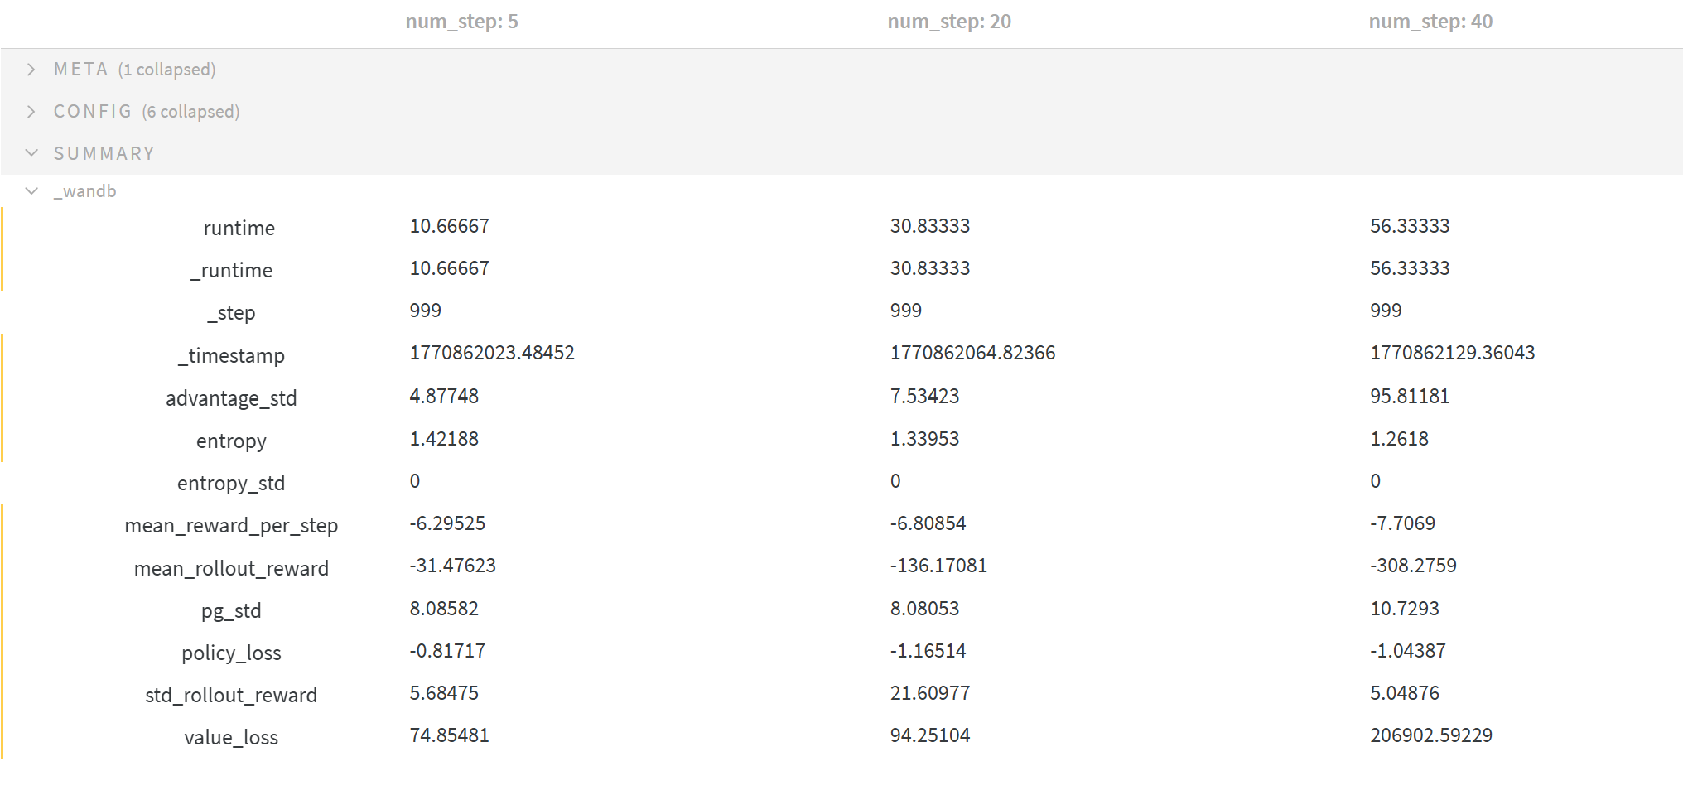

Effect of Rollout Length on Agent Performance and Stability
- Mean rollout reward (mean_rollout_reward)
As num_step increases, the mean rollout reward decreases significantly: -31.48 for num_step = 5, -136.17 for num_step = 20, and -308.28 for num_step = 40. Shorter rollouts allow the agent to update more frequently and maintain a more stable policy. In contrast, longer rollouts increase bias in advantage estimates due to stale actions, which can destabilize learning.
Reward stability (std_rollout_reward)
std_rollout_reward is highest for num_step=20 (21.61), reflecting greater variability for medium-length rollouts. Interestingly, it drops for num_step=40 (5.05), likely because the extremely high value loss (206,902) dominates the learning dynamics, causing the actor to make large but inconsistent updates. https://wandb.ai/arc_agi/Modern-Actor-Critic/sweeps/kdmszigc/runs/511vrsmg
- Advantage and policy gradient variance (advantage_std, pg_std)
Both metrics increase with longer rollouts, most dramatically for num_step=40 (adv_std = 95.81, pg_std = 10.73). This shows that longer rollouts produce unstable gradient estimates and high variance in policy updates, consistent with the credit assignment problem: early actions in long trajectories disproportionately affect returns, and the critic struggles to estimate them accurately.
- Value loss (value_loss)
The extreme increase in value loss for num_step=40 indicates that the critic cannot reliably estimate long-horizon returns. This contributes to instability in both the value function and the policy updates.
- Entropy (entropy) and exploration (entropy_std)
Entropy slightly decreases as num_step increases (1.42 → 1.26), suggesting the policy becomes slightly more deterministic. The standard deviation remains near zero, indicating consistent exploration across environments.
- Policy loss (policy_loss)
Remains relatively stable across num_step values, with small increases for medium rollouts, reflecting the actor’s response to fluctuations in advantage estimates.
Interpretation:
From these trends, it is evident that longer rollouts exacerbate the credit assignment problem, as reflected in exploding advantage_std, pg_std, and value_loss. Shorter rollouts balance update frequency and variance, enabling more stable learning and better sample efficiency.

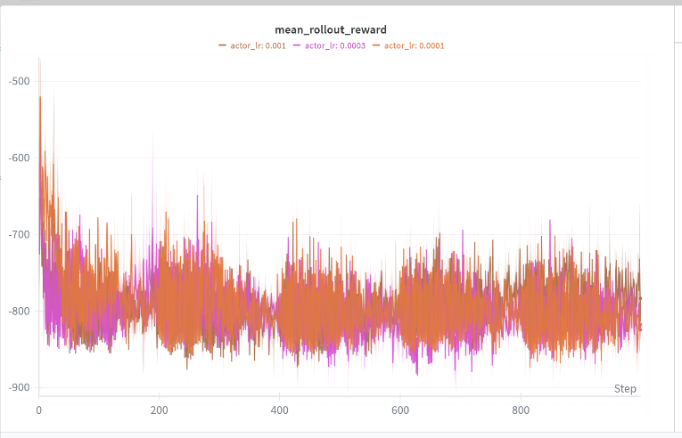
2.
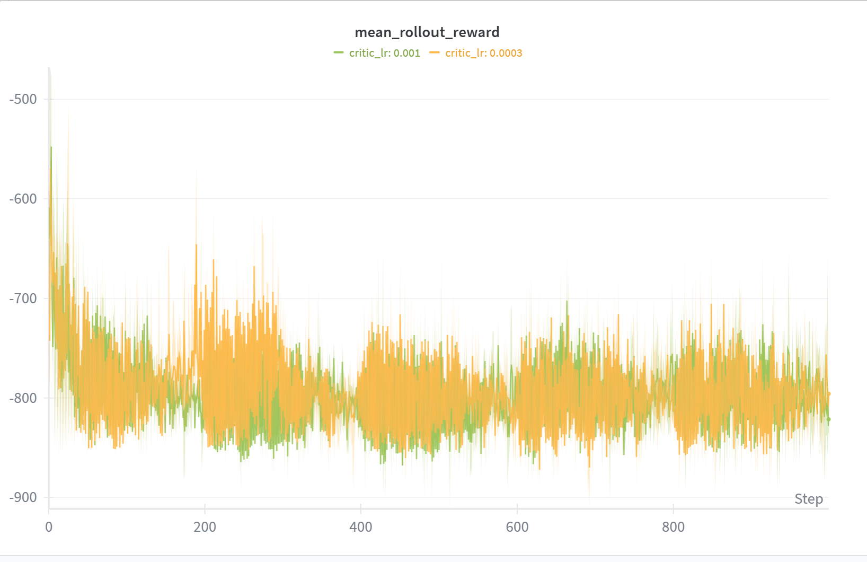
The above two graphs present the mean rollout reward grouped by critic learning rate (left) and actor learning rate (right).
It is observable that varying the critic learning rate does not significantly affect the overall rollout reward. This is expected, as the critic does not directly determine the action selection; rather, it provides value estimates that influence the actor through advantage computation. As long as the critic remains sufficiently accurate and stable, changes in its learning rate primarily affect value loss dynamics rather than final policy performance.
In contrast, the actor learning rate has a clear impact on convergence speed. Among the tested values, 3e-4 (0.0003) emerges as the most effective setting for this network configuration. It achieves faster convergence compared to 1e-4 while avoiding the instability observed at 1e-3. This suggests that 3e-4 provides a balanced update magnitude, enabling efficient policy improvement with controlled policy gradient variance.

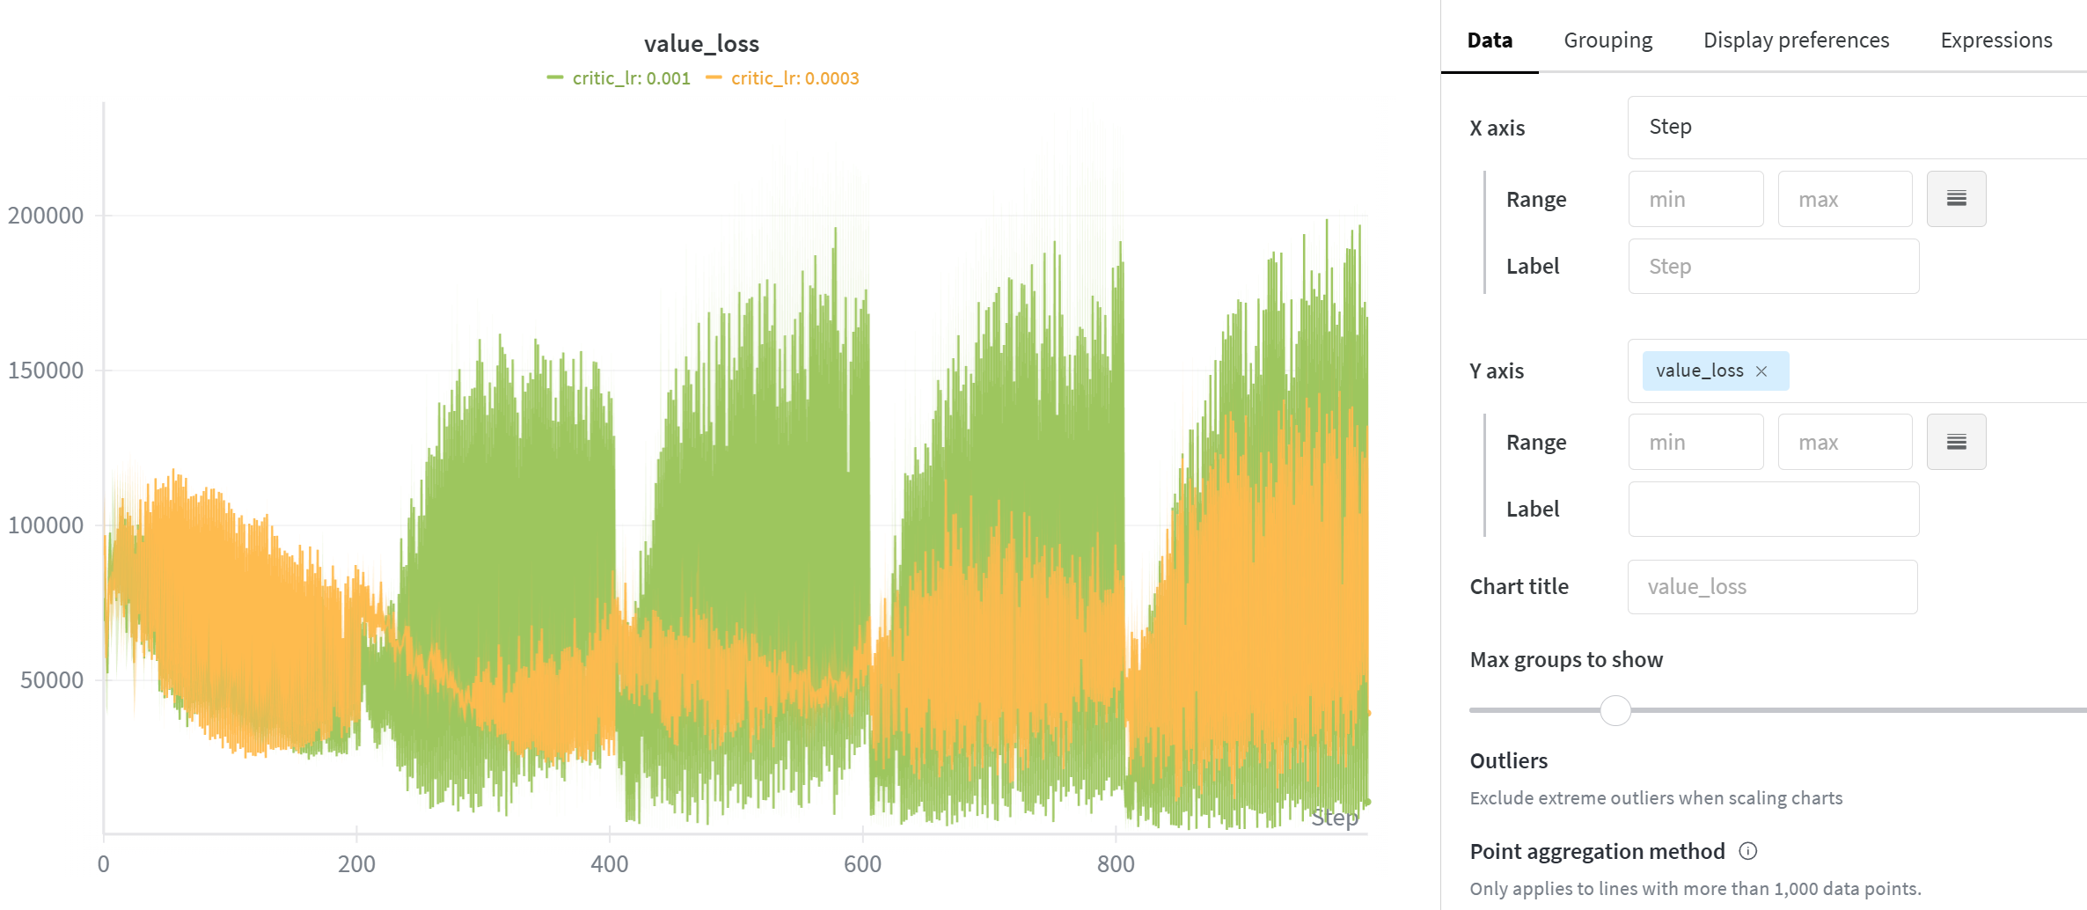
A smaller critic learning rate (0.0003) exhibits lower value loss during early training due to conservative updates. However, as the policy improves and return targets shift, the critic struggles to track the evolving value function. This results in a gradual increase in value loss over time, reflecting underfitting rather than instability.
This behaviour is consistent with the observed increase in advantage variance, as lagging value estimates introduce larger errors in advantage computation.

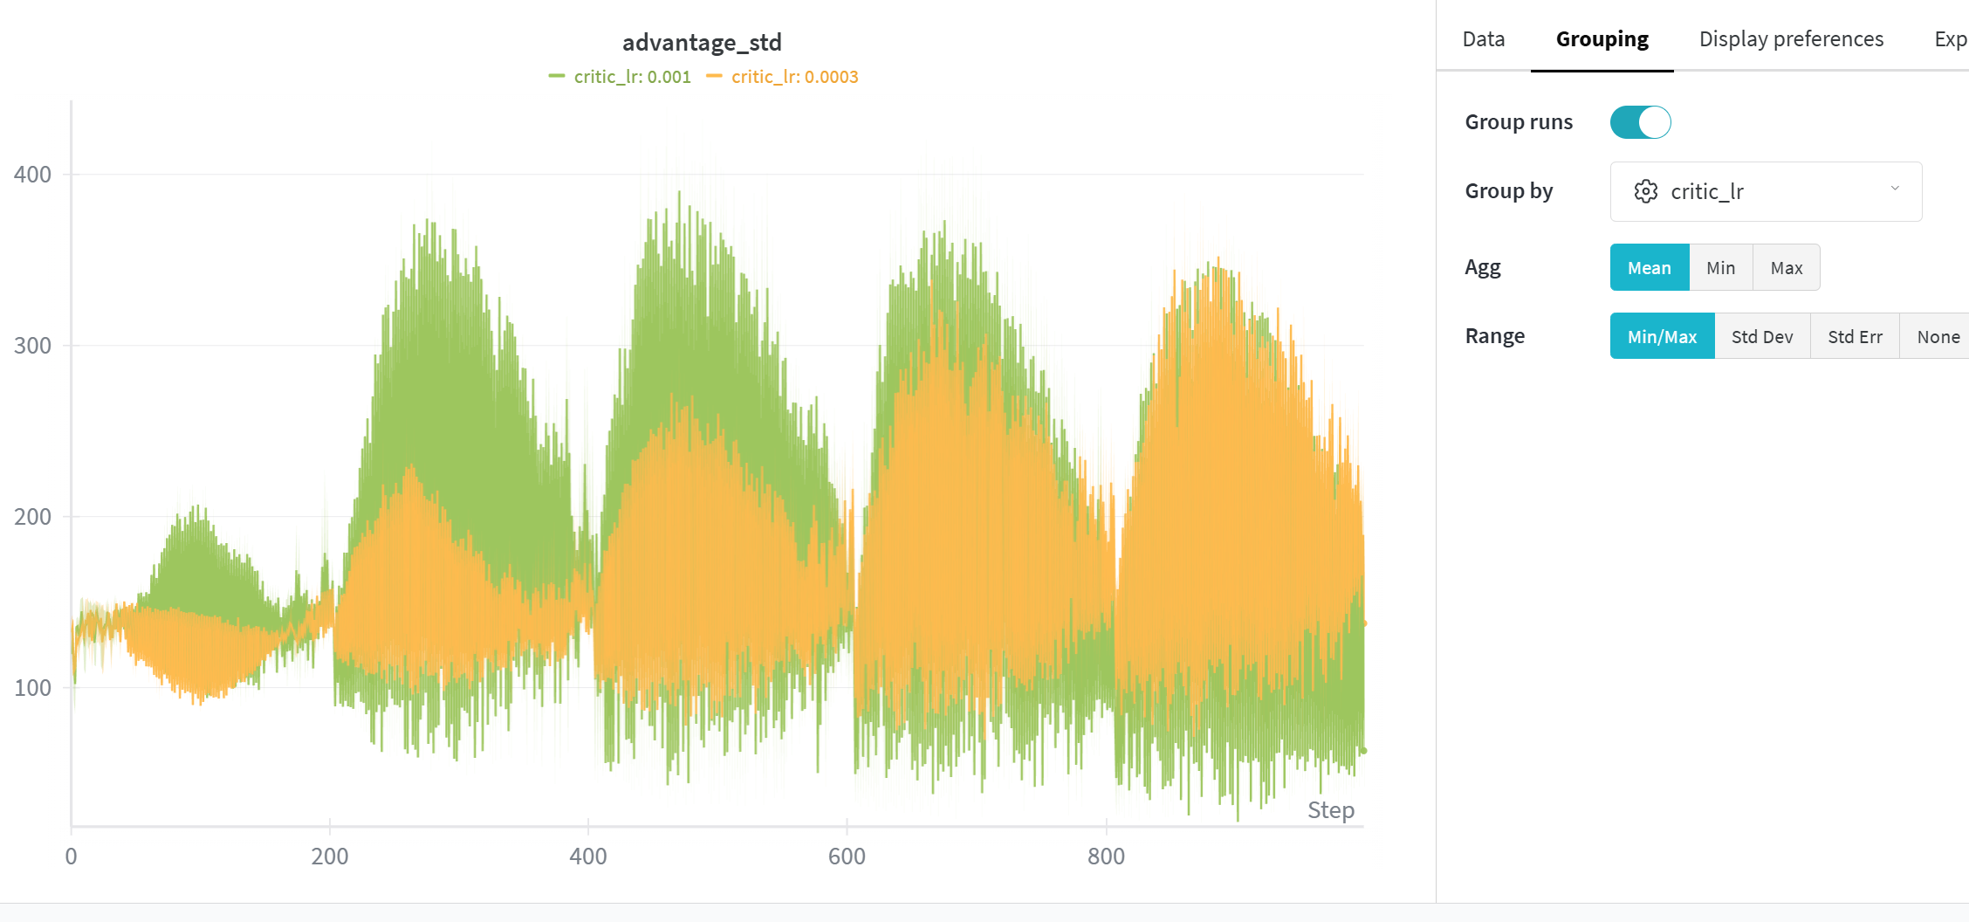
Interestingly, a lower critic learning rate (0.001) exhibits smaller advantage variance during early training, reflecting conservative and smooth value updates. However, as training progresses and the policy begins to improve, the slower critic struggles to track the evolving return distribution. This lag increases bias in the advantage estimates, causing the variance to grow and approach (or exceed) that of the higher learning rate setting.
In contrast, critic_lr = 0.003 adapts more quickly to changing return targets, resulting in more stable advantage estimates over longer training horizons.

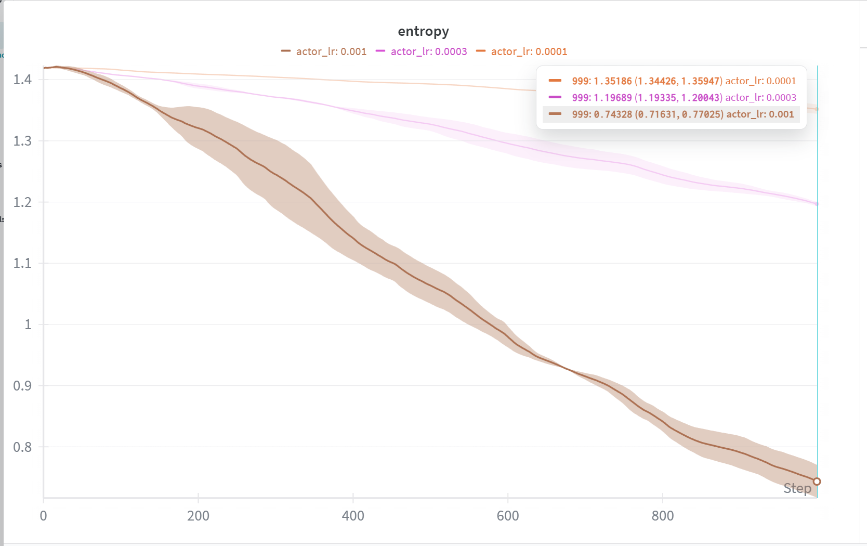
Entropy decreases faster with higher actor learning rates, reflecting more aggressive policy updates. For actor_lr = 0.001, entropy drops to 0.743, indicating the policy becomes deterministic quickly. In contrast, lower learning rates (0.0003 → 1.196, 0.0001 → 1.351) retain higher entropy, preserving exploration. This demonstrates the tradeoff between convergence speed and sustained exploration.
3)
From the above graph, the purple, red, green, and blue lines represent the largest, second-largest, third-largest, and smallest hidden dimensions, respectively. Convergence speed improves with larger networks, as higher expressivity allows the agent to adapt faster. Advantage standard deviation (adv_std) is lower for larger hidden dimensions throughout training, indicating more stable value estimates, while smaller networks exhibit higher variance early on; all configurations tend to converge to similar variance near the end. Policy gradient variance (pg_std) increases faster for larger networks, reflecting that more expressive policies produce larger updates per step. Value loss starts higher for the largest network but gradually decreases, whereas smaller networks accumulate higher value loss over time. Reward variability (std_rollout_reward) shows no clear trend, suggesting that rollout-to-rollout noise is dominated by the environment rather than network capacity. (See Appendix C for full hidden dimension sweep plots.)
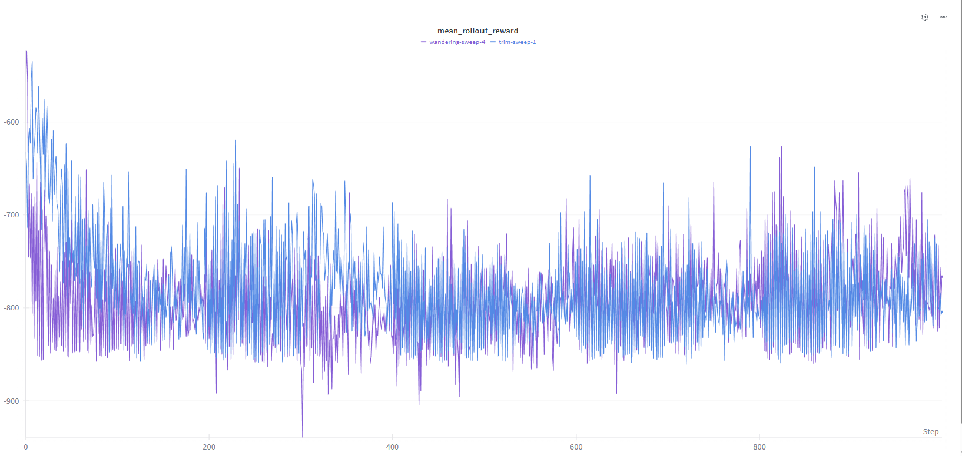
From the above graph, the purple line represents higher hidden dimensions while the blue line represents lower hidden dimensions. The convergence speed improves with higher dimension , as larger network ahs greater expressvitiy and can dadapt faster .
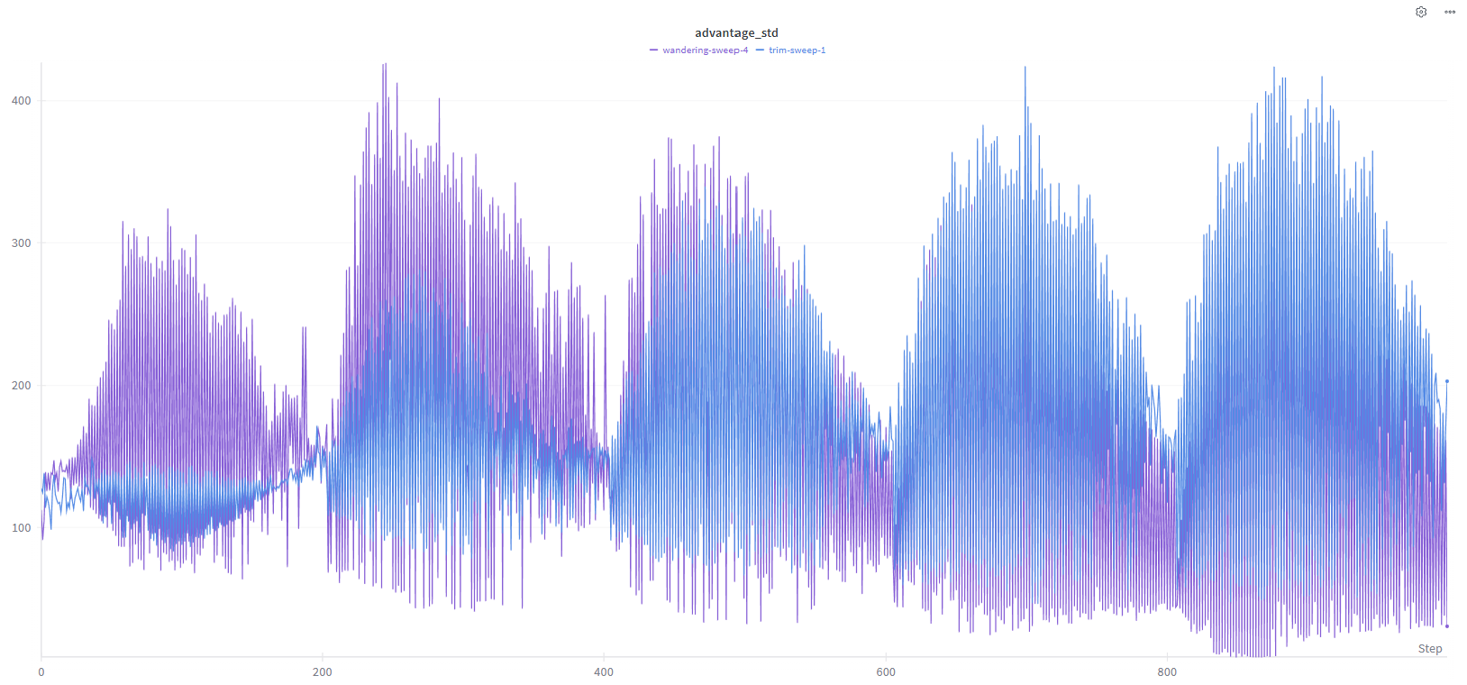
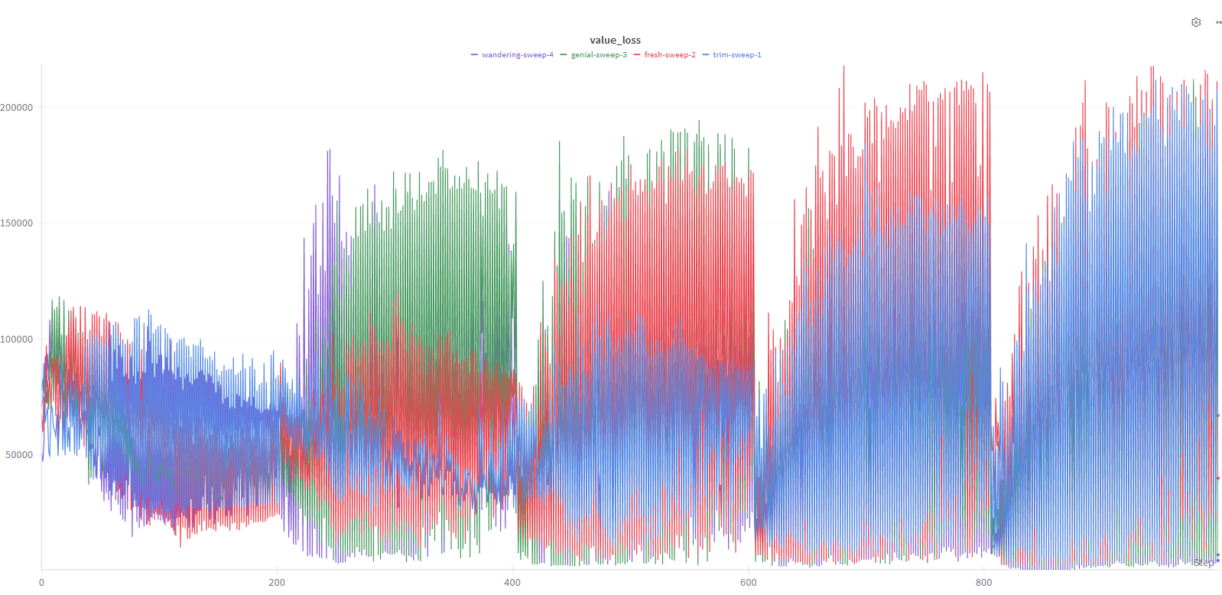
This graph show the advantages standard deviation is lower for the larger dimension throughout training, indiiating more stable valiue estimates while smaller networks exhiit higher adv_std earlyt on all configurations tend to converge to similar variance near the end.
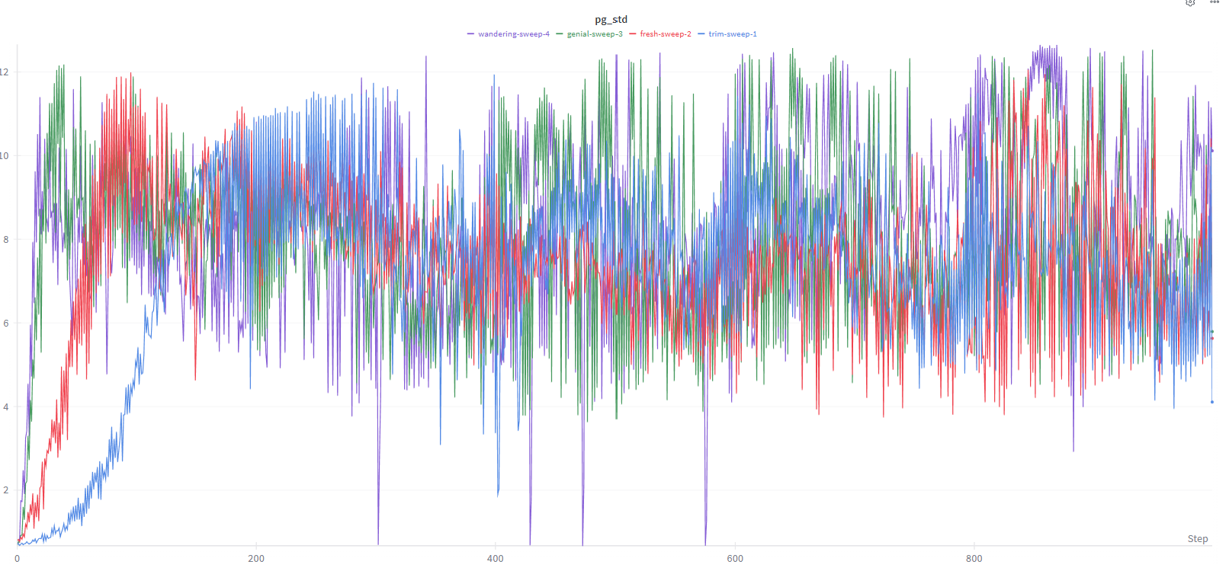
Policy gradient variance (pg_std) increases faster for larger hidden dimensions, reflecting that more expressive policies produce larger updates per step.
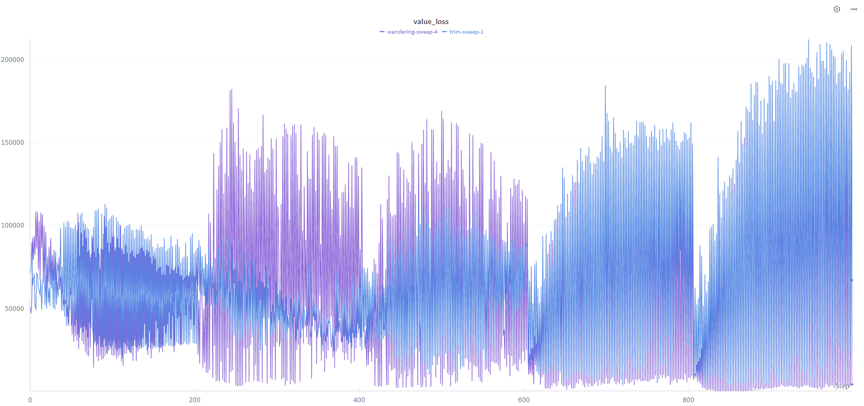
value loss exhibits an interesting pattern: the largest hidden dimension starts high but gradually decreases, whereas smaller networks accumulate higher value loss over time, likely due to underfitting.
No clear trend is observed in reward variability (std_rollout_reward), suggesting that rollout-to-rollout reward noise is dominated by the environment rather than network capacity. Overall, hidden dimension primarily affects convergence speed, advantage stability, and early value loss, with minimal effect on reward variance.

DDPG
In DDPG, I grouped those hyperparameters
2000 × 128 × 4 = 1,024,000 steps

trPO with

Training PPO . Reward scores are climbning but the KL dirvergenbec term si spiking. Shopuld we set the KL coefficient to – to unblock the model and maximisze the reward faster . Do we approve the PR?????
But remove the KL penalty. The model stops trying to be a helpful assistance sand starts Reward’s Hacking ( Goodhart’s Law)

Alfgorithm complexitry
O(asdfda)

Appendix

A

$$d^{π}\left(s\right)=\sum_{t=0}^{∞}{γ^{t}\operatorname{Pr}\left(S_{t}=s \right|π, S_{0}\sim p_{0})}$$

The expected discounted return:
$$J(θ)=E_{π_{θ}}[\sum_{t=0}^{T}{γ^{t}}R_{t+1}]$$
- Here $R_{t+1}$depends on state $S_{t}$and action $A_{t}$.
- $S_{t}$depends on the previous states and actions, which in turn depend on policy parameters $θ$.
So when you change $θ$, you don’t just change the action distribution, you also change which states the agent is likely to visit.

2️⃣ Chain rule intuition
Formally, the derivative w.r.t $θ$:
$$∇_{θ}J(θ)=\frac{∂}{∂θ}E_{π_{θ}}[\sum_{t=0}^{T}{γ^{t}}R_{t+1}]$$
Think in two parts:
- Effect of $θ$on actions:
  - Changing $π_{θ}(a∣s)$changes the probability of actions at each state
  - This directly changes $R_{t+1}$because you may pick a better or worse action
- Effect of $θ$on states (the $d^{π}(s)$term):
  - Changing the policy also changes which states the agent visits in the future
  - Later rewards $R_{t+1},R_{t+2},...$depend on these states
  - Chain rule pulls in $∇_{θ}d^{π}(s)$
So the gradient has two components:
$$∇_{θ}J(θ)=\underset{\text{change in states visited}}{\underset{⏟}{\sum_{s}{∇_{θ}}d^{π}(s)V^{π}(s)}}+\underset{\text{change in actions at each state}}{\underset{⏟}{\sum_{s}{d^{π}}(s)∇_{θ}V^{π}(s)}}$$
- The first term is intractable because $d^{π}(s)$depends on all future state transitions.
- The second term is what policy gradient theorem cleverly uses: we can sample states $s∼d^{π}$from rollouts and compute gradients with $∇_{θ}ln⁡π_{θ}(a∣s)$, avoiding explicit $∇_{θ}d^{π}(s)$.

B

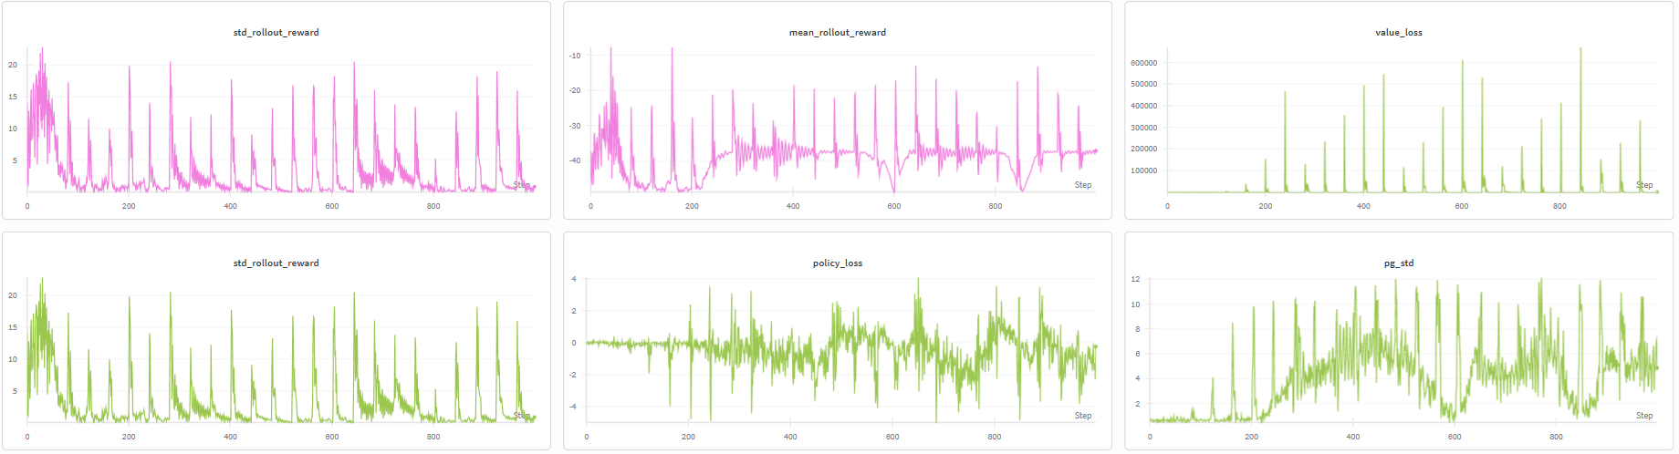
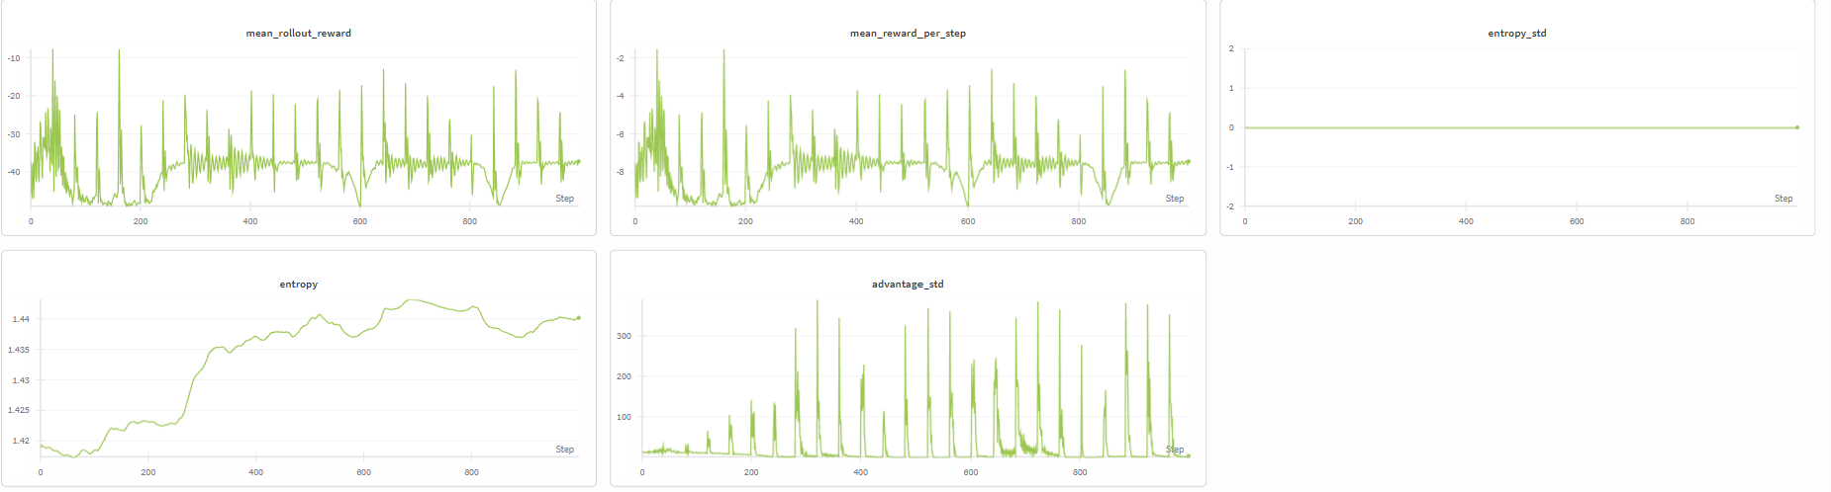
https://wandb.ai/arc_agi/Modern-Actor-Critic/sweeps/kdmszigc/runs/gemmour8

Reading list
- https://link.springer.com/article/10.1007/BF00992696 (REINFPORCE)

- https://www.alphaxiv.org/abs/1205.4839 ( actor- critic)

- https://www.alphaxiv.org/abs/1801.01290 (SAC)

- https://www.alphaxiv.org/abs/2503.06343 (STUDYING THE INTERPLAY BETWEEN THE ACTOR AND CRITIC REPRESENTATIONS IN REINFORCEMENT LEARNING)

- https://arxiv.org/pdf/1506.02438 GAE

- Overestimation, Overfitting, and Plasticity in Actor-Critic: the Bitter Lesson of Reinforcement Learning

- Representations for Stable Off-Policy Reinforcement Learning

- Simplicial Embeddings Improve Sample Efficiency in Actor-Critic Agents

- Bridging the Gap Between Value and Policy Based Reinforcement Learning

- Relational Object-Centric Actor-Critic

- Bridging the Gap Between Value and Policy Based Reinforcement Learning

- Dueling Network Architectures for Deep Reinforcement Learning

