Modern Actor–Critic methods for stable policy optimization.

1. Introduction
- Motivation for Actor–Critic (AC) methods
- Limitations of pure value-based methods (e.g., DQN) for continuous action spaces
- Overview of what will be compared (A2C, A3C, DDPG, TRPO, PPO, SAC)
- Brief statement on focus: progression and trade-offs within the AC family

2. Background / Theoretical Foundation
- Actor–Critic concept (actor + critic structure)
- On-policy vs off-policy distinction
- Policy-gradient basics
- Advantages of AC methods in continuous and high-dimensional environments

3. Individual Algorithms
For each algorithm, include:
- Core idea / innovation
- Key equations or update rules (brief, intuitive)
- Type: on-policy / off-policy, discrete / continuous
- Implementation notes (what you coded, buffers, tricks, etc.)
- Strengths and limitations
Suggested subsections:
- A2C – baseline AC, synchronous updates
- A3C – asynchronous updates, multi-threading
- DDPG – off-policy, continuous actions, deterministic policy
- TRPO – trust-region constrained updates, stable learning

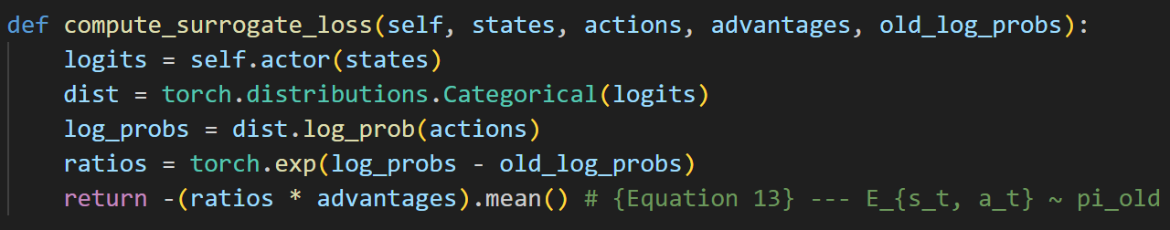

Compare
The perfromacen of these two
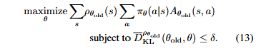
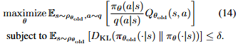

What is fisher_vector_product

- PPO – clipped surrogate objective, practical simplification of TRPO
- SAC – entropy-regularized off-policy, stochastic policies

4. Experimental Setup
- Environments used (e.g., CartPole, Pendulum, LunarLanderContinuous)
- Common neural network architecture and hyperparameters
- Training protocol: episodes, seeds, evaluation frequency
- Metrics:
  - Reward vs steps / episode
  - Sample efficiency
  - Stability (variance across runs)
  - Computational cost / training time

5. Results
- Plots: learning curves, cumulative rewards, variance
- Tables: sample efficiency, episode length, convergence speed
- Highlight comparisons:
  - On-policy vs off-policy
  - Continuous vs discrete environments
  - Stability and robustness

6. Discussion
- Interpret the results
- Explain why some algorithms outperform others in certain conditions
- Failure cases or sensitivity to hyperparameters
- Insights into practical trade-offs (e.g., PPO vs TRPO, SAC vs DDPG)

7. Conclusion / Lessons Learned
- Summarize key takeaways from the AC family
- When to use each algorithm (discrete vs continuous, sample efficiency, stability)
- Reflections on implementation challenges
- Suggestions for future work (e.g., combining AC methods, exploring meta-RL)

8. Optional Appendix
- Hyperparameter tables
- Detailed pseudocode
- Additional plots
- Ablation studies
Algorithm | Ablation Idea | Why It Matters
A2C | Vary rollout length or remove advantage normalization | Shows effect of variance reduction and batch size on stability
A3C | Run with single-threaded updates vs multi-threaded | Demonstrates benefit of asynchronous updates
DDPG | Remove target networks or vary replay buffer size | Shows importance of stabilizing Q updates and off-policy learning
TRPO | Remove KL constraint or vary step size | Shows why trust region prevents policy collapse
PPO | Remove clipping or change clip range | Illustrates effect of surrogate objective clipping on stability
SAC | Remove entropy term or vary α (temperature) | Demonstrates role of maximum entropy in exploration and stability

