IFQ582 Assignment 2
Application Walkthrough & Screenshots
Indigenous Digital Library
Student: Ted Brennan
Queensland University of Technology
IFQ582 – Rapid Web Development with Databases
Assignment 2 – Fully Developed Web Application

Figure 1 – Homepage 2
Figure 2 – Login 3
Figure 3 – Collection Search 4
Figure 4 – Collection Item Details 5
Figure 5 – Access Request 6
Figure 6 – Reviewer Dashboard 7
Figure 7 – Review Decision 8
Figure 8 – MySQL Database 9
Figure 9 – UML Class Diagram 10
Figure 10 – Entity Relationship Diagram 11
Figure 11 – GitHub Repository 12

Figure 1 – Homepage
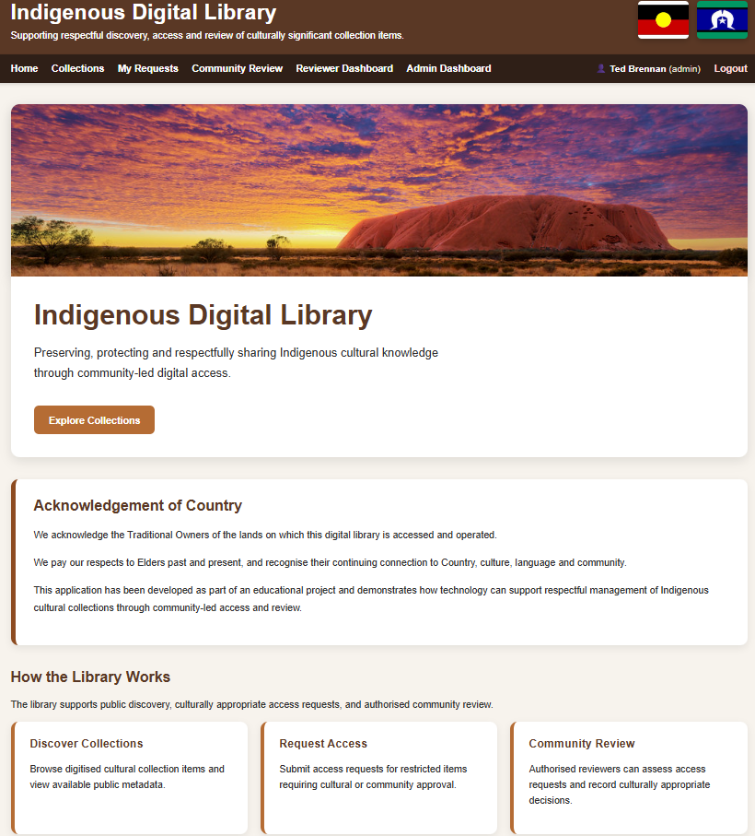
Caption: Homepage introducing the Indigenous Digital Library, navigation and project overview.

Description
The homepage provides an introduction to the application and serves as the main navigation point for all users.

Key Functionality Demonstrated
- User interface and navigation
- Application feature being demonstrated
- Database interaction (where applicable)
- Role-based functionality (where applicable)

Figure 2 – Login
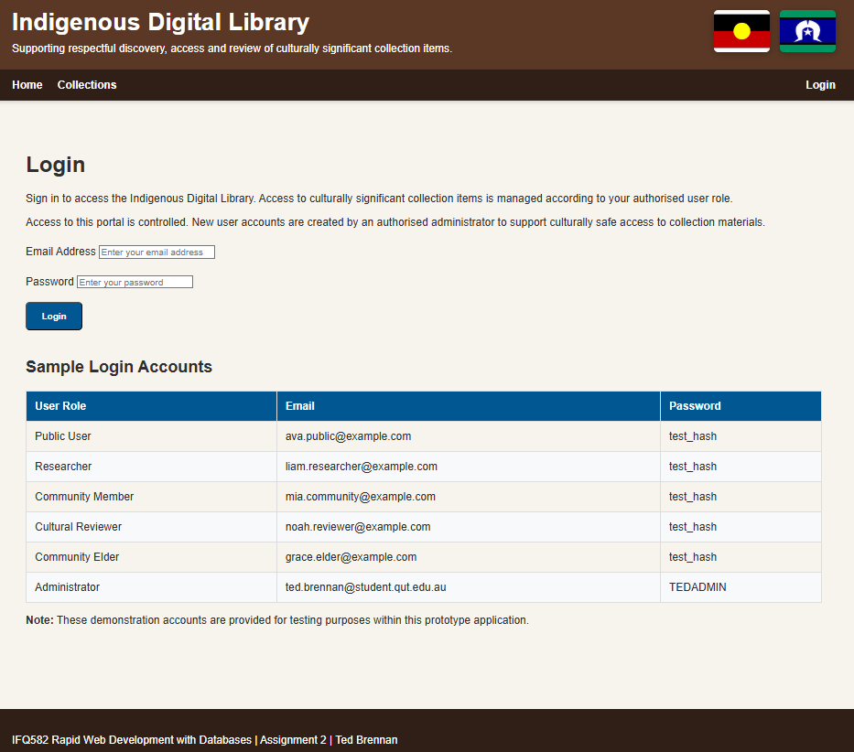
Caption: Secure login page used to authenticate registered users.

Description
This page demonstrates authentication and role-based access to protected features.

Key Functionality Demonstrated
- User interface and navigation
- Application feature being demonstrated
- Database interaction (where applicable)
- Role-based functionality (where applicable)

Figure 3 – Collection Search
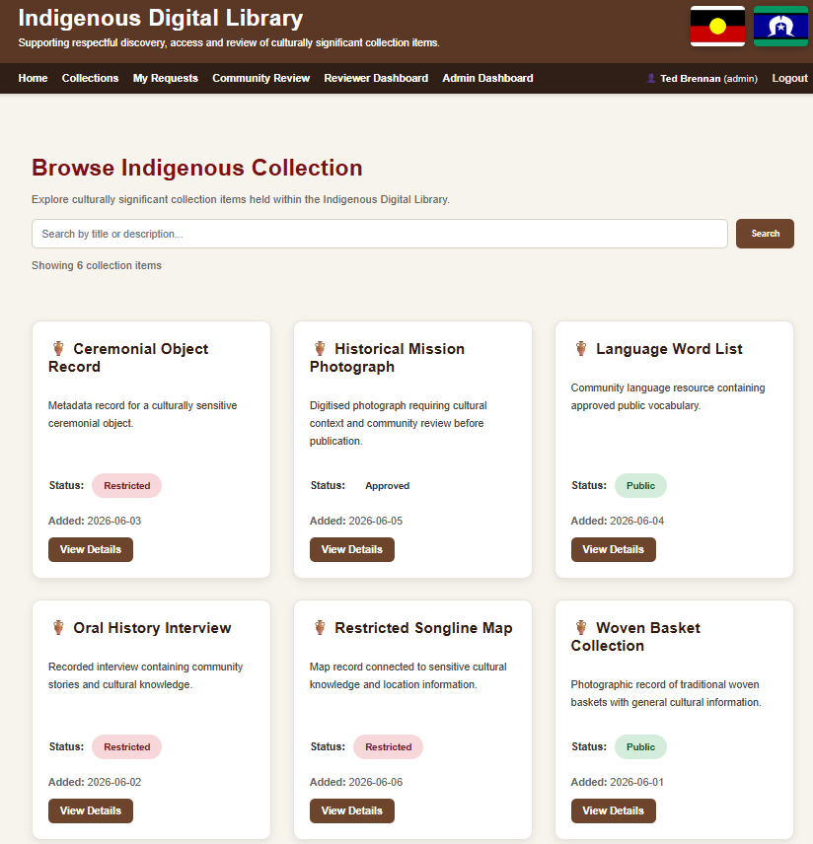
Caption: Collection search page allowing users to search approved collection items.

Description
Users can locate cultural items using search functionality before viewing details.

Key Functionality Demonstrated
- User interface and navigation
- Application feature being demonstrated
- Database interaction (where applicable)
- Role-based functionality (where applicable)

Figure 4 – Collection Item Details
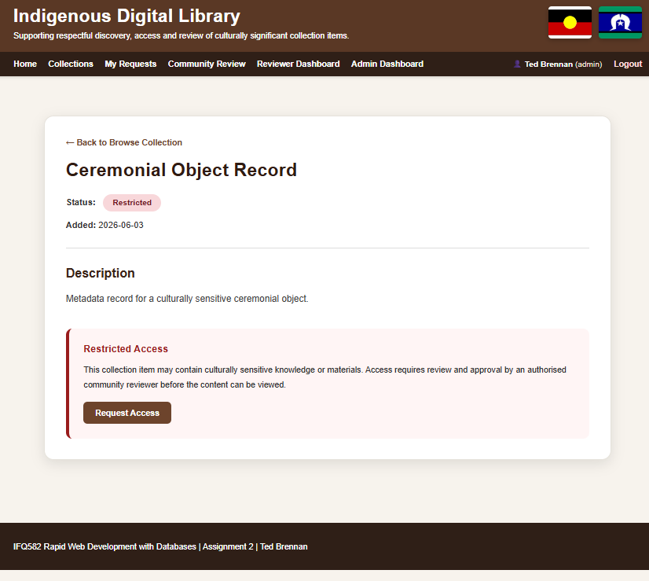
Caption: Detailed view of a collection item showing metadata, cultural sensitivity and availability.

Description
This page demonstrates how metadata is presented and whether access restrictions apply.

Key Functionality Demonstrated
- User interface and navigation
- Application feature being demonstrated
- Database interaction (where applicable)
- Role-based functionality (where applicable)

Figure 5 – Access Request
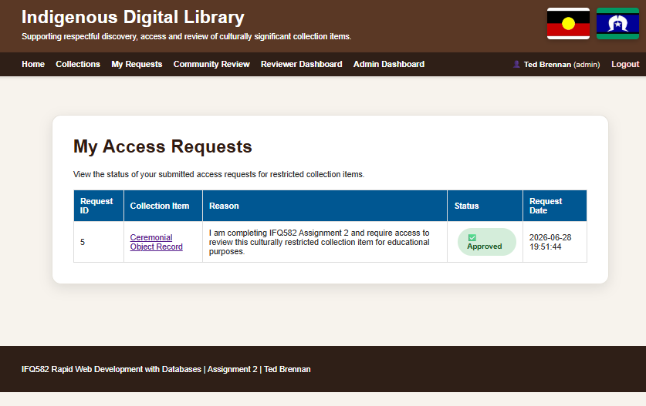
Caption: Access request form used to request permission for restricted cultural material.

Description
This demonstrates the controlled access workflow for culturally sensitive items.

Key Functionality Demonstrated
- User interface and navigation
- Application feature being demonstrated
- Database interaction (where applicable)
- Role-based functionality (where applicable)

Figure 6 – Reviewer Dashboard
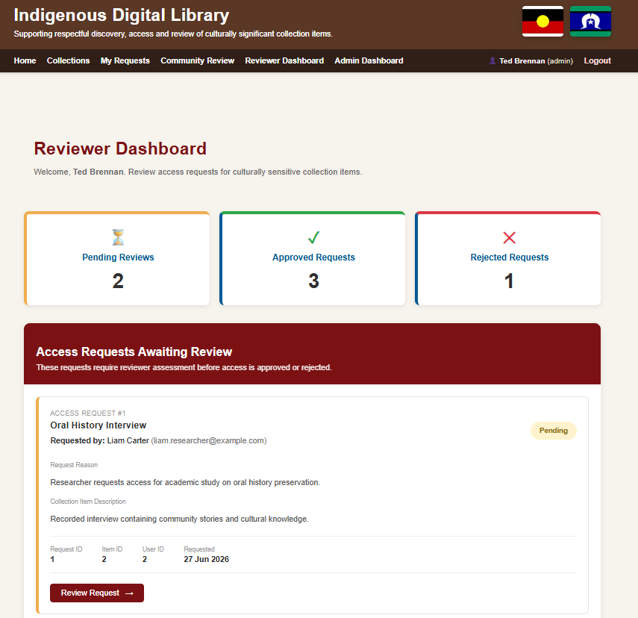

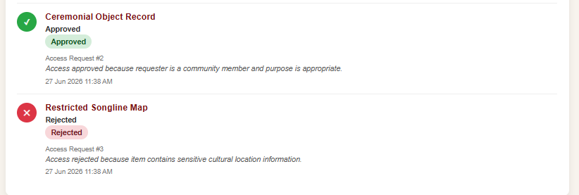
Caption: Reviewer Dashboard displaying pending review requests and review statistics.

Description
This dashboard provides reviewers with a central location to manage pending assessments.

Key Functionality Demonstrated
- User interface and navigation
- Application feature being demonstrated
- Database interaction (where applicable)
- Role-based functionality (where applicable)

Figure 7 – Review Decision
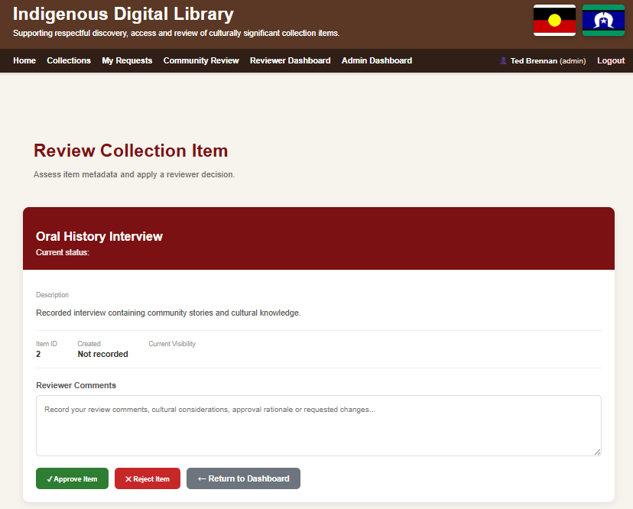
Caption: Review page where reviewers approve or reject submitted collection items.

Description
This page records review decisions, comments and updates the item status.

Key Functionality Demonstrated
- User interface and navigation
- Application feature being demonstrated
- Database interaction (where applicable)
- Role-based functionality (where applicable)

Figure 8 – MySQL Database
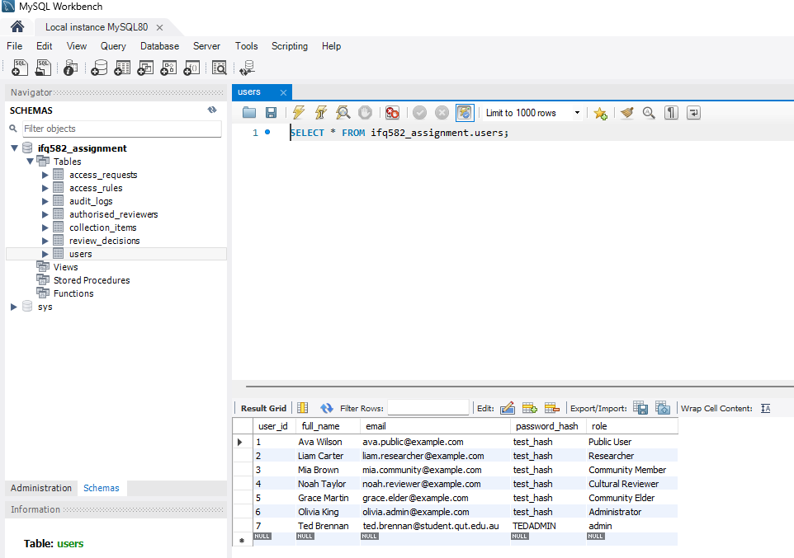
Caption: MySQL Workbench showing the relational database tables.

Description
This demonstrates the physical implementation of the relational database.

Key Functionality Demonstrated
- User interface and navigation
- Application feature being demonstrated
- Database interaction (where applicable)
- Role-based functionality (where applicable)

Figure 9 – UML Class Diagram
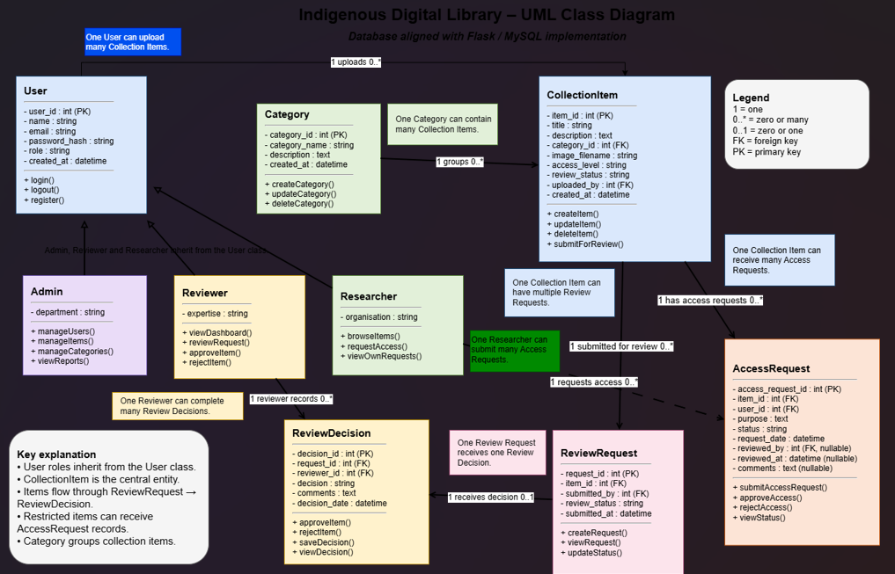
Caption: UML Class Diagram describing the application's object-oriented design.

Description
The UML diagram illustrates classes, attributes, methods and relationships.

Key Functionality Demonstrated
- User interface and navigation
- Application feature being demonstrated
- Database interaction (where applicable)
- Role-based functionality (where applicable)

Figure 10 – Entity Relationship Diagram
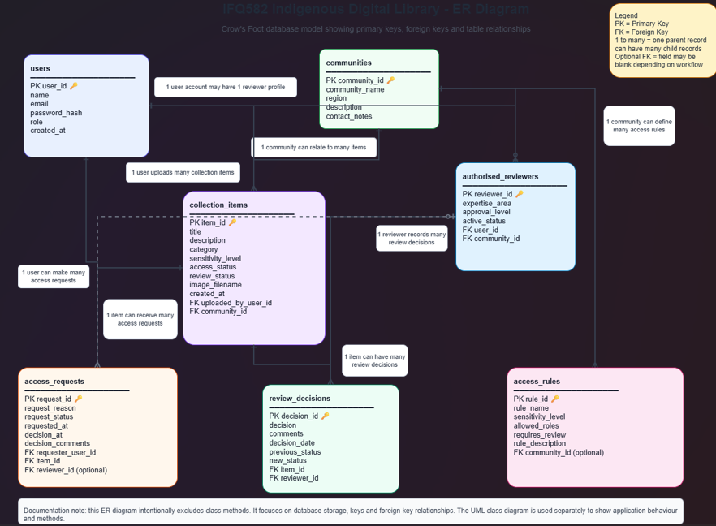
Caption: ER Diagram showing tables, primary keys, foreign keys and Crow's Foot relationships.

Description
The ER diagram documents the relational database design used by the application.

Key Functionality Demonstrated
- User interface and navigation
- Application feature being demonstrated
- Database interaction (where applicable)
- Role-based functionality (where applicable)

Figure 11 – GitHub Repository
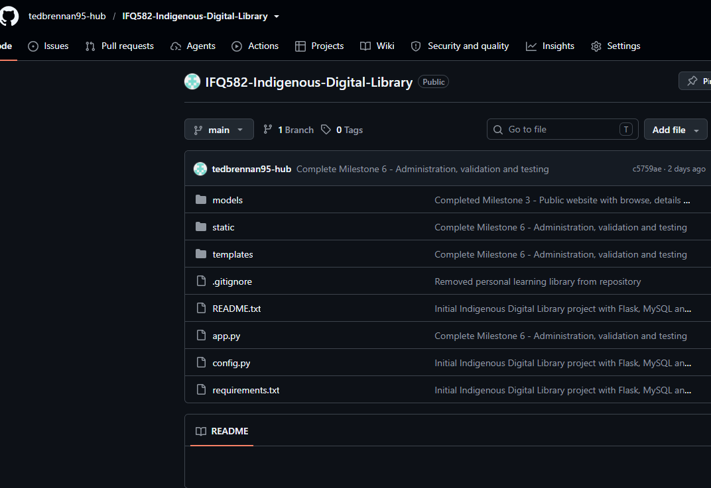
Caption: GitHub repository used for version control throughout development.

Description
This demonstrates source control and iterative software development practices.

Key Functionality Demonstrated
- User interface and navigation
- Application feature being demonstrated
- Database interaction (where applicable)
- Role-based functionality (where applicable)

