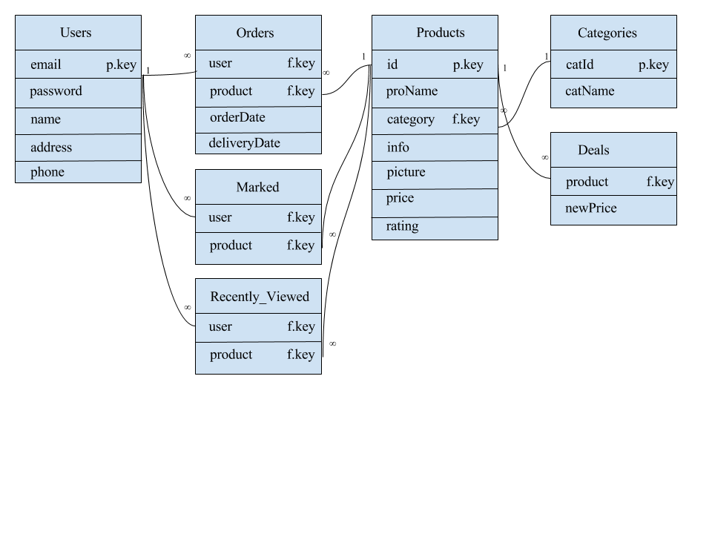**Users:**

CREATE TABLE Users(

email VARCHAR(30) PRIMARY KEY,

password VARCHAR(20) NOT-NULL,

name VARCHAR(30),

address VARCHAR(50),

phone VARCHAR(15)

);

**Categories:**

CREATE TABLE Categories(

catId VARCHAR(10) PRIMARY KEY,

catName Varchar(20) NOT-NULL

);

**Products:**

CREATE TABLE Products(

id INT(6) UNSIGNED AUTO-INCREMENT PRIMARY KEY,

proName VARCHAR(30) NOT-NULL,

category VARCHAR(10) NOT-NULL,

info TEXT NOT-NULL,

picture LONGBLOB NOT-NULL,

price DOUBLE UNSIGNED NOT-NULL,

rating DOUBLE UNSIGNED,

FOREIGN KEY(category) REFERENCES Categories(catId)

);

**Deals:**

CREATE TABLE Deals(

product INT(6) PRIMARY KEY,

newPrice DOUBLE UNSIGNED NOT-NULL

FOREIGN KEY(product) REFERENCES Products(id)

);

**Orders:**

CREATE TABLE Orders(

user VARCHAR(30),

product INT(6),

orderDate DATE NOT-NULL,

deliveryDate DATE,

PRIMARY KEY (user, product),

FOREIGN KEY(user) REFERENCES Users(email),

FOREIGN KEY(product) REFERENCES Products(id)

);

**Marked:**

CREATE TABLE Marked(

user VARCHAR(30),

product INT(6),

PRIMARY KEY (user, product),

FOREIGN KEY(user) REFERENCES Users(email),

FOREIGN KEY(product) REFERENCES Products(id)

);

**Recently_Viewed:**

CREATE TABLE Recently _Viewed(

user VARCHAR(30),

product INT(6),

PRIMARY KEY (user, product),

FOREIGN KEY(user) REFERENCES Users(email),

FOREIGN KEY(product) REFERENCES Products(id)

);